American International University-Bangladesh (AIUB)  
**Department of Computer Science  
Faculty of Science & Technology (FST)  
Fall 21_22**

**Section:   
Group No:**

**PROJECT TITLE**

Software Project Management Plan

for

Textile Operations Management System

A Software Development Project Management Project submitted

By

| **SN** | **Student Name** | **Student ID** | **Contribution (%)** |
| --- | --- | --- | --- |
| 15 | Deb,Hridoy Chandra | 18-36333-1 | 24.5 |
| 13 | MD. Ashraful Alam Shah | 18-36063-1 | 25 |
| 12 | Suhas Iftakhar | 18-36059-1 | 24.5 |
| 1 | Rabby, K M Fazly | 10-16482-2 | 26 |
|  |  |  |  |

Software Project Management Plan

for

Textile Operations Management System

**Version 1.0 approved**

**Prepared by**

Rabby, K M Fazly

Deb,Hridoy Chandra

Suhas Iftakhar

MD. Ashraful Alam Shah

**Aiub**

2021.10.06

**Table of Contents**

**Project Introduction** **5**

1.2 Background to the Problem 5

1.3 Solution to the Problem 5

**REQUIREMENT SPECIFICATION** **6**

**2.1** System Features 6

2.2 System Quality Attributes 8

**Project Organization** **9**

**3.1** [**Effort Estimation Plan  
 <identify all the micro tasks related to project management and categorize them within   
 the WBS structure>**](#_17dp8vu) **9**

**3.2** [**Work Break Down Structure  
 <draw a network diagram of the identified tasks from WBS>**](#_3rdcrjn) **9**

**3.3** [**Activity Plan  
 <estimate the project development effort using the standard techniques>**](#_26in1rg) **9**

**3.4** **Resource Allocation** **9**

*<describe the available resources and their allocation >* *9*

***3.5*** [**Risk Management Plan  
 <identify all the potential risks in your project development and provide a mitigation plan>**](#_1ksv4uv) **9**

**Revision History**

| **Revision** | **Date** | **Updated by** | **Update Comments** |
| --- | --- | --- | --- |
| 0.1 | 2021.10.06 | Deb,Hridoy Chandra | First Draft |
| 0.2 | 2021.10.13 | Suhas Iftakhar | Requirements specified. |
|  |  |  |  |
|  |  |  |  |
|  |  |  |  |
|  |  |  |  |
|  |  |  |  |
|  |  |  |  |
|  |  |  |  |

**Project Deliverable**

| 1. Preliminary Project Plan | 2021.02.06 |
| --- | --- |
| 1. Requirements Specification | 2021.03.13-2021.04.01 |
| 1. Analysis [Object model, User interface] | 2021.04.02-2021.06.10 |
| 1. Source Code | 2021.06.11 - 2021.10.19 |
| 1. Test Plan | 2021.10.20 - 2021.12.12 |
| 1. Final Product / Demo | 2021.12.13 - 2021.12.31 |

# Project Introduction

A Dyehouse management system has to be designed to support digital record keeping, inventory tracking and forecasting for a textile dyeing unit. The software application needs to be web based so it can be accessed from anywhere securely by users with different access levels. The application must be able to receive inputs for all textile activities and produce easy to understand reports with visuals for speedy interpretation. Continuous integration and continuous delivery (CI/CD) needs to be in place for uninterrupted updates and maintenance.

**1.1ProjectOverview**This project is to create a web based management system for a textile dyeing factory where data entry operators can create entries from different documents such as chemicals consumption sheet, gate pass, daily dyes and chemicals report. These inputs are then saved to a database and are used to create reports

## 1.2 Background to the Problem

* Crystal Composite Limited are facing difficulty with the tracking of orders that are being processed and the inventory requirements that arise with processing the orders. The day to day data are being collected but the data does not provide any comprehensive overview of the operations. Because of this, they are facing issues like congestion and their time slots are not being utilised properly leading to inefficiency and losses.
* The root cause of the problems is that the data are being collected and compiled using legacy systems and tools like excel sheets. The data is therefore hard to comprehend and cannot be accessed from everywhere by management for them to be able to make quick decisions and foresee necessary actions.

## 1.3 Solution to the Problem

* The requirements for the solution are that of a standard ERP and CRM system. Building a fully featured ERP system is out of scope due to the budget constraint.
* Open source solutions are available that can be customised to meet the requirements. This solution saves development hours while providing the benefits of a receiving regular bugs and security updates.
* The open source solution we have identified to be optimal for these set of requirements is [Odoo](https://www.odoo.com/app/inventory-features). This has a large community behind it that is improving the software and all its different modules everyday. We will extend these modules to meet our requirements that will minimize the chances of the features to break with critical updates.

# REQUIREMENT SPECIFICATION

## System Features

**1. System Login**  
Functional Requirements

* 1. The software shall allow users to login with their given username and password
  2. If the username and/or password has been inserted wrong for more than three times, the random verification code will be generated by the system to retry login.
  3. If the number of login attempt exceed its limit (5 times), the system shall block the user account login for one hour *[optional function]*

Priority Level: High  
Precondition: user have valid user id and password

**2. Restricted Views**

2.1 The software shall have several user levels.

2.2 The software will have different views and functionalities based on the user leve.

Priority Level: High  
Precondition: correct user levels are set

**3. Privileged users can update/edit presets that are required for the software to operate.**

Priority: High

Precondition: Users are created with correct access levels.

**4. Live production tracking**

4.1 The software shall provide data on ongoing production

Priority Level: High  
Precondition: Required data are available

**5. Cash and expenses tracking**

5.1 The software shall track live cash transactions and balance data records with preceeding targets

Priority Level: High

Precondition: Operations presets and targets are available and preset by enterprise board

**6. Chemical inventory tracking:**

6.1 The software shall track remaining chemical inventory, chemical inventory purchases and daily usage

Priority: Medium

Precondition: Existing inventory balances and their purchase records including Purchase rates, Total Purchases will be compiled

**7. Chemical inventory alerts**

7. 1 Software will alert users when it is time to restock Commodity dyeing chemicals

Priority: High

Precondition: Commodity Materials Critical Presets, average time to restock materia are

taken into account and critical levels are preset.

**8. List view of orders**

8.1 Software will display total list of orders that have and have not been allocated a production schedule

Priority: Medium

Precondition: All Orders, Contact Directory, Production Pricing is readily available for the user to select.

**9. Order schedule**

9.1 Software will display allocated orders according to calender and date of selection, materials required, total cost of production and profit margins of proceeding order with a link on the dashboard.

Priority: High

Precondition: User will allocate all orders according to the best alloted machine

according to production capacity

**10. Requisition management**

Software will display all required Materials for procurements according to required dates and average usage rates

Priority: High

Precondition: All Average Usage Rates, Orders and Materials Remaining Datasets have to be preset and functioning in synchronization for the requisition management system to be able to operate coherently.

## System Quality Attributes

O Usability: A trained user shall be able to submit a complete request for a chemical selected from a vendor catalog in an average of four and a maximum of six minutes.

Availability: The system shall be accessible over the internet from any device including mobile devices.

O Speed: Any system feature shall not take longer than 30 seconds to load with a 1MBps connection or above.

# Project Organization

## 3.1 Effort Estimation Plan *Here we use the cocomo model to estimate the estimation of our project. Suppose that our project is an organic type. The project is estimated to be 14,000 SLOC. Now we have to calculate effort, development time and required number of people.*

project type= organic, So

Coefficient<Effort Factor>=2.4,SLOC= source lines of code=14000, P= project complexity=1.05

We know that,

Effort =PM= Coefficient<Effort Factor>*(SLOC/1000) ^P

=2.4 *(14000 / 1000) ^ 1.05

=38

Here,T= SLOC-dependent coefficient=0.38,PM=38

We know that,

Development time= DM= 2.50*(PM)^T

=2.50*(38) ^0.38

=10 month

Here,PM=38, DM=10

We know that,

Required no. of people = ST = PM/DM

= 38/10

=4

Here per developer salary per working hour=800 taka.22 days working day in a month and 7 hours working hours in day

Here 10 months=10*22*7=1540 working hour.

Total developer salary=800*1540=12,32,000 Taka

For requirement analysis,

Time 1 month=22 days*7 working hour

=154 working hour

Hourly wage of 1 requirement analysis person= 300 taka

Total cost= 300*154 =46, 200 Taka

Transport; 10000 Taka

Utility cost in 10 months, 12,000 Taka

Hardware Expenses= 80,000 Taka

Rent service: Room per month :7000 taka

10 month=70000 Taka

Maintenance cost= Required time 50 hours

Per hour cost 1100 taka

Net total cost=1100*50=55000 Taka

Training cost= 10,000 Taka

Total estimation cost=1,056,000+ 35,200 +12,000 + 16,000 + 1,20,000 + 50,000 + 50,000+10,000

=12,32,00+46,200+10000+12000+80000+70000+55000+10000

=15,15,200 Taka

Profit:

20 % of total estimation cost=15,15,200*18%

=2,72,736

Total budget of project =15,15,200+ 2,72,736

=17,87,936 Taka

## 3.2 Work Breakdown Structure

## 3.3 Activity Plan HERE: 2 WEEKS= 1

## ACTIVITY KEY:

## *A. Requirements Gathering*

## *B. Design and analysis*

## *C. Backend Development, Mock API and API*

## *D. Frontend development, Module views*

## *E. Frontend development, Admin views and reports*

## *F. Testing*

## *G. Deployment*

## 3.4 Resource Allocation

Resource Histogram for staff required.

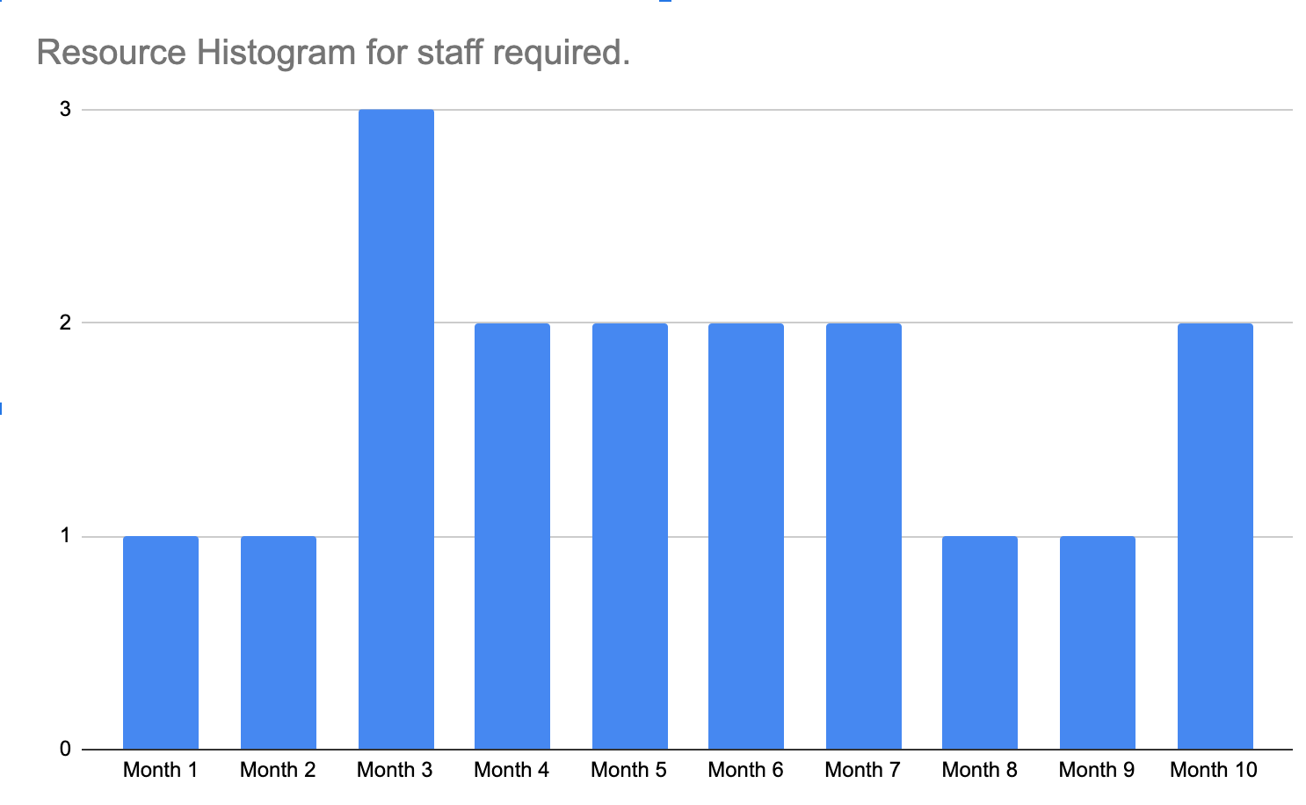

## 3.5 Risk Management Plan

| Risks | Category | Probability | Impact | RMMM |
| --- | --- | --- | --- | --- |
| Size estimation significantly low | PS | 30% | 2 | - Use multiple size estimation techniques to verify the estimation.  - Have room for error in the budget |
| Developer inexperienced | ST | 40% | 2 | - Define required experiences for the job clearly while recruiting.  - Have senior developer with previous experience lead the development work |
| Customer changes requirement at development stage | PS | 60% | 2 | - Communicate scope of changes and the change control policy clearly with the customer  - Have a change control board |
| Technology stack gets deprecated | TE | 20% | 3 | - Use LTS versions where possible  - Decouple as much as possible so replacements are possible. |
| Breaking changes in prebuilt packages | TE | 30% | 2 | - Prevent automatic updates to the repository modules and packages - Analyse each update before applying the updated version  - Use a version control system |
| Funding lost | CU | 15% | 1 | - Communicate frequently - Secure early funding - Collect an upfront payment |

**Impact values:**

Catastrophic - 1  
Critical - 2  
Marginal - 3  
Negligible - 4

**REFERENCES**

Hasan, M.M. (2015). E-Government Service Research Development: A Literature Review*.*

*International Journal of E-Services and Mobile* Applications,volume **7**, issue 1, page 22-49.

Hasan, M.M., Loucopoulos, M. and Nikolaidou, M. (2014). Classification and qualitative analysis of non-functional requirements approaches. In *Enterprise, Business-Process and Information Systems Modeling*. Thessaloniki, Greece, page 348-362.

CHR – Citizens Help Request (2012). Available at <http://chr.police.gov.bd>, Retrieved on May 29, 2012.

**Text Format:**

* Style: Times New Roman
* Size: 12
* Space: 1.0
* Alignment: Justify
* Length: Maximum 5 pages (including cover page)