# HRIDOY CHANDRA DEB 18-36333-1

**SEC:D**

**Features**

Features are listed below. **High**, **Medium** and **Low** are used to indicate the importance of each feature.

|  |  |  |  |
| --- | --- | --- | --- |
| **Feature ID** | **Description** | **Priority** | **Requester** |
| **FE01** | Web based and accessible from devices (with internet connection) And login phase. Accessible only to authenticated and authorized users | High |  |
| **FE02** | Contact, Reminder, event module will be added. Clients will be able to store contact details, create Clients event description with date specified.  Picture and video added to any specific event and modify the existing events and can delete any specific event added in this phase. | High |  |
| **FE03** | User management and auditing user activities | High |  |
|  |  |  |  |

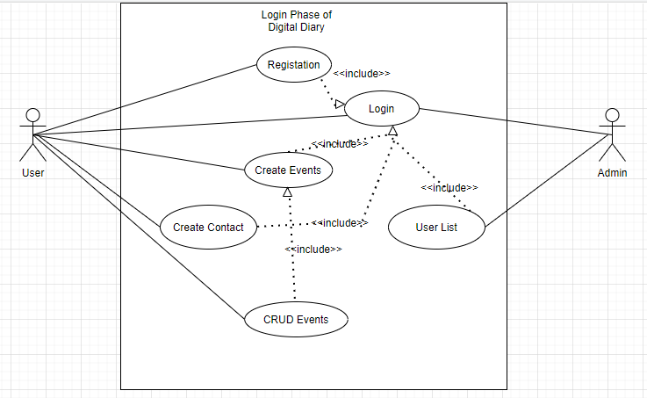

**Use Cases**

|  |  |
| --- | --- |
| **FE01 – Login Phase** | |
| **FE01_UC01 - User Registration** | |
| **Brief Description** | The user opens up the portal and the portal shows the login form for access. |
| **Pre-condition/s** | * User is not registration in already |
| **Priority** | High |
| **Actor/s** | Users of all classes. |
| **Main Success**  **Scenario** | 1. User opens up the web portal 2. The system displays a registration form 3. User signup successfully. 4. The system displays a login form 5. User enters his/her user id and password 6. When id and password match user access to enter home screen. |

|  |  |
| --- | --- |
| **Alternative Scenario** | * The system cannot find a match for the user and re- displays the login form with an error message. * The system runs into internal error (i.e. database unavailable) and notifies user and asks the user to contact administrator |
| **Notes/Questions** | Must need clarification on dashboard for each user type. |

|  |  |
| --- | --- |
|  | |
| **FE02_UC01** – Home Display | |
| **Brief Description** | The system will display user information |
| **Priority** | High |
| **Actor/s** | User |
| **Main Success**  **Scenario** | Contact, Reminder, event module will be added. User will be able to store contact details, create Clients event description with date specified.  Picture and video added to any specific event and modify the existing events and can delete any specific event added in all this features. |
| **Notes/Questions** | The types of views must be mentioned |

|  |  |
| --- | --- |
|  | |
| **FE03_UC01** - View user list | |
| **Brief Description** | The system will display user information |
| **Priority** | High |
| **Actor/s** | ADMIN |
| **Main Success** | 1. The user list will be displayed in a single organized page |

|  |  |
| --- | --- |
| **Scenario** |  |
| **Alternative Scenario** | * The system is unable to extract employee information from the database and generates error message |
| **Notes/Questions** | The types of views must be mentioned |