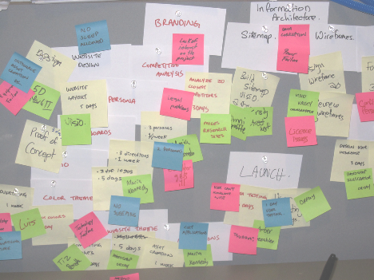

Integrated Airline Ticketing System

## 10.15.2018

~~─~~

Raihan Uddin Ahmed

## Saz Commodities and Services 178 Arambag, 1st Lane Dhaka, 1000

**Overview**

The project involves creating a web based solution to provide an integrated environment for clients to search for and subsequently book airline ticket for 4 different airlines existing in Bangladesh. This site will allow clients to search based on dates, from and to locations. Dat will be collected through web scraping since the airlines do not offer any APIs (Application Programming Interface) to gather data on ticket availabilities.

# Justification

Currently, all four airlines - Bangladesh Biman, NovoAir, US Bangla Airlines and Regents - offer individual online ticketing systems to search and book tickets. So, it is difficult for a client to search all four of these online ticket booking systems to get the desired ticket based on availabilities and price. An integrated environment where all four of these online systems can be searched for tickets and subsequently booking tickets from the same environment would be a beneficial solution.

# Goals

1. Create a responsive web application where users can have a single interface to search for air ticket availabilities for all four Airlines operating in Bangladesh
2. Provide an easy interface for booking airline tickets for any of the four airlines operating in Bangladesh.

# Specifications

1. Ticket search module will allow clients to search for tickets for all airlines.
2. A booking module that will allow clients to book tickets from any airline
3. A payment module to work with booking module to accept payments for tickets
4. An admin module to view reports on various activities such as total daily sales, total cancellations, or total number of ticket changes (dates or locations)
5. ALl ticket data will be scraped from the following sites -
   1. <https://www.flynovoair.com/>
   2. <https://flyusbair.com/welcome>
   3. <http://www.flyregent.com/>
   4. <https://www.biman-airlines.com/>

# Constraints

The system will have to do web scraping for data collection from all four airlines since those airlines do not provide any API or direct database access to get the ticket information.

The System has to be a responsive web application to be usable from both desktop and mobile devices.

# Assumptions

It is assumed that web scraping of data is allowed by the airlines.

The client will provide web hosting and domain registration to deploy the application. The client has merchant account or BKash account to accept payments

# Project Duration

16 weeks.

# Project Start Date

Date here will be the date that the advance payment is cleared.

# Milestones/Phases with cost

|  |  |  |  |
| --- | --- | --- | --- |
| **Phases** | **Description** | **Duration** | **Cost (BDT)** |
| Phase 1 | In this phase, the search module will be completed. Clients will be able to only search for available tickets of all four airlines from a single search page. | 5 weeks | 30,000 |
| Phase 2 | In this phase, booking will be added. Clients will be able to search and book airline tickets. They will be able to pay through BKash or credit cards | 6 weeks | 30,000 |
| Phase 3 | This phase will involve developing the | 5 weeks | 30,000 |

|  |  |  |  |
| --- | --- | --- | --- |
|  | admin dashboard for generating reports, monitoring activities acounting and so on. |  |  |
| Total | | 16 weeks | 90,000 |

**Payment Plan**

1. An advance payment of BDT 10,000 will be required to start the project.
2. The rest of the money must be paid based on phases. Complete payment due for each phase must be paid within 10 days of the completion of the phase.

# Other Terms and Conditions

1. The Advance payment becomes non-refundable after two weeks of the project initiation.
2. After the final delivery of the product (completion of all phases), the client will have a window of one (1) month to report any issues that may have been caused by the application programming. These issues will be fixed for free.
3. After the end of one month of free support period after final product delivery, any and all works requested by client will incur charges on the client based on negotiated pricing.

# Agreement

**On behalf of the client seeking product/service**

Raihan Uddin Ahmed

**On behalf of the product/service provider**

Raihan Uddin Ahmed

Chief Technical Officer (CTO) Saz Commodities and Services

Chief Technical Officer (CTO) Saz Commodities and Services