RESUME OF MD RIDOY HOSSAIN
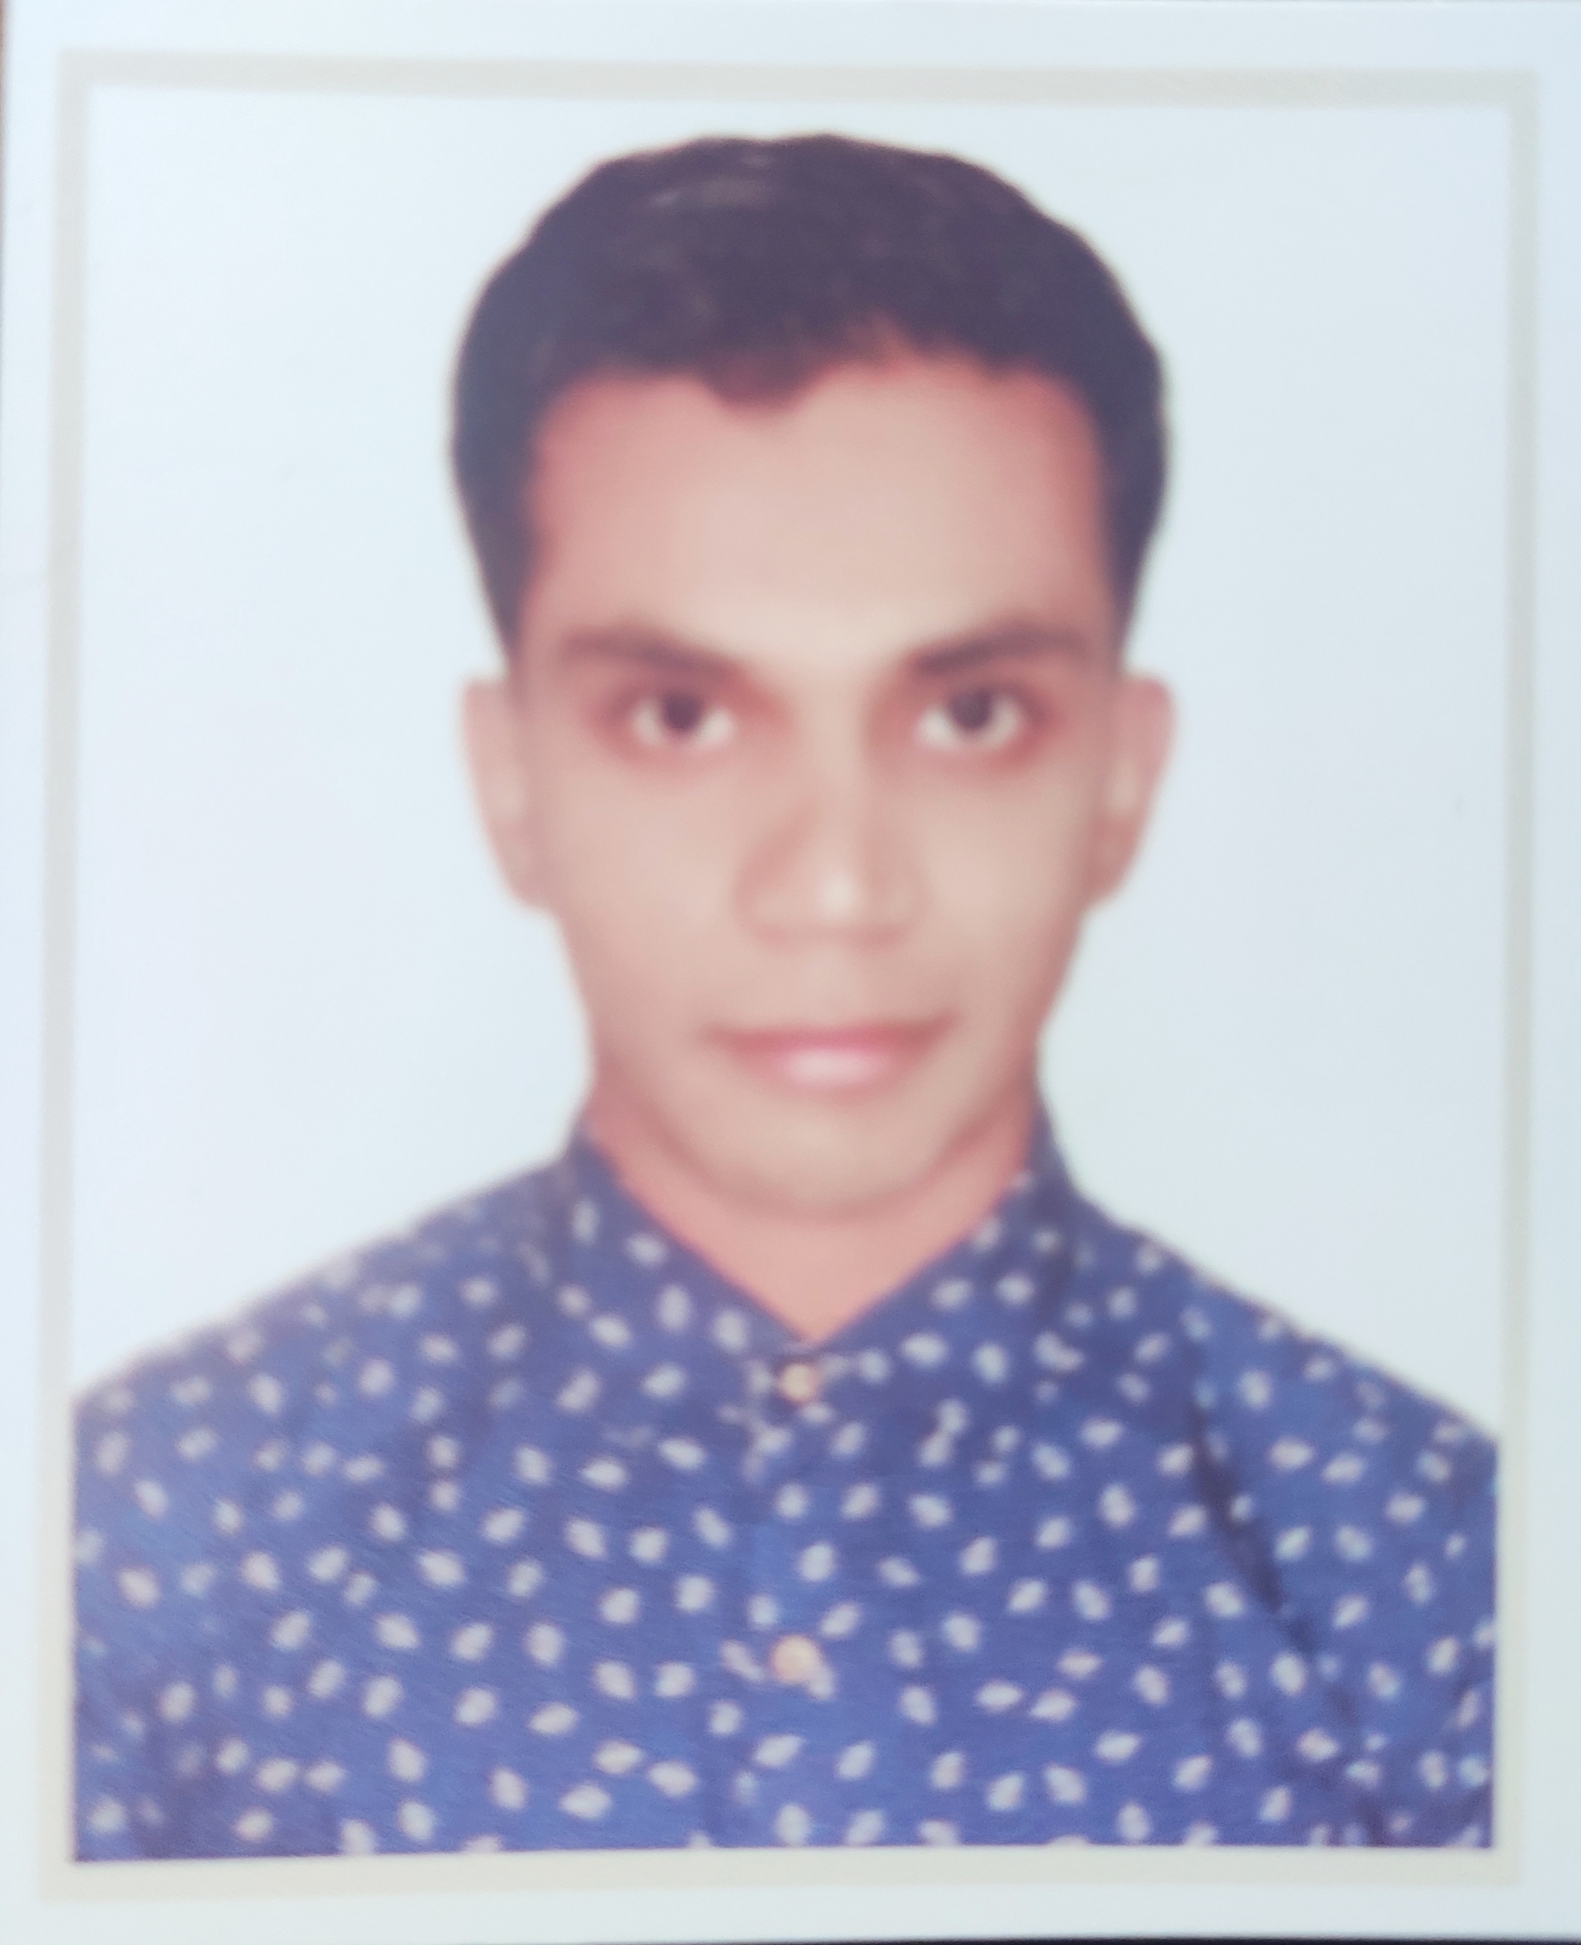
Present Address:
House #11, Road #09, Sector #06
Uttara, Dhaka-1230.
Mobile: +8801622825992, +8801704589642
E-mail: mrhninfo@gmail.com
Apply for: Laravel Developer

OBJECTIVE:
To run a responsible position where I could use my technical and interpersonal skills, creativity and above all my learning experience in order to develop my career and as well as to contribute to the welfare of the company.

MY SKILLS:

HTML5
CSS3
Bootstrap
PHP
Laravel

ACADEMIC BACKGROUND:

Institute Of Royal Marine Academy Diploma-In-Engineering
Course : Marine Engineering
Semester : 8th
Board : BTEB

DALAL BAZAR DEGREE COLLEGE HSC EXAMINATION Group : Commerce
Board : Comilla
Passing year: 2017
Result: B (GPA- 3.06)

MOHAMMAED ULLAH HIGH SCHOOL SSC EXAMINATION Group : Commerce
Board : Comilla
Passing year: 2016
Result: A (GPA- 4.00)

PERSONAL INFORMATION:

Name : Md Ridoy Hossain
Father’s Name : Md Shahajahan
Mother’s Name : Jesmin Akter
Permanent Address : Vill: Gongapur, P.O: Gongapur,
Sadar, Lakshmipur, Chittagong, Bangladesh.
Date of Birth : 25-06-1998
Nationality : Bangladeshi (by Birth)
Religion : Islam
Sex : Male
Blood Group : B(+ve)
Marital Status : Unmarried

ADDITIONAL TRAINING:

- Has successfully and satisfactorily completed a short course of plumbing at (SEIP)
- Has successfully and satisfactorily completed a short course of welder at (Sudokkho)

EXTRA CURRICULAM:

Good Communication Skill Over English
Playing Efficiecy: Cricket, Football, Volleyball and others Games.

LAUNGAUGE:

Language | Reading | Writing | Speaking
Bengali | Excellent | Good | Good
English | Excellent | Good | Good

SPECIALITY:

Determinant Sincere to work.
Eager to learn Something New Thing.
Ready to take challenge Responsibility.
Communicative Friendly.
Always Developing in company.

REFERNCES :

Mostahidur
Department Head of Marine
Saic Institute Of Management and Technology (SIMT)
Mobile: 01936-005886
E-mail: supornasmita@gmail.com

(HRIDOY)

