**GAF-Screener**

The GAF-Screener is a selenium based browser automation stock screener named after the team GAFIA, which scrapes data from google finance into the API in real-time and returns the data to the compiler segregated into two types, whether the ticker value is INDIAN (numerical ticker) or AMERICAN (alphabetical ticker).

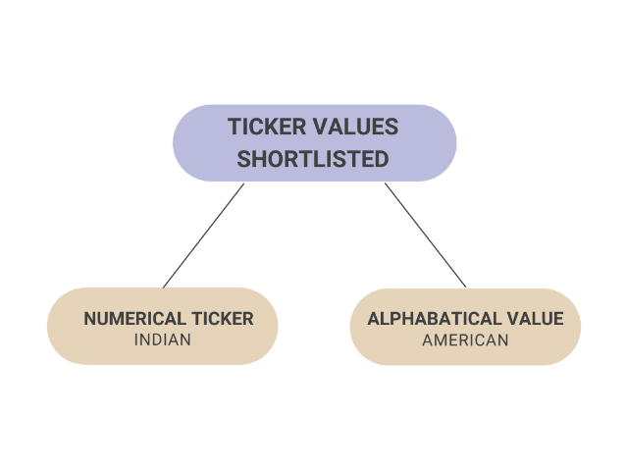

It is a tool that helps us shortlist stocks from the 2022-23 WGYP list based on user-input criteria, thus generating a list of potential companies that qualify the given requirements. The screener allows the user to define certain filters which are then used to narrow down options for their next trade.

It filters out the businesses based on their:

1. Sector
2. Beta Range
3. Debt to Equity Ratio
4. Net profit margin
5. PE ratio

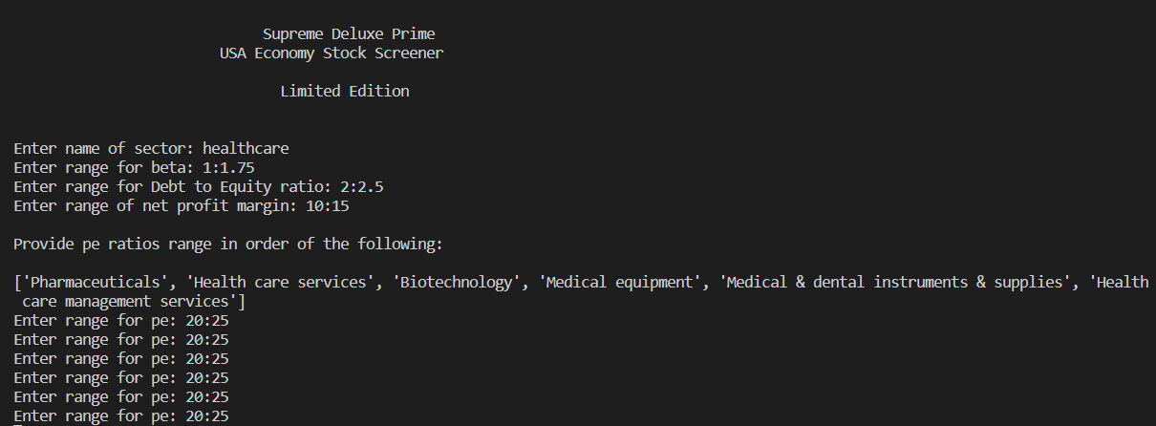

The screener returns the result in the form of two tables:

1. **Cash Profit Table**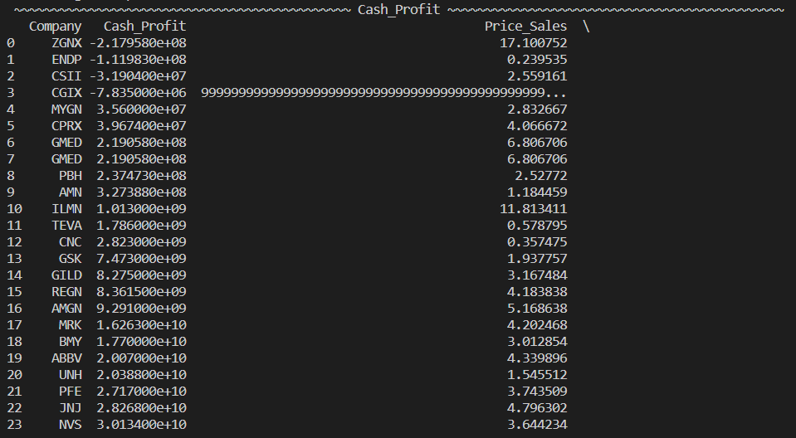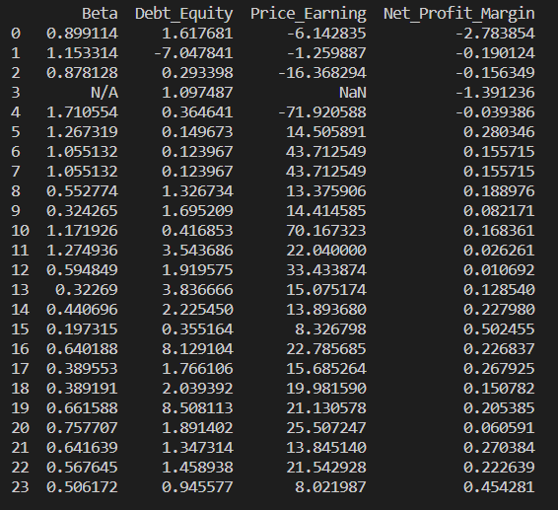

**2. Profit Sales Table:**

This allows the team to quickly sort through the myriad of available stocks and increasing exchange-traded funds according to the criteria specified by the user, drastically reducing the amount of time required in choosing the ideal stock.