YOLO Tooth Detection Evaluation Report

Prepared by:- Hridvi Saluja

Email:- salujahridvi@gmail.com

Date:- 29/08/2025

**1. Introduction**

The goal of this project is to use the YOLOv9 object detection framework to automatically detect and number teeth in panoramic dental X-ray images. The FDI World Dental Federation numbering system (32 classes) was used to annotate the information, allowing for accurate tooth localization and categorization.

**2. Dataset**

The dataset consists of ~500 annotated images, split into 80% training, 10% validation and 10% testing. Each image was paired with YOLO-format text annotations, ensuring high-quality supervision during training.

**3. Training**  
The YOLOv9s model was trained on Google Colab with GPU acceleration for 100 epochs. The training pipeline included:

* Input resolution of 640×640 pixels
* Confidence threshold set to 0.25
* Optimizer: SGD with momentum 0.937
* Augmentation: HSV shifts, random flipping and mosaic augmentation

**4. Evaluation**

The trained model was evaluated on the validation and test sets, with the following results:

* Precision, Recall, mAP@50 and mAP@50–95 as core metrics
* A confusion matrix per class to highlight classification performance
* Training curves illustrating the convergence of loss and improvements in accuracy metrics
* Sample prediction outputs demonstrating correct tooth detection and numbering

**1. Training Curves**

The following plot shows training and validation loss, along with precision, recall and mAP values over epochs.

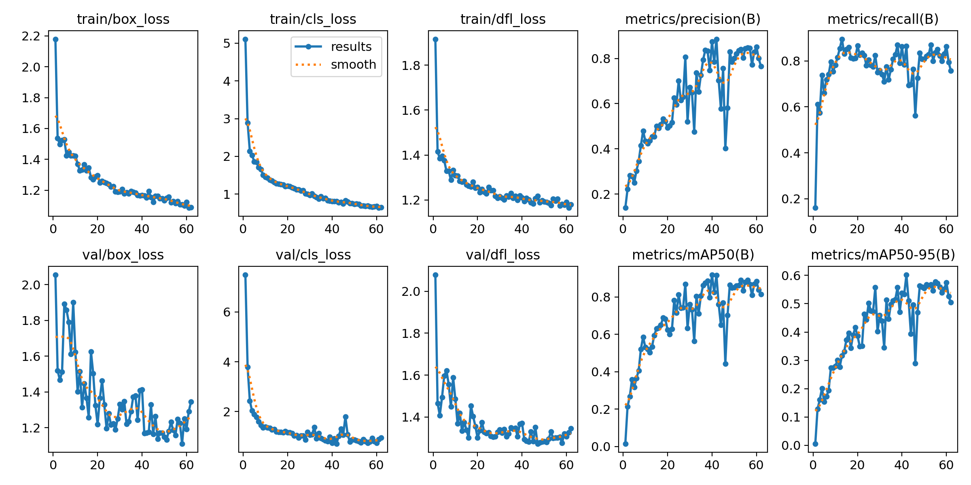

# 4. Sample Predictions

The following are sample predictions from the trained model on test images. Each image shows bounding boxes with FDI tooth IDs.

