Walchand College of Arts and Science
Solapur

Project on:
{C++ Programming}
Fight Night – The Game

By:
- Hrishikesh Hiraskar (1877)
- Anmol Waychal (1932)
- Omkar Kumbar (1909)

Std: XII

Teacher Incharge: Mr. P. R. Joshi
Index

- Acknowledgement 1
- Technical Documentation 2
    - Introduction 3
    - Program Source Code 4
    - Program Source Code 19
Explanation
    - Output 23
- End User Documentation 26
    - Introduction 27
    - Navigation 28
    - How To Play 29
    - Read Me File 30
- Conclusion 32
- Bibliography 33

Acknowledgement

We are very glad to express a sense of gratitude towards the members of staff who helped us to make our project a grand success.
We are highly indebted to our Principal. Manikshetti Sir for the valuable support and motivation and also Shaha sir for support.
We welcome their opportunities to express my deep gratitude and sincere thanks our guide Mr.P.R.Joshi Sir.
We are thankful to all other staff members for their valuable suggestion.
We should not forget all other non-teaching staff from laboratory, without their Co-operation and help towards us will not be able to do this.
The special thanks to great blessing and inspiration of our parents and friends also. Last but not the least we should like to thanks all those who were directly or indirectly involved in making our project successful.
With regards,
- Hrishikesh Hiraskar (1877)
- Anmol Waychal (1931)
- Omkar Kumbhar (1909)

Technical Documentation
For Programmers
Introduction

Fight Night is a text based Fighting game made using C++ language. In this game the user or player fights with CPU/PC by making certain specific moves. In each round both the players start with full health power (HP) Eventually by making moves one can degrade opponent's HP or he can save his by making some defensive moves. The first one to make opponent's HP zero wins the game.
Fight night comes with player profiles where user can create new player and save his progress. He can also delete unwanted player profiles.
Fight night includes level for players. After winning some specific number of games the level of user increments. As the level increases the difficulty of the game increases, the player's HP increases, his attack power and defensive skill also increases. Thus the thrill of the game also increases.

PROGRAM SOURCE CODE

Following is the C++ source code of the Fight Night game:

#include<iostream.h>
#include<conio.h>
#include<stdlib.h>
#include<time.h>
#include<string.h>
#include<dir.h>
#include<stdio.h>

void main_menu();
void startup();
void startgame();
void umove();
float getran();
void sel(int, char);
void checkstats();
void stopgame();
void help();
void about();

struct uplayer
{
char name[12];
int lvl;
int uindx;
};

class player
{
public:
int hp, iscpu, defend;
player(int x)
{
iscpu = x;
hp = 100;
defend = 0;
}
void attack(char g)
{
sel(iscpu, g);
checkstats();
}
};

player user(0);
player cpu(1);

struct uplayer userd;
FILE *f;
int cnt=0;

void sel(int k, char n)
{
if ((k == 0 && cpu.defend != 1) || (k == 1 && user.defend != 1))
{
switch(n)
{
case '1': // hpunch
if (k == 0)
cpu.hp -= 10 * userd.lvl;
else
user.hp -= 10 * userd.lvl;
break;
case '2': // lpunch
if (k == 0)
{
cpu.hp -= 2 * userd.lvl;
user.defend = 1;
}
else
{
user.hp -= 2 * userd.lvl;
cpu.defend = 1;
}
break;
case '3': // hkick
if (k == 0)
cpu.hp -= 15 * userd.lvl;
else
user.hp -= 15 * userd.lvl;
break;
case '4': // lkick
if (k == 0)
{
cpu.hp -= 5 * userd.lvl;
user.defend = 1;
}
else
{
user.hp -= 5 * userd.lvl;
cpu.defend = 1;
}
break;
case '5': // defend
if (k == 0)
user.defend = 1;
else
cpu.defend = 1;
break;
case '0':
cout << "\nYou Quit...\n";
stopgame();
break;
default:
cout<<"Invalid input. Please try again. Hit enter...";
getch();
cout<<"\n\n";
umove();
}
}
else
{
if (k == 0)
cpu.defend = 0;
if (k == 1)
user.defend = 0;
}
}

int gameover = 0,wins=0;

void main()
{
clrscr();
srand((unsigned)time(NULL));
mkdir("User files");
main_menu();
getch();
}

void main_menu()
{
clrscr();
char c;
cout << "************************************\n";
cout << "***** FIGHT NIGHT v1.0b *****\n";
cout << "************************************\n";
cout << "By: Hrishi Hiraskar\n";
cout << "\n1. New Player\n2. Load Player\n3. Delete Player\n0. Exit\nEnter choice...";
cin >> c;
cout << endl;
f=fopen("User files/count.hri","r");
fread(&cnt,1,sizeof(cnt),f);
fclose(f);
switch(c)
{
case '1':
cout<<"Enter Player name:\t";
cin>>userd.name;
userd.lvl=1;
userd.uindx=cnt;
f=fopen("User files/players.hri","a");
fwrite(&userd,1,sizeof(userd),f);
fclose(f);
cnt++;
f=fopen("User files/count.hri","w");
fwrite(&cnt,1,sizeof(cnt),f);
fclose(f);
startup();
break;
case '2':
struct uplayer users[10];
int p;
f=fopen("User files/players.hri","r");
fread(&users,cnt,sizeof(users),f);
fclose(f);
cout<<"\n\nSr.No.\tPlayer\tLevel\n";
for(int r=0;r<cnt;r++)
{
cout<<(r+1)<<".\t"<<users[r].name<<"\t"<<users[r].lvl<<endl;
}
cout<<"\nEnter choice...";
if(cin>>p)
{
if(p>0 && p<=cnt)
{
p--;
strcpy(userd.name,users[p].name);
userd.lvl=users[p].lvl;
//userd.lvl=5;
userd.uindx=users[p].uindx;
startup();
}
else
{
goto elss;
}
}
else
{
cin.clear();
cin.ignore();
elss:
cout<<"\nInvalid input. Please try again. Hit enter...";
getch();
main_menu();
}
break;
case '3':
struct uplayer users1[10];
int q;
f=fopen("User files/players.hri","r");
fread(&users1,cnt,sizeof(users1),f);
fclose(f);
cout<<"\n\nSr.No.\tPlayer\tLevel\n";
for(int t=0;t<cnt;t++)
{
cout<<(t+1)<<".\t"<<users1[t].name<<"\t"<<users1[t].lvl<<endl;
}
cout<<"\nEnter player number to be deleted...";
if(cin>>q)
{
if(q>0 && q<=cnt)
{
q--;
for(int l=q;l<cnt-1;l++)
{
strcpy(users1[l].name,users1[l+1].name);
users[l].lvl=users[l+1].lvl;
users[l].uindx=users[l+1].uindx;
}
cnt--;
f=fopen("User files/count.hri","w");
fwrite(&cnt,1,sizeof(cnt),f);
fclose(f);
f=fopen("User files/players.hri","w");
fwrite(&users1[0],cnt,sizeof(users1[0]),f);
fclose(f);
cout<<"Deleted successfully...";
getch();
main_menu();
}
else
{
goto elsd;
}
}
else
{
cin.clear();
cin.ignore();
elsd:
cout<<"\nInvalid input. Please try again. Hit enter...";
getch();
main_menu();
}
break;
case '0':
exit(0);
default:
cout<<"\nInvalid input. Please try again. Hit enter...";
getch();
main_menu();
break;
}
}

void startup()
{
clrscr();
char a;
cout << "************************************\n";
cout << "***** FIGHT NIGHT v1.0b *****\n";
cout << "************************************\n";
cout << "By: Hrishi Hiraskar\n";
cout << "\nPlayer: "<<userd.name<<". Level: "<<userd.lvl<<" Wins: "<<wins;
cout <<
"\n\n1. Start New Game.\n2. Help.\n3. About Dev.\n4. Save progress\n5. Load/New Player\n6. Credits\n0. Exit.\nEnter choice...";
cin >> a;
switch (a)
{
case '1':
startgame();
case '2':
help();
case '3':
about();
case '4':
f=fopen("User files/count.hri","r");
fread(&cnt,1,sizeof(cnt),f);
fclose(f);
struct uplayer users[10];
f=fopen("User files/players.hri","r");
fread(&users,cnt,sizeof(users),f);
fclose(f);
users[userd.uindx].lvl=userd.lvl;
f=fopen("User files/players.hri","w");
fwrite(&users[0],cnt,sizeof(users[0]),f);
fclose(f);
cout<<"\nSaved succesfully";
getch();
startup();
break;
case '5':
main_menu();
break;
case '6':
cout<<"\nDeveloper - Hrishi Hiraskar\nDocumentation - Anmol Waychal & Omkar Kumbhar";
getch();
startup();
case '0':
exit(0);
case 'L':
if(wins==7)
{
cout<<"\nEnter the level you want to play(<300):\t";
cin>>userd.lvl;
startup();
}
default:
cout<<"\nInvalid input. Please try again. Hit enter...";
getch();
startup();
}
getch();
}

void umove()
{
char b;
cout << "Your HP: " << user.hp << "\tEnemy\'s HP: " << cpu.hp;
cout <<
"\n\n1. High Punch.\n2. Low Punch.\n3. High Kick.\n4. Low Kick.\n5. Defend.\n0. Stop Game.\nEnter choice...";
cin >> b;
cout<<"\n\n";
user.attack(b);
}

float getran()
{
float r = rand(), max = RAND_MAX;
return (r / max);
}

void startgame()
{
clrscr();
if(userd.lvl<=300)
user.hp=(cpu.hp=100*userd.lvl);
char f[5]={'1','2','3','4','5'};
while (gameover == 0)
{
umove();
int m = (int)(getran() * 5);
cpu.attack(f[m]);
}
getch();
}

void checkstats()
{
int j;
if (user.hp > 0 && cpu.hp <= 0)
{
gameover = 1;
cout << "\nEnemy killed! You WIN!!!\nYou have "<<user.hp<<" HP left.\n";
wins++;
if(wins==10)
{
userd.lvl++;
wins=0;
cout<<"\n*********** Level Up! ***********\nYour level: "<<userd.lvl<<"\n";
}
}
else if (user.hp <= 0 && cpu.hp > 0)
{
gameover = 1;
if(wins-1>=0)
wins--;
cout << "\nYou got killed! Sorry, You LOSE!!!\nEnemy has "<<cpu.hp<<" HP left.\n";
}
else if (user.hp <= 0 && cpu.hp <= 0)
{
gameover = 1;
cout << "\nDRAW!!!\n";
}
if (gameover == 1)
stopgame();
}

void stopgame()
{
gameover = 0;
user.hp=100;
cpu.hp=100;
user.defend=0;
cpu.defend=0;
char j;
cout << "\n1. Next Round.\n2. Main Menu.\n0. Exit.\nEnter choice...";
cin >> j;
if (j == '1')
startgame();
else if (j == '2')
startup();
else if (j == '0')
exit(0);
else
{
cout<<"Invalid input. Please try again. Hit enter...\n";
getch();
stopgame();
}
getch();
}

void help()
{
cout <<
"\nFIGHT NIGHT is a text based fighting game in which player fights against CPU.\nEach player starts with 100 HP and first to reach 0 HP loses.\nThere are various choices of attacks and defences.\nAttacks are punches and kicks, each divided into high power and low power. High power attacks do a great deal of damage but lack in any defence. Low power attacks have low damage but defend us. Defending blocks any enemy attack keeping your HP safe.\nSo, c'mon get'em down and be the King of FIGHT NIGHT...\nHit enter to continue...";
getch();
startup();
}

void about()
{
cout <<
"\nFIGHT NIGHT v1.0beta\nBy: Hrishi Hiraskar\n\nContact:-\nEmail: hrishihiraskar@gmail.com\nFacebook: http://www.facebook.com/hrishi.hiraskar7/\nHit enter to continue...";
getch();
startup();
}

Program Source Code Explanation

A) Header Files:
1.<iostream.h>
All the basic functions of C++ language are included in this file.
2.<conio.h>
Some functios like clrscr( ) [used for clearing screen], getch( ) [used for getting character] are included in this file.
3.<stdlib.h>
An important function exit(0) which is used for exiting the program is included here.
4.<time.h>
Some timing functions used in program are included here.
5.<string.h>
String functions such as string concatenation are included in this file.
6.<dir.h>
This file includes mkdir( ) function which is used to make directory.
7.<stdio.h>
Some file functions and pointers used In the program are included here.

B) Functions:
1. void main_menu( );
This function shows the main menu on the screen. This function has options like creating new player profile, load existing player profile or delete it, or exit the program. This Function also creates and modifies files in which user data is stored.
2. void startup( ) ;
This Function shows the starting screen of the game this includes options like starting a new game , seeking help, information about program and developer, save progress of player to player profile, navigation to main menu and exiting the program.
3. void startgame( );
This Function starts the actual game i.e. The fight. This initializes the user and CPU for the fight. This also gives artificial intelligence to CPU for playing the game.
4. void umove( );
This function shows the list of attacks and defences which user can perform. Attacks include high punch, low punch, high kick and low kick. User can also defend. Here user can stop the game at any position.
5. float getran( );
This function returns random number in the form of float. This is used by CPU AI.
6. void sel(int, char);
This Functions switches between the various attacks and defences the user and CPU can do. This function decreases specific amount of HP on specific attacks done by User or CPU on his opponent. This also defends opponents attacks on defense call.
7. void checkstats( );
This Function checks the status of the ongoing game. This checks if any of the player has won the match or there is a draw and gives necessary prompts. In such cases it stops the game.
8. void stopgame( );
This function Stops the game. This Function can be called by user if he desires to stop game or by the program in case of win or tie. It also clears all the game variables and prompts user if he wants to play a new round or navigate to main menu or exit the program.
9. void help( );
This Function shows short, descriptive, quick help to the user about how to play the game.
10. void about( );
This function shows the version details, developers and their contacts.

C) Variables:
1. struct uplayer
This is a structure variable. This variable stores information about user's profile i.e. his name, his current level and his index in the database. Following variables are used in this structure:
I. char name[ ] - It stores the name of the user.
II. int lvl - It stores the current level of the user.
III. int under - It stores the index of user in the database.

2. class player
This variable is a entity of player who will play the fighting match. This variable stores information about player's HP. Following are the variables used inside :
I. int hp - Stores HP of the object
II. int iscpu - It indicates whether the object is CPU or not.
III. int defend - It is used as defense toggle by the program.
Class player has following functions:
I. player(int) [Constructer] - This Function is a constructor used to initialize the variables of the object.
II. void attack(char) - This Function is used to switch between attacks made by the object.
Following are the objects of this class:
I. player user - This is object of user.
II. player cpu - This is the object of CPU.

Output
Start Page
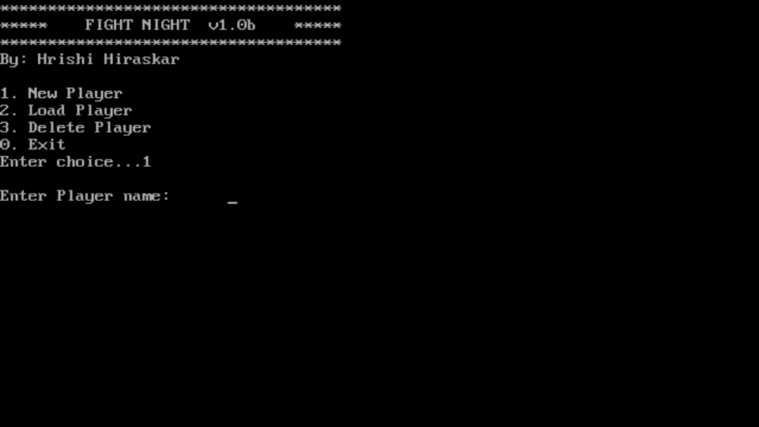
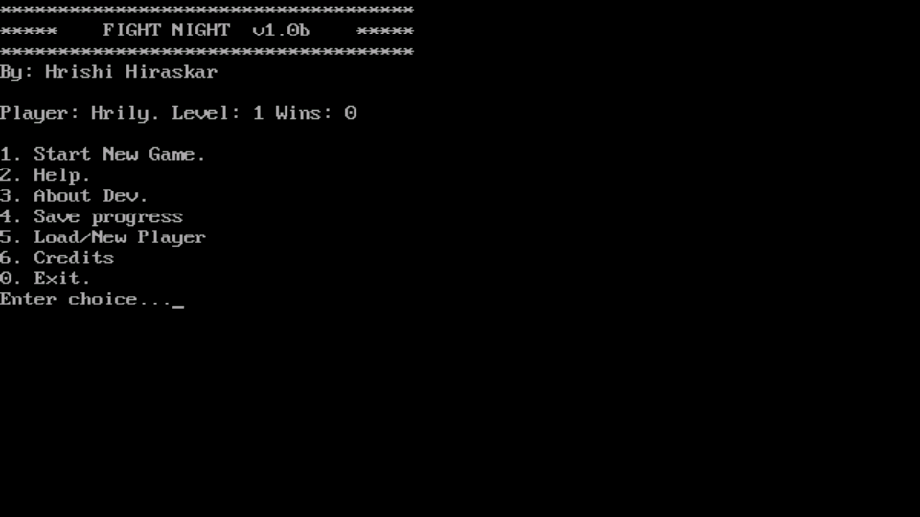Main Page
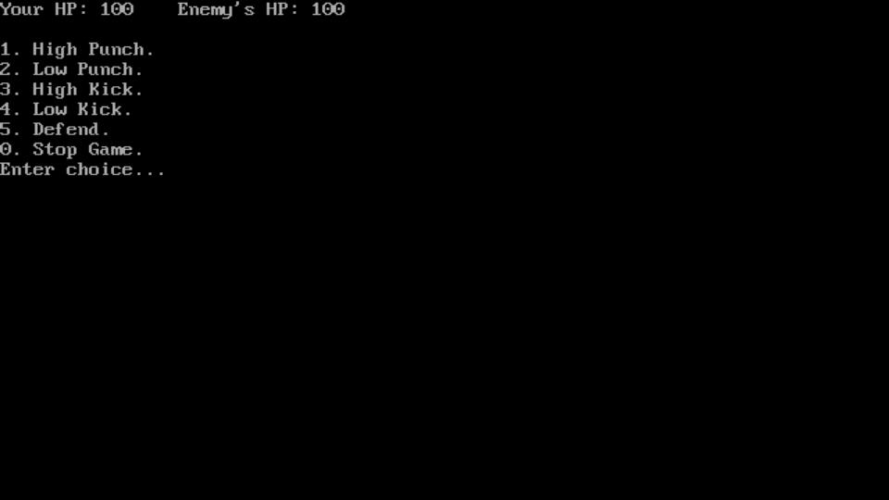Main Game

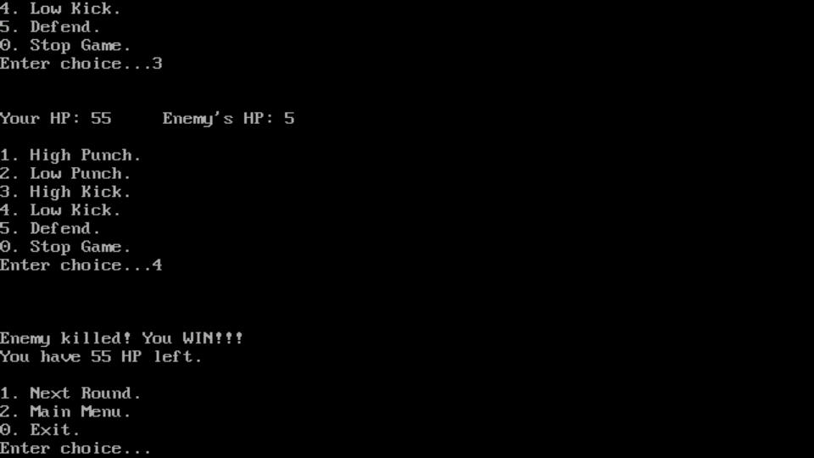Game End

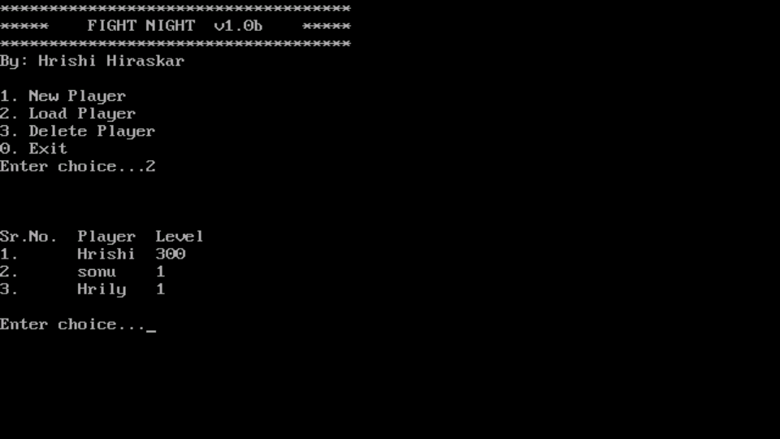Load Player

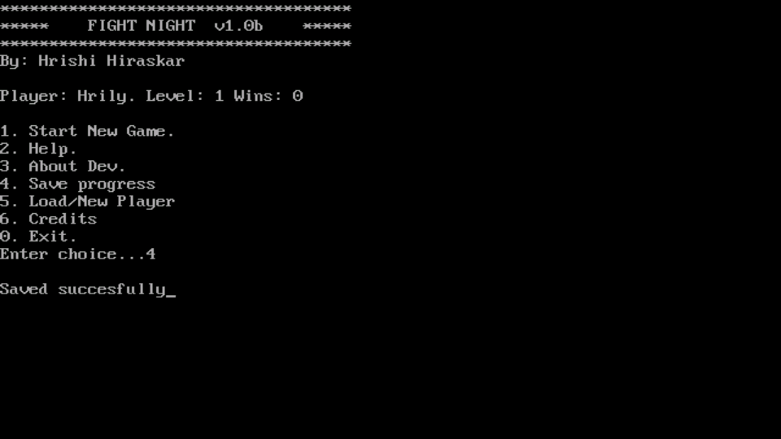Save Game

End user Documentation
For Users

Introduction

Fight Night is a text based Fighting game made using C++ language. In this game the user or player fights with CPU/PC by making certain specific moves. In each round both the players start with full health power (HP) Eventually by making moves one can degrade opponent's HP or he can save his by making some defensive moves. The first one to make opponent's HP zero wins the game.
Fight night comes with player profiles where user can create new player and save his progress. He can also delete unwanted player profiles.
Fight night includes level for players. After winning some specific number of games the level of user increments. As the level increases the difficulty of the game increases, the player's HP increases, his attack power and defensive skill also increases. Thus the thrill of the game also increases.

Navigation

Main menu
Main menu is starting Screen of game. Here you can create a new player profile or you can load a player profile if you have already created one. You can also delete a player profile if you don't need it. By creating a new player or loading it you can get into actual game.
Game menu
This is a starting menu of the game . Here you can start new game ,save your game progress, get help about the game go to main menu or quit the game. You can start the game by entering the option corresponding to '' Start New Game "

The Game
The actual game can be played here. The screen shows your & your HP,and the list Various moves you can perform. The moves are high punch ,low punch ,high kick & low kick . You can also stop the game or quit it.

How To Play

Start the game , select a player from main menu or load it to go to main menu. Start a new game and you will see a list of various moves you can perform. You can also see your and your enemies HP. Wisely perform the moves to decrease your enemies HP and simultaneously defend yours from decreasing. The various moves you can perform are high kick, low kick, high punch, low punch. The high attacks do great damage to enemies HP but they make you come to damage by your enemy. On the side, a low attacks do less damage but they defend your HP so do the right moves on the right time to make enemies HP zero and win the game. Fight night also contains levels, to increase your level win 10 games consecutively. After playing the game you must save your progress or else it will be deleted , so whenever you restart the game, your player profile will be up to date .Fight night also contains cheats, to get the cheats please contact the developer.
Read Me File

System Requirements
1.Processor:
X86 processor Or higher.
2.RAM:
2 mb or higher.
3.DISK SPACE :
512 kb of free space.
4. OS :
Any MS-DOS compatible OS.
5. Graphics Card :
As the game is text based so no graphics card is needed.

Installation:
The Game doesn't require any installation. Just copy the files to the desired folder or if you have got the archive just extract it.

Troubleshooting :
The game may have bugs as it is in beta version. If you encounter any bugs during game play please restart the game. If problems persist Please contact us.
CONTACT Details :
Dev – Hrishi Hiraskar
Documentation – Anmol Waychal & Omkar Kumbhar
Email - hrishihiraskar@gmail.com
Facebook - www.facebook.com/hrishi.hiraskar7

Conclusion

We come to know that C++ makes our task easier because instead of writing and preserving the records in a book it’s just easy to click and install all necessary records and make changes when required.
It serves an important advantage i.e. it saves Memory also saves our Time.
We conclude by saying that in today’s era of Computer and Technology life of man has become a easy life with all its part and parcel

Bibliography

- Google
- Wikipedia
- Game inspired from – Heroes of Atlantis (A MMORPG)
- Basics of C++ (Book for reference)

