Day 1 Report — Repository & Environment Setup (pip/venv)

1. Purpose and Scope
This report documents Day-1 activities for the LCT Correlation Replication project. The goal was to establish a clean, reproducible foundation—tooling, structure, and basic stubs—so subsequent statistical method implementation (Fisher-z baselines; LCT-N/LCT-B) can proceed smoothly.

2. Objectives (Day-1)
- Initialize a version-controlled Python project with a standard layout.
- Provision a consistent Python environment using venv + pip (no Conda).
- Add minimal, importable source stubs and a smoke test to validate tooling.
- Provide a brief Quickstart notebook to confirm the environment and notebook stack.
- Record decisions and acceptance criteria for “Day-1 complete.”

3. Environment and Tooling
Python: 3.11 (≥3.10 acceptable)
Package set: numpy, scipy, pandas, numba, joblib, dask, matplotlib, networkx, tqdm, pytest, jupyterlab, ipykernel
Environment manager: venv + pip (alternatives: Conda or Poetry)
Reasoning: venv is lightweight and built-in; with pinned wheels and ipykernel, it works well for research notebooks and CI.
Setup (pip/venv):
# Create and activate virtual environment
python3 -m venv .venv
# macOS/Linux:
source .venv/bin/activate
# Windows PowerShell:
# .venv\Scripts\Activate.ps1

# Upgrade core tooling
python -m pip install --upgrade pip setuptools wheel

# Install packages
pip install numpy scipy pandas numba joblib dask matplotlib networkx tqdm pytest jupyterlab ipykernel

# Register kernel for Jupyter
python -m ipykernel install --user --name lct --display-name "Python (lct)"
Version pinning (recommended) — requirements.txt (example):
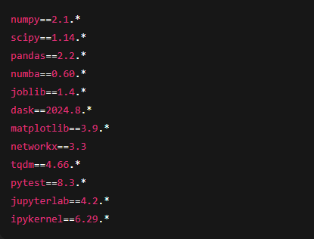

4. Repository Layout
A lightweight, research-friendly structure separates methods, simulations, evaluation, plots, notebooks, results, and tests:
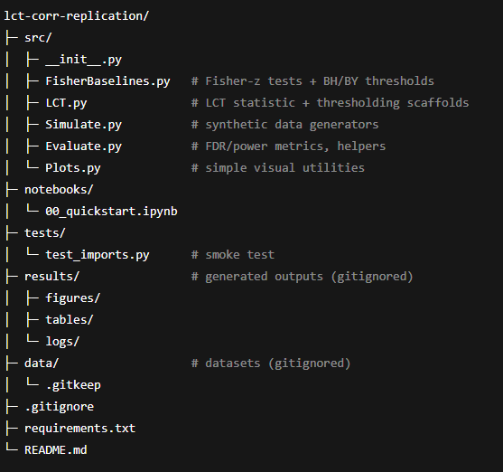

Rationale:
- src/ has reusable, testable modules.
- notebooks/ calls into src/ for reproducibility.
- results/ and data/ are gitignored (keeps repo slim).
- tests/ supports quick validation and future CI.
5. Procedure Executed
Repository initialization
- Created project directory; initialized Git.
- Added a .gitignore for Python, environments, notebooks, and generated artifacts.
Environment provisioning (pip/venv)
- Created .venv, upgraded build tools, installed the scientific stack, and registered a Jupyter kernel (Python (lct)).
Source stubs
- FisherBaselines.py: fisher_z, two_group_z_stat, pvals_from_Z, BH/BY thresholding helpers.
- LCT.py: placeholder lct_edge_stat (to be replaced with the variance-stabilized LCT statistic), lct_threshold_normal (normal-tail scan API; bootstrap variant coming on Day-6/7).
- Simulate.py: Gaussian sampler + block-covariance builder.
- Evaluate.py: correlation helper and FDR/Power routines.
- Plots.py: minimal heatmap helper.
Notebook and tests
- 00_quickstart.ipynb: verifies imports and ensures the Jupyter kernel uses the .venv.
- tests/test_imports.py: validates dependency availability and imports from src.
Documentation
- Concise README.md (setup with pip/venv, run tests, open notebooks).
- Captured acceptance criteria and next-step pointers.

6. Acceptance Criteria (Day-1 “Done”)
- Environment sanity: JupyterLab launches with kernel “Python (lct)”; the Quickstart notebook prints “Environment OK.”
- Tests: pytest -q passes the smoke test.
- Imports: All src/ modules import without errors.
- Structure: Project tree matches spec; data/ and results/ are gitignored; repo committed (git add . && git commit).

7. Risks and Mitigations (pip/venv specific)
- Binary wheels/SciPy build errors: Keep pip/setuptools/wheel updated; prefer CPython 3.11; if a package lacks wheels on your OS/arch, pin to a wheel-available version.
- Kernel mismatch: If the notebook uses the wrong interpreter, switch the kernel in JupyterLab (top-right) to Python (lct) or re-run python -m ipykernel install ….
- Large results in Git: .gitignore covers data/ and results/; add .gitattributes/LFS only if you must version artifacts.
- Floating-point variability across platforms: Pin versions in requirements.txt and log environment metadata in results (later automated with run cards).

8. Handover State (End of Day-1)
- Repo is ready for Day-2 Fisher-z + BH/BY baselines (toy notebook + tests).
- LCT module has a placeholder statistic with a working thresholding API, enabling a drop-in replacement with the true Cai–Liu statistic on Day-5.
- Simulation/evaluation scaffolds exist so we can produce the first FDR/Power table by Day-3.

9. Next Actions (Preview)
- Day-2: Implement Fisher-z baselines end-to-end (toy data + unit tests + small CLI).
- Day-3: Build Gaussian simulation harness; generate the first CSV table (mean FDR/Power over 50 reps).
- Day-4/5: Replace LCT placeholder with the true variance-stabilized statistic; validate on toy sims.
- Day-6/7: Implement LCT-B bootstrap under H0H_0H0​ with parallelization; run a small non-Gaussian scenario.

-------------------------------------------------------------------------

