|  |
| --- |
| BHILAI STEEL PLANT, SAIL |
| REDESIGNING OF SCHOLARSHIP DISBURSEMENT |
| INTERNSHIP PROJECT REPORT |

|  |
| --- |
| HRISHABH PUROHIT  V.T No. P-17/6493 |

**REPORT**

I, Hrishabh Purohit [V.T No.P-17/6493] did my internship project on “***Redesigning of Scholarship Disbursement***” which comes under General Services section of CNIT dept. (BSP). I was guided by Mrs. Bhuvana Chawla , DGM of C&IT department, BSP.

The project was to do study on existing Scholarship Disbursement module and redesign it using Java Server Pages [JSP]. I have done my level best to achieve the target. It was an excellent learning experience for me, as I gained good knowledge in HTML & Java Server Pages [JSP] as well as the Scholarship system which is provided to the meritorious wards of BSP employees.

My training started on 22/05/2017 & ended on 17/06/2017. I was alloted a seat in the C&IT dept. of Ispat Bhawan and I used to sit there and work from 9:00 am to 5:00pm. Bhuvana Madam helped me a lot during this period by clearing my doubts whenever I approached her. Moreover, her keen nature for being updated about my learning experience helped me a lot in gaining deep knowledge about my project.

**BHILAI STEEL PLANT ( BSP )**

**INTRODUCTION**

Bhilai Steel Plant (referred to as BSP here-in-after), the proud winner of the prestigious Prime Minister’s Trophy for 11 times, came into being during the 2nd Five year plan as a part of Hindustan Steel Ltd (later known as Steel Authority of India Ltd - SAIL) in collaboration with erstwhile USSR. It is one of the five integrated steel plants under SAIL and is located strategically in the mineral rich central region of India. BSP has always been major contributor to the bottom line of Maharatna Company-SAIL and hence is admired as its flagship unit. BSP’s inbound supply chain has the strategic advantage of having captive mines. The outbound supply chain logistics is facilitated by being located on the Howrah-Mumbai railway route. The entire value chain of BSP is supported by other corporate units of SAIL like Central Marketing Organization (CMO) – the largest industrial marketing network in the country, Research and Development Centre for Iron and Steel (RDCIS), Centre for Engineering and Technology (CET), Management Training Institute (MTI), Raw Materials Division, Environment Management Division, Growth Division and Safety Organization.

* **Main Products of BSP (SAIL) :**

BSP produces a wide range of Plates, world’s cleanest Rails, Heavy Structurals, Merchant Products (TMT Bars, Angles, Channels and Rounds) and Wire rods. BSP has a unique product portfolio, of having both long and flat products and it has the capability to offer customized products to its customer. The prime product mix of BSP comprises of Rails, Bars, Rods and Structurals and Plates. BSP is the sole supplier of rails to Indian Railways and is currently supplying up to 260 meter long rails – longest welded rail panel in the world dispatched from works – to meet the objectives of improving passenger safety, comfort and reducing track maintenance activities. BSP products have found applications in a number of prestigious infrastructure projects of the country in the areas of rail lines, bridges, dams, air / sea ports, refineries, pipelines, etc. SAIL – BSP was the proud supplier of DMR 249 A plates used for building India’s first Indigenous Aircraft Carrier INS ‘Vikrant’ which was launched on August 12th , 2013. Similarly, thick web asymmetric rails- ‘Zu 1-60’ (an import substitution) for switch – point applications was developed in-house.

**CNIT ( BSP ) :**

CNIT department under Bhilai Steel Plant is one of the various functional departments of BSP whose contribution is one of the most significant one that makes Bhilai Steel Plant what it is today. It caters to all the business functions and processes of plant. It comprises of various sections which lubricates its functioning. Some of the sections are as follows:

* ERP system (Enterprise Resource Planning)
* MES (Manufacturing Execution System)
* General Services
* Basis
* IT infrastructure and many more.

These systems work on different software platforms. For ex – the ERP section works on the SAP software platform, the General Services section works on the Oracle application forms etc.

**General Services:**

The General Services section manages the various facilities (officially called services) given to the BSP, employees, sister units, third parties, etc. There are, in total, 25 service modules. Some of the examples are:

1. Scholarship Disbursement
2. Hospital Management
3. School Services

In particular, the scholarship disbursement involves number of steps. The process for applying for any BSP scholarship is as follows : Firstly, there is an application form which needs to be filled by the applying body i.e. the wards of BSP employees. After this, the processing of the form starts and it is sent to the education department where the data is entered to update the existing database. The whole processing of the form ensures an equitable distribution of the scholarships. The present system is developed in Oracle databse and the user interface is Oracle Forms and Reports.

The project assigned to me was the transformation of the system from Oracle Forms to JSP files for the processing of the application forms.

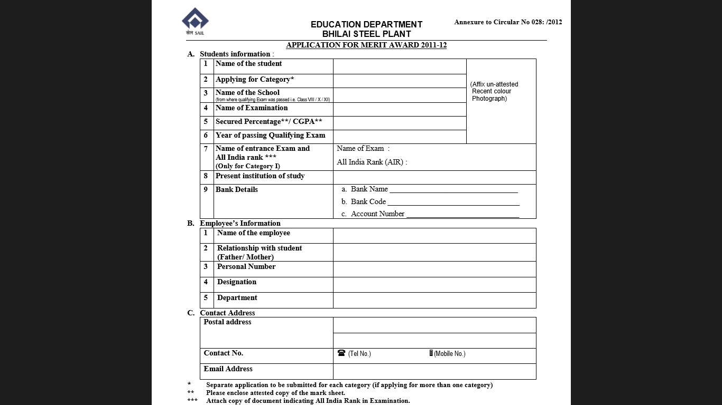

**Our Project – Scholarship Module Redesigned:**

This part of the report describes the gradual progression of my project and its resultant learning experience.

Step 1: Setting up the Environment:

This step is the most significant part of the project built. It involves the setting up of Oracle database express edition and the IDE to work on JSP. Though it seems easy, but is the most time taking step towards the climax. In the IDE, a local server must be set for the JSP file to run on it, making the server a local host. The Oracle database and the the IDE server uses a HTTP listener port through a port number. This port number needs to be set differently for both, for the Oracle database and the server to run simultaneously.

Step 2: Building up the Module:

The assigned projects were as follows:

1. Master Data creation for the Sarvotam scholarship (the highest level of scholarships provided):

* The Entry screen:

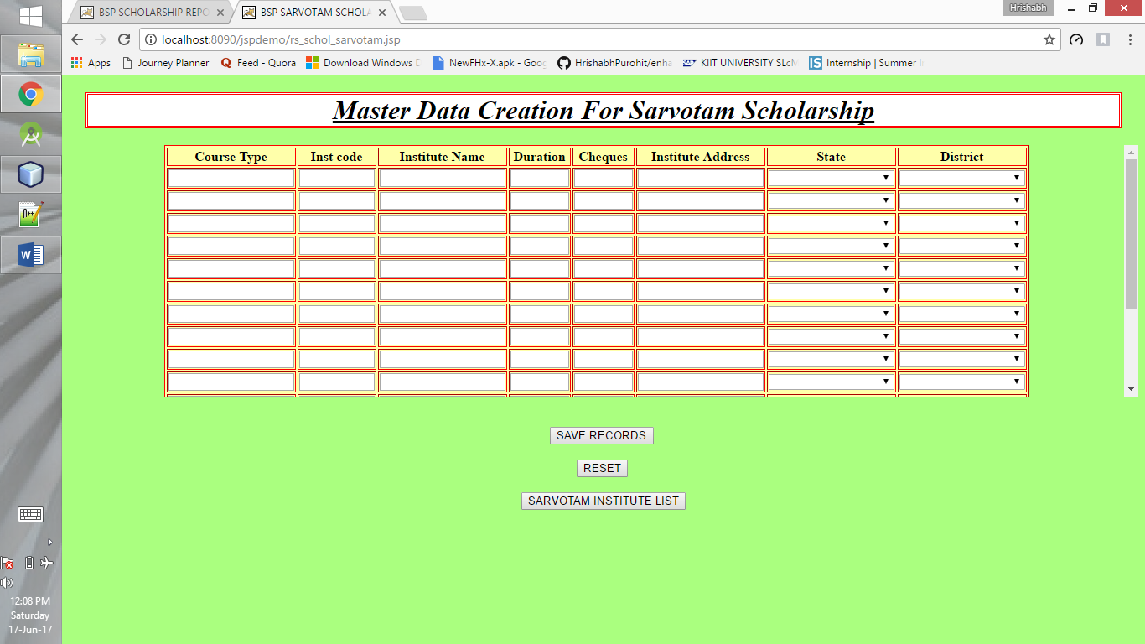

* Viewing the Sarvotam database : This page includes an additional feature to export database into an excel file.

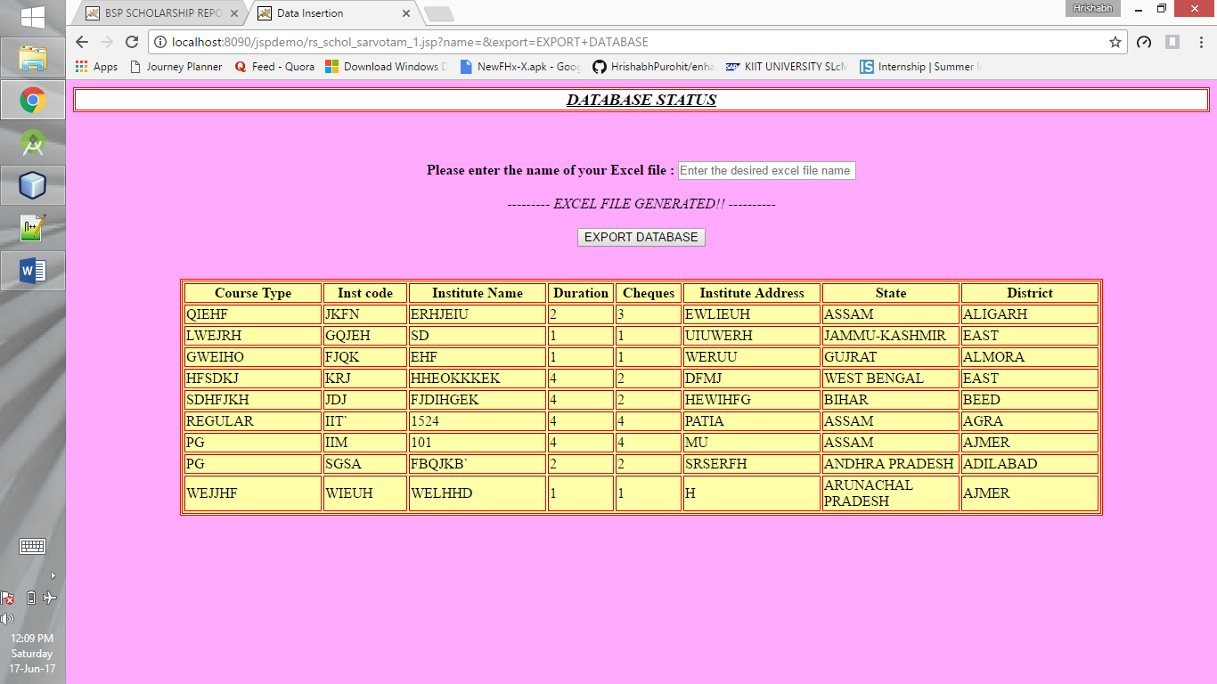

1. Creating Master for scholarships other than Sarvotam:

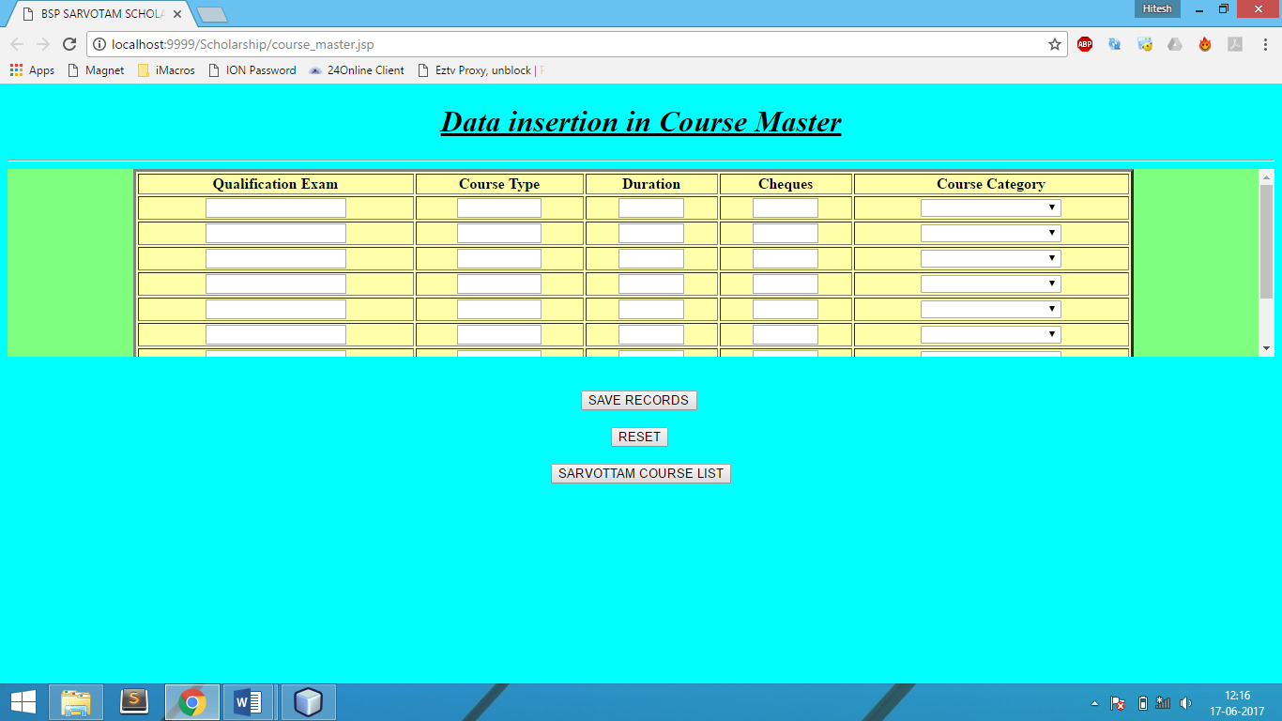

1. Check current year data fed into the system :

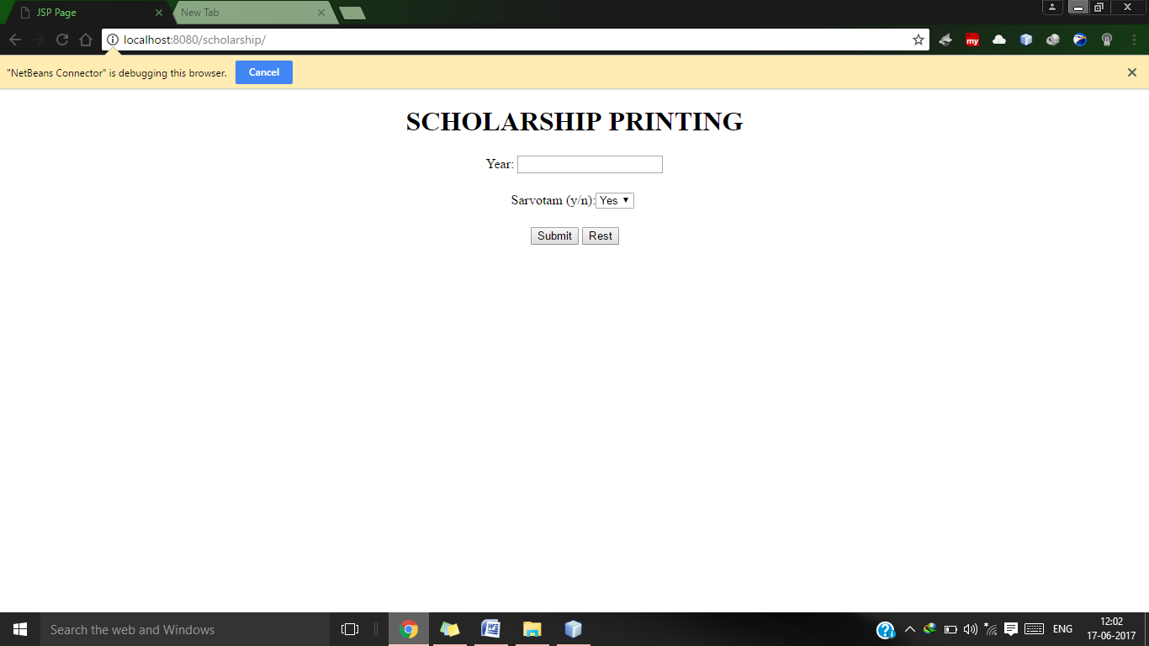

* The output screen for the above :

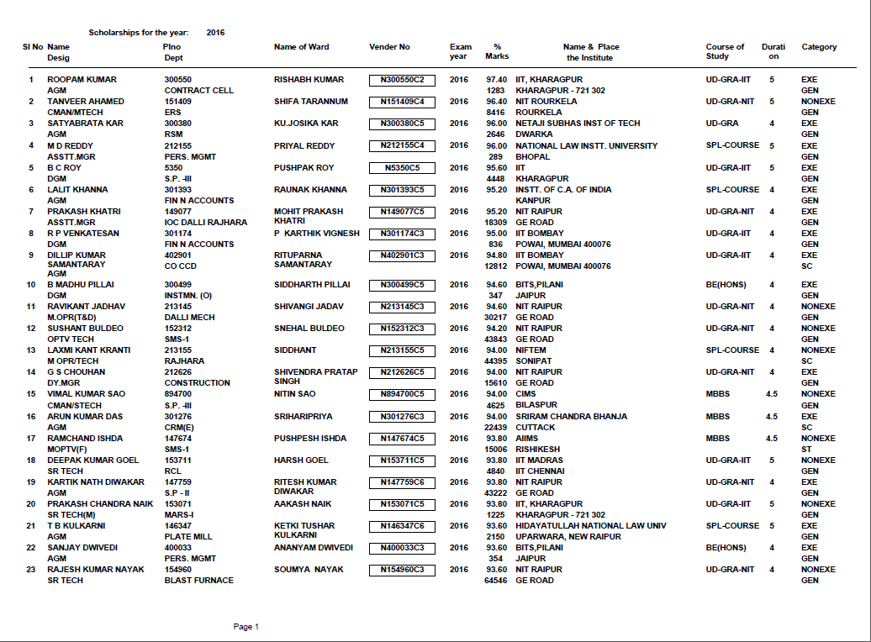

1. Scholarship reports for various scholarships :

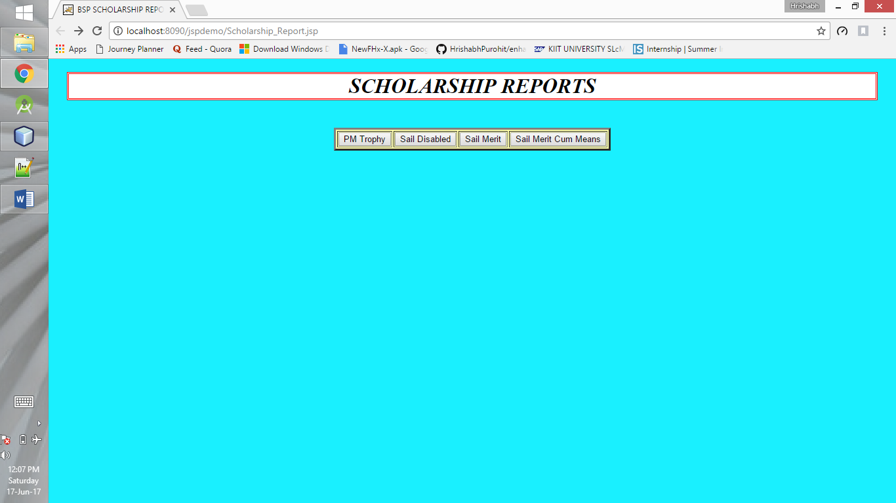

* PM Trophy selection screen :

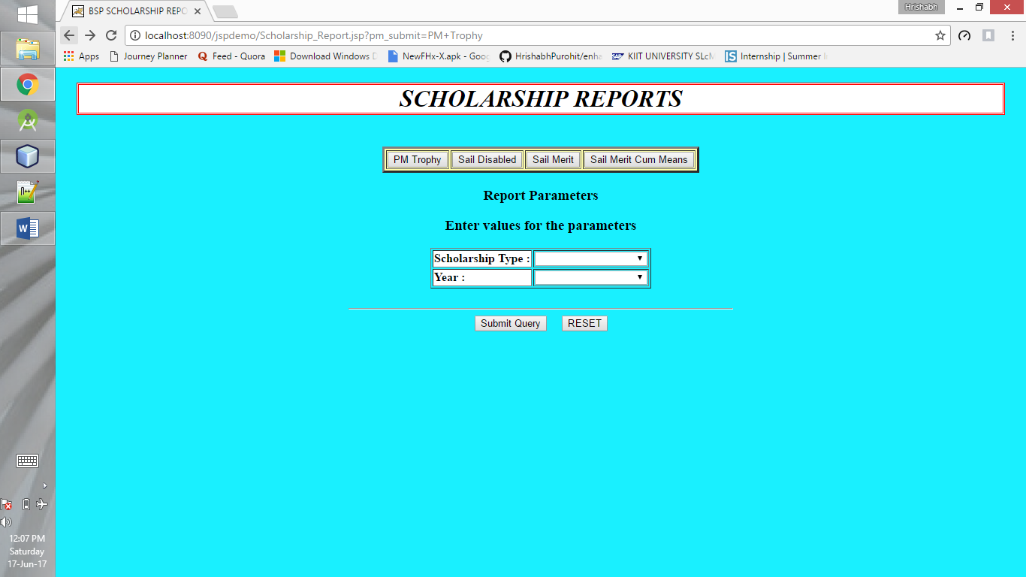

* Sail Disabled selection screen :

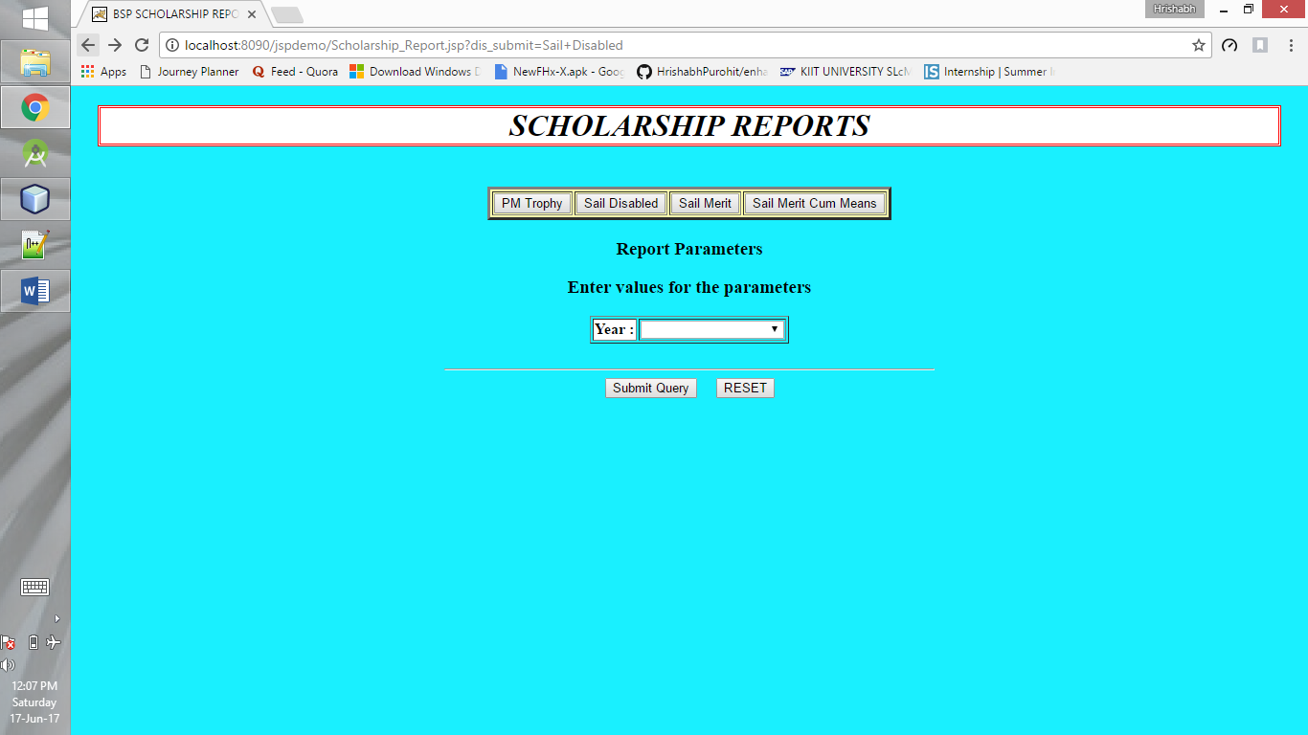

* Sail Merit selection screen :

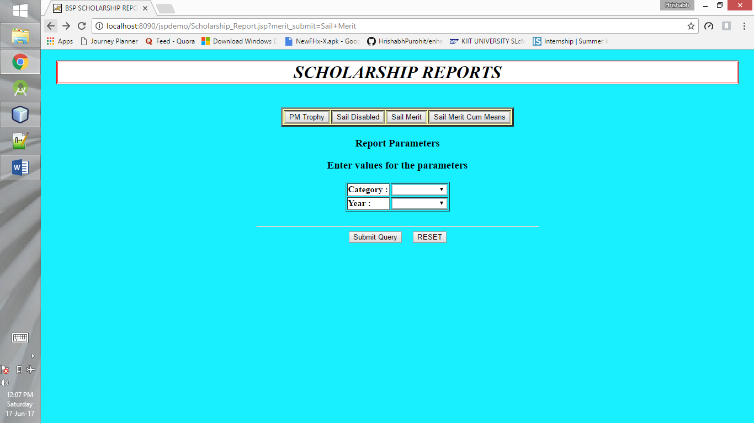

* Sail Merit cum Means :



The Master tables used for the above JSPs are:

1. SCHOL_COURSE_MASTER :

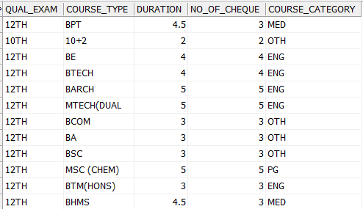

1. SCHOL_SARVOTAM_MASTER :

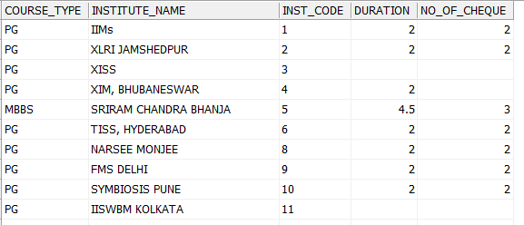

1. SCHOL_SARVOTAM_INST_MASTER :

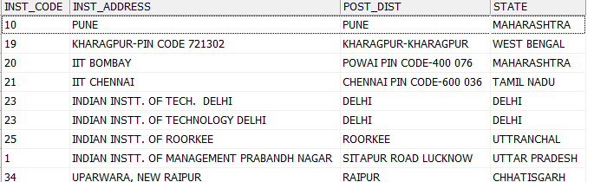

1. V_DEPENDENTS :

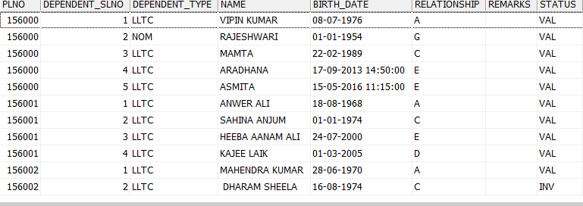

1. SCHOLARSHIP
2. EMPLOYEES
3. V_EMP_CATEGORY