WEBSITE AUDIT
InAmigos Foundation
Usability • Functionality • Visual Design • Responsive Behaviour • Account Security

Website | https://inamigosfoundation.org.in/
Audit period | 6–7 November 2026
Prepared as | Internship website audit deliverable
Repository | https://github.com/HrishavSarma/UI-UX-audit-for-internship

Prepared from the documented audit findings, functional test log, recommendations and supplied screenshot evidence.

Table of Contents
This report is organized into the following sections.
1. Executive Summary | 3
2. Scope and Method | 3
3. Findings Overview | 3
4. Detailed Findings and Recommendations | 5
5. Functional Testing Summary | 10
6. Priority Recommendations | 11
7. Screenshot Evidence | 11
8. Limitations and Notes | 19
9. Conclusion | 19

Page numbers refer to this version of the report.

1. Executive Summary
A manual website audit was conducted on the InAmigos Foundation website to assess visual presentation, navigation, core interactions, blog functionality, responsive behaviour and account-security controls. The audit identified 23 documented findings: 5 High, 13 Medium and 5 Low severity. The most consequential issues affect contact and newsletter communication, password recovery, and password changes within an authenticated session.
23 | 5 | 31 | 5
Findings | High severity | Recorded tests | Tests passed
Testing recorded 5 PASS, 14 FAIL, 11 Improvement Required and 1 PARTIAL result. These labels reflect the original test log; Improvement Required includes usability and presentation observations, not necessarily functional failures.
The report documents issues and recommends corrective actions. No website implementation or remediation was performed as part of this audit. The responsive overflow finding was confirmed manually at 375px and 768px; 430px was inspected but the issue was not separately confirmed.

2. Scope and Method
Website reviewed: https://inamigosfoundation.org.in/
Pages and areas inspected included the homepage, About Us, Causes, Categories, Contact, Gallery, Volunteers, Events, Blog listing and articles, login, registration, password recovery, and My Profile / Edit Profile.
Methods included manual visual inspection, navigation checks, form submissions, account-flow testing, link checks, pagination and lightbox interaction checks, and responsive viewport inspection. The supplied audit record includes desktop inspection and responsive visual checks at 375px, 430px and 768px.
This was a manual audit, not an automated accessibility, security penetration or performance assessment. The announcement-bar contrast was verified using the downloaded homepage HTML and CSS: white text (#FFFFFF) on a green background (#00CC83), producing a calculated contrast ratio of approximately 2.11:1. The live production site's current CSS was not independently inspected.

3. Findings Overview
The detailed findings below preserve the IDs and severity levels used in the audit register.
ID | Finding | Severity | Page / Area
HOME-001 | Insufficient Contrast in Announcement Bar | High (confirmed WCAG 2.1 Level AA contrast failure) | Homepage
HOME-002 | Undersized Header Logo | Medium | Homepage
HOME-003 | Unbalanced Whitespace in About Section | Medium | Homepage
HOME-004 | Inconsistent Event Card CTA Alignment | Medium | Homepage
HOME-005 | Undersized Footer Logo | Low | Homepage
HOME-006 | Opportunity to Improve Colour Palette | Low | Homepage
HOME-007 | Poor Visual Affordance of Homepage Action Cards | Medium | Homepage
HOME-008 | Empty Causes Page | Medium | Causes
FUNC-001 | Newsletter Subscription Server Error | High | Homepage (Footer)
FUNC-002 | Contact Form Submission Failure | High | Contact
FUNC-003 | Gallery Lightbox Image Loading Failure | Medium | Gallery
FUNC-004 | Gallery Pagination Not Functioning Correctly | Medium | Gallery
FUNC-005 | Incorrect Social Media Link Destinations | Medium | Homepage / Footer
FUNC-006 | Outdated and Inactive Social Media Icons | Low | Homepage / Footer
FUNC-007 | Restricted Clickable Area on Category Cards | Medium | Categories
ABOUT-001 | Incorrect About Page Breadcrumb Label | Low | About Us
BLOG-001 | Password Reset Email Failure | High | Blog / Forgot Password
BLOG-002 | Inconsistent Blog Post Tag Presentation | Low | Individual Blog Articles
BLOG-003 | Incorrect Individual Blog Tag URL Generation | Medium | Individual Blog Articles
BLOG-004 | Malformed Tag Link on Project Vikas Article | Medium | Project Vikas Blog Article
AUTH-001 | Poor Discoverability of Login and Account Access | Medium | Sitewide Navigation / Blog
SEC-001 | Password Change Without Current-Password Verification | High | My Profile / Edit Profile
RESP-001 | Horizontal Overflow in Homepage Hero Section | Medium | Homepage

4. Detailed Findings and Recommendations

HOME-001 — Insufficient Contrast in Announcement Bar
Severity: High (confirmed WCAG 2.1 Level AA contrast failure) | Page: Homepage
Observation: The announcement bar displays white text (#FFFFFF) against a green background (#00CC83). The calculated contrast ratio is approximately 2.11:1. At 15px, the text is normal-sized and requires a minimum contrast ratio of 4.5:1 under WCAG 2.1 Level AA.
User impact: Visitors with low vision or reduced contrast sensitivity may find the information difficult to read.
Recommendation: Increase the contrast between the announcement text and its background to at least 4.5:1 for normal-sized text to meet WCAG 2.1 Level AA.
Proposed approach: Use a sufficiently darker green background or another accessible text/background colour combination. Verify the rendered result after any change.
Audit status: Verified against downloaded homepage HTML and CSS.

HOME-002 — Undersized Header Logo
Severity: Medium | Page: Homepage
Observation: The organization logo occupies a relatively small area within the navigation bar.
User impact: Brand visibility and recognition are reduced, particularly for first-time visitors.
Recommendation: Increase the displayed logo size while preserving its aspect ratio and navigation spacing.
Proposed approach: Adjust the logo dimensions and header alignment.
Audit status: Identified

HOME-003 — Unbalanced Whitespace in About Section
Severity: Medium | Page: Homepage
Observation: The About section contains a long text column alongside an image positioned near the top of its column, leaving a substantial unused area below the image.
User impact: The section feels visually unbalanced and creates inefficient use of available screen space.
Recommendation: Reconsider the two-column layout, image dimensions and content hierarchy.
Proposed approach: Introduce a better-balanced image and text arrangement, with shorter paragraphs and clearly separated content.
Audit status: Identified

HOME-004 — Inconsistent Event Card CTA Alignment
Severity: Medium | Page: Homepage
Observation: Event cards have different content heights, resulting in their Read More buttons appearing at different vertical positions.
User impact: The inconsistent alignment reduces visual consistency and makes the card section appear less organized.
Recommendation: Standardize card heights and internal content layout.
Proposed approach: Use a flexible card layout with a consistent content area and bottom-aligned call-to-action buttons.
Audit status: Identified

HOME-005 — Undersized Footer Logo
Severity: Low | Page: Homepage
Observation: The organization logo appears relatively small within the footer column.
User impact: The organization's branding becomes less prominent in the footer.
Recommendation: Increase logo visibility and maintain consistent branding across header and footer.
Proposed approach: Adjust logo dimensions while maintaining appropriate spacing.
Audit status: Identified

HOME-006 — Opportunity to Improve Colour Palette
Severity: Low | Page: Homepage
Observation: The website relies heavily on bright green accents, white backgrounds and dark sections. The overall combination could benefit from a more consistent colour hierarchy.
User impact: Inconsistent colour application can reduce visual cohesion and make important interface elements less distinguishable.
Recommendation: Establish a cohesive colour system with defined primary, secondary, background and accent colours.
Proposed approach: Develop a refined colour palette and verify text and interactive-element contrast against WCAG 2.2 AA.
Audit status: Identified

HOME-007 — Poor Visual Affordance of Homepage Action Cards
Severity: Medium | Page: Homepage
Observation: The Donate Us, Become A Volunteer and Join Us cards do not clearly communicate that they are clickable.
User impact: Visitors may not recognize these elements as interactive and may miss important engagement options.
Recommendation: Make the interactive nature of these cards more visually apparent.
Proposed approach: Introduce clear button styling, hover states, visual cues or other recognizable interaction indicators.
Audit status: Verified

HOME-008 — Empty Causes Page
Severity: Medium | Page: Causes
Observation: The Causes page displays "NO RESULTS" and contains substantial unused space.
User impact: Visitors looking for the foundation's causes or initiatives may find no meaningful information or engagement opportunities.
Recommendation: Populate the page with relevant causes or provide a useful empty-state explanation.
Proposed approach: Display available causes with descriptions and relevant calls to action. If no causes are available, provide a meaningful message and alternative navigation.
Audit status: Verified

FUNC-001 — Newsletter Subscription Server Error
Severity: High | Page: Homepage (Footer)
Observation: Submitting a valid-format email address produces a Swift_TransportException with HTTP 503. The server reports that local sendmail is disabled.
User impact: Visitors may be unable to subscribe to newsletter updates, preventing the foundation from collecting interested subscribers through this form.
Recommendation: Correct the server-side email delivery configuration and verify successful subscription processing.
Proposed approach: Configure a supported SMTP or mail delivery service, handle delivery errors gracefully and display clear success or failure feedback.
Audit status: Verified

FUNC-002 — Contact Form Submission Failure
Severity: High | Page: Contact
Observation: Submitting the contact form produces a Swift_TransportException with HTTP 503. The server reports that local sendmail is disabled.
User impact: Visitors may be unable to contact the foundation through its website, potentially preventing enquiries, support requests and other communication.
Recommendation: Restore reliable contact form submission and provide appropriate confirmation or error feedback.
Proposed approach: Configure a supported email delivery service, implement server-side error handling and test successful message delivery.
Audit status: Verified

FUNC-003 — Gallery Lightbox Image Loading Failure
Severity: Medium | Page: Gallery
Observation: Clicking a gallery image blurs the background, but the selected image does not load and the interface appears to remain in a loading state.
User impact: Visitors cannot properly view enlarged gallery images, reducing the usefulness of the gallery.
Recommendation: Investigate and correct the image lightbox loading behaviour.
Proposed approach: Verify image source paths, lightbox configuration and loading/error handling. Ensure the selected image displays correctly and the viewer can be closed.
Audit status: Verified

FUNC-004 — Gallery Pagination Not Functioning Correctly
Severity: Medium | Page: Gallery
Observation: The gallery indicates 10 entries per page but appears to display all images. The pagination controls do not behave as expected.
User impact: Visitors cannot reliably navigate gallery content in manageable pages.
Recommendation: Correct the gallery pagination behaviour and ensure the displayed entry count matches the selected page.
Proposed approach: Review the pagination implementation, page-size configuration and image-list rendering logic.
Audit status: Verified

FUNC-005 — Incorrect Social Media Link Destinations
Severity: Medium | Page: Homepage / Footer
Observation: Several social media icons do not lead to the expected foundation profiles. The Twitter and Pinterest icons open generic platform homepages, the Instagram icon points to an incorrect destination, and the Facebook destination reports that its content is unavailable.
User impact: Visitors may be unable to find or follow the foundation's official social media accounts, reducing trust and engagement.
Recommendation: Verify and correct all social media destinations.
Proposed approach: Replace incorrect URLs with verified official profile links. Remove links for accounts that are no longer active or available.
Audit status: Verified

FUNC-006 — Outdated and Inactive Social Media Icons
Severity: Low | Page: Homepage / Footer
Observation: The social media section displays the outdated Twitter bird icon and an unnecessary Google+ icon that redirects to google.com.
User impact: Outdated or irrelevant branding can make the website appear poorly maintained and may confuse visitors about the foundation's active social channels.
Recommendation: Update the social media icon set to reflect the foundation's currently active platforms.
Proposed approach: Replace the outdated Twitter branding where appropriate, remove the inactive Google+ icon and retain only verified, relevant social links.
Audit status: Verified

FUNC-007 — Restricted Clickable Area on Category Cards
Severity: Medium | Page: Categories
Observation: Category cards visually appear to be fully interactive, but navigation is triggered only when clicking directly on the category text. Clicking the surrounding card area does not activate the link.
User impact: Visitors may assume the cards are unresponsive, causing confusion and making category navigation less intuitive.
Recommendation: Make the entire category card a clickable target.
Proposed approach: Extend the anchor element to wrap the complete card, including its image and text, while preserving appropriate keyboard accessibility and focus styling.
Audit status: Verified

ABOUT-001 — Incorrect About Page Breadcrumb Label
Severity: Low | Page: About Us
Observation: The breadcrumb displays "Home / Page" instead of identifying the current page as "About Us". The Home link works correctly.
User impact: Visitors may receive unclear page-location information when using the breadcrumb navigation.
Recommendation: Display the correct current-page title in the breadcrumb.
Proposed approach: Update the breadcrumb label dynamically or configure the About page breadcrumb to display "About Us".
Audit status: Verified

BLOG-001 — Password Reset Email Failure
Severity: High | Page: Blog / Forgot Password
Observation: Submitting a registered email address through the password reset form produces a Swift_TransportException with HTTP 503. The server reports that local sendmail is disabled.
User impact: Users who forget their passwords may be unable to recover access to their accounts.
Recommendation: Restore reliable password reset email delivery.
Proposed approach: Configure a supported SMTP or email delivery service, implement appropriate error handling and verify that reset links reach registered users.
Audit status: Verified

BLOG-002 — Inconsistent Blog Post Tag Presentation
Severity: Low | Page: Individual Blog Articles
Observation: Blog post tags are presented inconsistently. Project Vikas displays tags together in one container, other posts display individual tag boxes, and Animal Protection has an empty Post Tags section.
User impact: Inconsistent tag presentation reduces visual consistency across article pages and may leave visitors uncertain about the purpose of the empty section.
Recommendation: Standardize tag presentation across all blog articles and avoid displaying empty tag sections.
Proposed approach: Use a consistent tag component and individual tag elements. Hide the Post Tags section when no tags are assigned.
Audit status: Verified

BLOG-003 — Incorrect Individual Blog Tag URL Generation
Severity: Medium | Page: Individual Blog Articles
Observation: Some individual tag links generate URLs with an unwanted leading hyphen. For example, the `-sustainability` and `-climate-action` URLs return no results, while the corresponding clean tag slugs work.
User impact: Visitors may be unable to access relevant articles through affected tag links.
Recommendation: Correct the generation of individual tag URLs.
Proposed approach: Review tag slug generation and ensure each tag link uses the correct registered slug without unintended characters.
Audit status: Verified

BLOG-004 — Malformed Tag Link on Project Vikas Article
Severity: Medium | Page: Project Vikas Blog Article
Observation: The entire Project Vikas tag section behaves as one clickable link. The generated URL combines all hashtags into one malformed URL, and clicking the section leads to a 404 error.
User impact: Visitors cannot use the Project Vikas tags to discover related articles.
Recommendation: Render each tag as a separate functional link.
Proposed approach: Correct the tag markup and URL generation so that each tag has its own anchor element and valid destination.
Audit status: Verified

AUTH-001 — Poor Discoverability of Login and Account Access
Severity: Medium | Page: Sitewide Navigation / Blog
Observation: No obvious Login or Register entry point was identified in the primary navigation during testing. The login page was located by opening the Blog, selecting an individual article, scrolling to the comment section and clicking the hyperlink attached to the word “LOGGED” in the message, “You must be LOGGED in to post a comment.” Register and Forgot Password pages were accessible from the login page.
User impact: New and returning visitors may struggle to locate account access options. Visitors who want to log in or register may not discover these functions unless they navigate through an individual blog article’s comment section.
Recommendation: Provide a clearly visible and consistently accessible entry point for account access.
Proposed approach: Add Login and Register links to the main navigation or a clearly identifiable account menu. Ensure the login page provides accessible links to registration and password recovery.
Audit status: Verified through manual navigation testing.

SEC-001 — Password Change Without Current-Password Verification
Severity: High | Page: My Profile / Edit Profile
Observation: An authenticated user can change their account password without supplying the existing password or completing an equivalent reauthentication check.
User impact: Someone with access to an unattended authenticated session could change the account password and prevent the legitimate account owner from logging in.
Recommendation: Require current-password verification or recent reauthentication before allowing password changes.
Proposed approach: Implement server-side current-password verification before processing password updates. Ensure the verification cannot be bypassed by directly submitting a request.
Audit status: Verified

RESP-001 — Horizontal Overflow in Homepage Hero Section
Severity: Medium | Page: Homepage
Observation: The homepage can be manually scrolled horizontally towards the left while the hero section is visible, exposing a blank white area. The page cannot be manually scrolled back towards the right. It automatically returns to its normal alignment when the "Get to Know Us Better" section begins.
User impact: Unexpected horizontal movement disrupts the browsing experience and exposes blank space beside the page content.
Recommendation: Identify and correct the element causing horizontal overflow in the hero section.
Proposed approach: Inspect the hero container, slider dimensions, image sizing, positioning and overflow rules at responsive breakpoints.
Audit status: Verified through manual responsive testing.

5. Functional Testing Summary
The following table summarizes the 30 recorded test cases. Full test descriptions and actual results are maintained in the project's functional testing log.
Test ID | Scenario | Result
TEST-NEWS-001 | Invalid Email Format | PASS
TEST-NEWS-002 | Valid-format Email Submission | FAIL
TEST-NEWS-003 | Duplicate Subscription Feedback | PARTIAL
TEST-001 | Outdated Twitter Branding | Improvement Required
TEST-002 | Facebook Link Failure | FAIL
TEST-003 | Incorrect Twitter Destination | FAIL
TEST-004 | Unnecessary Google+ Icon | Improvement Required
TEST-005 | Incorrect Pinterest Destination | FAIL
TEST-006 | Incorrect Instagram Destination | FAIL
TEST-007 | Poor Visual Affordance of Homepage Action Cards | Improvement Required
TEST-008 | Empty Causes Page | Improvement Required
TEST-009 | Event Links Open in Current Tab | Improvement Required
TEST-010 | Gallery Lightbox Failure | FAIL
TEST-011 | Volunteers Pagination Layout | Improvement Required
TEST-012 | Gallery Pagination Inconsistency | FAIL
TEST-013 | Footer Links Open in Current Tab | Improvement Required
TEST-014 | Blog Links Open in Current Tab | Improvement Required
TEST-015 | Contact Form Submission Failure | FAIL
TEST-016 | Restricted Clickable Area on Category Cards | FAIL
TEST-017 | Incorrect About Page Breadcrumb Label | Improvement Required
TEST-018 | Blog Login Functionality | PASS
TEST-019 | Blog User Registration | PASS
TEST-020 | Password Reset Email Failure | FAIL
TEST-021 | Blog Article Navigation | PASS
TEST-022 | Blog Category Filtering | PASS
TEST-023 | Individual Blog Tag URL Generation | FAIL
TEST-024 | Project Vikas Tag Link Structure | FAIL
TEST-025 | Inconsistent Blog Post Tag Presentation | Improvement Required
TEST-026 | Password Change Without Current-Password Verification | FAIL
TEST-027 | Homepage Horizontal Overflow | FAIL
TEST-028 | Login Page Discoverability | Improvement Required

6. Priority Recommendations
The implementation sequence below follows the recommendation register. Priority reflects the documented potential impact; it is not a statement that the issues have been fixed.
Order | Recommendation | Priority
1 | Restore contact form functionality (REC-002) | High
2 | Restore newsletter subscription functionality (REC-001) | High
3 | Restore password reset functionality (REC-010) | High
4 | Secure account password changes (REC-014) | High
5 | Fix gallery image viewer (REC-003) | Medium
6 | Correct gallery pagination (REC-004) | Medium
7 | Correct social media destinations (REC-005) | Medium
8 | Improve homepage action card affordance (REC-006) | Medium
9 | Improve Causes page content (REC-007) | Medium
10 | Correct individual blog tag URLs (REC-011) | Medium
11 | Correct Project Vikas tag link structure (REC-012) | Medium
12 | Improve Login and Account Access Discoverability (REC-016) | Medium
13 | Fix responsive homepage horizontal overflow (REC-015) | Medium
14 | Update social media branding (REC-008) | Low
15 | Improve homepage visual consistency (REC-009) | Low
16 | Standardize blog post tag presentation (REC-013) | Low

7. Screenshot Evidence
Selected original and annotated screenshots are included below to illustrate representative observations. The complete original and annotated evidence sets are retained separately in the audit repository. No screenshot was captured for the responsive horizontal-overflow test; that observation is recorded as manual inspection evidence only.

Header branding and logo sizing (HOME-002).

Homepage About-section spacing (HOME-003).
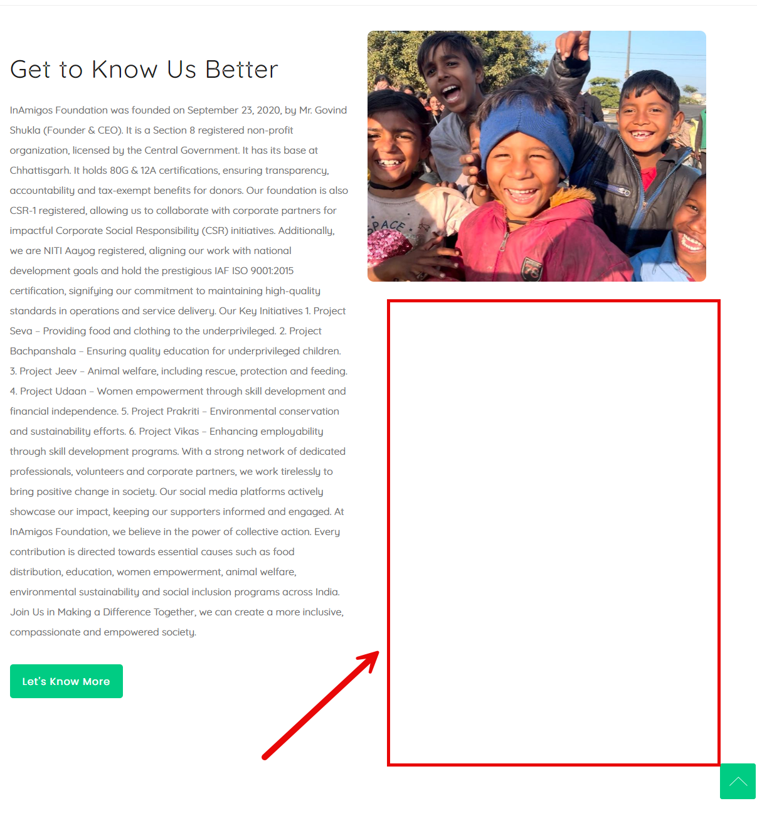

Event-card CTA alignment (HOME-004).
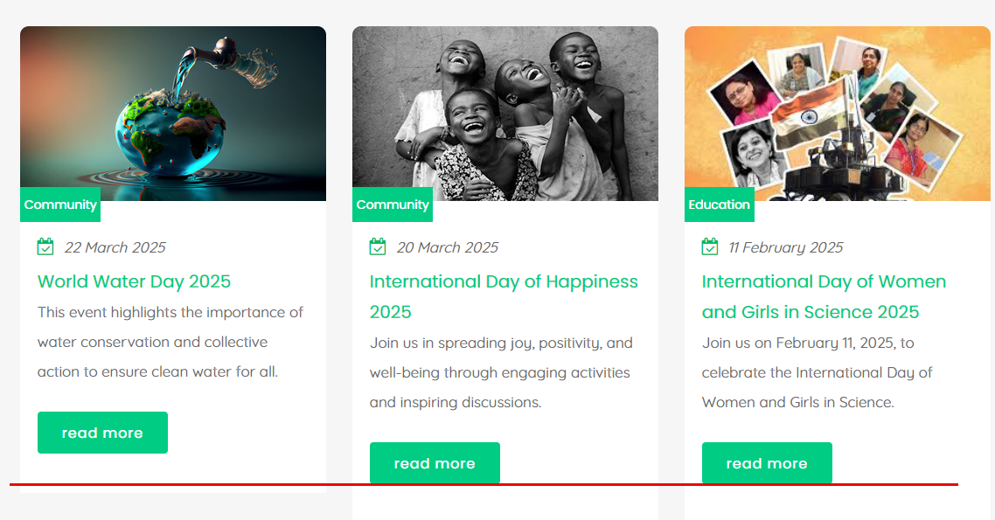

Footer branding and layout (HOME-005).
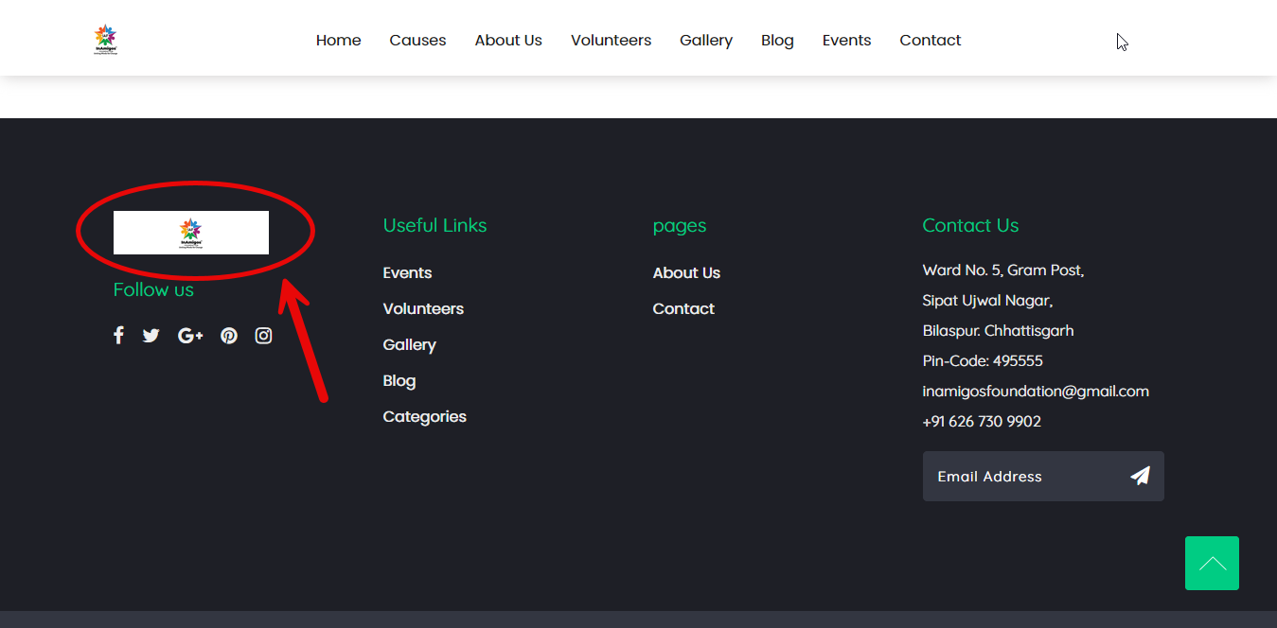

Outdated social-media branding (FUNC-006).

Social-media destination concerns (FUNC-005).
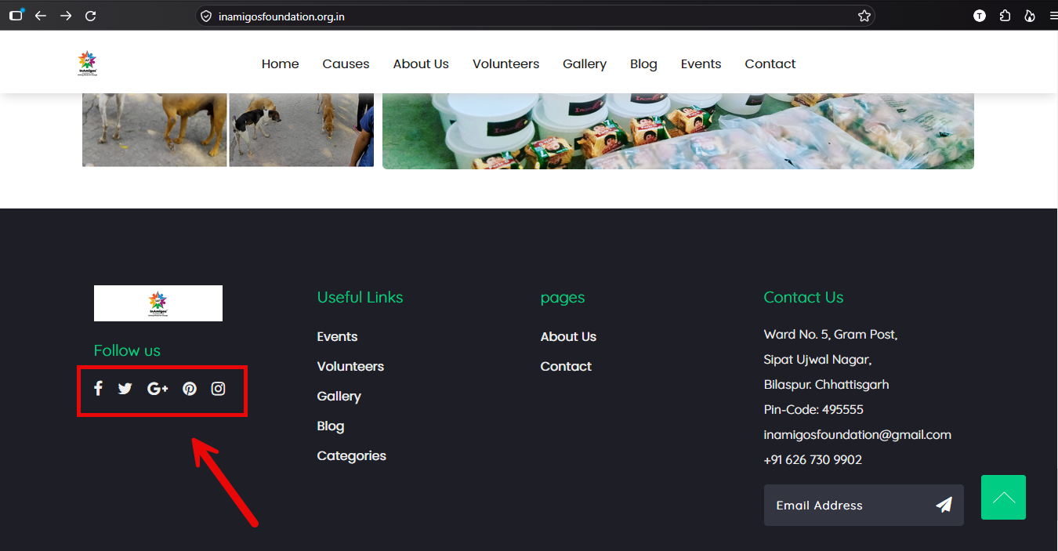

Restricted clickable area on category cards (FUNC-007).
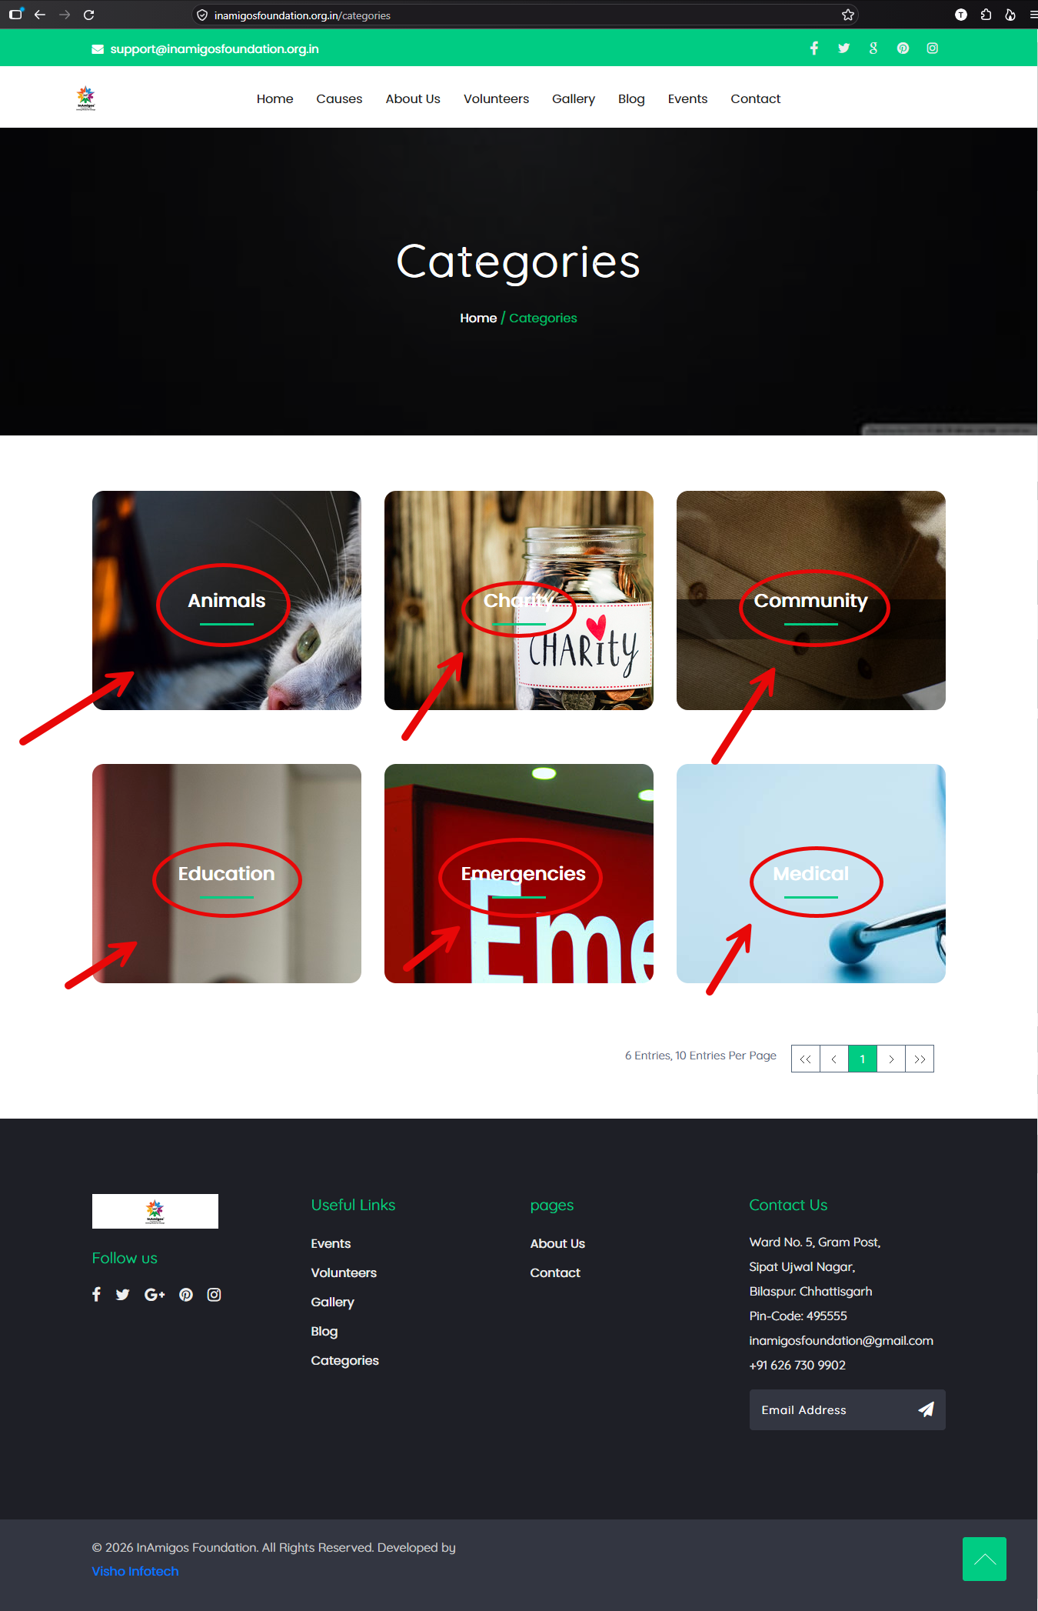

Incorrect About Us breadcrumb (ABOUT-001).
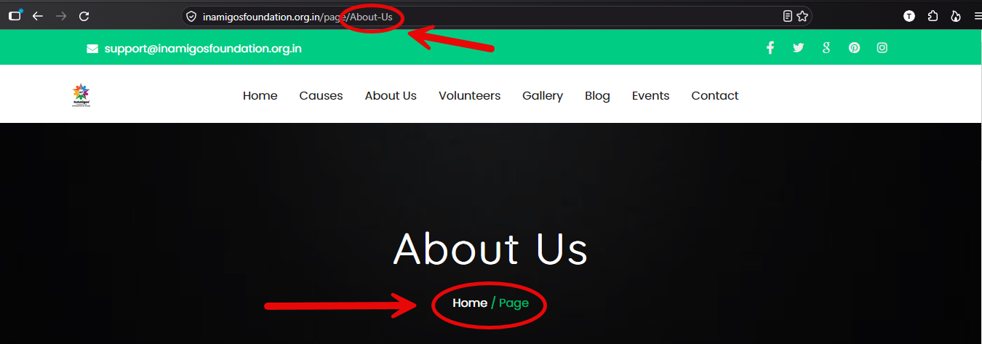

Malformed individual blog tag URL example (BLOG-003).
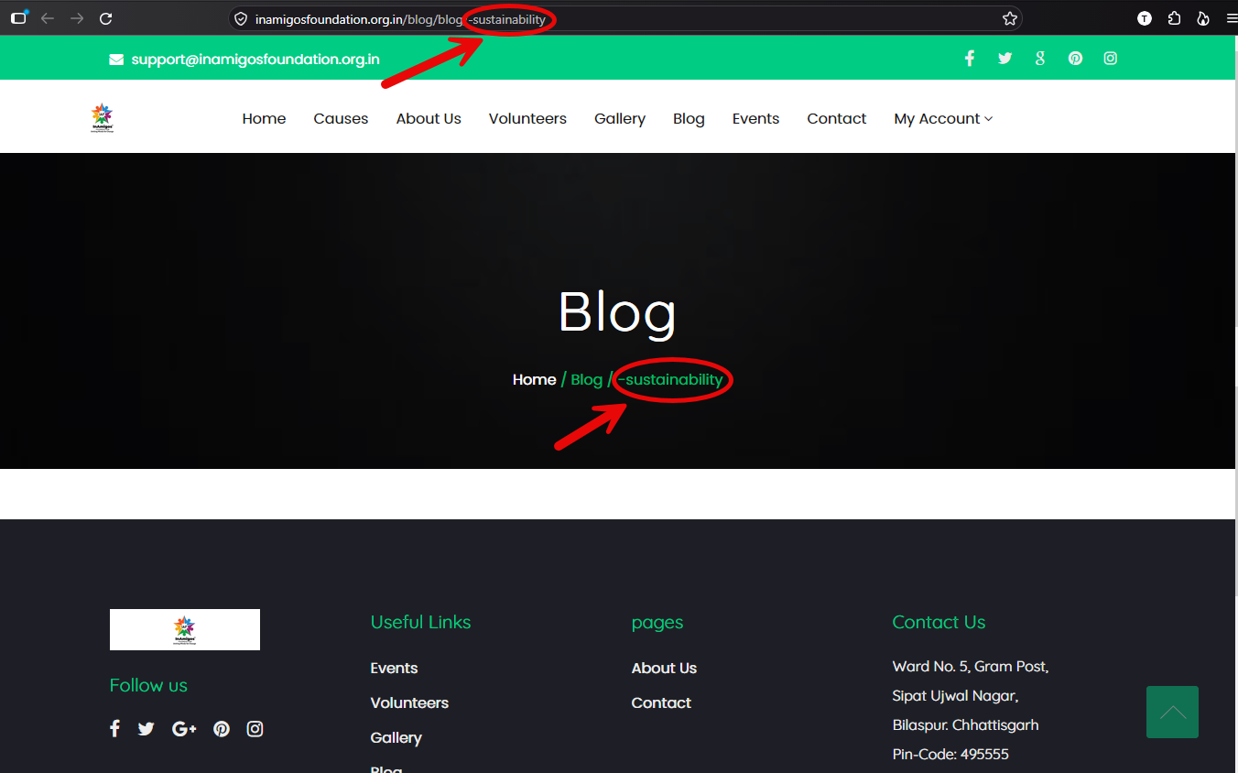

Project Vikas tag-link structure (BLOG-004).
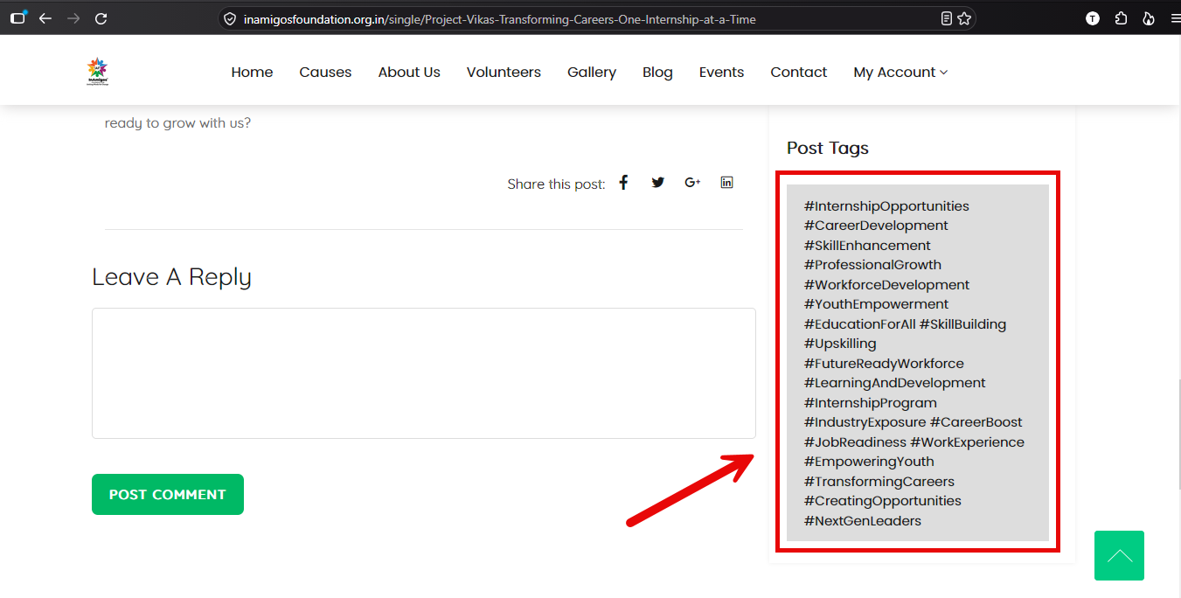

Blog tag presentation comparison (BLOG-002).
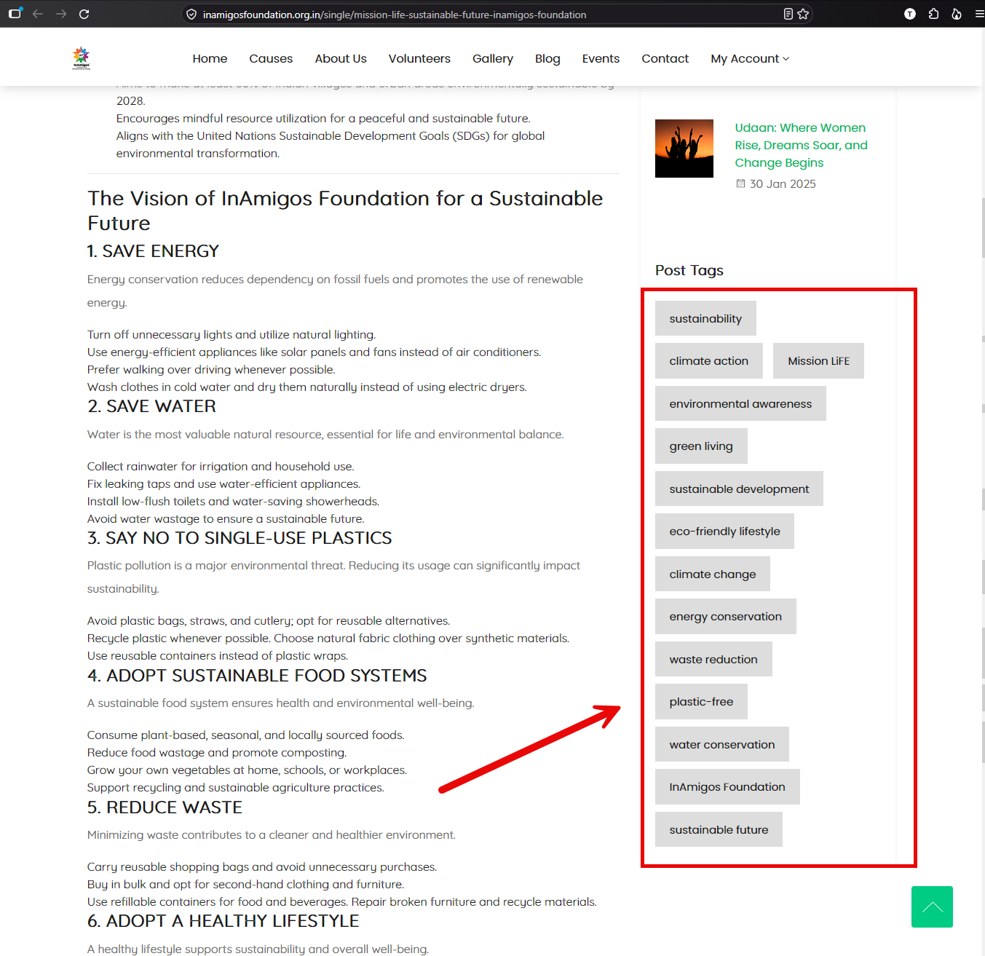

Empty Post Tags section (BLOG-002).
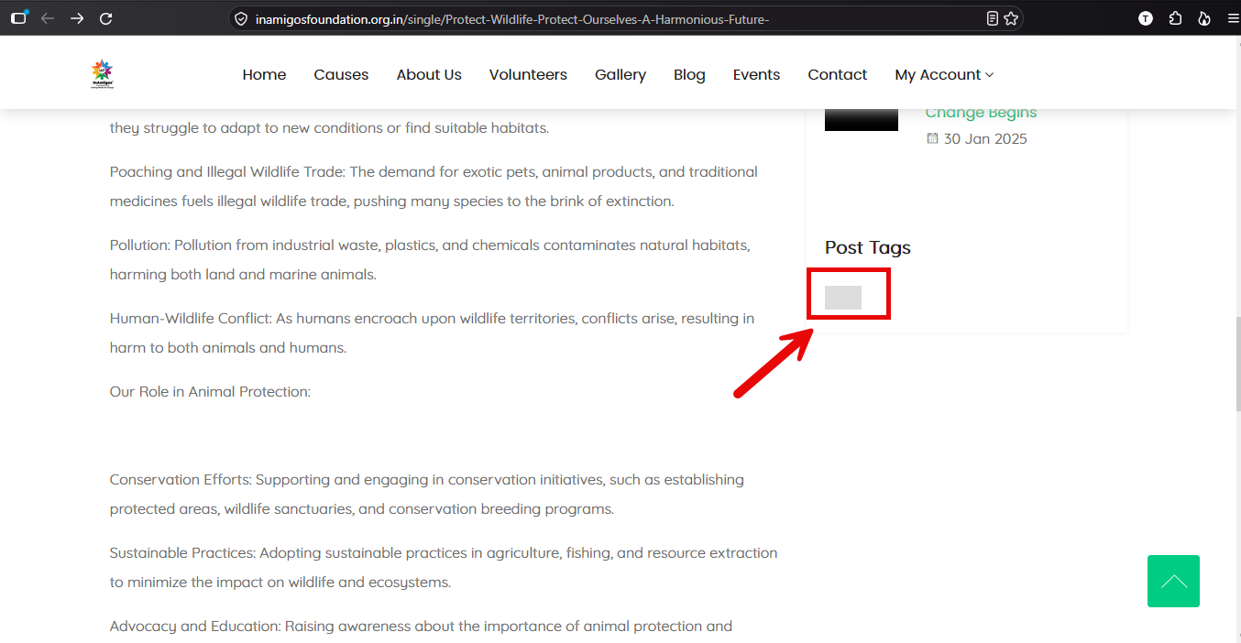

Login link hidden within the blog comment prompt (AUTH-001)
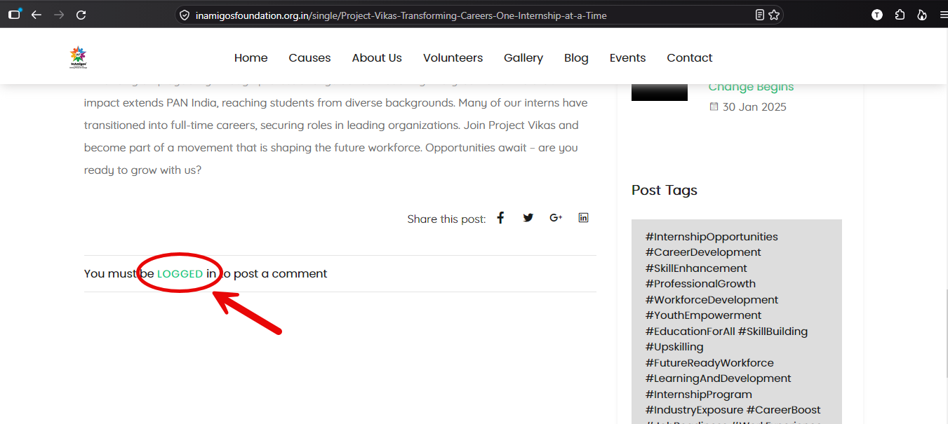

Error code when submitting contact message (FUNC-002)
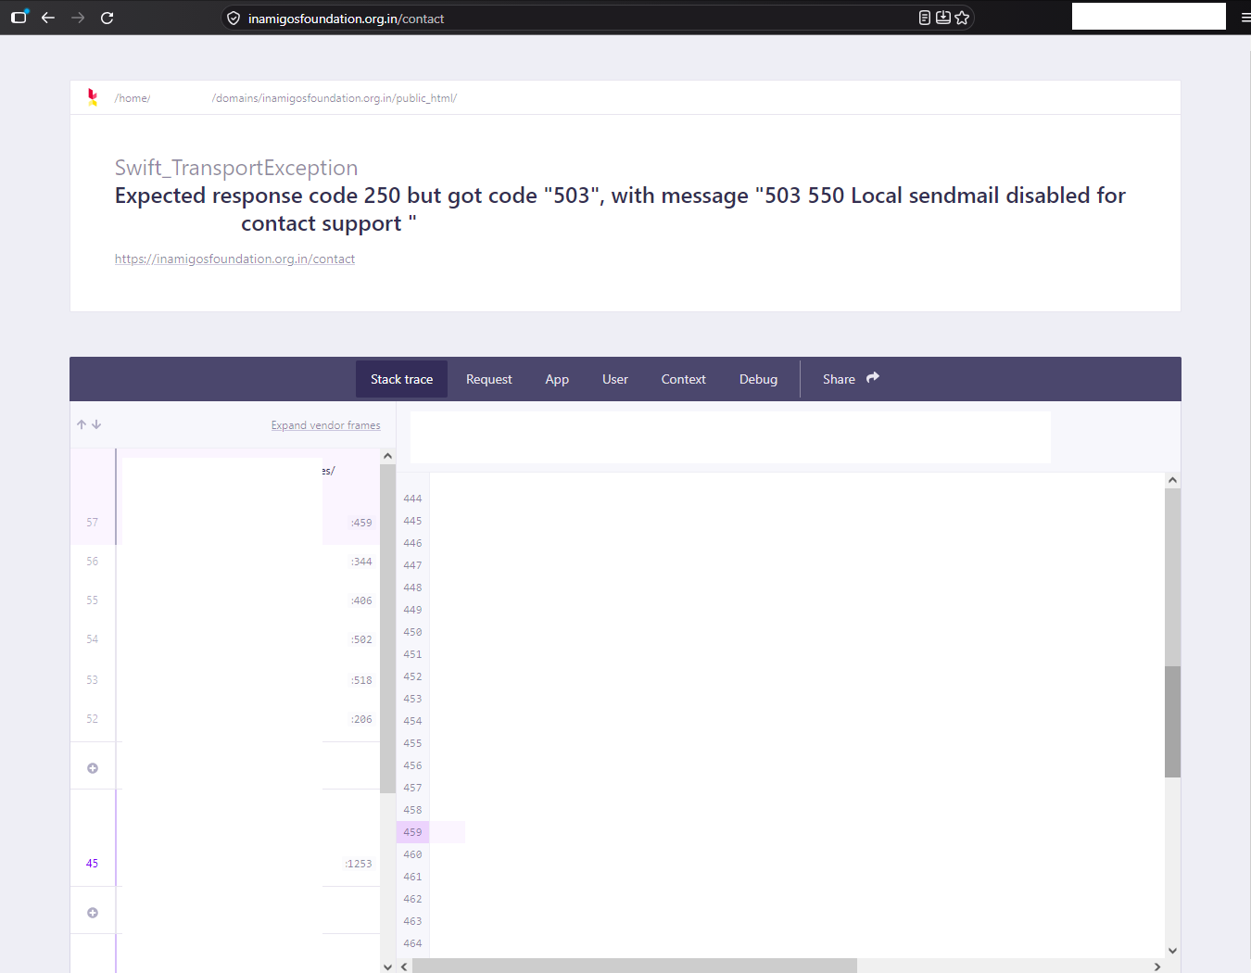

Non-recognizable buttons (HOME-007)
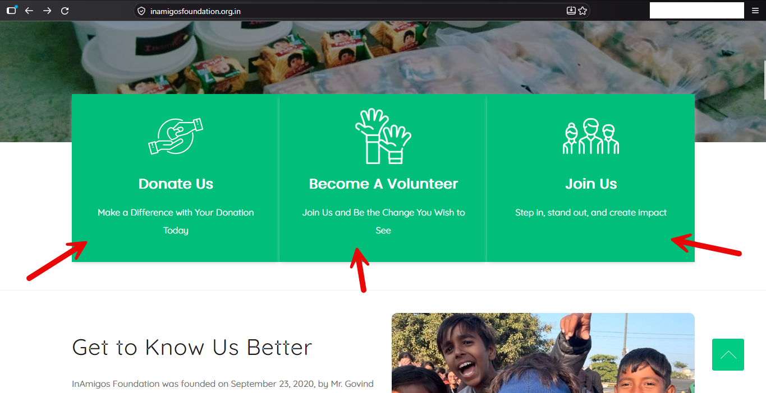

8. Limitations and Notes
- The audit records manual observations and tests; no automated accessibility, load, penetration or cross-browser test suite is claimed.
- The announcement-bar contrast ratio was calculated from colour values found in the downloaded homepage HTML and CSS. The live production site's current CSS was not independently inspected.
- The Facebook destination was observed to show unavailable content; this does not independently establish the reason the destination is unavailable.
- The homepage horizontal overflow was confirmed at 375px and 768px. The 430px viewport was inspected, but the issue was not separately confirmed.
- No responsive screenshot evidence was captured for TEST-027.
- The responsive root cause was not established. Owl Carousel was identified as a likely area for further investigation, but no code change was made.
- All findings are recommendations for the website owner/development team. The audit did not include implementation or confirmation of fixes.

9. Conclusion
The audit identified several issues that can affect visitor communication, account access, navigation and content discovery, alongside visual consistency improvements. The recommended first actions are to restore the contact form, newsletter and password-reset email flows, and strengthen password-change verification. Medium-priority work should then improve login and registration discoverability, followed by the gallery, social destinations, category interaction, causes content, blog tags and responsive homepage overflow. The GitHub repository contains the detailed findings, test logs, recommendations and full screenshot evidence supporting this report.
Website: https://inamigosfoundation.org.in/
Audit repository: https://github.com/HrishavSarma/UI-UX-audit-for-internship

