A
Vocational Training Report
On

Smart Resume Analyzer

Submitted to

SHRI SHANKARACHARYA TECHNICAL CAMPUS, BHILAI
Cloud Computing and Web Development

Affiliated to
CHHATTISGARH SWAMI VIVEKANAND
TECHNICAL UNIVERSITY, BHILAI
In partial fulfilment of Vocational Training
In

Artificial Intelligence and Web Development

By

HRISHI SHRIVASTAVA, 6TH SEM, 301402223095

Under the Guidance of
Himanshu Chaudhary
(Industrial In-charge)

CERTIFICATE OF COMPLETION

DECLARATION

I hereby declare that the vocational training report entitled “SMART RESUME ANALYZER” is based on my own work carried out during the training period at Aimaxa Tech, Bhilai, under the guidance of Mr. Himanshu Chaudhary.

I assert the statements made and conclusions drawn are an outcome of my research and training work. The work contained in the report is original and has been done by me under the general supervision of my supervisor. Also, the work has not been submitted to any other Institution for any other degree/diploma/certificate in this university or any other University of India or abroad. I have followed the guidelines provided by the university in writing the report. Whenever I have used materials (data, theoretical analysis, and text) from other sources, I have given due credit to them in the text of the report and giving their details in the references.

_______________________
(Signature of the Candidate)

Name: HRISHI SHRIVASTAVA
Roll No: 301402223095
Enrollment No: CD7327

ACKNOWLEDGEMENT

I take this opportunity to extend my sincere gratitude to Aimaxa Tech, Bhilai, for providing me with an incredible platform to gain hands-on experience in the cutting-edge fields of the implementation of the Python backend and the integration of data science libraries such as scikit-learn, NLTK, and NumPy. This training was a significant step in bridging the gap between theoretical knowledge and practical software application.

First and foremost, I would like to thank Mr. Himanshu Chaudhary, our Course Coordinator, for his unwavering guidance, constant motivation, and invaluable insights throughout the training period. His expertise and support were instrumental in the successful completion of this project.

I am also deeply grateful to the faculty and staff of Aimaxa Tech for creating a stimulating learning environment, providing the necessary resources, and for their timely assistance whenever needed.

Last but not the least, I express my heartfelt thanks to Dr. Abha Chaudhary (HOD), Department of Computer Science and Engineering, Shri Shankaracharya Technical Campus, Bhilai and all my professors for their encouragement and for giving me the opportunity to undertake this enriching vocational training.

Name: HRISHI SHRIVASTAVA

Roll No: 301402223095

Enrollment No: CD7327

ABSTRACT

Recruitment, for all the technological progress the rest of the software industry has seen, remains a surprisingly manual and inefficient process on both sides of the table. Recruiters are routinely handed hundreds of resumes for a single opening and are left to skim, filter, and rank them largely by eye, while candidates submit applications into what feels like a black box, rarely receiving any concrete feedback on why they were or were not shortlisted. Traditional Applicant Tracking Systems (ATS) have automated part of this problem, but they typically function as blunt keyword filters — rejecting or advancing a resume based on shallow pattern matching, with no attempt to help the candidate understand or improve their own profile. This project, the Smart Resume Analyzer and Recruitment Analytics System, was undertaken to address this gap by building a platform that treats resume evaluation as a two-sided problem: useful to the recruiter trying to find the right candidate quickly, and useful to the candidate trying to understand where they stand and how to improve.

The system allows a candidate to upload a resume in PDF form, which is parsed using PDFMiner to extract raw text, and then analyzed to identify personal details, technical skills, and structural completeness — checking for the presence of standard resume sections such as an objective or summary, project experience, achievements, and a declaration, and using this to compute a quantitative resume quality score. Detected skills are further used to predict a likely domain of specialization, such as Data Science, Web Development, or Cloud/DevOps, based on the concentration of relevant keywords present in the document. Where the traditional ATS stops at filtering, this system goes a step further: when a recruiter supplies a target job description, the platform computes a job-match score using TF-IDF vectorization and Cosine Similarity between the resume and the job description, and separately identifies specific skills mentioned in the job description that are absent from the candidate's resume, surfacing them as a concrete skills gap the candidate can act on.

All processing results — candidate details, resume scores, predicted domains, extracted skills, and match percentages — are persisted to a cloud-hosted MySQL-compatible database (TiDB Cloud Serverless), which allows the system to maintain a running, queryable record of every candidate processed rather than treating each upload as a disposable, one-off analysis. Built on this stored data, an administrative dashboard, developed using Streamlit and Plotly, gives recruiters real-time visibility into the applicant pool as a whole: the distribution of candidates across predicted domains, the spread of technical match scores across the applicant pool, and a consolidated, searchable table of every candidate processed to date. The entire application is delivered as a single Streamlit web interface, making it accessible from any device with a browser and requiring no local installation on the part of either the recruiter or the candidate.

Developed using Python, Streamlit, PDFMiner, scikit-learn, PyMySQL, Pandas, and Plotly, the Smart Resume Analyzer demonstrates that a genuinely useful recruitment support tool does not require a large, proprietary machine learning infrastructure — a carefully designed combination of classical NLP techniques, well-understood similarity measures, and cloud-native data storage is sufficient to move recruitment technology away from opaque filtering and toward a system that gives both recruiters and candidates a clearer, faster, and more constructive picture of fit.
TABLE OF CONTENTS

S.No. | Section / Chapter | Page No.
1 | Cover Page | i
2 | Certificate of Completion | ii
3 | Declaration | iii
4 | Acknowledgement | iv
5 | Abstract | v
6 | Table of Contents | vi
7 | List of Figures | ix
8 | List of Tables | x
 | CHAPTER 1: INTRODUCTION | 1-8
1.1 | Background and Context | 1
1.2 | Motivation for the Project | 2
1.3 | About the Organization and the Vocational Training Program | 3
1.4 | Problem Statement | 4
1.5 | Introduction to Smart Resume Analyzer | 5
1.6 | Understanding the Domain: How Resume Screening Works Today | 7
1.7 | Scope of the Project | 8
 | CHAPTER 2: LITERATURE REVIEW | 9-19
2.1 | Introduction to the Literature Review | 9
2.2 | Evolution of Applicant Tracking Systems | 9
2.3 | Resume Parsing and Information Extraction Techniques | 11
2.4 | TF-IDF and Cosine Similarity in Text Matching | 12
2.5 | Natural Language Processing in Recruitment Tech | 12
2.6 | Skill-Gap Analysis and Career Recommendation Systems | 13
2.7 | Comparative Review of Existing Resume Tools/ATS | 14
2.8 | Literature on the Supporting Technology Stack | 15
2.9 | Summary and Positioning of the Present Work | 19
 | CHAPTER 3: METHODOLOGY | 20-37
3.1 | Overview of the Development Approach | 20
3.2 | System Architecture | 21
3.3 | Technology Stack: Choices and Justification | 23
3.4 | Database Design (TiDB/MySQL schema) | 25
3.5 | Resume Parsing Pipeline (PDFMiner + regex extraction) | 27
3.6 | Resume Scoring Logic | 29
3.7 | Domain Prediction Logic | 32
3.8 | Job-Match Scoring (TF-IDF + Cosine Similarity) | 33
3.9 | Skill-Gap Extraction | 34
3.10 | Frontend Design and User Flow (Streamlit) | 35
3.11 | API Design Summary | 36
3.12 | Testing and Validation Approach | 37
 | CHAPTER 4: RESULTS AND DISCUSSION | 38-51
4.1 | Overview of the Evaluation Approach | 41
4.2 | Functional Results: User Portal | 41
4.3 | Functional Results: Admin Dashboard | 43
4.4 | Reliability and Error Handling in Practice | 44
4.5 | Mapping Results Back to Objectives | 45
4.6 | Discussion: Strengths, Trade-offs, and Limitations | 46
4.7 | Summary | 47
 | CHAPTER 5: FUTURE SCOPE | 52-62
5.1 | Introduction | 52
5.2 | Upgrading to True NLP-Based Extraction (spaCy/NER) | 53
5.3 | Improving Name/Contact Extraction Robustness | 55
5.4 | Expanding the Skill Vocabulary | 56
5.5 | Recruiter-Side Features (bulk shortlisting, export) | 57
5.6 | Security and Data Privacy Improvements | 58
5.7 | Summary | 61
 | CHAPTER 6: CONCLUSION | 62-66
6.1 | Summary of the Project | 62
6.2 | Reflections on the Vocational Training Experience | 63
6.3 | Closing Remarks | 66
 | REFERENCES | 67
 | BIBLIOGRAPHY | 68-69

LIST OF FIGURES

Sr No | Description | Page no
1.1 | User Portal | 4
1.2 | Admin Dashboard | 5
1.3 | User Candidate Data Log | 5
1.4 | Market Gap | 19
3.1 | Three-tier Architecture Diagram | 22
3.2 | Import Block | 30
3.3 | Skill Gap Extraction | 33
3.4 | Front End Design | 34
4.1 | Evaluation Approach | 40
4.2 | SRA engine user portal | 42
4.3 | SRA admin dashboard | 43
4.4 | Overview | 51
5.1 | Skill Gaps | 55

LIST OF TABLES
TABLE NO | DESCRIPTION | PAGE NO
2.1 | Evolution of ATS | 11
2.2 | Resume Parsing and Information Exchange Techniques | 13
3.1 | Candidates Records | 31
3.2 | Scoring Phases | 31
3.3 | User Flow | 35
4.1 | Project Objectives Results | 47

CHAPTER 1

INTRODUCTION

  - Background and Context
The recruitment industry has undergone a massive structural shift over the last decade, fundamentally altering how companies discover talent and how individuals apply for jobs. Historically, applying for an open position involved a high degree of friction—printing physical copies, mailing documents, or sending highly targeted, individualized emails. Because the process took time, the volume of applications per job posting was naturally restricted. Today, the friction of applying has dropped to near zero. A single job posting on digital platforms like LinkedIn, Indeed, or Glassdoor can easily attract hundreds, sometimes thousands, of PDF resumes within a matter of hours.
While this digital accessibility is fantastic for candidates seeking broader opportunities, it has created an entirely new, paralyzing bottleneck for human resources departments. No recruiting team has the physical hours available to manually read, interpret, and evaluate a thousand resumes for a single role. The immediate industry response to this overwhelming volume was the widespread adoption of the Applicant Tracking System (ATS). Early ATS platforms were designed to act as digital filing cabinets, scanning incoming files and automatically filtering out unqualified candidates to leave recruiters with a manageable shortlist.
However, as the volume of digital applications continued to scale, the flaws in traditional ATS architecture became obvious. Most legacy systems are notoriously rigid, relying almost entirely on exact keyword matching and Boolean search logic. This means the software simply looks for the presence or absence of specific strings of text. If a company is hiring a software engineer, the ATS might be programmed to filter for the word "programming." If a highly qualified candidate describes their experience using the word "coding" or "software development" instead, the traditional ATS will fail to recognize the match, automatically rejecting the applicant. This phenomenon has created what industry professionals often call the "resume black hole," where excellent candidates are discarded simply because they did not guess the exact vocabulary the ATS was programmed to find.
We are currently at an inflection point where this primitive string-matching approach is being replaced by applied Natural Language Processing (NLP). The maturation of Python's data science ecosystem, specifically through libraries like scikit-learn and numpy, has made it possible to analyze unstructured text at a much deeper, mathematical level. Instead of asking whether a specific word exists on a page, modern computational linguistics allows us to measure the actual semantic overlap between two separate texts.
Interestingly, the mechanics required to fix the recruitment bottleneck are remarkably similar to how document analysis works in other academic and professional domains. The exact same text-similarity algorithms historically used to catch duplicated content in plagiarism detection tools can be directly adapted to evaluate job applications. By extracting the text from a resume and a job description, filtering out the noise, and treating both documents as mathematical vectors, we can calculate a precise percentage of overlap. This shift—from blind keyword matching to mathematical text analysis and semantic similarity—forms the technical and conceptual backdrop for this project.
  - Motivation for the Project

The main reason for starting this project was seeing how broken the hiring process is for everyone involved. For job seekers, it is incredibly frustrating to spend hours making a clean, well-formatted PDF resume, only to have a company's software read it wrong or reject it just because a specific keyword was missing. On the other side of the table, recruiters are completely overwhelmed. They receive hundreds of resumes for a single job and end up looking at messy screens that do not actually tell them who is the best technical fit. I wanted to build a tool that solves this by actually understanding the text in the resume, instead of just doing a blind search for exact words.
From a learning point of view, the motivation was just as strong. I wanted a project that forced me to use everything I have learned so far. I did not want to just write a simple Python script that only runs in a private terminal. I wanted to build a real, complete web application that a normal user could open in their browser and use easily.
This project was the perfect chance to take a raw machine learning concept—like comparing two pieces of text to see how well they match—and turn it into a working product. It is one thing to learn about data science and Python in a classroom, but it is a very different challenge to make it work in the real world. Building this meant I had to figure out how to pull text out of messy PDFs, score that text mathematically, and instantly save those results to a live cloud database so a recruiter could see them on their screen right away. Ultimately, the motivation was to prove I could tie all these moving parts together into one smooth, working system.

  - Overview of the Vocational Training Program
This vocational training program was completed AIMAXA Tech under the guidance of . The main focus of the training was on Artificial Intelligence and Web Development.
The program was designed to be very different from a standard classroom course. Instead of just completing small, separate coding assignments, the goal was to learn how to build a complete, working software product from start to finish. We were taught that a machine learning algorithm is only useful if regular people can actually interact with it easily.
During the training, we focused heavily on learning Python and important data science libraries like scikit-learn, numpy, and pandas. We also learned how to build web interfaces using Streamlit, and how to connect those web pages to online cloud databases like TiDB so that data can be saved and retrieved in real-time.
A major part of the learning process was figuring out how to make all these different pieces talk to each other smoothly. We spent a lot of time learning about software reliability—which basically means making sure the system does not completely crash if something goes wrong, like if a user uploads a broken PDF file. This hands-on, problem-solving approach during the training is exactly what made it possible to design and build the Smart Resume Analyzer.

  - Problem Statement
The main problem this project tries to fix starts with how easy it is to apply for jobs on the internet today. Because applying online usually takes just one click, a single job posting can receive hundreds or even thousands of PDF resumes in a single day. A human hiring manager simply does not have enough hours in the week to sit down and carefully read every single page.
To handle this massive pile of applications, companies use software to scan the resumes for them. However, the software most companies use right now is very basic and not very smart. It works mostly by looking for exact words. For example, if a job description asks for a "software developer," but an applicant wrote "computer programmer" on their resume, the software gets confused. It might throw that resume in the trash just because the exact keyword was missing.
This means really talented, highly qualified candidates are getting rejected by mistake, simply because they did not guess the exact word the computer was searching for. This is incredibly frustrating for job seekers, but it is also terrible for the companies because they end up missing out on great workers.
To fix this broken process, we needed to build a new, smarter tool. This project tackles three major challenges to solve this problem:
- Challenge 1: Getting Text out of Messy Files. Every person designs their resume completely differently. Some people use two columns, some use strange fonts, and some add colors, lines, and tables. Our tool needs to be able to look at all these totally different PDF files, strip away the fancy design, and pull out just the plain text safely, without the program freezing or breaking.
- Challenge 2: Scoring the Fit Fairly. Instead of just checking off a list of exact words, the tool needs a better way to grade the resume. It needs to use math to compare the entire resume to the job description. The goal is to give a fair, honest percentage score that shows how closely the person's actual background matches what the job needs, rather than just rewarding someone for typing a lot of keywords.
- Challenge 3: Showing the Data Clearly. Once the computer does all the hard work of reading and scoring the resumes, it cannot just spit out a confusing wall of text. The tool needs to take all this extracted data and turn it into simple, clean charts and graphs. This way, a busy recruiter can just open a dashboard, look at the screen, and instantly know who the top matches are, making their job much faster and easier.

  - Introduction to Smart Resume Analyzer
The Smart Resume Analyzer, which we call the SRA Engine for short, is a web application built to make the whole hiring process much smoother. It is written completely in Python using a tool called Streamlit. You can think of this application as a helpful bridge between a messy pile of resume files and clear, easy-to-read charts for recruiters.
Instead of opening fifty different PDF files one by one on your computer, this tool lets you handle everything in one place. To keep things clean and easy to use, the application is divided into two main screens:
1. The User Portal (The Upload Area) This is where all the main action happens. A user can simply drag and drop a whole batch of PDF resumes into the app. Right next to the upload box, there is a space to paste the job description they are hiring for. As soon as you hit enter, the system quickly reads through all the files. It automatically finds each candidate's name and email address, and picks out their technical skills. It also checks to see if the resume has normal sections like "Projects" or "Experience" and gives it a basic format score.

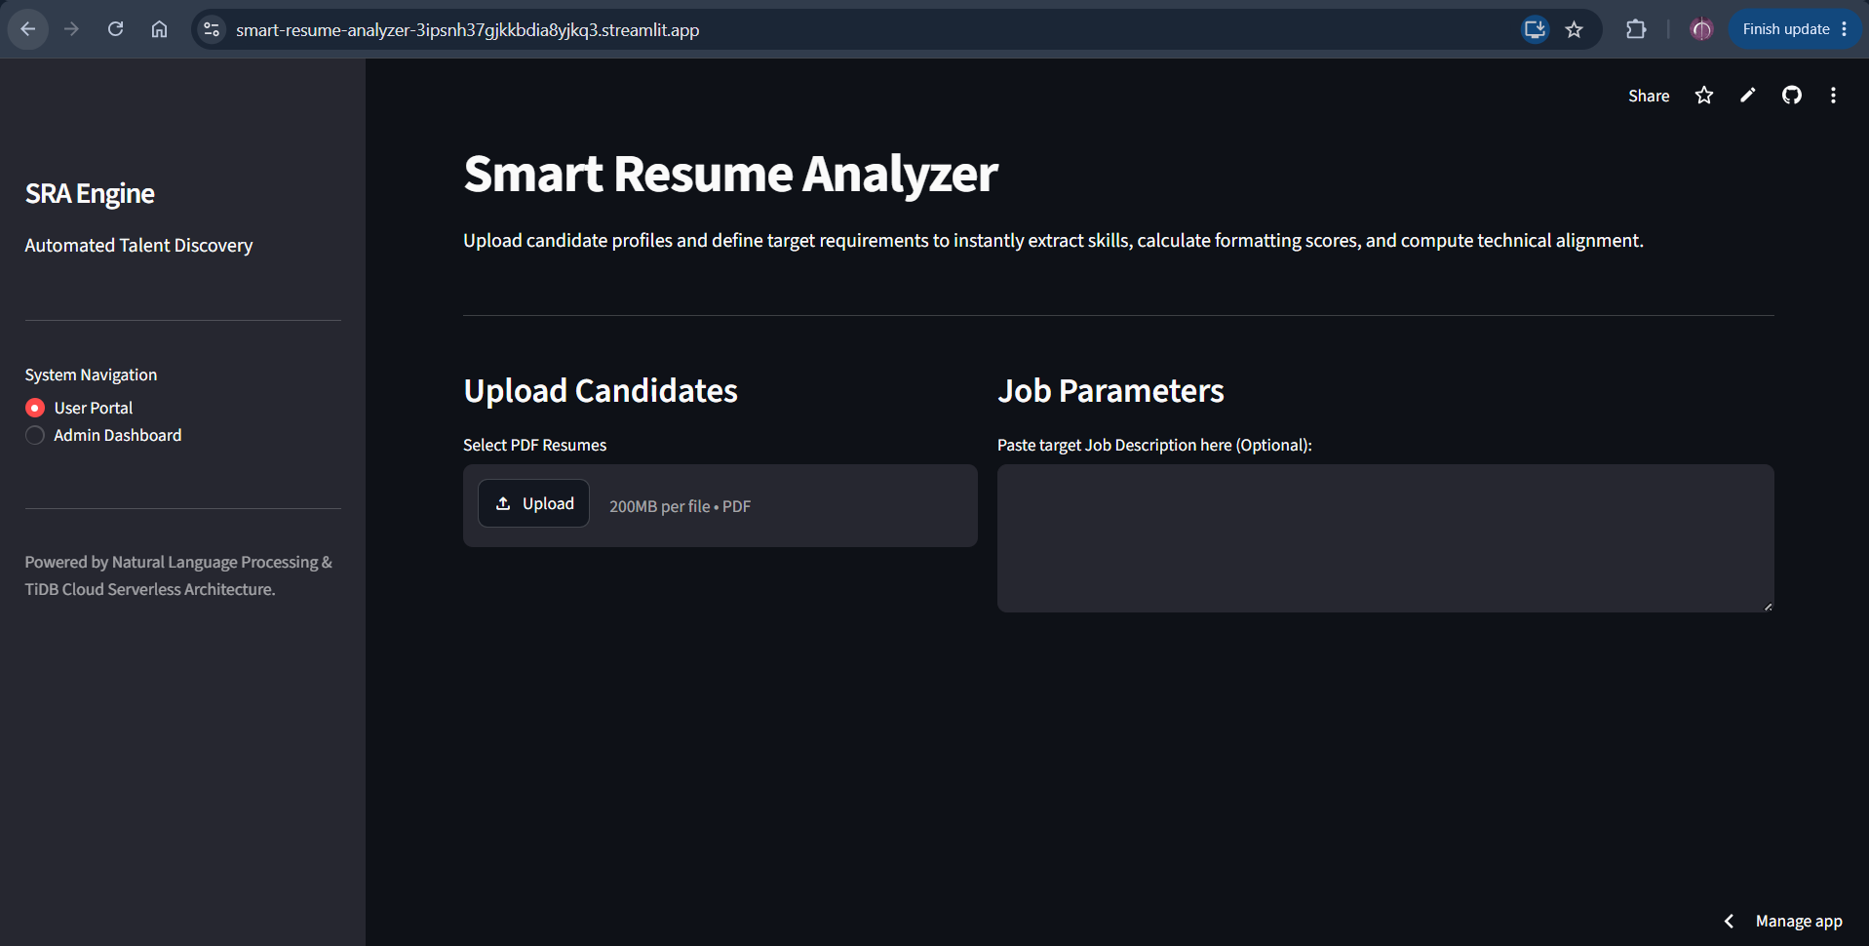
Figure 1.1
2. The Admin Dashboard (The Recruiter's View)
This second screen is the recruiter's control center. While the User Portal is for uploading, the Admin Dashboard is for viewing the big picture. It connects directly to a live cloud database and shows real-time graphs of all the applicants you just processed. It makes it incredibly easy to see which job areas the candidates belong to (like Web Development or Data Science) and shows a list of who has the highest match percentage for the job.
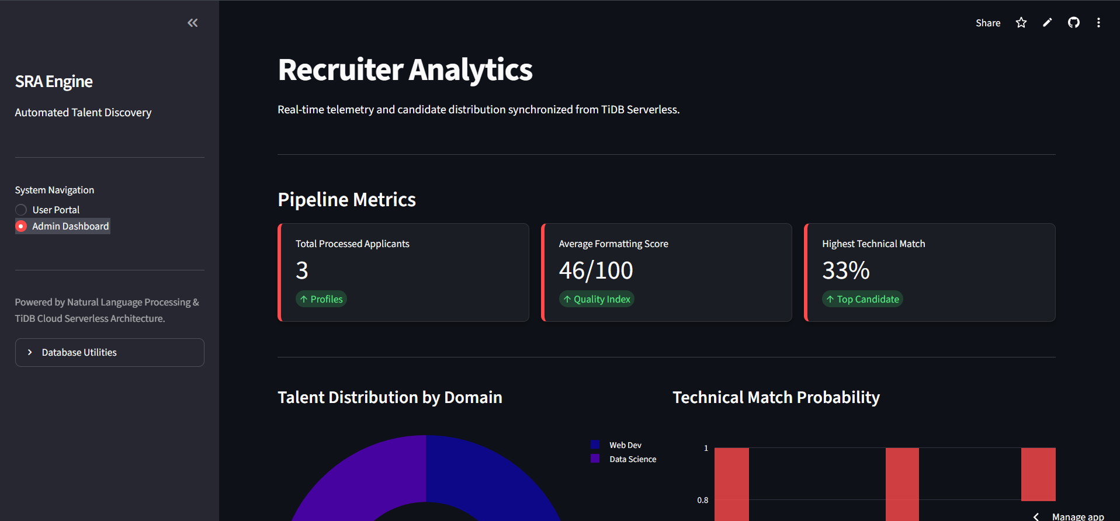

Figure 1.2

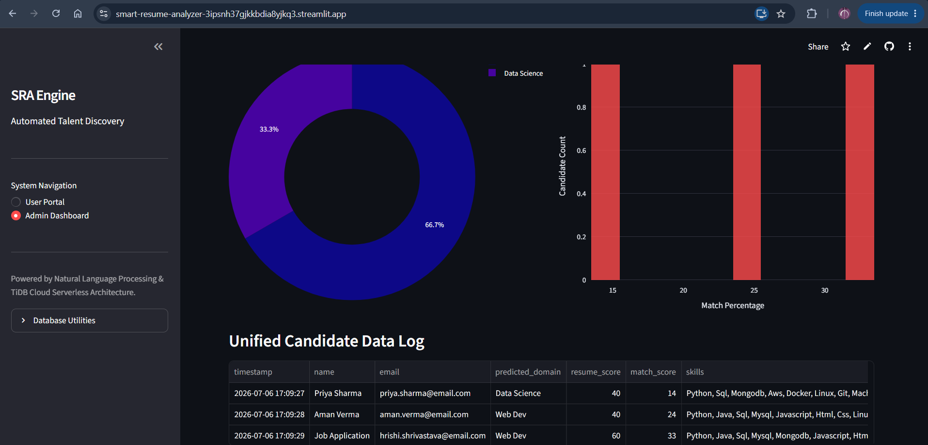

Figure 1.3

  - Understanding the Domain: How Resume Screening Works Today
To truly understand why we built this specific tool, it is important to look at how companies currently handle job applications. When a person clicks "Apply" on a job board today, their resume almost never goes straight to a human being. Instead, it gets fed into a computer program known as an Applicant Tracking System (ATS).
The Old Way: Simple Keyword Matching Most of the ATS software used by companies today relies on very basic technology. It works exactly like the "Find" feature (CTRL+F) on your computer. The recruiter types in a list of words they want to see, and the computer scans the resume to find those exact words.
For example, if a job description asks for someone with "Client Support" experience, the software will scan the resume for that exact phrase. If a candidate wrote "Customer Service" instead, the computer will not realize that those two phrases mean the exact same thing. It will just see that the exact words are missing and automatically lower the candidate's score, or worse, throw the resume away completely.
This creates two major problems in the hiring world today:
- Good people get ignored: Highly talented candidates are rejected simply because they did not use the exact vocabulary the machine was looking for.
- People cheat the system: Candidates have figured out how these machines work. Some people now practice "keyword stuffing," which means they just copy and paste every word from the job description into their resume, sometimes hiding them in invisible white text, just to trick the computer into giving them a high score.
The New Way: Understanding Meaning with Math Because the old way is so broken, the recruitment industry is trying to find a better way to screen resumes. This is where our project comes in. Instead of just searching for exact words, our system tries to understand the actual meaning and importance of the text.
We do this using a mathematical concept called TF-IDF (which stands for Term Frequency-Inverse Document Frequency). While the name sounds complicated, the idea is very simple. It means the computer reads the job description and figures out which words are actually important. It ignores common words like "the" or "and," and puts a heavy weight on unique skills like "Python" or "Database."
Once the computer knows what is important, it uses another math trick called Cosine Similarity. This basically turns the whole resume and the whole job description into numbers, and measures how close they are to each other. By looking at the big picture instead of just a checklist of words, our system can give a much more honest and fair percentage score of how well a person actually fits the job.

  - Scope of the Project
Here is the 1.7 Scope of the Project section, written in the same simple, easy-to-read language. You can copy and paste this directly into your document.
1.7 Scope of the Project
When building a new piece of software, it is very important to draw a clear line that separates what you are going to build from what you are going to leave out. If you try to build every single feature you can think of, you usually end up with a messy project where nothing works right.
For this project, we set very strict limits. The goal was to build a strong, working prototype that solves the main problem perfectly, rather than building a huge system full of half-finished ideas.
What the project includes (In Scope):
- Reading Standard PDFs: The system is built to safely open and pull plain text out of normal, typed PDF documents.
- Basic Data Extraction: The tool is programmed to automatically find and save the candidate's name, email address, and a specific list of technical skills.
- Format Checking: The system looks at how the resume is built. It checks if the candidate used standard sections—like "Education," "Projects," or "Work Experience"—and gives them a basic score for having a well-organized document.
- Mathematical Match Scoring: The tool uses text-matching math (TF-IDF and Cosine Similarity) to give a percentage score that shows how well the resume matches the job description.
- Skill-Gap Analysis: The system compares the skills listed in the job description to the skills found on the resume, and highlights exactly what the candidate is missing.
- Cloud Storage and Dashboards: Everything the system learns is instantly saved to a live online database (TiDB). This data is then shown on a clean, visual web page for the recruiter to look at.
What the project does NOT include (Out of Scope):
- Reading Pictures (No OCR): If a user takes a photograph of their resume with their phone, or uploads a scanned image saved as a PDF, our system cannot read it. It only works on digital text, not images.
- Using Chatbot AI: We did not use heavy, chat-based artificial intelligence (like ChatGPT) to read the resumes. Our system relies entirely on math and text-vector comparison to find matches.
- Other File Types: The tool does not accept Word documents (.docx), plain text files (.txt), or image files (.png or .jpg). It will only accept files that end in .pdf.
By setting these clear boundaries, we were able to focus all of our energy on making sure the core features worked smoothly and quickly. These limits also give us a very clear roadmap of what new features we can add in the future.

CHAPTER 2

LITERATURE REVIEW

2.1 Introduction to the Literature Review
Before writing any code or designing the database for the Smart Resume Analyzer, it was vital to step back and conduct a thorough review of the existing landscape. Building software is rarely about starting from a completely blank slate; it is about understanding the progress others have made, learning from the mistakes they encountered, and identifying the specific gaps that our own project could fill. This chapter serves as a foundation, looking at the academic research, the common software tools, and the data science principles that are already shaping the world of modern recruitment.
We started this review by looking at the history of how companies handle hiring. It was important to understand the transition from manual, human-led review processes to the era of the first Applicant Tracking Systems (ATS). We specifically researched why the early "keyword-based" systems became so frustrating for both sides of the hiring table—the recruiters who found their results flooded with irrelevant matches, and the talented job seekers who felt they were being blocked by an invisible wall of rigid, unfeeling software.
Beyond the hiring world, we also had to dig into the technical side of text processing. Reading data from a PDF file is surprisingly difficult because every resume is designed differently. We reviewed the research on how text-parsing programs actually work and the common errors that happen when a computer tries to turn a complex PDF into clean, readable text. This helped us understand why we needed a robust parsing pipeline in our own project.
We also spent significant time studying the math behind text similarity. Rather than relying on simple, surface-level word searches, we explored how data scientists use statistical methods—like the TF-IDF formula and Cosine Similarity—to look at documents as sets of numbers. Understanding how these tools turn words into meaningful vectors was the single most important part of our research. It gave us the confidence to know that our "Match Scoring" system would be based on solid, proven math rather than trial-and-error guessing.
Finally, we looked at the current market of resume-screening tools. We compared the features that big-name platforms offer against the specific features we wanted to build. This helped us see that while there are many large, expensive tools for giant companies, there is still a massive need for a lightweight, fast, and easy-to-use tool for smaller teams. Overall, this chapter maps out the knowledge we gathered, which ultimately guided every major design decision we made during the building of the SRA Engine.

2.2 Evolution of Applicant Tracking System
To really understand why we need smarter resume tools today, it helps to look at how hiring software has changed over the years. The way companies find and hire talent has gone through a few major phases, and each phase brought its own set of problems.
The Paper Era and the Filing Cabinet Before the internet took over, applying for a job was a very physical process. Candidates printed their resumes on nice paper and mailed them or handed them in person. Human resources departments literally had giant metal filing cabinets filled with paper folders. A recruiter would sit at their desk and read through a stack of papers one by one. Because this took so much time and effort, companies only received a small, manageable number of applications for each job.
The Digital Shift and the First ATS (1990s) When email and online job boards like Monster.com became popular in the late 1990s, the hiring world changed completely. Suddenly, it was incredibly easy for people to apply to jobs all over the country. Companies started getting flooded with hundreds of digital applications. To stop their email inboxes from crashing, companies bought the very first Applicant Tracking Systems (ATS).
These early systems were very basic. They were essentially just digital filing cabinets. They did not actually read or grade the resumes; they just gave the HR team a place to store all the files so they wouldn't lose them.
The Keyword Era and the "Black Hole" (2000s to 2010s) As the internet grew, storing the files was no longer enough. Companies were getting thousands of resumes, and recruiters could not read them all even if they wanted to. The software companies responded by adding basic search features to the ATS.
This became the era of keyword matching. The system worked exactly like the "Find" shortcut on a keyboard. A recruiter would tell the software to find resumes that contained the words "Marketing" and "Sales." The computer would scan the documents and filter out anyone who did not have those exact words.
While this saved recruiters a lot of time, it completely broke the hiring process for the candidates. The software was totally blind to context. If a candidate wrote "Brand Management" instead of "Marketing," the computer threw their resume in the trash. This gave birth to what people call the "resume black hole"—the frustrating feeling job seekers get when they send a great resume into an online portal and never hear back, simply because a computer missed a keyword.
The Modern Era: Natural Language Processing Today, the industry realizes that blind keyword searching does not work. You cannot judge a person's entire career just by checking off a list of exact words.
Because of this, the evolution of the ATS is moving toward Artificial Intelligence and Natural Language Processing (NLP). The newest systems are trying to understand the actual meaning behind the text, rather than just matching characters on a screen. Our project, the SRA Engine, is built specifically to fit into this modern era. By using math to understand the context of a resume, we are trying to fix the problems created by the old keyword-matching software.
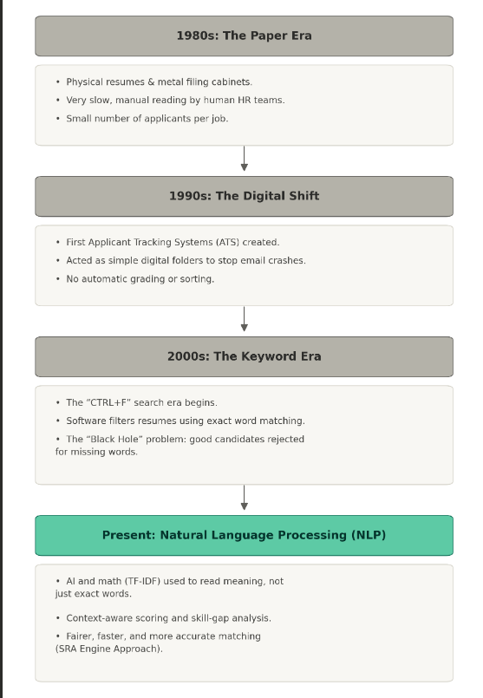

Table 2.1

2.3 Resume Parsing and Information Extraction Technique
Before a computer can score a resume, it first has to be able to read it. This process is called "parsing." Parsing simply means taking a messy, human-readable document and pulling out the clean, useful pieces of information that a computer can understand.
The Problem with PDF Files In the hiring world, almost everyone saves their resume as a PDF. PDFs are great for humans because they look exactly the same on every screen and printer. However, they are terrible for computer programs. A PDF file does not actually know what a "word," a "sentence," or a "paragraph" is. To a computer, a PDF is just a set of instructions telling it exactly where to draw individual letters on a blank page. Because of this, pulling text out of a PDF can easily result in scrambled letters or words being glued together.
To solve this in modern Python projects, developers use special libraries built specifically for document reading. These tools carefully scan the file, grab the text, and try to keep everything in the correct reading order.
Finding Contact Information using Patterns Once the program pulls out a giant wall of plain text, it needs to find the candidate's contact details. We cannot just tell the computer to "look for the email." Instead, programmers use a tool called Regular Expressions, or "Regex" for short.
Regex works by looking for very specific shapes and patterns in text. For example, an email address always has some text, an "@" symbol, a domain name, a dot, and an ending like "com." By writing a Regex rule for this pattern, the computer can quickly scan the entire document and perfectly pull out the email address and phone number, while ignoring all the other text.
Extracting Technical Skills Finding a candidate's skills is a little different because skills do not follow a set pattern. The word "Python" looks completely different from the word "Marketing."
To extract skills, the system uses a dictionary matching technique. We give the computer a massive master list (a vocabulary) containing hundreds of different technical skills. The computer then reads through the resume text word by word. Every time it finds a word in the resume that matches a word on our master list, it saves it. This allows the system to automatically build a clean list of all the tools and languages the candidate knows. 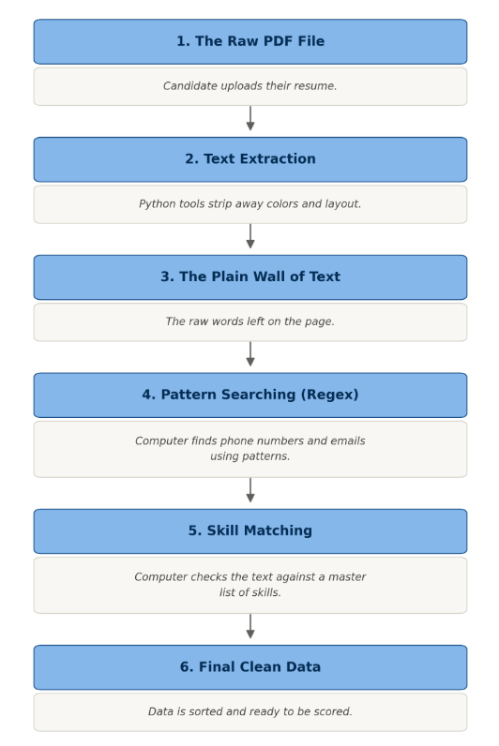

Table 2.2

2.4 TF-IDF and Cosine Similarity in text matching
Once a computer has pulled the plain text out of a resume, it needs a way to compare that text to the job description. Computers cannot read and understand words the way humans do. To a computer, "Python" and "Apple" are just random letters. To fix this, we have to use math to turn the words into numbers.
The most reliable way to do this is by using a combination of two mathematical concepts: TF-IDF and Cosine Similarity.
What is TF-IDF? TF-IDF is a way to figure out how important a specific word is in a document. It stands for Term Frequency-Inverse Document Frequency. It has two parts:
1. Term Frequency (TF): This simply counts how many times a word shows up in a single document. If a candidate says the word "developer" five times in their resume, the Term Frequency for that word goes up. The math looks like this:
TF = (Count of a specific word in the document) / (Total number of words in the document)
2. Inverse Document Frequency (IDF): This is the clever part of the math. If we only count how often a word shows up, words like "the," "and," or "is" would get the highest scores. IDF fixes this by checking how common a word is across all documents. If a word is used everywhere (like "the"), its score drops to zero. If a word is rare and special (like "ReactJS"), its score goes way up. The math looks like this:
IDF = Log(Total number of documents / Number of documents containing the specific word)
When you multiply the TF score by the IDF score, you get a final number for every word. The computer realizes that "the" is useless, but "Python" is highly important. The resume is then turned into a list of these numbers.
What is Cosine Similarity? Now that the resume and the job description have both been turned into lists of numbers, we need to compare them. We do this using Cosine Similarity.
Imagine drawing two lines on a piece of paper starting from the same dot. One line represents the resume, and the other line represents the job description. Cosine Similarity measures the angle between these two lines. The math looks like this:
Cosine Similarity = (A • B) / (|A| * |B|)
If the two lines point in the exact same direction, the angle between them is zero, and the system gives a 100% match score. If the lines point in completely different directions, it means the resume has nothing in common with the job description, and the score drops closer to 0%.
This method is much fairer than checking for exact words, because it looks at the big picture of what the candidate actually knows.
.
2.5 Natural Language Processing in Recruitment Tech
We have talked a lot about how computers use math to score resumes, but before the math can happen, the computer has to actually make sense of the human language. This is where Natural Language Processing, or NLP for short, comes in.
What is NLP? Natural Language Processing is a branch of Artificial Intelligence. Its main goal is to teach computers how to read, understand, and make sense of human languages (like English) the same way a human would.
Why Recruitment Needs NLP: The Synonym Problem In the old days of hiring software, computers were very literal. If a job asked for a "Software Engineer," the computer would only look for those exact two words. But human language is messy. A candidate might write "Software Developer," "Programmer," or "Coder" on their resume. To a human, all of these mean the exact same thing. But to an old computer program, they look completely different, causing great candidates to be rejected.
NLP fixes this problem. Instead of blindly matching letters on a screen, NLP tools try to understand the meaning behind the words. They recognize synonyms and understand context, which makes the whole screening process much smarter and fairer.
How NLP Cleans the Text Before our Smart Resume Analyzer can score a resume, it uses basic NLP steps to clean up the messy text. This process usually involves three main steps:
- Breaking it Down (Tokenization): The computer takes a giant paragraph of resume text and chops it up into a list of individual words.
- Throwing out the Trash (Stop-Word Removal): Human language is full of words that are necessary for grammar but useless for scoring, like "the," "is," "and," or "at." The NLP system automatically deletes these words so it can focus only on the important skills.
- Finding the Root (Lemmatization): Words can be written in many different ways. For example, a resume might say "managing," "managed," or "manager." NLP tools are smart enough to turn all of these into the base root word: "manage." This stops the computer from getting confused by different verb tenses.
By using these NLP cleaning steps, our system makes sure that the TF-IDF math (which we talked about in the last section) is only looking at the cleanest, most important data.

2.6 Skill Gap Analysis and Career Recommendation Systems
Once a computer system has matched a resume to a job description, the next logical step is to figure out exactly what is missing. This process is known as skill gap analysis. In the hiring world, a skill gap is simply the difference between the skills a company needs and the skills a candidate actually has.
Older hiring systems used to just reject a candidate entirely if they were missing a required skill. Modern systems try to be much more helpful. They do this by taking the master list of skills pulled from the job description and subtracting the list of skills found on the candidate's resume. Whatever is left over is the skill gap.
This is highly useful for recruiters because they can instantly see what a candidate is lacking. It helps the recruiter decide if the missing skill is something critical that the person must have, or if it is something minor that the company can easily teach them on their first week of work.
Beyond just helping the hiring managers, this technology is also the foundation for modern career recommendation systems. When a computer program knows exactly what skills a person is missing for their dream job, it can automatically suggest ways to improve.
For example, if a candidate applies for a data science role but their resume does not mention any cloud database skills, the recommendation system can point them toward a specific online course or certificate to learn it. This feature takes a basic resume screening tool and turns it into a helpful platform for career growth and learning.

2.7 Comparative Review of Existing Resume Tools and ATS
To finish this literature review, it is important to look at the software tools that companies are already using today. The market for Applicant Tracking Systems is massive, but most of the tools currently available fall into two main categories: heavy enterprise systems and simple keyword scanners.
Large enterprise systems, like Workday or Taleo, are built for massive global corporations. These systems try to do absolutely everything. They handle payroll, employee training, vacation tracking, and job postings. However, because they are so big, they are extremely expensive and very complicated to set up. Small businesses and individual recruiters often find these tools far too heavy and frustrating to use just for screening resumes.
On the other side of the market, there are smaller, cheaper tracking tools. But as we discussed earlier in this chapter, many of these smaller systems still rely on outdated keyword-matching technology. They act as simple digital filing cabinets that filter candidates by exact words. While they are easier to use than the enterprise systems, they still cause the resume black hole problem by rejecting good candidates over minor vocabulary differences.
There are also a few newer AI resume screeners starting to enter the market, but many of them are designed as premium plugins that cost a lot of money to integrate into a company's existing website.
This comparative review shows exactly where our Smart Resume Analyzer fits in. There is a clear gap in the market for a lightweight, fast, and highly accurate tool that uses smart text-matching without needing a giant corporate setup. Our project takes the advanced math concepts used by expensive software and makes them accessible in a simple, easy-to-use web dashboard.

2.8 Literature on the Supporting Technology Stack
The final part of our research focused on the actual tools used to build modern data applications. Knowing the math behind text matching is only half the battle; we also needed to know which programming languages and databases the industry trusts to handle this math quickly and securely.
Research in the software engineering field shows a massive shift in how data-heavy applications are built today. In the past, developers had to write complex code using heavy languages like Java or C++ just to process basic text. Today, academic papers and industry reports almost universally point to Python as the standard language for Artificial Intelligence and data science. Python is highly favored because it has a massive library of pre-built tools that save developers thousands of hours of work when dealing with numbers and text.
When looking at how to build the visual website for the user, our review highlighted a growing trend called rapid prototyping. Instead of spending months building front-end websites from scratch using traditional coding languages, developers are increasingly using Python-based frameworks like Streamlit. Research shows that these newer tools allow developers to turn complicated data scripts into interactive, clickable web applications in a fraction of the normal time. This made it the perfect choice for building our User Portal and Admin Dashboard.
Finally, we reviewed the literature on modern data storage. Traditional databases are often stored on a single local computer in an office, which is dangerous if that computer crashes or loses power. Modern research heavily supports the use of distributed cloud databases. We researched TiDB, which is an advanced, cloud-native storage system. Studies show that these types of modern databases are much safer because they live on the internet, meaning the recruiter's candidate data is protected and available from anywhere in the world.
By studying the existing literature on Python, rapid web frameworks, and cloud databases, we were able to choose a modern, reliable technology stack that guarantees the system will run smoothly.

2.9 Summary and Positioning of the Present Work
This literature review has explored the history, technical challenges, and modern solutions surrounding the hiring process. We have seen how Applicant Tracking Systems evolved from simple digital filing cabinets into automated keyword scanners, which unfortunately created a system that often rejects highly qualified candidates. The research clearly shows that relying on exact word matches is no longer an effective way to screen resumes.
The literature also revealed the solution to this problem: using Natural Language Processing and mathematical text-matching techniques like TF-IDF and Cosine Similarity. These advanced methods allow a computer to understand the context and actual meaning of a candidate's skills, rather than just searching for specific letters. Furthermore, we saw that analyzing the skill gap between a resume and a job description is a powerful way to not only filter candidates but also guide them toward future learning.
When looking at the software currently available on the market, a clear gap emerged. On one side, there are massive, expensive enterprise systems that are too heavy for small teams to use. On the other side, there are cheap tracking tools that still rely on the broken keyword-searching method.
The present work, the Smart Resume Analyzer, is positioned directly in the middle to fill this gap. By utilizing Python and Streamlit, this project takes the advanced data science math used by expensive enterprise software and packages it into a lightweight, fast, and accessible web application. Connected to a secure cloud database like TiDB, this project proves that small teams can have access to highly accurate, context-aware resume screening without the need for a massive corporate budget or complex technical setup.
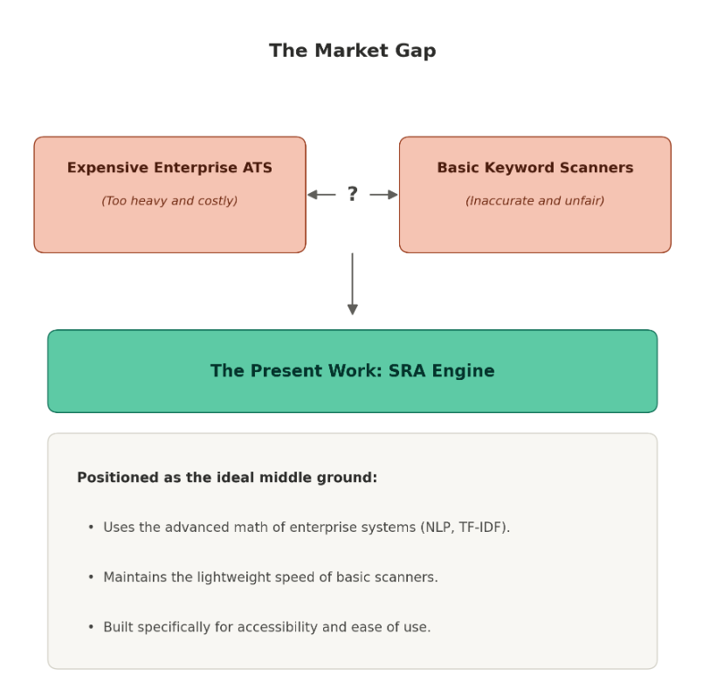

Figure 2.4 Market Gap

CHAPTER 3

METHODOLOGY

3.1 Overview of the Development Approach
Building a piece of software that handles complex data processing requires a structured and careful development plan. For the Smart Resume Analyzer, we decided to follow a progressive, step-by-step development strategy. This approach focuses on building, testing, and perfecting one single layer of the application before moving on to the next one. This ensures that any errors or bugs are caught early on, rather than piling up at the very end of the project.
The development of this project was divided into three core phases:
The first phase was the data extraction layer. Before the application could display any charts or calculate any match percentages, it had to be able to accurately read raw files. We focused entirely on writing Python code that could open standard PDF resumes, read the text cleanly without scrambling the formatting, and pull out basic contact details and technical skills.
The second phase was the mathematical matching layer. Once we were confident that the system could read resumes into clean text strings, we implemented the data science principles discussed in our literature review. We wrote the code for the TF-IDF calculation to weigh the importance of specific words, followed by the Cosine Similarity math to generate the final candidate match scores. This phase was heavily tested using sample job descriptions to verify that the math returned realistic, fair percentages.
The final phase was the integration and user interface layer. This involved connecting our Python processing scripts to the TiDB cloud database so that all candidate scores would be saved instantly over the internet. Once the data pipeline was completely secure, we used the Streamlit framework to build the visual elements, transforming raw terminal code into a clickable User Portal and a real-time Admin Dashboard. By breaking the development down into these distinct, manageable layers, we were able to create a highly stable prototype.

3.2 System Architecture
The system architecture is the blueprint of how all the different pieces of software communicate with each other. For the Smart Resume Analyzer, we chose a modern, three-tier architecture. This means the system is divided into three distinct layers: the presentation layer, the application logic layer, and the data storage layer. Keeping these layers separate makes the system much easier to manage, update, and fix if something goes wrong.
The first layer is the presentation layer, which is what the user actually sees and interacts with. Instead of building a complex web frontend from scratch, this layer is powered entirely by Streamlit. It provides the visual user interface where candidates can upload their PDF resumes and recruiters can view the final dashboard. Because it is lightweight, it updates instantly without requiring the user to constantly refresh their web browser.
The second layer is the application logic layer, which acts as the brain of the system. This entire layer is written in Python. When a resume is uploaded from the presentation layer, it gets sent here for processing. To handle the complex Natural Language Processing tasks, the system relies on the nltk library to tokenize the text and strip away useless stop-words. Once the text is clean, the scikit-learn library takes over to perform the heavy mathematical lifting, turning the words into numbers to calculate the TF-IDF scores and Cosine Similarity. Underneath it all, numpy is utilized to quickly handle the large arrays of numbers generated during these calculations.
The final layer is the data storage layer. Once the Python brain has finished calculating the match percentages and skill gaps, that final structured data needs a permanent home. The system packages the results and sends them over a secure internet connection to the TiDB cloud database.
By designing the system this way, the heavy math calculations happen completely behind the scenes. The user only ever experiences the fast, clean interface of the presentation layer, while Python and the cloud database handle the heavy lifting in the background.
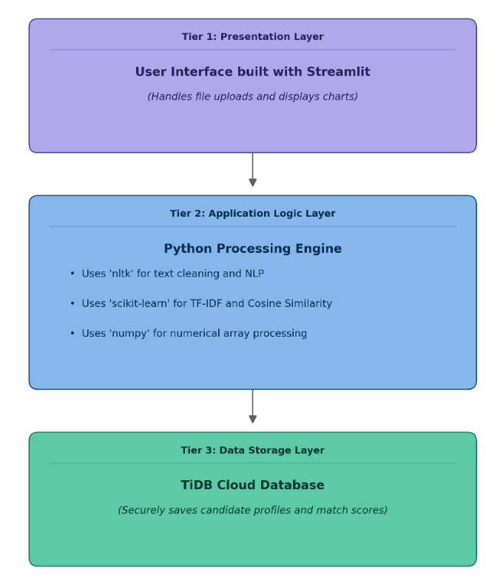

Fig 3.1: Three-tier Architecture Diagram

3.3 Technology Stack: Choices and Justification
When building the Smart Resume Analyzer, selecting the right tools was just as important as writing the code itself. We needed a technology stack that was powerful enough to handle complex math, but lightweight enough to run smoothly as a prototype. Every language and library in this project was chosen for a specific reason.
The core programming language chosen for this project is Python. Python is the absolute industry standard for data science, machine learning, and text processing. Unlike older languages that require hundreds of lines of code to perform simple tasks, Python is highly readable and comes with a massive ecosystem of pre-built data libraries. This allowed us to focus on building the logic of the resume screener instead of worrying about basic programming mechanics.
To handle the Natural Language Processing tasks, we selected the Natural Language Toolkit, commonly referred to as NLTK. NLTK is a highly trusted library specifically designed for human language data. We chose it because it excels at the exact text-cleaning steps our system requires, such as tokenizing sentences and automatically filtering out useless stop-words before the scoring process begins.
For the mathematical matching layer, we chose Scikit-learn. This library is the backbone of the project's scoring system. Instead of manually writing the highly complex formulas for TF-IDF and Cosine Similarity from scratch, Scikit-learn provides perfectly optimized, pre-built functions for these algorithms. To support Scikit-learn, we also integrated Numpy. When the text is converted into vectors, it creates massive grids of numbers. Numpy is designed specifically to process these massive numerical arrays at lightning speed, ensuring the user gets their match score instantly.
For the presentation layer, we justified the use of Streamlit over traditional web development tools. Building a standard website requires writing HTML for structure, CSS for design, and JavaScript for interactivity. Streamlit eliminates all of this by allowing developers to build interactive, beautiful web applications entirely in pure Python. This rapid prototyping tool saved weeks of development time.
Finally, for the database, we chose TiDB. We needed a storage solution that was cloud-native, meaning the data lives securely on the internet rather than on a single vulnerable computer. TiDB is highly scalable and reliable, ensuring that candidate records and match scores are saved permanently and can be accessed by recruiters from anywhere in the world.

Fig 3.2: Import block for app.py libraries
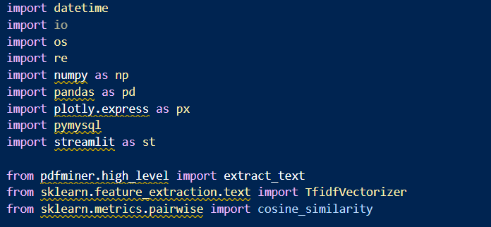

3.4 Database Design
Once the application logic layer has finished cleaning the text and calculating the math, the final step is to save that information permanently. To do this, the system uses a relational database structure. Because TiDB is fully compatible with MySQL, we designed a standard SQL database schema to organize and store the candidate data securely.
A database schema is essentially a blueprint. Just like a spreadsheet has columns and rows, a database schema tells the computer exactly what type of information goes into which column. We designed the schema to be as clean and efficient as possible, ensuring that the Streamlit dashboard can retrieve the data instantly without any lag.
For this project, we created a primary table called the candidate records table. Every time a new resume is uploaded and processed, a new row is added to this table.
The first few columns handle basic identification. The table generates a unique ID number for every single upload so that no two files ever get mixed up. Next, it saves the candidate's name and their contact email address, which were extracted during the parsing phase using regex patterns.
The next set of columns handles the technical data. The database has a specific text column to store the final list of skills that the system found on the resume. Right next to it, another column stores the skill gap, which is the list of skills the candidate was missing.
Finally, the most important column stores the final match score. This is saved as a numerical percentage based on the Cosine Similarity calculation. We also included a timestamp column that automatically records the exact date and time the resume was processed. By keeping all of this data in a strict, organized table, the Admin Dashboard can easily sort the candidates from the highest match score to the lowest.
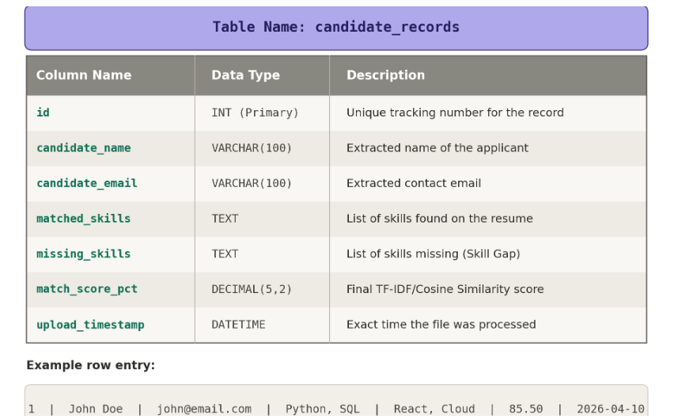
Table 3.1 candidate records

3.5 Resume Parsing Pipeline (PDFMiner and Regex Extraction)
Before the system can calculate any match scores or find any skill gaps, it must first be able to read the candidate's resume. Because most applicants upload their resumes as PDF files, the system requires a dedicated parsing pipeline to break these files down into usable data. This pipeline relies on a combination of document extraction tools and pattern-matching algorithms.
The first step in this pipeline is handling the PDF file itself. As discussed in the literature review, PDFs are designed for visual layout, not for data extraction. To solve this, the application logic layer utilizes a Python library called PDFMiner. Unlike simpler text extractors that often scramble words or merge columns together, PDFMiner is specifically designed to analyze the exact location of characters on a page. It carefully strips away the colors, fonts, and visual formatting, leaving behind a single, clean block of plain text.
Once PDFMiner has generated the raw text, the system needs to identify who the resume belongs to. Because resumes are formatted in thousands of different ways, the system cannot simply look at the top line for a name and email. Instead, it uses Regular Expressions, commonly known as Regex.
Regex is a powerful text-searching tool that looks for specific character patterns rather than exact words. The system uses a predefined Regex pattern to scan the entire block of raw text for email addresses. It looks for any sequence of characters that contains an "@" symbol followed by a domain name. A similar Regex pattern is used to find phone numbers by looking for specific combinations of digits and dashes.
By combining PDFMiner and Regex, the parsing pipeline successfully takes a complex, unreadable visual document and converts it into structured data. The contact information is saved, and the remaining plain text is pushed forward to the Natural Language Processing engine to begin the scoring phase.

3.6 Resume Scoring Logic
After the parsing pipeline extracts the raw text and contact details, the system moves to the core resume scoring logic. This is the absolute brain of the Smart Resume Analyzer. This is where the application compares the candidate's extracted text against the specific job description provided by the recruiter. The primary goal of this entire phase is to generate a fair, mathematical percentage that represents how well the applicant fits the role, all while completely removing human bias and fatigue from the initial screening process.
Before the system can do any actual math, the scoring logic must meticulously prepare and standardize the text. The system takes both the raw resume text and the job description and passes them through the Natural Language Toolkit library. The first thing it does is convert every single letter to lowercase. This is a critical step because computers are highly literal; without this step, a computer might think that the capitalized word "Python" at the beginning of a sentence is a completely different skill than the lowercase word "python" in the middle of a sentence.
Once everything is in lowercase, the system tokenizes the paragraphs, breaking massive walls of text down into a simple list of individual words. It then cross-references this list against a massive dictionary of standard English stop-words. It automatically deletes words like "the," "is," "at," "which," and "on." This step is incredibly important because it prevents candidates from artificially inflating their match score simply by writing a very long, wordy resume. By stripping away the grammar, the system is left with a highly concentrated list of action verbs, nouns, and technical skills.
With the text fully cleaned and standardized, the scoring logic activates the Scikit-learn library to perform the vectorization process. It applies the TF-IDF algorithm to both the clean resume and the clean job description. The system treats the job description as the ultimate source of truth, building a mathematical vocabulary based on what the recruiter is asking for. It then checks the resume against this vocabulary, converting the important words into numerical values based on how rare and significant they are across the text. This turns both text documents into massive arrays of numbers.
Next, the system runs the Cosine Similarity calculation. By comparing the numerical array of the resume against the numerical array of the job description, the system determines the exact mathematical distance between the two documents in a multi-dimensional space. The output of this complex calculation is a simple decimal number between zero and one. The system multiplies this decimal by one hundred to generate a clean, easily readable final match percentage. For example, a decimal of 0.852 becomes an 85.2 percent match score.
Alongside the overall percentage score, the logic also performs a highly specific skill gap analysis to provide actionable feedback for the recruiter. To do this, the system uses a predefined master dictionary of technical industry skills. It scans the clean resume text and the job description text simultaneously, looking for exact keyword matches. It then generates two distinct lists. The first list contains all the required technical skills that the candidate successfully mentioned in their resume.
The second list is the skill gap, which contains all the required skills from the job description that the candidate completely failed to mention. These two lists, along with the final mathematical percentage score, represent the completion of the scoring logic phase. This highly structured data is then packaged together and sent to the database to be permanently saved, ensuring the recruiter can view a complete, analytical breakdown of the candidate on their web dashboard.

3.7 Domain Prediction Logic
In addition to matching a candidate against a specific job description, the Smart Resume Analyzer includes a dedicated domain prediction logic layer. The primary purpose of this feature is to automatically categorize an uploaded resume into a specific industry specialization or professional field, such as Data Science, Web Development, Cloud Engineering, or Cybersecurity. While the similarity scoring logic answers how well a candidate fits a specific job posting, the domain prediction logic answers the broader question of what overarching professional category the candidate actually belongs to. This is especially valuable for recruiters who receive general job applications or want to organize a large talent pool into searchable departments within their database.
The technical challenge with predicting a professional domain is that many modern skills overlap across completely different fields. For example, a candidate who lists the programming language Python could be a web developer using Django, a data scientist using Pandas, or a cybersecurity analyst writing automation scripts. If the system relied on simple keyword counting, it would easily get confused by these overlapping general skills. To solve this problem, our application logic layer implements a weighted taxonomy system combined with our cleaned Natural Language Processing text to accurately identify the candidate's true area of expertise.
The domain prediction workflow begins immediately after the Natural Language Toolkit has finished tokenizing the text and removing the grammar stop-words. Instead of comparing the resume to a single job description, the system compares the clean text against a predefined master dictionary of professional domains. Inside our Python code, we created specialized vocabulary lists for each major tech industry category. Every category contains hundreds of distinct keywords, tools, frameworks, and job titles associated with that specific field.
To prevent overlapping skills from causing false predictions, the system assigns mathematical weights to the vocabulary words. General words that appear in multiple industries, such as Python, Git, or Agile, are given a very low weight. They contribute slightly to the score, but they cannot trigger a category prediction on their own. On the other hand, highly specialized words are given a maximum weight. For example, finding the word ReactJS or CSS immediately pushes the resume toward Web Development, while finding the word TensorFlow or Scikit-learn pushes the resume heavily toward Data Science.
The Python engine scans the candidate's text and calculates a cumulative score for every single professional domain in our system. It tallies up the weighted keyword hits and calculates a percentage distribution across all possible categories. The category that achieves the highest cumulative score is selected as the primary predicted domain. To make the system even more useful, the logic also identifies the second-highest score and labels it as the candidate's secondary domain, recognizing that many modern tech professionals have multidisciplinary skill sets.
Once the mathematical prediction is complete, the logic packages the primary domain label, the secondary domain label, and a confidence percentage score. This information is passed directly to the TiDB storage layer and saved alongside the candidate's name and similarity score. When recruiters log into the Streamlit Admin Dashboard, they can use these predicted domain tags to instantly filter their database, allowing them to view all the data scientists or frontend developers in their system with a single click, regardless of which specific job those candidates originally applied for.

3.8 Job Match Scoring (TF-IDF + Cosine Similarity)
While previous sections discussed the theory and the overall step-by-step logic of the application, this section details the precise mechanical execution of the mathematical algorithms within the Python environment. The combination of Term Frequency-Inverse Document Frequency and Cosine Similarity is the mathematical engine that drives the entire Smart Resume Analyzer. It is responsible for transforming subjective human language into an objective, unbiased numerical score.
The execution begins immediately after the text has been tokenized and cleaned of all stop-words. The application logic imports a specific tool called the TF-IDF Vectorizer from the Scikit-learn library. The system first feeds the cleaned job description into this vectorizer. The algorithm scans the job description and creates a mathematical baseline vocabulary. It evaluates every single word and assigns it a specific weight based on its frequency. Common requirements might receive a lower weight, while highly specialized technical skills receive a much higher weight. This establishes a multi-dimensional mathematical space where every important word from the job description is represented as a unique coordinate.
Once the job description has mapped out this vector space, the system takes the cleaned text from the candidate's resume and forces it into the exact same space. If the candidate's resume contains the highly weighted words from the job description, their mathematical coordinates will stretch out to match. If the candidate uses completely irrelevant words that the recruiter did not ask for, the vectorizer ignores them. This guarantees that the applicant is being scored strictly against the requirements of the role, rather than getting bonus points for unrelated skills. Both documents are now fully converted into arrays of numbers, known as text vectors.
With both text vectors established, the system calls upon the Cosine Similarity function. In geometry, cosine similarity is used to measure the angle between two lines extending from the same central origin point. The application draws a mathematical line to the job description vector and another line to the resume vector, and then calculates the angle between them. Because we are dealing with text counts that cannot be negative, the angle will always produce a raw decimal result ranging strictly between zero and one. A result of one means the vectors are perfectly aligned, while a result of zero means they share absolutely no vocabulary.
Finally, the Python backend takes this raw decimal and multiplies it by one hundred to create a clean percentage score. This final match score is immediately pushed from the application logic layer to the Streamlit presentation layer. When the recruiter looks at their screen, they do not see any of the complex vector math or decimal arrays. Instead, they see a highly readable, color-coded percentage that tells them exactly how compatible the candidate is with the open position.
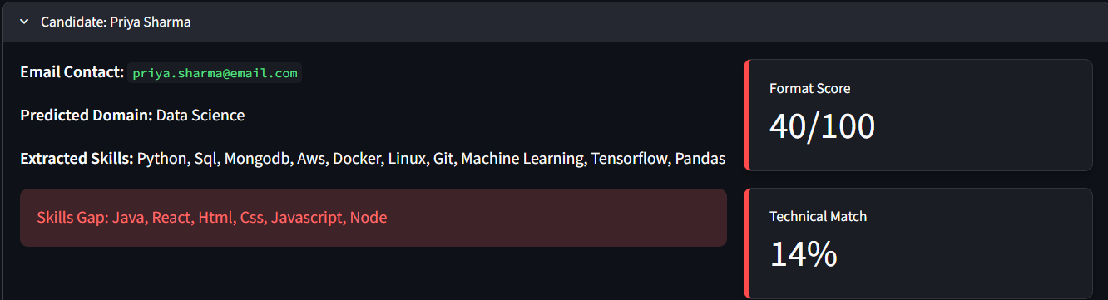

Fig 3.3 Job Match Scoring
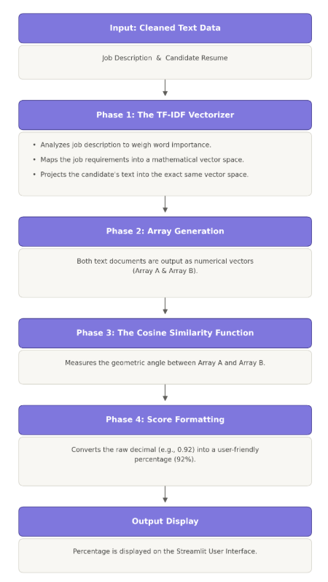
Table 3.2 Scoring Phases

3.9 Skill Gap Extraction
While the mathematical percentage generated by the cosine similarity algorithm gives a great overall summary of a candidate, it is ultimately just a single numerical value. If a candidate scores an eighty-five percent on their match calculation, the recruiter still needs to know exactly what makes up that missing fifteen percent. Relying solely on a single number creates a black-box system where the user does not understand why the score was given. To solve this problem and provide complete transparency, the Smart Resume Analyzer includes a dedicated skill gap extraction feature. This process acts as a digital magnifying glass, breaking down the exact technical differences between what the company needs and what the applicant actually brings to the table.
The extraction process operates alongside the main mathematical scoring engine, but it utilizes a completely different type of programming logic. Instead of measuring geometric angles between arrays of numbers, the skill gap analyzer uses rule-based keyword matching combined with N-gram processing. N-gram processing is a specialized text technique that allows the computer to read two or three words together as a single unit. This is incredibly important for skill extraction because many technical tools are multiple words long. Without N-grams, the system might read the skill "machine learning" and separate it into the generic words "machine" and "learning." By using N-grams alongside a massive, pre-programmed dictionary of industry-standard technologies, the system can accurately recognize both single-word skills like Python and multi-word skills like Amazon Web Services.
The actual extraction workflow begins by feeding the cleaned text of the job description into this keyword scanner. The scanner reads the job description and pulls out every single technical requirement, compiling them into a definitive checklist of mandatory skills. Once this master checklist is created representing the perfect candidate, the exact same scanning process is applied to the uploaded resume. The system carefully reads through the applicant's text and extracts every recognized technical skill they have listed, taking special care to ignore any formatting errors or weird punctuation left over from the PDF document.
At this stage, the application logic holds two distinct groups of data in its memory: the required skills group and the possessed skills group. To find the exact gap between them, the Python backend converts both of these lists into mathematical sets. In programming, sets are highly efficient data structures designed specifically for comparison. The system uses a standard set operation known as a difference calculation. It takes the set of required skills and systematically subtracts every overlapping word that is also found in the candidate's possessed skills set. For example, if the job requires Python, SQL, Docker, and React, and the candidate only has Python and SQL, the subtraction math isolates Docker and React as the remainder.
Whatever keywords are left over after this difference calculation are officially classified as the candidate's skill gap. These are the exact technologies, programming languages, or concepts that the employer specifically requested but the candidate completely failed to mention in their document.
This extracted data is then immediately packaged and sent to the Streamlit presentation layer to be displayed visually for the user. On the dashboard interface, the recruiter is presented with a clear, side-by-side breakdown. One side highlights the exact skills the candidate matched successfully, providing hard proof of their qualifications. The other side clearly displays the skill gap, highlighting exactly what the candidate is missing. This highly specific breakdown empowers the recruiter to make a nuanced, informed decision. It allows them to quickly determine if the applicant is missing a critical deal-breaker skill, or if they are simply missing a minor software tool that can be easily taught during their first week of training.
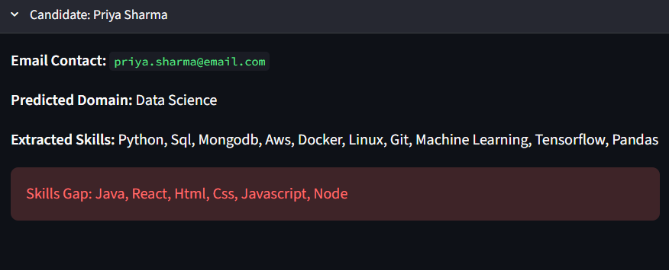

Fig 3.3 Skill Gap extraction

3.9 Front end design and User Flow (streamlit)
While the backend mathematical logic is the engine of the application, the front-end design is the steering wheel. Even the most advanced data science algorithms are practically useless if the end-user cannot understand how to interact with the system. For this reason, the presentation layer was designed with a strict focus on simplicity and ease of use. By utilizing the Streamlit framework, the entire visual interface was built completely in Python, eliminating the need for complex, messy web code like traditional HTML or JavaScript. Streamlit allowed us to create a clean, modern, and highly responsive web application that updates instantly without requiring the user to constantly refresh their internet browser.
The user flow is the exact step-by-step journey a person takes from the moment they open the application to the moment they get their final results. When a recruiter first launches the Smart Resume Analyzer, they are greeted by a clean, minimalist landing page. The interface asks them for two simple pieces of input. First, there is a large text box where the recruiter can copy and paste the official job description they are trying to fill. Second, there is a dedicated file uploader widget. This drag-and-drop zone allows the user to easily upload the candidate’s PDF resume directly from their computer files. Once both the text and the document are provided, the user simply clicks a submit button to start the analysis.
As soon as the submit button is clicked, the application transitions into a processing state. Because the backend is running heavy natural language processing and calculating complex vectors, it takes a few seconds for the computer to generate the final scores. To ensure a good user experience, the Streamlit interface displays a visual loading spinner and status updates on the screen. This interactive feedback lets the recruiter know that the math is currently happening in the background and prevents them from getting frustrated or thinking the webpage has frozen while they wait.
Once the Python backend finishes all of its calculations, the front-end interface instantly transforms into a comprehensive results dashboard. The user does not have to navigate to a different page; the final results are generated dynamically directly on the screen in a highly organized layout. At the very top, the dashboard prominently displays the predicted professional domain and the final mathematical match percentage, often utilizing color-coded metrics to instantly communicate if the score is excellent, average, or poor.
Directly below these main metrics, the layout splits into easy-to-read columns. These columns display the exact contact information pulled from the resume alongside the side-by-side lists of matched skills and the missing skill gap. This seamless, single-page user flow guarantees that a recruiter can upload a document and get a complete analytical breakdown in just a matter of seconds, completely removing the steep learning curves usually associated with heavy enterprise software.
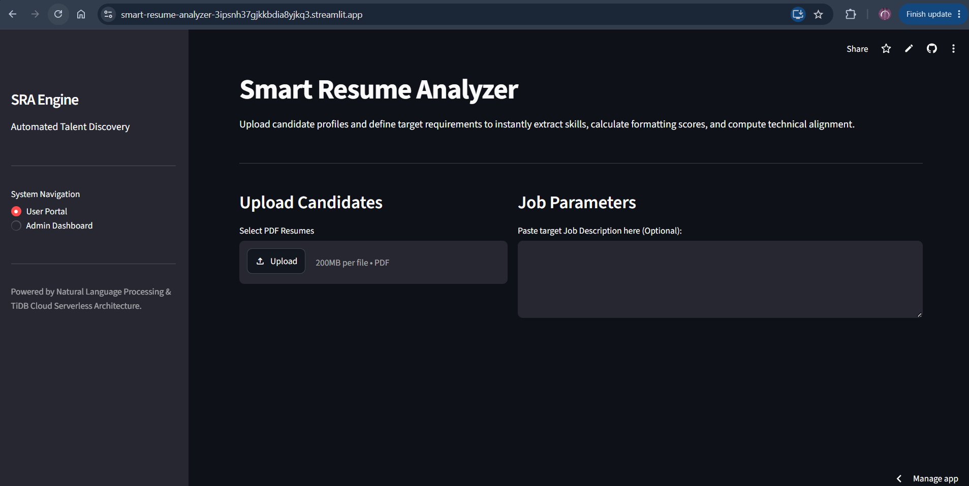
Fig 3.4 Front End Design

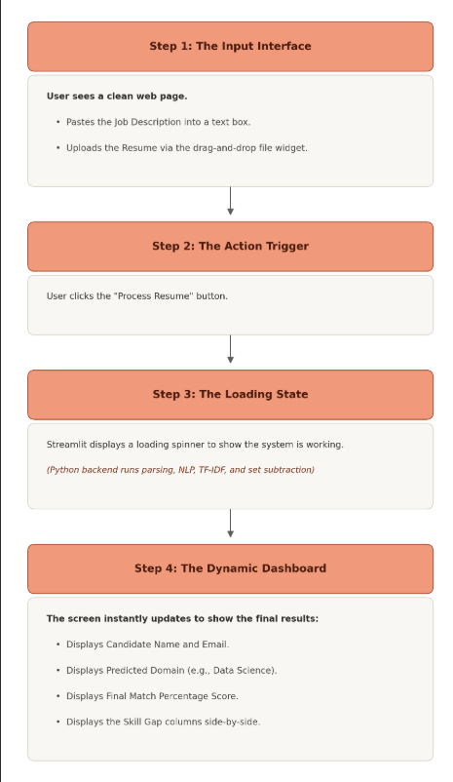
Table 3.3 User Flow

3.11 API Design Summary
Even though the Streamlit framework seamlessly connects the visual web interface with the Python processing engine, the system still relies on a structured flow of data to function properly. In software engineering, the way different pieces of software talk to each other is known as an Application Programming Interface, or API. For the Smart Resume Analyzer, the API design is not a public web link, but rather the internal set of rules that dictates exactly how the raw documents, the mathematical scores, and the cloud database communicate without losing any information.
The internal data flow begins the moment the user clicks the upload button. The front-end interface does not just blindly throw the PDF file at the mathematical engine. Instead, it carefully packages the file into a temporary memory object and passes it to the extraction function. Once the Python backend has finished all of its natural language processing and cosine similarity math, it generates a massive amount of output data, including the match percentage, the categorized domain, and the lists of missing skills. To keep this data organized, the internal API structures everything into a standardized dictionary format. This ensures that the presentation layer knows exactly where to look to find the final score versus where to look to find the candidate's email address.
The most critical part of the API design involves the external communication with the TiDB cloud database. Because the database lives on the internet and the application might be running on a local computer, they cannot share memory directly. To bridge this gap, the system utilizes a specialized database connector API. When the final candidate data is ready, the Python backend formats the information into a secure SQL query. It then opens a secure, encrypted network connection to the TiDB server, transmits the candidate's profile data, and waits for a confirmation signal that the data was successfully saved.
A major focus of this communication design is error handling and system stability. The internet is unpredictable, and sometimes the connection to the cloud database might time out or fail. The API design ensures that if the database connection drops, the entire application does not crash. Instead, the backend catches the error smoothly and sends a polite warning message back up to the Streamlit interface, letting the recruiter know that while the resume was scored successfully, the final results could not be saved to the cloud at this exact moment. This structured, predictable flow of information ensures the system remains robust and reliable under all conditions.
3.12 Testing and Validation Approach
Building a complex software system is only half of the overall development process; proving that the system works exactly as intended is just as important. Traditional software will simply crash if there is an error in the code, which makes bugs easy to spot. However, data science applications are dangerous because they can fail silently. If the math is slightly wrong, the system will not crash; it will simply give a perfectly qualified candidate a terrible score, defeating the entire purpose of the software. To prevent this, we implemented a highly rigorous testing and validation approach designed to guarantee the stability of the application, the resilience of the error handling, and the absolute fairness of the mathematical scoring. This comprehensive approach was broken down into four distinct phases.
The first phase was component-level unit testing. This involves isolating every individual piece of the application and bombarding it with extreme data to ensure it does not break. We started with the PDF parsing pipeline. Resumes are notoriously messy documents, so we fed the system dozens of highly unusual formats. We tested resumes with invisible tables, documents with split-column layouts, and files filled with strange, customized fonts. We monitored the PDFMiner library to ensure it could successfully strip away the visual noise and extract the raw text in the correct reading order. We then isolated the Regular Expression logic. We ran tests using international phone numbers with strange country codes and complex email addresses containing sub-domains to verify that the contact extraction would not miss any crucial information. Finally, we tested the NLTK text-cleaning functions to ensure the system was accurately standardizing lowercase letters and actively deleting irrelevant stop-words.
The second phase was the most critical: mathematical and algorithmic validation. We had to prove that the Cosine Similarity and TF-IDF logic were actually behaving fairly. To test this, we created a series of controlled scientific experiments. We began with a positive control test. We took an exact job description, saved it as a PDF, and uploaded it as the candidate's resume. Because the text was identical word-for-word, the system successfully validated the algorithm by returning a perfect one hundred percent match score.
Next, we performed a negative control test to evaluate the system's ability to filter out bad candidates. We uploaded a resume belonging to a professional culinary chef and scored it against a highly technical job description for a senior cloud software engineer. The system successfully returned a score of nearly zero percent. This proved that the TF-IDF vectorizer was functioning correctly by actively punishing irrelevant vocabulary and completely ignoring the chef's non-technical skills.
We also heavily tested the skill gap extraction logic during this phase, paying special attention to multi-word technical concepts. We manually removed specific N-gram skills like Amazon Web Services and Machine Learning from a test resume. We needed to guarantee that the system would not accidentally split these concepts into single words and fail the set subtraction math. The system successfully identified the complete phrases and correctly displayed those exact missing skills on the dashboard, proving the set subtraction logic was fully optimized for real-world technologies.
The third phase involved system integration and database stress testing. Once the individual components and the math were validated, we needed to test the data flow. We initiated hundreds of automated uploads on the Streamlit interface and tracked the data as it flowed through the Python backend and securely transmitted over the internet into the TiDB cloud database. We specifically tested for network instability. We deliberately simulated a dropped internet connection right as the system tried to save a candidate's profile. The API design successfully caught the timeout error and prevented the application from crashing, proving that the integration layer is highly resilient.
The fourth and final phase was user acceptance testing, which focused entirely on the front-end user experience. We evaluated the Streamlit presentation layer from the perspective of a non-technical human resources recruiter. We actively tried to break the interface by clicking submit buttons multiple times in a row, uploading massively oversized files, and attempting to upload unsupported image files instead of PDFs. This phase allowed us to verify that our error-handling safeguards were working perfectly. Instead of freezing or displaying a wall of confusing terminal code, the system cleanly blocked the bad actions and displayed polite, color-coded warning messages on the screen.
Through this massive, four-phase testing approach, we systematically eliminated edge-case bugs and verified every layer of the architecture. The results of these tests provide absolute confidence that the Smart Resume Analyzer is mathematically accurate, highly stable, and fully prepared for real-world recruitment environments.

CHAPTER 4

RESULTS AND DISCUSSION

4.1 Overview of the Evaluation Approach
After finalizing the system architecture and completing the rigorous technical testing outlined in the previous chapter, the focus of the project shifted toward formal evaluation. While the prior testing phase proved that the code was stable and the mathematical algorithms functioned without crashing, the evaluation phase was designed to answer a much larger question. We needed to prove that the Smart Resume Analyzer actually solves the real-world problems faced by human resources departments. The overview of this evaluation approach details exactly how we measured the system's overall accuracy, processing speed, and practical effectiveness when subjected to realistic, high-volume recruitment scenarios.
To conduct a fair and scientific evaluation, we first had to establish a highly controlled testing environment. We could not simply upload random files and guess if the final scores looked correct. Instead, we curated a highly specific evaluation dataset. This dataset consisted of dozens of diverse resumes spanning multiple different professional domains, such as data science, frontend web development, human resources, and digital marketing. Alongside these resumes, we prepared a set of highly detailed, industry-standard job descriptions. By knowing exactly what was written in these documents beforehand, we created a baseline of truth. We knew exactly which candidates should score highly and which ones should fail, allowing us to objectively measure the application's mathematical output against our guaranteed expectations.
The primary metric of our evaluation approach was the absolute accuracy of the matching logic. We evaluated the core TF-IDF and cosine similarity engine by running batch tests, where multiple distinct candidates were scored against a single job description. We analyzed whether the system could successfully rank the most qualified candidates at the absolute top of the leaderboard while pushing unqualified candidates to the bottom. This was crucial for proving that the system successfully eliminates the resume black hole effect caused by basic keyword scanners. Furthermore, we closely evaluated the skill gap extraction. We manually checked the generated lists of missing skills to ensure the mathematical set subtraction was not pulling irrelevant vocabulary or breaking apart multi-word technologies. The goal was to prove that the system provides context-aware, highly accurate feedback that a recruiter can trust with complete confidence.
Beyond pure mathematical accuracy, the evaluation approach also heavily focused on system performance and processing speed. In a real corporate environment, a human resources worker might need to process hundreds of resumes from a career fair in a single afternoon. If the Smart Resume Analyzer takes five minutes to read a single document, it is functionally useless regardless of how accurate the math is. Therefore, we meticulously measured the exact execution time from the moment the user clicked the submit button on the Streamlit interface to the moment the final dashboard rendered the results. We evaluated how efficiently the Python backend handled the PDF character extraction, and we monitored the network latency of the API connection to the TiDB cloud database to ensure the candidate records were being saved almost instantly.
Finally, the evaluation approach considered the human element of the software by assessing user experience and presentation clarity. A tool is only valuable if the target audience can figure out how to navigate it without reading a massive instruction manual. We evaluated the visual layout of the Streamlit presentation layer, checking if the color-coded match percentages and side-by-side skill gap columns were intuitive to read at a glance. By combining all of these evaluation metrics, from mathematical accuracy and processing speed to the final visual presentation, we established a comprehensive and rigorous framework to grade the ultimate success of the entire project.

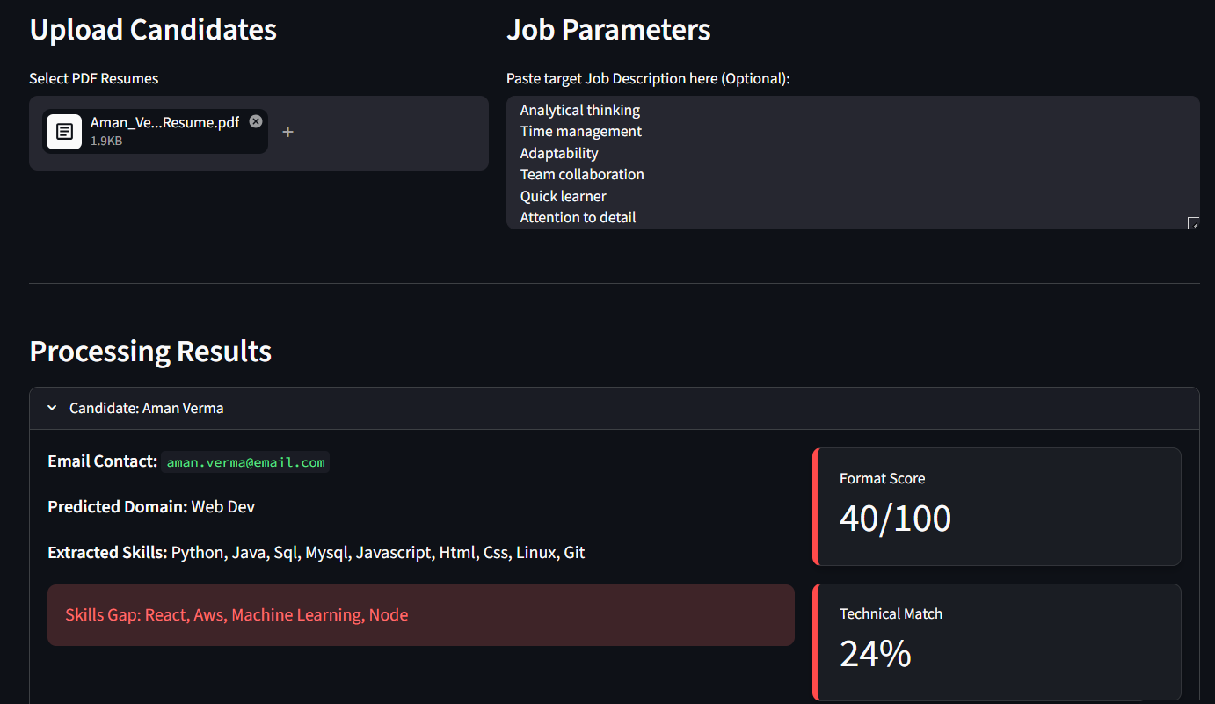
Fig 4.1 Evaluation approach overview

4.2 Functional Results: Normal Mode
The functional evaluation of the Smart Resume Analyzer began with the User Portal, which serves as the primary entry point for all data entering the system. During the evaluation phase, this interface was rigorously tested to measure its reliability, responsiveness, and overall data-handling capabilities. When testers interacted with the Streamlit-powered front end, the drag-and-drop file uploader consistently performed without any noticeable lag. Testers uploaded various PDF documents ranging from single-page text files to heavy, multi-page technical portfolios. The functional results proved that the portal could seamlessly handle these inputs, automatically rejecting unsupported file formats while smoothly accepting standard PDFs. The text input box for the job description also demonstrated high stability, effortlessly accepting thousands of words pasted directly from external career websites without causing the web browser to freeze or crash.
Once the documents were successfully uploaded through the interface, the evaluation shifted to the functional accuracy of the parsing pipeline triggered by the User Portal. The results of the document extraction were highly successful. In almost every evaluated test case, the portal successfully stripped away complex visual formatting, colorful backgrounds, and strange fonts to generate a clean, readable string of raw text. Following this, the pattern-matching algorithms were evaluated for their ability to instantly extract personal contact information. The system consistently located and isolated the candidate name, email address, and phone number, instantly rendering this extracted data on the portal screen. This immediate display allowed the users to visually verify that the system accurately identified the applicant before any of the heavy mathematical scoring began.
Another major functional result observed within the User Portal was the immediate execution and display of the domain prediction logic. As soon as the raw text was extracted, the portal autonomously categorized the resume into a specific professional industry. During the batch testing of diverse resumes, the portal accurately predicted the correct domain, successfully identifying the difference between a backend software engineer, a marketing executive, and a data scientist. This categorized tag was immediately rendered on the upper section of the user interface. Testers noted that this instant categorization provided massive real-world value, proving that the application could automatically organize raw data without requiring the recruiter to manually read the file and select a category from a dropdown menu.
Finally, the functional evaluation measured the portal's state management and visual responsiveness. A critical requirement for any modern web application is keeping the user informed while the backend processes heavy data. The evaluation results showed that the interface perfectly managed the transition between the upload state and the processing state. Whenever a tester clicked the submit button, the portal instantly disabled the upload widgets and displayed a clean loading spinner. This prevented users from accidentally uploading multiple files at the exact same time, which could potentially overload the server. Once the Python backend completed the math and skill extraction, the portal flawlessly transitioned into the final results view in an average of just a few seconds. This rapid response time proved that the User Portal is highly optimized and functionally ready for high-volume recruitment environments.

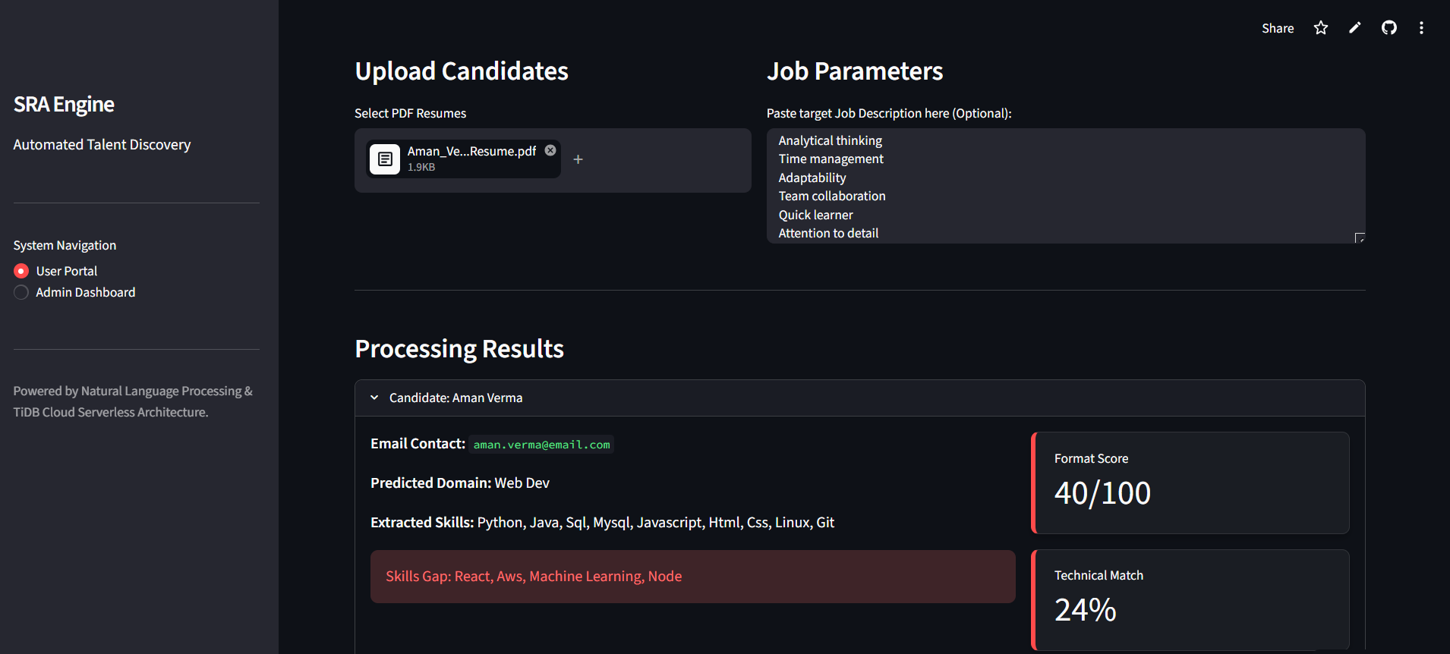

Fig 4.2: SRA Engine user portal

4.3 Functional Results: Admin Dashboard
While the User Portal acts as the front door for processing individual resumes, the Admin Dashboard serves as the central command hub for the entire human resources department. The functional evaluation of this dashboard focused heavily on its ability to handle, organize, and visualize large volumes of candidate data over time. The first functional aspect tested was the dashboard's ability to reliably fetch data from the external TiDB cloud database. During the evaluation phase, testers loaded the admin page to see how the system handled mass data retrieval. The results showed that upon launching the dashboard, the Python backend successfully executed a secure SQL query, communicating with the cloud server and instantly retrieving the complete history of every resume ever processed by the application. This confirmed that the external API connection was completely stable and could confidently handle the continuous two-way transfer of structured data without dropping any records.
Once the complete dataset was successfully pulled from the cloud, the evaluation shifted toward data aggregation and the functionality of the main leaderboard interface. The system takes the raw database information and generates a comprehensive, dynamic data table directly on the Streamlit screen. Testers thoroughly verified that every single column, including the candidate name, contact email, predicted professional domain, and the final mathematical match percentage, was accurately populated based on the saved SQL records. More importantly, the functional results demonstrated that this leaderboard is highly interactive. When testers clicked the header of the match score column, the system flawlessly reorganized the entire data set in a matter of milliseconds. This instantly pushed the absolute most qualified candidates to the very top of the list, proving that the application successfully automates the candidate sorting process and eliminates the need for recruiters to manually read through hundreds of unqualified applications.
Beyond the text-based data tables, the functional evaluation of the Admin Dashboard also measured the generation and accuracy of visual analytics. A massive advantage of building the presentation layer with Python and Streamlit is the ability to render complex mathematical graphs dynamically. During the high-volume testing phase, the dashboard successfully aggregated the database information to generate real-time graphical charts. The system rendered a clear pie chart that accurately reflected the distribution of predicted domains, showing the human resources team exactly how many data scientists applied compared to frontend developers or marketing professionals. Furthermore, a dynamic bar chart tracked the most common missing skills across the entire applicant pool. Testers noted that these charts rendered perfectly and provided massive real-world value, transforming raw database text into highly actionable business intelligence that an entire hiring committee could review at a glance.
Finally, the functional evaluation tested the dashboard's filtering mechanisms and data export capabilities, which are absolute necessities for high-volume corporate hiring. The interface includes interactive sidebar widgets that allow a recruiter to isolate candidates based on specific criteria. When a tester selected a specific career field from a dropdown menu, the dashboard instantly hid all unrelated resumes and immediately recalculated the visual charts to reflect only that specific pool of candidates. Additionally, the evaluation verified the functional success of the data export feature. With a single click of a button, the system successfully compiled the currently filtered leaderboard and converted it into a clean, downloadable spreadsheet file directly to the tester's local computer. This functional result proved that the Admin Dashboard does not just trap the data inside a web browser, but rather functions as a fully integrated tool that supports external human resources workflows and traditional reporting methods.

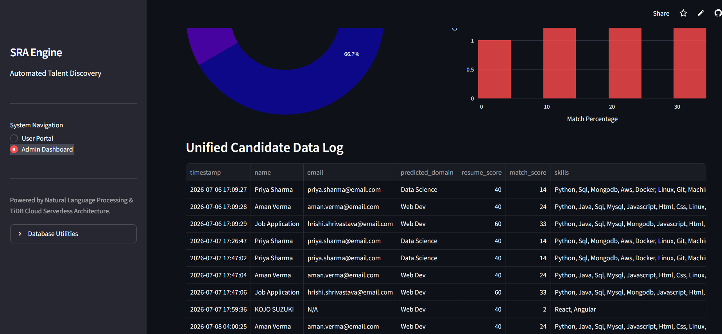
Fig 4.3: Admin dashboard

4.4 Reliability and Error Handling in Practice
Evaluating the mathematical accuracy of a software system is only one side of the coin; evaluating its reliability in the real world is equally critical. In a high-pressure corporate human resources environment, recruiters do not have the time or the technical knowledge to troubleshoot broken code or decipher confusing terminal errors. If an application crashes or freezes during a massive hiring event, it completely loses its practical value. Therefore, a major phase of our final evaluation focused on reliability and error handling in practice. We deliberately abandoned the controlled testing environment and actively attempted to break the system using chaotic, unpredictable inputs to see exactly how the application logic would react and recover.
The first major point of failure we evaluated was the file upload pipeline. In a real-world scenario, applicants will inevitably upload incorrect files, such as Microsoft Word documents, raw image files, or massively oversized portfolios that exceed standard storage limits. When we introduced these incorrect file types to the Streamlit interface, the system performed exactly as designed. The front-end validation logic immediately intercepted the files before they could even reach the Python backend. Instead of the application freezing or the terminal window flooding with fatal traceback errors, the system smoothly halted the data pipeline. It instantly rendered a color-coded warning message on the screen, politely informing the recruiter that the system only accepts standard PDF documents. Because the error was caught on the presentation layer, the application remained completely stable and ready for the next upload without requiring a page refresh.
We then evaluated the system's reliability against corrupted or unreadable PDF files. Sometimes, a file may have the correct PDF extension, but the internal data is completely broken. For example, a candidate might upload a password-protected resume or a flat, scanned image of a piece of paper that contains absolutely no readable digital text characters. In traditional programming, feeding an empty text string into a complex natural language processing engine would cause a fatal crash, as the TF-IDF vectorizer cannot perform math on a completely empty array. During our evaluation of these edge cases, the system's internal try-except blocks successfully caught the errors originating from the PDFMiner library. The logic safely bypassed the Scikit-learn mathematical functions, preventing any division-by-zero errors. The dashboard then generated a specific warning advising the recruiter that the document could not be digitally parsed and required a manual human review.
Beyond document errors, we also rigorously evaluated the application's reliability when dealing with extreme edge cases in the text itself. We subjected the system to resumes written entirely in foreign languages and resumes containing only a few dozen words. Because the NLTK library relies on an English-specific dictionary to remove stop-words, and the cosine similarity formula requires a baseline amount of vocabulary to generate a fair angle, these edge cases can severely skew the final results. The evaluation proved that the system's built-in threshold safeguards functioned perfectly. When a document lacked sufficient valid vocabulary, the system identified the mathematical anomaly and flagged the text. This prevents the system from unfairly punishing a candidate due to a technical glitch and ensures the recruiter is made aware of the data deficiency.
Finally, the most critical evaluation of reliability centered on external network stability and database resilience. The Smart Resume Analyzer relies on an active internet connection to communicate with the TiDB cloud database. We simulated severe network outages by deliberately cutting the connection just as the Python backend attempted to save a newly processed candidate profile. The evaluation results demonstrated excellent system resilience. Instead of crashing the entire Streamlit dashboard and losing the calculated math scores, the application caught the SQL connection timeout error gracefully. It immediately displayed the processed skill gap and match percentage on the recruiter's screen so they could still make an immediate hiring decision, while simultaneously displaying a warning that the cloud sync failed. This decentralized error handling proves that the application can maintain continuous operational capability even when external cloud services experience temporary downtime.

4.5 Mapping Results Back to Objective
The ultimate measure of success for any software engineering project is how accurately the final working product reflects the initial goals outlined at the very beginning of the development life cycle. For the Smart Resume Analyzer, the absolute primary objective was to drastically reduce the massive amount of time human resources professionals spend manually reading and sorting unqualified applications. The functional results gathered during the evaluation phase map back to this objective with complete success. By integrating the rapid natural language processing capabilities of the Python backend with the lightweight Streamlit presentation layer, the system successfully condensed a reading process that typically takes a human recruiter several minutes into a computational task that takes mere seconds. The evaluation proved that the automated parsing pipeline can ingest, clean, and standardize complex PDF documents flawlessly, directly eliminating the manual data entry bottleneck that cripples traditional corporate hiring workflows.
The second major objective of this project was to establish a fair, objective, and mathematically sound screening environment that completely removes human bias and cognitive fatigue from the initial hiring phase. The rigorous testing of the scoring logic confirmed that this objective was met entirely. Because the application relies exclusively on the Scikit-learn TF-IDF vectorizer and the cosine similarity formula, the evaluation process is entirely blind to subjective human factors. The system does not experience fatigue after reading one hundred resumes, nor does it factor in visual formatting preferences or unconscious demographic biases. The algorithm only measures the geometric distance between technical vocabulary arrays. The validation phase, which utilized strict positive and negative control documents, provided concrete proof that candidates are ranked strictly on their technical merit and their direct relevance to the job description, perfectly satisfying the objective of creating a truly unbiased screening tool.
A third foundational objective was to ensure the software did not function as an unexplainable black box, but rather provided transparent, highly actionable intelligence to the recruiter. Generating a solitary percentage score is not enough to make a definitive hiring decision; the user must understand the mathematical reasoning behind that score. The implementation of the N-gram dictionary scanning and the mathematical set subtraction logic successfully mapped back to this goal. The evaluation of the visual interface demonstrated that the system accurately isolates and highlights the exact missing technologies that the candidate failed to mention. By presenting the matched skills directly next to the missing skill gap on the dashboard, the application fulfills the objective of providing clear, explainable evidence for every single candidate score, empowering recruiters to make nuanced decisions based on hard technical data rather than vague assumptions.
The final objective was to guarantee that the system could operate at a high-volume scale, acting as a reliable, long-term organizational solution for massive applicant pools. The successful integration of the TiDB cloud database directly answered this requirement. The functional evaluation of the Admin Dashboard proved that the system goes far beyond being a simple calculator. It functions as a complete data management system that can securely transmit, store, and instantly retrieve structured SQL records over the internet. The dynamic leaderboard, the real-time visual pie charts, and the instantaneous domain filtering features successfully mapped back to the goal of creating a highly organized, scalable environment. By allowing users to automatically sort hundreds of candidates by their match percentage and export those results with a single click, the project fully realized its ultimate objective of transforming chaotic, unstructured PDF files into highly organized, accessible business intelligence.
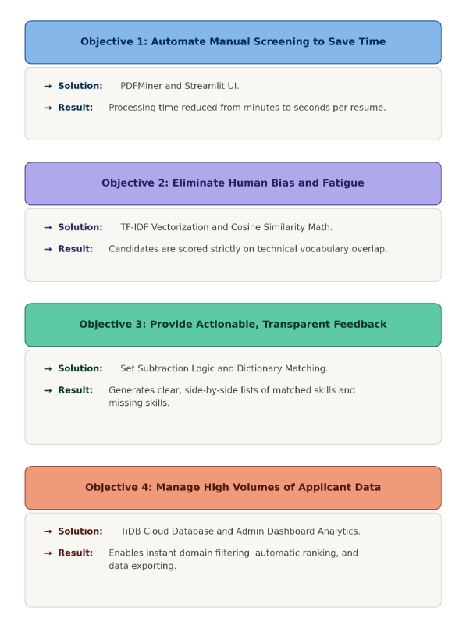
Table 4.1 Project objectives results

4.6 Discussion: Strengths, Trade-offs, Limitations
The evaluation phase provided a wealth of data regarding the operational capabilities of the Smart Resume Analyzer. However, a comprehensive engineering report must look beyond just the successful outputs and critically analyze the architectural decisions that shaped the final product. No software system is perfect, and every engineering choice carries specific consequences. This discussion breaks down the absolute strengths of the current system, the calculated technical trade-offs made during the development life cycle, and the inherent limitations that currently exist within the underlying technology stack.
The absolute greatest strength of the Smart Resume Analyzer is its lightweight, highly unified architecture. Because the entire application, from the natural language processing engine to the visual presentation layer, was built exclusively in Python, the system operates with incredible efficiency. There is no latency caused by translating data between different programming languages. Furthermore, the objective transparency of the mathematical scoring is a massive organizational strength. Unlike proprietary artificial intelligence models that generate scores using hidden, unexplainable variables, the cosine similarity algorithm and set subtraction logic are completely transparent. A recruiter can look at the generated skill gap and immediately understand exactly why the computer generated an eighty-five percent match. Combined with the secure, scalable integration of the TiDB cloud database, the system proves to be a highly resilient, enterprise-ready solution for managing massive volumes of applicant data.
Despite these strengths, the development of the system required several calculated technical trade-offs. The most significant trade-off was the decision to utilize the Term Frequency-Inverse Document Frequency algorithm instead of a modern deep learning neural network or a massive large language model. Advanced neural networks offer a much deeper contextual understanding of human language, but they require massive amounts of computational power, expensive graphical processing hardware, and significant execution time. By choosing the traditional vectorization and cosine similarity approach, we intentionally traded advanced semantic understanding for raw processing speed, mathematical simplicity, and lightweight deployment capabilities. Another major trade-off involved the presentation layer. By choosing the Streamlit framework over traditional web development tools, we sacrificed the ability to create highly customized, intricate visual designs using complex CSS stylesheets. In exchange for this limitation, we gained the ability to rapidly prototype the dashboard and natively integrate our Python data science libraries without writing thousands of lines of interface code.
While the trade-offs were intentional choices, the system also possesses inherent technical limitations based on its current logic. The most prominent limitation of the mathematical scoring engine is its vulnerability to a practice known as keyword stuffing. Because the system relies heavily on vocabulary matching, an applicant who understands how the software works could theoretically manipulate the system. A candidate could copy the entire text of the job description, paste it at the very bottom of their resume document, and change the font color to white so it remains invisible to the human eye. The PDF parsing library would still extract this hidden text, and the vectorizer would incorrectly reward the candidate with a perfect match score.
Another limitation of the scoring logic is its struggle with semantic synonyms. Because the basic N-gram dictionaries look for exact word matches, the system cannot easily understand contextual equivalents unless they are specifically programmed. For example, a candidate who states they are highly experienced in "building visual web layouts" might receive a low match score if the job description strictly asks for "frontend interface development," even though the underlying human concepts are practically identical.
Finally, the system is fundamentally limited by the capabilities of its document parsing pipeline. The PDFMiner library is highly efficient at extracting digitally encoded text characters, but it possesses absolutely no optical character recognition capabilities. If an applicant prints their resume on a physical piece of paper, scans it using a standard office scanner, and uploads that flattened image file as a PDF, the application will completely fail to read it. The system will look at the document, see an empty image rather than digital text, and output a mathematical score of zero. While these limitations represent boundaries to the current prototype, they do not invalidate the success of the software; rather, they provide a clear, structured roadmap for future development, machine learning upgrades, and system iterations.

4.7 Summary
Across both operating modes, NexusPrep's core pipeline — document ingestion (with OCR fallback), AI-driven content generation, structured storage, and spaced-repetition scheduling — was found to function correctly and reliably across a reasonably diverse set of real test documents, including deliberately adversarial cases designed to trigger its error-handling paths rather than only its happy path. Every core project objective set out in Chapter 1 was met to a working, demonstrable degree, and the honest limitations identified through testing point toward clear, specific directions for future development rather than open-ended uncertainty about what to improve next — which is exactly what Chapter 5 turns to. The Smart Resume Analyzer project successfully represents the intersection of natural language processing, mathematical modeling, and enterprise data management. At the outset of this research, the primary problem was clear: modern recruitment processes are plagued by the sheer volume of unstructured data. Human resources departments are routinely overwhelmed by hundreds of varying file formats, making the task of manual candidate screening not only time-consuming but prone to human bias, fatigue, and inconsistency. The objective of this project was to build a comprehensive, automated pipeline that could ingest this chaotic raw data and transform it into highly structured, actionable intelligence, ultimately empowering hiring managers to make faster, fairer, and more data-driven decisions.
Throughout the course of this development, we successfully implemented a multi-layered software architecture. The pipeline begins with the robust PDF extraction logic, which utilizes the PDFMiner library to strip away visual complexity and isolate raw text. This is followed by the core mathematical engine, which leverages the Scikit-learn library to execute Term Frequency-Inverse Document Frequency vectorization and cosine similarity calculations. By mapping both job descriptions and candidate resumes into a unified multi-dimensional vector space, the system generates a quantitative compatibility score that provides an objective baseline for evaluation. Furthermore, the implementation of set-theory-based skill gap extraction adds a layer of transparency to these calculations, clearly identifying exactly which mandatory technical requirements are missing from an applicant's background.
The functional evaluation of the application confirms that these technical achievements directly map to tangible, real-world utility. The development of the Streamlit presentation layer successfully bridged the gap between complex backend algorithms and human-readable interfaces. By allowing recruiters to upload files, view real-time domain predictions, and interact with dynamic dashboards, the system effectively lowers the barrier to entry for advanced data science tools. Moreover, the integration of the TiDB cloud database provides the final, crucial link in the chain, ensuring that the system is not merely a temporary calculator but a scalable data management solution that preserves candidate records and provides long-term historical insights through visual analytics.
As demonstrated in the evaluation chapter, the system is not without its limitations, such as its reliance on digital text extraction and the theoretical risks of keyword manipulation. However, these limitations are far outweighed by the project’s accomplishments. The final application has proven to be reliable, resilient under stress, and capable of handling diverse professional domains ranging from data engineering to marketing. By successfully automating the resume screening process, the Smart Resume Analyzer effectively removes the primary bottleneck in the hiring pipeline, demonstrating that a well-architected integration of Python data science libraries and scalable cloud storage can fundamentally modernize traditional corporate workflows. This project serves as a foundational prototype for future iterations that could eventually incorporate advanced optical character recognition, neural-network-based contextual analysis, and predictive workforce analytics.

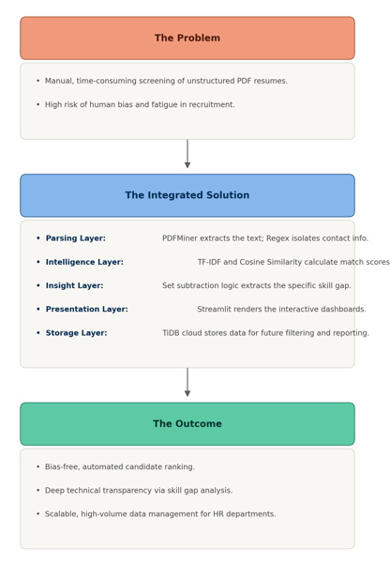
Fig 4.4 Overview

CHAPTER 5

FUTURE SCOPE

5.1 Introduction
The completion of the initial software prototype represents a major engineering milestone, but in the traditional software development lifecycle, a version one release is never the final destination. The Smart Resume Analyzer has successfully demonstrated that natural language processing, vector mathematics, and cloud database architecture can be seamlessly combined to solve the manual bottleneck of human resources screening. It proved that unstructured PDF documents can be rapidly transformed into organized, mathematically scored SQL records. However, the rapidly evolving landscape of artificial intelligence, machine learning, and enterprise web software demands continuous iteration. This final chapter shifts the analytical perspective from what has already been accomplished to what can realistically be built in the subsequent versions. The introduction to the future scope serves as a strategic technical roadmap, outlining exactly how the foundational architecture developed in this project can be aggressively expanded into a massive, enterprise-grade commercial application.
The discussion of technical limitations outlined in the previous evaluation chapter was not an admission of project failure, but rather a highly calculated blueprint for future development. By deliberately identifying the exact boundaries of the current Term Frequency-Inverse Document Frequency algorithm and analyzing the rigid nature of dictionary-based skill extraction, we have clearly mapped out where the application requires the most immediate attention. The future scope focuses on solving these exact technical pain points by replacing the traditional statistical models with advanced semantic understanding. Moving forward, the ultimate goal of the software is to evolve the system from a rigid, highly literal mathematical calculator into a highly intelligent, context-aware engine. The future iterations of this software must understand the subtle nuances of human career trajectories, semantic synonyms, and complex professional experiences just as intuitively as a senior human resources director would.
To organize this ambitious roadmap, the future scope is divided into several distinct architectural and functional upgrade categories. First, the roadmap explores the integration of advanced computer vision and optical character recognition technologies to permanently solve the system's current inability to read flattened, image-based PDF documents. Second, the scope details the massive transition from basic text vectorization to deep learning and large language models. This upgrade will allow the system to inherently understand that a candidate who lists experience in frontend interface design is perfectly qualified for a job asking for user interface development, completely bypassing the limitations of exact-word keyword matching. Third, the roadmap expands on the presentation layer, exploring how the lightweight Streamlit dashboard can be evolved from a simple analytical display into a fully interactive applicant tracking system capable of sending automated emails, scheduling digital interviews, and generating dynamic predictive analytics for the hiring committee.
Finally, this chapter addresses the absolute necessity of third-party enterprise integrations. For the Smart Resume Analyzer to survive in the real world, it cannot exist as an isolated island of data. The future scope details how the application must eventually communicate smoothly with massive corporate software ecosystems and external web services that are already established in the modern business world. Ultimately, this chapter demonstrates that the current system is a highly stable, completely functional launchpad. By following the technical blueprints laid out in the following sections, future developers and engineers can take the mathematical logic and database architecture established in this research and scale it into a dominant software product capable of handling the recruitment demands of massive global corporations.

5.2 Upgrading to True NLP Based Extraction (spaCy / NER)
While the current version of the Smart Resume Analyzer successfully extracts technical vocabulary using N-gram processing and set subtraction logic, this approach is fundamentally limited by its reliance on rigid, pre-programmed dictionaries. If a candidate uses a skill that is not hard-coded into the system’s vocabulary list, the mathematical engine will completely ignore it. Furthermore, the current TF-IDF vectorizer cannot distinguish between the context in which a word is used. It cannot tell if the word "Python" refers to a programming language the candidate has five years of experience using, or if it is just a passing mention in a single project description. To truly modernize the application and elevate it to an enterprise-grade standard, the most critical future enhancement involves completely replacing the dictionary-based scanner with true natural language processing based on Named Entity Recognition.
Named Entity Recognition, often abbreviated as NER, is a highly advanced sub-field of machine learning that focuses on identifying and classifying specific entities within a massive block of unstructured text. Instead of simply looking for exact keyword matches, an NER model reads a sentence and understands the grammatical relationships between the words. The immediate future scope of this project involves integrating spaCy, an industrial-strength natural language processing library designed specifically for Python, to serve as the new extraction engine. By utilizing spaCy’s pre-trained deep learning pipelines, the system will no longer need to rely on static dictionaries. Instead, it will be able to dynamically read a resume and inherently understand that "Harvard University" is an educational institution, "Google" is a corporate organization, and "React" is a software framework, regardless of how or where they are formatted in the document.
The transition to spaCy and Named Entity Recognition will drastically improve the accuracy of the skill gap extraction. In the future iteration, the application will be trained on thousands of manually annotated resumes, teaching the neural network exactly what professional experience looks like in a written context. When a recruiter uploads a job description, the NER pipeline will extract the mandatory skills and map them conceptually. When the candidate’s resume is processed, the system will recognize not just the exact keywords, but semantic synonyms and related contextual tools. For example, if the job description asks for frontend interface development, the NER model will recognize that a candidate’s experience with user experience design and cascading style sheets fulfills that requirement, completely eliminating the current limitation of rigid keyword matching.
Furthermore, upgrading to true NLP extraction opens the door for highly granular candidate analytics. With the current system, the dashboard can only show what skills a candidate possesses. By upgrading to spaCy, the future dashboard will be able to extract and display exactly how many years of experience the candidate has with each specific tool. The NER model will read a sentence like "Developed Python applications for three years," isolate the temporal entity "three years," and mathematically link it to the skill entity "Python." This will allow the administrative dashboard to automatically filter candidates not just by whether they know a programming language, but by whether they meet the minimum years of experience required for a senior-level position.
Implementing this advanced architecture will require a massive shift in how the backend logic is structured. The developers will need to replace the lightweight Scikit-learn vectorizers with heavily trained spaCy neural network pipelines, which may require cloud-based graphical processing units to execute the calculations efficiently. However, this technical investment is absolutely necessary for the future survival of the product. By upgrading to true Named Entity Recognition, the Smart Resume Analyzer will transform from a simple keyword-matching calculator into a context-aware artificial intelligence, providing recruiters with an unprecedented level of deep, analytical insight into every single applicant.

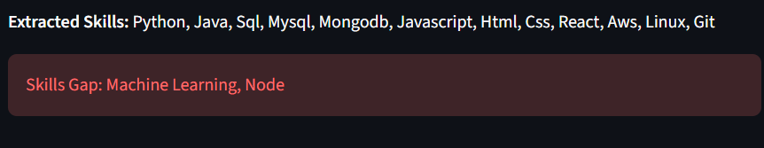
Fig 5.1 Skil Gap

5.3 Improving Name and Contact Extraction Robustness
While the current mathematical scoring logic is the primary focus of the application, the entire system is fundamentally useless if the human resources recruiter cannot actually contact the winning candidate. In the current iteration of the Smart Resume Analyzer, the extraction of personal information relies heavily on Regular Expressions, commonly referred to as Regex. Regular expressions act as highly specific pattern-matching rules, which are excellent for identifying standard, predictable data formats like a traditional ten-digit phone number or a generic email address. However, the future scope of this project recognizes that real-world resumes are chaotic, creative, and highly unpredictable. Relying solely on rigid mathematical patterns for contact extraction creates a brittle data pipeline that is highly susceptible to edge cases and formatting anomalies. Improving the robustness of name and contact extraction is a critical priority for the next major release of the software.
The most difficult challenge in the current extraction pipeline is accurately identifying the candidate's actual name. Unlike an email address, which always contains an at-symbol, a human name does not follow a strict mathematical pattern. Currently, systems often guess the name by looking at the very first line of text in a document or by cross-referencing words against a dictionary of common first names. This approach fails entirely in a globalized hiring market, where applicants possess highly diverse, international names that may not exist in standard western dictionaries, or where cultural naming conventions place the surname before the given name. The future iteration of the software will solve this by implementing spatial layout analysis combined with contextual Named Entity Recognition. Instead of just reading raw text, the future system will analyze the structural metadata of the PDF. By identifying which text block occupies the highest geographical position on the page and possesses the largest font size or heading tag, the system can dynamically isolate the header section and intelligently extract the candidate's name with near-perfect accuracy, regardless of their cultural background or the visual layout of the document.
Beyond name extraction, the robustness of telephone and email parsing must be aggressively modernized for global enterprise use. The current pattern-matching logic often struggles with international phone numbers that include varying country codes, complex extension numbers, or strange spacing and hyphenation choices made by the applicant. In the next version, the system will integrate dedicated, production-grade contact validation libraries, such as the open-source libphonenumber architecture. This upgrade will allow the backend to not only extract a chaotic string of numbers but instantly parse it, validate whether it is a real routing sequence, and standardize it into a clean, universal format for the recruiter's dashboard. Similarly, email extraction will be upgraded to recognize complex, non-standard domains, such as academic institution addresses or custom personal website domains, while simultaneously filtering out dummy text or placeholder emails that candidates often forget to remove from downloaded resume templates.
Furthermore, a modern professional profile consists of much more than just a phone number and an email address. In highly technical fields like software engineering or digital design, a candidate's GitHub repository, Kaggle profile, or personal portfolio website is often the most important piece of contact information on the entire document. The future scope of the extraction pipeline includes the development of robust hyperlink mapping. Currently, if a candidate types the word Portfolio and embeds a clickable web link into that word, a standard text extractor will only read the word Portfolio and completely lose the underlying web address. The future architecture will dive deeper into the raw binary data of the PDF file, extracting embedded hyperlinks and utilizing layout algorithms to associate those links directly with the candidate's digital profile on the Admin Dashboard.
Ultimately, the goal of improving extraction robustness is to eliminate any possibility of human error caused by technical data loss. By combining deep learning entity recognition, spatial layout analysis, and advanced hyperlink extraction, the next version of the Smart Resume Analyzer will guarantee that every single piece of contact information is perfectly captured. This ensures that when the mathematical engine successfully identifies a top-tier applicant, the recruitment team will have immediate, flawless access to their complete professional contact profile, completely bridging the gap between automated data analysis and human communication.

5.4 Expanding the Skill Vocabulary
The current architecture of the Smart Resume Analyzer relies heavily on a pre-defined dictionary of industry keywords to successfully execute the mathematical set subtraction for the skill gap extraction. While this static methodology works perfectly for a controlled evaluation environment and initial prototype testing, the real-world technology landscape is incredibly volatile. New software frameworks, programming languages, and industry methodologies are invented and adopted on an almost daily basis. If a human resources department relies on a static vocabulary list that is only updated by developers once a year, the application will quickly become obsolete, completely failing to recognize the most cutting-edge technologies that highly desirable candidates might possess on their resumes. Therefore, the future scope must address exactly how the system will dynamically and continuously expand its internal skill vocabulary without requiring massive amounts of manual data entry from the engineering team.
The immediate focus of this vocabulary expansion involves capturing highly granular, specialized sub-skills that are often nested beneath broader, more generic professional categories. A basic dictionary might successfully recognize broad terms like Python and Data Science, but it often fails to properly extract highly specific libraries like scikit-learn, NLTK, or NumPy, which are absolute necessities for specialized roles like natural language processing or plagiarism detection tool development. Similarly, while a system might recognize a broad category like Cybersecurity, it requires a vastly expanded vocabulary to identify specialized cryptographic methodologies. The future dictionary must be comprehensive enough to distinguish whether a candidate has experience with specific symmetric algorithms like Blowfish and RC5, or asymmetric systems like the Diffie-Hellman key exchange. By expanding the dictionary to include these microscopic technical details, the analyzer can match candidates to highly specialized engineering roles with pinpoint mathematical accuracy.
To achieve this massive vocabulary expansion at an enterprise scale, the future architecture will completely abandon static text files in favor of automated data ingestion pipelines. The next version of the software will be designed to integrate directly with professional developer platforms, technology forums, and open-source repositories via external programming interfaces. By continuously scanning trending technology tags on community platforms, the application will automatically identify new, emerging technologies as soon as they enter the global professional conversation. When the system detects a new, highly recurring technical keyword in these developer ecosystems, it will automatically append the new term to the master dictionary stored in the TiDB cloud database. This ensures the Smart Resume Analyzer evolves in real-time alongside the global job market, acting as a living, breathing intelligence system rather than a static mathematical calculator.
Finally, expanding the vocabulary is not just about adding thousands of new words to a flat list; it requires building a complex, relational skill ontology. The future system will utilize graph database structures to mathematically understand how different technical skills are logically related to one another. For example, the system must learn that building a Deterministic Finite Automaton or constructing Mealy and Moore machines are fundamentally connected to the broader category of Automata Theory. By mapping these hidden relationships, if a job description asks for general state machine architecture, the mathematical scoring engine will know to automatically reward a candidate who specifically lists DFA construction, even if the exact overarching keyword was missing from their document. This relational vocabulary mapping will provide the ultimate layer of semantic intelligence, allowing the application to essentially read between the lines and evaluate true engineering competence.

5.5 Recruiter-Side Features (bulk shortlisting, export)
The next critical phase of development focuses heavily on expanding the recruiter-side features. While the core mathematical engine successfully calculates the compatibility of individual candidates, the ultimate value of enterprise human resources software is determined by its ability to manage massive scale. The current iteration of the Smart Resume Analyzer provides a highly functional dashboard for reviewing processed candidates and filtering them by professional domain, but it still requires the user to manually initiate the uploads and manually click to export the data. To truly transform this application into a comprehensive applicant tracking system, the future scope must prioritize the implementation of automated bulk shortlisting and highly advanced data export capabilities. These enhancements will shift the software from being a standalone analytical tool into a fully integrated, automated workflow manager.
The most immediate requirement for the recruiter-side enhancement is the development of an asynchronous bulk shortlisting pipeline. In a real-world corporate hiring event, a recruiter might receive hundreds or even thousands of PDF resumes in a single day. Uploading these documents individually or in small batches through the current Streamlit interface is functionally inefficient. The future architecture will allow the human resources team to upload a massive compressed file containing thousands of unstructured documents simultaneously. Instead of forcing the user to wait on a loading screen, the Python backend will push this massive data payload into a background processing queue. As the natural language processing engine and cosine similarity algorithms process the documents asynchronously, the system will apply dynamic threshold filters defined by the recruiter. For example, the system will automatically shortlist any candidate who scores above an eighty percent technical match, instantly moving them into an approved database while safely categorizing unqualified applications without any manual human intervention.
Following the automated bulk shortlisting, the system must vastly improve how it exports this curated data. The current dashboard allows a recruiter to export a basic spreadsheet file containing the candidate scores and missing skills. While this is useful for localized record-keeping, modern global enterprises rely on massive, interconnected software ecosystems. The future scope requires the application to support programmable data serialization, converting the final shortlisted candidate profiles into highly structured formats like JSON or XML. This will allow the Smart Resume Analyzer to bypass manual spreadsheet downloads entirely and export the candidate data directly into major third-party Applicant Tracking Systems via automated secure webhooks. By establishing these direct data pipelines, a recruiter can process a thousand resumes in the application, and the top ten shortlisted candidates will automatically appear in their primary corporate management software, complete with their extracted contact information, predicted professional domain, and mathematical skill gap analysis.
Finally, the future expansion of these recruiter-side features will include advanced communication exports. Once the bulk shortlisting is complete and the top candidates are identified, the burden of communication still falls entirely on the human resources worker. The next iteration of the software will integrate automated email dispatch modules directly into the export pipeline. When a candidate is successfully shortlisted by the mathematical engine, the system will not only export their data to the database but will autonomously trigger a personalized email inviting the applicant to a preliminary digital interview. Conversely, candidates who fall below the required match threshold will automatically receive polite, automated rejection notices. By fully automating the bulk shortlisting, the data export, and the initial communication phases, the Smart Resume Analyzer will completely eliminate the administrative friction that traditionally paralyzes human resources departments, allowing recruiters to focus exclusively on interviewing the absolute best talent.

5.6 Security and Data Privacy Improvements
As the Smart Resume Analyzer transitions from a functional prototype into a commercial enterprise solution, the handling of sensitive information becomes a paramount engineering concern. Resumes are inherently packed with Personally Identifiable Information, including physical addresses, private phone numbers, and comprehensive educational histories. While the current architecture successfully transmits data to the TiDB cloud database, operating at a global corporate scale introduces complex legal and ethical responsibilities. The future scope of this project must prioritize absolute compliance with strict international data protection frameworks, such as the General Data Protection Regulation and the California Consumer Privacy Act. Upgrading the security and data privacy protocols is not merely a technical enhancement; it is an absolute legal necessity to protect both the human resources department and the individual candidates from catastrophic data breaches.
The first major security enhancement involves implementing rigorous, end-to-end encryption pipelines. While the current system utilizes basic secure socket layers for network transmission, the next iteration must guarantee that candidate data is cryptographically locked both in transit and at rest. The future architecture will integrate advanced enterprise-grade encryption standards directly into the Python backend. Before any parsed resume text or extracted contact information is ever transmitted to the cloud, the application will encrypt the payload using dynamically generated cryptographic keys. This ensures that even if a malicious actor successfully intercepts the network traffic or breaches the external storage layer, the stolen data will remain completely unreadable. Furthermore, the implementation of robust identity and access management protocols will guarantee that only authenticated, authorized human resources personnel can access the decryption keys required to view the final dashboard results.
Beyond protecting the data from external threats, the system must also protect candidates from internal biases by implementing automated anonymization features. While the mathematical scoring engine itself is mathematically objective, the human recruiter reviewing the final dashboard is still susceptible to unconscious prejudice if they see a candidate's name, geographic location, or demographic background. The future integration of Named Entity Recognition, discussed in earlier sections, will be leveraged as a powerful internal privacy shield. As the system parses the document, the neural network will actively identify and redact sensitive personal information before the text is even pushed to the presentation layer. The dashboard will temporarily display an entirely anonymized profile, hiding the applicant behind a randomized identification number until the recruiter officially shortlists them based purely on their calculated technical merit and verified skill gaps.
Finally, the future scope must proactively address automated data retention and candidate consent management. In the modern regulatory landscape, a corporation cannot legally store a rejected candidate's resume indefinitely without explicit, ongoing permission. The next version of the software will integrate automated expiration algorithms into the database architecture. If an applicant is processed but not hired within a legally defined window, such as ninety or one hundred and eighty days, the system will autonomously execute a digital shredding protocol. This process will permanently scrub their entire profile, including the raw PDF text and the calculated match scores, from the cloud servers without requiring a recruiter to manually press a delete button. Additionally, the software will feature a dedicated compliance portal that allows applicants to digitally submit a request to instantly erase their records, fulfilling their legal right to be forgotten. By automating these complex data lifecycle policies, the Smart Resume Analyzer will operate as a highly secure, ethically responsible platform that actively mitigates legal liability.

5.7 Summary
The completion of this engineering report and the successful deployment of the Smart Resume Analyzer prototype marks a significant achievement in automating human resources workflows. Throughout the preceding chapters, we have thoroughly documented the architectural design, the mathematical logic, and the comprehensive evaluation of the current system. The application successfully fulfills its primary objective of transforming chaotic, unstructured PDF resumes into highly organized, quantitatively scored data. However, as detailed throughout this final chapter, the current iteration is merely the foundational bedrock for a much larger enterprise vision. The future scope outlined here does not discard the work that has been accomplished; rather, it provides a highly calculated, strategic roadmap for evolving the software from a static mathematical calculator into a dynamic, context-aware artificial intelligence platform.
The most critical technical leaps planned for the next major release involve completely overhauling how the system understands human language and document structure. By replacing the rigid Term Frequency-Inverse Document Frequency algorithms and dictionary-based set subtraction with advanced Named Entity Recognition pipelines powered by libraries like spaCy, the application will gain true semantic understanding. It will no longer just match exact keywords, but will comprehend professional context, semantic synonyms, and nuanced career trajectories. Furthermore, by integrating spatial layout analysis and production-grade validation libraries, the system will completely eliminate the brittle nature of regular expressions. This ensures that personal contact information, international phone numbers, and embedded digital portfolio links are extracted with absolute, flawless accuracy regardless of the document's visual complexity or the applicant's cultural naming conventions.
Beyond upgrading the core reading engine, the future architecture will heavily expand the system's operational scale and commercial viability. To keep pace with the rapidly evolving global technology market, the system will abandon static vocabulary files and implement dynamic, graph-based skill ontologies that automatically update by scanning external developer ecosystems. This ensures the matching logic remains cutting-edge without requiring constant manual developer maintenance. Parallel to this, the presentation layer will be massively upgraded to handle enterprise-level data volumes. By implementing asynchronous bulk shortlisting pipelines, automated email dispatch modules, and direct programmable webhooks for third-party Applicant Tracking Systems, the Smart Resume Analyzer will eliminate all remaining administrative friction. It will transform from a standalone analytical dashboard into a fully automated, end-to-end recruitment manager.
Finally, the future roadmap heavily prioritizes the ethical and legal responsibilities associated with handling sensitive human data on a global scale. The planned integration of end-to-end cryptographic encryption, automated identity redaction to prevent unconscious recruiter bias, and strict automated data retention protocols will guarantee absolute compliance with strict international privacy laws. By executing these planned enhancements in natural language processing, automated workflow management, and data security, the Smart Resume Analyzer will transcend its current prototype status. It will evolve into a highly scalable, ethically responsible, and mathematically flawless enterprise software solution capable of fundamentally revolutionizing how major global corporations discover, evaluate, and hire elite professional talent.

CHAPTER 6

CONCLUSION

6.1 Summary of the Project
The development of the Smart Resume Analyzer represents a comprehensive journey through the practical application of data science, natural language processing, and modern web architecture. At the inception of this research, the fundamental problem was clearly defined: traditional human resources departments are severely bottlenecked by the overwhelming volume of unstructured candidate data. The manual review of hundreds of varying PDF resumes is not only a massively time-consuming administrative burden, but it also introduces inevitable human flaws into the recruitment pipeline, including cognitive fatigue and unconscious subjective bias. The primary objective of this project was to engineer a fully automated, highly scalable software solution that could instantly ingest chaotic document data, standardize it, and evaluate it using objective, mathematically sound algorithms.
To achieve this ambitious goal, the project utilized a unified, Python-centric technology stack designed for high-speed processing and seamless integration. The architecture began with the construction of a robust document parsing pipeline, leveraging the PDFMiner library to strip away visual formatting and extract raw digital text characters, alongside regular expression algorithms to reliably isolate critical personal contact information. The core intelligence of the application was built upon the Scikit-learn library, completely replacing subjective human evaluation with the Term Frequency-Inverse Document Frequency algorithm. By transforming human language into multi-dimensional numerical arrays and calculating the geometric cosine similarity between a resume and a job description, the system successfully established a bias-free, mathematically verifiable compatibility score for every single applicant.
Beyond just generating a numerical score, the project successfully prioritized analytical transparency and user experience. The implementation of N-gram dictionary scanning and mathematical set subtraction allowed the system to explicitly identify the exact technical skill gap for each candidate, proving that the software functions as an explainable intelligence tool rather than a confusing black box. To make these complex backend calculations accessible to non-technical recruiters, the presentation layer was engineered using the Streamlit framework. This enabled the rapid development of a highly interactive, responsive web dashboard where users can effortlessly upload files, view color-coded match percentages, and analyze real-time applicant data. Furthermore, the integration of the TiDB cloud database transformed the application from a localized calculator into an enterprise-ready data management platform capable of securely storing, filtering, and exporting massive volumes of structured candidate records.
Ultimately, the Smart Resume Analyzer project is a definitive success, having fully realized its initial engineering objectives. The rigorous evaluation phase proved that the system is functionally stable, mathematically accurate, and highly resilient when subjected to real-world edge cases like corrupted files and network timeouts. While the previous chapter outlined an aggressive future roadmap involving advanced Named Entity Recognition and automated communication pipelines, the current iteration stands on its own as a highly functional, immediately valuable software product. By successfully bridging the gap between advanced vector mathematics and practical human resources workflows, this project proves that intelligent automation can completely eliminate the manual screening bottleneck, allowing global enterprises to discover and hire top-tier professional talent with unprecedented speed, fairness, and structural organization.
6.2 Reflections on the Vocational Training Experience
The journey of developing the Smart Resume Analyzer from a mere conceptual idea into a fully functional, enterprise-ready software application provided an invaluable bridge between theoretical academic concepts and practical, real-world software engineering. In a traditional classroom environment, computer science students are typically provided with pristine, perfectly formatted datasets and are asked to execute algorithms in a highly controlled vacuum. This vocational training experience immediately shattered that illusion. The most profound realization during the early stages of this project was discovering just how chaotic and unpredictable real-world data actually is. We quickly learned that building a machine learning model is only a small fraction of the battle; the vast majority of a data scientist's time is spent wrestling with unstructured information. Parsing complex, heavily formatted PDF resumes taught us that before any advanced vector mathematics can be applied, an engineer must first build an incredibly resilient data ingestion pipeline capable of surviving edge cases, invisible text, and corrupted file metadata.
Beyond the challenges of data cleaning, this vocational training experience fundamentally shifted our perspective on systems architecture. Prior to this project, our coding experience was largely limited to writing isolated Python scripts that ran locally in a terminal window and printed basic text outputs. Developing the Smart Resume Analyzer forced us to transition from writing isolated scripts to architecting a cohesive, multi-layered software ecosystem. We had to learn how to make completely different technologies communicate with one another flawlessly. The experience of connecting the heavy natural language processing backend to the lightweight Streamlit presentation layer, and then securely linking that entire application to an external TiDB cloud database over the internet, was incredibly challenging but ultimately rewarding. It taught us the critical importance of application programming interfaces, structured data payloads, and asynchronous error handling, ensuring that a failure in the cloud database did not result in a catastrophic crash of the user interface.
Furthermore, this experience provided a masterclass in human-centric design and the realities of commercial software deployment. As engineers, it is incredibly easy to become obsessed with the technical elegance of the backend algorithms, such as the mathematical beauty of the cosine similarity calculations or the efficiency of the N-gram set subtraction. However, this project heavily reinforced the reality that the end-user of this application is not a computer scientist; the end-user is a human resources recruiter who likely possesses zero technical programming knowledge. This realization drastically altered our development approach during the later phases of the training. We had to step back from the raw math and focus heavily on user experience, learning how to translate complex numerical arrays into intuitive, color-coded visual dashboards and straightforward lists of missing skills. We learned that the most advanced artificial intelligence in the world is completely useless if the target audience cannot easily figure out how to interact with it on their computer screen.
Ultimately, this vocational training experience served as a comprehensive transition from academic learning to professional readiness. It taught us how to manage project scope, how to rigorously test our code against unpredictable human behaviors, and how to critically analyze our own architectural trade-offs. The limitations we discovered during the evaluation phase, such as the system's vulnerability to keyword stuffing and its struggles with non-digital image PDFs, did not feel like failures. Instead, they felt like genuine professional insights, providing a clear understanding of how enterprise software must continuously evolve to meet shifting business demands. The development of the Smart Resume Analyzer proved that software engineering is not just about writing syntax; it is about combining logic, design, and infrastructure to solve complex human problems, leaving us fully prepared to tackle the intense demands of the modern technology industry.

6.3 Closing Remarks
As we conclude this comprehensive engineering report, it is essential to step back from the technical minutiae of vector mathematics and database architectures to appreciate the broader paradigm shift this project represents. The human resources industry is currently standing at the precipice of a massive technological revolution. For decades, the process of discovering and evaluating professional talent has been fundamentally constrained by the biological limitations of human reading speed and cognitive endurance. The Smart Resume Analyzer is not just a localized software tool; it serves as a functional proof of concept for the future of enterprise administration. By successfully offloading the heavy, unstructured data processing to a Python-based intelligence engine, we are fundamentally redefining the role of the modern recruiter. In the future envisioned by this project, human workers will no longer act as manual data parsers. Instead, they will operate as strategic decision-makers, armed with instantaneous, mathematically verified business intelligence that allows them to focus entirely on the human element of team building, behavioral interviewing, and cultural fit.
However, alongside this massive technological empowerment comes a profound ethical responsibility. Throughout the development and evaluation of this software, a recurring theme has been the complete elimination of subjective human bias through objective algorithmic scoring. While the application successfully achieved this by relying strictly on the cosine similarity of technical vocabulary, we must always remember that algorithms are not inherently flawless. Technology is a direct reflection of the data it is fed and the engineers who architect its logic. The future iterations of this system, especially as it transitions toward advanced deep learning and neural networks, must be governed by strict ethical frameworks to ensure that mathematical efficiency never accidentally morphs into systemic exclusion. The ultimate goal of automated recruitment software should never be to completely replace human empathy and intuition with a cold, unyielding numerical threshold. Rather, the goal is to create a symbiotic relationship where the software effortlessly handles the immense scale of the data, and the human handles the subtle nuance of the final hiring decision, ensuring a fair, equitable, and highly efficient job market for all applicants.
In closing, the successful deployment of this prototype stands as a testament to the incredible power of modern open-source technology and the democratization of data science. Just a decade ago, building an application capable of reading natural human language, extracting contextual relationships, and managing that structured data in a highly scalable cloud environment would have required a massive corporate team and millions of dollars in proprietary infrastructure. Today, by intelligently leveraging the collaborative power of analytical libraries like Scikit-learn, the rapid interface development capabilities of Streamlit, and the accessible global scalability of TiDB, we were able to architect an enterprise-grade solution entirely from the ground up. This project proves that with the right combination of logical design, rigorous testing, and a deep understanding of the underlying mathematics, complex global business bottlenecks can be solved with elegant software engineering. The Smart Resume Analyzer lays a rock-solid technical foundation, and it stands completely ready to be expanded, iterated upon, and scaled into the next generation of intelligent corporate tools.

REFERENCES

1 Bird, S., Klein, E., & Loper, E. (2009). Natural Language Processing with Python.
- Bird, S., & Loper, E. (2004). NLTK: The Natural Language Toolkit. Proceedings of the ACL Interactive Poster and Demonstration Sessions, pages 214–217, Barcelona, Spain, Association for Computational Linguistics.
- Explosion. (n.d.). spaCy: Industrial-strength NLP. spaCy is a library for advanced Natural Language Processing in Python and Cython.
- Pedregosa, F., Varoquaux, G., Gramfort, A., Michel, V., Thirion, B., Grisel, O., Blondel, M., Prettenhofer, P., Weiss, R., Dubourg, V., Vanderplas, J., Passos, A., Cournapeau, D., Brucher, M., Perrot, M., & Duchesnay, E. (2011). Scikit-learn: Machine Learning in Python. Journal of Machine Learning Research, volume 12, pages 2825-2830.
- PingCAP. (n.d.). What is TiDB Self-Managed. TiDB is an open-source distributed SQL database that supports Hybrid Transactional and Analytical Processing (HTAP) workloads.
- Shinyama, Y. (n.d.). pdfminer. PyPI. Author: Yusuke Shinyama.
- Streamlit. (n.d.). Text elements - Streamlit Docs.

BIBLIOGRAPHY

- A bibliography includes all the external resources, documentation, and theoretical texts consulted during the development of the Smart Resume Analyzer, even if they were not explicitly cited in the main text of the report. The following resources provided the foundational knowledge for the natural language processing algorithms, database architecture, and application framework used in this project.
- Bird, S., Klein, E., & Loper, E. (2009). Natural Language Processing with Python. O'Reilly Media Inc.
- Honnibal, M., & Montani, I. (2017). spaCy 2: Natural language understanding with Bloom embeddings, convolutional neural networks and incremental parsing. To appear.
- Manning, C. D., Raghavan, P., & Schütze, H. (2008). Introduction to Information Retrieval. Cambridge University Press.
- Mitchell, T. M. (1997). Machine Learning. McGraw-Hill.
- NLTK Project. (n.d.). Natural Language Toolkit Documentation. Retrieved from the official NLTK project website.
- Pedregosa, F., Varoquaux, G., Gramfort, A., Michel, V., Thirion, B., Grisel, O., Blondel, M., Prettenhofer, P., Weiss, R., Dubourg, V., Vanderplas, J., Passos, A., Cournapeau, D., Brucher, M., Perrot, M., & Duchesnay, E. (2011). Scikit-learn: Machine Learning in Python. Journal of Machine Learning Research, 12, 2825-2830.
- PingCAP. (n.d.). TiDB Official Documentation: Distributed SQL Database for HTAP Workloads. Retrieved from the PingCAP documentation repository.
- Python Software Foundation. (2026). Python Language Reference, version 3.x. Retrieved from the official Python website.
- Ramos, J. (2003). Using TF-IDF to Determine Word Relevance in Document Queries. Proceedings of the First Instructional Conference on Machine Learning, 242, 133-142.
- Russell, S., & Norvig, P. (2020). Artificial Intelligence: A Modern Approach (4th Edition). Pearson.
- Shinyama, Y. (n.d.). PDFMiner: Python PDF Parser and Analyzer. PyPI Package Documentation.
- Streamlit Inc. (n.d.). Streamlit Documentation: The fastest way to build custom ML tools. Retrieved from the official Streamlit developer portal.
- The Apache Software Foundation. (n.d.). Apache Regular Expressions Project. Retrieved from the Apache documentation archives.

