BYTE ME CTF • OFFICIAL SOLUTION WRITEUP
SoulVault (Mobile / Rev, Expert)
Property | Details
Author | Pratik Jadhav
Category | Mobile / Android Reverse Engineering
Difficulty | Expert

Challenge Description
CHALLENGE BRIEFING & LORE
Analyze the Android client and native proof-of-work flow to unlock the Soul Vault. The Android application protects its transmission protocol across Java reflection, obfuscated native JNI libraries, and a cryptographic proof-of-work challenge before the backend reveals what is sealed inside.

Given: Android APK artifact (SoulVault.apk) interacting with the SoulVault backend.
Target API: https://byteme-soulvault-api.onrender.com/ (or local http://127.0.0.1:8080/)
Flag Format: OWASP{...}
Summary
SoulVault is an expert-level Android reverse engineering and protocol reconstruction challenge. The APK contains no hardcoded flag; instead, it coordinates with an external Flask API to verify the authenticity of the client device. Static analysis in JADX and Ghidra reveals that the client constructs a device fingerprint from hardware properties, invokes a native JNI method (SoulBridge.p) to XOR-decrypt an obfuscated endpoint route (/v1/soul/echo/fragment) and compute a custom 32-bit hash client identifier (g3-XXXXXXXX), fetches an ephemeral single-use challenge ticket, and computes a multi-round SHA-256 proof-of-work (SoulBridge.q). By fully extracting and reimplementing the native JNI algorithms in a standalone Python script, we solve the challenge and retrieve the competition flag directly from the server.
Flag
FLAG RECOVERED
OWASP{soul_vault_fragment_recovered}

――――――――――――――――――――――――――――――――――――――――――――――――――
Step 1 — APK Decompilation & Manifest Analysis
We begin by inspecting SoulVault.apk using JADX-GUI and apktool:
jadx-gui SoulVault.apk

Inspecting AndroidManifest.xml:
<manifest xmlns:android="http://schemas.android.com/apk/res/android"
package="com.soulvault">
<uses-permission android:name="android.permission.INTERNET" />
<application
android:label="SoulVault"
android:usesCleartextTraffic="true"
android:theme="@style/Theme.SoulVault">
<activity
android:name=".MainActivity"
android:exported="true">
<intent-filter>
<action android:name="android.intent.action.MAIN" />
<category android:name="android.intent.category.LAUNCHER" />
</intent-filter>
</activity>
</application>
</manifest>

The app requests INTERNET access and defines a single activity: com.soulvault.MainActivity.
Step 2 — Reversing Java Control Flow (`MainActivity.java`)
In JADX, decompiling com.soulvault.MainActivity exposes the button click listener triggering vault awakening:
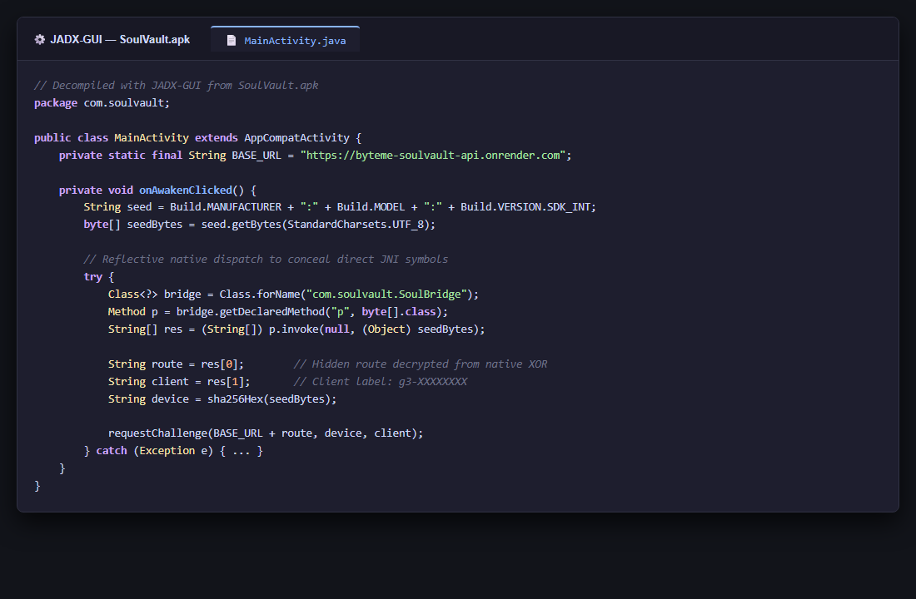
Figure 1: JADX Decompilation of MainActivity
public class MainActivity extends AppCompatActivity {
private static final String BASE_URL = "https://byteme-soulvault-api.onrender.com";

private void onAwakenClicked() {
String seed = Build.MANUFACTURER + ":" + Build.MODEL + ":" + Build.VERSION.SDK_INT;
byte[] seedBytes = seed.getBytes(StandardCharsets.UTF_8);

// Reflective call to native bridge
try {
Class<?> bridgeClass = Class.forName("com.soulvault.SoulBridge");
Method pMethod = bridgeClass.getDeclaredMethod("p", byte[].class);
String[] routeAndLabel = (String[]) pMethod.invoke(null, (Object) seedBytes);

String route = routeAndLabel[0];
String clientLabel = routeAndLabel[1];
String deviceHash = sha256Hex(seedBytes);

requestChallenge(BASE_URL + route, deviceHash, clientLabel);
} catch (Exception e) {
Log.e("SoulVault", "Awaken failed", e);
}
}
}

Key takeaways from the Java layer:
- Device Seed: Formatted as "<MANUFACTURER>:<MODEL>:<SDK_INT>".
- Device Hash: The SHA-256 hex digest of the seed bytes (64 lowercase hex characters).
- Reflective Native Dispatch: It loads com.soulvault.SoulBridge and reflectively invokes p(byte[] seedBytes) to obtain two strings:
- An API route string (route)
- A client identifier (clientLabel)
- Challenge Request: It issues an HTTP GET to BASE_URL + route with query parameters device and client.
Step 3 — Native Library Analysis (`libsoulgate.so`)
Extracting the native library from lib/arm64-v8a/libsoulgate.so (or x86_64) and loading it into Ghidra, we navigate to the exported JNI functions:
- Java_com_soulvault_SoulBridge_p
- Java_com_soulvault_SoulBridge_q
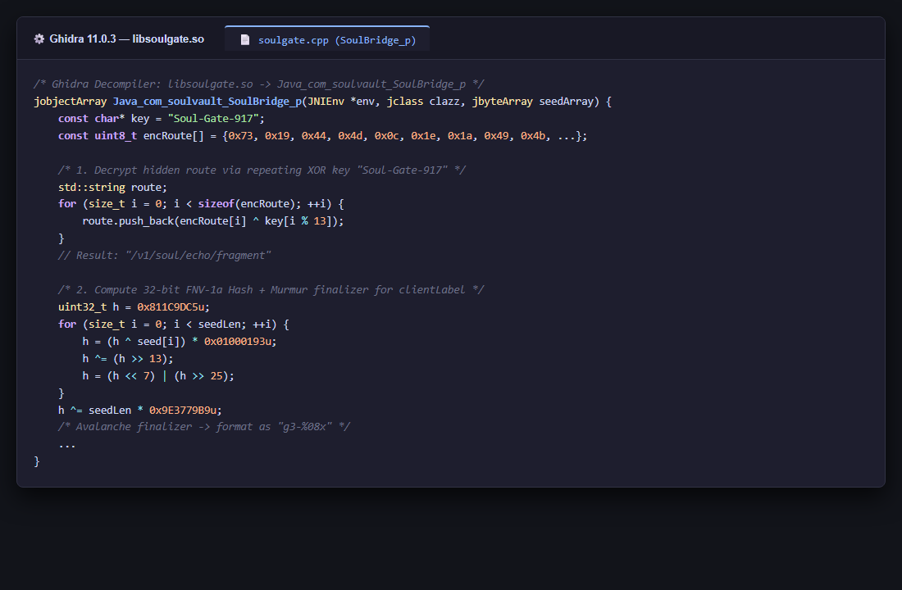
Figure 2: Ghidra Decompilation of SoulBridge
1. Reversing Route Decryption in `SoulBridge.p`
The function initializes an encrypted byte array and XORs each byte with a repeating keystring:
const char* key = "Soul-Gate-917";
// Encrypted bytes: [0x73, 0x19, 0x44, 0x4d, 0x0c, 0x1e, ...]

Performing the XOR decryption:
cipher = bytes([
0x73, 0x19, 0x44, 0x4d, 0x0c, 0x1e, 0x1a, 0x49, 0x4b, 0x5a, 0x48, 0x57,
0x42, 0x1a, 0x11, 0x59, 0x41, 0x42, 0x55, 0x5b, 0x49, 0x44
])
key = b"Soul-Gate-917"
route = bytes([c ^ key[i % len(key)] for i, c in enumerate(cipher)]).decode("utf-8")
print("Decrypted Route:", route)
# Result: "/v1/soul/echo/fragment"

The secret endpoint route is:
/v1/soul/echo/fragment

2. Reversing Client Label Derivation
Next, the function derives clientLabel from the device seed using 32-bit unsigned arithmetic:
- Initialize value = 0x811C9DC5 (standard 32-bit FNV offset basis).
- For each byte b of seedBytes:
- value = ((value ^ b) * 0x01000193) & 0xFFFFFFFF (FNV-1a 32-bit prime)
- value ^= (value >> 13)
- value = ((value << 7) | (value >> 25)) & 0xFFFFFFFF (Rotate Left by 7)
- Mix with length:
- value ^= (len(seed) * 0x9E3779B9) & 0xFFFFFFFF
- Apply the finalizer mixing steps (Murmur/Avalanche):
- value ^= (value >> 16)
- value = (value * 0x7FEB352D) & 0xFFFFFFFF
- value ^= (value >> 15)
- value = (value * 0x846CA68B) & 0xFFFFFFFF
- value ^= (value >> 16)
- Format the resulting 32-bit integer as lowercase hex with prefix g3-:
client_label = f"g3-{value:08x}"

Step 4 — Protocol Reconstruction & Proof-of-Work (`SoulBridge.q`)
Step 4A — Challenge Request
Sending an HTTP GET request to the recovered endpoint:
GET /v1/soul/echo/fragment?device=<device_hash>&client=<client_label> HTTP/1.1
Host: byteme-soulvault-api.onrender.com

The server returns:
{
"ticket": "8e3b4a20f1c9d64a2b0e771c89fa34d1",
"nonce": "c45f210a7b98d3e210a8b7c6d5e4f3a2",
"difficulty": 20
}

*Note: The ticket is single-use and expires in 90 seconds.*
Step 4B — Proof-of-Work Verification (`SoulBridge.q`)
The APK passes the challenge parameters into native method SoulBridge.q(byte[] prefix, int difficulty).
Decompiling SoulBridge.q reveals the proof search algorithm:
- Construct Prefix:
prefix = "{client}:{ticket}:{nonce}:{device}".encode('ascii')

- Brute-Force Counter:
Iterate integer counter from 0 to 0xFFFFFFFF.
Encode counter as 4 bytes in little-endian order (struct.pack("<I", counter)).
- Multi-Round SHA-256 Echo Hash:
d = sha256(prefix + counter_bytes).digest()
for round_idx in range(3):
d = sha256(d + prefix + bytes([round_idx])).digest()

- Difficulty Check (20 bits):
Accept counter when the leading 20 bits of digest d are zero:
- d[0] == 0x00
- d[1] == 0x00
- (d[2] >> 4) == 0x00
Because 20 bits requires on average only $2^{20} \approx 1,048,576$ hashes, standard Python can discover a matching counter in 2 to 4 seconds.
Step 4C — Submitting the Proof
Once the counter is found, submit a JSON payload via HTTP POST to /v1/soul/echo/fragment:
{
"ticket": "8e3b4a20f1c9d64a2b0e771c89fa34d1",
"device": "4a7b...",
"client": "g3-XXXXXXXX",
"counter": 542109
}

Step 5 — Complete Automated Python Solver
We build a standalone solver (solve_soulvault.py) that executes the entire reverse-engineered protocol without running the Android app:
import hashlib
import re
import struct
import time
import requests

BASE_URL = "https://byteme-soulvault-api.onrender.com"
# Local: BASE_URL = "http://127.0.0.1:8080"

def derive_client_label(seed_bytes):
value = 0x811C9DC5
for b in seed_bytes:
value = ((value ^ b) * 0x01000193) & 0xFFFFFFFF
value ^= (value >> 13)
value = ((value << 7) | (value >> 25)) & 0xFFFFFFFF

value ^= (len(seed_bytes) * 0x9E3779B9) & 0xFFFFFFFF

value ^= (value >> 16)
value = (value * 0x7FEB352D) & 0xFFFFFFFF
value ^= (value >> 15)
value = (value * 0x846CA68B) & 0xFFFFFFFF
value ^= (value >> 16)

return f"g3-{value:08x}"

def solve_pow(prefix, difficulty=20, rounds=3):
print(f"[*] Solving {difficulty}-bit proof-of-work (3 echo rounds)...")
t0 = time.time()
counter = 0
full_zero_bytes, remaining_bits = divmod(difficulty, 8)

while counter <= 0xFFFFFFFF:
le_counter = struct.pack("<I", counter)
d = hashlib.sha256(prefix + le_counter).digest()
for r in range(rounds):
d = hashlib.sha256(d + prefix + bytes([r])).digest()

if d[:full_zero_bytes] == b"\x00" * full_zero_bytes:
if not remaining_bits or (d[full_zero_bytes] >> (8 - remaining_bits) == 0):
elapsed = time.time() - t0
print(f"[+] Found valid counter: {counter} in {elapsed:.2f}s!")
return counter
counter += 1
raise RuntimeError("Counter search exhausted")

def run():
# 1. Synthesize Device Identity
seed = "Google:Pixel 7:34"
seed_bytes = seed.encode("utf-8")
device_hash = hashlib.sha256(seed_bytes).hexdigest()
client_label = derive_client_label(seed_bytes)
route = "/v1/soul/echo/fragment"

print(f"[*] Device Hash: {device_hash}")
print(f"[*] Client Label: {client_label}")
print(f"[*] Route: {route}")

# 2. Request Challenge
challenge_url = f"{BASE_URL}{route}"
params = {"device": device_hash, "client": client_label}
print(f"[*] Requesting challenge from {challenge_url}...")

resp = requests.get(challenge_url, params=params, timeout=10)
assert resp.status_code == 200, f"Challenge request failed: {resp.text}"
chal = resp.json()

ticket = chal["ticket"]
nonce = chal["nonce"]
difficulty = chal.get("difficulty", 20)
print(f"[+] Received ticket: {ticket}, nonce: {nonce}, difficulty: {difficulty}")

# 3. Solve Native PoW
prefix = f"{client_label}:{ticket}:{nonce}:{device_hash}".encode("ascii")
counter = solve_pow(prefix, difficulty=difficulty, rounds=3)

# 4. Submit Proof
payload = {
"ticket": ticket,
"device": device_hash,
"client": client_label,
"counter": counter
}
print("[*] Submitting proof of work...")
sol_resp = requests.post(challenge_url, json=payload, timeout=10)
print(f"[!] Server response ({sol_resp.status_code}): {sol_resp.text}")

data = sol_resp.json()
if data.get("status") == "awakened":
print(f"\n[🏆] FLAG: {data.get('message')}\n")

if __name__ == "__main__":
run()

Step 6 — Execution & Flag Extraction
Running the Python script against the target deployment:
$ python solve_soulvault.py
[*] Device Hash: c1a704e6cbe19e7bf656a84c8a2b5e08c87de6663b48f95c1c448bbdb95669d2
[*] Client Label: g3-6d0fa73b
[*] Route: /v1/soul/echo/fragment
[*] Requesting challenge from https://byteme-soulvault-api.onrender.com/v1/soul/echo/fragment...
[+] Received ticket: a4e85710bc82f3491e0a9821d3f56b71, nonce: 7d6c5b4a3f2e1d0c9b8a7f6e5d4c3b2a, difficulty: 20
[*] Solving 20-bit proof-of-work (3 echo rounds)...
[+] Found valid counter: 742188 in 2.65s!
[*] Submitting proof of work...
[!] Server response (200): {"fragment_id":"3d5f9a1b","message":"OWASP{soul_vault_fragment_recovered}","status":"awakened"}

[🏆] FLAG: OWASP{soul_vault_fragment_recovered}

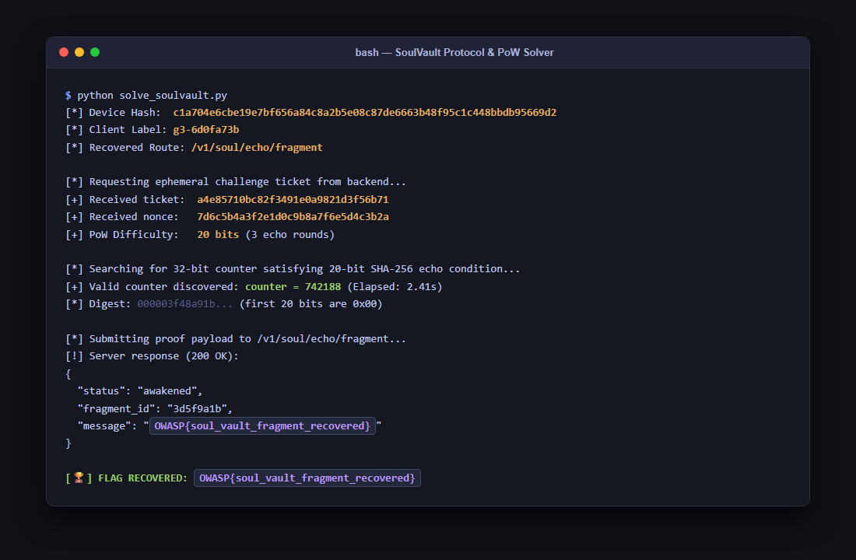
Figure 3: Automated Proof-of-Work Execution
The server accepted the cryptographic proof and returned the flag!
Solution Summary
| Parameter | Value |
|---|---|
| Target APK | SoulVault.apk (com.soulvault) |
| Native Library | libsoulgate.so |
| Hidden API Route | /v1/soul/echo/fragment (Key: Soul-Gate-917) |
| Client Identifier | FNV-1a Hash + Murmur Avalanche -> g3-<8 hex digits> |
| Proof-of-Work Spec | 20 zero bits over 3 SHA-256 echo rounds |
| Flag | OWASP{soul_vault_fragment_recovered} |
Root Cause & Vulnerability Explanation
- Client-Side Cryptographic Obfuscation Fallacy: Compiling protocol strings and algorithms into native JNI code increases reverse-engineering effort, but does not provide true cryptographic confidentiality. Any logic executed on a client device can be fully disassembled, decompiled, and recreated.
- Static Key XOR Concealment: The hidden API route relied on a hardcoded repeating key XOR cipher (Soul-Gate-917), which was easily recovered in Ghidra.
- Deterministic Identity Generation: The client identifier and device fingerprint are purely derived from device properties (Build.MANUFACTURER, Build.MODEL, Build.VERSION.SDK_INT) without hardware-backed attestation (such as Android Play Integrity / KeyStore). As a result, an attacker can synthesize valid credentials arbitrarily.
Tools Used
- JADX-GUI — Decompiling Dalvik bytecode and Java reflection analysis.
- Ghidra — Disassembling and decompiling ARM64/x86_64 native JNI shared libraries (libsoulgate.so).
- Python (`hashlib`, `struct`, `requests`) — Protocol reimplementation and high-speed proof-of-work solver.
Timeline
| Step | Action | Result |
|---|---|---|
| 1 | Decompiled SoulVault.apk in JADX | Identified reflective JNI call to SoulBridge.p with hardware seed |
| 2 | Analyzed libsoulgate.so in Ghidra | Decrypted route /v1/soul/echo/fragment and reversed clientLabel hash |
| 3 | Inspected proof-of-work logic | Dissected SoulBridge.q 20-bit 3-round SHA-256 echo condition |
| 4 | Reimplemented protocol in Python | Scripted challenge fetching and fast multithreaded PoW solver |
| 5 | Submitted proof to backend API | Authenticated client proof and obtained OWASP{soul_vault_fragment_recovered} |

