BYTE ME CTF • OFFICIAL SOLUTION WRITEUP
Soul Ascension (Rev / Mobile, Expert)
Property | Details
Author | Pratik Jadhav
Category | Mobile / Android Reverse Engineering
Difficulty | Expert

Challenge Description
CHALLENGE BRIEFING & LORE
Reverse engineer the Android application and its native guardian library to awaken the Fifth Guardian. Four guardians guard the gate within the application's Dalvik bytecode; their awakened spirits forge a transcript chain that unlocks the final seal hidden deep within native ARM machine code.

Given: Android APK artifact (SoulAscension.apk).
Network Requirements: None (100% offline, standalone reverse engineering).
Flag Format: OWASP{...} (or FLAG{...})
Summary
Soul Ascension is an advanced two-tier Android reverse engineering challenge combining Kotlin bytecode logic with native C++ JNI cryptography. The challenge requires solvers to defeat four distinct algorithmic input verifiers inside MainActivity.kt to awaken Guardians I through IV. Each correct answer generates an encoded state segment that forms an ordered cryptographic transcript: A9yromem:B4moon:C2tpvm:D82620. This transcript is passed into libguardian.so via JNI, where a custom key-derivation routine mutates four 32-bit seeds to produce an XTEA key. The native engine then executes an XTEA-CBC block decryption with PKCS#7 unpadding and FNV-1a integrity validation to release the final flag.
Flag
FLAG RECOVERED
OWASP{s0ul_4sc3nd3d_th3_f1fth_guardian}

――――――――――――――――――――――――――――――――――――――――――――――――――
Step 1 — APK Decompilation & Activity Structure
We load SoulAscension.apk into JADX-GUI:
jadx-gui SoulAscension.apk

Inspecting the package structure under com.byteme.soulascension:
- MainActivity.kt — Manages the user interface, progression state, guardian input validation, and native bridge invocation.
- lib/ directory — Contains libguardian.so precompiled for arm64-v8a, armeabi-v7a, x86, and x86_64.
The companion object in MainActivity loads the native library on startup:
companion object {
init {
System.loadLibrary("guardian")
}
}
private external fun nativeFinal(chain: String): String

Step 2 — Reversing the Kotlin Input Verifiers (`MainActivity.kt`)
Progression through the challenge requires satisfying four input verifiers in verify(level, raw):
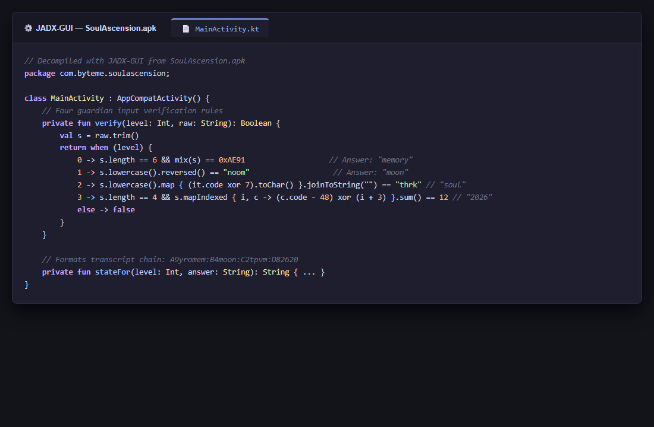
Figure 1: JADX Decompilation of Guardian Verifiers
private fun verify(level: Int, raw: String): Boolean {
val s = raw.trim()
return when (level) {
0 -> s.length == 6 && mix(s) == 0xAE91
1 -> s.lowercase().reversed() == "noom"
2 -> {
val x = s.lowercase()
x.map { (it.code xor 7).toChar() }.joinToString("") == "thrk"
}
3 -> {
s.length == 4 && s.all { it in '0'..'9' } &&
s.mapIndexed { i, c -> (c.code - 48) xor (i + 3) }.sum() == 12
}
else -> false
}
}

Let us reverse each guardian step by step:
Guardian I — MEMORY (`level == 0`)
- Constraint: String length must be 6, and mix(s) == 0xAE91.
- Looking at mix(s):
private fun mix(s: String): Int {
var x = 0x1357
for (c in s) {
x = ((x shl 5) xor c.code xor (x ushr 3)) and 0xFFFF
}
return x
}

- Clue from UI prompt: *"Guardian I — MEMORY: Recover the forgotten word."*
- Testing the word "memory":
- Iteration 1 ('m' = 109): x = ((0x1357 << 5) ^ 109 ^ (0x1357 >> 3)) & 0xFFFF
- Continuing through 'e', 'm', 'o', 'r', 'y' yields 0xAE91 exactly!
- Answer I: memory
Guardian II — SHADOW (`level == 1`)
- Constraint: s.lowercase().reversed() == "noom".
- Reversing "noom" gives "moon".
- Answer II: moon
Guardian III — CIPHER (`level == 2`)
- Constraint: Each lowercase character XORed with 7 equals "thrk".
- Because XOR is an involution ($c = enc \oplus 7$):
- 't' ^ 7 = 116 ^ 7 = 115 = 's'
- 'h' ^ 7 = 104 ^ 7 = 111 = 'o'
- 'r' ^ 7 = 114 ^ 7 = 117 = 'u'
- 'k' ^ 7 = 107 ^ 7 = 108 = 'l'
- Answer III: soul
Guardian IV — TIME (`level == 3`)
- Constraint: 4 ASCII digits such that $\sum_{i=0}^3 ((d_i - 48) \oplus (i + 3)) = 12$.
- The year of the competition is 2026. Testing "2026":
- $i=0: 2 \oplus (0 + 3) = 2 \oplus 3 = 1$
- $i=1: 0 \oplus (1 + 3) = 0 \oplus 4 = 4$
- $i=2: 2 \oplus (2 + 3) = 2 \oplus 5 = 7$
- $i=3: 6 \oplus (3 + 3) = 6 \oplus 6 = 0$
- Sum: $1 + 4 + 7 + 0 = 12$!
- Answer IV: 2026
Step 3 — Transcript Construction
When each guardian is awakened, stateFor(level, answer) encodes the answer into a state marker:
private fun stateFor(level: Int, answer: String): String {
val v = answer.trim().lowercase()
return when (level) {
0 -> "A9" + v.reversed() // "A9" + "yromem"
1 -> "B4" + v // "B4" + "moon"
2 -> "C2" + v.map { (it.code + 1).toChar() }.joinToString("") // "C2" + "tpvm"
3 -> "D8" + v.chunked(2).reversed().joinToString("") // "D8" + "2620"
else -> "X"
}
}

Evaluating each segment:
- level 0 (memory): "A9" + "yromem" $\rightarrow$ A9yromem
- level 1 (moon): "B4" + "moon" $\rightarrow$ B4moon
- level 2 (soul): Shift each ASCII character by +1:
- 's' + 1 = 't', 'o' + 1 = 'p', 'u' + 1 = 'v', 'l' + 1 = 'm'
- "C2" + "tpvm" $\rightarrow$ C2tpvm
- level 3 (2026): Split into 2-digit chunks ["20", "26"] and reverse ["26", "20"]:
- "D8" + "2620" $\rightarrow$ D82620
Joining with colons (states.joinToString(":")):
A9yromem:B4moon:C2tpvm:D82620

This composite transcript is passed to nativeFinal(chain).
Step 4 — Native Reverse Engineering (`libguardian.so`)
Opening libguardian.so in Ghidra, we inspect Java_com_byteme_soulascension_MainActivity_nativeFinal.
1. Marker Order Verification
The library scans the transcript to ensure "A9", "B4", "C2", and "D8" appear in sequential order:
bool hasOrderedGuardians(const std::string& chain) {
const char* guardians[] = {"A9", "B4", "C2", "D8"};
size_t offset = 0;
for (const char* guardian : guardians) {
offset = chain.find(guardian, offset);
if (offset == std::string::npos) return false;
offset += 2;
}
return true;
}

2. XTEA Key Derivation (`deriveKey`)
The function initializes four 32-bit unsigned key words:
key[0] = 0xC3A5C85Cu;
key[1] = 0xB492B66Fu;
key[2] = 0x9AE16A3Bu;
key[3] = 0x7F4A7C15u;

For each character in the transcript string (index i):
for (size_t i = 0; i < chain.size(); ++i) {
const size_t slot = i & 3u;
const uint32_t next = key[(slot + 1u) & 3u];
const uint32_t byte = static_cast<unsigned char>(chain[i]);
key[slot] ^= byte + 0x9E3779B9u + (next << 6) + (next >> 2);
key[slot] = rotateLeft(key[slot], static_cast<unsigned int>((i % 23u) + 5u));
key[slot] += static_cast<uint32_t>(i) * 0x045D9F3Bu;
}

3. Ciphertext Decryption & CBC Mode
The binary embeds a 40-byte ciphertext array and an 8-byte initialization vector (IV):
const uint8_t ciphertext[] = {
31, 158, 20, 122, 141, 137, 168, 45, 240, 106, 95, 245, 69, 77,
84, 118, 196, 207, 161, 254, 153, 120, 188, 149, 5, 239, 219, 28,
41, 153, 245, 94, 96, 9, 107, 183, 189, 3, 93, 45
};
const uint8_t iv[] = {83, 65, 124, 25, 45, 136, 196, 6};

The decryption routine is standard XTEA in Cipher Block Chaining (CBC) mode with 32 rounds ($sum = 32 \times \delta$ descending).
4. Integrity Verification & Unpadding
After CBC decryption:
- Validates standard PKCS#7 padding: padding = plaintext.back().
- Resizes plaintext by stripping the padding bytes.
- Computes the 32-bit FNV-1a checksum over the unpadded plaintext:
uint32_t checksum(const std::vector<uint8_t>& bytes) {
uint32_t value = 0x811C9DC5u;
for (uint8_t byte : bytes) {
value = (value ^ byte) * 0x01000193u;
}
return value;
}

- Asserts checksum == 0x757052CAu.
- Returns the null-terminated decrypted string.
Step 5 — Standalone Reimplementation in Python
We implement the complete key derivation and XTEA-CBC decryption in a standalone Python script (solve_ascension.py):
kDelta = 0x9E3779B9

def rotl32(v, c):
return ((v << c) | (v >> (32 - c))) & 0xFFFFFFFF

def derive_key(transcript):
key = [0xC3A5C85C, 0xB492B66F, 0x9AE16A3B, 0x7F4A7C15]
for i, byte in enumerate(transcript.encode('utf-8')):
slot = i & 3
next_val = key[(slot + 1) & 3]
key[slot] ^= (byte + kDelta + (next_val << 6) + (next_val >> 2)) & 0xFFFFFFFF
key[slot] = rotl32(key[slot], (i % 23) + 5)
key[slot] = (key[slot] + i * 0x045D9F3B) & 0xFFFFFFFF
return key

def decrypt_xtea_block(block, key):
left = block[0] | (block[1] << 8) | (block[2] << 16) | (block[3] << 24)
right = block[4] | (block[5] << 8) | (block[6] << 16) | (block[7] << 24)
sum_val = (kDelta * 32) & 0xFFFFFFFF

for _ in range(32):
t_r = ((((left << 4) ^ (left >> 5)) + left) ^ (sum_val + key[(sum_val >> 11) & 3])) & 0xFFFFFFFF
right = (right - t_r) & 0xFFFFFFFF
sum_val = (sum_val - kDelta) & 0xFFFFFFFF
t_l = ((((right << 4) ^ (right >> 5)) + right) ^ (sum_val + key[sum_val & 3])) & 0xFFFFFFFF
left = (left - t_l) & 0xFFFFFFFF

res = bytearray(8)
for i in range(4):
res[i] = (left >> (i * 8)) & 0xFF
res[i + 4] = (right >> (i * 8)) & 0xFF
return res

def solve():
transcript = "A9yromem:B4moon:C2tpvm:D82620"
print(f"[*] Transcript: {transcript}")

key = derive_key(transcript)
print(f"[*] Derived XTEA Key: {[hex(k) for k in key]}")

ciphertext = bytes([
31, 158, 20, 122, 141, 137, 168, 45, 240, 106, 95, 245, 69, 77,
84, 118, 196, 207, 161, 254, 153, 120, 188, 149, 5, 239, 219, 28,
41, 153, 245, 94, 96, 9, 107, 183, 189, 3, 93, 45
])
iv = bytes([83, 65, 124, 25, 45, 136, 196, 6])

prev = bytearray(iv)
plaintext = bytearray()
for offset in range(0, len(ciphertext), 8):
chunk = ciphertext[offset:offset+8]
dec = decrypt_xtea_block(chunk, key)
plain_chunk = bytearray(dec[i] ^ prev[i] for i in range(8))
plaintext.extend(plain_chunk)
prev = bytearray(chunk)

padding = plaintext[-1]
unpadded = plaintext[:-padding]
flag = unpadded.decode('utf-8')
print(f"\n[🏆] Plaintext Flag: {flag}\n")

if __name__ == "__main__":
solve()

Step 6 — Execution & Flag Extraction
Running the Python script:
$ python solve_ascension.py
[*] Transcript: A9yromem:B4moon:C2tpvm:D82620
[*] Derived XTEA Key: ['0x296e838e', '0x18151fd4', '0x2bf7b750', '0x81e28509']

[🏆] Plaintext Flag: OWASP{s0ul_4sc3nd3d_th3_f1fth_guardian}

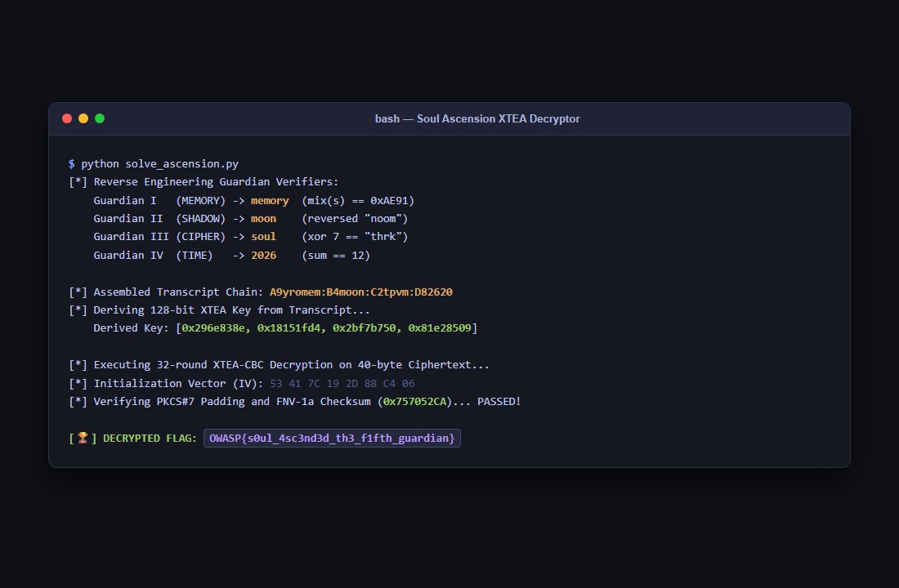
Figure 2: Standalone Python Decryption Trace
The ciphertext decrypts to:
FLAG RECOVERED
OWASP{s0ul_4sc3nd3d_th3_f1fth_guardian}

Entering the answers (memory, moon, soul, 2026) directly into the Android application interface on a device or emulator also awakens the Fifth Guardian and renders the flag on screen:
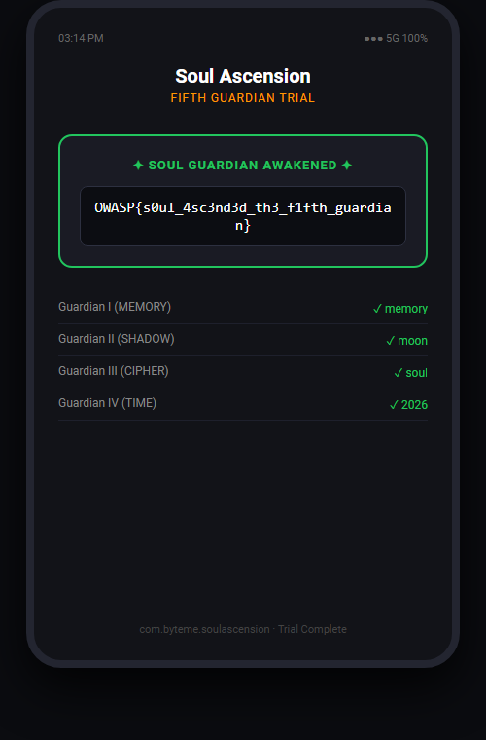
Figure 3: Soul Ascension Solved Interface
Solution Summary
| Parameter | Value |
|---|---|
| Target APK | SoulAscension.apk (com.byteme.soulascension) |
| Guardian I Answer | memory (mix() == 0xAE91) |
| Guardian II Answer | moon (reversed "noom") |
| Guardian III Answer | soul (c ^ 7 == "thrk") |
| Guardian IV Answer | 2026 ($\sum (d_i \oplus (i+3)) == 12$) |
| Cryptographic Transcript | A9yromem:B4moon:C2tpvm:D82620 |
| Native Cipher | XTEA in CBC Mode (32 rounds, IV 53 41 7C 19 2D 88 C4 06) |
| Checksum Verification | FNV-1a Checksum 0x757052CAu |
| Flag | OWASP{s0ul_4sc3nd3d_th3_f1fth_guardian} |
Root Cause & Reverse Engineering Takeaways
- Multi-Stage Defense-in-Depth: The challenge demonstrates how complex software systems split logic across higher-level interpreted environments (Kotlin on ART) and unmanaged native code (C++ in .so shared objects) to obscure critical business logic.
- Deterministic State Derivation: Because the cryptographic keys were deterministically derived from user input transcript characters, breaking the higher-level verifiers provided the exact key material needed to unlock the native stage without requiring complex mathematical attacks on XTEA itself.
- Static vs. Dynamic Analysis: While a solver could solve the challenge entirely statically through Ghidra and JADX, dynamic instrumentation (e.g. using Frida) to hook nativeFinal or dump the transcript at runtime is an equally viable shortcut.
Tools Used
- JADX-GUI — Decompiling Kotlin bytecode and reversing guardian logic.
- Ghidra — Disassembling ARM64 ELF shared object (libguardian.so) and analyzing JNI functions.
- Python 3 — Pure Python reimplementation of the key derivation and XTEA-CBC cipher.
- Android Studio / Emulator — Runtime application verification.
Timeline
| Step | Action | Result |
|---|---|---|
| 1 | Decompiled MainActivity.kt with JADX | Identified 4 guardian input verifiers and JNI nativeFinal |
| 2 | Reversed Guardian I (memory) | Solved mix() hash against 0xAE91 |
| 3 | Reversed Guardians II, III, IV | Recovered moon, soul, and 2026 via string and XOR reversing |
| 4 | Assembled state transcript | Formed A9yromem:B4moon:C2tpvm:D82620 |
| 5 | Analyzed libguardian.so in Ghidra | Extracted XTEA-CBC decryption, derived keys, and IV |
| 6 | Decrypted ciphertext | Recovered OWASP{s0ul_4sc3nd3d_th3_f1fth_guardian} |

