

**AlgoDomain Solutions**

**Product Details**

**Built a REST API to perform CRUD operation and**

**to Calculate Product Details**

**Understanding Document:**

This is understanding document on how to perform CRUD operation with this REST API.

Github Link: [*https://github.com/HrishiZanjad/AlgoDomain_ProductDetails*](https://github.com/HrishiZanjad/AlgoDomain_ProductDetails)

Follow below Steps to perform various operation on the API.

1. **Create/Save Operation:** To save Product in the database.

Provide product details in the Body -> raw

**HTTP request:** POST

**url:**[*http://localhost:8080/api/product/save*](http://localhost:8080/api/product/save)

Running URL on Postman:

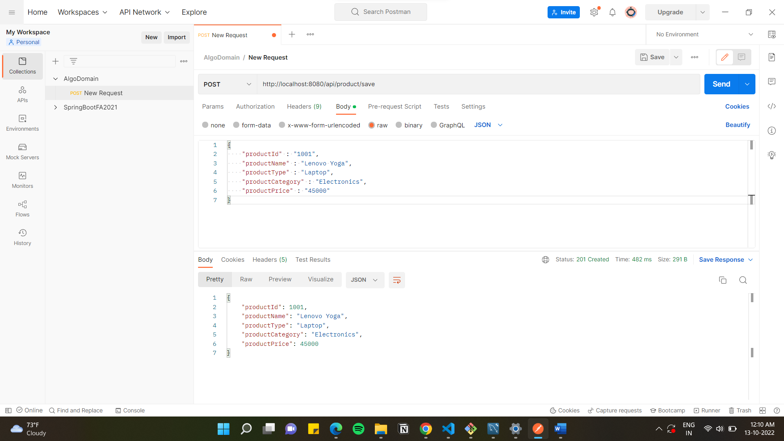

Product in the Database:

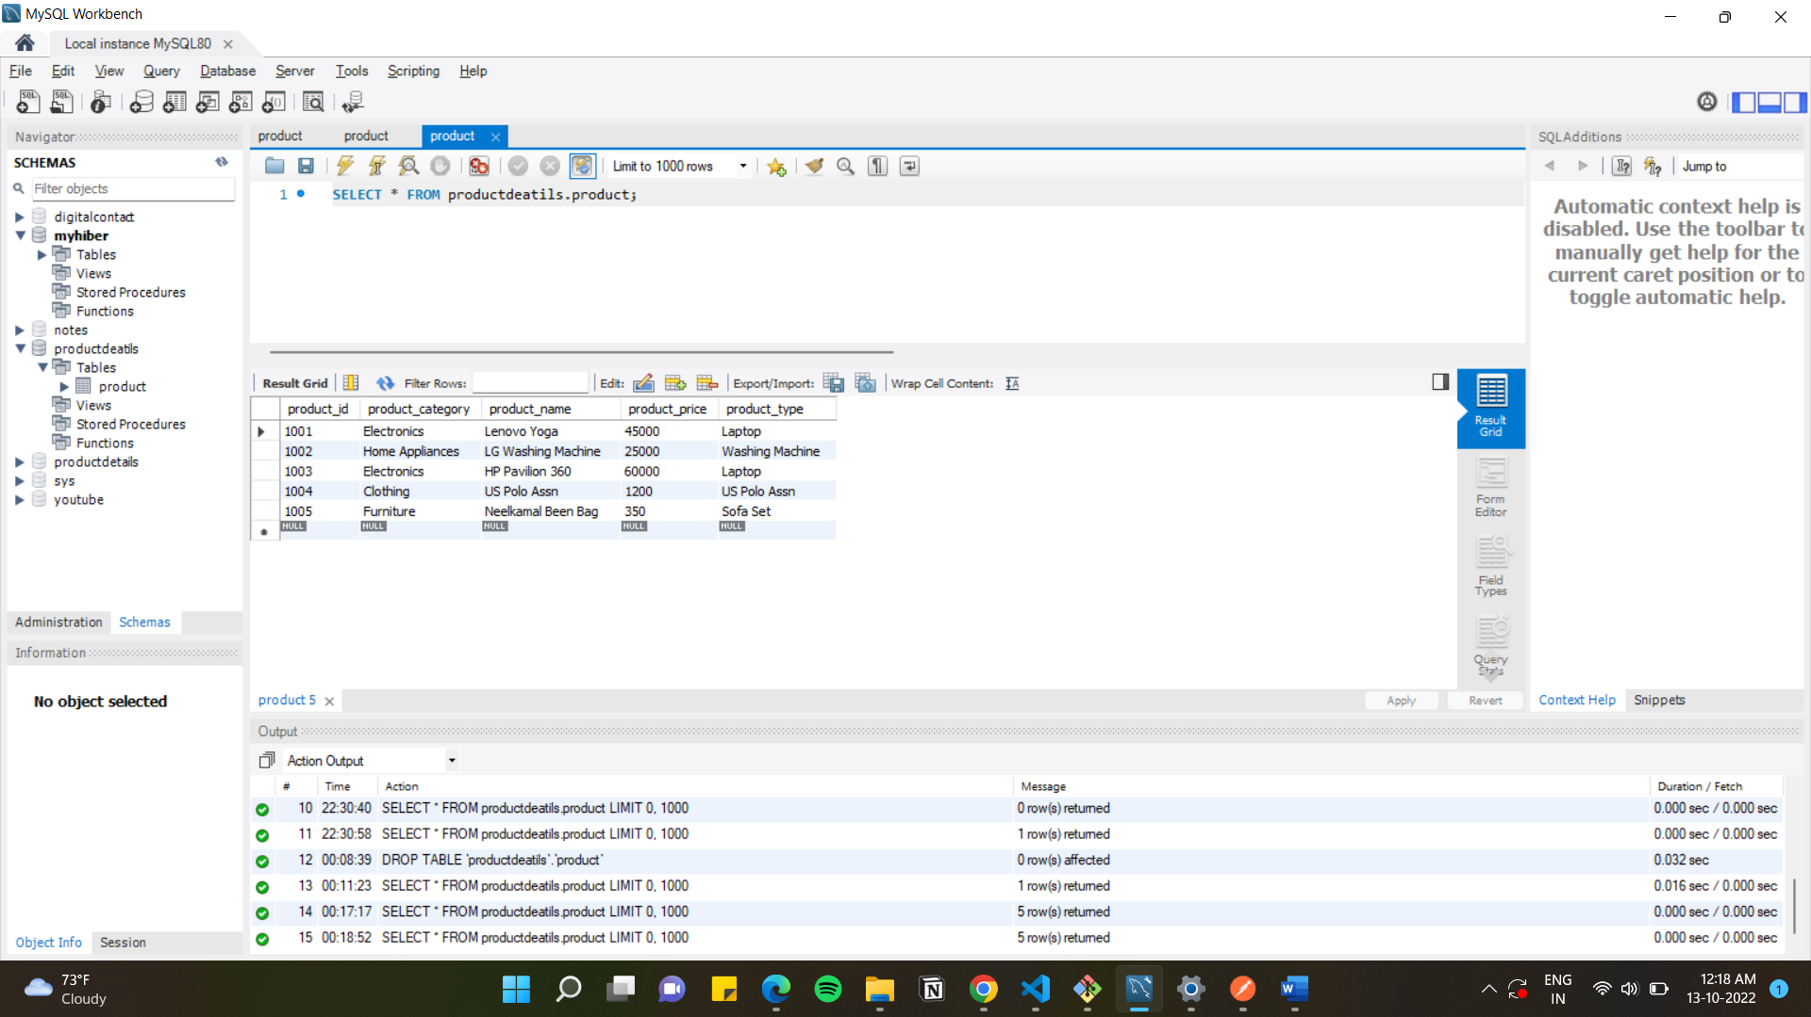

1. **Get Operation:** To get all products from the database

**HTTP request:** GET

**url:** [*http://localhost:8080/api/product/get*](http://localhost:8080/api/product/get)

Get Request on Postman:

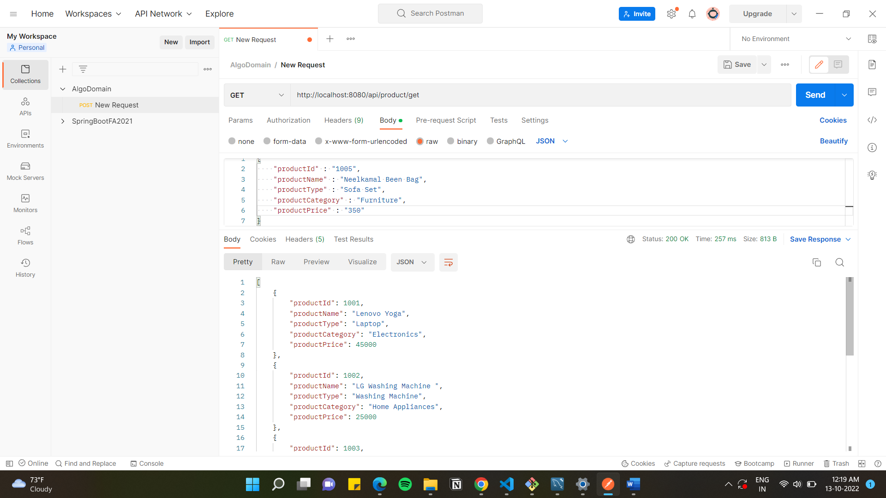

1. **Get By ID Operation:** To get product with particular Id

**HTTP request:** GET

**url:** [*http://localhost:8080/api/product/getById/{ID}*](http://localhost:8080/api/product/getById/%7bID%7d),where {ID} is Id of the Product.

Product with particular Id:

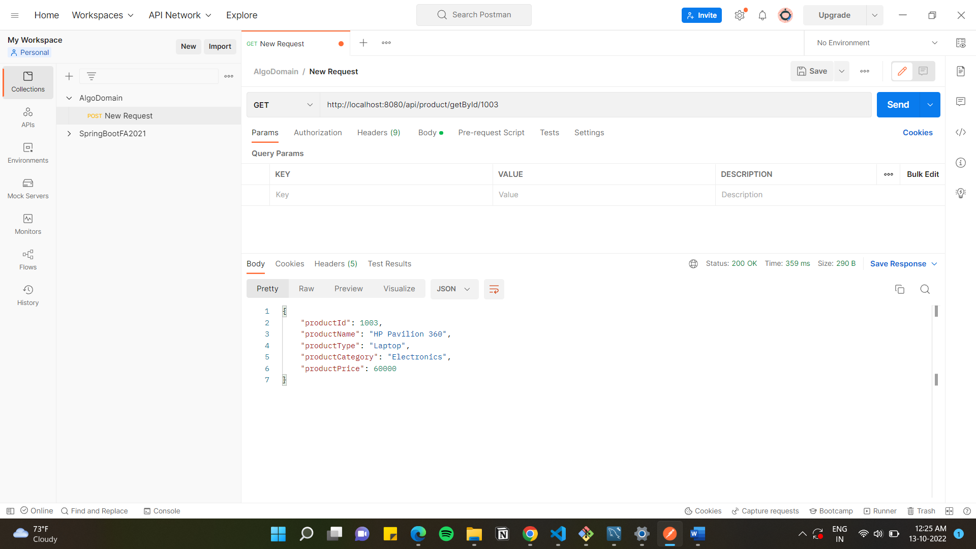

1. **Update Operation:** To update product details

Provide updated product details in Body-> raw

**HTTP request**: PUT

**url:** [*http://localhost:8080/api/product/update/{ID}*](http://localhost:8080/api/product/update/%7bID%7d), where {ID} is Id of the Product to be updated

Updated Product:

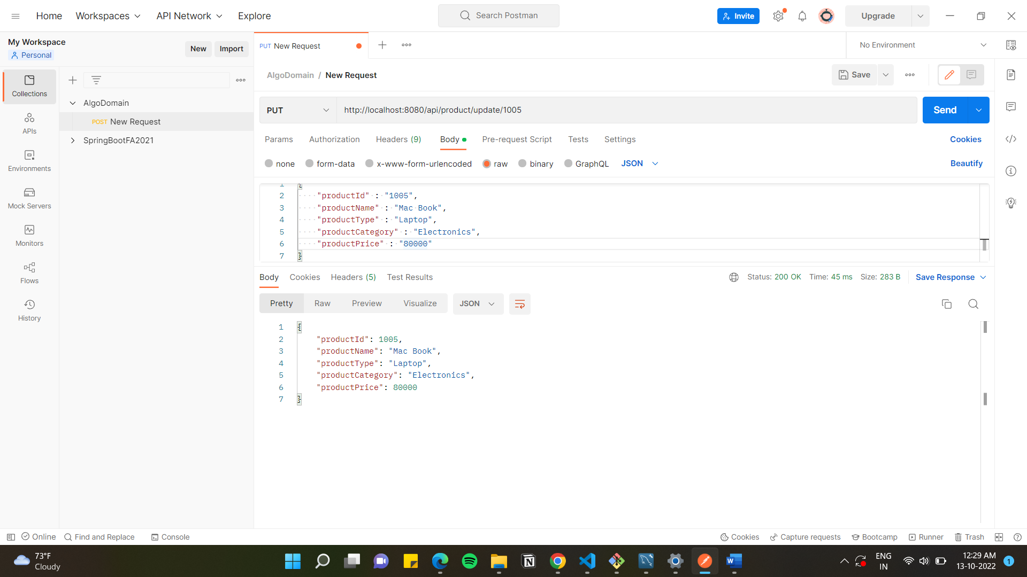

Product Updated in database:

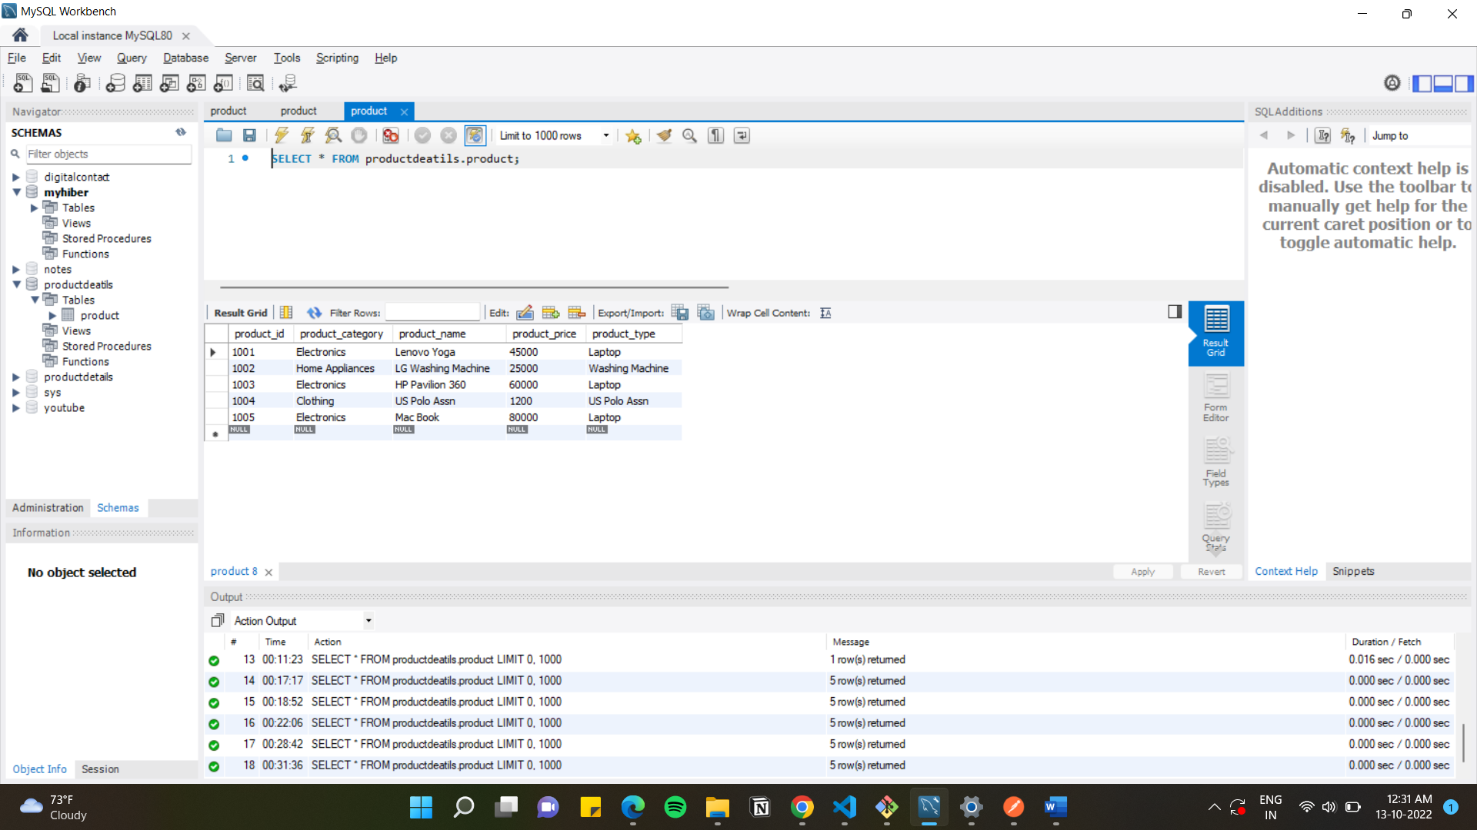

1. **Delete Operation:** To perform Delete operation

**HTTP request:** Delete

**url:** [*http://localhost:8080/api/product/delete/{ID}*](http://localhost:8080/api/product/delete/%7bID%7d), where {ID} is Id of the Product to be deleted.

Product with Id 1005 is deleted:

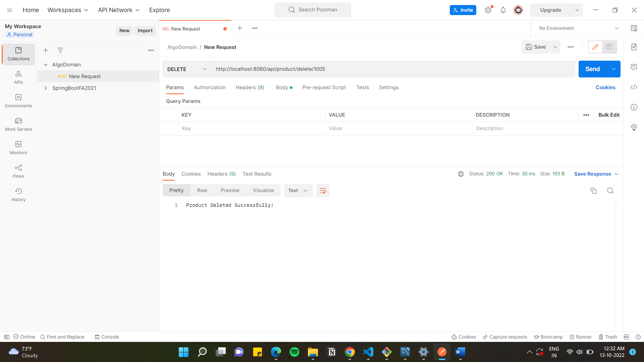

Product with Id: 1005 deleted from database

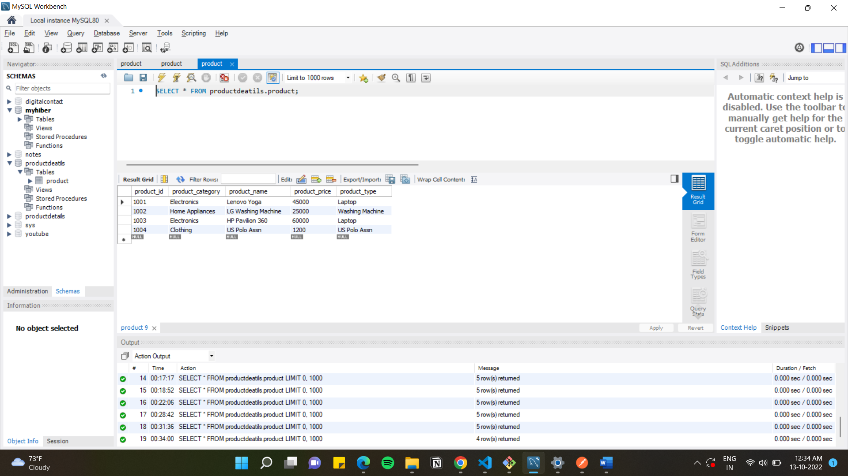

1. **Get Products:** To run getProducts method for calculating final price of each product **based on discount and other charges.**

**HTTP request: GET**

**url:** [*http://localhost:8080/api/product/getProducts/{ID}*](http://localhost:8080/api/product/getProducts/%7bID%7d), where {ID} is Id of the Product for which details to be calculated.

