**Packer & Unpacker**

**Scope:**

Aim of our project is to provide a safe and easy to use software for packing and unpacking data.

As well as reducing time required for packing and unpacking.

Platform Indepandent

Many companies use their own packing & unpacking application but it’s often times heavier on the system, so we intend to create a light weight software for the same.

**Working :**

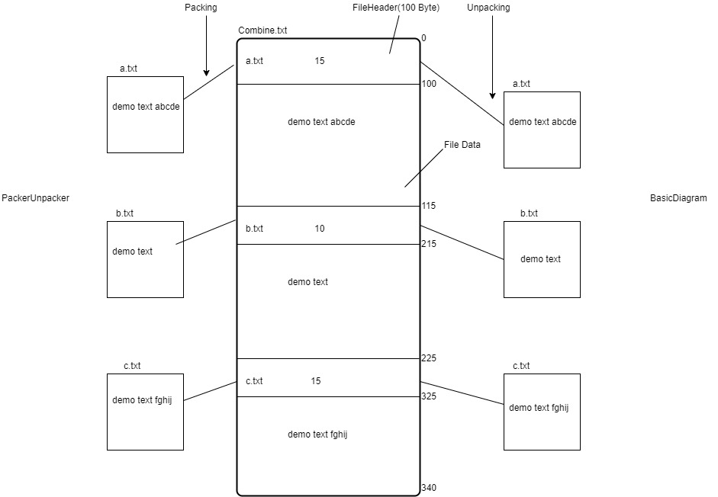

**UI of Packer & Unpacker:**

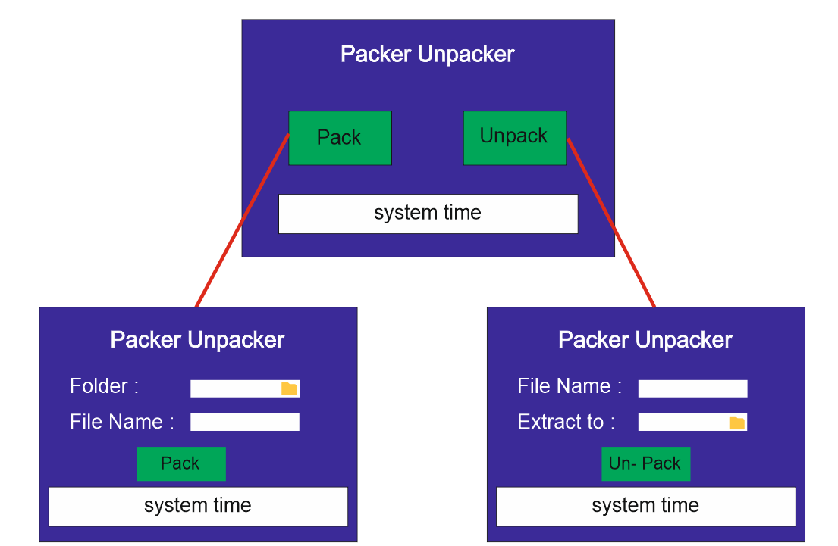

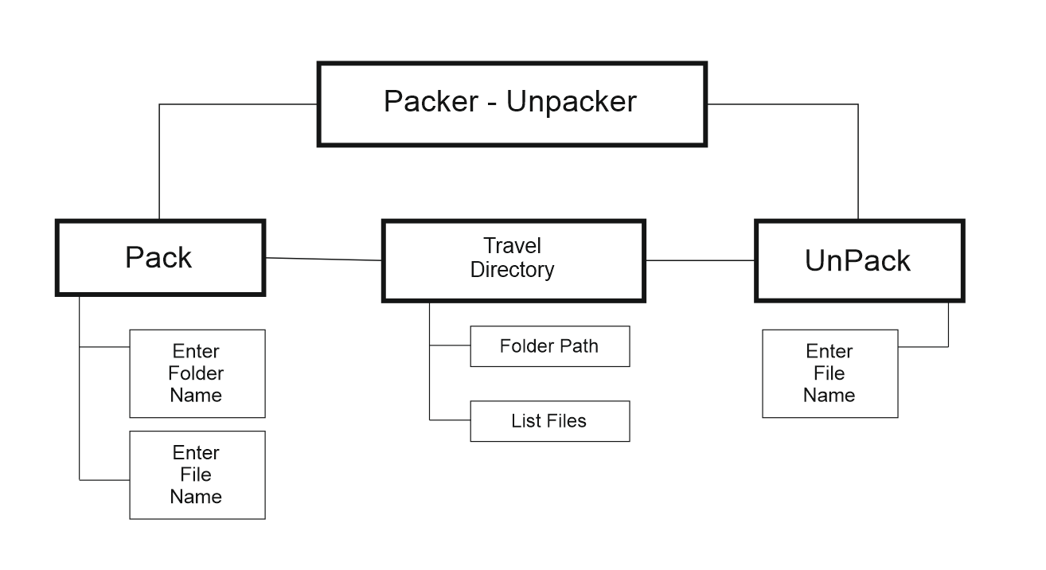FDD: