Design Document
Auto Agents — Text-to-SQL Agentic System

Created: 2026-03-15
Team: PaSS / Product and Software Security
Status: Draft
Classification: Adobe Internal

1.1 Overview of the Feature / Product
Auto Agents is a fully autonomous agentic Text-to-SQL system built for internal Adobe use. Users ask natural language questions via a chat interface, and a multi-agent LangGraph pipeline:
- Researches the database schema using AI-driven tool calls
- Generates SQL queries using Claude LLM (via Azure AI Foundry)
- Validates SQL through a 4-pass validation pipeline (RLS, syntax, schema, semantic)
- Applies Row-Level Security (RLS) filters based on user identity
- Executes the query against SQL Server (MSSQL)
- Presents results with AI-generated insights and optional interactive dashboards

Scope for Threat Modeling
Attribute | Detail
Hosting | Azure App Service (Windows) for production; localhost HTTPS for development
Users | Internal Adobe employees, access-controlled via Okta OAuth 2.0 + LDAP allowlist
Data Sensitivity | Enterprise data: sales pipeline, customer health, account hierarchy, quota, regional performance. Contains employee names, sales figures, and account-level data (PII)
Technology Stack | Express.js (Node 18+), React 19, SQL Server (MSSQL), Claude LLM (Opus/Haiku) via Azure AI Foundry, LangGraph, Okta OAuth 2.0 with PKCE
Threat Surface | Full request lifecycle: browser -> Express server -> LLM (Azure AI Foundry) -> SQL Server -> browser. Includes LLM prompt injection risks

1.2 Use-Cases
# | Use-Case | Actor | Description
UC-1 | Natural language query | Authenticated user | User types a question in ChatPanel; system classifies intent, generates SQL, executes, returns results + insights
UC-2 | Multi-query decomposition | Authenticated user | Complex questions are decomposed into sub-queries run in parallel through the pipeline
UC-3 | Dashboard creation | Authenticated user | DASHBOARD-intent requests generate interactive tile specs with slicers; paginated data via /dashboard-data
UC-4 | Follow-up / conversation | Authenticated user | Follow-up questions reuse prior SQL as template; conversation context in session memory
UC-5 | User impersonation (RLS) | Authenticated user | User selects another person's identity to scope data via dynamic RLS injection
UC-6 | Login / authentication | Any user | Okta OAuth 2.0 PKCE flow: browser redirects to Okta, code exchange, session creation
UC-7 | View checkpoint history | Authenticated user | Retrieve LangGraph checkpoint history for a conversation thread
UC-8 | Health monitoring | Ops / monitoring | Unauthenticated GET /api/health checks server, DB, and LLM connectivity
UC-9 | Knowledge harvesting | Admin (CLI) | Offline scripts regenerate schema knowledge and distinct values from the database

1.3 Components
Component | Technology | Description | Location
Client SPA | React 19, Vite, Tailwind CSS v4 | Chat interface, dashboard renderer, agent trace viewer | client/
API Server | Express.js 4, Node 18+ (CommonJS) | REST + SSE API, session management, middleware | server/index.js, server/routes/
Auth Module | Okta OAuth 2.0 + PKCE, express-session | Login flow, session cookies, LDAP allowlist | server/auth/, server/routes/auth.js
LangGraph Workflow | @langchain/langgraph StateGraph | 16-node multi-agent pipeline with checkpointing | server/graph/
Research Agent | Claude Haiku via Azure AI Foundry | Schema discovery with 6 tools | server/graph/nodes/researchAgent.js
SQL Writer Agent | Claude Haiku via Azure AI Foundry | SQL generation with 16 tools | server/graph/nodes/sqlWriterAgent.js
RLS Injector | Custom JS (regex-based SQL rewriting) | Automatic WHERE-clause injection for 8 RLS-protected tables | server/utils/rlsInjector.js
Validation Pipeline | RLS + Syntax + Schema + Semantic (LLM) | 4-pass SQL validation before execution | server/validation/
Query Executor | mssql package (TDS protocol) | Executes validated SQL with TOP row limit and timeout | server/services/queryExecutor.js
Knowledge Layer | JSON + Markdown, in-memory keyword index | Schema, business rules, joins, KPIs, distinct values, examples | server/vectordb/, server/context/knowledge/
Session Memory | In-memory Map + LangGraph MemorySaver | Per-session query and correction history | server/memory/sessionMemory.js
Database | SQL Server (MSSQL) via TDS | Enterprise data warehouse (external) | server/config/database.js
LLM Service | Claude Opus & Haiku via Azure AI Foundry | Text generation, structured output, semantic validation (external) | server/config/llm.js
Security Headers | Helmet.js v8 | X-Frame-Options, HSTS, CSP, X-Content-Type-Options | server/index.js

1.4 Architecture

Architecture Diagram
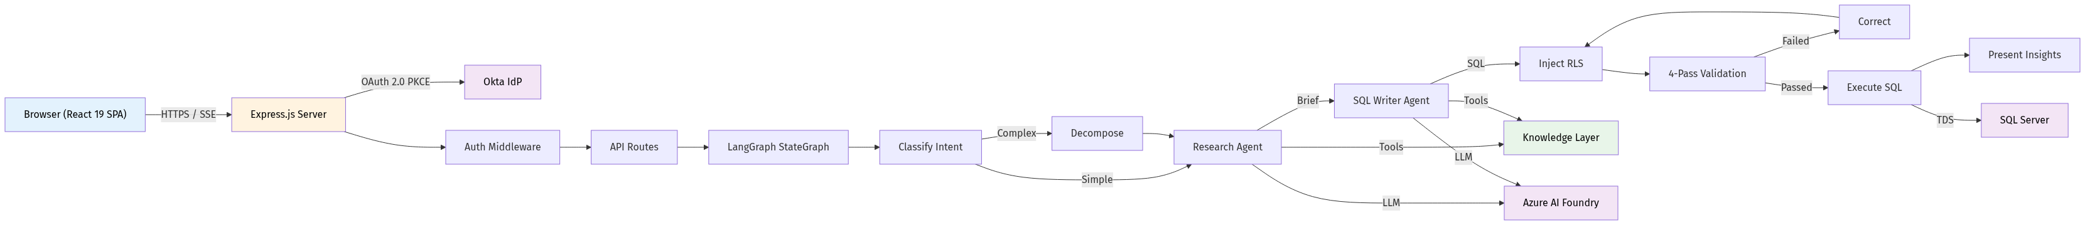

Architecture Summary
Monorepo with two packages:
- server/ — Express.js + LangGraph backend (CommonJS, Node 18+)
- client/ — React 19 + Vite + Tailwind CSS v4 frontend (ESM)
Deployment model:
- Client builds to server/public/ for production; dev uses Vite proxy on port 5174 -> Express on port 5000
- Single Express process (no microservices)
- LangGraph MemorySaver checkpointer for conversation state (in-memory, not persisted across restarts)
External dependencies:
- Okta IdP — OAuth 2.0 authentication with PKCE
- Azure AI Foundry — Claude LLM API. Two model profiles: Opus (quality) and Haiku (fast)
- SQL Server (MSSQL) — Single connection pool (min: 0, max: 10, 60s request timeout)

Core Pipeline (LangGraph StateGraph)
Classify → [Decompose] → ResearchAgent → SqlWriterAgent → InjectRLS → Validate → Execute → CheckResults → [AccumulateResult] → Present
- Classify determines intent (SQL_QUERY, DASHBOARD, GENERAL_CHAT, CLARIFICATION) and match type (exact, partial, followup, none)
- Exact template matches skip research + writing; partial matches skip research only
- Complex questions get decomposed into sub-queries via parallelSubQueryPipeline
- Failed validations route to correct (up to 3 retry rounds)
- Empty results trigger diagnoseEmptyResults which can auto-rewrite and retry
- Dashboard intent routes to dashboardAgent which builds interactive tile specs

1.4.1 Data Flows

Authentication Flow
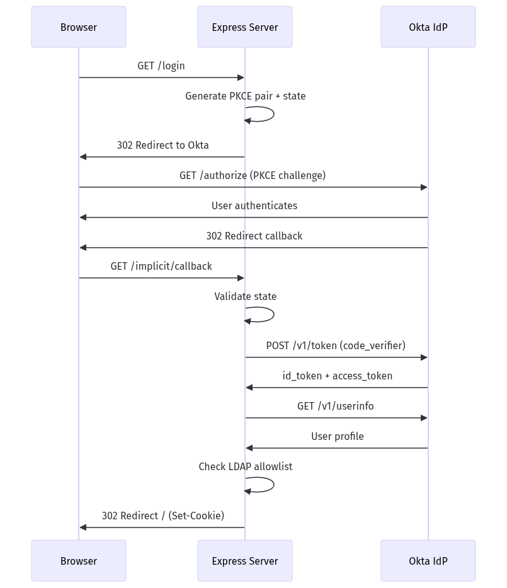
- Browser requests GET /login
- Server generates PKCE pair (64-byte code_verifier, SHA-256 code_challenge) + random state token
- Browser redirected to Okta /authorize with PKCE challenge
- User authenticates on Okta; Okta redirects back to /implicit/callback?code=X&state=Y
- Server validates state, exchanges code + code_verifier for tokens via POST /v1/token
- Server fetches user profile via GET /v1/userinfo
- Server checks LDAP against allowedUsers.json, creates session, sets autoagents.sid cookie

Query Lifecycle (Primary Threat Surface)
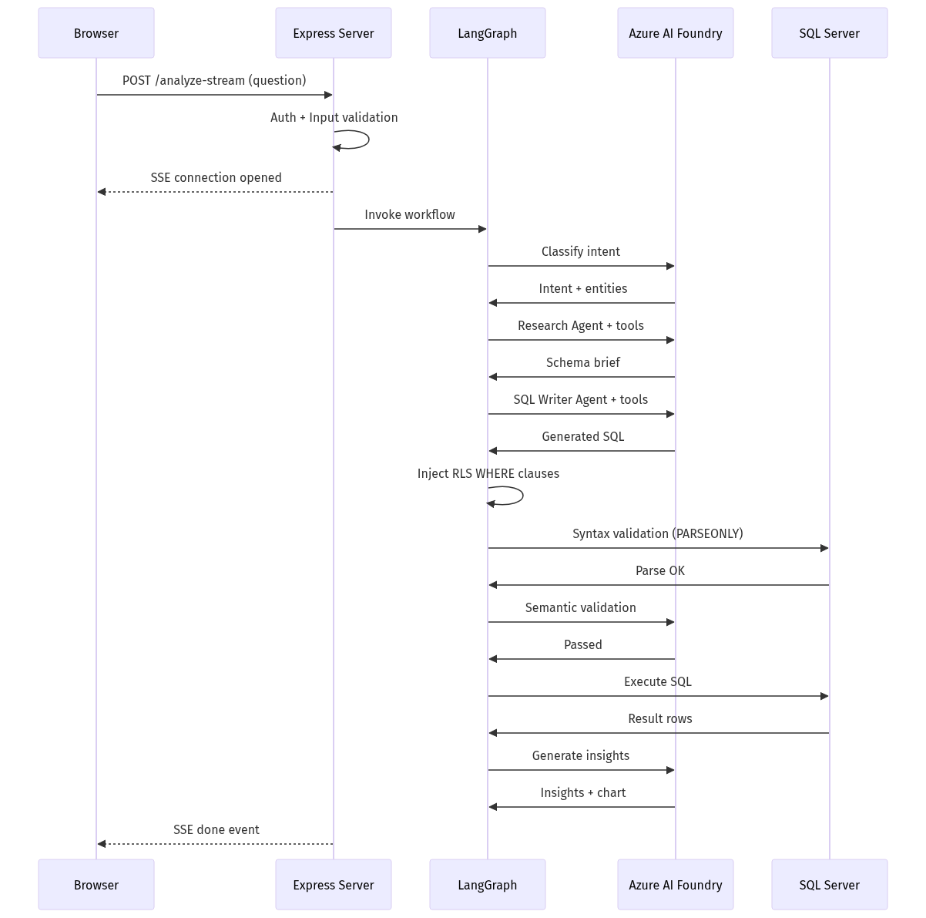
- Browser POSTs question to /api/text-to-sql/analyze-stream (SSE)
- Auth middleware validates session + LDAP allowlist
- Input validation (non-empty question, 5MB body limit)
- LangGraph workflow invoked: classify -> research -> write SQL -> inject RLS -> validate (4-pass) -> execute -> present
- SSE events streamed back: thinking, tool_call, tool_result, node_complete, insight_token, done
- Query results rendered in ChatPanel / DashboardOverlay

Trust Boundaries
Boundary | Protocol | Sensitive Data
Browser <-> Express Server | HTTPS/TLS, session cookie | Session cookie (httpOnly, secure, sameSite=lax)
Express Server <-> Okta IdP | HTTPS/TLS, OAuth tokens | id_token, access_token (stored server-side only)
Express Server <-> Azure AI Foundry | HTTPS/TLS, API key in header | API keys (env vars), user questions (prompt injection risk), generated SQL
Express Server <-> SQL Server | TDS (encrypted), SQL auth | DB credentials (env vars), query results (may contain PII)

1.5 Security

1.5.1 Authentication
- Okta OAuth 2.0 Authorization Code flow with PKCE (S256)
- PKCE: 64-byte random code_verifier, SHA-256 code_challenge (server/auth/pkce.js)
- State parameter: 16-byte random, validated on callback (CSRF protection for OAuth)
- Session: express-session with cookie name autoagents.sid
- Cookie attributes: httpOnly: true, secure: true (HTTPS/production), sameSite: lax
- Tokens stored server-side only (id_token, access_token in session — never exposed to client)

1.5.2 Authorization
- LDAP-based allowlist: server/config/allowedUsers.json
- Middleware requireAuthorization checks session has okta_user AND user LDAP is in allowlist
- Allowlist hot-reloaded on file mtime change (no restart needed)
- Public paths exempted: /api/health, /login, /implicit/callback, /logout, /api/auth/me
- Returns 401 for unauthenticated, 403 for unauthorized

1.5.3 Row-Level Security (RLS)
Automatic WHERE clause injection for 8 RLS-protected tables:
- Direct filter (REGION_ID): vw_TF_EBI_P2S, vw_TF_EBI_QUOTA, vw_TF_EBI_PIPE_WALK, vw_TF_EBI_CUSTOMER_SOLUTION_HEALTH_MOVEMENT
- Indirect filter (multi-step join): vw_TD_ICP_UCP_SCORES, TD_EBI_UCP_COMPETITORS, TD_EBI_REPORT_DX_ACCOUNT_PROFILE_OPG, TF_EBI_TPT_INFO
- Numeric IDs validated with Number.isFinite() before SQL interpolation
- String values escaped with single-quote doubling
- SQL comments stripped before RLS analysis (stripComments())
- Post-injection validation by rlsValidator.js (Pass 1 of validation pipeline)

1.5.4 Input Validation
Input | Validation
Request body size | 5MB limit (express.json({ limit: '5mb' }))
question field | Must be non-empty string
Dashboard columns | Regex whitelist: /^[a-zA-Z_][a-zA-Z0-9_]*$/, max 20 columns
Dashboard pageSize | Numeric, clamped 1–200
Dashboard mode | Strict allowlist: ['page', 'distinct']
Impersonate q | Minimum 2 characters
Impersonate limit | Capped at 50

1.5.5 SQL Injection Prevention
- Impersonate search: fully parameterized queries (request.input('query', TYPES.NVarChar, ...))
- RLS injector: numeric IDs validated via Number.isFinite(), strings escaped via replace(/'/g, "''")
- Query executor: ensureTopLimit() caps result rows at 1000
- Syntax validation: SET PARSEONLY ON prevents execution during dry-run

1.5.6 LLM Security
- Prompt injection risk: user questions are sent directly to LLM as part of prompts
- Model calls go through Azure AI Foundry (adds Azure's security layer)
- LLM-generated SQL is validated through the 4-pass pipeline before execution
- Agent tools are read-only (schema exploration — no DDL/DML writes)
- Guard rails: max 15 iterations for SQL agent, 3 correction rounds, 2 result retries

1.5.7 Encryption
- HTTPS/TLS for server (self-signed or provided certs via SSL_CERT_PATH, SSL_KEY_PATH)
- TDS encrypted connection to SQL Server (mssql driver default)
- Session cookie marked secure: true in HTTPS/production mode

1.5.8 Security Headers (Helmet.js)
- X-Frame-Options (clickjacking protection)
- X-Content-Type-Options: nosniff
- Strict-Transport-Security (HSTS)
- Content-Security-Policy (default Helmet CSP)
- X-XSS-Protection
- Referrer-Policy

1.5.9 CORS
- Whitelist-based: ALLOWED_ORIGINS env var (comma-separated)
- credentials: true for cookie-based auth

1.5.10 Logging and Audit
- Console-based structured logger with levels (debug/info/warn/error)
- Login audit trail: username, LDAP, timestamp (UTC + local), success/failure
- Token usage tracking per request (cost, latency)
- Security events: auth failures, validation failures, execution errors

1.5.11 Security Findings
Severity | Finding | Details
HIGH | Dashboard-data SQL pass-through | POST /api/text-to-sql/dashboard-data accepts a sql field from the client and executes it against the database. Column names are regex-validated, but the base SQL is not re-validated or RLS-re-injected. If arbitrary SQL reaches this endpoint, it is a direct SQL injection vector.
HIGH | No rate limiting | No request-level rate limiting on any endpoint. SSE connections could exhaust server resources.
HIGH | IDOR on thread history | GET /api/text-to-sql/history/:threadId has no ownership verification. Any authenticated user can access any thread's history.
MEDIUM | Default session secret | Fallback 'auto-agents-session-secret-change-in-production' if SESSION_SECRET env var is not set (server/index.js:89).
MEDIUM | Impersonation without role-based authorization | Any authenticated user can impersonate any FLM/Rep/SLM/TLM without role-based checks on who can impersonate whom.
MEDIUM | In-memory session store | Sessions not persistent across restarts; no Redis/DB backing. No explicit TTL/expiry configured.
MEDIUM | RLS only applied with impersonation | RLS WHERE clauses are only injected when impersonateContext is provided. Without impersonation, queries run without row-level filtering.
LOW | Health endpoint info disclosure | Error messages in /api/health may reveal internal infrastructure details (DB host, LLM endpoint status).
LOW | /api/auth/me returns full Okta userinfo | May expose more user attributes than necessary.
INFO | No CSRF tokens | Relies solely on sameSite=lax cookie attribute.
INFO | trustServerCertificate option | When DB_TRUST_SERVER_CERT is enabled, DB connections skip certificate validation.

1.6 API Details

POST /api/text-to-sql/analyze
Attribute | Detail
Auth | Required (session + LDAP allowlist)
Request Body | { question: string, conversationHistory: array, previousEntities: object, resolvedQuestions: array, impersonateContext: {type, id}, validationEnabled: boolean, isFollowUp: boolean, enabledTools: object, useFastModel: boolean }
Headers | x-session-id (optional, for session memory keying)
Response | JSON: intent, SQL, execution results, insights, chart spec, usage metrics
Input Validation | question must be non-empty string
Sensitive Data | Query results may contain PII; generated SQL exposed; token usage/cost in response
IDOR Risk | x-session-id is user-controllable; impersonateContext allows querying as another user
Note | validationEnabled flag can bypass the entire validation pipeline

POST /api/text-to-sql/analyze-stream
Attribute | Detail
Auth | Required
Request Body | Same as /analyze plus presentMode, previousDashboardSpec, dashboardDataSources
Response | SSE stream (text/event-stream): thinking, tool_call, tool_result, node_complete, insight_token, query_plan, query_progress, dashboard_progress, done, error
Security Notes | SSE keeps connection open — resource exhaustion risk without rate limiting. Events filtered by sessionId.

POST /api/text-to-sql/dashboard-data
Attribute | Detail
Auth | Required
Request Body | { mode: "page"|"distinct", sql: string, page: number, pageSize: number, columns: string[] }
Input Validation | sql must be non-empty; mode in ['page', 'distinct']; columns regex-validated; pageSize clamped 1–200
SECURITY CONCERN (HIGH) | The sql field is passed directly from the client and executed. No server-side re-validation or RLS re-injection.

GET /api/text-to-sql/history/:threadId
Attribute | Detail
Auth | Required
Response | { threadId, checkpoints: [{id, timestamp, source, step, state}] }
IDOR Risk | No ownership check — any authenticated user can access any threadId

GET /api/impersonate/search?q=<query>&limit=<n>
Attribute | Detail
Auth | Required
Input Validation | q >= 2 chars; limit capped at 50
SQL Injection | Fully parameterized — safe
Response | [{ name, role, impersonateType, impersonateId }] — returns employee names/roles (PII)

GET /login
Attribute | Detail
Auth | Not required (public)
Action | Generates PKCE pair + state, stores in session, redirects to Okta authorize URL

GET /implicit/callback
Attribute | Detail
Auth | Not required (public)
Action | Validates state, exchanges code for tokens with PKCE, fetches userinfo, checks LDAP

GET /logout
Attribute | Detail
Auth | Not required (public)
Action | Destroys session, redirects to /login

GET /api/auth/me
Attribute | Detail
Auth | Not required (returns 401 if no session)
Response | Full Okta userinfo object (may contain more fields than necessary)

GET /api/health
Attribute | Detail
Auth | Not required (public)
Response | { server, database, llm } status. Error messages may leak internal details.

1.7 Code Pointers
Area | File Path | Description
Server entry + middleware | server/index.js | Express setup: Helmet, CORS, session, auth middleware, body limits
Authentication flow | server/routes/auth.js | Okta OAuth routes: /login, /implicit/callback, /logout, /api/auth/me
PKCE implementation | server/auth/pkce.js | Code verifier / challenge generation (SHA-256)
Authorization middleware | server/auth/requireAuth.js | Session + LDAP allowlist check, 401/403 responses
Login audit | server/auth/logUserLogin.js | Login event logging with timestamps
Main API routes | server/routes/textToSql.js | /analyze, /analyze-stream, /dashboard-data, /history
Impersonate API | server/routes/impersonate.js | Parameterized user search for RLS impersonation
Health check | server/routes/health.js | Public health endpoint (DB + LLM connectivity)
LangGraph workflow | server/graph/workflow.js | Pipeline definition, node routing logic, conditional edges
Workflow state | server/graph/state.js | State channel definitions (Annotation API)
RLS injection | server/utils/rlsInjector.js | SQL rewriting for row-level security (8 tables)
RLS validation | server/validation/rlsValidator.js | Validates RLS filters are present in generated SQL
Syntax validation | server/validation/syntaxValidator.js | SET PARSEONLY ON dry-run against SQL Server
Schema validation | server/validation/schemaValidator.js | Column and table name verification
Semantic validation | server/validation/semanticValidator.js | LLM-based logic review of SQL correctness
Validation orchestrator | server/validation/validator.js | 4-pass validation pipeline orchestration
Query execution | server/services/queryExecutor.js | SQL execution with TOP limit + timeout
Database config | server/config/database.js | SQL Server connection pool (mssql)
LLM config | server/config/llm.js | Model routing (Opus/Haiku), token tracking, API key handling
Constants | server/config/constants.js | Timeouts, limits, model profiles, cost rates
Allowed users | server/config/allowedUsers.json | LDAP allowlist for authorization
Error classes | server/utils/errors.js | Typed error hierarchy
Logger | server/utils/logger.js | Console-based structured logging
Session memory | server/memory/sessionMemory.js | In-memory per-session query history
Agent tools | server/tools/ | 22 tools for research + SQL writing agents
Knowledge files | server/context/knowledge/ | Schema JSON, business rules MD, join rules, KPIs
Client API | client/src/utils/api.js | Fetch + SSE client with credential handling
Client entry | client/src/App.jsx | React SPA root component
Vite proxy | client/vite.config.js | Dev proxy to Express server (5174 -> 5000)

