DETAILED DIAGNOSTIC REPORT
Property: Flat No-8/63, Yamuna CHS, Mulund
Generated on: 18 April 2026
────────────────────────────────────────────────────────────────────────────────

# Detailed Diagnostic Report (DDR)

## 1. PROPERTY ISSUE SUMMARY
The property exhibits multiple issues primarily related to dampness, seepage, and cracks. Key areas affected include the Hall, Bedrooms, Kitchen, and Common Bathroom, with notable dampness at skirting levels and walls. Seepage is evident in the Parking Area, and there are cracks in the external wall near the Master Bedroom. These issues indicate potential plumbing problems and inadequate waterproofing.

## 2. AREA-WISE OBSERVATIONS

### Hall
- **Visual Damage Observed:** Dampness at skirting level.
- **Thermal Camera Confirmation:** Hotspot 28.8°C, Coldspot 23.4°C (27/09/22).
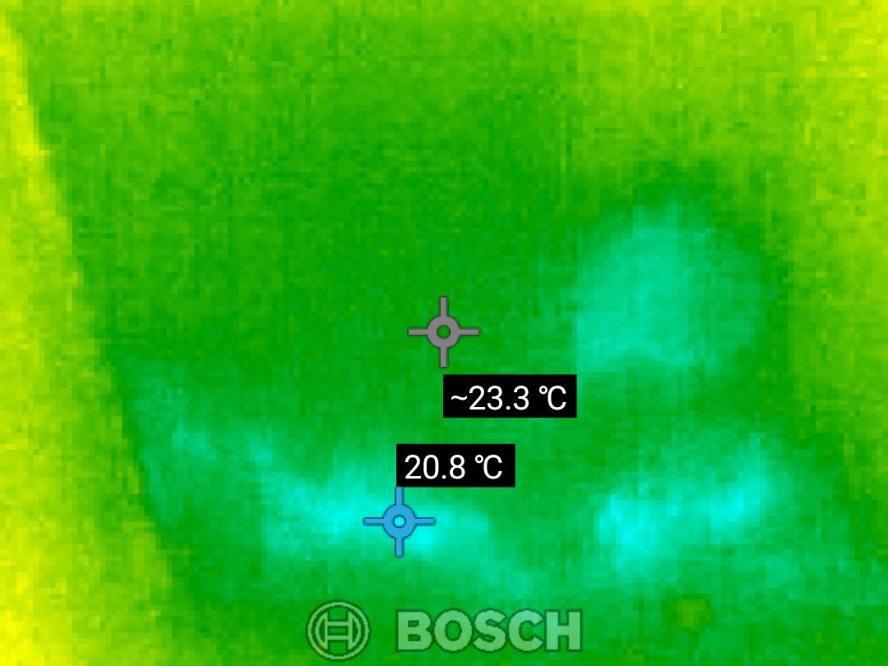
[Thermal Report - Page 1] - **Note:** Hall

### Bedroom
- **Visual Damage Observed:** Dampness at skirting level.
- **Thermal Camera Confirmation:** Hotspot 25.5°C, Coldspot 20.5°C (27/09/22).
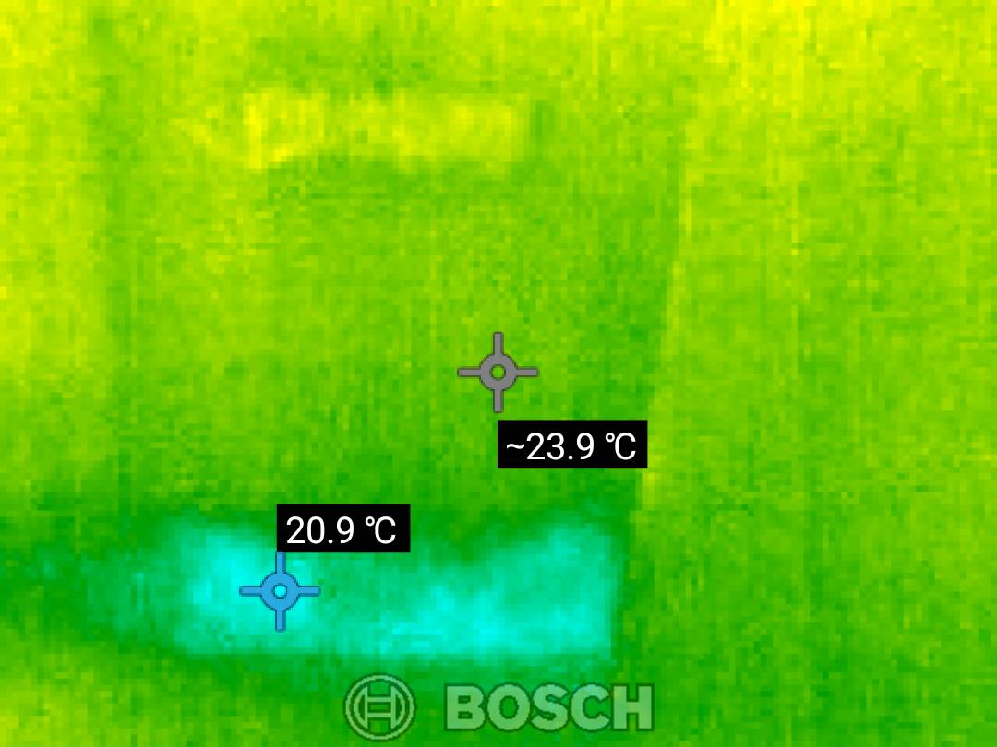
[Thermal Report - Page 1] - **Note:** Bedroom

### Kitchen
- **Visual Damage Observed:** Dampness at skirting level.
- **Thermal Camera Confirmation:** Hotspot 27.0°C, Coldspot 22.0°C (27/09/22).
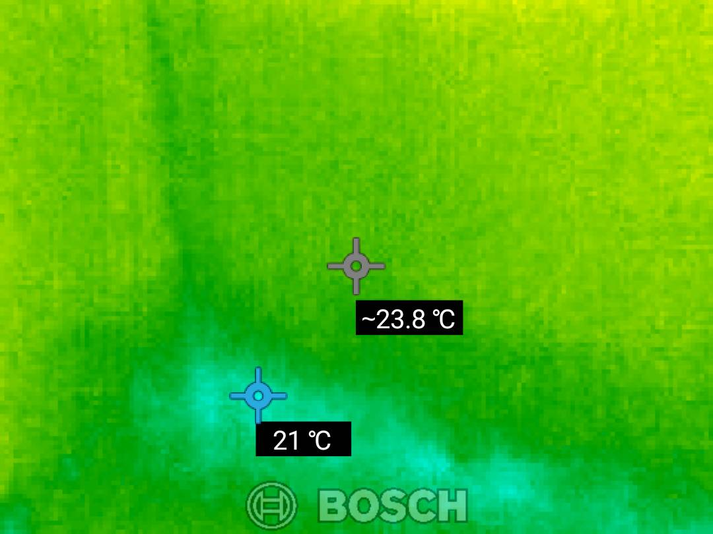
[Thermal Report - Page 1] - **Note:** Kitchen

### Master Bedroom
- **Visual Damage Observed:** Dampness on the wall and skirting level.
- **Thermal Camera Confirmation:** Hotspot 25.5°C, Coldspot 20.5°C (27/09/22).
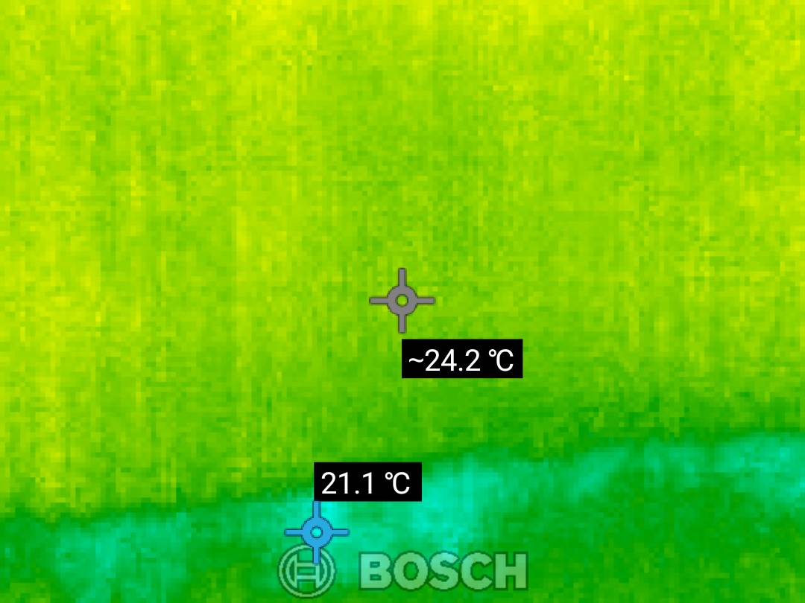
[Thermal Report - Page 1] - **Note:** Master Bedroom

### Parking Area
- **Visual Damage Observed:** Seepage noted.
- **Thermal Camera Confirmation:** Not specifically measured.
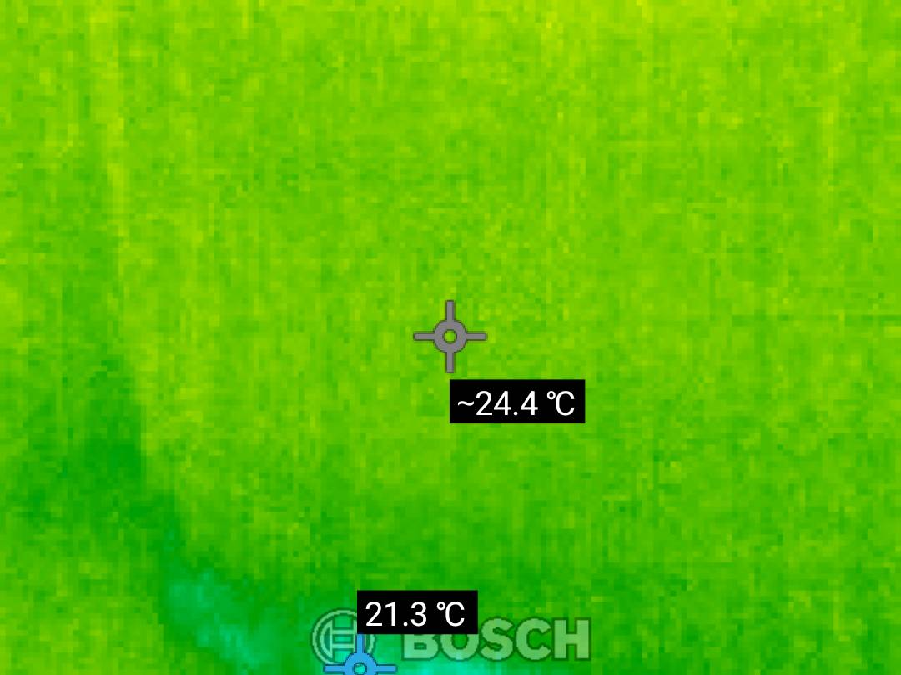
[Thermal Report - Page 1] - **Note:** Parking Area

### Common Bathroom
- **Visual Damage Observed:** Dampness on the ceiling.
- **Thermal Camera Confirmation:** Hotspot 25.7°C, Coldspot 20.7°C (27/09/22).
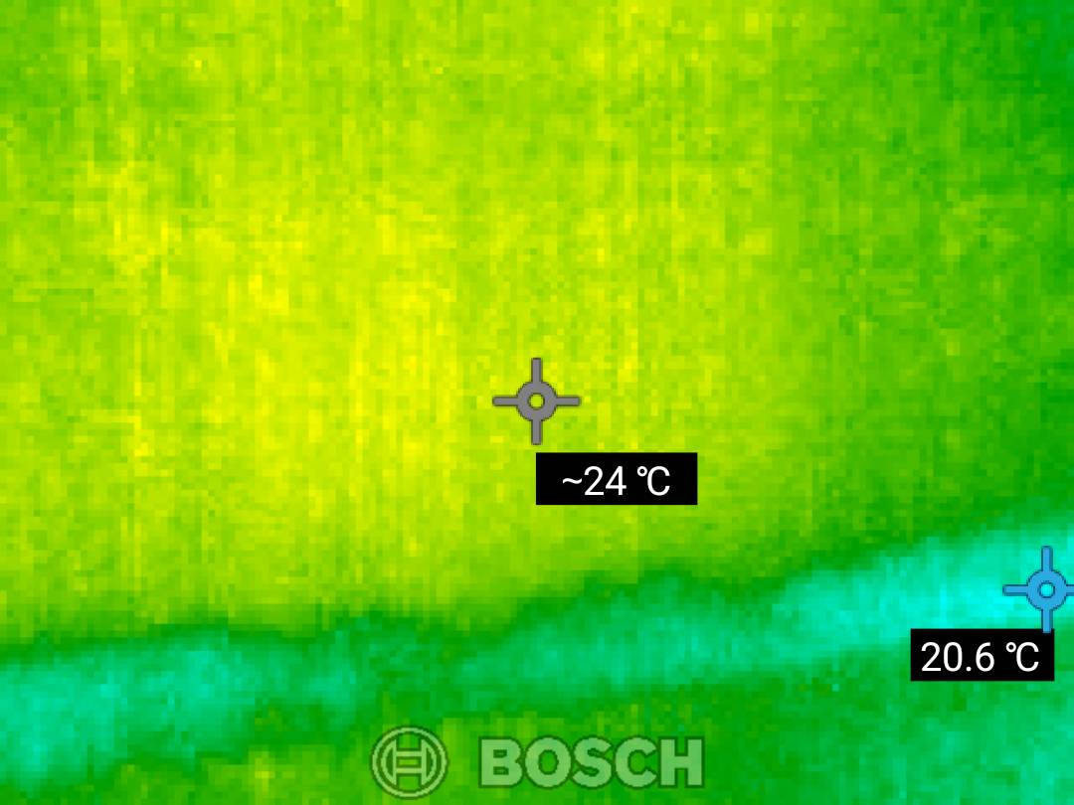
[Thermal Report - Page 1] - **Note:** Common Bathroom

## 3. PROBABLE ROOT CAUSE
- **Dampness:** Likely due to inadequate waterproofing and poor drainage, leading to moisture accumulation at skirting levels and walls.
- **Seepage:** Possibly caused by plumbing leaks or external water intrusion.
- **Cracks:** May result from structural settling or inadequate construction practices.

## 4. SEVERITY ASSESSMENT
- **Hall:** HIGH - Significant dampness affecting the skirting.
- **Bedroom:** HIGH - Dampness at skirting level could lead to mold growth.
- **Kitchen:** MEDIUM - Dampness present but less severe than other areas.
- **Master Bedroom:** HIGH - Dampness on the wall could affect structural integrity.
- **Parking Area:** MEDIUM - Seepage indicates potential plumbing issues.
- **Common Bathroom:** MEDIUM - Dampness on the ceiling needs attention.

## 5. RECOMMENDED ACTIONS
- **Hall:** Treat dampness at skirting level with appropriate waterproofing solutions.
- **Bedroom:** Address dampness at skirting level and inspect for hidden leaks.
- **Kitchen:** Repair dampness at skirting level and ensure proper drainage.
- **Master Bedroom:** Treat wall dampness and inspect plumbing for leaks.
- **Parking Area:** Investigate and resolve seepage issues, possibly involving plumbing repairs.
- **Common Bathroom:** Repair ceiling dampness and check for plumbing leaks.

## 6. ADDITIONAL NOTES
- It is advisable to monitor the affected areas for any signs of mold growth due to prolonged dampness.
- Ensure that any repairs include adequate waterproofing to prevent future issues.

## 7. MISSING OR UNCLEAR INFORMATION
- Specific details regarding the extent of plumbing issues are not available.
- Thermal imaging data does not include measurements for the Parking Area, which may indicate a lack of thorough inspection in that section.
- All thermal imaging readings were taken on 27/09/22, and there are no discrepancies noted between documents regarding dates or properties.

APPENDIX: SUPPORTING IMAGES
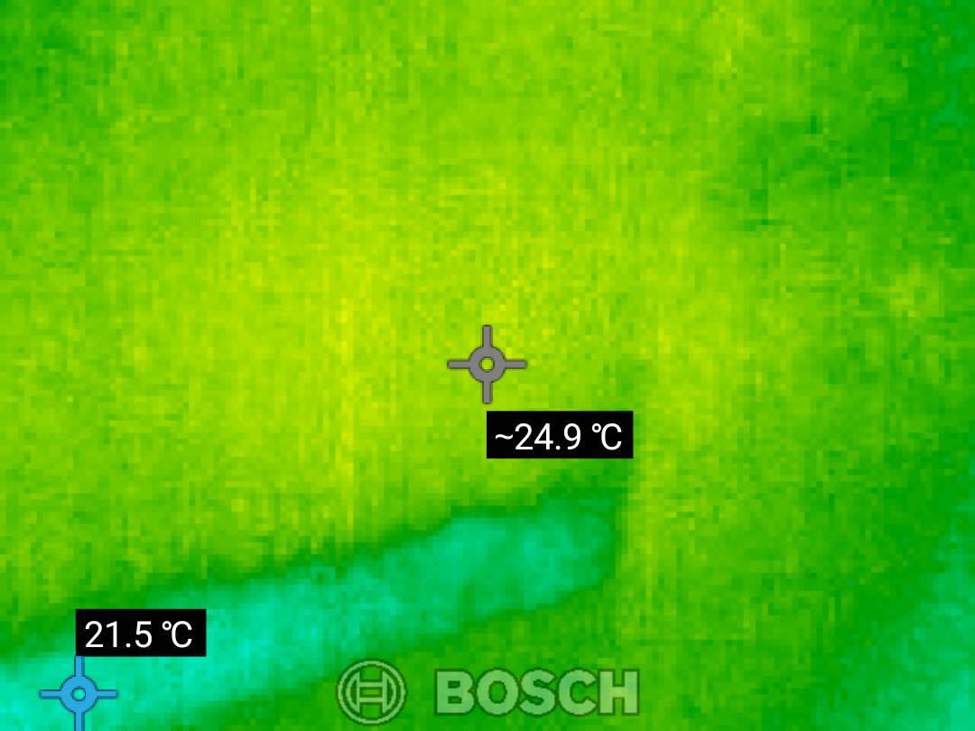
Source: Thermal Report — Page 1
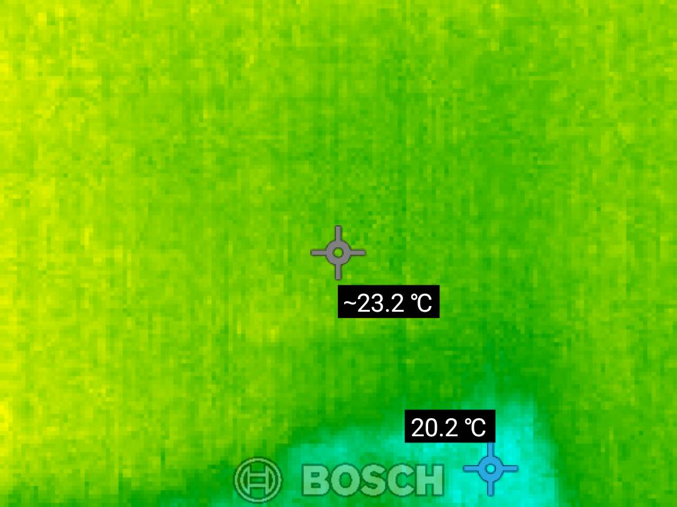
Source: Thermal Report — Page 1
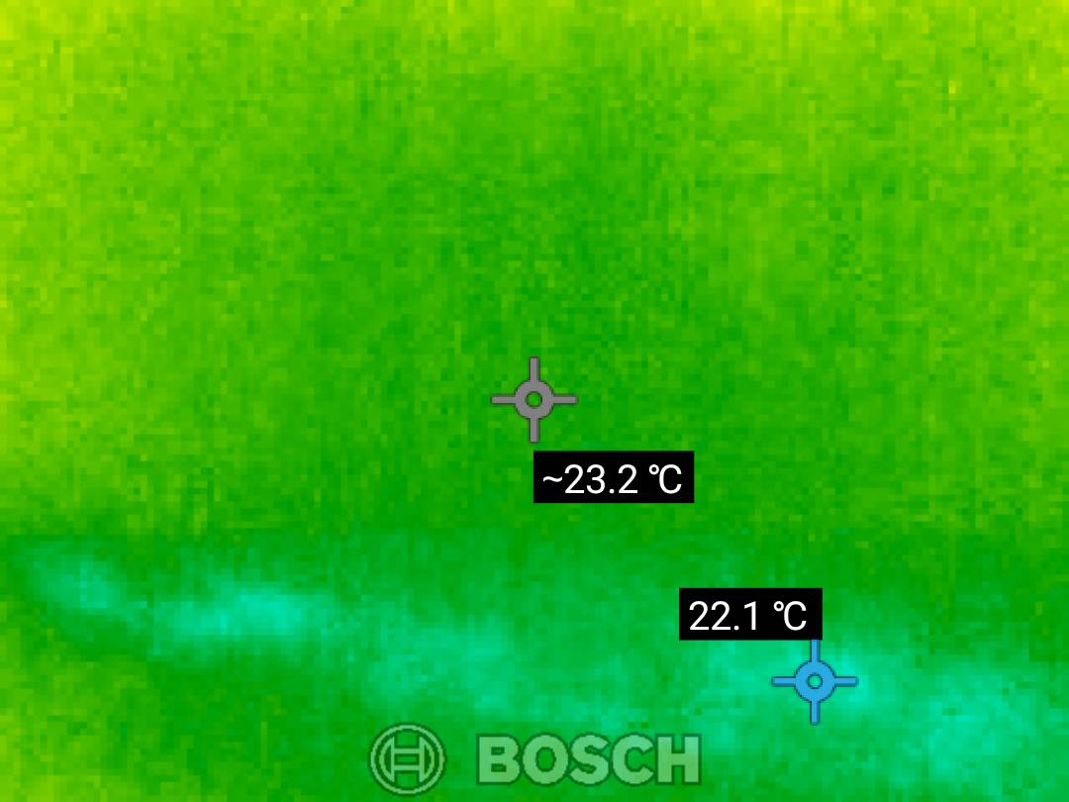
Source: Thermal Report — Page 1
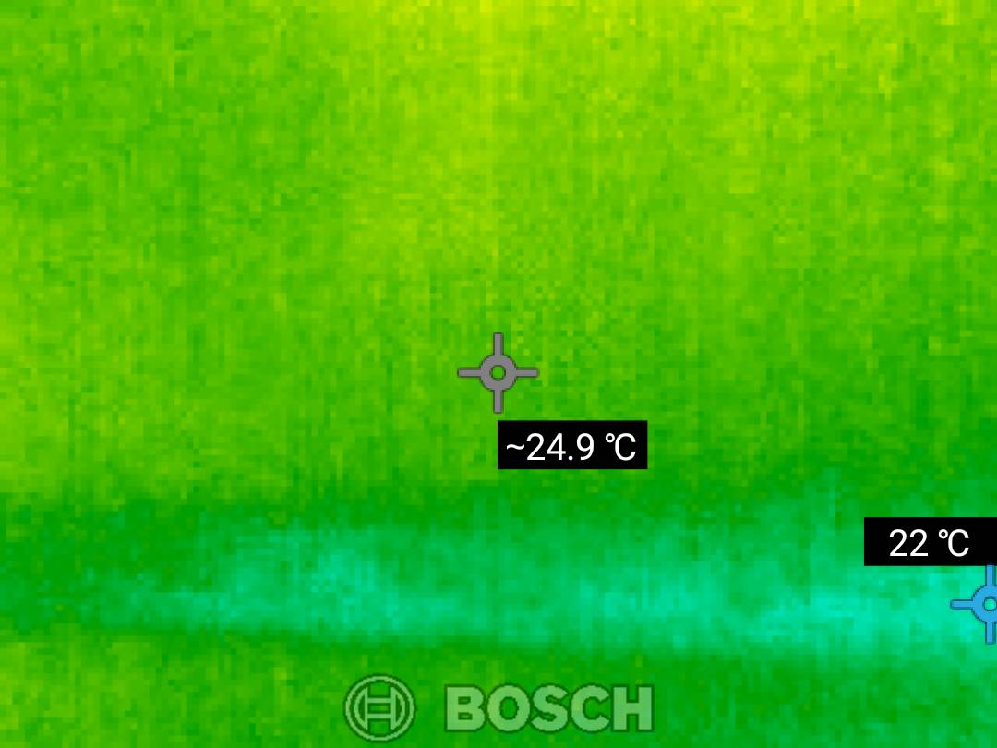
Source: Thermal Report — Page 1
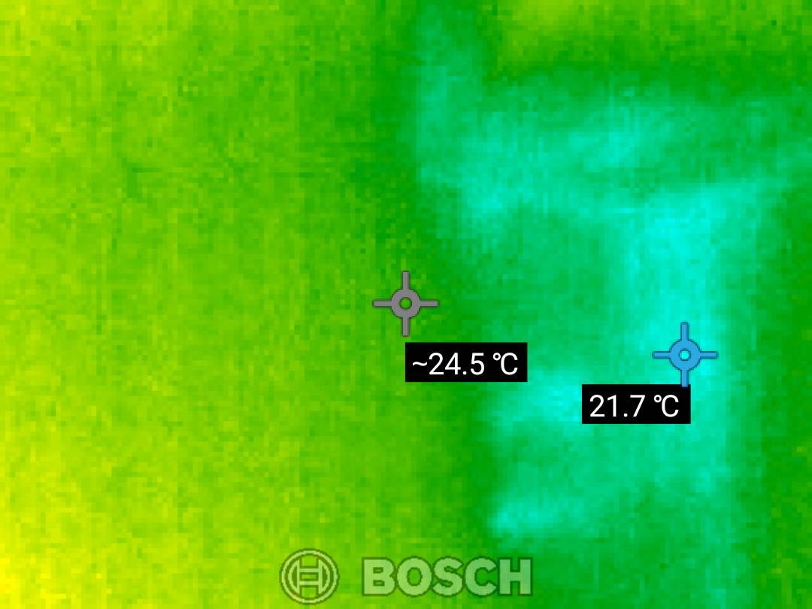
Source: Thermal Report — Page 1
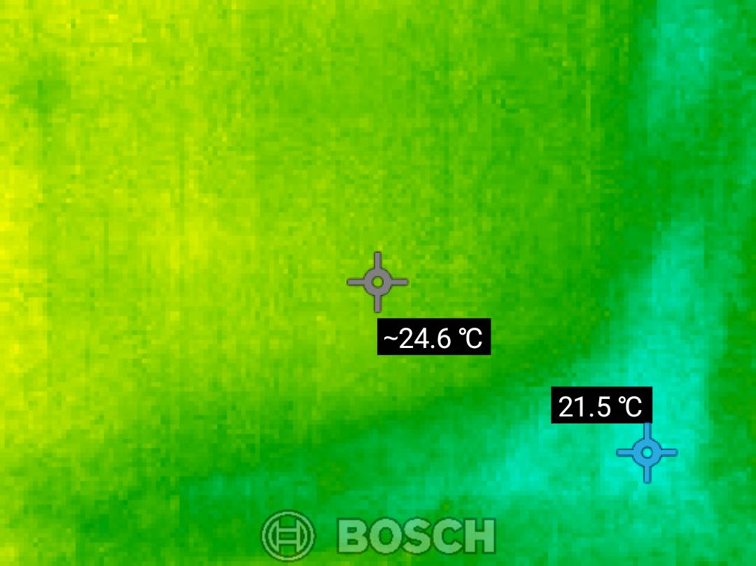
Source: Thermal Report — Page 1
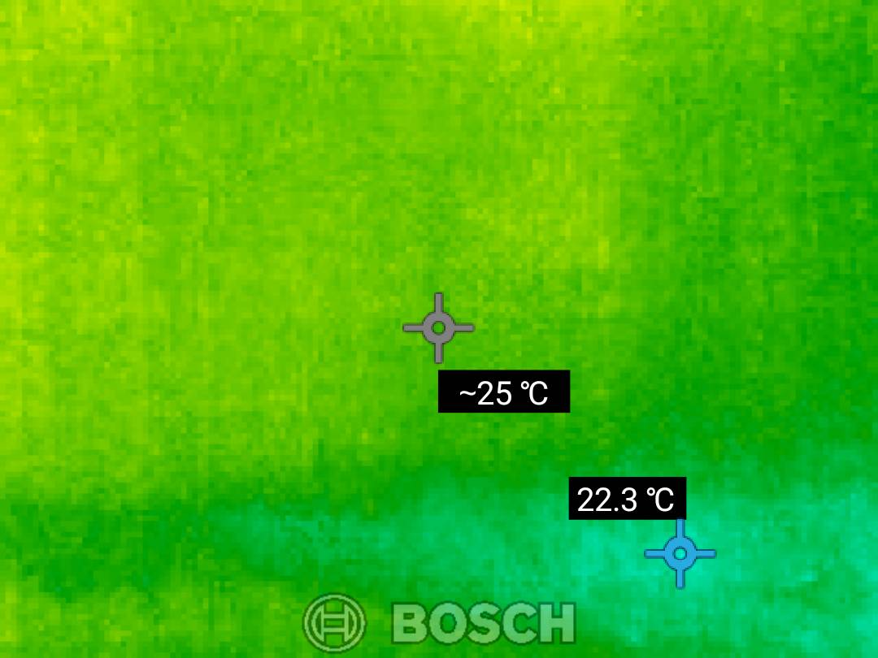
Source: Thermal Report — Page 1
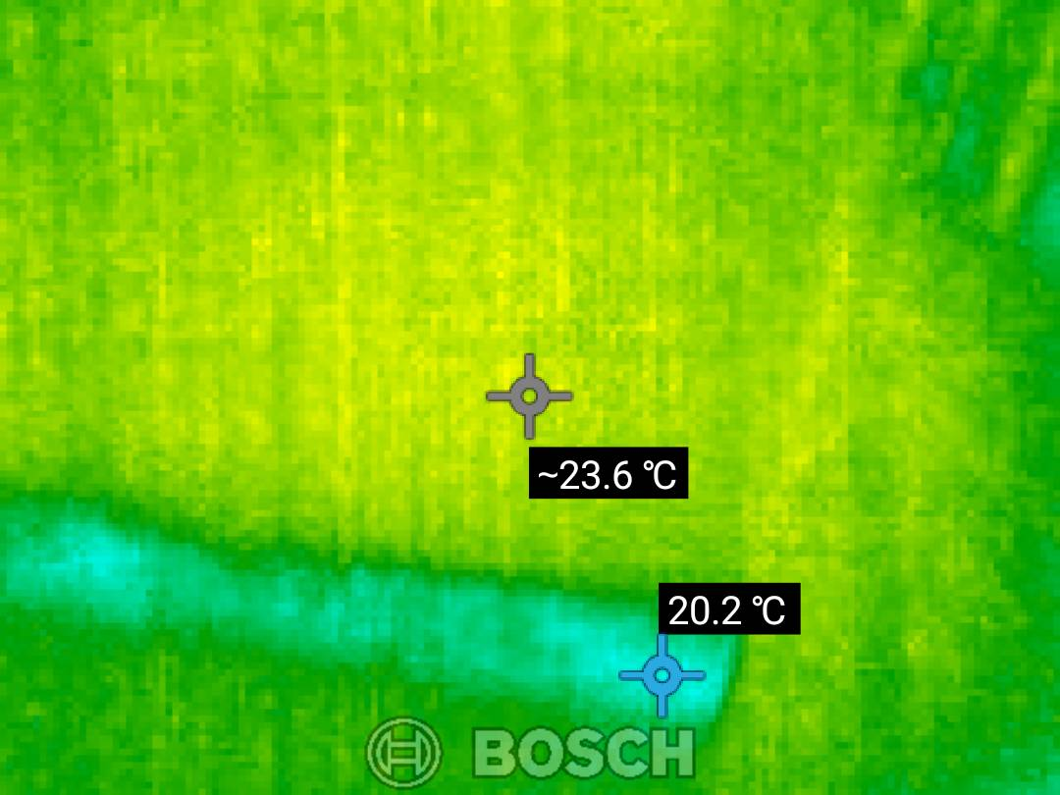
Source: Thermal Report — Page 1
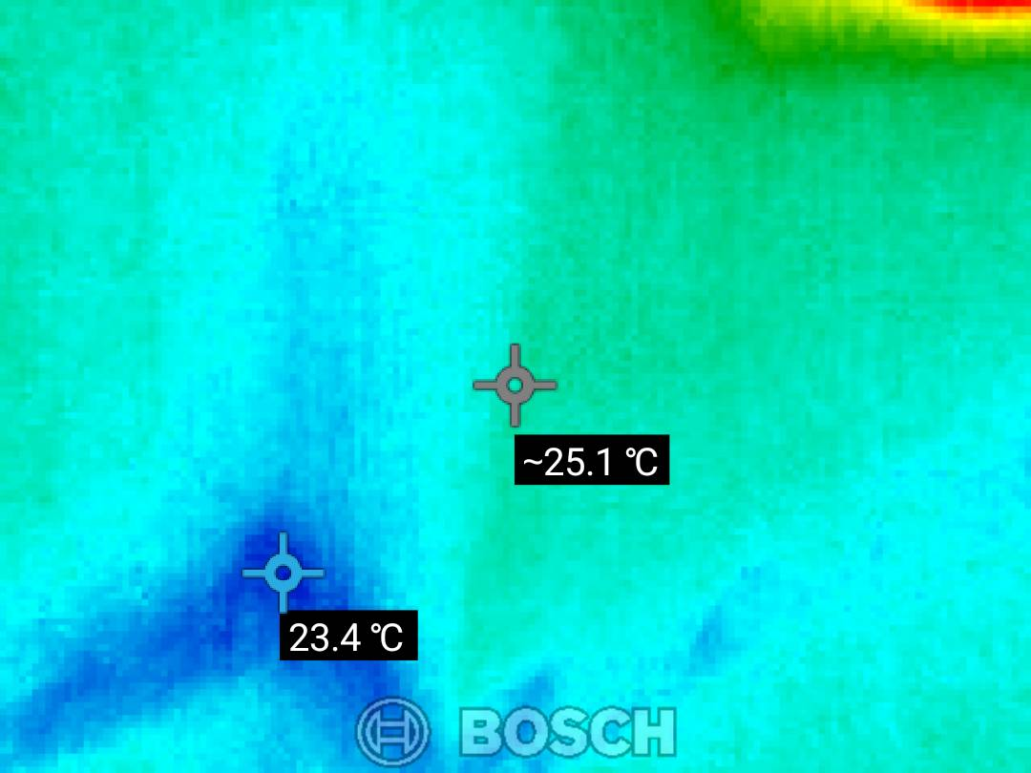
Source: Thermal Report — Page 1
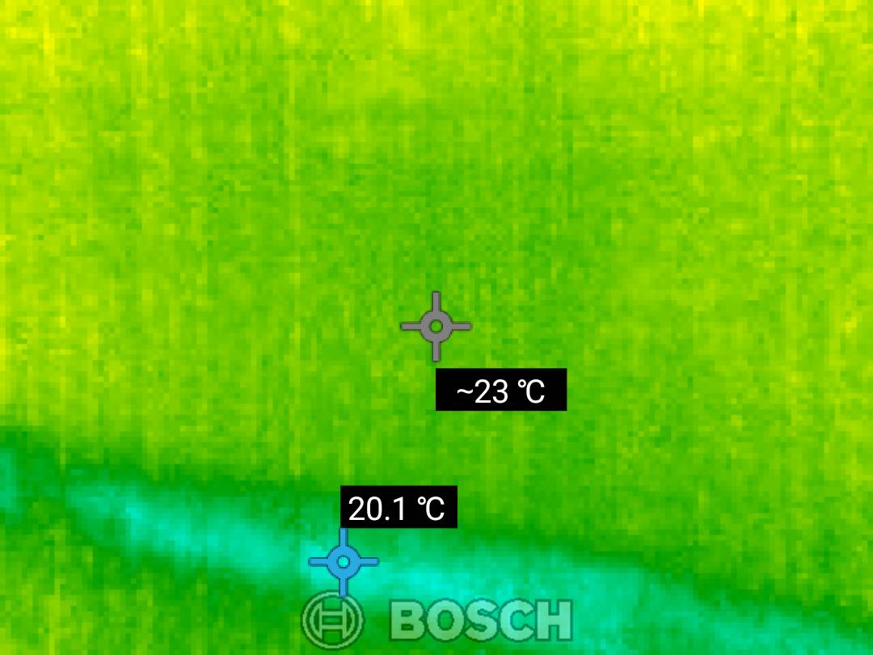
Source: Thermal Report — Page 1
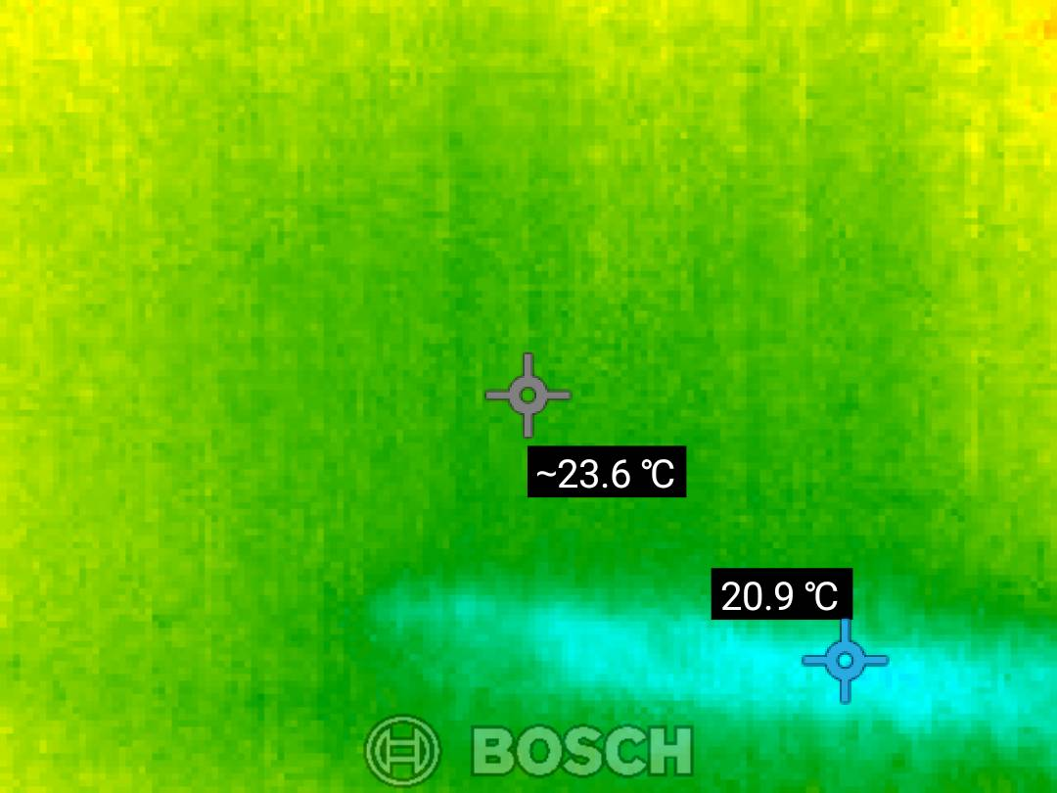
Source: Thermal Report — Page 1
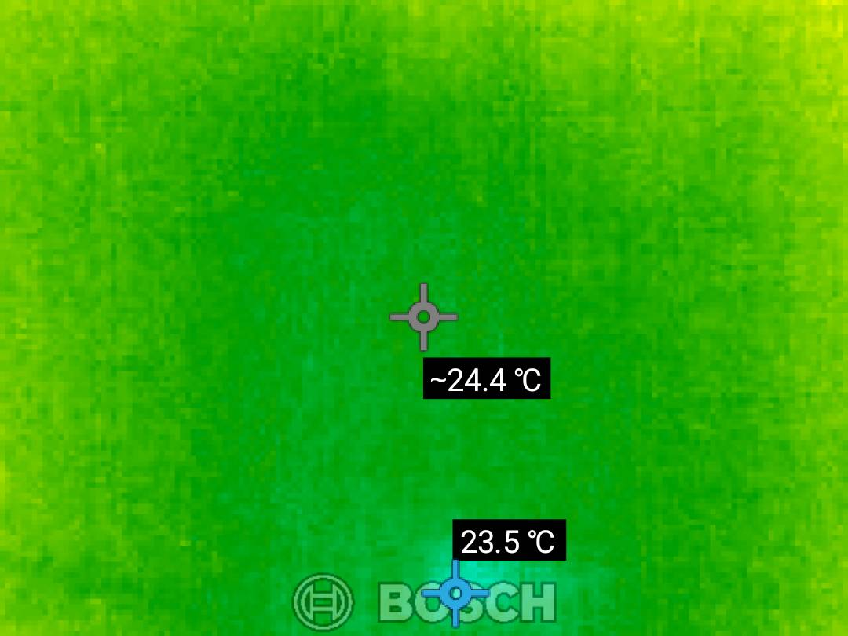
Source: Thermal Report — Page 1
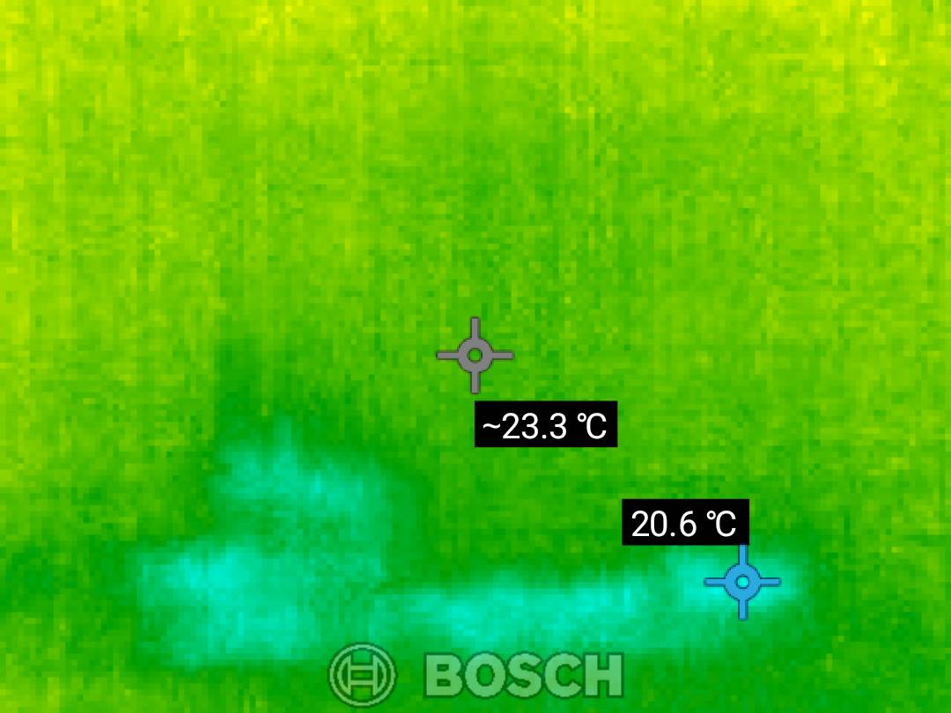
Source: Thermal Report — Page 1
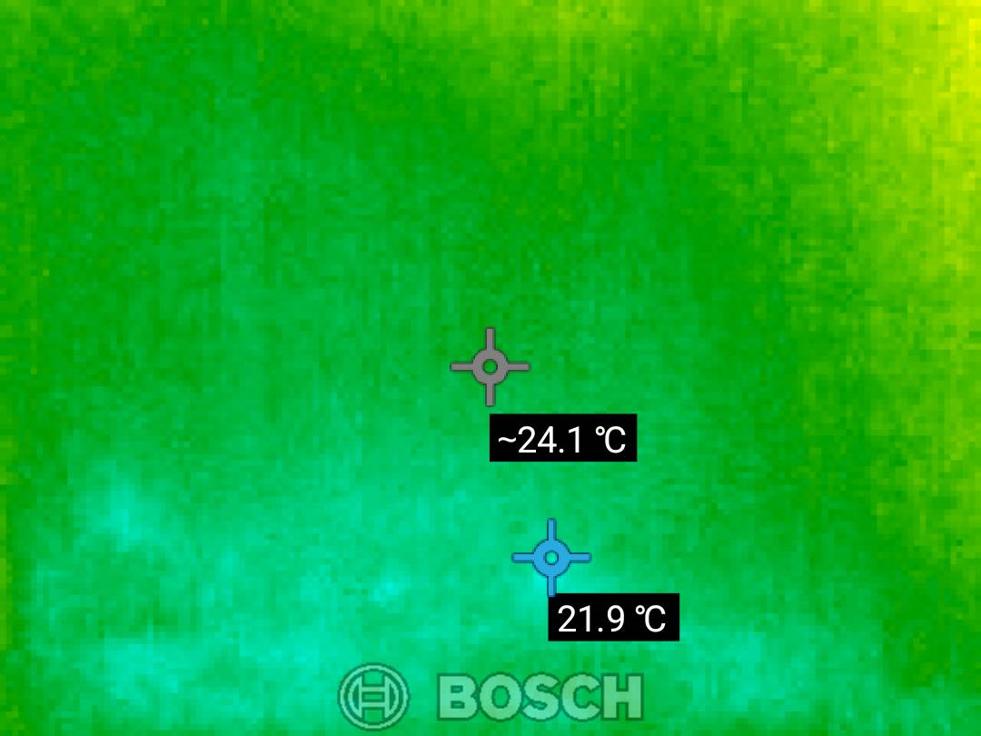
Source: Thermal Report — Page 1
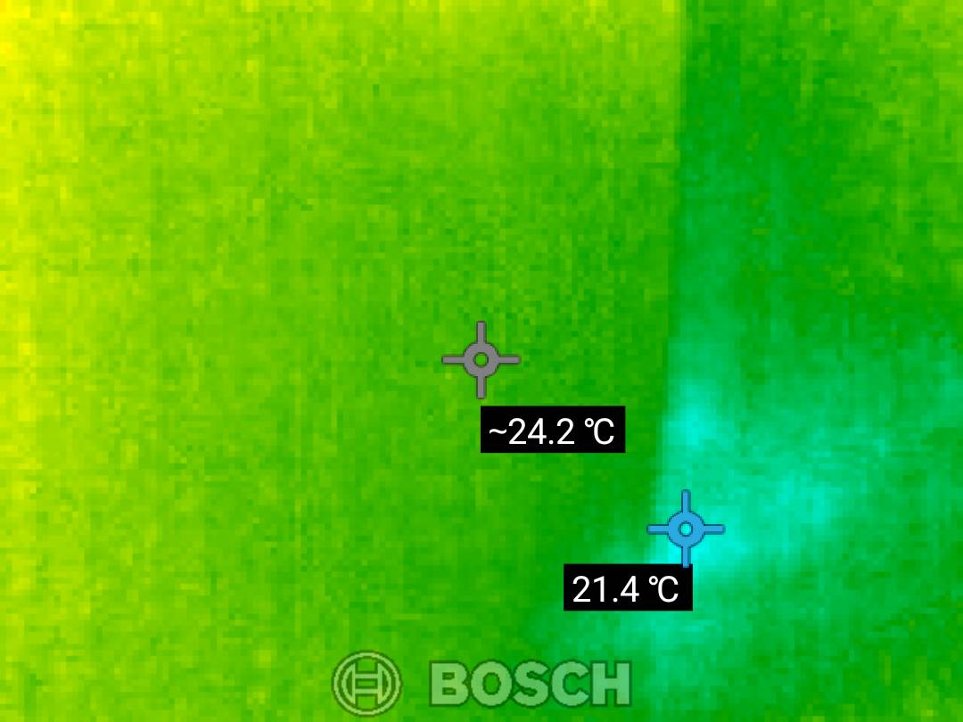
Source: Thermal Report — Page 1
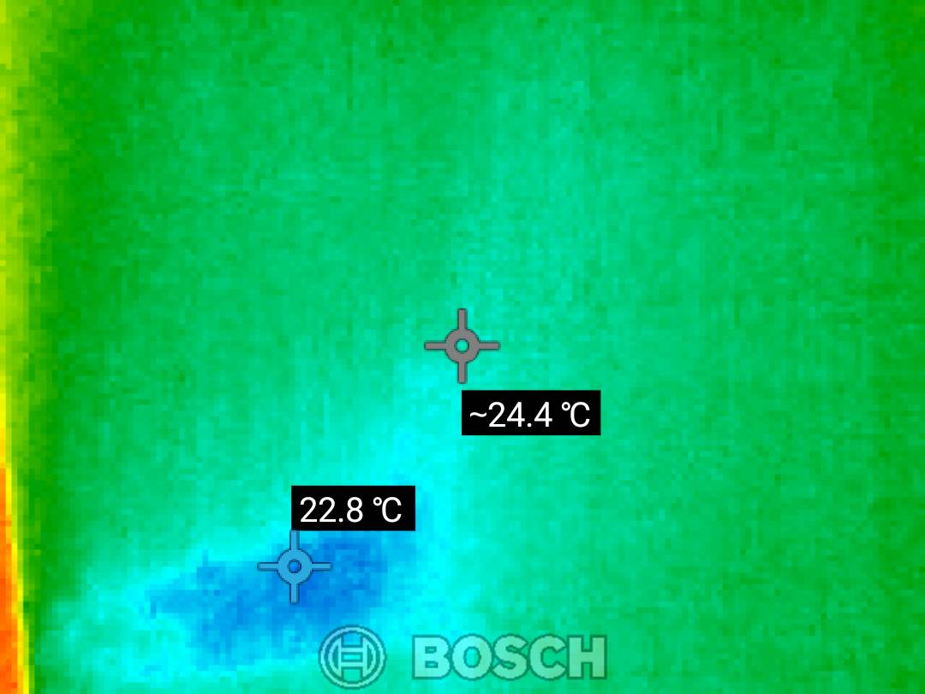
Source: Thermal Report — Page 1
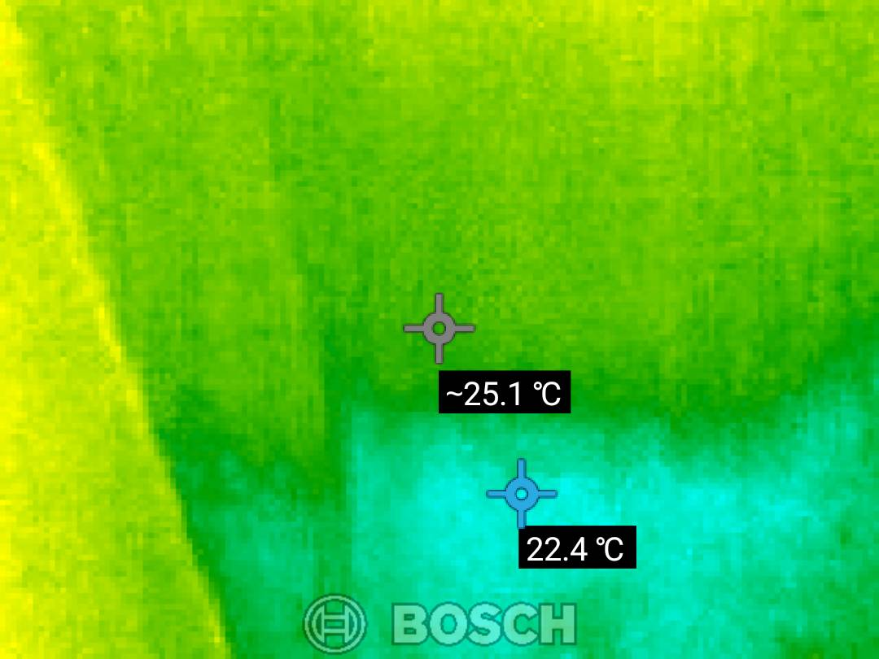
Source: Thermal Report — Page 1
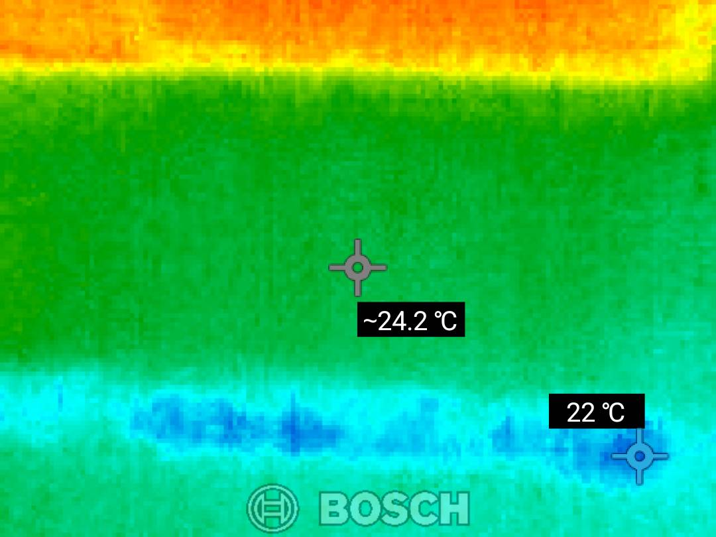
Source: Thermal Report — Page 1
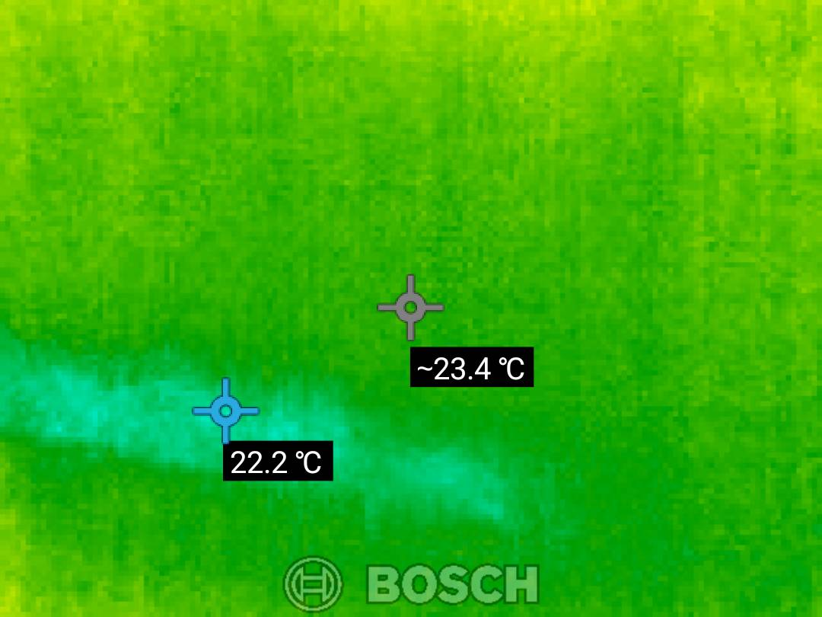
Source: Thermal Report — Page 1
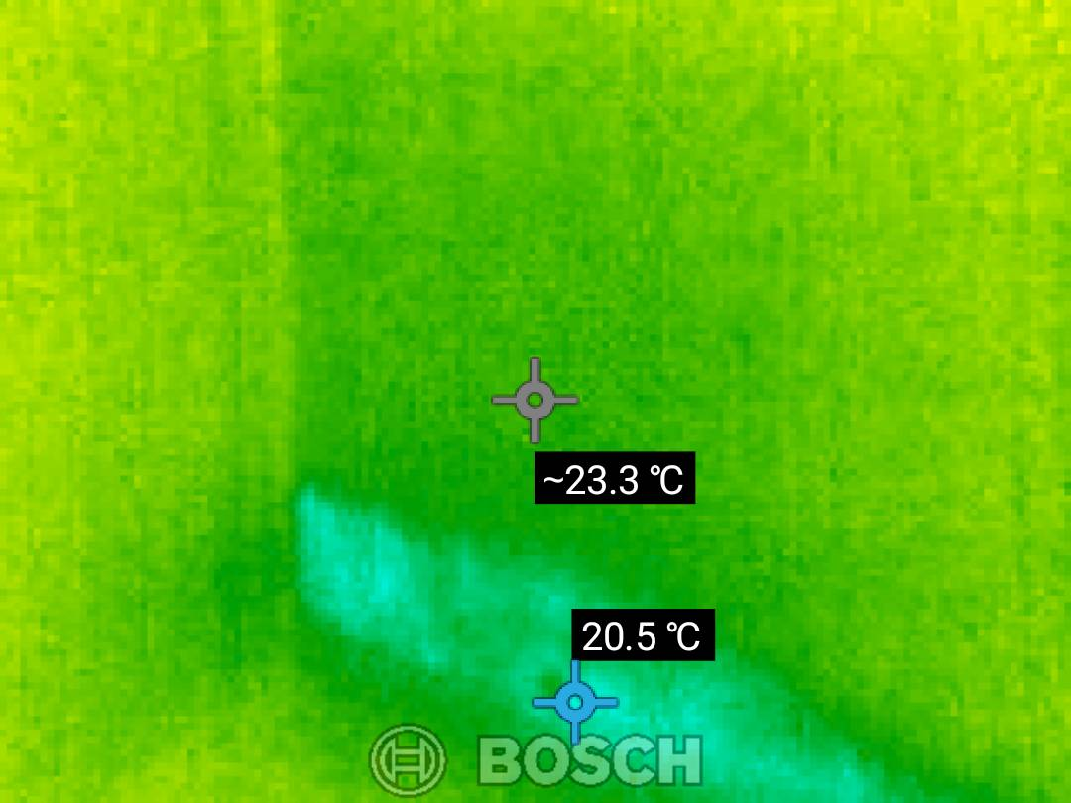
Source: Thermal Report — Page 1
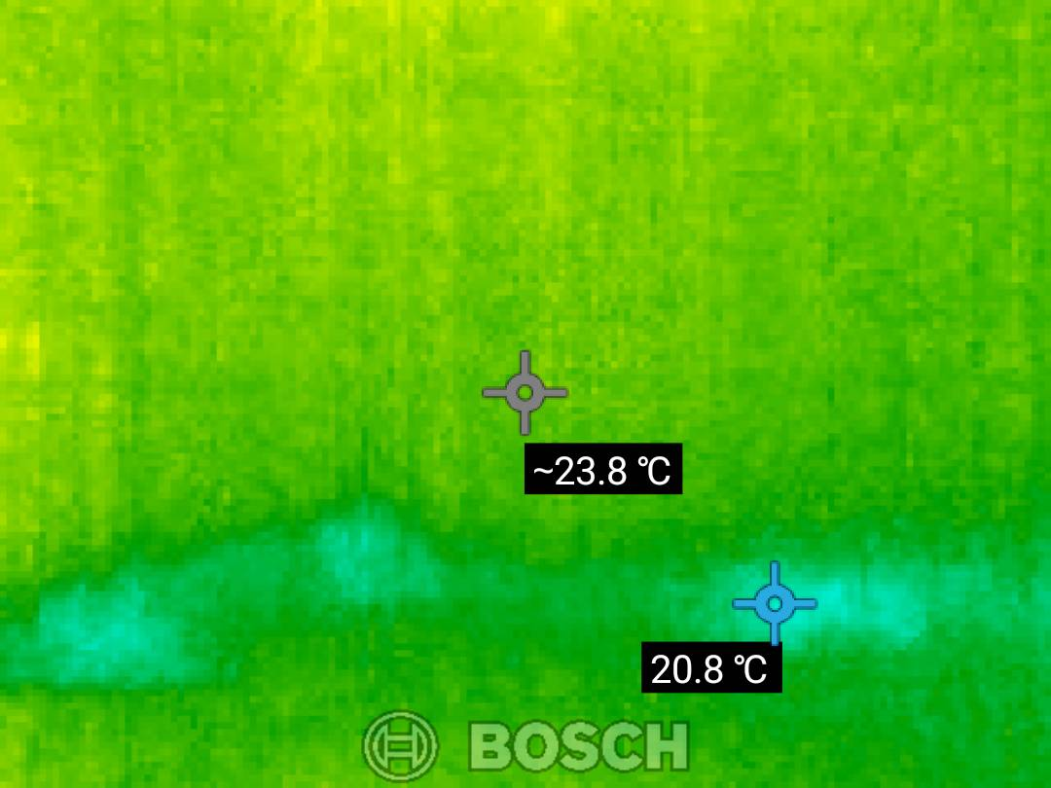
Source: Thermal Report — Page 1
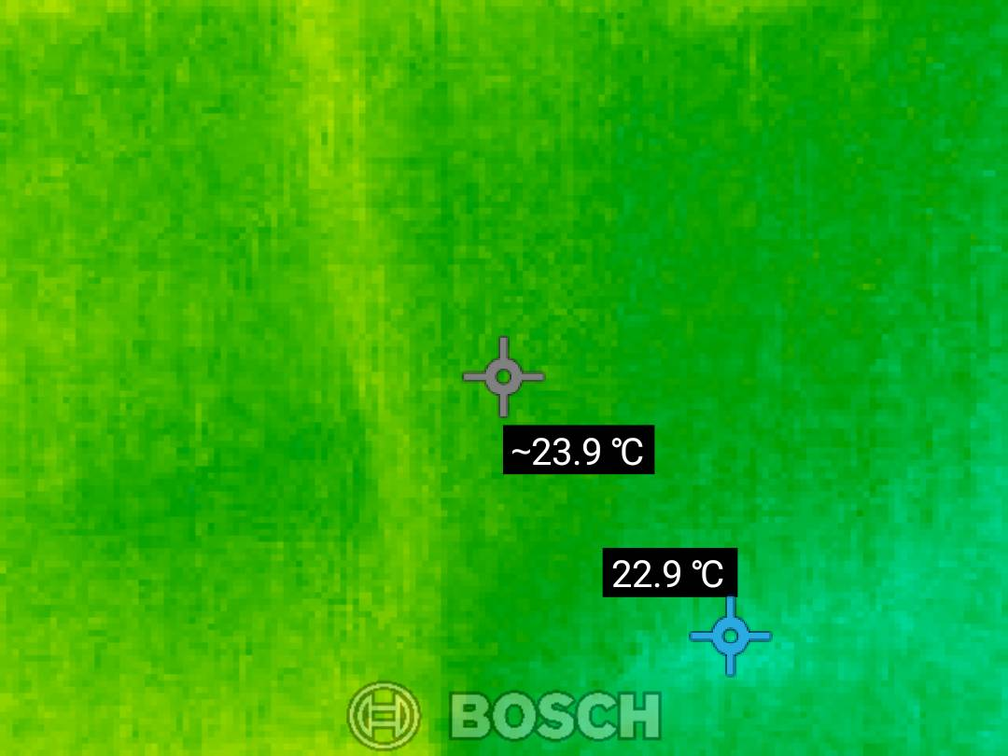
Source: Thermal Report — Page 1
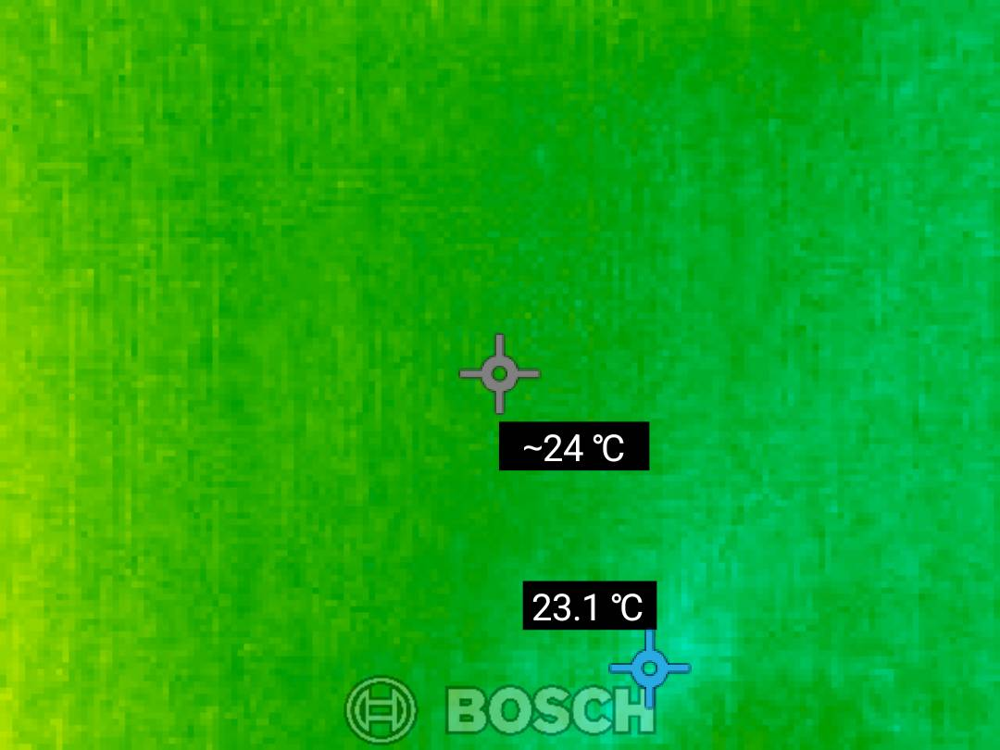
Source: Thermal Report — Page 1

────────────────────────────────────────────────────────────────────────────────
This report is generated by an AI-assisted system based on provided inspection and thermal documents. All findings should be verified by a qualified professional.

