## 36-Hrishikesh Kavale roll no 36

**Code:-**

<?php

echo "<h1>HRISHIKESH KAVALE 36</h1>";

echo "<h3>a. Write a PHP script to Calculate length of a string Without using string functions

</h3>";

$string = "Hrishikesh Kavale Roll no 36";

$string_length = 0; while(@$string[$string_length] !=

null){

$string_length++;

}

echo "Length of $string is

$string_length : ";

echo "<h3>b. Write PHP script to Count the number of words in string Without using string functions </h3>";

$words = explode(" ",

$string);

echo "The number of words in

$string are:- ".count($words);

echo "<h3>c. Write a simple PHP script to demonstrate following built-in functions:<br>

str_word_count( ), strlen( ), strrev( ), strpos( ), str_replace( ), ucwords( ),

strcmp( ), strtoupper( ), strtolower( ) </h3>";

echo "Length of $string using strlen() is:- ".strlen($string);

echo "<br>Words in $string using str_word_count() is:- ".str_word_count($string);

echo "<br>Printing Hello in reverse:- ".strrev("Hello");

echo "<br>Position of Kavale in $string is:- ".strpos($string,"Kavale");

echo "<br>Using replace function:- ".str_replace("no","number",$string)

;

echo "<br>".ucwords("hello world");

echo "<br>".strcmp("Hello","Hello1");

echo "<br>".strtoupper("hrishikesh kavale");

echo "<br>".strtolower("HRISHIKEsH Kavale");

?>

## 36-Hrishikesh Kavale roll no 36

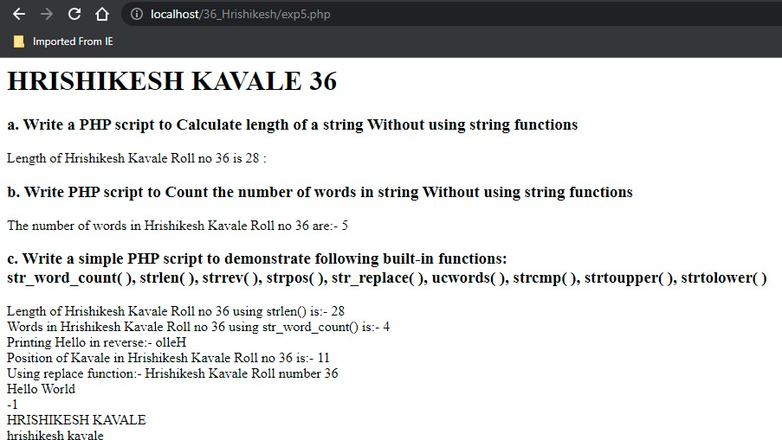

**Output:-**

**36-Hrishikesh Kavale roll no 36**

**Code:-**

<?php

echo "<h1>HRISHIKESH KAVALE 36</h1>";

echo "<h3>a.Write PHP script to calculate sum of two numbers with parameter and return value. </h3>";

function addTwoNumbers(int $x, int $y)

{

return $x + $y;

}

echo " sum of 10 and 25 : " . addTwoNumbers(10, 25);

echo "<h3>b.Write PHP script to calculate cube of a number without parameter and return value. </h3>";

function cube()

{

$num = 2;

echo "Cube of $num is :- ".$num**$num*$num;

}

cube();

?>

## 36-Hrishikesh Kavale roll no 36

**Output:-**

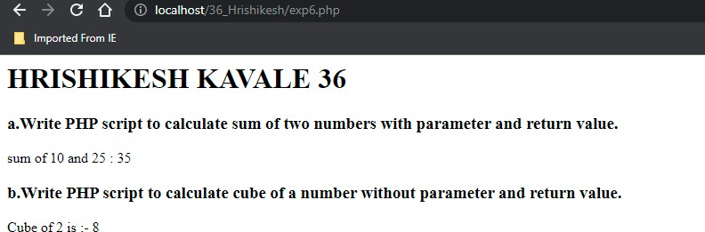

**36-Hrishikesh Kavale roll no 36**

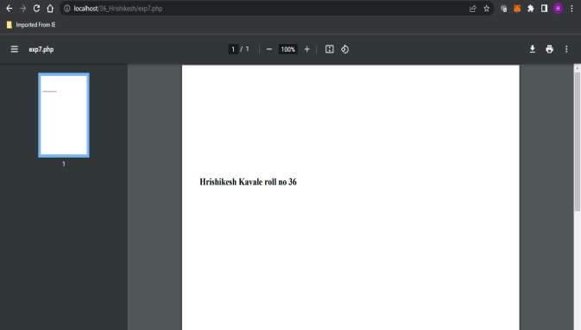

**Code:-**

<?php require('C:/xampp/php/pear/fpdf/fpdf.php');

$pdf=new fpdf();

$pdf->addpage();

$pdf->setfont("Times","B",14);

$pdf->cell(100,100,"Hrishikesh Kavale roll no 36");

$pdf->output();

?>

## Output:-

<?php

// The parent class class Car {

# Experiment 8 –A

//Set the class model name

$sportsCar1 -> setModel('Mercedes Benz');

//The $model property is now protected, so it can be accessed

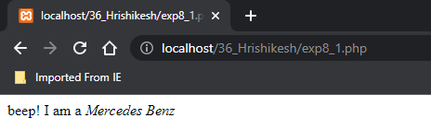

// from within the class and its child classes

protected $model;

//Public setter method

public function setModel($model)

{

$this -> model = $model;

}

}

// The child class

class SportsCar extends Car {

//Has no problem to get a protected property that belongs to the parent

public function hello()

{

return "beep! I am a <i>" . $this -> model . "</i><br />";

}

}

//Create an instance from the child class

$sportsCar1 = new SportsCar();

//Get the class model name echo $sportsCar1 -> hello();

?>

<?php

class Employee

{

public $name; public $position;

function

construct($name,$position)

{

// This is initializing the class properties

$this->name=$name;

$this->position=$position;

}

# Experiment 8-B

function show_details()

{

echo $this->name." : ";

echo "Your position is ".$this-

>position."\n";

}

}

$employee_obj= new Employee("Rakesh","developer");

$employee_obj->show_details(); echo "<br>";

$employee2= new Employee("Vikas","Manager");

$employee2->show_details();

?>



<?php

class Rectangle

{

public $dim1 = 2; public $dim2 = 10;

# Experiment 9- A

$this->side = $side;

}

function print()

{

$area = $this->side*$this->side;

function Rectangle($dim1,$dim2)

{

$this->dim1 = $dim1;

$this->dim2 = $dim2;

}

function area()

{

return $this->dim1*$this->dim2;

}

function display()

{

echo "Area of Rectangle is:".$this-

>area()."<br>";

}

}

class Square extends Rectangle

{

public $side = 2; function Square($side)

{

echo "Area of square= $area <br>";

}

}

$r = new Rectangle(4,2);

$r->display();

$r->area();

$s = new Square(5);

$s->print();

$s->area();

//get the class varibale i.e properties

$class_properties = get_class_vars("Rectangle");

//get object properties

$object_properties = get_object_vars($r);

//get class methods

$class_methods = get_class_methods("Rectangle");

//get class corresponding to an object

$object_class = get_class($r);

$class_exist = class_exists("Rectangle");

$parent = get_parent_class("Rectangle");

print_r($class_properties); echo "<br>"; print_r($object_properties); echo "<br>"; print_r($class_methods); echo "<br>"; print_r($object_class);

echo "<br>"; print_r($class_exist); echo "<br>"; print_r($parent); echo "<br>";

//get the class varibale i.e properties

$class_properties2 = get_class_vars("Square");

//get object properties

$object_properties2 = get_object_vars($s);

//get class methods

$class_methods2 = get_class_methods("Square");

//get class corresponding to an object

$object_class2 = get_class($s);

$class_exist2 = class_exists("Square");

//$class_name = get_declared_classes();

//$parent2 = get_parent_class("Square");

print_r($class_properties2); echo "<br>"; print_r($object_properties2); echo "<br>"; print_r($class_methods2); echo "<br>"; print_r($object_class2);

echo "<br>"; print_r($class_exist2); echo "<br>";

//print_r($class_name); echo "<br>";

//print_r($parent2); echo "<br>";

?>

|  |  |  |
| --- | --- | --- |
|  | | |
| Area of Rectangle is:20 |  |  |
| Area of square= 4 |  |  |
| ( [deal] => 2 [dim2] 10 ) |  |  |
| ( [deal] => 2 [dim2] 10 ) |  |  |
| ' ( [0] => Rectangle [1] => area [2] => display ) |  |  |
| Rectangle |  |  |
| ' ( [side] 2 [diml] 2 [dun2] => 10 ) |  |  |
| ' ( [deal] => 2 [dim2] 10 [side] => 2 ) |  |  |
| ' ( [0] => Square [1] print [2] => Rectangle | 3] | area [4] => display ) |
| Square |  |  |

<?php

# Experiment 9-B

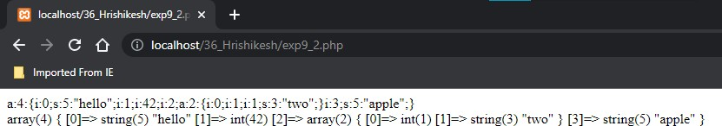

$data = serialize(array('hello',42,array(1, 'two'),'apple')); echo $data . "<br>";

$test = unserialize($data); echo var_dump($test);

//foreach($test as $value)

//echo $value." ";

?>

# Html

<form action="exp10.php" method="post">

<fieldset>

<table align="center">

# Experiment 10

<td>Languages:</td>

<td><input type="checkbox" name="branch[]" value="CO"> CO

<input type="checkbox"

<legend> Enter Details </legend>

<tr>

<td> Name: </td>

<td> <input type="text" name="name"></td>

</tr>

<tr>

<td> Gender:</td>

<td> <input type="radio" name="year" value="First"> First Year

<input type="radio" name="year" value="Second"> Second Year

<input type="radio" name="year" value="Third"> Third Year</td>

</tr>

<tr>

name="branch[]" value="ME"> ME

<input type="checkbox" name="branch[]" value="CE"> CE

<input type="checkbox" name="branch[]" value="IT">IT

<input type="checkbox" name="branch[]" value="EJ">EJ</td>

</tr>

<tr>

<td align="center" colspan="2">

<input type=submit name="submit">

</td>

</tr>

</table>

</fieldset>

</form>

# Php:

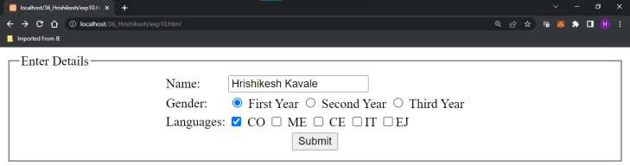

<?php

$name = $_REQUEST["name"];

$year = $_REQUEST["year"];

$branch = $_REQUEST["branch"]; echo "Name is <b> $name </b> <br>"; echo "Year is <b> $year </b> <br>"; echo "Branch is ";

foreach($branch as $i) echo "<b> $i </b>";?>

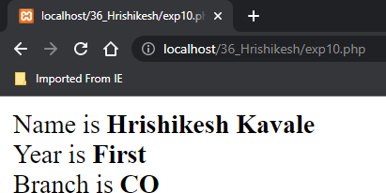

# Experiment 11

**Html:**

<form action="exp11.php" method="post">

<fieldset>

<table align="center">

<legend> Enter Details </legend>

<input type="hidden" name="exp_no" id="exp" value="11.1"/>

<tr>

<td> Name: </td>

<td> <input type="text" name="name"></td>

</tr>

<tr>

<td>City:</td>

<td><select name="city" size = "3">

<option value="Hyderabad"> Hyderabad </option>

<option value="Delhi"> Delhi

</option>

<option value="Chennai"> Chennai

</option>

<option value="Mumbai"> Mumbai

</option>

<option value="Banglore"> Banglore </option>

</select></td>

</tr>

<tr>

<td>Year:</td>

<td><select name="year" size = "1">

<option> Select a year </option>

<option value="First"> First Year

</option>

<option value="Second"> Second Year </option>

<option value="Third"> Third Year

</option>

</select></td>

</tr>

<tr>

<td align="center" colspan="2">

<input type=submit name="submit">

</td>

</tr>

</table>

</fieldset>

</form>

# PHP:

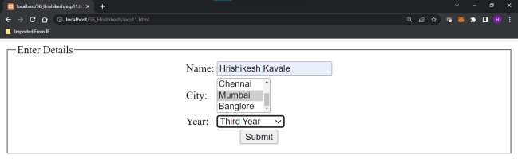

<?php

$name = $_POST["name"];

$city = $_POST["city"];

$year = $_POST["year"];

$exp_no = $_POST["exp_no"];

echo "Experiment <b>$exp_no</b><br/>"; echo "Name is <b> $name </b> <br/>"; echo "City is <b> $city </b> <br/>";

echo "Year is <b> $year </b>";

?>

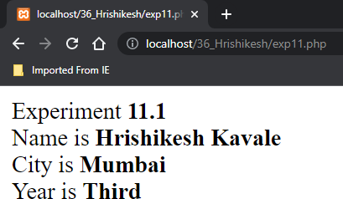

<html>

<head>

<style>

.error {color:red;}

</style>

</head>

<body>

<?php

# Experiment 12

$emailError="Email is required"; else

{

$email = test_input($_POST["email"]);

// check if e-mail address is well- formed

if(!filter_var($email, FILTER_VALIDATE_EMAIL))

$nameError=$emailError=$mobileEr ror="";

$name=$email=$mobileno=""; if($_SERVER["REQUEST_METHOD"]

=="POST")

{

if(empty($_POST['name']))

$nameError="Name is required"; else

{

$name = test_input($_POST['name']);

if(!preg_match('/^[a-zA-Z

]*$/',$name))

$nameError= "Only letters and whitespace allowed";

}

if(empty($_POST['email']))

{

$emailError= "Invalid email format";

}

}

if (empty($_POST['mobileno']))

{

$mobileError="Mobile number is required";

}

else

{

$mobileno = test_input($_POST['mobileno']);

// check if mobileno contains only 10 digits

if (!preg_match('/^[0-9]{10}$/',

$mobileno))

{

$mobileError= "Enter valid 10 digit Mobile Number";

}

}

}

function test_input($data)

{

$data = trim($data);

$data = stripslashes($data);

$data = htmlspecialchars($data); return $data;

}

?>

<h1>Data Validation</h1>

<p><span class="error">* required field</span></p>

<form action=exp12.php method=POST>

<table>

<tr>

<td>Name</td>

<td> <input type="text" name="name">

<span class="error">* <?php echo

$nameError; ?></span>

</td>

</tr>

<tr>

<td>Email</td>

<td><input type="text" name="email">

<span class="error">* <?php echo

$emailError; ?></span>

</td>

</tr>

<tr>

<td>Mobile Number</td>

<td><input type="text" name="mobileno">

<span class="error">* <?php echo

$mobileError; ?></span>

</td>

</tr>

<tr>

<td>

<input type="submit" name="submit" value="Submit"><br>

</td>

</tr>

</table>

</form>

<?php

echo "<h2>Your Responses are:</h2>";

echo $name."<br>";

echo $email."<br>"; echo $mobileno."<br>";

?>

</body>

</html>

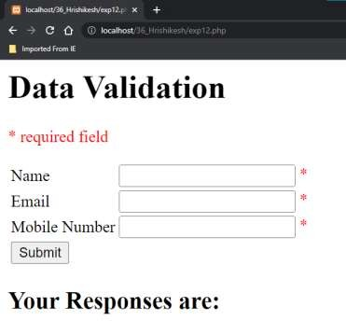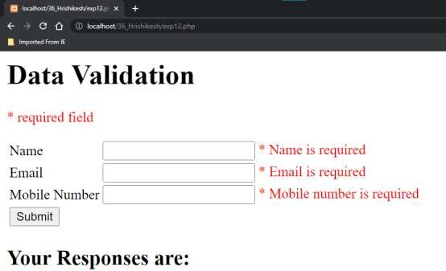

Your Responses are:

8655563255

• only letters and whitespasa zllawed Email * lay ide nail format

Mabile Number • Emer valiil IO digit ivtobile Number

Data Validation



Your Responses are:

Hrishikesh Kavale [chandrakant.co046l@tpoly.in](mailto:chandrakant.co046l@tpoly.in) 8655563255

Name

Email

Mobile Number

Submi

Data Validation

* required field

<?php

//setting cookie

$cookie_name="PHP";

# Experiment 13-A

echo "Cookie named '" .

$cookie_name . "' is not set!<br>";

}

$cookie_value="Cookie Practical";

setcookie($cookie_name,$cookie_v alue,time()+86400,"/","",1,1);

if (isset($_COOKIE[$cookie_name])) echo

$_COOKIE[$cookie_name]."<br>";

//modifying cookie

$cookie_name="guest";

$cookie_value="Alex Porter";

setcookie($cookie_name,$cookie_v alue,time()+86400,"/","",1,1);

if(!isset($_COOKIE[$cookie_name]))

{

else

{

echo "Cookie '" . $cookie_name . "' is set!<br>";

echo "Value is: " .

$_COOKIE[$cookie_name]."<br>";

}

//deleting cookie setcookie($cookie_name,

$cookie_value, time()- 3600,"/","",1,1);

echo "Cookie '" . $cookie_name . "' is deleted.<br>";

?>

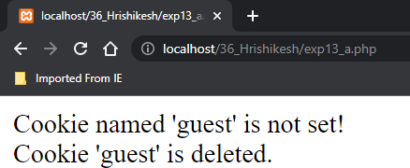

<?php

// Start the session session_start();

?>

<!DOCTYPE html>

<html>

<body>

<?php

// Set session variables

# Experiment 13-B

print_r($_SESSION);

// to change a session variable, just overwrite it

$_SESSION["favcolor"] = "yellow"; print_r($_SESSION);

// remove all session variables session_unset();

// destroy the session session_destroy();

$_SESSION["favcolor"] = "green";

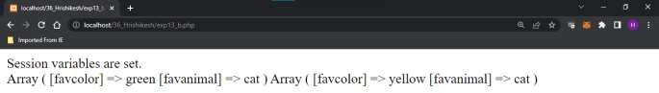

$_SESSION["favanimal"] = "cat";

echo "Session variables are set.<br>";

// Echo session variables that were set previously

?>

</body>

</html>

# Experiment 15

<?php

//Create Connection

$conn=mysqli_connect("localhost","root"); if($conn)

echo "Connection Successful.<br>"; else

die("Error in connection".mysqli_connect_error());

//Create Database

if(mysqli_query($conn,"CREATE DATABASE kk12345")) echo "Database created successfully.<br>";

else

echo "Could not create database".mysqli_error($conn); mysqli_select_db($conn,"kk12345");

//Create Table

$query="CREATE TABLE k888(rollno int(4),name varchar(20))"; if(mysqli_query($conn,$query))

echo "Table created successfully.<br>"; else

echo "Error in table creation".mysqli_error($conn);

//Insert into Table

$query="INSERT INTO k888(rollno,name) VALUES(1,'Kalpesh'),(2,'Manish'),(3,'Kashif')"; if (mysqli_multi_query($conn, $query))

echo "New record created successfully<br>"; else

echo "Error: " . $query . "<br>" . mysqli_error($conn);

//Select & Display Data from table

$query="SELECT * from k888";

$result=mysqli_query($conn,$query);

//echo "<br>" . mysqli_error($conn); if(mysqli_num_rows($result) > 0)

{

while($row=mysqli_fetch_assoc($result))

{

echo "Roll No:".$row['rollno']. "<br> Name:".$row['name']."<br>";

}

}

else

echo "Zero records.";

//Close Connection mysqli_close($conn);

?>

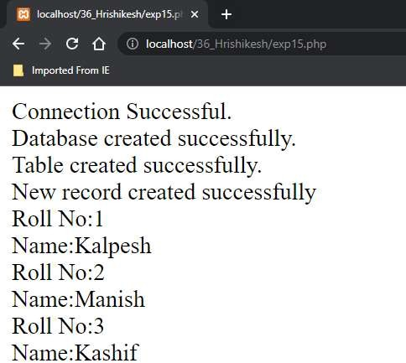

# Experiment 16

<?php

//Create Connection

$conn=mysqli_connect("localhost","root"); if($conn)

echo "Connection Successful.<br>"; else

die("Error in connection".mysqli_connect_error()); mysqli_select_db($conn,"kk12345");

$sql = "DELETE FROM k888 WHERE rollno=3"; if (mysqli_query($conn, $sql))

{

echo "Record deleted successfully<br>";

}

else

{

echo "Error deleting record:".mysqli_error($conn);

}

$sql = "UPDATE k888 SET name='Hrishikesh' WHERE rollno=1"; if (mysqli_query($conn, $sql)) {

echo "Record updated successfully";

} else {

echo "Error updating record: " . mysqli_error($conn);

}

//Select & Display Data from table

$query="SELECT * from k888";

$result=mysqli_query($conn,$query); if(mysqli_num_rows($result) > 0)

{

while($row=mysqli_fetch_assoc($result))

{

echo "Roll No:".$row['rollno']. "<br> Name:".$row['name']."<br>";

}

}

else

echo "Zero records.";

//Close Connection mysqli_close($conn);

?>

