DAC- GROUP D1

ECOMMERCE PLATFORM

ANUPAM SINGH (87065) | AYUSH KUSHWAHA (87261)

ASIM MULLA (86875) | HRISHIKESH JADHAV (87260)

**Functional Requirements**

1. User Management
2. Users must be able to register with email and password
3. Users must be able to login/logout
4. System must differentiate between admin and regular users
5. Users must be able to view/edit their profile
6. Users must be able to reset their password
7. Users must be able to view items in cart.
8. Product Management
9. Admin must be able to add/edit/delete products
10. Admin must be able to manage product categories
11. Admin must be able to manage product inventory
12. System must display products with details (name, price, description, image)
13. System must support product categorization
14. Users must be able to search for products
15. Users must be able to filter products by category, price
16. Users must be able to sort products by price, name, date
17. Shopping Cart
18. Users must be able to add/remove items
19. Users must be able to modify quantities
20. System must calculate total price including any taxes
21. System must save cart items for returning users
22. System must validate stock availability
23. Order Processing
24. Users must be able to enter shipping information
25. Users must be able to select payment method
26. System must generate order confirmation
27. Users must be able to view order history
28. Admin must be able to view and manage orders
29. Admin Dashboard
30. Admin must be able to view basic analytics
31. Admin must be able to manage users
32. Admin must be able to manage orders
33. Admin must be able to view inventory status

**Non-Functional Requirements**

1. Security
2. User passwords must be encrypted
3. Admin access must be restricted
4. Payment information must be handled securely
5. Session management must be implemented
6. System must prevent SQL injection
7. System must prevent cross-site scripting (XSS)
8. Usability
9. Interface must be intuitive and easy to navigate
10. System must be responsive across devices
11. Error messages must be clear and helpful
12. Forms must have proper validation
13. System must provide feedback for user actions
14. Maintainability
15. Code must be well-documented
16. System must follow modular design
17. System should be easy to update
18. Database schema should be properly structured
19. Data Management
20. Regular database backups
21. Efficient data retrieval
22. Data integrity maintenance
23. Proper error logging

**Must-Have Features (Core)**

1. User Authentication & Management
2. User registration and login
3. Role-based access (Admin/Customer)
4. Basic profile management
5. Password reset functionality
6. Product Management & Display
7. Product listing page with grid/list view
8. Product details page with images, description, price
9. Search functionality
10. Sorting (price high/low, newest, alphabetical)
11. Filters (category, price range, availability)
12. Shopping Cart
13. Add/remove products
14. Update quantities
15. Cart total calculation
16. Save cart items for returning users
17. Checkout Process
18. Shipping address input
19. Basic payment form (simulation is fine)
20. Order confirmation
21. Order history
22. Admin Panel
23. Dashboard overview
24. Product management (CRUD operations)
25. Order management/tracking
26. User management
27. Basic inventory tracking
28. Category management

**Implementation order**

1. Start with user authentication and admin setup
2. Implement product management through admin panel
3. Build product listing with sorting and filters
4. Add shopping cart functionality
5. Create checkout process
6. Finally, polish the user interface and add any secondary features if time permits

USE CASE DIAGRAM

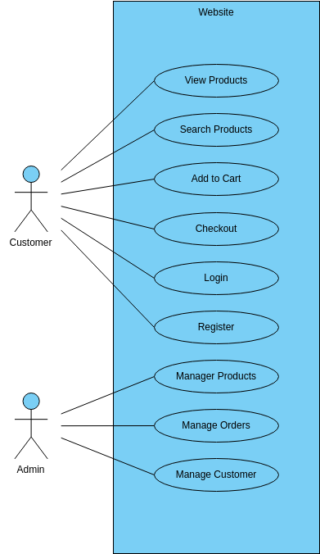

Customer Facing Use cases:

**1-View Products:**

Customers can view products on home screen.

**2-Search for products:**

Customers can search for their desired products from the provided search box.

**3-Add to Cart:**

Customers can add the desired product to a shopping cart.

**4-Checkout:**

Customers can checkout for payments for their added products.

**5-Login:**

Registered user can login in with id and password.

**6-Register:**

New users have the option to register on the website.

**7- Place Order**

Customer can place final order for selected products

Business Facing Use Cases:

**1-Manage Customers:**  
Admin can manage the customers on the platform, add customers, delete customers etc.

**2-Manage Orders:**

Admin can view all the orders placed on the platform.  
  
**3-Manage Products:**

Inventory can be managed, restocking of sold out products, etc.

**ER DIAGRAM**

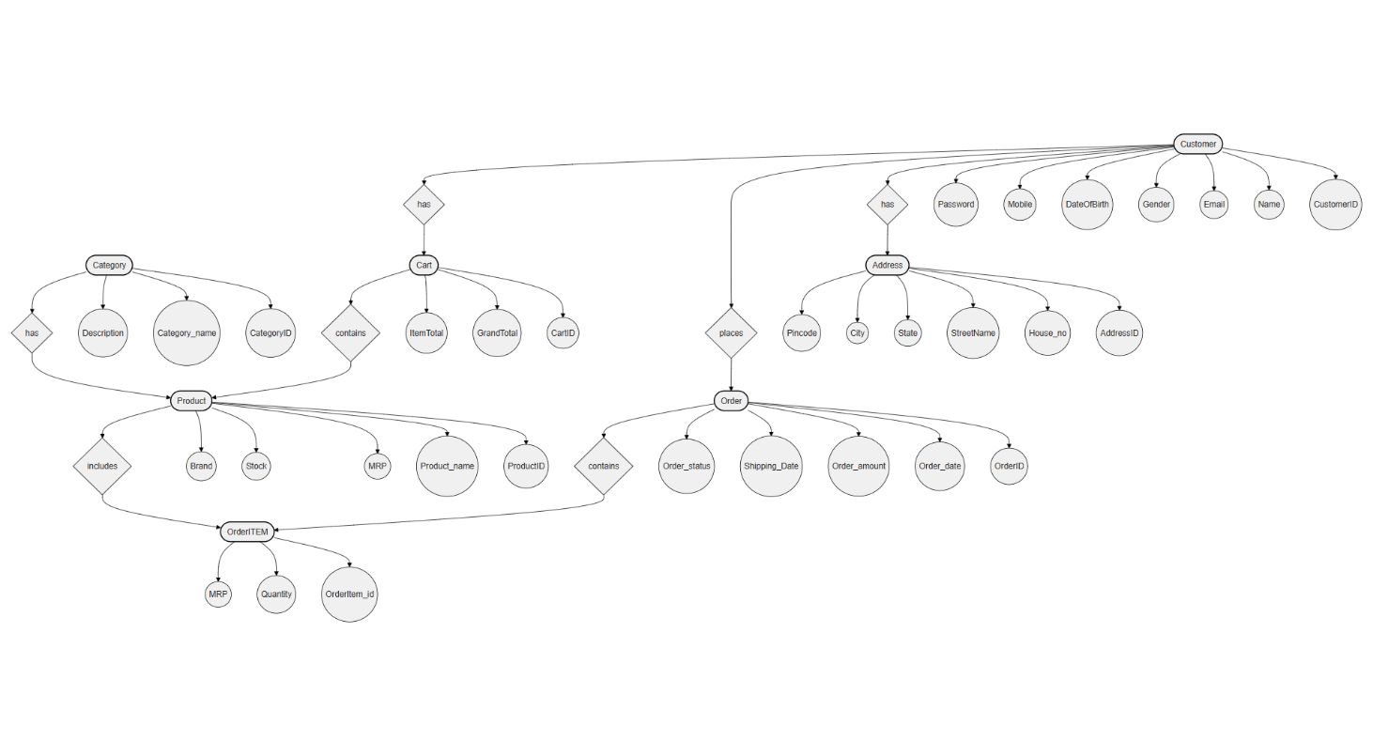

DataBase Design

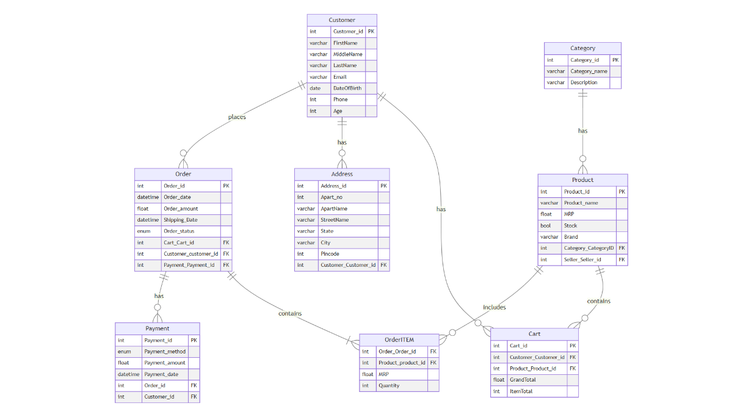

UI Interactions

1. Main UI and LOGIN Page

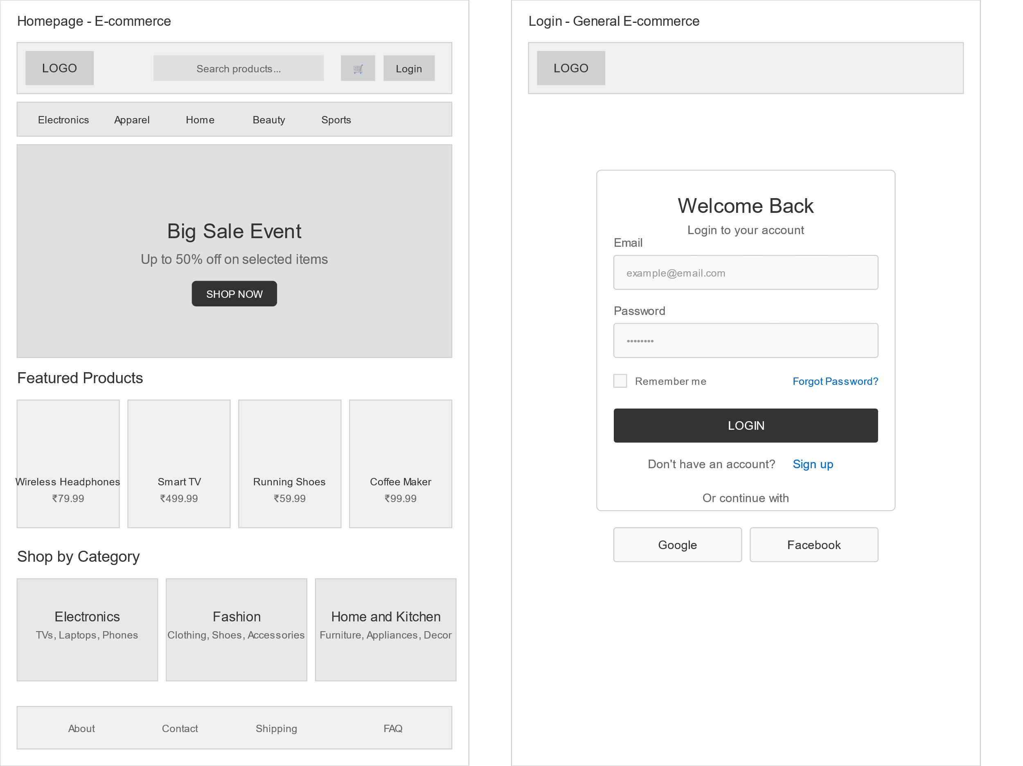

1. Sign UP UI

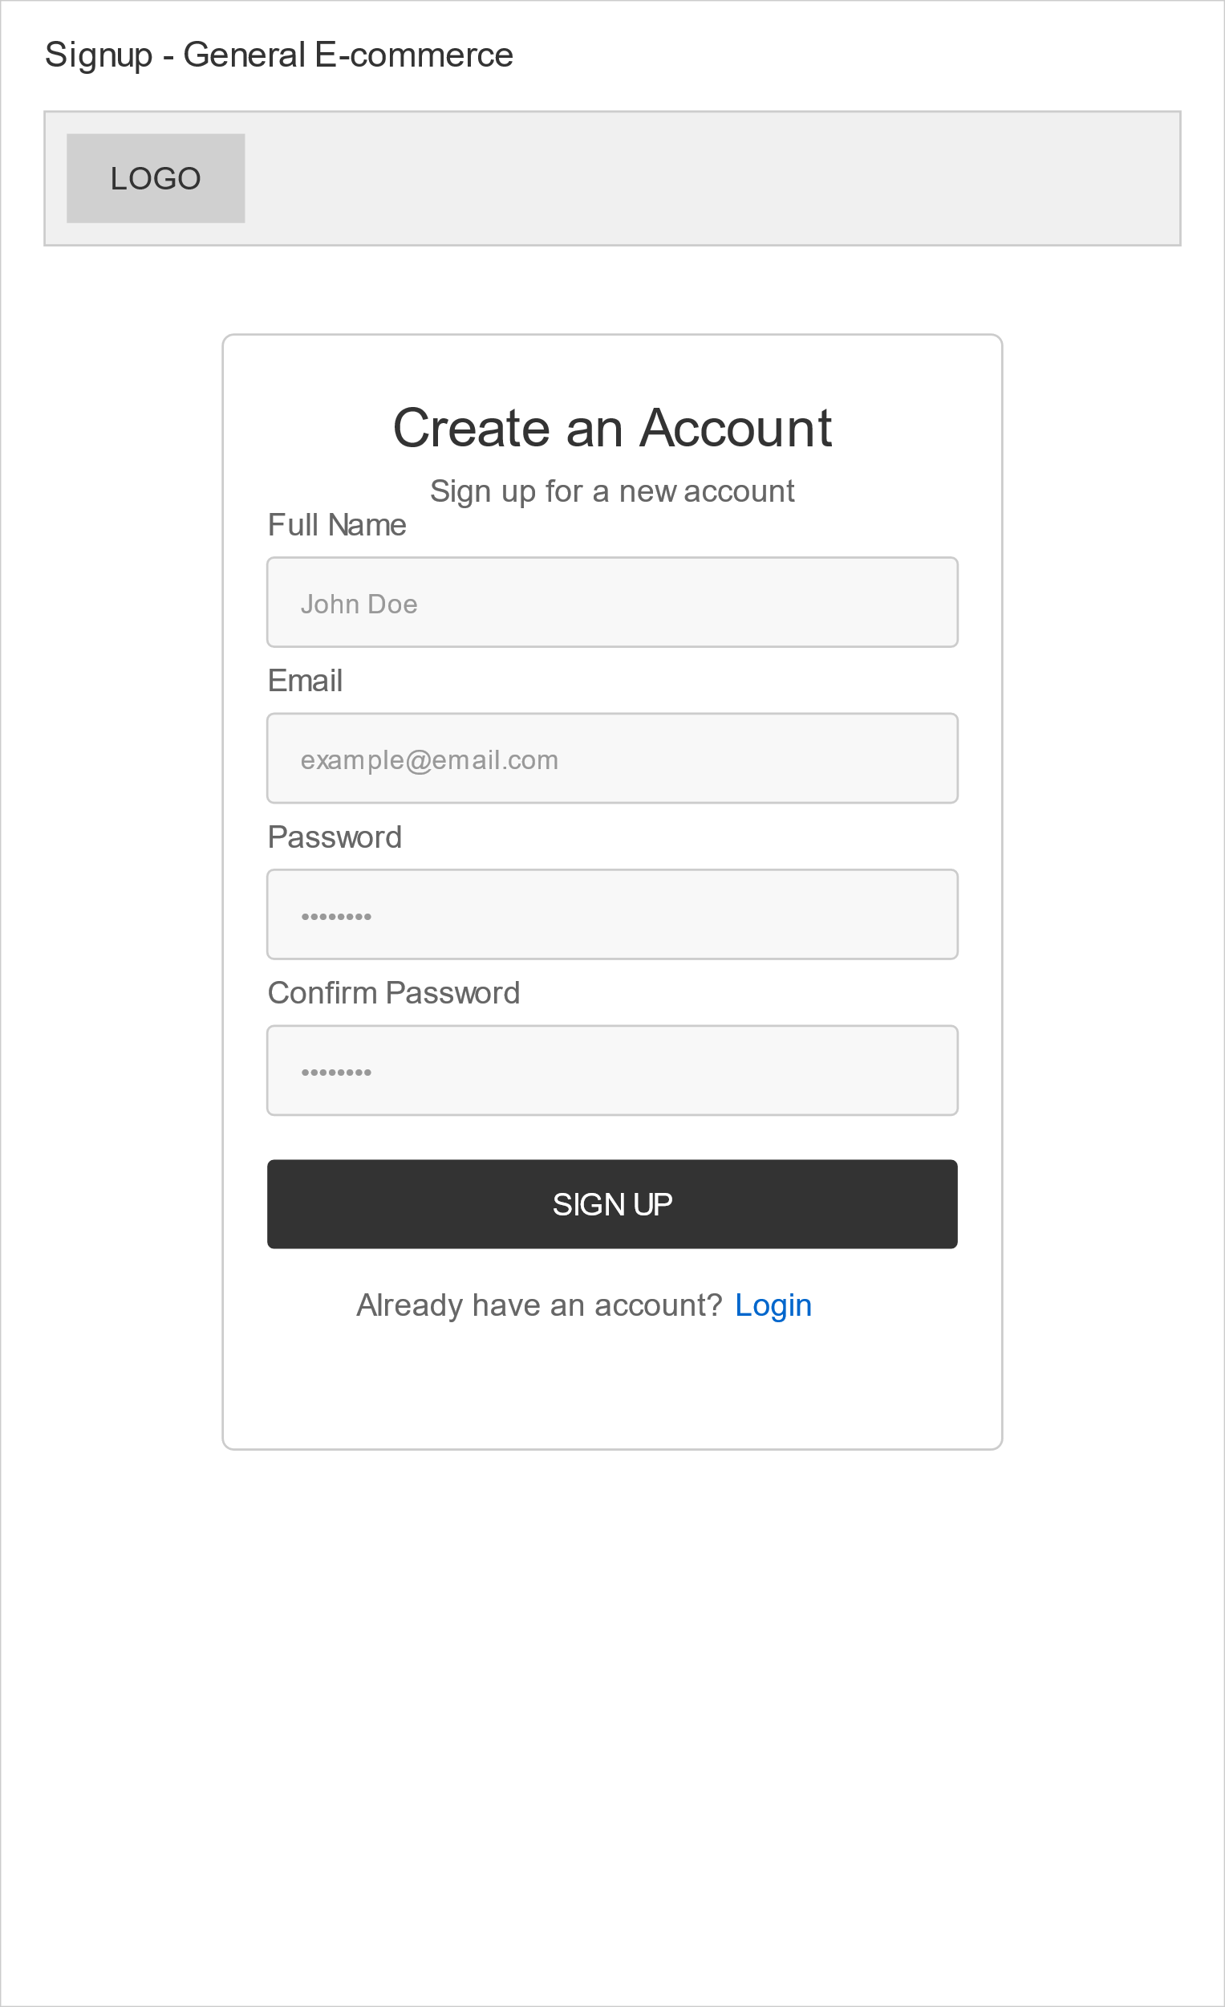

3-Cart UI

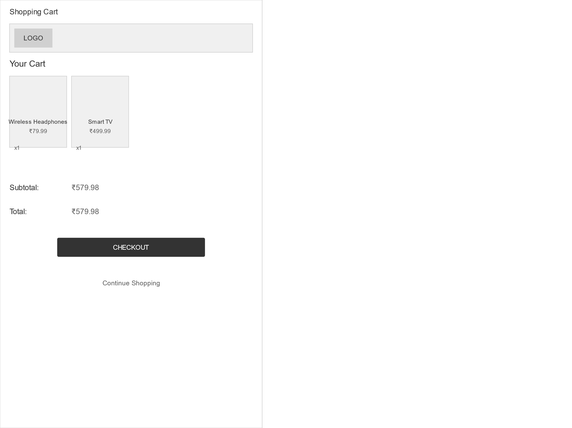

4-Product Page UI

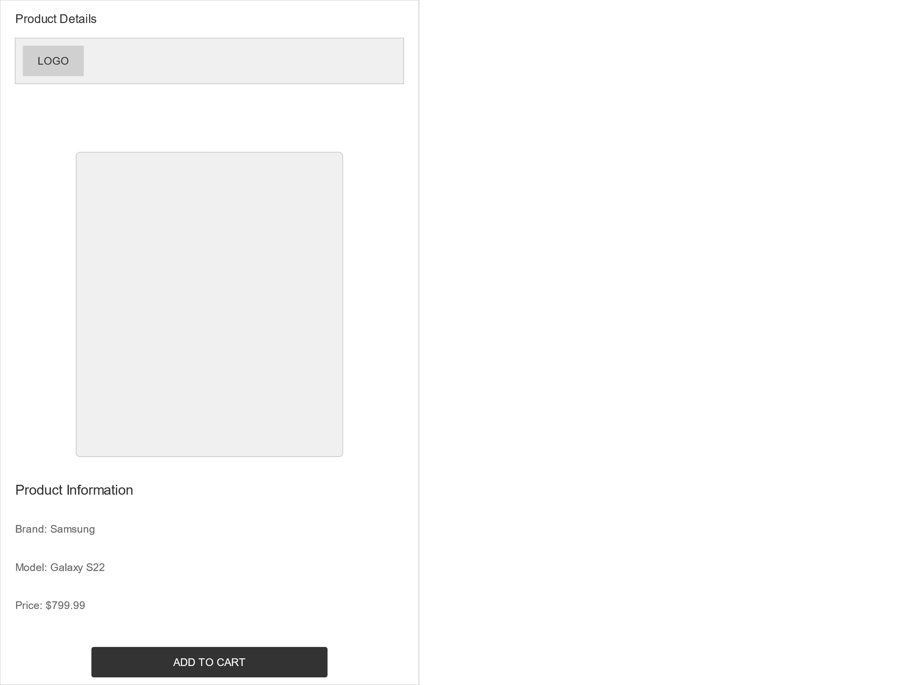

5-Category UI

