**Tomita’s Algorithm**

**Set of symbols used here**:

***Q*** – a set of vertices storing the subgraph in expand function (which is a subset of a maximal clique)

***V*** – the set of vertices in the overall graph

$SUBG$– the intersection set of vertices which **are adjacent to all nodes** in Q in the graph

***CAND*** – the set of candidates for e

***Γ(u)*** – the set of adjacent vertices of a vertex u

${EXT}_{u}$– the set of vertices after removing Γ(u) from CAND

***MAXCLIQUES*** – the set of maximal cliques

***MaxCliqueSize*** – the size of largest maximal clique observed until now

Tomita’s Algorithm for finding maximal cliques uses a depth first search (backtracking) method to generate all maximal cliques for an undirected graph. It makes use of a Global set Q, initially empty, which it expands using the expand function. Set Q stores subgraph constituting the cliques at each instance of expand function. Size of MAXCLIQUES at the end of the algorithm gives the number of cliques.  
  
The procedure of algorithm is fairly straightforward.

* The function Expand takes in two parameters SUBG and CAND both of which are initially set to V.
* If the SUBG = ∅, then we have found the maximal clique since there are no nodes who share an edge with all other nodes in Q (current clique.
  + Here we update the clique count
  + Print clique to notify user
  + Add Q to MAXCLIQUES
  + Also size of Q is compared with MaxCliqueSize and MaxCliqueSize is updated
* If not, then we find a vertex u in SUBG such that it maximizes |CAND ∩ Γ(u)| (maximize function is used for the same which utilizes binary search and linear time search to find the intersection).
  + ${EXT}_{u}$ is defined and while ${EXT}_{u}$ ≠ ∅, a vertex q is picked from ${EXT}_{u}$. This vertex is a node in the search tree. We then add this vertex to our current clique Q.
  + We define ${SUBG}_{q}$ = SUBG ∩ Γ(q) and ${CAND}_{q}$ = CAND ∩ Γ(q).
  + We then apply Expand function recursively with ${SUBG}_{q}$ and ${CAND}_{q}$ as the parameters.
  + CAND and ${EXT}_{u}$ are updated by removing q
  + Q is updated by removing q (new clique) and print back to notify the user that we are moving to the previous state of vertices in Q to find a new clique.

**Observations and Findings**

On applying the algorithm on multiple datasets, here is the output that was observed:

Dataset 1:

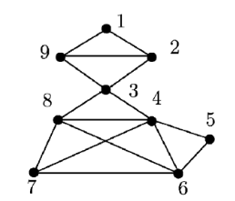

**FIG 1**: The figure corresponding to the graph dataset given in the paper (Tomita, Tanaka & Takahashi, 2006).

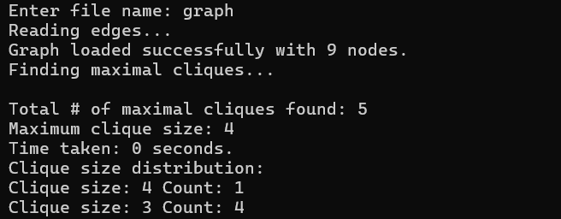

**FIG 2**: Output of the code for dataset 1 using Tomita’s algorithm.

Dataset 2:

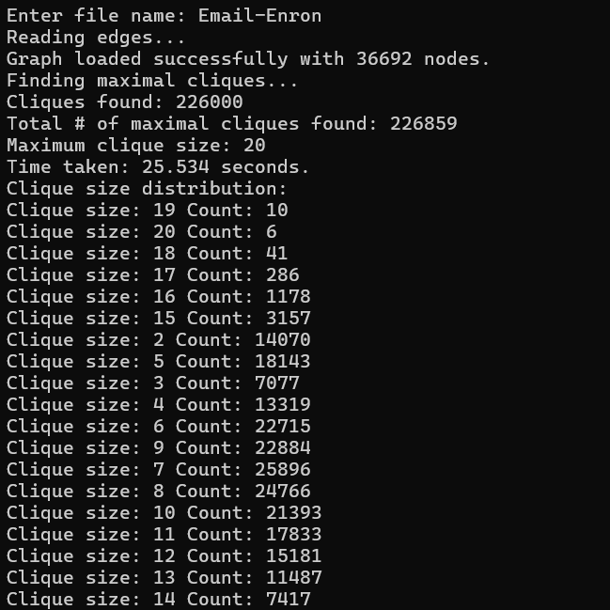

**FIG 3**: Output of the code for dataset 2 using Tomita’s algorithm.

Dataset 3:

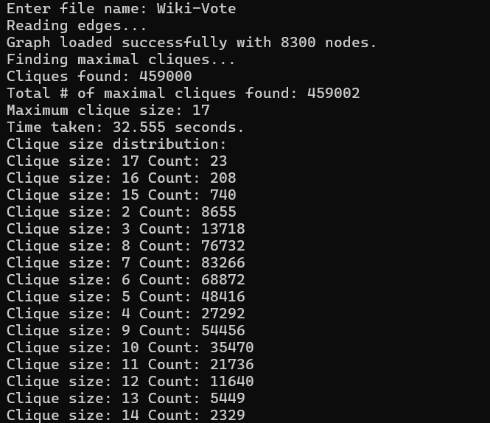

**FIG 4**: Output of the code for dataset 3 using Tomita’s algorithm.

Dataset 4:

**FIG 5**: Output of the code for dataset 4 using Tomita’s algorithm.

Comparison of execution times for each algorithm

**FIG 6.1**

**FIG 6.2**

**FIG 6.3**

**FIG 6.4**

**FIG 6.1-6.4**: Comparison of execution times in seconds of each of the algorithms for each dataset.

**FIG 7**: Distribution of Clique Sizes for Dataset 1.

**FIG 8**: Distribution of Clique Sizes for Dataset 2.

**FIG 9**: Distribution of Clique Sizes for Dataset 3.

**FIG 10**: Distribution of Clique Sizes for Dataset 4.