High Level Design (HLD)

Bike Sharing prediction system

Revision Number: 1.0

Last date of revision: 28/10/2021

|  |  |  |  |
| --- | --- | --- | --- |
| Date Issued | Version | Description | Author |
| 28/10/2021 | 1 | Initial HLD - VI .0 | Hrishikesh |
|  |  |  |  |
|  |  |  |  |
|  |  |  |  |
|  |  |  |  |
|  |  |  |  |
|  |  |  |  |

Contents

Abstract 3

1.1 Why this High-Level Design Document? 4

1.2 Scope 4

1.3 Definitions 5

2 General Description 6

2.1 Product Perspective 6

2.2 Problem statement 6

2.3 PROPOSED SOLUTION 6

2.4 Technical Requirements 6

2.5 Data Requirements 6

2.6 Tools used 9

2.7 Constraints 9

2.8 Assumptions 9

3. Design Details 8

3.1 Process Flow 8

3.1.1 Model Training and Evaluation 9

3.1.2 Deployment Process 9

3.2 Event log 10

3.3 Error Handling 10

4.Performance 11

4.1 Reusability 11

4.2 Application Compatibility 11

4.3 Resource Utilization 11

4.4 Deployment 11

Conclusion 12

## Abstract

Bike sharing systems are a new generation of traditional bike rentals where the whole process from membership, rental and return back has become automatic. Through these systems, users are able to easily rent a bike from a particular position and return back at another position. Currently, there are about over 500 bike-sharing programs around the world which is composed of over 500 thousand bicycles. Today, there exists great interest in these systems due to their important role in traffic, environmental and health issues. Apart

from interesting real-world applications of bike sharing systems, the characteristics of data being generated by these systems make them attractive for the research. The goal here is to build an end-to-end regression task. Here the user will provide the data and the result will be given by the best performing hyper tuned Machine Learning model.The user will also get privileges to choose the deployment options

## 1.1 Why this High-Level Design Document?

The purpose of this High-Level Design (HLD) Document is to add the necessary detail to the current project description to represent a suitable model for coding. This document is also intended to help detect contradictions prior to coding, and can be used as a reference manual for how the modules interact at a high level.

The HLD will:

* Present all of the design aspects and define them in detail
* Describe the user interface being implemented
* Describe the hardware and software interfaces
* Describe the performance requirements
* Include design features and the architecture of the project
* List and describe the non-functional attributes like:

Security

Reliability

Maintainability

Portability

Reusability

Application compatibility Resource utilization

Serviceability

## 1.2 Scope

The HLD documentation presents the structure of the system, such as the database architecture, application architecture (layers), application flow (Navigation), and technology architecture. The HLD uses non-technical to mildly-technical terms which should be understandable to the administrators of the system.

## 1.3 Definitions

Term Description

|  |  |
| --- | --- |
| Database  IDE  AWS  BSS | Collection of all the information monitored by this system  Integrated Development Environment  Platform where deployed the application.  Bike Sharing System |

## 2 General Description

## 2.1 Product Perspective

## The Bike Sharing Prediction system is a machine learning-based default prediction model which will help us to know the demand of bikes in a particular day.

## 2.2 Problem statement

## Today, there exists great interest in BSS due to their important role in traffic, environmental and health issues. Apart from interesting real-world applications of bike sharing systems, the characteristics of data being generated by these systems make them attractive for the research.

## The goal here is to build an end-to-end regression task. Here the user will provide the data

## and the result will be given by the best performing hyper tuned Machine Learning model.

## The user will also get privileges to choose the deployment options.

## 2.3 PROPOSED SOLUTION

## The solution proposed here is a BSS prediction model can be implemented to perform above mention use case. ln this case, we have to enter the date , weather details, weather the day is working day or holiday, season. Based on the above details model predicts the possible demand of bikes in that particular day.

## 2.4 Technical Requirements

## This document addresses the requirements for detecting Bikes in demand possible value for a particular day.

## We require a good working system with very good internet connection to use the app.

## As we are deploying the application in AWS we can access the app using its link. So the above will be sufficient.

## 2.5 Data Requirements

## Data requirement completely depend on our problem statement.

## We need as many data as available.

## Each datapoint must include date , weather details, importance of the day(Holiday/Working day)

## Season of the month.

## Weather situation like Cloudy, Rainy, Fall, Misty.

## Number of casual customers bikes used.

## Number of registered customers bikes used

## 2.6 Tools used

## Python programming language and frameworks such as NumPy, Pandas, Scikit-learn, Imblearn, resreg, Flask used to build the whole model.

## VScode is used as IDE.

## For visualization of the plots, Matplotlib, Seaborn and Plotly are used.

## AWS is used for deployment of the model.

## Cassandra is used to retrieve, insert, delete, and update the database.

## Front end development is done using HTML/CSS.

## Python is used for backend development.

## GitHub is used as version control system.

## 

## 2.7 Constraints

## The BSS application must be user friendly, as automated as possible and users should not be required to know any of the workings.

## 2.8 Assumptions

## The main objective of the project is to implement the use cases as previously mentioned (2.2 Problem Statement) for new dataset that comes through forms in application webpage. Machine Learning based prediction model is used for detecting the above-mentioned use cases based on the input data. It is also assumed that all aspects of this project have the ability to work together in the designer is expecting.

## 3. Design Details

## 3.1 Process Flow

## For predicting the possibility of bikes in demand, we will use a machine learning base model. Below is the process flow diagram is as shown below.

## Proposed methodology

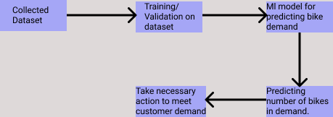

## 3.1.1 Model Training and Evaluation

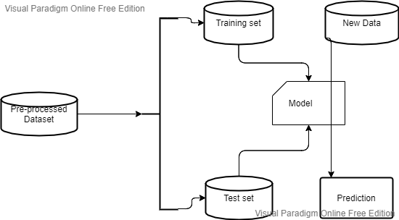

## 3.1.2 Deployment Process

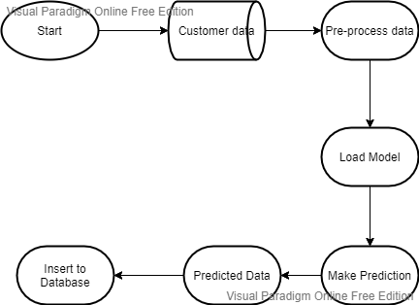

## 3.2 Event log

## The system should log every event so that the user will know what process is running internally.

## Initial Step-By-Step Description:

## The System identifies at what step logging required

## The System should be able to log each and every system flow.

## Developer can choose logging method. You can choose database logging/ File logging as well.

## System should not hang even after using so many loggings. Logging just because we can easily debug issues so logging is mandatory to do.

## 3.3 Error Handling

## Should errors be encountered, an explanation will be displayed as to what went wrong? An error will be defined as anything that falls outside the normal and intended usage

## 4.Performance

## The BSS application is used for prediction of total number of bikes in demand by a bike sharing system for a particular day. As we already trained the model with sufficient data it predict the default with high accuracy. Also, model retraining is very important to improve the performance.

## 4.1 Reusability

## The code written and the components used should have the ability to be reused with no problems.

## 4.2 Application Compatibility

## The different components for this project will be using Python as an interface between them. Each component will have its own task to perform, and it is the job of the Python to ensure proper transfer of information.

## 4.3 Resource Utilization

## When any task is performed, it will likely use all the processing power available until that function is finished.

## 4.4 Deployment

## We will be deploying the application in AWS .To deploy the app to AWS, we use the git push command to push the code from local repository's master or main branch to our AWS remote.

## Conclusion

## The BSS model will predict possible demand for number of bikes of a Bike sharing system for a particular day based on various details of the day , weather details data used to train our algorithm, so we can identify the possible business demand of a system in early stages and can take necessary preparation to meet the demand and provide better service to the customer leads to customer satisfaction and business growth.