BIKE SHARING SYSTEM PREDICTION

Wireframe Documentation

Homepage

1.Home page of the Bike sharing system prediction app shows the title of the project with a tag line also has one button on header, one to navigate us to form page.

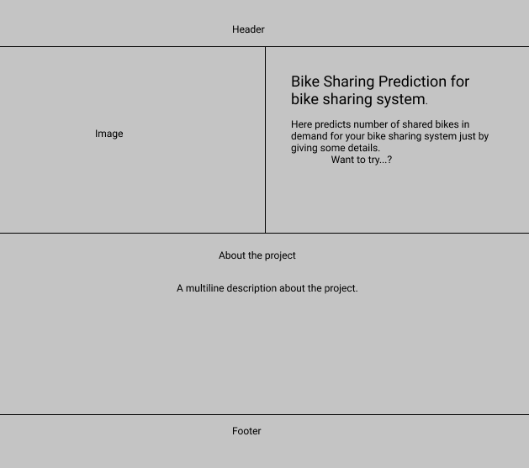

Form page

This page we divided the box into rows, in each rows we have label of what data to input and the textbox to input the data.

One button also there on click which start the prediction.

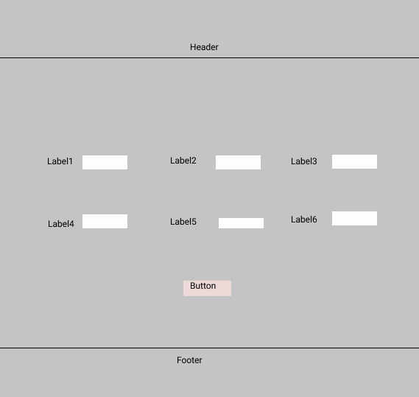

Result page

We have one result page

1. Page which shows the customer won’t default payment.

