




Submittedto:

ATTN:

Wichita, KS

February 16, 2026
some clarifications regarding the Sheriff’s Office Management of Off-Duty Programs:

Offeredby:

Extra Duty Solutions
6 Corporate Drive, Suite 830
Asbury Park, NJ 07712

EIN: 47-3058816

Extra Duty Solutions, Chief Executive Officer proposals@extradutysolutions.com Office: 203-202-3991



SECTIONA:LETTEROF TRANSMITTAL
Extra Duty Solutions
6 Corporate Drive, Suite 830
Attn: Proposal Team
Asbury Park, NJ 07712

? For instance the program must be fully live and functional by January 1,

Wichita, KS

To the Selection Committee:
Extra Duty Solutions d / b / a () appreciates the opportunity to submit this for The scope of services provided by Extra Duty Solutions includes the following key components: 1. **Administrative Responsibilities**: We manage all aspects of off-duty employment requests, ensuring compliance with established criteria and facilitating communication between hiring entities and law enforcement personnel. 2. **Scheduling and Coordination**: Our platform automates the scheduling of off-duty assignments, utilizing a configurable matrix to determine staffing needs based on event requirements. 3. **Payment Handling and Invoicing**: The vendor is responsible for guaranteeing timely payments to deputies for completed assignments, while also handling the collection of fees from hiring entities. 4. **Reporting and Compliance Support**: We provide comprehensive reporting capabilities to track off-duty work, ensuring compliance with municipal regulations and audit requirements. 5. **Ongoing Support and Training**: Extra Duty Solutions offers continuous operational assistance, structured on boarding, and training for users to ensure effective utilization of the platform. Our dedicated customer success team is available during business hours, with 24/7 emergency escalation support. for and ().
Extra Duty Solutions offers a comprehensive management platform specifically designed for the administration of off-duty and extra duty programs for law enforcement agencies. With over 12 years of experience serving 235 agencies, our operational model retains policy control with the city while providing a flexible billing structure that can accommodate direct payments to officers or centralized handling. Our solution enhances administrative efficiency, mitigates risks associated with off-duty employment, and ensures compliance with municipal audit requirements. The platform is tailored to meet the unique needs of public safety organizations, ensuring that established rules and labor agreements are respected. Our extensive experience with public safety agencies positions us as a reliable partner for Sedgwick County in managing off-duty programs effectively.
We provide all these services and more on a timely basis with a administration fee , charged to the . Our annual fee for On Duty is .
During the contract term, the City and police department benefit from the expertise of our software division, Extra Duty Solutions, which has been providing configured time and attendance software solutions for law enforcement agencies since 12. Additionally, the City benefits from our 12 partnership administering off-duty programs with agencies and businesses in Wichita, KS and beyond, supported by our account team.
The benefits of include:
Technology that Supports the Way You Work: The Extra Duty Solutions platform is designed with a high degree of config ur ability, allowing it to align with the specific policies and work flows of the City. While the software can be tailored to meet agency specific requirements, it does not support custom development that would fundamentally alter the operational processes. Configuration options include adjustments to scheduling parameters, reporting formats, and user permissions, enabling agencies to maintain their established operational protocols without necessitating significant changes to their existing systems. The Extra Duty Solutions platform supports access via secure web portals and is optimized for common mobile platforms, including i OS and Android devices. This ensures that users can manage off-duty assignments and access relevant information from various devices, enhancing operational flexibility and responsiveness.
Operational Sophistication: Administering off-duty and extra duty programs involves significant operational complexity due to the variability in scheduling and the need to adhere to policy driven rules established by the agency. Each assignment requires careful consideration of staffing levels based on event specifics, which can fluctuate widely. Additionally, the timing of payments and coordination between multiple stakeholders—including deputies, hiring entities, and the Sheriff's Office—adds layers of complexity to the operational process. Extra Duty Solutions has extensive experience navigating these challenges while ensuring that the City’s policies remain intact, thereby facilitating a seamless integration of off-duty employment into existing operational frameworks. Extra Duty Solutions employs a structured staffing model to deliver services effectively. This includes dedicated account management personnel who oversee client relationships and operational teams responsible for scheduling and coordination. Technical support staff ensure the platform's functionality and assist users with any software related inquiries. Our support coverage is available during business hours, with provisions for 24/7 emergency assistance. This separation of roles allows for specialized attention to both administrative operations and software support, ensuring that all aspects of the service are managed efficiently.
Significant Regional Experience: We currently provide on-duty software for agencies across KS, including more than 235 agencies, with strong working relationships in .
Industry Leading Risk Mitigation and Insurance: Risk allocation, indemnification, and insurance requirements will be negotiated in accordance with RFP specifications and municipal procurement guidelines. Standard professional liability and general liability coverage is maintained with certificates provided upon request. The City retains policy control while the vendor assumes operational risk for administrative functions.
In this , we express our firm commitment to provide software solutions that support the way you work and to professionally administer the police off-duty assignment program for .
As the individual authorized to commit Extra Duty Solutions to this , I am pleased to submit the enclosed offer and am prepared to provide any additional information required in support of this effort.

Sincerely,

Extra Duty Solutions, Chief Executive Officer
Extra Duty Solutions
203-202-3991
Fax: 203-202-3991
proposals@extradutysolutions.com

ScopeofPractice
EDS and our software division, J iv a soft, provide software to more than 300 agencies, and administer extra duty programs for 235 law enforcement agencies across these states:

Alabama
Arizona
Arkansas
California
Colorado
Connecticut
Delaware
Florida
Georgia
Illinois
Indiana
- Kansas
- Kentucky
- Louisiana
- Maryland
- Massachusetts
- Minnesota
- Mississippi
- Nevada
- NewHampshire
- NewJersey
- NewYork
- NorthCarolina
- Ohio
- Oregon
- RhodeIsland
- SouthCarolina
- Tennessee
- Texas
- Virginia
- Washington

Wehavebegunwork oneveryRFP / RFQ wehavebeenawarded.

Address
Ourcompanyheadquarters islocatedat 6Corporate Drive,Suite830,Shelton,CT 07484.
Toensurecontinuityofoperations,wehavemultipleredundantoperationscentersinConnecticut, North Carolina, Florida, Texas, and New Jersey. All operations centers provide 24/7/365 work spaces for all account coordinator and account management functions.
Our fac i lies and technology infrastructure are designed to seamlessly support our staff and clients. We are the only provider to have multiple geo redundant operations centers to provide continuity and resiliency against catastrophic events and natural disasters, such as fires,tornadoes,orothersituationsthatmightdisruptoneoperationscenterforaperiodof-me.
Ourmultipleoperationscentersprovide:
  - Diverse Communication Technologies:We leverage multiple independent communicationservicesfromvariousprovidersforbothdataandvoicecircuits.Thisdiversity mitigates the risk of service disruption.
  - RedundantHigh speedConnections:Withenterprisefiberandhigh speed5 Gcellular data connections, we provide redundant internet and voice services. Automatic real-time fail over ensures uninterrupted connectivity, even during outages.

  - Geographically diverse Operations Centers:Our operations centers, strategically locatedinCT,NJ,FL,NC,andTX,enhanceourITresiliency.Thisgeographicaldiversityprotects against regional disruptions, ensuring continuous access to critical systems.
  - Cloud based Architecture for Maximum Accessibility:Our cloud based operational and criticalbusinessarchitectureallowsforsimultaneousaccesstosystemsfromanyofourregional centers and disaster recovery locations. This setup guarantees that we can operate seamlessly from multiple locations.
  - World class Hosting Solutions:We host all our software on geographically diverse serverswithleadingcloudhostingproviders.Thisensuresworld classsecurity,performance, and uptime for business applications.
{{#INCLUDE_DR_PLAN}}See the attached Disaster Recovery Plan{{ / INCLUDE_DR_PLAN}} for our Disaster Recovery Plan (Yes).
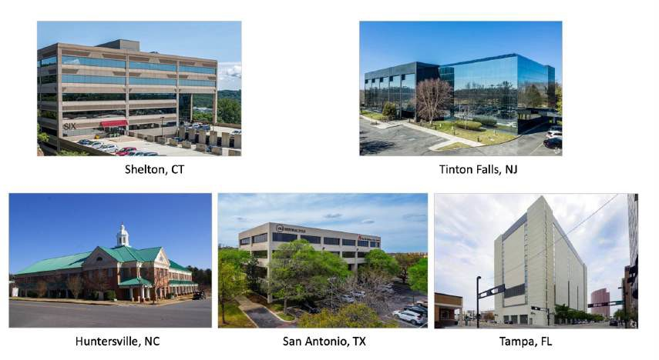

Experience
Hart Halsey, LLC d / b / a Extra Duty Solutions has been administering extra duty detail services for more than eight years. Our first client was Delray Beach, FL who started with us in January 2016 and continues to with us this day. We are the first, largest and fastest growing firm to offerprogramsforthefulladministrationofpaiddetailsaswellason-dutyschedulingsoftware in the state of New Jersey and throughout the United States.
EDScanfulfilltheneedsandgoalsoftheAPPDtoprovidecloud basedschedulingsoftware,and manage and administer the police’s department’s off-duty details on its behalf. We do this in accordance with the City’s policies and regulations, and with no substantial changes to the way off-duty details are distributed.



Prior to serving law enforcement agencies, we managed extra duty programs for large, corporate clients including Marriott, Star wood, Ryder, Aon, and Master Card, among others. Whileservingcorporateclients,werealizedthatadministeringsuchprogramswasburdensome for law enforcement
agenciesandmeaningfully increased municipal risk. We then offered a managed service solution for law enforcement agencies and exited the corporate side of the business to avoid any conflicts of interest.
Oursoftwaredivision,
J iv a soft,wasfoundedin1999byDanRyan,whosefatherwasacaptainandbrotherwasa deputysuperintendentwiththeLowell(MA)PoliceDepartment.Ini-ally,J iv a softaimedtocreate ac-ve duty and extra duty scheduling software just for Lowell PD’s use. Now, J iv a soft is one of the leading providers of scheduling software to the public safety sector, and tailors applications to meet the needs of small municipalities to large agencies, such as theNashville Police Department(1700 sworn) and theUnited Nations. In June 2019, we acquired J iv a soft, enabling us to offer fully integrated software tailored to our clients’ needs.
Since our launch in 2016, Hart Halsey has grown rapidly. To ensure we provide exceptional servicetoourrapidlyexpandingclientbase,wehaveadded52employeestoourcompanyin the most recent three years. Most of these employees are software developers and account team members who directly support our government agencies.
KEY POINT: All of our software, including our on-duty scheduling software, our extra duty administration suite of software, and mobile apps was developed by our technology staff in San Antonio TX, is maintained by us, and is wholly owned by us. We can modify, customize and advance our software as our clients ask and as we need to. Our solution does not involve a third-party software firm over which we have no control.
Everything we discuss in this proposal has been created by us and is owned by us. None of our software development is outsourced outside of our company or overseas.
HartHalsey,LLC(EDS)isnotasecuritycompany,isnotownedbyasecuritycompany,andnone oftheownersoremployeeshaveanyaffiliationorownershipstakesin anysecuritycompanies. We operate solely to further the best interests of the municipal and law enforcement agencies weserve.Wedonotindemnifynon governmententitiesnorotherwiseintroducelegalriskto the City by signing supplier agreements directly with such entities. We represent the best interests of our governmental partners exclusively and at all times.
Unlike other extra duty providers, we have refused to sign Suppliers Agreements with local utilitycompanies.Theseagreementsmayeliminateallliabilityfromtheutilitycompanyand

removesharedworkerscompensationrequirementspreviouslysetbyNJcaselaw.Thisaction could place any financial liability costs directly to your taxpayers, and could put the City and APPD at financial risk.
Three Factors of a Standard Supplier Agreement You May Want Your Counsel to Look At

- One Way Indemnification
  - May shift all the vendor’s legal risk on to the officers, department, and municipality for “death or bodily injury to person” and “injury or damage to property”
  - May negate your liability insurance provider’s obligation to pay for premise or bodily injury caused by an officer working a detail
  - Transfers payment obligation to municipality’s taxpayers

- Standards of Integrity
Officers working a detail are contractually required to operate under the utility company’s “standards of integrity” which may differ, or be in direct conflict with, your department’s rules, regulations and policies.

- Dual Employment Status
  - In the State of NJ, the dual employment status and protection exists!
  - Officers are protected when working any off or extra duty job detail for a third-party such as a utility company
  - For officers’ Workers Compensation cases, the vendor and the municipality share responsibility. (Case law Domanoski v. Borough of Fanwood, 237 N.J. Super. 452 (App. Div. 1989). Case law Dutcher v. Pedeiro, 2017 WL5619258 *1 (N.J. App. Div. Nov. 22, 2017).

Samples of Reports

Our software suites are highly customizable and will provide you the reports (including payroll) you need in the format (e. g. Excel, PDF, CSV, etc.) and frequency you desire. Reports will have filtering options. We do not charge extra fees for payroll reports.
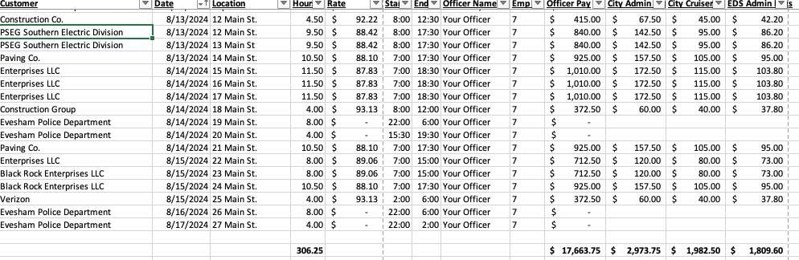

In addition to real-time reports, EDS will also create and automatically generate and distribute recurring reports, such as Invoice Register and Officer Reports (hours worked, location, and
customer) each pay period. We can also provide you with Prior Day Jobs Worked Report, and Same Day Jobs Report. We currently have more than 70 di e rent template d reports that can be run at any -me or auto-run on a scheduled cadence. The data is transparent, so you can get the information you need when you need it.
Your EDS account team, available 24/7/365 via phone and email, can also provide you with one-off reports, or any other information you might need for management, FEMA or OPRA requests.
EDS can also enable selected staff members to create their own reports, as needed, via their online portals. Oeen, our client agencies will want certain command staff personnel to view and report upon certain information for a sub-set of customers. If APPD would like to restrict access to certain reports for certain people, we can establish access control in our software. We learn these requirements from you during the knowledge transfer meeting, and configure our software to support them.

KeyIndividuals

EDS provides you an experienced project management team to ensure all aspects of program implementation and operations meet or exceed yourexpectationsWhile you will work closely withRicky,Adamandyouraccountmanagerquitefrequently,Danandhissoftwaredevelopers are poised to customize your software to ﬁt your program and as your needs evolve. EDS’s senior leadership of Rich and John are guiding the company to new levels of performance to enhance your customer experience. Every member of your team is just a phone call or email away to assist you.

Their full resumes are in the Appendices.

Rich Milli man,CEO


As CEO of EDS, Rich is the single point of contact for escalation and relationship management with the City, throughouttheon boardingprocessfollowingcontractaward and beyond. Rich’s professional background is heavily focused in business services and operations. After serving as a management consultant for Mc Kinsey and Company, Rich ran portfolio marketing and operations at Bank One Corporation’s credit card unit. He then ran a number of emerging and mid sized business services firms for a European family office. Before co founding Extra Duty Solutions, Rich was heavily involved in operational risk, security and back office operations at the world’s largest hedge fund, Bridgewater Associates LP.






JohnZe browski,DirectorofOrgan iz a LonalDevelopment
John Ze browski brings more than 35 years of law enforcement experience to EDS. In 2022, he retired from the Sayre ville (NJ) Police Department after serving as its Chief of Police for 11 years. During his tenure as chief, the department began working with EDS in 2016. John is a licensed attorney in New Jersey and Pennsylvania, a Certified Public Manager for the State of New Jersey, and our liaison with the NJ Association of Chiefs of Police. John is available to provide “lessons learned” and help to the police command staff throughout our partnership with APPD.

RickyBraen,BusinessDevelopmentExecutive
Ricky retired from Brick Township Police Department after more than 25 years of service and continued an active role with Man to lo king Police and completed over 39 years of service. He was the supervisor in charge of managing off-duty employment and payroll with Brick for over 10 years. He understands the challenges departments face in providing this service to the community. Ricky is available to provide training and in person meetings to ensure APPD is completely satisfied with our services.



AdamBogdan,VicePresidentofAccountManagement
Adam has been with EDS since 2019. As FLPD’s primary point of contact, Adam leads the City’s Account Management team, including all escalations involving billing, officer issues, and scheduling matters. Adam will update and maintain the officer rules and policies, ensuring that our Account Management team is properly trained to handle any and all issues.



DanRyan,CTOandPresident,J iv a softDivision
Dan has been working with EDS since its inception. He is a Harvard educated computer scientist who comes from a law enforcement family. At the request of the agency where his father was a member of the command staff, Dan created scheduling software specific to law enforcement needs. That was more than 20 years ago, and it was the humble beginning of J iv a soft, one of the leading providers of on-duty and extra duty software to the law enforcement world. Dan will oversee software customization s for the City.



MikeWilson,VicePresidentofCustomerExperience, J iv a soft Division
Mike began his career as a telecommunications dispatcher with the Charlotte mecklenburg Police Department. He then transitioned to CAD / RMS system administration and later advanced to systems analyst for Charlotte mecklenburg PD. Mike joined the J iv a soft team in 2015 and is responsible for overseeing on-duty software implementation and customer satisfaction during the entire lifetime of the relationship or contract. Mike’s team handles 24/7 customer support and is responsible for tracking and managing customer service requests for on-duty software.

YourAccountTeam
In addition to the project management team, APPD has its own dedicated account team. The City’saccountteamcoordinatesallaspectsofschedulingamongtheofficers,agency,andyour

customers. Account representatives also resolve user leveltechnicalissues,suchascomputerlog-in problems and data entry errors. Your account manager troubleshoots complex technical problems with our software and maintenance team, and calls you back when they resolve the issue. That means, you are not on hold for tech support, or waiting on the phone while our technicians ﬁx the problem. Your account team is available 24/7/365 through a phone number created for and dedicated to your agency. We do

notuseacallcenterapproach.We do not use a call center approach. Your dedicated account team (consisting of one primary and several secondary coordinators) handles all your calls and emails.

KEY POINT: All officer and customer calls are answered by our W-2 employees. We do not outsource officer or customer engagement at any time. We also do not force or strongly encourage customers to use their portals if they prefer to engage with their account management team by phone. We very much prioritize customer service over cost reduction.

References

BelowarefivereferencesfromourmanyNJclients.Pleasefeelfreetocallthem,oranyofthe agencies we partner with. We will provide you a link to a list of our clients upon request.

Absecon Police Department
Contracting Agency/Client: | Absecon Police Department 500 Mill Rd.  Absecon, NJ 08201
Period of Performance: | May 2021 to Present
Services Provided: | On-duty scheduling software, plus full administration on off-duty program
Point-of-Contact: | Lt. Jeffrey Mazer jmazer@abseconpd.org 609-641-0667

East Brunswick (NJ) Police Department
Contracting Agency/Client: | East Brunswick Police Department 1 Civic Center Drive  East Brunswick, NJ 08816
Period of Performance: | August 2017 to Present
Services Provided: | On-duty scheduling software, plus full administration on off-duty program
Point-of-Contact: | Lt. Wade Gordon wgordon@ebpd.net 732-390-6969

Matawan (NJ) Police Department
Contracting Agency/Client: | Matawan Police Department 201 Broad Street  Matawan, NJ 07747
Period of Performance: | September 2020 to Present
Services Provided: | On-duty scheduling software, plus full administration on off-duty program
Point-of-Contact: | Lt. Sean McCabe smccabe@matawanpolice.org 908-601-6462

Monmouth County Sheriff’s Office
Contracting Agency/Client: | Monmouth County Sheriff’s Office 2500 Kozloski Rd.  Freehold, NJ 07728
Period of Performance: | March 2023 to Present
Services Provided: | Full administration on off-duty program
Point-of-Contact: | Sgt. Robert Derasmo RDerasmo@MCSONJ.org 732-431-6400 ext. 1169

Ocean Township Police Department
Contracting Agency/Client: | Ocean Township Police Department 399 Monmouth Rd.  Oakhurst, NJ 07755
Period of Performance: | January 2022 to Present
Services Provided: | Full administration on off-duty program
Point-of-Contact: | Capt. Patrick Martin pmartin@oceantwp.org 732-531-1800 ext. 2211

We also invite you to visit the testimonial section of our website. Here is a sample of what some of our NJ clients say about our services:


ChiefRayHay duck a,SouthBrunswickPoliceDepartment,SouthBrunswickNJ
“We have been using Extra Duty Solutions for over a year. We have been very happy with the service. It allowed me to reassign a civilian clerical worker to perform other duties because the off-duty scheduling and billing was a full time job. It has resulted in a significant savings to the City. The officers are also happy because they are always updated via e-mail or text message as to the availability of jobs.”


Chief James P. Abbott, West Orange Police Department, West Orange,NJ
I have been serving as the Chief of Police for nearly 22 years and in such capacity have dealt with a multitude of vendors. I can state unequivocally that EDSisthemostclientcenteredvendorIhaveyettoexperienceandtheirservices areembraced by ourrank and file aswell as superior unionsin addition tosenior
management.EDSisuniqueinthatunlikemostotherservicestheywilltailortheir product to your needs rather than a one size fits all approach.


TheresaFitzgerald,Haddon el dPoliceDepartment
“I just wanted to reach out and tell you that, once again, your employees did a wonderful job. They worked all weekend trying to fill multiple jobs for today (Monday, 10/18/2021). I was notified last night at 11: 30 p. m. that one of the jobs could not be filled. I decided to wait until this morning to deal with that situation by moving people around. Upon arriving to work this morning, I found that they had filled ALL of the jobs. I was extremely grateful. This is routine behavior for your people; they always give 100%..”

Chief(Ret.)DavidIri zar ry,Metuchen(NJ)PoliceDepartment

““Metuchen City has been using Extra Duty Solutions since September of 2018. Prior to that, we had a lieutenant in charge of the off-duty scheduling and records clerks helping our CFO with billing. Many companies made it difficult to collect payment. It seemed we were always chasing money. The City even had to eat some of the non-payments. We also had the constant complaints from officers on how the scheduling system wasn’t fair. Extra Duty Solutions changed our life in Metuchen. My staff members now have time to do their actual jobs. NO MORE CHASING THE MONEY! Most importantly, their rotation system is fair and transparent. Thank you, Extra Duty Solutions!”

AdditionalInformation

In 2018, 2020, 2022, and 2024, EDS passed SOC I Type II audits. In these audits, a Certified Public Accountant conducted a thorough examination of our organization to verify that we have an effective system of controls related to security, processing integrity, availability, confidentiality, and / or privacy. These reports provide you reasonable assurance about the design and operating effectiveness of controls and any potential risks.
A copy of our two most recent SOC audit letters is in the Appendices (Yes, 12).
Additionally, our company has passed two external bank review audits and had our financial statements verified by external accounting firms in 2019 and 2022.
A description of our on-duty software is provided in the System Capabilities section. The Administration of Off-Duty Program section outlines our services for full administration of your off-duty program. Our customer service approach is described in the Customer Service section. The Implementation and Training section provides information on program implementation and training. Ourresponse to the books and record requirements is contained in the Books and Records section. We describe our comprehensive insurance in the Insurance section. The Maintenance and Support section outlines our software maintenance and support.

Fee

Pricing

EDS proposes an administration fee and charged to the .

If purchased without off-duty program administration, the fully configured on-duty software fee is .

Custom software development requests are evaluated through a formal change control process. Scope, timeline, and cost estimates are documented and submitted for City approval prior to any development work. Standard configuration is included in base pricing; custom development beyond configuration requires separate agreement. Initial training for City staff and officers is included in the implementation fee, delivered through web based modules and optional on-site sessions. Additional training sessions are available at , 500 per day plus reasonable travel expenses. Insurance costs are incorporated into the administrative fee structure. General liability and professional liability coverage is maintained at industry standard levels with the municipal entity listed as additional insured. Coverage limits meet or exceed million per occurrence with annual policy renewal and certificate provision. Platform updates, security patches, and feature enhancements are included in the standard service agreement at no additional cost. Major version upgrades requiring significant implementation effort may be subject to additional fees determined through mutual agreement and documented change orders.

These fees are valid for Proposed fees remain valid for 12 months from contract execution date. Annual fee adjustments, if any, will be negotiated in accordance with contract terms and will not exceed the lesser of 3% or the CPI increase for the prior 12-month period. and will be applied proportionally.

Fee Category | Percentage of Hourly Rate or Fee | Notes
 | Administrative fee structure is detailed in the pricing section and is based on an 8% rate applied to detail services, with alternative pricing models available for City review and negotiation. | Administrative fee details are provided in the pricing section and are structured to align with municipal budget cycles and accounting requirements.
Check Pre-Pay |  | Administrative fee details are provided in the pricing section and are structured to align with municipal budget cycles and accounting requirements.
Check
ACH/Wire
Detail Modiﬁcation | Detail modifications made within 12 hours of scheduled start time are subject to a administrative fee to cover re-scheduling and notification costs. Standard modifications made with adequate notice are processed without additional fees. | Detail cancellations require 24-hour notice to avoid administrative fees. Emergency cancellations are processed without penalty upon proper documentation. City-initiated contract termination follows notice requirements outlined in the agreement with no early termination penalties.
Cancellation | Detail cancellations made within 24 hours of scheduled start time are subject to a administrative fee per detail to offset coordination costs. Emergency cancellations with proper documentation are exempt from fees.
In-Person Training | 0$ | Conducted when and where you require.
On-Duty Software | $5, 750 | If purchased without off-duty program administration.

PaymenttotheCity

KEY POINT: We pay the City and officers regardless of when the customer pays us — thus eliminating financial risk for the City.

Wecanalsopayoutsideagenciesonthesameordifferentschedule.

SystemCapabilities

Thedashboardcanbetailoredtoeachperson’sroleandaccesslevel.
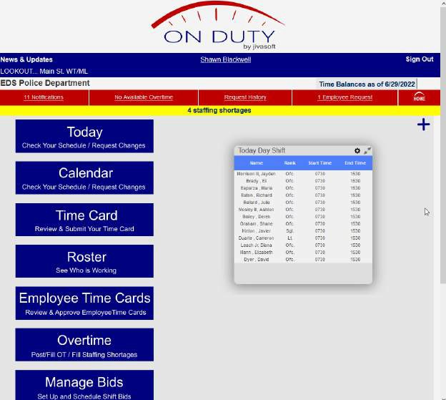

Workcalendarscanbeviewedinmultipleways.

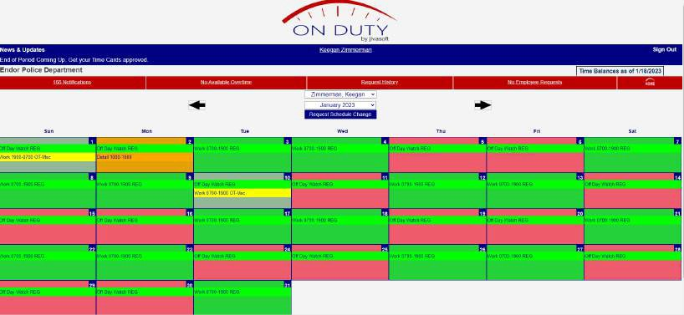

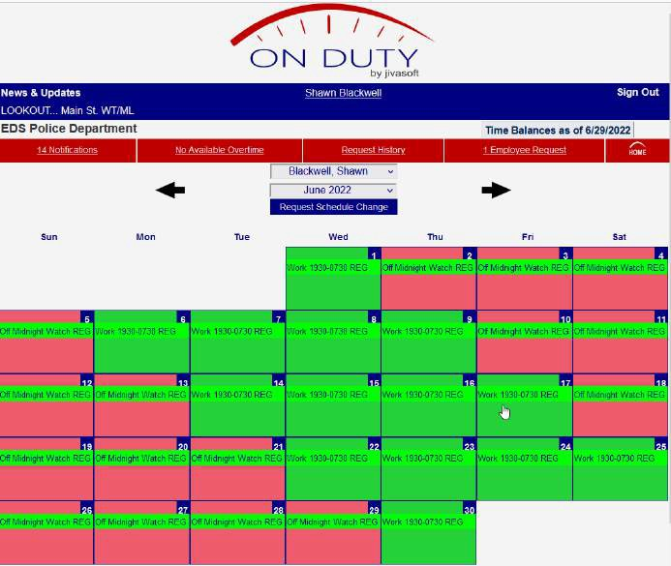

Designated users can view and print a daily assignment sheet that reflects who is working and their vehicle assignment. Notes or tags can be entered for each shift.

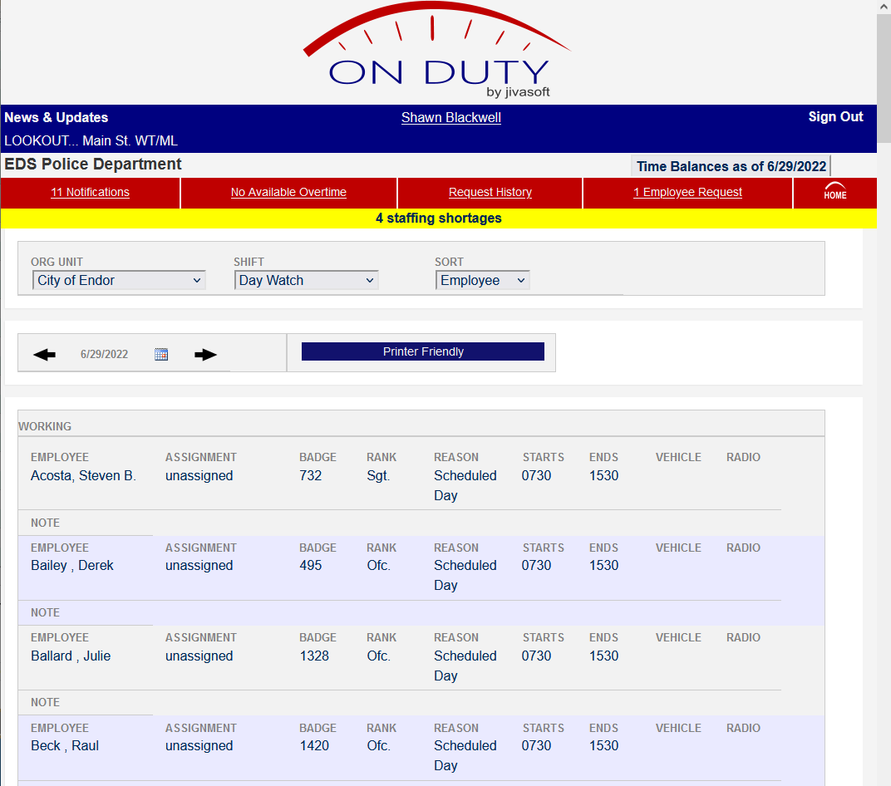

Staffinglevelscanbeseenataglance.Wecanaddnotificationsforshortages,andviolationsof work polices such as exceeding maximum number of hours.

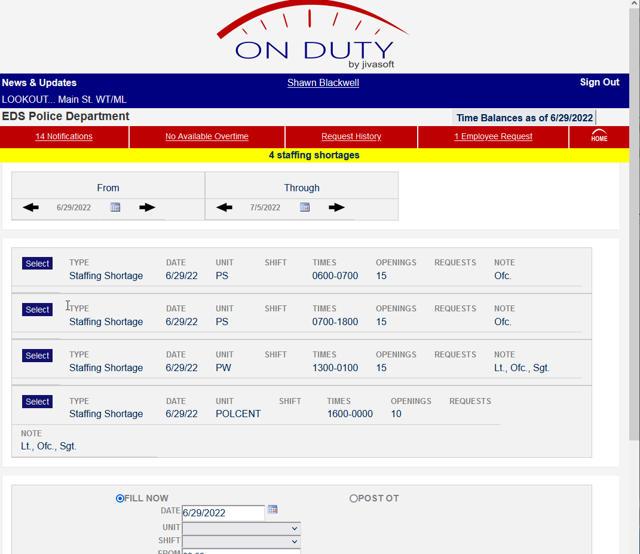

Shift bidding is another feature the configured software offers.

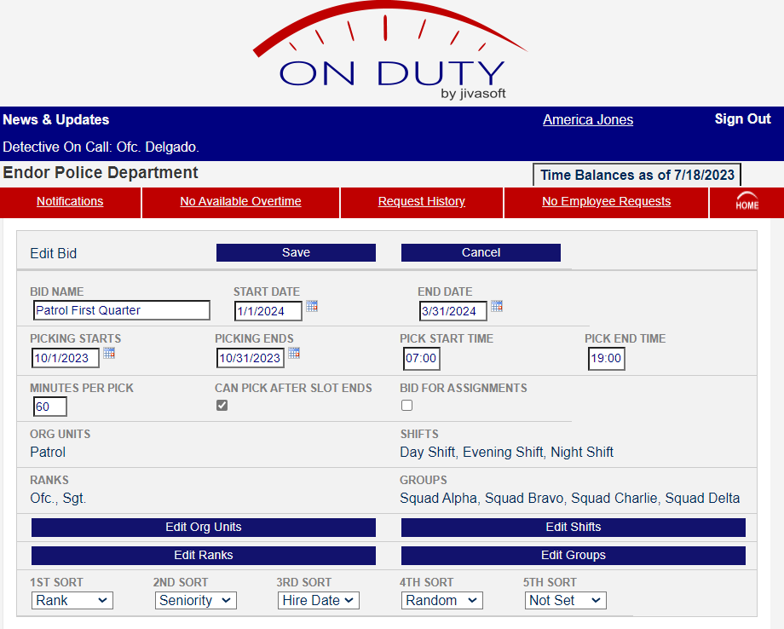

This screenshot indicates a staffing shortage. Supervisors can be granted permissions within the program to fill these vacancies in real time — even if it results in overtime for employees.

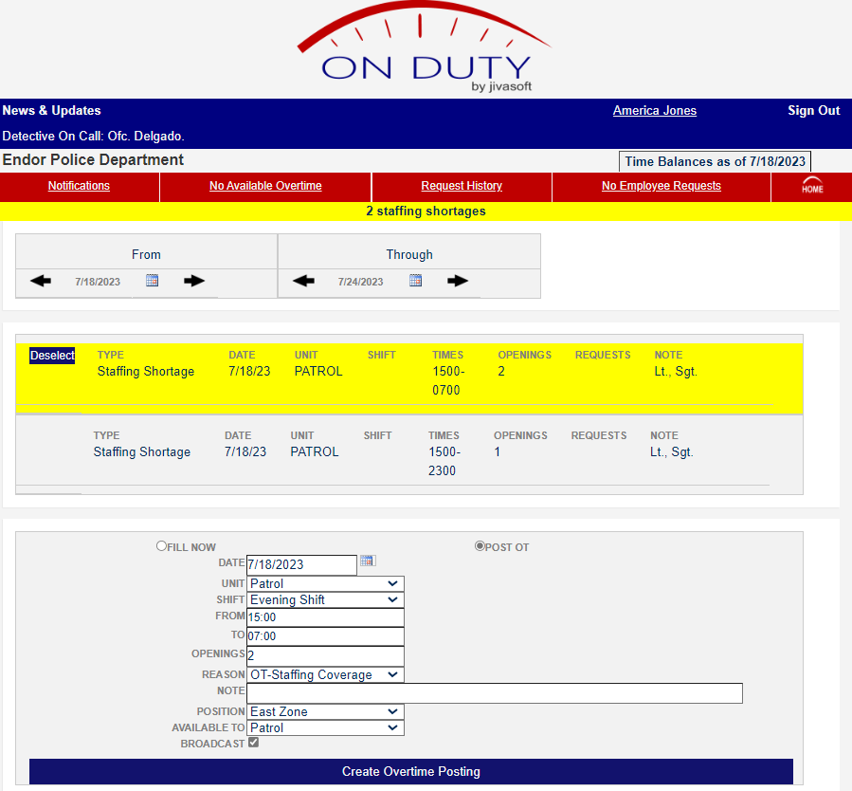

The system can track multiple realtime accrual banks. We customize the categories and accrual rates based on your department’s policies (such as anniversary date accruals). Data can be entered a year in advance. This feature is part of program configuration and is provided at no cost to the City.
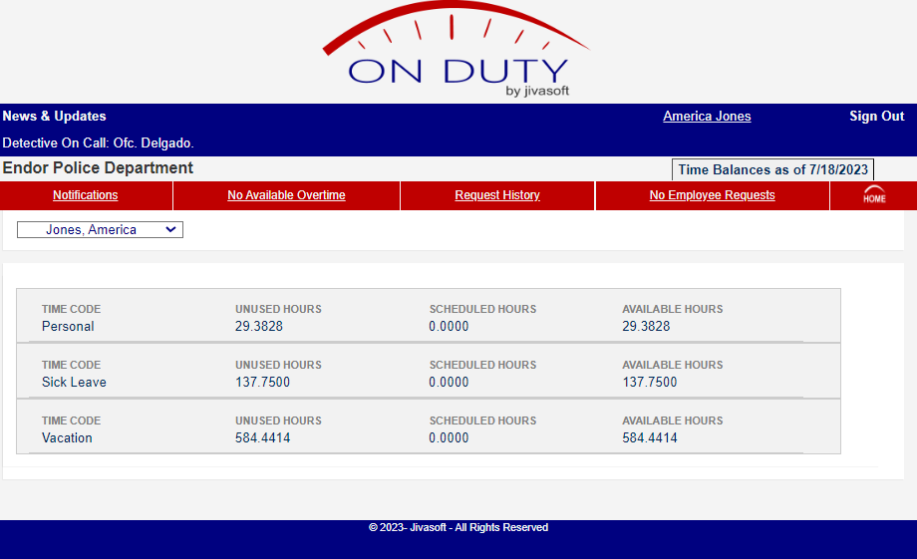

We can build in levels of controls for different functions. In this sample, a supervisor’s approval is required to grant an employee vacation.

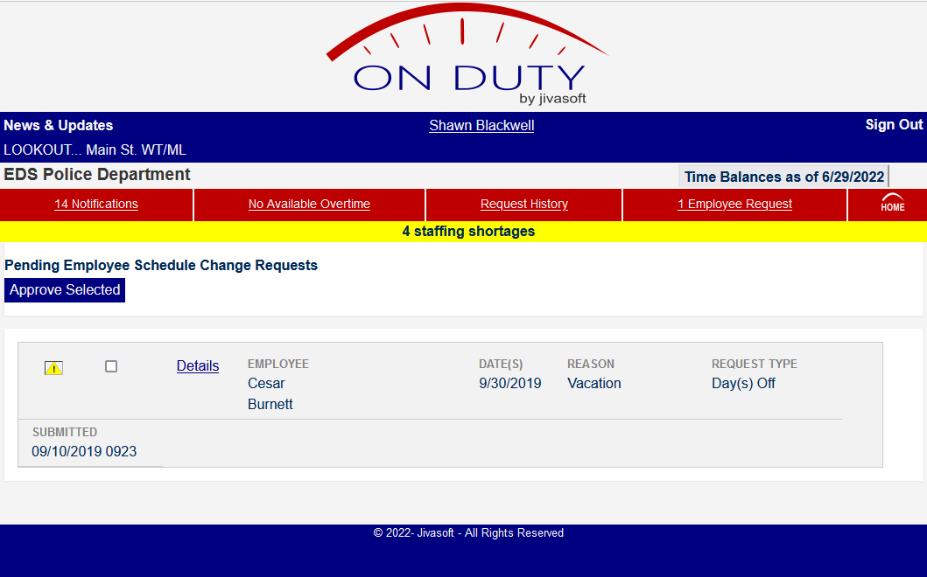

SECTION C: ON-DUTY SCHEDULING SOFTWARE
We offer on-duty scheduling and timekeeping software that is directly integrated with the off-duty administration solution. Our on-duty software is robust, flexible, and customized to support your business practices. When we formed a partnership with J iv a soft in 2016, we recognized its excellence in scheduling software. Three years later, we acquired the company outright. We own the software and have complete control over it. This means we provide you the configured solutions you need — directly — with no middleman.
On Duty and Responder have two-way links. Officer profiles are directly linked between the systems. Officers have visibility of their off-duty schedules from the on-duty application and vice versa. As a standard feature, both on-duty and extra duty schedules are shown together in one view on your mobile device in the On Duty or Responder portals.
On Duty does much more than scheduling. At its core, it manages work assignments by scheduling employees efficiently, meeting staffing needs, and filling coverage gaps. It also tracks attendance, helps employees schedule vacations and other leave time, and facilitates schedule change requests and supervisor review. It accrues benefit time and tracks compensatory time and overtime. On Duty supports multi level time card approvals and exports timekeeping information to the payroll system. In short, On Duty is a complete solution to automate an agency’s human resources operation.
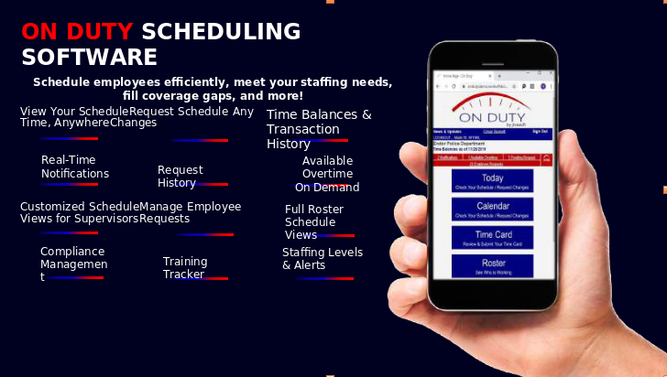

The Responder software prevents overlapping assignments between off-duty and on-duty. Supervisors can view both on-duty assignments and off-duty assignments from the On Duty web portal. All integration is bidirectional and real time. On Duty can be configured to produce a payroll export file that incorporates both on-duty and extra duty detail payrolls in a format compatible with most agencies’ payroll systems.

We offer a cloud based Software as a service (Saa S) solution, specifically Jivasoft’s On Duty Scheduling Software. This Saa S solution facilitates on-duty scheduling, overtime administration, and payroll preparation / integration. The proposed solution can integrate with most payroll systems and is able to import data from an agency’s SAP system. The proposal includes all services necessary to implement the software, including installation and configuration, software setup, assistance and guidance on data entry, testing, training, and ongoing support.

All of our cloud infrastructure is hosted by Rack space, a world class cloud server hosting service. All servers and data reside within the continental United States.
EDS recognizes that the security of networks, systems, and data used to deploy cloud applications is of paramount importance. EDS is committed to continuous vigilance and ongoing efforts to protect its cloud infrastructure. EDS protects that infrastructure by adhering to industry best practices, using state of the art technology, and relying on proven, reliable partners.

SECTION D: ADMINISTRATION OF OFF-DUTY PROGRAM
All extra duty police details. Our services include receiving requests for service, scheduling work, payroll, invoicing, financing accounts payable, and collecting payments. We do this in accordance with the City’s policies and regulations, with no substantial changes to the way off-duty details are distributed.
The City does not incur additional costs or fees associated with our services, which include:
- Coordinating and scheduling officers to work assignments based on the City’s protocols through our secure online platform and apps — and doing so without outsourcing customer interaction to third party call centers, without using “robocalls,” and without forcing customers to use apps to request officers
- Electronically and securely sending the funds to the City to cover off-duty jobs on the cadence directed by the City
- Invoicing clients and collecting client payments
- Customized software and reports for both the City and its customers
- Data hosting through secure, redundant servers and online platforms
- A dedicated account team providing customer service 24/7/365 via email, online interaction, and telephone for customers, officers, and command staff
- Ongoing training, support, and maintenance

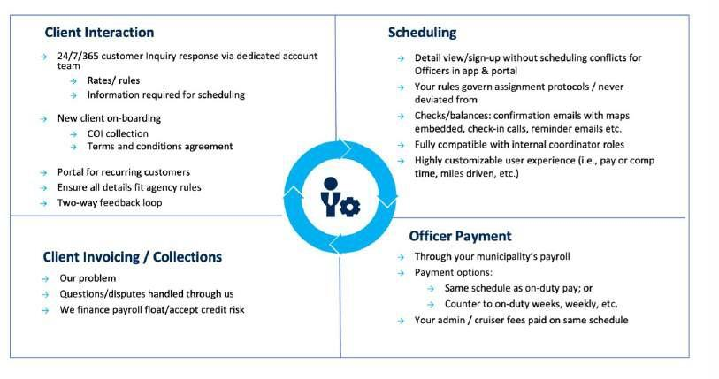
EDS understands that no two law enforcement agencies are exactly the same. Upon contract award, one of the first things we do is learn your rules for off-duty details. Your officers. Your rules. You manage the program; we administer it under your guidance. We customize our software applications, infrastructure, account team, and communication flows to meet your specific needs. For example, we have many ways to award details:
First come, first served. Whichever officer signs up for a detail first gets the detail.
By seniority: Details are offered to higher tenured officers initially. Those that remain unfilled after a predetermined amount of time are then made available to less tenured groups — and so on down the tenure line.
By a static or dynamic rotation list.
By a point system. Officers are assigned points based on policy. For example, an officer might be assessed one point for each off duty hour worked since January 1, one point per detail worked or one point for each off duty dollar earned this quarter.
By a combination. e. g., security details being awarded by a point system, but ASAP traffic details are awarded first come, first served.

We can also build in safeguards to ensure police officers are not scheduled for off-duty employment that requires them to:
- Serve or sell alcoholic beverages
- Perform work as bouncers, doormen, or cashiers at nightclubs or bars
- Perform work for insurance agencies, collection agencies, private investigators,
- attorneys, bail bond agencies, or taxi companies
- Perform work with wreckers or service sta-ons that contract services with the City of
Asbury Park.
- Work or openly associate with convicted or known criminals.
- Perform off-duty work that would require them to work more than sixteen (16) hours within a twenty four (24) hour period without the prior approval of the working officer’s Administrative Commander.
- Work more than two jobs in a 24 hour period.
We provide you three customized software components to support scheduling work, engaging with customers, payroll, and invoicing: (1) the web based customer portal; (2) the web based officer portal; and (3) the officer mobile app, called Responder App. The software has the same functionality regardless of the device through which it is used and can be accessed anywhere there is internet / Wi-Fi connectivity.

“Behind” these three user facing components is very sophisticated, robust, cloud based scheduling, document management, and communication software, which has been handling the on-duty and extra duty scheduling needs of public safety agencies since 1999, including, for example, the Nashville Police Department (550, 000 extra duty detail hours worked per year).

The Officer Portal and App

Scheduling is done through the officer portal or app, twin software systems that can be used interchangeably. The portal can be accessed from any online device, including laptops, Android phones, i Phones, i Pads, etc. Our app can be downloaded at no cost. Officers can use the portal, the app, or both at any time. Users are not required to have a smartphone to engage with our technology.

Through both platforms, officers can view, sign up for, and track their extra duty employment. Each officer receives access to our officer portal, a logon, and sets his / her own password. The officer portal and Responder app are highly customizable and provide as much or as little transparency as you require. Officers’ current point totals, rotation list positions, etc., are either visible or hidden from an officer’s view. We can create fields and p repopulate data to display information and options based on your rules and protocols.

This portal and app can also be used by approved outside jurisdictions offering officers to work off-duty assignments. We can release those jobs at a time you designate.

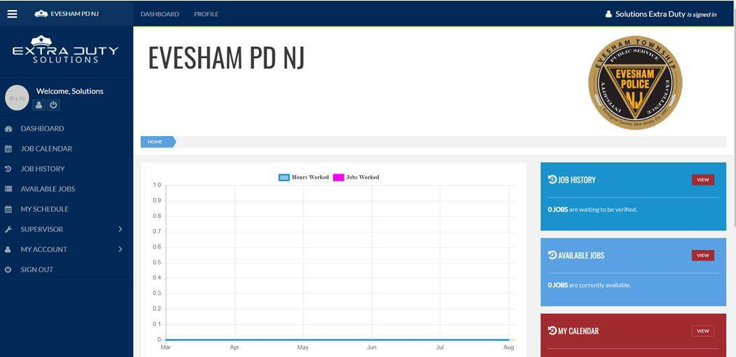


ASBURY PARK POLICE NJ

In addition to scheduling, officers can:
Customize their profilesby specifying whether they want to receive notifications (such as reminders for upcoming assignments) by email, text, push notification, or all three. They can also provide personal information for payment or scheduling purposes. Fields within each profile can be customized to meet your specific needs. Fields that should be defined by department management can be pre populated by our APPD account team. Asbury Park PD may wish, for example, that the account team be responsible for verifying an officer’s tenure, K 9 certification, whether an officer is certified to work extra duty at a local hospital, and similar information. APPD can also prohibit suspended or unauthorized officers from accepting details.

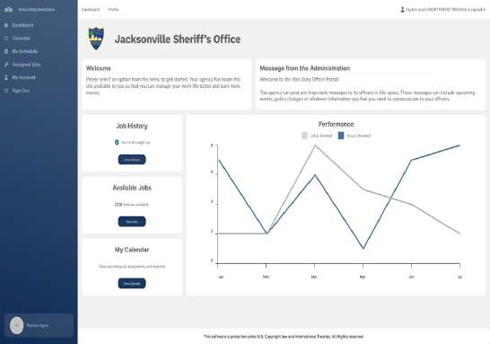

Verify paid detail hours worked.Officers can log on to their portals to punch in when they arrive at a paid detail. This can be done at the job-site via the portal or app, or any -me after the end of a detail. filet. If the officer is no longer able to attend, our representatives will make their best efforts to locate another officer to work the detail. Similarly, when a detail is over, an officer can “check / punch out” of the detail on his or her portal or app to verify its comp leon. If an officer states the start and / or end

Asbury Park PD NJ

Asbury Park PD NJ
time of the detail was di e rent from the scheduled time, he or she can explain the di e rence within the portal. For example, the officer can confirm that the customer requested an extra hour, and we can ensure the officer is paid for that time. An officer can also just verify hours after a detail has been completed, in the app or the portal. Officers do not need to have smartphones to engage with our technology

Communicate available and unavailable timesthat they can work secondary employment. An officer can “opt in” or “opt out” of specific times on individual days or on a recurring basis. Details can then be assigned to officers based on their availability and the guidelines established by each law enforcement agency.

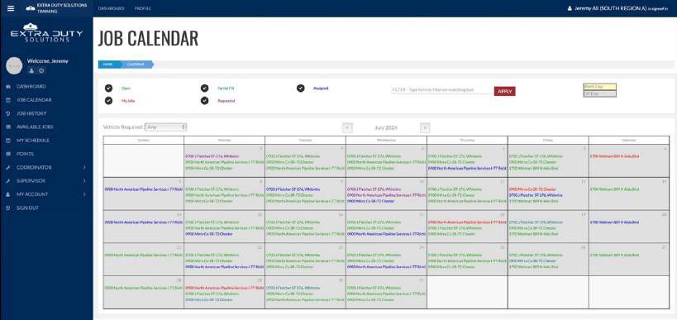
Review their extra duty calendars.Officers can view all details worked, scheduled, and available via an easy to use calendar or list view. Officers can quickly review the last month, current month, next four weeks, year to date, or any date range they define.

If required, now or in the future, we can also provide more than one scheduling methodology simultaneously. For example, a given month’s recurring security details might be awarded on the 10 th day of the prior month on a first come, first served basis, while road jobs requested on an ongoing basis may be awarded as needed.

Regardless of the scheduling algorithm used, we can override it in the event of an emergency or last minute officer cancellations, if necessary. In such situations, we can use the “blast-out” method of communication with either a first come, first served or short time-frame (15 or 30 minutes, typically) open period award process.

Some details may only be open to a sub-group of APPD officers. For example, special event organizers may request motorcycle officers for their function. Non motorcycle officers may be awarded those details only if too few motor officers sign up to work the event. A detail requiring K 9 certification would only be open to officers with that certification, and so on.

Officer assignment region can be incorporated into the assignment process in highly customized ways. For example, a detail might be offered to officers in one region, but if no officer requests the detail, it can then be opened to officers in a second region, and then a third, and so on.
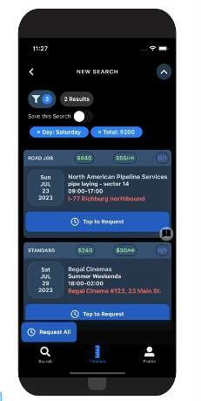
Confirm locations worked through geo fencing. If your agency requests, we can configure our mobile app to track the location of the officer while the officer is working off-duty through his or her mobile device. This data can be provided to the agency through routine, scheduled reporting. Please note that location tracking can be controlled by the user of a mobile device. If agency policy permits officers to disable location tracking, or if the officer disables location tracking in violation of policy, our app will not be able to access or report on the officer’s location.

Screenshots of User Interface
The officer portal and Responder app remain highly customizable. We can create fields and p repopulate data to display information and options based on APPD’s rules and protocols. Based on feedback from our clients, we have improved the functionality and appearance of our off-duty app and website. Both remain highly customizable and provide as much or as little transparency as you require. Officers’ current point totals, rotation list positions, etc., are either visible or hidden from an officer’s view.

Officers can also customize the way they view information on their devices.

More screenshots of theResponderapp and portal are in the Appendices

The Customer Portal
Recurring City customers seeking off-duty officers can directly access our software online. This enables them to easily request new extra duty details, modify or cancel existing details, communicate with our staff, and view their service history including, but not limited to, their invoices, payments, which officers filled their past details, and which officers are scheduled to work upcoming details. This convenient tool reduces the need for calls, although our staff accepts calls 24/7/365.

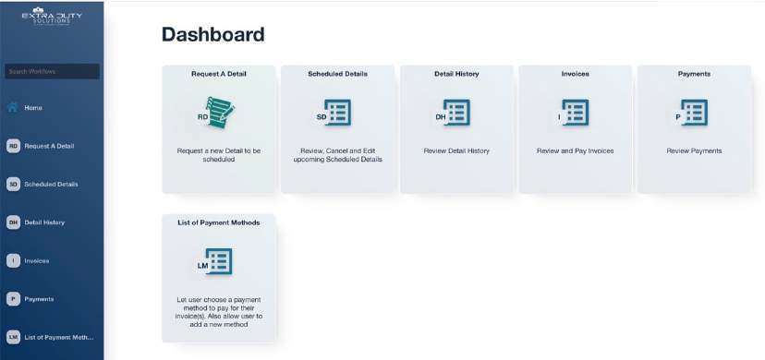

Utility foremen can use this portal to find out which officers are assigned to jobs. They can also view and / or upload vouchers.

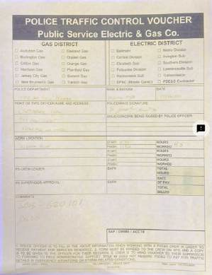
Many recurring customers from the City will form first name basis relationships with account managers and feel comfortable submitting requests by email. Often, utility firms and contractors have complex and changing needs and require the 24/7/365 account team phone support structure we provide. Before any new customer can request service solely through the portal, your APPD dedicated account team will speak with them on the phone to ensure the request is consistent with department rules.

Our software includes a built-in document management system. This allows customers to visit a custom page for each public agency where they can view that agency’s required documents and agree to specific terms. Such documents might include extra duty service agreements detailing rates and department policies, or terms and conditions. Customers can also upload key documents such as certificates of insurance and vouchers. All documents can then be transferred to agencies in batches.
or on a rolling basis as they are submitted by customers. Individuals within APPD can also be included in the on-line review process for some or all customers in the event APPD wants to review and approve some or all new customer requests.
Screenshots of the customer portal are in the Appendices.

Interacting with City Customers

Our goal is to make it easy for your customers to use EDS’s extra duty program. Before going live, we send letters to active City customers explaining the process for hiring officers and how to contact us for any questions or concerns. In addition to our company contact information, we create a unique phone number and email address specific to the APPD account so prospective customers can easily reach us.
Before any new customer can request service solely through the portal, your account team will speak with them on the phone to ensure the request is consistent with APPD rules.
Customers who use our system to request officers for extra duty find it easy and responsive. If they wish, they can submit a request for an officer when it is convenient for them and are no longer dependent on coordinating extra duty support during the law enforcement agency’s business hours. Even with the ease of our online customer portal, most customers (85%) prefer to engage with the account team by phone. Often, recurring customers get to know the account team and have weekly or monthly calls with them to ensure their extra duty needs are being handled smoothly. On average, in the Northeast, where most off-duty work is traffic control, 15% of customers use the portal exclusively, while the other 85% prefer to call the account team for assistance. Often, utility firms and contractors have complex and changing needs and require the 24/7/365 account team phone support structure we provide.

Payment Processing
We can run reports with the data you need, in the format you want, in the frequency you choose.
We understand that the City will provide us with a list of officers approved for off-duty employment and the guidelines for this program.
We further understand that outside jurisdictions wishing to provide back fill for off-duty details that cannot be filled by APPD must be approved by the City and Police Chief. That information will be gathered during on boarding.

Billing
Many of our municipal clients charge different rates for different categories of work. We can easily bill your customers and account for officer pay for traffic control details, security details, city paid details, and grant work. The categories of work can be included as fields in reports.

City customers can be billed in one-hour increments.

We typically invoice all publicly traded companies and the City’s long term customers via mail or within the customer portal. They pay us directly. EDS finances the float and accepts the credit risk, thus eliminating the program’s financial risk for the City. In the past 12 months, approximately 92% of the extra duty work that we administered was invoiced. We also have options to require all customers to prepay or to require only non recurring, non credit worthy customers to prepay. Such customers can pay via an escrow account, overnight check, credit card, wire transfer, e-check, or even Walmart electronic transfers.

We have a very structured process to handle collections and evaluate credit worthiness. Delinquent customers will receive emails and calls from our account or finance teams (depending on the customer relationship) to become current. If they are still delinquent, we may require prepayment on future detail requests from that customer. If a customer is delinquent and there are no future detail requests, we can send a legal demand letter or forward the customer’s information to our collections firm for action. We have served more than 9, 000 agency customers and have had to send only nine demand letters and initiate legal action twice.

We often preclude delinquencies by having non recurring customers prepay or place a credit card on file with us so that we can charge the card if they do not pay their invoice.

We will inform the City of any customer or individual we deem non credit worthy.

SECTIONE:CUSTOMERSERVICETO APPD
In addition to a project management team, APPD has its own dedicated account team. The City’saccountteamcoordinatesallaspectsofoff-dutyschedulingamongtheofficers,agency,

and your customers. Account representatives also resolve user level technical issues, such as computer log-in problems and data entry errors. Your account manager troubleshoots complex technical problems with our software and maintenance team, and calls you back when they resolve the issue. That means, you are not on hold for tech support, or waiting on the phone while our technicians ﬁx the problem. Your account team is available 24/7/365 through a phone number created for and dedicated to your agency. We do
notuseacallcenterapproach.Yourdedicatedaccountteam(cons is ngofoneprimaryand several secondary coordinators) handles all your calls and emails.
KEY POINT: All officer and customer calls are answered by our W-2 employees. We do not outsource officer or customer engagement at any time. We also do not force or strongly encourage customers to use their portals if they prefer to engage with their account management team by phone. We very much prioritize customer service over cost reduction.
At night and on weekends, this same number is answered by our internal night / weekend coordinator teams working in one of our operations centers. If there were an event that affectedanyofouroperationscenters,callsaretransferredtoothercenterswithinthree(3) seconds. We never outsource call handling to external call centers or other third parties.
Moreover,APPD’saccountteamwillbesplitacrosstwoofouroperationscenters,sothata hurricane or other disaster in one location does not affect our ability to respond to calls.
OurcallroutingsoftwareisthesamesoftwareusedbyApplecomputersupport.Ourincoming calls are immediately routed to the correct account teams. We answer ninety four percent (94%) of our incoming calls by the end of the third ring and routinely answer 1, 025 incoming calls on an average weekday.
In addition, J iv a soft provides unlimited support 24/7/365 via email and / or telephone to designatedadministratorsateachagency.Individualsupervisorsandofficersareencouragedto seek assistance internally from designated personnel at each agency, as, more often than not, theirquestionswouldberelatedtoagencypoliciesandprocedures,ratherthantechnicalissues with the software. However, our Texas based technology team will gladly provide support to

officersiftheycontactus.
If a technical issue is affecting your on-duty scheduling system, our technology staff will immediatelytroubleshoot,remediateandresolvetheissue.Wehaveastrongtrackrecordand excellentreputationforensuringthatitssoftware,networkandCloudplatformarerobustand reliable. We are committed to ensuring smooth operation and continuous availability of itsservices.
We are com mined to applying rigorous quality assurance procedures in all critical aspects of our service delivery operations and infrastructure.
{{#INCLUDE_QA_PLAN}}See the attached Quality Assurance Plan{{ / INCLUDE_QA_PLAN}} for our Quality Assurance Plan (Yes).

SECTIONF:IMPLEMENTATIONAND TRAINING

On-DutySchedulingSoftware

Implementation is usually completed within 30–60 days. Upon contract award, our team will immediately set up the technical environment to support implementation. Once the technical environment is in place, we will begin the configuration and customization process. Our team will coordinate with key personnel at your agency to finalize the configuration and customization of various software options.

Implementing On Duty Scheduling requires:
- Multiple online setup sessions with the department’s project team and scheduling administrators
- Building the organizational structure within the software to conform with the agency’s hierarchy, ranks, and types of employees (e. g., salaried, sworn, civilian)
- Importing employee data from current records (officer name, salary, current leave balances, section details, certifications, etc.)
- Creating detailed schedules and rotational groups and applying them to employee records
- Setting up the agency’s time-off and overtime reasons, along with existing leave time banks for balance tracking and time accruals
- Customizing minimum staffing rules built around the agency’s staffing needs, including notifications to supervisors when staffing falls below minimum levels multiple days in advance
- Building payroll processing and exporting files
- Training selected departmental members on administrative functionality

We coordinate with your team to obtain the officer data you want loaded into the software. This ensures you begin with complete and accurate information about your officers.
Once all data loads are complete, we test the software in “sandbox mode” by training administrators on how to use the program.
When this trial period is over, we replace the sandbox database with a clean production database. Administrators can then begin scheduling officers in anticipation of going live. Once live, your designated personnel can perform the administrative and daily tasks necessary to maintain an accurate scheduling system.

Training
We have found that users require minimal training to use On Duty given its intuitive format. However, not all users have the same level of technical skills, and some will need more support. Our team will prepare a “Quick Start Guide” document for supervisors and officers to help them get started with the web portal. In addition, we will prepare a short video showing supervisors how to access and operate the web portal and the mobile app. We will also create a custom video that reflects your agency’s specific policies and procedures.

A senior member of our technical or customer support team will train your administrators through a combination of presentations and hands-on assistance. During the training, administrators will exercise all of the scheduling, reporting, and timekeeping features of the On Duty software.

Should you decide to conduct training classes, our team will work with your administrators and / or training personnel to prepare materials and a training agenda. J iv a soft support personnel will be available remotely during the training in case questions arise that cannot be answered by your staff.
Weprovideunlimitedremoteassistanceforsupervisorandemployeetraining

Off-DutyProgramAdministration

After you are satisfied with the off-duty software program, we will train your officers on how to use it. Training for your officers is provided at no cost to your municipality. We offer training through an officer training document, a video tutorial on the use of Responder App, as well as live group training.

LiveGroupTraining:We can schedule training based on your agency's scheduling needs. We can conduct it during roll call, in larger group settings, at any time of the day or night. In person training takes approximately 30 minutes per session.

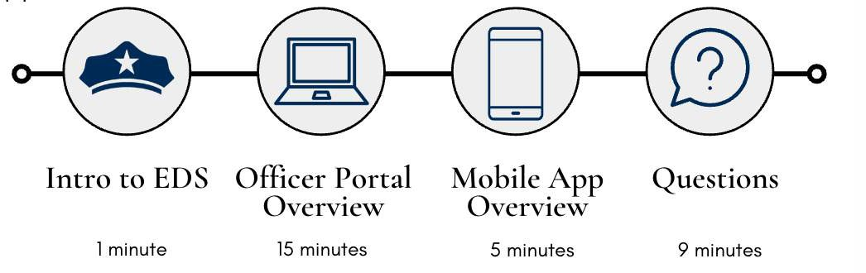

Documentation: Our team will create a custom document for your off-duty program with step by step instructions on how the system works. It will outline how officers log in to the system for the first time, request jobs, view future jobs, check in and out of jobs, and perform all other functions you request. The document will also provide an overview of your agency’s assignment process.

Video:We will provide a video tutorial (click to view) for your agency that offers an overview of how your off-duty program will work and a step by step guide on how to use the system. The video is a valuable resource for officers who cannot attend in person training, for in service training, or for future new hires.


SECTIONG: BOOKSAND RECORD
To ensure we can provide you the records and books you require, all of APPD’s data is securely stored within the United States, specifically in the Dallas / Fort Worth data center of Rack space. Rack space is a world leader in Infrastructure as a service (Iaa S) and Saa S hosting. J iv a soft uses a combination of servers to provide its services. We protect that infrastructure by adhering to industry best practices, using state of the art technology, and relying on proven, reliable partners.
We have a sophisticated data backup approach that ensures both high availability and recover ability under virtually any disaster scenario. Data is stored in highly reliable Microsoft SQL Server databases. Databases are fully backed up each day, with incremental backups occurring throughout the day. Database backups are archived daily to remote cloud storage devices to provide additional security against device failures, ransom ware, and other malware. Servers are imaged weekly to allow quick recovery in the case of a hardware failure or other catastrophic event.
To protect credit card data, a Qualified Security Assessor Company (QSA-C) provides a PCI compliance program for our Merchant Services Account. We also carry data breach and privacy insurance, along with third party and employee theft insurance.
The City may examine any books, data, and records associated with its account at any time. EDS will maintain all files associated with this contract for a minimum of five years and will destroy or return records that contain personal information in accordance with applicable requirements.
Thisservice isat no costto theCity.
- Indicate your experience in providing administrative services, including customer service, scheduling, billing, collections, payroll, and administrative services management.
Pleaseseethe Experience section.
- Provide samples of the reports that will be provided to the City of Asbury Park and a description of the hardware and software that will be used for this engagement.
Pleaseseethe Key Individuals sectionandthe Appendices.
- Identify the key individuals, their roles, and experience who would be assigned to the City of Asbury Park. Describe their roles in detail and provide a brief description of their professional experience in administrative services management.
Pleaseseethe Key Individuals section.
- Please provide any additional information that you believe will assist the City of Asbury Park in moving forward with the outside administration of off-duty employment.
Pleaseseethe Additional Information section.
- Provide the standard fees and cost structure for these services.Please see the Fee section.

SECTIONH:INSURANCE
APPD officers are covered through our comprehensive insurance program while working off-dutyemployment.Ourinsuranceisprimarytoyouragency’sinsuranceandfurtherprotectsthe agency with a waiver of sub rog ation. The agency, and its employees, will be named as an
additional insured. Our insurance includes a $21 M annual limit on general and specific liabilityinsurancecoveringtheactionsoftheofficers.
Thelimitsandridersoutlinedherearepartofourstandardcontract.Wedonotchangethe termsorconditions,orapplylowerinsurancelimitsuponcontractawardwithyouragency. However, if your risk management team requires higher limits or additional riders, we can usually fulfill such requests in a manner of days.
Our insurance is reviewed annually by Cross Insurance’s high risk group. Other entities in the Cross high risk group include the New England Patriots, the Boston Bruins, the Boston Red Sox, and numerous national construction firms and municipalities. The high risk team advises us on appropriate riders and coverage limits.
Coverage | Total Limit | Per Incident Limit
Professional Liability/ Technology E&O | $3M | $3M
General Liability | $2M | $1M
Excess Liability | $10M | $10M
Auto | $1M | $1M
Personal Injury | $1M | $2M
Management Liability | $1M | $1M
Property | $152K
Network & Security Liability
Third Party Liability Coverage | $3M | $3M
Regulatory Defense & Penalties | $3M | $3M
Business Interruption Coverage | $3M | $3M
Cyber Extortion | $3M | $3M
Breach Response | $3M | $3M
Liability | $3M | $3M
Crime
Employee Theft | $1M | $1M
Third Parties Property | $1M | $1M
ERISA | $1M | $1M
Forgery | $1M | $1M
Inside & Outside Losses | $1M | $1M
Tech Fraud | $1M | $1M
Workers Compensation - All States
Workers Compensation | Statutory
Employers Liability- By Accident | $1M | $1M
Employers Liability - By Disease | $1M | Policy limit
Employers Liability - By Disease | $1M | Each employee

We have more information about our comprehensive insurance.

SECTIONI:MAINTENANCEAND SUPPORT
We have adopted a continuous upgrade approach to maintaining our software. This approach results in more frequent but less disruptive updates that are usually unnoticed by users and do not require system downtime. The way updates occur varies based on which technology is being updated. The mobile app is updated through “over-the-air” updates that are transparent to the user. Web portal updates are performed during low volume times and do not require downtime.
Support for our software is available 24/7/365 by contacting our agency support team using the local telephone number provided to your agency. Our support team will attempt to resolve issues immediately. Critical issues, such as unplanned system outages, will be escalated immediately to a member of our technical staff who is on call. Non critical issues reported outside of normal business hours will either be resolved by the customer support team or routed to our technical staff for follow-up during normal hours.
EDSmakesthefollowingwar ran esforthedurationofitscontracts:
- EDS warrants that its software and IT infrastructure meet all legal requirements and accepted industry standards with respect to:

  - Reliability
  - DataSecurity
  - Recover ability
  - Availability
  - Audit ability

- EDS warrants that it will continue to exercise due diligence in the hiring and supervision of employees, as follows:
  - Allemployeesundergoabackgroundcheck
  - Allemployeesaresupervised,reviewedandheldaccountableforthequalityof their work
  - Employees who perform below expectations are terminated
  - CustomerserviceisperformedexclusivelybyEDSW-2employees
  - Customerserviceisnotoutsourcedorsubcontractedever
  - To the extent that certain internal business functions are performed by subcontractors,suchasprovisioningandadministeringITinfrastructure,EDS warrants that such subcontractors will be rigorously screened and held toaccount
- EDSwarrantsthatitmakescommerciallyreasonableeffortstoensurethatthesoftware does not contain viruses or other malware.
- EDS warrants that its software and IT infrastructure are stable, reliable, and functionally sufficient to provide the proposed services without defects or disruption. If defects in the software or IT infrastructure are identified and reported to EDS, EDS will make diligent efforts to remedy the defects as quickly as is reasonably possible. EDS will keep you informed of the progress of these efforts and will meet with agency staff as needed to keep the agency informed about the impact of the defect and the timeline for it being remedied.

APPENDIX {{Letter}}: DISASTER RECOVERY PLAN



DisasterRecovery&IncidentResponsePlan
RevisionDate:11/29/2023

TableofContents

Overview 1
Loss of Internet Connectivity or Electrical Power at EDS Operations Centers 1
Event Description 1
Potential Impact 1
Mitigation Factors 1
Response 2
Destruction or Loss of Access to EDS’s Offices 2
Event Description 2
Potential Impact 2
Mitigation Factors 3
Response 3
Cloud Server Crash 3
Event Description 3
Potential Impact 4
Mitigation Factors 4
Response 4
Rackspace’s Dallas Data Center Goes Offline 5
Event Description 5
Potential Impact 5
Mitigation Factors 5
Response 5
Cloud Server Penetration 6
Event Description 6
Potential Impact 6
Mitigation Factors 6
Response 7
Appendix: Security and Data Breach Incident Response Protocol 8
Detect the Attack 8
Stop the Attack 8
Notify Executive Management 8
Assess the Impact of the Attack 8
Notify External Stakeholders Impacted by the Attack 9
Acquire Resources to Respond to the Attack 9
Deploy Available Resources to Recover from the Attack 9
Take Additional Steps to Prevent Future Attacks 9

Overview
ThetechnologyandaccountmanagementteamsatExtraDutySolutions(EDS)providesoftware,Saa S (Software as a Service) products and customer service directly to public safety agencies, their employees, and their customers. These end users rely on the reliability, availability, and continuity of EDS’s services for their day to day operations. It is critical to the financial and operational success of Extra Duty Solutions and the welfare of its customers that the company is prepared to recover from any disaster quickly, smoothly, and transparently.
Disasterscanoccurwithverylittleornowarning.EDSmustanticipatethetypesofdisasters,betheynaturalorman-made,thatcouldbefallthecompanyoritsinfrastructuretoensurethatitcanrapidlyrecover and ensure continuity of its services to its stakeholders.
Thisplanspecificallyaddresses theprospectofdisastersthatresultinthedestructionorlossofaccess tocomputers,computernetworks,communicationsservicesandphysicalfacilitiesthatarevitaltothe continuity of Extra Duty Solutions as a business enterprise or the continuity, availability and reliability of Saa S services provided by EDS to its customers.
This document will present various types of potential disaster scenarios, assess what impact those disasterscouldhaveontheoperationofthecompanyanditsservices,identifypoliciesandprocedures currentlyinpacetomitigatetheimpactofeachdisasterandthestepsnecessarytorecoverandrestore continuity of the company and its services.

LossofInternetConnectivityorElectricalPoweratEDSOperationsCenters
EventDescription
ItispossiblethatEDScouldloseelectricalpowerorInternetconnectivityatanyofitsoffices.
PotentialImpact
EDS’s employees rely on Internet connectivity to perform many of their daily tasks and to communicatewithoneanotherandwithexternalstakeholders.EDS’sprimarytelephonesystemisa Voiceover ip (VOIP) system, and it relies both on electrical power and Internet connectivity to operate. EDS’s ability to provide customer service and support, a critical element of its day today operations, relies on the availabilityoftelephonesandemail.ManyofEDS’s employees usedesktop computers for most of their day today work, and the loss of the ability to operate an Internet connected computer would disrupt the productivity of virtually every employee of the company.
MitigationFactors
EDS’s Saa S services are hosted in a secure data center in Dallas, Texas with extensive power and networkredundancy.Rack spacemaintainsInternetconnectivitythroughmultipleTier1connections to multiple carriers.
ApowerlossorlossofInternetconnectivityatanyEDSoperationscenterswouldnotaffectthe availability of its Saa S services to its external stakeholders.
EDS’sSheltonOperationsCenterhasitsowngeneratorpowerfulenoughtooperatetheHVACandto provide light and electricity for all essential equipment.
EDS’sSheltonOperationsCentermaintainsredundantnetworkconnectionsfromvariouscarrierswith
automaticfail over.Thesenetworksandfail overcapabilitiesaretestedroutinely.
EDS’sVOIPtelephoneservicewillforwardcallstootheroperationscentersautomatically,and,if necessary, to cell phones of key personnel if the office phones are not available.
EDS’sVOIPtelephoneservicecanbeaccessedviatheInternet.EmployeescanuseInternet connected laptops and cell phones to operate all the essential features of the company phone system.
EDS’skeyemployeeshavelaptopcomputersandInternetathomeandcouldworkfromhomeifnecessary.
PublicWi-Fiisavailable inmanyplaces,suchascoffeeshops,restaurants,shoppingmalls andpublic buildings.Intheeventofabrieflossofpowerand / orInternet,criticalfunctionscouldbeperformedover public Wi-Fi.
Response
If EDS loses power or Internet, the top ranking person on site at the time will immediately attempt to determinetheexpecteddurationoftheoutage.Thispersonwillalsodetermineiftheoutagecreatesa health or safety risk for personnel.
If the outage is expected to last for less than an hour, and there is no risk to the health or safety of employees, then employees will simply wait for the incident to end. Incoming phone calls will automaticallyroutetoemployeesinotheroperationscenters.Employeeswillusetheirpersonalcell phones, as necessary, to communicate with customers and to access their company email.
If the outage is expected to last for more than an hour or if there is risk to the health or safety of the employees,thenemployeeswillbeaskedtogohomeandwork.Employeeswillberequiredto verify that they are redeploying to a location that has power and Internet.
Inthecaseofawidespreadoutagethatisexpectedtolastmultipledays,itmaybenecessaryforEDS to organize a team of critical employees to travel to a remote location that has power and Internet, most likely another EDS Operations center in another part of the country. The method of travel would be determined based on the scope and nature of the disaster. For example, employees could be asked to drive to a nearby city or some other location that is not affected by the disaster and to work from a hotel room until the outage is resolved. Alternatively, employees could fly to another EDS operations center and work from there.

DestructionorLossofAccesstoEDS’sOffices
EventDescription
ItispossiblethatoneofEDS’sofficescouldbedestroyedorrenderedinaccessibleforanextendedperiod.
PotentialImpact
MostofEDS’semployeesroutinelyworkinanoffice.EDSkeepsfurnishings,fixtures,computer software source code, computers, data storage and networking equipment at its offices. The destruction of its
officeswouldposeachallengetothecompany’sabilitytocontinuedevelopingsoftware,operatingits business, and supporting its customers.
MitigationFactors
EDS’s Saa S services are hosted in a secure data center in Dallas, Texas with extensive power and networkredundancy.Thedestructionorun availabilityofanyofEDS’sofficeswouldhavenodirect impact on the availability of Saa S services to its customers.
EDS’sVOIPtelephoneservicewillforwardcallstootheroperationscentersorthecellphonesofkey personnel in the event that the office phones are not available.
EDS’s VOIP telephone service can be accessed via the Internet or a smartphone app. Employees can use Internet connected laptops and cell phones to operate all the essential features of the company phone system.
ManyofEDS’skeyemployeeshavelaptopcomputersandInternetathomeandcouldworkfromhome if necessary.
EDSmaintainsacasualtyinsurancepolicythatisadequatetoprovidethefinancialresourcesto reconstitute the office in a new or temporary location.
EDSmaintainsacorporatecreditlinethatwouldenableittoimmediatelypurchasecritical furnishings and equipment to reconstitute a new or temporary location.
EDSreceivespaymentsfromitscustomerseitheratabanklockboxoraP. O.Boxatalocalpostoffice, as well as through electronic funds transfers to its bank accounts. Destruction of EDS’s offices would not disrupt EDS’s cash flow or financial viability.
EDS maintains an offsite repository of all its softwaresource code that is accessible through the Internet.IfEDS’sofficesaredestroyedorinaccessible,EDSwouldnotloseoneofitsmostvitalassets, i. e., its computer software source code.
EDS’s corporate and financial records are maintained through Cloud services in electronic format. Therefore,thedestructionofEDS’sofficeswouldnotresultinalossofcriticalbusinessandfinancialdata.
Response
IfEDS’sofficesaredestroyedorrenderedinaccessible,employeeswillbeaskedtoworkfromhome.
EDS’sexecutivemanagementwouldimmediatelyfileacasualtyclaimwiththecompany’scasualtyinsurer.
EDS’s executive management would immediately contact a commercial realtor to identify an appropriateofficespacewithimmediateavailability.Executivemanagementwouldworkdiligentlyto arrange for the re constitution of core office capabilities, such as utilities, local area networking, broadband Internet access, desks, phones and computers.
Employees would reconstitute their own personal work environments, restoring data and files from off- site backups and re installing third party software.

CloudServerCrash
EventDescription
ItispossiblethatoneofEDS’svirtualCloudServerssuffersanun recoverablehardwareorsoftwarefailure.
PotentialImpact
EDSoperatesvariousCloudServers. Shouldoneofthese servers become incapacitated for any reason,there could be a significant loss of access to EDS’s Saa S services for some or all of EDS’s employees and external stakeholders.
MitigationFactors
EDS’sSaa SservicesarehostedinasecuredatacenterinDallas,Texaswithextensivepowerand network redundancy.
EDScreatesCloudBackupsofcustomerdatabasesdaily.Shoulditbenecessarytorestoreoneormore customerdatabasesfrombackup,thiscouldbedoneveryquickly,easily,andreliablyfromanylocation with a wired Internet, Wi-Fi, or cellular data connection.
EDScreatesCloudBackupsofSystemImagesofitsserversonaweeklybasis.Shouldaparticularserver become disabled, EDS could provision a new server with the most recent viable image of the disabled server.Theentireprocessofprovisioninganewserverfromabackupimagewouldtakeaboutanhour.
Response
EDSwouldcontactRack spacetodeterminethecauseoftheserveroutage.IfRack spaceisableto recover the server quickly, EDS staff would not need to take further action.
EDSstaffwouldnotifyallimpactedcustomersoftheoutageandprovideanexpectedtimelinefor the resumptionof service. In the case ofpotential dataloss, EDS will notify the customer of what data they can expect to recover and what data EDS staff would need to reconstitute. In no case would customers expect to lose any data prior to the early morning of the day of the outage.
IfRack spaceisnotabletorecovertheserverorifthereislikelytobeanextendedoutage,EDS’sstaff would provision a replacement server through the Rack space Control Panel using the most recent, viablesystemimageforthedisabledserver.Ifcustomerdatabasesresideonthedisabledserver,EDS staff would attempt to recover the databases from attached storage from the disabled server. If EDS IT staff cannot recover the databases from attached storage, then staff would recover the databases from Cloud Storage.
EDSwillworkwithRack spacesupporttoattempttotransfertheIPaddressofthefailedservertothe newly re provisioned server. If Rack space is not able to configure the new server with the same IP Address, EDS staff will update the DNS entries for the affected server to point to the newly re provisioned server.
Iftherewerechangestotheserverenvironmentsincetheimagewasbackedup,staffwilldocument and re-create the changes.
OnceEDSITstaffhasreconstitutedtheserver,EDSwillnotifycustomersthattheservicesareonce again available.
EDSITstaffwillmeettoreviewwhat,ifany,changesweremadetotheserverenvironmentthatmay have contributed to the crash. Staff will document the cause of the crash and what steps should be taken in the future to avoid repetition of the failure.

Rackspace’sDallasDataCenterGoesOffline
EventDescription
ItispossiblethatRackspace’sDallasDataCenterbecomesinaccessibleduetolossofpower,lossof Internet connectivity, or destruction of equipment or facilities.
PotentialImpact
EDS operates its various Cloud Servers through Rack space. All of EDS’s Cloud Servers are physically locatedinRackspace’sDallasDataCenter.ShouldtheRack spaceDallasDataCentergooffline,allof EDS’s Saa S services would become unavailable.
MitigationFactors
Rack spaceoperatesaphysicallysecuredatacenterwithextensivepowerandnetworkredundancy.
EDScreatesCloudBackupsofcustomerdatabasesdaily.Onaweeklybasis,customerdatabasesare backed up to Cloud Storage located in a Rack space Data Center in Kansas City, Missouri.
EDScreatesCloudBackupsofSystemImagesofits serversonaweeklybasis.These images arestored in a Rack space Data Center in Kansas City, Missouri. In the event that a particular server became disabled, EDS could provision a new server with the most recent viable image of the disabled server. Theentireprocessofprovisioninganewserverfromabackupimagewouldtakeapproximately30-60minutes.
Response
EDSwouldcontactRack spacetodeterminethecauseofthedatacentergoingoffline.IfRack space anticipates that the data center will be operational and available within 8 hours,no further action would be required.
EDSstaffwouldnotifyallimpactedcustomersoftheoutageandprovideanexpectedtimelinefor the resumptionof service. In the case ofpotential dataloss, EDS will notify the customer of what data they can expect to recover and what data would need to be reconstituted. In no case would customers expect to lose any data prior to the early morning of the day of the outage.
IfRack spaceisnotabletorecovertheserversorifthereislikelytobeanoutagelongerthan8hours, EDS’sstaffwouldprovisionreplacementserversthroughtheRack spaceControlPanelusingthemost recent, viable system images for the disabled servers stored in the Rack space data center in Kansas City, Missouri.Customerdatabaseswouldberecoveredfrom CloudStorageandcustomerswouldbe notified of the extent of any data loss.
ItisunlikelythatRack spacewouldbeabletotransferIPaddressesfromtheserversintheDallasdata center to the newly re provisioned servers in the Kansas City data center. Therefore, EDS staff would update the DNS entries for the lost servers to reflect the addresses of the newly re provisioned servers. It can take several hours or longer for DNS entries to propagate completely through the Internet. As a result, EDS should prioritize the task of updating the DNS and do so as soon as the IP addresses of the newly provisioned servers are known. Due to delays in DNS propagation, some EDS customers or users could experience difficulty accessing the Saa S services for as long as a day.
Iftherewerechangestotheservers’environment(s)sincetheimageswerebackedup,staffwould document and re-create the changes on the newly re provisioned servers.
Oncetheservershavebeenreconstituted,EDSwillnotifycustomersthattheservicesareonceagainavailable.
Onceservicesarefullyrestored,EDSstaffwillreviewitsnewenvironmentandfine tuneanychanges thatarenecessarytoreestablishappropriatelevelsofredundancyandrecover ability.Forexample,if new servers are operating from the same data center where the offsite backups were stored, those backups are no longer offsite but rather are co located with the new servers. EDS staff will reconfigure backups to be stored off-site at another Rack space data center that is fully operational.

CloudServerPenetration
WhilewetakeextensivecaretopreventunauthorizedpenetrationofourCloudservers,itis impossible to preclude the possibility that such a penetration will occur.
EventDescription
Anunauthorizedperson,suchasahacker,isabletogainaccessand / orcontrolofoneormoreofour Cloud servers.
PotentialImpact
A server penetration could interfere with the delivery of our Saa S services. A hacker with access to one or more of our servers could install malware that would jeopardize the health and security of someorallourservers.Ahackercouldgainaccesstolargeamountofdata,includinglimitedpersonal information of thousands of law enforcement officers.
MitigationFactors
EDStakesextensivestepstoreducethelikelihoodthatanunauthorizedindividualcouldgainaccess to our servers. These steps include:
ComplexPasswords:Userloginsareprotectedwithlong,complexpasswordsthatwouldbe impossible to guess and impractical to break using other methods.
Firewall:AllofEDS’scloudserversresidebehindredundantfirewalldevices.Firewallrulesare configured to be as restrictive as possible to prevent unauthorized access.
Rack spaceSecurityService:OurfirewallandoverallsecuritypostureismonitoredbyRack spaceSecurity Service (RSS). RSS provides 24/7/365 monitoring for unusual activity.
Minimized Security Footprint: EDS takes extensive steps to minimize its security exposure. Traffic between EDS Cloud servers occurs over a private, non rou table backbone network to prevent unnecessarytransmissionofdataovertheInternet.Usersonlyhaveaccesstoserversandresources that they need to access to perform their job responsibilities. Access is revoked immediately for terminated employees.
Encryption:Dataintransitisencryptedusingstate of the artTLS1. 22048-bitencryption.Sensitivedata stored in databases is encrypted using standard, state of the art reversible encryption algorithms.
SecurityPatches:EDSroutinelyinstallsoperatingsystemsecuritypatchesastheyarereleased. Operating system updates are staged automatically by Rack space and they are applied during scheduled downtime, usually once per month.
Anti malware software: EDS uses Sophos server anti malware software to protect its servers from malwarethatcanassistinunauthorizedpenetration.EDSITstaffisabletomonitorandconfigurethe anti malware software on all its servers through a centralized control panel. Virus signature updates and antivirus engine updates are scheduled through the control panel.
Response
In the event of an unauthorized penetration, EDS IT staff would work with Rack space Security Service expertstodisrupttheintrusionandpreventitfromcontinuing.EDSwouldpreventallexternalaccessto the affected server until a full assessment of the manner and impact of the penetration could be determined. In the meantime, IT staff would reconstitute the affected servers using newly generated Cloud servers from clean system images.
Assoonasitwasdeterminedwhathappenedandwhattheexpectedimpactonourbusinessand externalstakeholderswouldbe,EDSwouldfollowitsstandardsecurityanddatabreachprotocol. This protocol is attached to this document as an appendix.

Appendix:SecurityandDataBreachIncidentResponseProtocol
EDS is prepared to respondtoa data breachorothersecurityincident in amanner that allowsus to continue providing services to our external stakeholders and to protect the reputation and financial well-being of our business.
Theincidentresponseplanconsistsofthefollowingtasks:
- Detecttheattack
- Stoptheattack
- Notifyexecutivemanagement
- Assesstheimpactoftheattack
- Notifyexternalstakeholdersimpactedbytheattack
- Acquireresourcestorespondtotheattack
- Deployavailableresourcestorecoverfromtheattack
- Takeadditionalstepstopreventfutureattacks
DetecttheAttack
EDS has implemented an array of monitoring capabilities to allow us to detect unusual activity or serviceinterruptions.Rack spaceSecurityServicemonitorsourfirewalltodetectsuspiciousactivityor brute force attacks. Our servers have monitoring agents running that notify IT when resource consumptionlevelsareparticularlyhigh.Ouranti malwaresoftwarenotifiesITstaffifanymalwareis detected on our servers. Our various automation services will provide notice if they stop operating through a heartbeat monitoring service running on another server. IT staff routinely review security logs of our servers to identify unsuccessful login attempts or other suspicious activity.
StoptheAttack
Ifanunauthorizedpenetrationordatabreachisdetectedinprogress,theaffectedserverwillbeshutdownimmediately.ThefirewallwillbeconfiguredtoblockALLaccesstotheserverfromtheInternet.EDSITstaffwillstillbeabletoaccesstheserverfromwithintheRack spaceinternalnetworktoassess and respond to the attack.
NotifyExecutiveManagement
TheChiefTechnologyOfficerwillberesponsiblefornotifyingexecutivemanagementofthecompany that a security incident has occurred. This notification will take place as soon as possible, ideally as soon as the affected servers are shut down or the attack is otherwise neutralized.
AssesstheImpactoftheAttack
The Chief Technology Officer, working with IT staff, Rack space Security Service and other professionals, asneeded,will conduct arapidassessmentofthemethodandextentoftheattack. The primary goals of this assessment are to be sure that the vulnerability that led to the attack is eliminatedandtodeterminewhatsystemsanddatawerecompromised.Thisassessmentwillbeused to determine what, if any, additional resources will be required and whether it is appropriate to involve law enforcement and to file a claim on the company’s cyber security insurance policy.
NotifyExternalStakeholdersImpactedbytheAttack
Itislikelythatanysuccessfulcyberattackagainstthecompanywillcausetemporarydisruptionofour Saa S services. In addition, it is possible that customer data may be compromised. EDS maintains an Incident Reporting Contact List with phone numbers and email addresses of key contacts at the agencies that use our services. The EDS technical team will compose messages that will be delivered to the contacts on the list and the account management team will be responsible for issuing the communications and fielding incoming inquiries.
AcquireResourcestoRespondtotheAttack
Thecompanywillworkwithitsinsurancecompanytofundoutsidetechnicalresourcesthatcanassist with a response to the attack.
DeployAvailableResourcestoRecoverfromtheAttack
Dependingonthenatureoftheattack,therecoverycouldbequickandpainlessorlongerandmore difficult. EDS technical staff will work with outside experts as needed to rapidly develop a response plan specific to the attack and to execute that plan.
TakeAdditionalStepstoPreventFutureAttacks
EDStechnicalstaffwillconsultwithcybersecurityexpertstofullyunderstandthevulnerabilitiesthat led to the attack and implement a plan to prevent similar attacks in the future.

APPENDIX {{Letter}}: SAMPLE REPORTS

Date | Employer | Job Name | Address | Start. | End | Officer
07/19/2023 | Blackbaud | Front Desk Security | 65 Fairchild Street | 0800 | 1230 | Your officer
07/19/2023 | Blackbaud | Front Desk Security | 65 Fairchild Street | 1230 | 1700 | Your officer
07/19/2023 | City Music Hall | Music Hall | 37 John St | 1830 | 2230 | Your officer
07/19/2023 | City School of Law | City School of Law | 81 Mary St | 1800 | 0000 | Your officer
07/19/2023 | City Visitor Center | VRTC Foot Patrol | 375 Meeting St | 0800 | 1200 | Your officer
07/19/2023 | City of City - Basketball |  |  |  | 2100 | Your officer
 |  | Flip Basketball League | 780 Playground Road (Forest 1800
 |  | 2023 | Park Playground) City
 |  |  | SC
07/19/2023 | City of City - Basketball | Flip Basketball League | 780 Playground Road (Forest 1800 |  | 2100 | Your officer
 |  | 2023 | Park Playground) City
 |  |  | SC
07/19/2023 | City of City - Bridgeview | Bridgeview | Bridgeview 0600 |  | 0900 | Your officer
07/19/2023 | City of City - Bridgeview | Bridgeview | Bridgeview 0900 |  | 1200 | Your officer
07/19/2023 | City of City - Bridgeview | Bridgeview | Bridgeview 1200 |  | 1500 | Your officer
07/19/2023 | City of City - Bridgeview | Bridgeview | Bridgeview 1800 |  | 2100 | Your officer
07/19/2023 | City of City - Team One | Team One Overtime | Team One Area 1900 |  | 2300 | Your officer
 |  | Extension
07/19/2023 | City of City - Team One | Team One Overtime | Team One Area 1900 |  | 2300 | Your officer
 |  | Extension
07/19/2023 | FineMark National Bank | FineMark National Bank | 865 Island Park Dr 0900 |  | 1300 | Your officer
07/19/2023 | FineMark National Bank | FineMark National Bank | 865 Island Park Dr 1300 |  | 1700 | Your officer
07/19/2023 | J Henry Stuhr Downtown | Funeral Escort | Ashley River Baptist Church 1130 |  | 1230 | Your officer
 |  |  | 1101 Savannah Highway
 |  |  | City, SC 29407 (Dana Brawdy)
07/19/2023 | J Henry Stuhr Downtown | Funeral Escort | Ashley River Baptist Church 1130 |  | 1230 | Your officer
 |  |  | 1101 Savannah Highway
 |  |  | City, SC 29407 (Dana Brawdy)
07/19/2023 | J Henry Stuhr Downtown | SUPRV: Funeral Escort | Ashley River Baptist Church 1130 |  | 1230 | Your officer
 |  |  | 1101 Savannah Highway
 |  |  | City, SC 29407 (Dana Brawdy)





Sample Police Department Prior Day Jobs Worked Report
07/19/2023
Tuesday, July, 18, 2023
Department
EndAssignmentFilled
Start
Job Name
Employer
Date
Next Week Unfilled Job Report
07/18/2023
07/18/2023 2006 EST
Thank You For Your Business
1

Date | Employer | Job Name | Location | Start | End | Officer
07/17/2023 | Blackbaud | Front Desk Security | 65 Fairchild Street | 0800 | 1230 | Your officer
07/17/2023 | City Music Hall | City Music Hall | 37 John St | 1830 | 2230 | Your officer
07/17/2023 | City School of Law | City School of Law | 81 Mary St | 1800 | 0000 | Your officer
07/17/2023 | City Visitor Center | VRTC Foot Patrol | 375 Meeting St | 0835 | 1235 | Your officer
07/17/2023 | City Visitor Center | VRTC Foot Patrol | 375 Meeting St | 1300 | 1700 | Your officer
07/17/2023 | City of City - Basketball | Flip Basketball League 2023 | 780 Playground Road (Forest Park Playground) City | 1800 |  | Your officer J
 |  |  | SC
07/17/2023 | City of City - Basketball | Flip Basketball League 2023 | 780 Playground Road (Forest Park Playground) City | 1800 | 2215 | Your officer
 |  |  | SC
07/17/2023 | City of City - Bridgeview | Bridgeview | Bridgeview | 0300 | 0600 | Your officer
07/17/2023 | City of City - Bridgeview | Bridgeview | Bridgeview | 0600 | 0900 | Your officer
07/17/2023 | City of City - Bridgeview | Bridgeview | Bridgeview | 0900 | 1200 | Your officer
07/17/2023 | City of City - Bridgeview | Bridgeview | Bridgeview | 1500 | 1800 | Your officer
07/17/2023 | City of City - Team One | Team One Overtime Extension | Team One Area | 1700 | 2100 | Your officer
07/17/2023 | City of City - Team One | Team One Overtime Extension | Team One Area | 1730 | 2230 | Your officer
07/17/2023 | Sterling Campus Center | Sterling Campus Center | 50 George St | 2100 | 0200 | Your officer
 | Apartments | Apartments

2023/07/18 | City of City Bridgeview | Bridgeview | 0000 | 0300 | 1 | 0 | City Police Department
2023/07/18 | City Visitor Center | VRTC Foot Patrol | 1300 | 1700 | 1 | 0 | City Police Department
2023/07/18 | City of City Bridgeview | Bridgeview | 1500 | 1800 | 1 | 0 | City Police Department
2023/07/18 | City of City - City Hall Meeting | City Hall Meeting | 1530 | 2030 | 1 | 0 | City Police Department
2023/07/18 | Banks Construction | Traffic - Lane Closure | 2000 | 0500 | 1 | 0 | City Police Department
2023/07/18 | City of City Bridgeview | Bridgeview | 2100 | 0000 | 1 | 0 | City Police Department



Sample Police Department Actual vs Checked Time Report
07/17/2023
Actual Start Actual EndActual Hours Check In Check Out
Employer
Job Type
ID # OfficerJob ID


1
Thank You For Your Business
07/18/2023 1602 EST
Nightly Unfilled Job Report
07/18/2023

Date | Employer | Job Name | Start | End | Assingments | Filled | Department
07/19/2023 | Your Visitor Center | VRTC Foot Patrol | 1300 | 1700 | 1 | 0 | Your Police Department
07/19/2023 | City of Your - Team One | Team One Overtime Extension | 1500 | 1900 | 1 | 0 | Your Police Department
07/19/2023 | City of Your Bridgeview | Bridgeview | 0000 | 0300 | 1 | 0 | Your Police Department
07/19/2023 | City of Your Bridgeview | Bridgeview | 0300 | 0600 | 1 | 0 | Your Police Department
07/19/2023 | City of Your Bridgeview | Bridgeview | 1500 | 1800 | 1 | 0 | Your Police Department
07/18/2023 | City of Your Bridgeview | Bridgeview | 2100 | 0000 | 1 | 0 | Your Police Department
07/18/2023 | Banks Construction | Traffic - Lane Closure | 2000 | 0500 | 1 | 0 | Your Police Department

376 | Your officer 2303007 | Detail - Day | Communications Specialist Inc | 09 00 |  | 17 00 | 8.0 | 09 13 | 17 23
387 | Your officer 2303009 | Detail - Day | Asplundh Tree Bid | 08 30 |  | 16 00 | 7.5 | 08 34 | 16 02
407 | Your officer 2303003 | Detail - Day | United Illuminating | 08 30 |  | 16 30 | 8.0 | 08 07 | 16 11
740 | Your officer 2303004 | Detail - Night/Wknd | United Illuminating | 18 00 |  | 00 00 | 6.0 | 18 16 | 23 53
782 | Your officer 2303004 | Detail - Night/Wknd | United Illuminating | 18 00 |  | 00 00 | 6.0 | 17 49 | 00 04
784 | Your officer 2302968 | Detail - Day | Surwilo Contracting Co. | 09 00 |  | 16 00 | 7.0 | 09 10 | 15 56
1182 | Your officer 2303003 | Detail - Day | United Illuminating | 08 30 |  | 16 30 | 8.0 | 08 46 | 17 32
2366 | Your officer 2302983 | Detail - Day | Oronoque Village Condo Ass. | 16 00 |  | 20 00 | 4.0 | 16 18 | 20 16
2484 | Your officer 2303006 | Detail - Day | HR Candee Construction | 08 00 |  | 15 30 | 7.5 | 08 29 | 15 44
2724 | Your officer 2303002 | Detail - Day | Conn Water Services LLC | 08 00 |  | 15 00 | 7.0 | 07 45 | 15 00
10805 | Your officer 2303031 | Detail - Night/Wknd | Bond Utility Construction Inc | 04 00 |  | 07 00 | 3.0 | missing | missing
10805 | Your officer 2302994 | Detail - Day | Bond Utility Construction Inc | 07 00 |  | 12 00 | 5.0 | 03 56 | 12 00
10805 | Your officer 2303024 | Town Job | Public Works - Conservation | 13 30 |  | 18 00 | 4.5 | 13 28 | 17 46
10827 | Your officer 2302969 | Town Job | Stratford Train Station | 17 00 |  | 21 00 | 4.0 | 16 41 | 21 00
13436 | Your officer 2303010 | Detail - Day | Asplundh Tree Bid | 08 30 |  | 16 00 | 7.5 | 08 37 | 16 23
13441 | Your officer 2302986 | Town Job | Public Works | 14 00 | 1 | 8 00 | 4.0 | 14 07 | 18 04


7/18/23, 4:09 PM

7/1/2023 to 7/31/2023
Xtra Duty - Job Assignments
Print Back

7/1/2023 | Young Israel | Young Israel | 193 Dunhams Corner | 0845 | 1145 | Your officer
7/1/2023 | ShopRite East Brunswick | ShopRite | ShopRite | 1800 | 2300 | Your officer
7/2/2023 | ShopRite East Brunswick | ShopRite | ShopRite | 1800 | 2200 | Your officer
7/3/2023 | Lake View Day Camp | 505 Riva Ave | 505 Riva Ave | 1500 | 1800 | Your officer
7/5/2023 | PSEG New Brunswick Gas District | 363 Dunhams Corner Rd | CANCELLED: 7/5 at 0730 - 363  Dunhams Corner Rd - Mike 848.228.6136 | 0730 | 1130 | Your officer
7/5/2023 | PSEG Central Electric Division | Victory Pl and Bush Pkwy | Victory Pl and Bush Pkwy - Scott 973-261-2892 | 0800 | 1200 | Your officer
7/5/2023 | PSEG Central Electric Division | Victory Pl and Bush Pkwy | Victory Pl and Bush Pkwy - Scott 973-261-2892 | 0800 | 1200 | Your officer
7/5/2023 | PSEG Central Electric Division | Victory Pl and Bush Pkwy | Victory Pl and Bush Pkwy - Scott 973-261-2892 | 0800 | 1200 | Your officer
7/5/2023 | PSEG Central Electric Division | Victory Pl and Bush Pkwy | Victory Pl and Bush Pkwy - Scott 973-261-2892 | 0800 | 1200 | Your officer
7/5/2023 | East Brunswick Court | 1 Jean Walling Civic Center Drive | 1 Jean Walling Civic Center Drive | 0830 | 1400 | Your officer
7/5/2023 | East Brunswick Court | 1 Jean Walling Civic Center Drive | 1 Jean Walling Civic Center Drive | 0830 | 1400 | Your officer
7/5/2023 | Planning and Engineering | Whitehall Rd & Sullivan Way | Whitehall Rd & Sullivan Way | 0900 | 1230 | Your officer
7/5/2023 | Planning and Engineering | Whitehall Rd & Sullivan Way | Whitehall Rd & Sullivan Way | 0900 | 1230 | Your officer
7/5/2023 | PSEG Central Electric Division | Victory Pl and Bush Pkwy | Victory Pl and Bush Pkwy - Scott 973-261-2892 | 1200 | 1600 | Your officer
7/5/2023 | PSEG Central Electric Division | Victory Pl and Bush Pkwy | Victory Pl and Bush Pkwy - Scott 973-261-2892 | 1200 | 1600 | Your officer
7/5/2023 | PSEG Central Electric Division | Victory Pl and Bush Pkwy | Victory Pl and Bush Pkwy - Scott 973-261-2892 | 1200 | 1600 | Your officer
7/5/2023 | PSEG Central Electric Division | Victory Pl and Bush Pkwy | Victory Pl and Bush Pkwy - Scott 973-261-2892 | 1200 | 1600 | Your officer
7/5/2023 | Planning and Engineering | Whitehall Rd & Sullivan Way | Whitehall Rd & Sullivan Way | 1230 | 1600 | Your officer



SamplePayrollReport
Software and Management Concerning the Scheduling, Fee Structure, Payment Processing and Record Keeping of On-Duty and Off-Duty Police Detail Administration

Customer | Date | Location | Hours | Rate | Start | End | Officer Name | Officer Pay | City  Admins Fee | City  Cruiser | EDS Admin  Fees
TT and E | 09/04/2021 | 1529 W. Garner Rd. | 9 | 35 | 12:00 | 21:00 | Officer's Name | $ 315.00 | $ 13.50 |  | $ 31.50
TT and E | 09/11/2021 | 1529 W. Garner Rd. | 9 | 35 | 12:00 | 21:00 | Officer's Name | $ 315.00 | $ 13.50 |  | $ 31.50
Abberly Place Apartments | 09/16/2021 | 500 Abberly Crest Blvd. | 4 | 35 | 16:15 | 20:15 | Officer's Name | $ 140.00 | $ 6.00 |  | $ 14.00
TT and E | 09/12/2021 | 1529 W. Garner Rd. | 9 | 35 | 21:00 | 06:00 | Officer's Name | $ 315.00 | $ 13.50 |  | $ 31.50
Abberly Place Apartments | 09/17/2021 | 500 Abberly Crest Blvd. | 3.5 | 35 | 12:05 | 15:35 | Officer's Name | $ 122.50 | $ 5.25 |  | $ 12.25
South Garner High School | 09/17/2021 | South Garner High School | 6 | 35 | 16:30 | 22:30 | Officer's Name | $ 210.00 | $ 9.00 |  | $ 21.00
TT and E | 09/06/2021 | 1529 W. Garner Rd. | 12 | 35 | 18:00 | 06:00 | Officer's Name | $ 420.00 | $ 18.00 |  | $ 42.00
TT and E | 09/07/2021 | 1529 W. Garner Rd. | 12 | 35 | 18:00 | 06:00 | Officer's Name | $ 420.00 | $ 18.00 |  | $ 42.00
Garner Magnet High School | 09/02/2021 | 2101 Spring Drive, Garner NC | 3 | 35 | 18:30 | 21:30 | Officer's Name | $ 105.00 | $ 4.50 |  | $ 10.50
South Garner High School | 09/17/2021 | South Garner High School | 6 | 35 | 16:30 | 22:30 | Officer's Name | $ 210.00 | $ 9.00 |  | $ 21.00
Garner Magnet High School | 09/29/2021 | 2101 Spring Dr, Garner NC | 3 | 35 | 17:00 | 20:00 | Officer's Name | $ 105.00 | $ 4.50 |  | $ 10.50
Garner Magnet High School | 09/24/2021 | 2101 Spring dr | 3 | 35 | 19:00 | 22:00 | Officer's Name | $ 105.00 | $ 4.50 |  | $ 10.50
TT and E | 09/26/2021 | 1529 W. Garner Rd. | 7 | 35 | 14:00 | 21:00 | Officer's Name | $ 245.00 | $ 10.50 |  | $ 24.50
El Toro Supermarket | 09/11/2021 | 3609 Junction Blvd. Raleigh NC | 5 | 35 | 16:00 | 21:00 | Officer's Name | $ 175.00 | $ 7.50 |  | $ 17.50
First Baptist Church | 09/12/2021 | 601 St. Mary's St. | 3 | 35 | 08:45 | 11:45 | Officer's Name | $ 105.00 | $ 4.50 |  | $ 10.50
Abberly Place Apartments | 09/19/2021 | 500 Abberly Crest Blvd. | 4 | 35 | 08:30 | 12:30 | Officer's Name | $ 140.00 | $ 6.00 |  | $ 14.00
TT and E | 09/05/2021 | 1529 W. Garner Rd. | 8 | 35 | 06:00 | 14:00 | Officer's Name | $ 280.00 | $ 12.00 |  | $ 28.00
TT and E | 09/14/2021 | 1529 W. Garner Rd. | 12 | 35 | 18:00 | 06:00 | Officer's Name | $ 420.00 | $ 18.00 |  | $ 42.00
TT and E | 09/16/2021 | 1529 W. Garner Rd. | 12 | 35 | 18:00 | 06:00 | Officer's Name | $ 420.00 | $ 18.00 |  | $ 42.00
 |  |  | 527.8 |  |  |  |  | $ 18,675.00 | $ 782.63 |  | $ 1,867.50
 |  |  |  |  |  |  | Total Deposit | $ 19,457.63



Weekly Hours Worked by Officer  From : 12/03/23 Through : | 12/09/23 |  | Weekly Hours Worked by Officer  From : 12/03/23 Through : | 12/09/23
Emp. # Name |  | Total Hours | Emp. # Name |  | Total Hours
027760 Anderson, Joseph  997248 Barrett, Raymon  997092 Christie, Marlon  136566 Cook, Fredrick  997463 Corbosiero, Giancarlo  152663 Csuka, Edward  300109 Cunningham, Charles  183239 Degrazio, Michael  006128 Dorsey, Christian  374206 Gutauskas, Lisa  376455 Guthrie, Garth  997392 Guthrie, Garth, JR  997008 Higgins, Callum  006023 Jones, Benjamin  477328 Jones, Jamar  997165 Juliano, Joseph  106102 Klukowicz, Brian  510130 Lalor, James  516878 Lee, Timothy  929849 Li Loia, Thomas  997042 Lumpkin, Keith  106137 Maroulis, Billy  006121 Medrano, Michael  606167 Mickens, Michael  997319 Muccio, Nicole  006025 Ortiz, Kevin  731306 Post, Richard |  | 21.00  4.00  16.00  9.00  20.50  9.00  9.00  10.00  9.00  8.00  10.00  14.00  10.00  15.00  4.00  8.00  16.00  9.00  8.00  23.00  10.00  6.00  15.00  10.00  26.00  29.00  9.00 | 780040 Romito, Robert  066122 Seifried, Stephen  null Thompson, Romaine  997461 Wadley, Brandon  997156 Webb, Sharif  985848 Williams, Tyrone  997391 Zazzara, Giancarlo  Grand Totals |  | 24.00  14.00  8.00  9.00  25.00  8.00  20.00  Sum 445.50

APPENDIX {{Letter}}: RÉSUMÉS OF KEY PERSONNEL

RICHMilli man
(203)216-9742|rmilliman@extradutysolutions.com

PROFESSIONALEXPERIENCE

HARTHALSEY/EXTRADUTYSOLUTIONSShelton,CT
ChiefExecutiveOfficer2014-Present
HH / EDS administer and provides on- and extra duty scheduling software for law enforcement agencies. HH / EDS helps law enforcement agencies focus on community safety by relieving the administrative burden associated with extra duty programs.

BRIDGEWATERASSOCIATESWestport,CT
ChiefOperatingOfficer2010-2013
Member of leadership team outsourcing core operations, technology and accounting areas to BNY Mellon (aimed at saving $140 M+ over initial 2 years). Considered the most complex, groundbreaking outsourcing in the hedge fund industry.
Responsible for all non-BAU activities and projects across the back office including management of all client- / compliance initiated change requirements.
Co manage operations, technology, fund accounting, counter party relations, and budgeting / planning, security and risk management back office departments with executive from BNY Mellon (outsource r).
HeadofRiskManagement2009-2010
Initiated and led firm wide risk management practice including an extensive fraud audit to assess the security of client funds and remediate areas of concern. Resulted in significant reduction in firm wide risk and increased security (as assessed by Ernst & Young) from the highest organizational levels through the minute details of monetary movements and client sensitiveinformation.
SeniorManagementAdvisor2008-2009
ReportingdirectlytoFounder / CEORayDalio,workedwithBridgewater’sseniormanagementteam
toaddressthemostpressingproblemsfacingthecompany.Someresultsinclude:
Significant labor efficiencies across the back office operations (collateral, consistency of procedures across asset classes, counter party interactions, etc.)
GreatlyenhancephysicalsecurityofseniorstaffandVIPvisitors.
Elimination of recurring errors in client accounting (NAV calculations and reconciliations with custodians / administrators), and client service (client communication preparation).
More throughput and fulfillment in HR recruiting; more thorough compliance (SAS 70 quality and process).
Initiated, designed and implementation of firm wide expenditure and vendor management process which directly reduced firm wide vendor expenditures by 25% by attaining superior rates / terms and eliminating waste.

IIRHOLDINGSN. V.NewYorkCity,NY
GroupPresident /ChiefOperatingOfficer2002-2007
Managed5companiesand2backoffice locationstotaling450staffand$210 Minrevenue.
Moved an acquisition from an annual loss of $5 M to a profit of $4. 4 M by greatly reducing costs and streamlining processes.
Implemented a cross company benchmarking process which led to utilizing significantly lower labor costs on major client engagements and more optimal ly deploying and sharing I. T. resources.

Eliminated several negative margin offerings while increasing revenue at a 14% annual i zed growthrate.
AssistedinthesaleofIIRtoUK-basedInformainlate2005.

Job directStamford,CT
ChiefExecutiveOfficerandPresident2001-2002
Recommendedandoversawcompleteshutdownofthecompanyafterresultsoftwomonthsof
analysiswerepresentedtoandapprovedbyKorn / Ferry’sboardandCEO.
Merged front-end sales and account management into another Korn / Ferry subsidiary; back-end staff functions into Korn / Ferry corporate departments. Sold off unneeded assets and managed the closureof the legal entity including lease terminations, severance allocations, and client contracts.
BANKONE(JPMorganChase)Wilmington,DE
SeniorVicePresident,PortfolioManagement2000-2001
Line management responsibility for $250 million in earnings; $30 billion in new balances. Responsible for all balance build, sales and usage, rewards and alliances, and retention marketing initiatives and programs.
Beat 2000 YTD earnings goal by 18%. 2001 plan showed an 18% increase in top-line growth with a 26% decrease in expenses.
Managedstaffof615includingmarketing,finance andcallcenteroperationspersonnel.
SeniorVicePresident,RetentionMarketingandOperations1999-2000
Line responsibility for $75 million in earnings; $10 billion in new balances. Responsible for 20 marketing and finance personnel and 3 call centers housing 500 phone reps and 50 management staff. 4% professional staff attrition (compared to 20% company wide).
Exceeded1999earningsforecastby26%,beating1998earningsby110%.
InitiatedalliancemarketingprogramswithAOL,e Bay,andHomeDepot.
Awarded“keyperformer”award-2/00;rated“outstanding”on’98and’99performance
reviews.
SeniorVicePresident,CompetitiveandMarketIntelligence1998-1999
Grewdepartment of3peopleto30in9months.3%staffattrition.
IntroducedsophisticatedmarketresearchtechniquestoFirst USAandFirst card.
Developedcompetitivetrackingdatabasesandintranet.

Mc KINSEYANDCOMPANYAtlanta,GA;LosAngeles,CA
EngagementManager1992-1997
Createdandimplementedmarketingandoperationstrategiesforawide rangeofclients.
InternationalexperienceinBrazil,CanadaandseveralEuropeancountries.Non clientactivities
included designing and conducting training / recruiting programs and teaching in Mc Kinsey’s mini-MBA program. Spent 1997 onsite at LRW managing the market research firm’s alliance with Mc Kinsey.Selected engagements:
Developed a penetration strategy targeting high net worth prospects for a Brazilian privatebank.
Createda Europeanmarket expansionstrategyforapersonal computermanufacturer.
Determined a telecommunication firm’s expected market share decrease resulting fromderegulation.
Definedandsegmentedthecommercialmarketforadvancedtelecommunicationsequipment.
Redesigned the product development process for a telecommunications firm, which led to a 50 percent decrease in time to market and a 60 percent decrease in person days required.
Developed a market strategy for a highly specialized private school increasing enrollment 15percent.

Reconfigured a building products distribution network yielding 30% lower costs with no revenue loss.
Completed a five month new product development process for an electric utility. This involved segmenting the business and consumer markets and leading idea tion sessions.
Definedtheinformationalandskill set needsforthederegulatedaffiliate ofanelectricutility.
INFORMATIONRESOURCES,INC.Chicago,IL
AssociateDirector,ProductDevelopment1991-1992
Created mathematical models using panel and scanner data to analyze and devise market strategies. Worked with several leading packaged goods companies (i. e., Kraft, Procter and Gamble, Ocean Spray, Quaker, James River, Conagra, Tropicana, Lever Brothers, S. C. Johnson, etc.). Managed a department of three statisticians.
Developedageneral iz able systemofmodelstoforecastseasonal effectsonsalesofpackagedgoods.
Developedprice andpromotionanalysismodelsthatgeneratedover$1millionofsalesinyearone.
Determined the effectiveness of manufacturers offering price rollbacks to retailers. Results convinced a major consumer packaged goods manufacturer to eliminate all price rollbacks.

DDBNEEDHAMWORLDWIDE,INC.Chicago,IL
AssociateStrategicPlanningDepartment1988-1991
Responsible for comprehensive strategic analysis of market and internal client data. Reviewed and devised strategic direction based on data analysis.
Analyzeddemographictrendsthat drovepositioningforSea WorldParks.
DefinedpossibleimageoptionsforthepositioningofBudDryBeer.
Determined theviability ofbrandextensionsforGeneralMills.
AnalyzedhouseholdbuyinghabitsforDisneymovievideos.

COMMUNITYINVOLVEMENT
CorporateBoardMember
HartHalseyLLC2015-Present
Falck Medical,Inc.2005-2007
VerdeInc.1999-2002
EDUCATION,PROFESSIONALDEVELOPMENT&AFFILIATIONS

Ph D.inBusinessAdministration,TheUniversityofChicago
Perceived Risk Attitudes: Relating Risk Perception to Risky Choicewritten with Elke U. Weber;Management Science, Vol. 43, No. 2, February 1997; winner of The Decision Analysis Society 1999 publication award

MastersofBusinessAdministration,TheUniversityofChicago
Majors:MarketingandBehavioralDecision-Making

B. S Business Administration,Syracuse University Majors: Statistics and Management Information Systems

JOHNZe browski

(732)762-9550|jzebrowski@extradutysolutions.com

PROFESSIONALEXPERIENCE

HartHalsey/ExtraDutySolutionsShelton,CT
DirectorofOrganizationalDevelopment2023–Present
- ResponsibleforallSalesandMarketingeffortsandpersonnel
Sayre villePoliceDepartment1987- 2022
- UniformedDivision,PatrolOfficerfrom1987–1993
- DetectiveDivision,IdentificationandJuvenileBureaufrom1993–1999
- Sergeant,DetectiveDivision / SupervisorofCriminalInvestigationsUnitfrom1995–1999
- Lieutenant,UniformDivisionasStationCommanderfrom2005–2009
- Captain,Administrative / DetectiveDivisionfrom2009–2011
- ChiefofPolicefrom2011–2022
- EmergencyManagementDirector–2018

EDUCATION
BachelorofScience,RutgersUniversity1981
Graduate,UnionPoliceAcademy1987
JurisDoctorate,SetonHallUniversityLawSchool1993
COMMUNITYINVOLVEMENT

New Jersey Association of Chiefs of Police (NJSACOP)  Graduate of Command & Leadership Program | 2012
Member of Executive Board | 2017
President  Foundation / Accreditation Chairman  Committee Chairperson of State Domestic Violence Working Group Member of Training/Education, Command/Leadership Committee Representative to NJ Clean Slate Task Force  Representative to the Police Training Commission (PTC) Advisory Board | 2021 – 2022
Middlesex County Association of Chiefs of Police (NJ)  Secretary | 2011 – 2012
Vice President | 2012 – 2013
President | 2013 – 2014
Chairman: Annual Fundraising | 2017 – 2022

PROFESSIONALDEVELOPMENT&AFFILIATIONS

Licensed to practice law in the states of New Jersey and Pennsylvania from 1993 to Present Sayre ville Borough Councilmember from 2023 to Present
Recognized by the State of New Jersey in 2015 as a Certified Public Manager from Rutgers University Subject Matter Expert (SME) for New Jersey Civil Service Commission
Contributing author of NJ Municipalities Magazine and IACP Police Chief Magazine Founding member of St. Peter’s Healthcare System Opioid Taskforce
T. A. C. (Terminal Agency Coordinator) Officer for New Jersey Criminal Justice Information System (NJCJIS) Created, administered and supervised the Sayre ville Domestic Violence Team
Former member of the Human Relations Committee for Sayre ville, NJ Former Co director of the Sayre ville Police Explorers ProgramElected member of Sayre ville Board of Education
Member of Sayre ville Planning Board, Zoning Board and Recreation Board Member of Sayre ville Knights of Columbus
Member of the NJ and Middlesex County Bar Association Board member of the Sayre ville Little League
PresidentofOurLadyofVictoriesAthleticAssociation

Coach for Sayre ville Little League, Sayre ville Recreation Department Basketball League and Our Lady of Victories Athletic Association Basketball

ADAMROSSBOGDAN

(203)434-0875|abogdan@extradutysolutions.com

SUMMARY

Experienced manager of six years with previous roles involving oversight of all day today operations throughout multiple locations in different countries, including business continuity, travel security, account management, and crisis management.

PROFESSIONALEXPERIENCE

HARTHALSEY/EXTRADUTYSOLUTIONSShelton,CT
Directorof AccountManagement2019-Present
- AccountableformanagementandsupportofAccountManagersandCoordinators.
- Pointofcontactforallescalationsinvolvingbilling,officerproblems,andschedulingissues.
- Overseehiring,counseling,andtrainingofAccountManagementandCoordinatorstaff.
- Manage department rules and all updates surrounding them, including creating a central locationfor important documents and rules storage.
- Handleback-endadministrativetasksinvolvedinon boardingnewdepartments.

BRIDGEWATERASSOCIATESWestport,CT
ChiefofOperationsandContingencyPlanning2014-2019
- SecurityManagerattheworld’slargesthedgefund;contractedbySe curit asSecurityServices.
- Responsible for oversight and management of a $4 million security account, including operationsin North America and Europe.
- Manage security team of 100 employees, including an operations center, security analysts, andsecurityguards.
- Planandstrat eg izesecurityoperationsforcompany wideeventswithover3, 000peopleinattendance.
- OverseeallphysicalsecurityinvestigationsonBridgewaterAssociatesstaff.
- Managecompany widebusinesscontinuityprogramincludingdailybusinessoperations.
- Managestaffscheduleofmorethan3000hoursperweek.
- Oversee Quality Assurance program that involves auditing security technology andrecommendingimprovements.
- Performandauditriskassessmentsduringconstructionphaseofnewbuildings.
- Manage security officer and security operations center training program, involving hosting company wide training seminars.
- Createdandimplementedacompany wideworkplaceviolenceresponseprogramforPhysicalSecurity.
- Project Manager for the security department including training on new systems, company wideaccess badge transition, and crisis management exercises.
Manager,SecurityOperationsCenter2013-2014
SecurityAnalyst2010-2013
EDUCATION,PROFESSIONALDEVELOPMENT&AFFILIATIONS
MasterofScienceinJusticeStudies,SouthernNewHampshireUniversity
BachelorofArtsinGeneralStudiesfocusedinSocietyandJustice,UniversityofConnecticut

Certifications
- CPR
- AED
- GraduateCertificateinPublicAdministration,SouthernNewHampshireUniversity

GeneralSkills
- Security Technology and Systems knowledge in CCTV / Access Control, C-Cure 9000, Victor Management Software, Genetec, Integral Software, and Send Word Now.
- Investigativeprocedures
- Staffing andscheduling
- Budgetmanagement
- Proficient in Microsoft Office (Excel, Outlook, Power Point, Word), Microsoft Vision, and MicrosoftShare Point

RICKYM.BRAEN

(732)677-0157|rbraen@extradutysolutions.com

PROFESSIONALEXPERIENCE

HartHalsey/ExtraDutySolutionsTintonFalls,NJ
SeniorBusinessDevelopmentExecutiveDec2018–Present
- Creates and maintains solid business relationships between Extra Duty Solutions and law enforcement agencies seeking full administration of their off-duty programs
- Develops and implements plans for growing the business by attracting new clients and overseeing the sales and implementation of services

VCS/Jobs 4 BlueFreehold,NJ
OperationsManagerSep2011–Dec2018
- Provided exclusive scheduling services for first responder s, health care organizations and privateindustries
- Created start-up of VCS’ new venture, Jobs 4 Blue, of outsourcing services for police officers’ off / extra duty employment
- Was responsible for acquiring clients, hiring staff and managing a multi million dollar operation, increasing customer base by approximately 30 %

TownshipofBrickBrick,NJ
PoliceOfficer1988– 2011
- Served as patrol officer for eight years: enforcing laws, providing community outreach and resolving quality of life issues for a community of 75, 000 people
- Advanced to patrol supervisor in 1996: oversaw operations for different patrol shifts consisting of 30officers
- Implementeda15-personbicyclesquadtoenhancecommunityengagementandbusinessoutreach
- Researchedandstoodupthedepartment’sfirstMarineunittosafeguardlocalwaterways
- Promoted to Officer in Charge of the Administrative Services Division for a 130-person department in2006
- WastheSupervisorinchargeofPoliceOfficerOff-DutyEmploymentAccountsandPayroll
- DesignatedasthePoliceDepartments’TerminalAccessCoordinator(TAC)
- AppointedtheDepartment’sHomelandSecurityLiaisonOfficer
- SecondarySupervisorforthePoliceRecordsDepartment

TownofMan to lo king,NJMan to lo king,NJ
ClassIIPoliceOfficer2015-Present
- Operatespatrolvesselenforcinglocalandstatemaritimelaws

DANIELRYAN

PROFESSIONALEXPERIENCE

J iv a softDIV / HARTHALSEYSanAntonio,TX
ChiefTechnologyOfficer2019-Present
President1999-2019
- Founded J iv a soft Corporation, a company dedicated to designing, developing, marketing and supporting administrative software for public safety agencies.
- Preside over all aspects of the company’s day today operations including sales, customer service and support, programming, administration and accounting.
- Provide consultingandtrainingservicestoagenciesusingJivasoft’sproducts
- ProvidetechnicalsupporttoagenciesusingJivasoft’sproducts
- Define the future strategic direction of the company and its products and lead the company toward itsgoals.
- Develop company’s software products using VB. Net, ASP. Net, SQL Server, Active Reports, GO and React Native.

RYANDATASERVICES,INC.Laredo,TX
President /TechnologyConsultant1996-1999
- Provide Information Technology Services to local businesses in Laredo, TX, including networking, custom software development, hardware specification, hardware installation, training and softwaresupport

LAREDONATIONALBANKLaredo,TX
ExecutiveVicePresident1994-1996
- Spearheadedmajortechnologyimprovementsincludingonlinebankingandwideareanetworking.
- Led efforts to improve customer service through establishment of telephone banking department and procedural improvements throughout operational areas of bank.
- Executiveresponsibleformanagingtechnology,bankingoperations,customerserviceandmarketing

SELFEMPLOYEDBoston,MA /Laredo,TX
TechnologyConsultant1988-1994
- Providedstrategictechnologyplanningservicestobusinessexecutives
- Advisedbusinessclientsonmajorsoftwaredevelopmentandacquisitionprojects
- Developedcustombusinesssoftwareandsoftwaredevelopmenttoolsforclientorganizations
- Servedasprojectleaderand / ormanagerformajorsoftwaredevelopmentprojects

BOSTONSYSTEMSCROUP,INC.Boston,MA
SeniorAssociate1984-1988
- Developedcustomsoftwaresolutionsforbusinessclients
- Servedasprojectleader / managerforinternal clientMISsoftware developmentprojects
- ProvidedtechnicaltrainingtoclientMISstaffs

MITRECor port ation.Bedford,MA
MemberoftheTechnicalStaff1983-1984
- Developed customized hardware and software for Air Force procurement activities.Tested and verified military communications equipment and protocols.
- GrantedSecretClearance

EDUCATION,PROFESSIONALDEVELOPMENT&AFFILIATIONS

Bachelor of Arts in Engineering and Applied Sciences with concentration in Computer Science,HarvardUniversity

MIKEWILSON

(704)490-7842|mike@jivasoft.com

PROFESSIONALEXPERIENCE

J iv a softCorporationSanAntonio,TX
VicePresidentofCustomerExperience2015–Present
- Strengthen User Interface Design operations by pro actively managing and optimizing features and functionality within the On Duty Scheduling Software
- Collaborate with development team in creation, roll out and management of updated product lines, including highly successful Scheduling and Payroll platforms
- Create eye catching and functional digital design concepts across various platforms to strengthen company brand and identity
- Enhancecompanybrandandidentitybydesigningdistinctivewebsiteandlogo
- Testsoftwarereleasesandperformtroubleshootingpriortodeployment
- Assess Software bugs and compile findings along with resolution techniques in documentation to disseminate to development team
- Actaspointofcontactwithcustomeragenciestoperformsoftwarerollout,upgradeandsupport

Charlotte mecklenburgPoliceDepartmentCharlotte,NC
SystemsAnalystSeptember2004–March2015
- Supported in-house development team with design configuration and rollout of Police Records Management System
- Enhanced RMS System through enterprise wide planning, thorough testing, efficient implementation and comprehensive support
- Defineddepartmentalgoalstodeterminevarioussystemrequirements
- Diagnosed,troubleshotandresolvednetworkandsystemproblems
- Establishedspecificationsandcoordinatedproductionwithsoftwaredevelopmentteam
- Investigatedandaddressedissueswithinvarioussystemstoenhanceusabilityandimprovefunctionality
- Organized system infrastructure documentation and operating procedures, strengthening controls and enhancing overall performance
- Improved Records Management System by adding new features and infrastructure, ensuring compliance with NIBRS Crime Reporting standards

Charlotte mecklenburgPoliceDepartmentCharlotte,NC
SystemAdministrator(ComputerAidedDispatchSoftware)May1997–September2004
- Establishedspecificationsandanalyzedwork flow,access,informationandsecurityrequirements
- Configured,testedandmaintainedComputerAidedDispatchsystem
- PromotedcompliancebyactingasagencyNCIC / DCI-SBITerminalAgencycoordinator
- Prepared and presented comprehensive reports to upper management and FBI / NCIC audit teams, covering issues and recommendations
- Advised management on needed or prohibited actions to comport with FBI and North Carolina State Bureau of Investigations system regulations
- Educated employees by conducting compliance training programs and issuing periodic communicationsto refresh knowledge of compliant work practices

EDUCATION
ElectricalEngineering,NorthCarolinaStateUniversity1986- 1957
CriminalJustice,CentralPiedmontCommunityCollege1987– 1989
AFFILIATIONS,ASSOCIATIONS,ADVISORYBOARDS
LawEnforcementCyclingAssociation(LECA)1994- 1996
NASCARHallofFameAdvisoryBoard2012-2015

APPENDIX {{Letter}} SOC AUDIT REPORTS



Independent Service Auditor’s Report on a Description of a Service Organization’s System and the Suitability of the Design and Operating Effectiveness of Controls

To:HartHalsey,LLCdbaExtraDutySolutions,
Scope
We have examined Hart Halsey, LLC dba Extra Duty Solutions’ (EDS) description of its lawenforcement extra duty program administration solutions and systems entitled “Description of the Service Organization’s System Provided by EDS Management” for processing user entities’transactions throughout the period January 1, 2023 to December 31, 2023 (description) and the suitabilityofthedesignand operatingeffectivenessofthecontrolsincludedinthedescriptiontoachieve the related control objectives stated in the description, based on the criteria identified in “Management Assertion of EDS” (assertion). The controls and control objectives included in the description are those thatmanagementofEDS believesare likelytoberelevanttouser entities’internal controloverfinancial reporting,andthedescriptiondoesnotincludethoseaspectsofthe lawenforcementextradutyprogram administration solutions and systems that are not likely to be relevant to user entities’ internal control over financial reporting.
EDS uses a third party data center (sub service organization) to house its critical production computer servers, applications and networking equipment. The description includes only the control objectives and related controls of EDS and excludes the control objectives and related controls of the sub service organization. The description also indicates that certain control objectives specified by EDS can be achieved only if complementary sub service organization controls assumed in the design of EDS’ controls are suitably designed and operating effectively, along with the related controls at EDS. Our examination did not extend to controls of the sub service organization, and we have not evaluated the suitability of the design or operating effectiveness of such complementary sub service organizationcontrols.
The description indicates that certain control objectives specified in the description can be achievedonlyifcomplementaryuserentitycontrolsassumedinthedesignof EDS’controlsaresuitablydesigned and operating effectively, along with related controls at the service organization. Our examination didnot extend to such complementary user entity controls, and we have not evaluated the suitability of the design or operating effectiveness of such complementary user entity controls.
The information in Section 5, "Other Information Provided by the Service Organization” that describes management’s responses to testing exceptions, is presented by the management of EDS to provide additional information and is not a part of EDS’ description of its law enforcement extra duty program administration solutions and systems made available to user entities during the period January 1, 2023 to December 31, 2023.EDS’ responses have not been subjected to the procedures applied in the examination and, accordingly, we express no opinion on it.
Serviceorganization’sresponsibilities
In Section 2, EDS has provided an assertionabout the fairness of the presentation of the description and suitability of the design and operating effectiveness of the controls to achieve the related control objectives stated in the description. EDS is responsible for preparing the description and assertion, including the completeness, accuracy, and method of presentation of the description and assertion, providing the services covered by the description, specifying the control objectives and stating them in the description, identifying the risks that threaten the achievement of the control objectives, selectingthecriteriastatedintheassertion,anddesigning,implementing,anddocumentingcontrolsthatare

HartHalsey,LLCdbaExtraDutySolutionsProprietaryandConfidential1



suitably designed and operating effectively to achieve the related control objectives stated in thedescription.
Serviceauditor’sresponsibilities
Our responsibility is to express an opinion on the fairness of the presentation of the description and on the suitability of the design and operating effectiveness of the controls to achieve the related control objectives stated in the description, based on our examination.
Our examination was conducted in accordance with attestation standards established by the American Institute of Certified Public Accountants. Those standards require that we plan and perform the examination to obtain reasonable assurance about whether, in all material respects, based on the criteria in management’s assertion, the description is fairly presented and the controls were suitably designed and operating effectively to achieve the related control objectives stated in the description throughout the period January 1, 2023 to December 31, 2023. We believe that the evidence we obtained is sufficient and appropriate to provide a reasonable basis for our opinion.
An examinationofadescription ofa serviceorganization’ssystemand thesuitabilityof thedesignand
operatingeffectivenessofcontrolsinvolves—
- performing procedures to obtain evidence about the fairness of the presentation of the description and the suitability of the design and operating effectiveness of the controls to achieve the related control objectives stated in the description, based on the criteria in management’s assertion.
- assessing the risks that the description is not fairly presented and that the controls were not suitably designed or operating effectively to achieve the related control objectives stated in thedescription.
- testing the operating effectiveness of those controls that management considers necessary to provide reasonable assurance that the related control objectives stated in the description wereachieved.
- evaluating the overall presentation of the description, suitability of the control objectives stated in the description, and suitability of the criteria specified by the service organization in itsassertion.
We are required to be independent and to meet our other ethical responsibilities in accordance with relevant ethical requirements relating to the examination engagement.
Inherentlimitations
The description is prepared to meet the common needs of a broad range of user entities and their auditors who audit and report on user entities’ financial statements and may not, therefore, includeevery aspect of the system that each individual user entity may consider important in its own particular environment. Because of their nature, controls at a service organization may not prevent, or detect and correct, all misstatements in processing or reporting transactions. Also, the projection to the future of any evaluation of the fairness of the presentation of the description, or conclusions about the suitability of the design and operating effectiveness of the controls to achieve the related control objectives, is subject to the risk that controls at a service organization may become ineffective.
Descriptionoftestsofcontrols
Thespecificcontrolstestedandthenature,timing,andresultsofthosetestsarelistedin Section4,the
“TestingMatrices.”

HartHalsey,LLCdbaExtraDutySolutionsProprietaryandConfidential2

Opinion
Inouropinion,inall material respects,basedonthecriteriadescribedinEDS’assertion—
- the description fairly presents the law enforcement extra duty program administration solutions and systems that were designed and implemented throughout the period January 1, 2023 to December 31, 2023.
- the controls related to the control objectives stated in the description were suitably designed to provide reasonable assurance that the control objectives would be achieved if the controls operated effectively throughout the period January 1, 2023 to December 31, 2023 and sub serviceorganizationsappliedthecomplementarysub serviceorganizationcontrolsanduser entities appliedthecomplementary user entity controls assumed inthedesign of EDS’ controls throughout the period January 1, 2023 to December 31, 2023.
- the controls operated effectively to provide reasonable assurance that the control objectives stated in the description were achieved throughout the periodJanuary 1, 2023 to December31, 2023 if complementary sub service organization controls and complementary user entity controls assumed in the design of EDS’ controls operated effectively throughout the period January 1, 2023 to December 31, 2023.
Restricteduse
Thisreport, includingthedescriptionoftests ofcontrols andresults thereofinSection4,is intended solely for the information and use of management of EDS, user entities of EDS’ law enforcement extra duty program administration solutionsand systems during some or all of the periodJanuary1, 2023 to December 31, 2023, and their auditors who audit and report on such user entities’ financial statements or internal control over financial reporting and have a sufficient understanding to consider it, along with other information, including information about controls implemented by user entities themselves, when assessing the risks of material misstatement of user entities’ financial statements. This report is not intended to be, and should not be, used by anyone other than these specified parties.

TheMooreGroupCPA,LLC
Nashua, NH January24,2024

HartHalsey,LLCdbaExtraDutySolutionsProprietaryandConfidential3



Independent Service Auditor’s Report on a Description of a Service Organization’s System and the Suitability of the Design and Operating Effectiveness of Controls

To:HartHalsey,LLCdbaExtraDutySolutions,
Scope
We have examined Hart Halsey, LLC dba Extra Duty Solutions’ (EDS) description of the general controls supporting its law enforcement extra duty program administration solutions and systemsentitled “Description of the Service Organization’s System Provided by EDS Management” for processing user entities’ transactions throughout the period January 1, 2021 to December 31, 2021 (description) and the suitability of the design and operating effectiveness of the controls included in the description to achieve the related control objectives stated in the description, based on the criteria identified in “Assertions by the Service Organization’s Management” (assertion). The controls and control objectives included in the description are those that management ofEDS believes are likely to berelevanttouserentities’ internalcontroloverfinancialreporting,andthe descriptiondoesnot include those aspects of the law enforcement extra duty program administration solutions and systems that are not likely to be relevant to user entities’ internal control over financial reporting.
EDS uses a third party data center (sub service organization) to house its critical production computer servers, applications and networking equipment. The description includes only the control objectives and related controls of EDS and excludes the control objectives and related controls of the sub service organization. The description also indicates that certain control objectives specified by EDS can be achieved only if complementary sub service organization controls assumed in the design of EDS’ controls are suitably designed and operating effectively, along with the related controls at EDS. Our examination did not extend to controls of the sub service organization, and we have not evaluated the suitability of the design or operating effectiveness of such complementary sub service organizationcontrols.
The description indicates that certain control objectives specified in the description can be achievedonlyifcomplementaryuserentitycontrolsassumedinthedesignof EDS’controlsaresuitablydesigned and operating effectively, along with related controls at the service organization. Our examination didnot extend to such complementary user entity controls, and we have not evaluated the suitability of the design or operating effectiveness of such complementary user entity controls.
The information in Section 5, "Other Information Provided by the Service Organization” that describes management’s responses to testing exceptions, is presented by the management of EDS to provide additional information and is not a part of EDS’ description of the general controls supporting its law enforcement extra duty program administration solutions and systems made available to user entities duringtheperiodJanuary1,2021toDecember31,2021.EDS’responseshavenotbeensubjected to the procedures applied in the examination and, accordingly, we express no opinion on them.
Serviceorganization’sresponsibilities
In Section 2, EDS has provided an assertionabout the fairness of the presentation of the description and suitability of the design and operating effectiveness of the controls to achieve the related control objectives stated in the description. EDS is responsible for preparing the description and assertion, including the completeness, accuracy, and method of presentation of the description and assertion, providing the services covered by the description, specifying the control objectives and stating them in

HartHalsey,LLCdbaExtraDutySolutionsProprietaryandConfidential2



the description, identifying the risks that threaten the achievement of the control objectives, selectingthe criteria stated in the assertion, and designing, implementing, and documenting controls that are suitably designed and operating effectively to achieve the related control objectives stated in thedescription.
Serviceauditor’sresponsibilities
Our responsibility is to express an opinion on the fairness of the presentation of the description and on the suitability of the design and operating effectiveness of the controls to achieve the related control objectives stated in the description, based on our examination.
Our examination was conducted in accordance with attestation standards established by the American Institute of Certified Public Accountants. Those standards require that we plan and perform the examination to obtain reasonable assurance about whether, in all material respects, based on the criteria in management’s assertion, the description is fairly presented and the controls were suitably designed and operating effectively to achieve the related control objectives stated in the description throughout the period January 1, 2021 to December 31, 2021. We believe that the evidence we obtained is sufficient and appropriate to provide a reasonable basis for our opinion.
An examinationofa descriptionofaserviceorganization’ssystem andthe suitabilityof thedesignand
operatingeffectivenessofcontrolsinvolves—
- performing procedures to obtain evidence about the fairness of the presentation of the description and the suitability of the design and operating effectiveness of the controls to achieve the related control objectives stated in the description, based on the criteria in management’s assertion.
- assessing the risks that the description is not fairly presented and that the controls were not suitably designed or operating effectively to achieve the related control objectives stated in thedescription.
- testing the operating effectiveness of those controls that management considers necessary to provide reasonable assurance that the related control objectives stated in the description wereachieved.
- evaluating the overall presentation of the description, suitability of the control objectives stated in the description, and suitability of the criteria specified by the service organization in itsassertion.
Inherentlimitations
The description is prepared to meet the common needs of a broad range of user entities and their auditors who audit and report on user entities’ financial statements and may not, therefore, includeevery aspect of the system that each individual user entity may consider important in its own particular environment. Because of their nature, controls at a service organization may not prevent, or detect and correct, all misstatements in processing or reporting transactions. Also, the projection to the future of any evaluation of the fairness of the presentation of the description, or conclusions about the suitability of the design or operating effectiveness of the controls to achieve the related control objectives, is subject to the risk that controls at a service organization may become ineffective.
Descriptionoftestsofcontrols
Thespecificcontrolstestedandthenature,timing,andresultsofthosetestsarelistedin Section4,the
“TestingMatrices.”

HartHalsey,LLCdbaExtraDutySolutionsProprietaryandConfidential3



Opinion
Inouropinion,inall material respects,basedonthecriteriadescribedinEDS’assertion—
the description fairly presents the law enforcement extra duty program administration solutions and systems that were designed and implemented throughout the period January 1, 2021 to December 31, 2021.
the controls related to the control objectives stated in the description were suitably designed to providereasonableassurancethatthecontrolobjectiveswouldbeachievedifthecontrolsoperated effectively throughout the period January 1, 2021 to December 31, 2021 and sub service organizations and user entities applied the complementary controls assumed in the design of EDS’ controls throughout the period January 1, 2021 to December 31, 2021.
the controls operated effectively to provide reasonable assurance that the control objectives stated in the description were achieved throughout the period January 1, 2021 to December 31, 2021 if complementary sub service organization controls and complementary user entity controls assumed in the design of EDS’ controls operated effectively throughout the period January 1, 2021 to December 31, 2021.
Restricteduse
This report, including the description of tests of controls and results thereof in Section 4, is intended solely for the information and use of management of EDS, user entities of EDS’ law enforcement extra duty program administration solutions and systems during some or all of the period January 1, 2021 to December 31, 2021, and their auditors who audit and report on such user entities’ financial statements or internal control over financial reporting and have a sufficient understanding to consider it, along with other information, including information about controls implemented by user entities themselves, when assessing the risks of material misstatement of user entities’ financial statements. This report is not intended to be, and should not be, used by anyone other than the specified parties.

TheMooreGroupCPA,LLC
Nashua, NH February4,2022

HartHalsey,LLCdbaExtraDutySolutionsProprietaryandConfidential4

APPENDIX {{Letter}}: IT SYSTEM AND DATA SECURITY MEASURES
EDS recognizes that the security of networks, systems and data used to deploy Cloud applications is of paramount importance. EDS is committed to continuous vigilance and effort to protect its Cloud infrastructure. EDS protects that Infrastructure by adhering to industrybestpractices,usingstate of the arttechnology,andrelyingonproven,reliablepartners.
In2018,2020and2022,EDSpassedSOCItypeIIaudits.Ouroperationalcontrolsandrisk mitigation processes are robust and effective.
Monitoringand Reporting of Security Threats andIncidents
EDSengagesRackspace’sManagedSecurityServiceto(MSS)providefrontlinemonitoringand reporting of security threats. Rackspace’s MSS offers a multi-layer defense and detection strategy to detect, mitigate and respond to advanced threats. These layers consist of Host basedprotection,Net basedprotectionandSecurityanalytics.Formalnotificationprocedures areinplacetoensurethatthreatsareimmediatelyrecognizedandrespondedto,aswellasto ensure that stakeholders are aware if an event occurs.
AllnetworktraffictoandfromEDSserversisencryptedandpassesthroughafirewalldevice that performs screening through deep packet inspection. The firewall identifies, blocks and reports attempted intrusions through an array of sophisticated analytics.
Data Security andRecover ability
EDS I. T. staff implement a sophisticated data backup approach that ensures both high availability and recover ability under virtually any disaster scenario. Data is stored in highly reliable Microsoft SQL Server Databases. Databases are backed up fully each day with incremental backups occurring throughout the day. Database backups are archived daily to remotecloudstoragedevicestoprovideadditionalsecurityagainstdevicefailures,ransom ware and other malware. Servers are imaged weekly to allow quick recovery in the case of a hardware failure or other catastrophic failure.
DisasterRecovery
We have a formal, written disaster recovery plan that addresses all aspects of our operations, including physical damage to our facilities or the facilities of our technology providers, power loss, voice and data network failures, cyber attacks and extreme weather events. Our productionserversarehostedbyRack space,aworld classproviderofmanagedcloudhosting, at their Dallas fort Worth data center. Their data centers meet the highest industry standards for continuity and disaster recovery.
In addition, we could quickly (in a matter of a few hours) reconstitute our entire production environmentatadifferentRack spacedatacenterintheeventthattheirDFWdatacenterwas incapacitatedorrendered inaccessible.Our telephonesystemsare designedto fail overtoany
ofour4geographicallydispersed(Connecticut,NewJersey,FloridaandTexas)operations centers in the case of loss of network connectivity to any one operations center.
DataBreachPolicy
Wehaveaformal,writtendatabreachresponseplanthatdefinesourapproachtoidentifying and responding to any event which could compromise the confidentiality or integrity of data stored for our internal use or in our role as data custodian for our clients.
We employ human and technical resources from Rack space Security Services to protect our data. If a cyber attack is detected, Rack space Security Services will take immediate action tostop the threat and will notify our staff immediately, 24/7/365. If we believe that client datahas been or could have been compromised, we will immediately notify the agency of the situation,includingthenatureandextentoftheinformationthatmayhavebeencompromised.
Wemaintainacyber securityinsurancepolicythatwillprovideusadditionalfinancialresources to dedicate experts to analyzing and recovering from a cyber attack or data breach.

ENDUSERIT ANDFACILITYINFRASTRUCTURE
ContinuityofOperationDuringEmergencythruGeographicDiversity
Geo redundant operations centers located in Connecticut (core), Florida, New Jersey, North Carolina,andTexasprovidecontinuityandresiliencyagainstcatastrophiceventsandnatural disasters, such as fires, tornadoes, or other situations that might cause a disruption to one operations center for a period of time
All operations centers provide 24/7/365 work spaces for all account coordinator and account management functions. The Extra Duty Solutions headquarters and core operations center in Shelton, Connecticut is designed to maximize the use of high availability solutions throughout. Thiscoreoperationscenterisfullytestedannuallytomeetdesignedrequirementsasaplaceof continuous operations and refuge during major events.
EDS’coreOperationsCenterinConnecticuthousesthefollowinginfrastructure:
- Three(3)independentcommunicationservicestechnologieswithfourdifferent providers for data and voice circuits.
- Enterprisefiber,business classcoaxial,anddual providerLTEcellulardataconnections provide triple redundant internet with automatic real-timefail over.
- Ouroperationscenterhastransitionalun interrupt ablebatterypower(UPS)andfull backup power provided by a dedicated 250 KW generator.
- Buildingenvironmentalcontrolsare100%supplementedbyourown10-toncooling system, which is also redundantly powered by the backupgenerator.
- OuroperationscentermaximizeshighavailabilityITresiliencysolutionsthroughout.For simultaneous access to critical business systems from our CT, NJ, FL, NC, and TX operations centers, we have built a cloud based architecture. All software is hosted on geographically diverse servers with world class cloud hosting providers.
Workstationand ServerHardware
Business network, computer workstations, firewalls and servers are actively monitored and managed 24/7/365 from a network operations center (NOC). Anti-virus and critical patch managementisperformedimmediatelyafterOEMreleaseandon-sitetesting.Allemployees haveaccesstoalivehelpdeskandportalforimmediatehumanassistanceforworkstationor application concerns.
Useraccounts,datastorageandtheemailsystemsaremonitoredandmaintainedunderthe strict standards of the Cisco Umbrella™. Using machine learning and artificial intelligence techniques, Cylance PROTECT™ provides malware and cyber threats monitoring andmaintenance.
Cloud basedArchitecture
Allbusiness criticalsystemsarecloudhostedusingredundantpointsofservice.Allcritical businesssystems(callcenter,ticketing,orders,email,etc.)areavailablewithoutregardto individual ops center status.

SYSTEMSERVICEEVENTS
Our production servers run Microsoft Windows Server operating systems (2016 & 2019). Since Microsoft releases Windows updates monthly, we schedule a monthly reboot of all of our servers. This reboot is scheduled in advance and typically causes less than 10 minutes of downtime.Wescheduleserverrebootsfortheearlyhoursofthemorning,typicallyat2: 00AM Eastern Time.
Operating system patches are installed automatically by Rack space to our Cloud servers. If patches require a server reboot, the patches are provisionally installed automatically, and EDS IT receives notification that a reboot is required to complete the patch process. IT staff will schedule a reboot of the affected servers within 7 days of being notified. Affected parties will benotifiedbyemailinadvanceofascheduledserverreboot.Scheduledservermaintenanceis conducted in the late evenings or early morning hours when they will have minimal impact on internal and customer operations.
Application software patches are scheduled in advance. Whenever feasible, they are combined withserverrebootstoreducethefrequencyofmaintenance relateddowntimeforinternaland external users.
Over the last year, we have had two incidents where a server malfunction required an emergencyreboot.Thisresultedinapproximately10minutesofdowntimeinthemiddleofa weekday. We have not had any downtime due to server hardware or network failures.
If an unscheduled event or emergency interrupts service, we will normally focus our efforts on immediateresolutionoftheissue.Iftheissuecanberesolvedinlessthan15minutes,itwillbe logged and documented, but we will not typically initiate our agency notification process. If an issuetakeslongerthan15minutestoresolve,wewillinitiateouragencynotificationprocessto provide you with information regarding the nature of the event, the impact on your personnel and the expected time required for resolution. If the time for resolution exceeds the expected
time,wewillprovideanupdatetoyouexplainingthesituationandwhenweexpectresolution. Once our systems are functioning normally again, we will notify you that the issues have beenresolved.
Wekeepdetailedlogsofany systemoutagesthataffectservicedelivery.
EDS IT staff implemented a sophisticated data backup approach that ensures both high availability and recover ability under virtually any disaster scenario. Data is stored in highly reliable Microsoft SQL Server Databases. Databases are backed up fully each day with incremental backups occurring throughout the day. Database backups are archived daily to remotecloudstoragedevicestoprovideadditionalsecurityagainstdevicefailures,ransom ware and other malware. Servers are imaged weekly to allow quick recovery in the case of a hardware failure or other catastrophic failure.
EDSengagesRackspace’sManagedSecurityService(MSS)toprovidefrontlinemonitoringand reporting of security threats. Rackspace’s MSS offers a multi-layer defense and detection strategy to detect, mitigate and recover from advanced threats. These layers consist of Host basedprotection,Net basedprotectionandSecurityanalytics.Formalnotificationprocedures areinplacetoensurethatthreatsareimmediatelyrecognizedandrespondedto,aswellasto ensure that stakeholders are aware when an event occurs.
AllnetworktraffictoandfromEDSserversisencryptedandpassesthroughafirewalldevice that performs screening through deep packet inspection. The firewall identifies, blocks and reports attempted intrusions through an array of sophisticated analytics.
Useraccounts,datastorageandtheemailsystemsaremonitoredandmaintainedunderthe strict standards of the Cisco Umbrella™. Using machine learning and artificial intelligence techniques, Cylance PROTECT™ provides malware and cyber threats monitoring andmaintenance.

CREDITCARDS
To protect credit card data, a Qualified Security Assessor Company (QSA-C) provides a PCI compliance program for our Merchant Services Account. We also carry data breach and privacy insurance along with third party and employee theft insurance.

CALLROUTINGSOFTWARE
OurcallroutingsoftwareisthesamesoftwareusedbyApplecomputersupport.Ourincoming calls are immediately routed to the correct account teams.

TEXTMESSAGINGINFRASTRUCTURE
Text message notifications to officers are at the heart of our commitment to fairness and dependability.EDSemploysasophisticatedtechnologysolutiontoensurethattextmessages are delivered quickly and reliably. We track the delivery status of every message we send.
While some companies use the free, but unreliable, email gateways that most mobile carriers provide, we work with a vendor that provides a direct connection to the carrier messaging network. All of our text message traffic is paid for and is given priority by the mobile carriers. Becauseofthesedirectconnections,wearenotifiedwhenmessagesaredeliveredorifthereis a delay or problem delivering a message. We capture and store message delivery status to assist with technical troubleshooting and to provide proof of delivery in the case of a dispute.

LEGALANDREGULATORYCOMPLIANCE
The EDS management team and IT staff stay current on legal, regulatory and I. T. industry. The company also employs Rack space Managed Security Services to ensure that the company’s I. T. securitymeasuresmeetU. S.andInternationalstandards.EDSundergoesabiennialSOC2Audit to ensure that it complies with appropriate laws, regulations, standards, and best practices.

APPENDIX {{Letter}}: SAMPLE SCREENSHOTS

MobilePhone–ResponderApplication
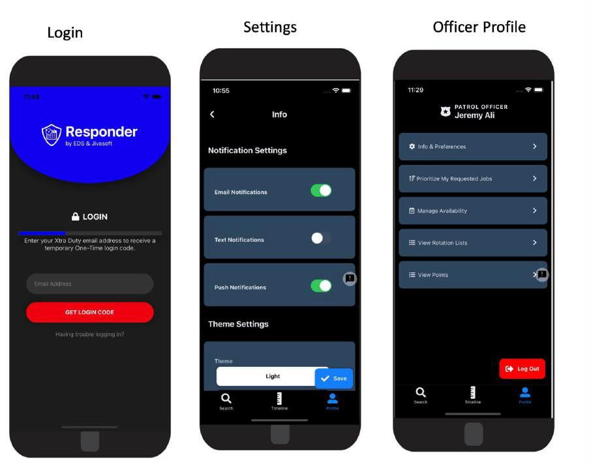

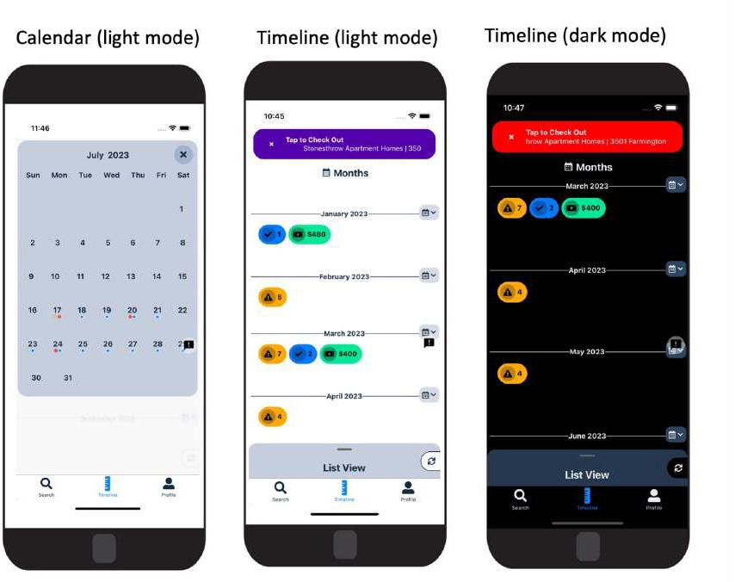

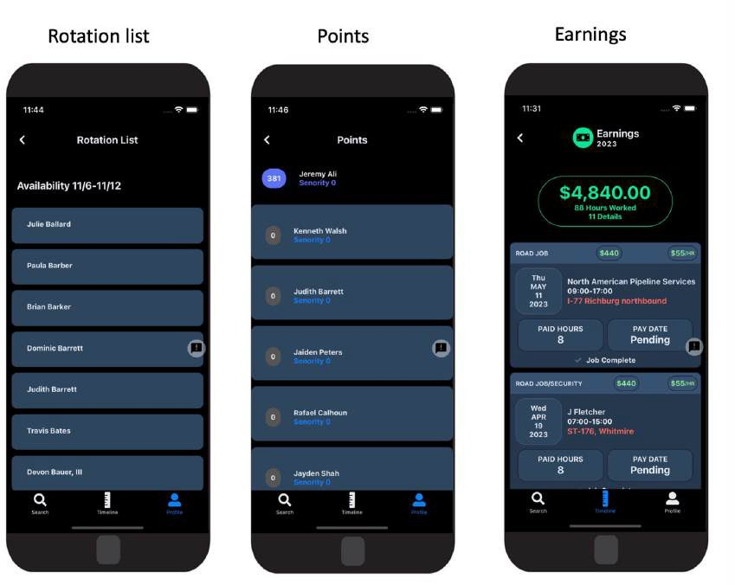

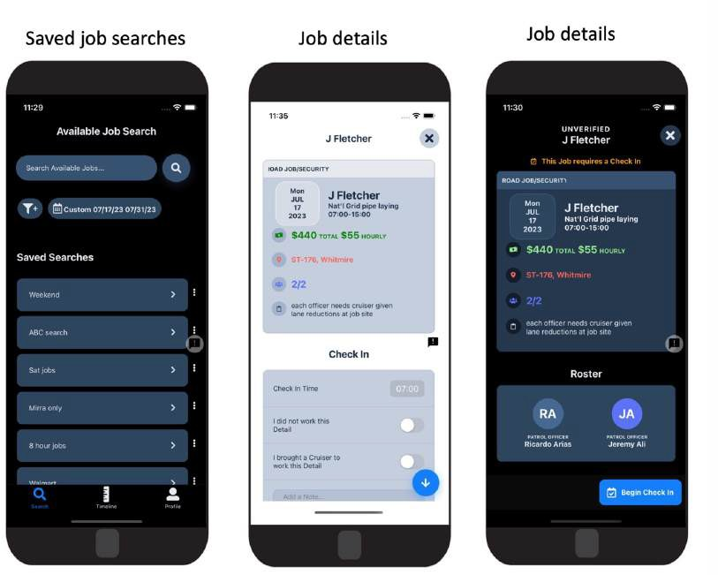

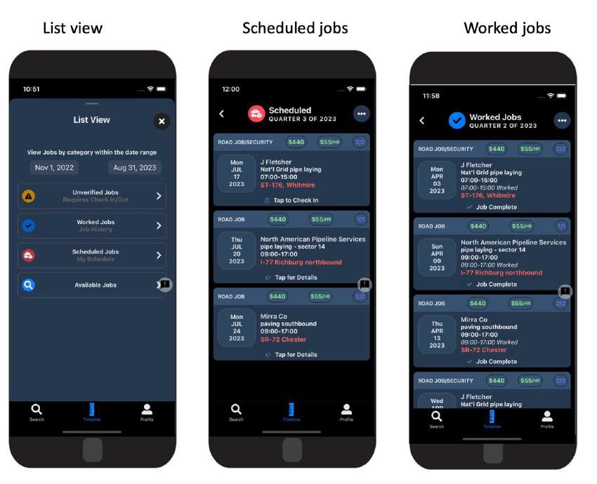

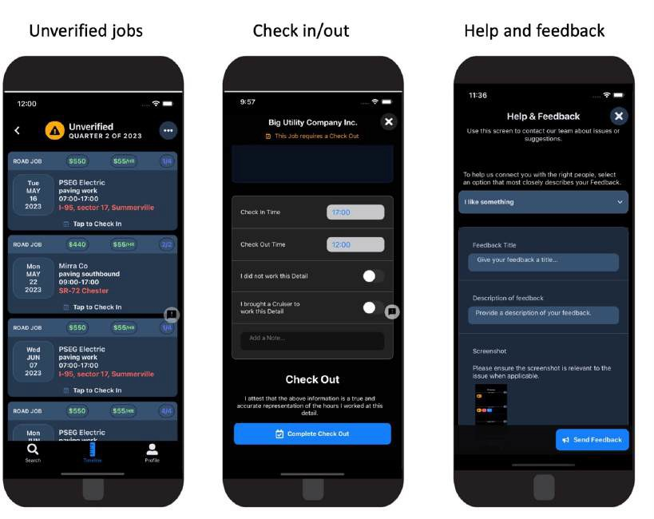


WebPages–OfficerPortal
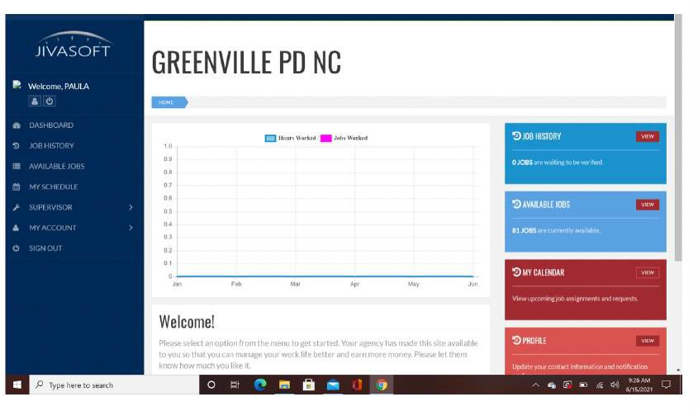
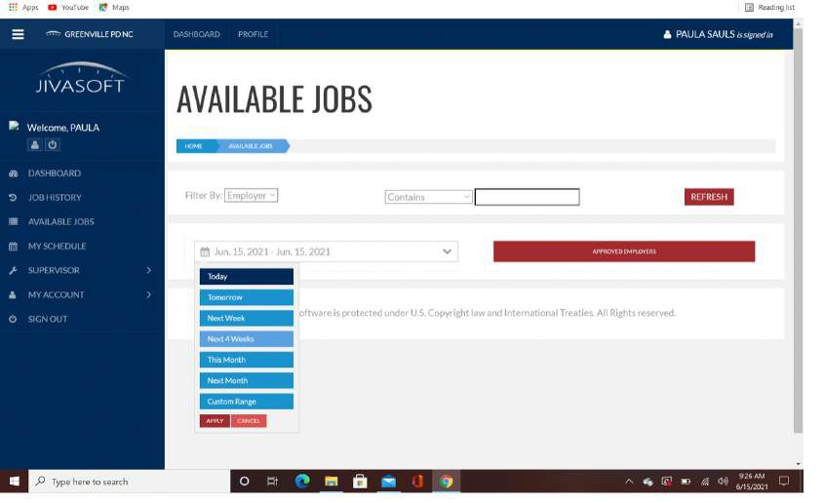

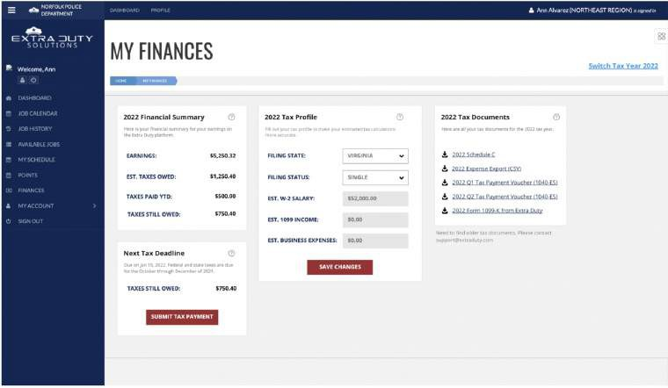


WebPages–CustomerPortal
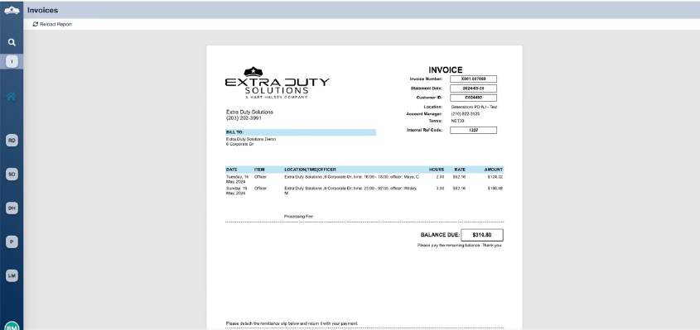

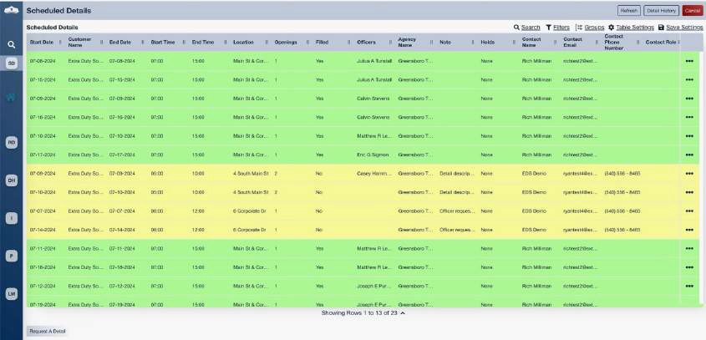


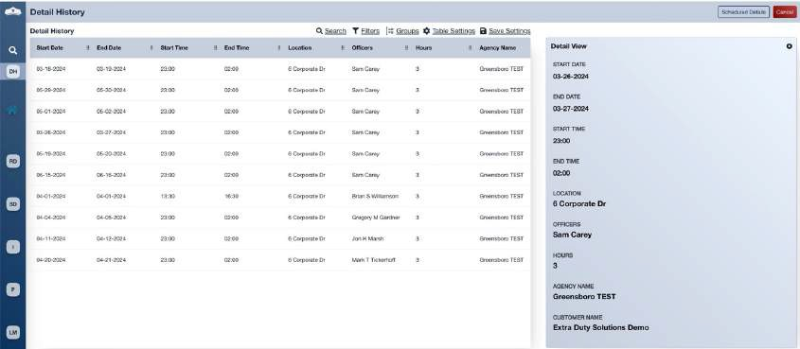

APPENDIX {{Letter}}: QUALITY ASSURANCE PLAN

QualityAssurancePlan



RevisionDate:11/30/2022
TableofContents
OVERVIEWERROR!BOOKMARKNOTDEFINED.
RISK CATEGORIES 3
APPROACH 3
EDS DATA ENTRY ERRORS 3
Late Hold or Award Time Report – All Agencies 4
Available and Award Times – Specific Agencies 4
Officer Errors and Omissions 4
Officer Did Not Work – All Agencies 4
AM / PMReport5
SPECIAL HANDLING AND OFFICER NOTES 5
Self-Assignments – Specific Agencies 5
Nightly payroll audit – All Agencies 5
Account Manager Payroll/Invoicing audit – All Agencies 5
UNFILLED DETAILS 6
Nightly Unfilled Details – All Agencies 6
INFORMATION TRACKING 6
Service Request Tracking and Escalation 6
Institutional Knowledge Management 6
IT INFRASTRUCTURE STABILITY, PERFORMANCE, AND RECOVERABILITY 7
Database Backups 7
Server Monitoring 7
MalwareProtection7
Heartbeat Monitoring 7
Server Imaging 7
Standardized Agency Setup Documentation 7
SOFTWARE DEVELOPMENT 8
Requirements Documentation 8
Mock-ups and Prototypes 8
Software Development Handbook 8
Code Review 8
End User Testing 8
Production Logging 8
COMMUNICATIONS 9
Inbound Voice Call Management and Continuity 9
Data circuit and network redundancy 9

OVERVIEW
ExtraDutySolutions(EDS)iscommittedtoapplyingrigorousqualityassuranceproceduresinall critical aspects of its service delivery operations and infrastructure to achieve the followingobjectives:
- Identifyandcorrecterrorsthatwouldbevisibleexternallyorthatwouldimpactthe accuracy or completeness of services applied to external stakeholders before they become externally visible or have external impact.
- Identifyandcorrecterrorsthatarevisibleinternallythatincreasethecostandreduce the efficiency of internal operations, doing so as early as possible to eliminate downstream impacts
- Utilizedatacollectionandsystemicfeedbackloopstoensurethatrepeaterrorsare corrected as close as possible to the source to prevent errors from recurring

RISKCATEGORIES
There are several areas where the complexity and volume of our work processes lead to a higherlikelihoodoferrorortoerrorsthathaveasubstantial,detrimentalimpactonthequality of the services that we deliver. These risk categories are:
- EDS data entryerrors
- Officererrorsandomissions
- Specialhandlingandofficernotes
- Unfilleddetails
- Informationtracking
- ITinfrastructurestability,performance,andrecover ability
- Softwaredevelopment
- Communications

APPROACH
Extra Duty Solutions employs several different approaches to improving the quality of our service delivery. Some of the most useful tools that we use are highly specialized reports that identify possible problems in our data. While at first glance, it might seem beneficial to automate the detection and correction of errors completely, our experience has shown us that the judgment and knowledge of experienced employees are an invaluable asset in the proper detection, diagnosis and correction of service delivery failures and other errors. Many of the situations that present themselves as potential errors are not errors at all. It often takes investigativeeffortbyaknowledgeablestaffmemberwhoisfamiliarwithspecificagencyrules, coupled with communication with external stakeholders to differentiate an error from a mere outlier. Our goal is to put “suspicious” situations in front of people who can handle complexity and ambiguity with judgment and experience.

EDSDATAENTRYERRORS
Many of our customers call us to request the services of off-duty law enforcement officers. Inherentinanyinteractionwhereinformationthatisverballycommunicatedisenteredintoa
software application is the risk of a typographical error or mis communication. Our goal is to identifyasmanypotentialdataentryerrorsaspossiblepriortosubsequentprocessingsuchas officer notification, detail requests or detail assignments.
To identify data entry errors, we run a series of automated reports each day. These reports are reviewedbymembersofouraccountmanagementteam.Throughacombinationofalgorithmic validation and the judgment of experienced reviewers, we can identify and correct most data entry errors that occur.
Dataentryerrorsaretrackedbytheemployeewhomadetheerror.Employeeswhoshowa pattern of making data entry errors are subject to disciplinary action.

LateHoldorAwardTimeReport–AllAgencies
- Reportis runtwice perday.
- EDS staff enters hundreds of details per day. This report flags any detail that has a “hold”timeafterthestarttimeofthedetail,oran“award”timeafterthestartofthedetail.
- When EDS staff notices a detail entered that’s set to open (hold) or award after its scheduledstarttime,theemployeewillupdatethistimesoitproperlyopens / awards.
AvailableandAwardTimes–SpecificAgencies
- Reportisrundailyforcertainagencies.
- Someagencieshaveveryspecificrulesforwhendetailsshouldbecomeavailableand when they should be awarded.
- Thisreportdisplaysalldetailsenteredtodayforaspecificagencyandshowsthe available and award times for each detail.
- Anydetailenteredtodaythathasawrongawardtimeisupdatedsoitawardsproperly with the rest of the details.
OfficerErrorsandOmissions
After an officer works a detail, the officer is required to indicate the actual times when he / she started and finished working the detail. There are times when officers fail to perform this action.Othertimes,theofficersmakeerrorswhencheckingoutofadetail.Certainreportsare run regularly and reviewed to identify officer errors and omissions.

OfficerDidNotWork–AllAgencies
- Reportis rundaily.
- Reportcapturesalldetailassignmentsforwhichtheofficerchecked“Ididnotworkthis detail” while verifying hours on a detail.
- Thisoptionisavailableforofficerstoindicatethattheydidnotworkadetail.
- Officersoccasionallyselectthisoptionbyaccident,resultingintheofficernotbeingpaid and EDS not invoicing the customer for the detail.
- EDSstaffwillreviewthisreportdailytoidentifysituationswheretheofficermayhave accidentally indicated that they did not work. The team member will review officer notes to see if the notes verify or contradict the indication that they did not work.
- Ifitisnotclearfromtheofficernoteswhethertheofficeractuallyworked,amemberof the account management team will contact the officer and verify.
AM / PMReport
- Reportis runnightly.
- Officers may confuse AM and PM times when checking in or out of a detail. For example,ifanofficerworked7 am-3 pmtheymaycheckoutfor3 am,whichendsup being a 20 hour detail.
- Thisreportflagsanydetailthatwasscheduledforlessthan12hourswheretheofficer verified their hours for more than 12 hours.
- AccountrepresentativescorrecttheofficerhourswhenanAM / PMissueisnoticed.If appropriate, the officer will be contacted to verify the correct times.

SPECIALHANDLINGANDOFFICERNOTES
Therearesomeroutinesituationsthatrequireinterventionbytheaccountmanagementteam. These situations are usually specific to certain agencies who have special handlingrequirements.

Self assignments–SpecificAgencies
- Reportisrun multipletimesper dayforcertainagencies.
- Officerscurrentlydonotmoveonrotationlistswhentheypickupdetailsas“self-assign” (first come first serve).
- Somedepartmentsrequirethatofficersmoveontherotationlistiftheypickupadetail as “self-assign”.
- Officersaremovedontherotationlistasneededbasedonthisreport.
Nightlypayrollaudit–AllAgencies
- Thenightlypayrollauditisruneverynight,Monday friday,byanemployeeworkingthe overnight shift.
- Theovernightemployeelooksatofficernotesforeveryagencyandvalidatesthenotes against the verified hours.
- Onoccasion,officerswillverifytheirhoursbutwritedifferenthoursintheirnotes.The overnight employee will review all notes and make appropriate changes as needed.
- Foranyoddsituationswherethenotesdon’tmakesense,theovernightemployeewill send the details to the Account Manager to review and handle in the morning.
AccountManagerPayroll / Invoicingaudit–AllAgencies
- TheAccountManagerpayrollauditisrun ondemand,atleastonMondaysandFridays.
- TheAccountManagerreviewsallofficerpaperworkforhis / heragencies.
- If any officer has not yet verified their hours for a completed detail, the Account Managerreachesoutviaphonecallortextmessagetoremindtheofficertoverify his / her hours.
- Anyinaccuracieswithcruisersandwrongrateschosenforthedetailareidentifiedand fixed at this time.
- AnyAM / PMissuescaughtduring thisauditthatwere notadjustedalreadyarefixed.
- Detailsaresplitifnecessary(ex:therateonthedetailchangestoadifferentrateintheevening)

UNFILLEDDETAILS
EDSmakesastrongefforttofilleverydetailwithofficersfromtheagencywherethedetailis scheduled or, when permitted, from neighboring agencies.

NightlyUnfilledDetails–AllAgencies
- Reportis runmultiple timesperevening.
- ReportIdentifiesallopendetailsfornextday.
- TheOverflowCoordinatorisresponsibleforfilling / outsourcingallnextdayopendetails. This report is used as a guideline for the Overflow Coordinator to compare what’s still open against what he / she has tried to fill for next day.
- ThefinalreportruneachnightisthelastcheckfortheOverflowCoordinator,sohe / she canmakesureallcustomerswhostillhaveopendetailstomorrowarenotifiedthatone or more of their details cannot be filled.

INFORMATIONTRACKING
ServiceRequestTrackingandEscalation
EDShandlesahighvolumeofrequeststhatcomefromavarietyofstakeholders.Someofthese requests are complex and require action from multiple EDS staff members or departments to complete. In the absence of a sophisticated mechanism for tracking these requests and escalating them when they are not resolved in an appropriate timeframe, there would be frequent service failures.
EDSemploysaproblemticketingsystemfromJIRA.EDShascreatedcustomdashboardsforits staff members to monitor and document tasks that are assigned to them. Service level requirementsandroutingpathshavebeendefinedfordifferenttypesoftasks.Whentasksare not completed within the defined service level requirement, the tasks are automatically escalated for review by a more senior member of the appropriate EDS department.
InstitutionalKnowledgeManagement
The inevitable turnover of employees can result in a loss of critical institutional knowledge. As part of its strategy to reduce the impact of knowledge loss, EDS employs a knowledge management tool called Confluence. Confluence provides a company wide repository of information, policy, and procedures. This knowledge repository is accessible at any time and updatedasneededbysubjectmatterexperts.Confluenceisacriticaltoolinthetrainingofnew
employeesandprovidesallemployeeswithasharedunderstandingoftherequirementsof their jobs and the service expectations of our stakeholders.

ITINFRASTRUCTURESTABILITY,PERFORMANCE,AND Recover ability
EDS maintains complex IT infrastructure that allows it to provide services to its agencies and customers. Service delivery is provided primarily through a series of cloud servers hosted at Rackspace’sDallas forthWorthdatacenter.EDSoperatesnumerouscustomandoff the shelf software products to deliver its services. Routine monitoring and maintenance of this IT infrastructure is performed to facilitate smooth, uninterrupted service delivery.
DatabaseBackups
All customer data is kept in Microsoft SQL Server databases. These databases are backed up increment allythroughouttheday.Overnight,weperformafullbackupofeachdatabase.Each day, all database backups are transferred to non attached storage to protect against a variety of possible attacks including malware, ransom ware, or employee sabotage. Daily reports are sent automatically to the Chief Technology Officer summarizing the database backup activity, highlighting any anomalies or errors. The CTO reviews these reports daily to ensure that backups are running correctly.
ServerMonitoring
Weekly,ITstaffsignintoeachservertocheckmemoryutilization,CPUusage,I / Operformance, disk capacity, and other metrics of server health. In addition, automatic monitoring is configured on key servers to notify IT staff of any excess resource utilization on those servers.Malware Protection
EDS deploys sophisticated malware protection on its servers. This malware protection is administered from a central dashboard. If malware is detected on any server, IT staff will receiveimmediatenotificationviaemail.Updatestovirussignaturesandtheantivirusengine are performed automatically and are monitored through the dashboard.
HeartbeatMonitoring
There are numerous automated services that have been developed as part of the service deliveryplatformatEDS.Theseservicesincludesuchthingsasdetailassignment,preparationof notifications, and transmission of email, text, and pop message notifications. In order to ensure that these services are running as expected, we have developed and implemented a “heartbeat” monitoring service. If any of these services fail to log their heartbeat within an expected time interval, IT staff are notified, and appropriate action is taken.
ServerImaging
Critical servers are imaged weekly, and the images are transferred to non attached storage. Thisactionensuresthatanymission criticalservercouldbereconstitutedquicklyreducingthe potential impact on our service delivery.
StandardizedAgencySetupDocumentation
ConfiguringtheITinfrastructurefornewagenciesisacomplexprocessthatinvolvesseveral EDS departments. We have developed a standard form that captures all the information
needed to configure our IT infrastructure to support a new agency. Staff in IT and other departmentsusethisdocumenttoensurethatthenewagencyisconfiguredcorrectlyandthat no steps in the process are missed.

SOFTWAREDEVELOPMENT
Most of the computer software applications used to deliver services to EDS’s agencies and customers is developed and maintained in-house by software developers on the EDS staff. EDS employsarigoroussoftwaredevelopmentapproachtoensurethatthesoftwareitdevelopscan support high quality service delivery to our stakeholders.
RequirementsDocumentation
Requests for new software or modifications to existing software are submitted to the software development team in writing. For more predictable and routine requests, such as reports, we have developed standardized request forms to simplify the communications and decision makingrequiredtocompletetherequest.Formorecomplexoruniquerequests,EDSpersonnel provide written requirements. These requirements are reviewed by the development team. As needed, meetings are held with the requesting departments to clarify requirements.
Mock-upsandPrototypes
Wheneverpracticalandappropriate,thesoftwareteamwillcreatevisualmock-upsorskeletal prototypes for the requesting departments to review and approve. It is always our goal to get as much feedback from the requesting departments as early as possible in the development lifecycle to reduce the number and impact of functional gaps, misunderstandings, or evolvingrequirements.
SoftwareDevelopmentHandbook
EDS has developed a software development handbook that is issued to all software development team members. This handbook provides a clear explanation of the software developmentmethodologyinuseatthecompany.Italsoprovidesdetailed,explicitcoding standards with which all developers are expected to comply.
CodeReview
Neworcomplexprogrammingcodeisreviewedwithsenior levelstafftoensurethatitmeets thecompany’scodingstandards.Seniorstaffmeetswiththedevelopertoreviewcompliance and to review the completeness and quality of the software. Deficiencies are identified and documented. A follow-up review is performed as needed to ensure that all software that becomes part of our service delivery infrastructure meets standards.
EndUserTesting
Softwareusedinourservicedeliveryandinternaloperationsmustbetestedbyusersbefore beingplacedinproduction.EDSmaintainsatestserverenvironmentthatisusedtotestpre production software. Only after end users have documented that the software functions properly will IT staff move the software to production.
ProductionLogging
Allinternallydevelopedsoftwareapplicationsuseextensiveloggingtodocumentbehaviorand internal decision making. These log files are used to troubleshoot problems and to identify errors. Log files are archived and kept indefinitely to assist in resolving any controversies that
mayarise, evenmonths oryears aftera serviceevent.

COMMUNICATIONS
InboundVoiceCallManagementandContinuity
Inbound voice calls on primary call center channels are recorded for quality assurance and training.Voicerecordingsarearchivedfor30daysattheprovider’scloudserviceandarchived for 5 years on an onsite server.Recordings are retrieved monthly for review and training.
Calls are retrieved as needed for customer review, clarification, and dispute resolution.Phonesystemredundancyistestedsemi annually.Theprimarycallchannel(FIVE 9)fail overto Mighty Call phase I (notification) is tested every time the system is unoccupied.Primary fail over to Mighty Call - Shelton center, (Phase II) is tested semi annually with a manual programming switch to 3 CX after notification.

Datacircuitandnetworkredundancy
Inbounddatacircuits(Fiber,broadbandandcellular)aretestedforfunctionweekly.Automatic fail over is tested semi annually. Network firewall High Availability and remote node control switching circuitry is tested for function semi annually.

APPENDIX {{Letter}}: INSURANCE DOCUMENTS
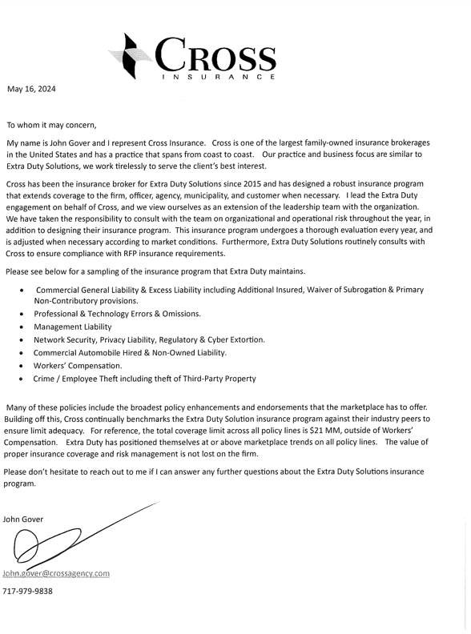

CERTIFICATE OF LIABILITY INSURANCE |  |  |  |  | DATE (MM/DD/YYYY)  5/7/2024

THIS CERTIFICATE IS ISSUED AS A MATTER OF INFORMATION ONLY AND CONFERS NO RIGHTS UPON THE CERTIFICATE HOLDER. THIS CERTIFICATE DOES NOT AFFIRMATIVELY OR NEGATIVELY AMEND, EXTEND OR ALTER THE COVERAGE AFFORDED BY THE POLICIES BELOW. THIS CERTIFICATE OF INSURANCE DOES NOT CONSTITUTE A CONTRACT BETWEEN THE ISSUING INSURER(S), AUTHORIZED REPRESENTATIVE OR PRODUCER, AND THE CERTIFICATE HOLDER.
IMPORTANT: If the certificate holder is an ADDITIONAL INSURED, the policy(ies) must have ADDITIONAL INSURED provisions or be endorsed. If SUBROGATION IS WAIVED, subject to the terms and conditions of the policy, certain policies may require an endorsement. A statement on
this certificate does not confer rights to the certificate holder in lieu of such endorsement(s).
PRODUCER |  | ^{CONTACT} Dee Bachman
Cross Insurance 2 Corporate Drive
Suite 335
 |  | ^{PHONE} 203-254-4518  (A/C, No, Ext): |  | ^{FAX} 203-254-7580  (A/C, No):
 |  | INSURER(S) AFFORDING COVERAGE |  |  |  | NAIC #
Shelton CT 06484
 |  | INSURER A : Twin City Fire Ins Co |  |  |  | 29459
INSURED  Hart Halsey, LLC  dba Extra Duty Solutions 6 Corporate Drive  Suite 830  Shelton CT 06484 | HARTH-1 |  | INSURER B : Gemini Insurance Company |  |  | 10833
 |  |  | INSURER C : Ascot Specialty Insurance Company |  |  | 45055
 |  |  | INSURER D : Indian Harbor Ins Co |  |  | 36940
 |  |  | INSURER E : Arch Specialty Ins Co |  |  | 21199
 |  |  | INSURER F : Hiscox Ins Co |  |  | 10200

Coverage s
CERTIFICATENUMBER:1441442088
REVISIONNUMBER:

THIS IS TO CERTIFY THAT THE POLICIES OF INSURANCE LISTED BELOW HAVE BEEN ISSUED TO THE INSURED NAMED ABOVE FOR THE POLICY PERIOD INDICATED. NOTWITHSTANDING ANY REQUIREMENT, TERM OR CONDITION OF ANY CONTRACT OR OTHER DOCUMENT WITH RESPECT TO WHICH THIS CERTIFICATE MAY BE ISSUED OR MAY PERTAIN, THE INSURANCE AFFORDED BY THE POLICIES DESCRIBED HEREIN IS SUBJECT TO ALL THE TERMS, EXCLUSIONS AND CONDITIONS OF SUCH POLICIES. LIMITS SHOWN MAY HAVE BEEN REDUCED BY PAID CLAIMS.
INSR LTR | TYPE OF INSURANCE |  |  |  |  |  |  |  |  | ADDL  INSD | SUBR  WVD | POLICY NUMBER | POLICY EFF (MM/DD/YYYY) | POLICY EXP (MM/DD/YYYY) | LIMITS
C | X | COMMERCIAL GENERAL LIABILITY |  |  |  |  |  |  |  |  |  | ESGL2410002162-02 | 5/7/2024 | 5/7/2025 | EACH OCCURRENCE |  |  |  | $ 1,000,000
 |  |  | CLAIMS-MADE X OCCUR |  |  |  |  |  |  |  |  |  |  |  | DAMAGE TO RENTED  PREMISES (Ea occurrence) |  |  |  | $ 100,000
 |  |  |  |  |  |  |  |  |  |  |  |  |  |  | MED EXP (Any one person) |  |  |  | $ Excluded
 |  |  |  |  |  |  |  |  |  |  |  |  |  |  | PERSONAL & ADV INJURY |  |  |  | $ 1,000,000
 | GEN'L AGGREGATE LIMIT APPLIES PER: |  |  |  |  |  |  |  |  |  |  |  |  |  | GENERAL AGGREGATE |  |  |  | $ 2,000,000
 | X | POLICY PRO- LOC JECT  OTHER: |  |  |  |  |  |  |  |  |  |  |  |  | PRODUCTS - COMP/OP AGG |  |  |  | $ 2,000,000
 |  |  |  |  |  |  |  |  |  |  |  |  |  |  |  |  |  |  | $
C | AUTOMOBILE LIABILITY |  |  |  |  |  |  |  |  |  |  | ESAL2410002163-02 | 5/7/2024 | 5/7/2025 | COMBINED SINGLE LIMIT  (Ea accident) |  |  |  | $ 1,000,000
 |  | ANY AUTO |  |  |  |  |  |  |  |  |  |  |  |  | BODILY INJURY (Per person) |  |  |  | $
 |  | OWNED AUTOS ONLY HIRED AUTOS ONLY |  |  |  |  |  | SCHEDULED AUTOS  NON-OWNED AUTOS ONLY |  |  |  |  |  |  | BODILY INJURY (Per accident) |  |  |  | $
 | X |  |  |  |  | X |  |  |  |  |  |  |  |  | PROPERTY DAMAGE  (Per accident) |  |  |  | $
 |  |  |  |  |  |  |  |  |  |  |  |  |  |  |  |  |  |  | $
D C |  | UMBRELLA LIAB  EXCESS LIAB |  |  |  |  | X |  | OCCUR CLAIMS-MADE |  |  | SXS005659704 ESXS2410003405-01 | 5/7/2024  5/7/2024 | 5/7/2025  5/7/2025 | EACH OCCURRENCE |  |  |  | $ 10,000,000
 | X |  |  |  |  |  |  |  |  |  |  |  |  |  | AGGREGATE |  |  |  | $ 10,000,000
 |  | DED |  | X | RETENTION $ 0 |  |  |  |  |  |  |  |  |  | $5M / $5M excess $5M |  |  |  | $
A | WORKERS COMPENSATION  AND EMPLOYERS' LIABILITY Y / N |  |  |  |  |  |  |  |  | N / A |  | 16WEQY5BX1 | 5/7/2024 | 5/7/2025 | X | PER STATUTE |  | OTH-ER
 |  |  |  |  |  |  |  |  |  |  |  |  |  |  | E.L. EACH ACCIDENT |  |  |  | $ 1,000,000
 | ANYPROPRIETOR/PARTNER/EXECUTIVE N
 | OFFICER/MEMBER EXCLUDED?
 |  |  |  |  |  |  |  |  |  |  |  |  |  |  | E.L. DISEASE - EA EMPLOYEE |  |  |  | $ 1,000,000
 | (Mandatory in NH)
 | If yes, describe under
 |  |  |  |  |  |  |  |  |  |  |  |  |  |  | E.L. DISEASE - POLICY LIMIT |  |  |  | $ 1,000,000
 | DESCRIPTION OF OPERATIONS below
B | Professional Liability |  |  |  |  |  |  |  |  |  |  | VGPL001610 | 5/7/2024 | 5/7/2025 | Per Occurrence/Agg |  |  |  | $3MM / $3MM
E F | Cyber Liability  Crime (incl. 3rd Party) |  |  |  |  |  |  |  |  |  |  |  |  |  | Per Claim/Agg Limit/Deductible |  |  |  | $3MM / $3MM  $1MM / $10K
 |  |  |  |  |  |  |  |  |  |  |  | C-4LPL-101297 UC2231071324 | 5/7/2024  3/23/2024 | 5/7/2025  3/23/2025
DESCRIPTION OF OPERATIONS / LOCATIONS / VEHICLES (ACORD 101, Additional Remarks Schedule, may be attached if more space is required)
*The Excess Liability Policy applies to General Liability and Hired & Non-Owned Auto Liability only. Evidence of Insurance
CERTIFICATEHOLDERCANCELLATION
Evidence of Insurance |  | SHOULD ANY OF THE ABOVE DESCRIBED POLICIES BE CANCELLED BEFORE THE EXPIRATION DATE THEREOF, NOTICE WILL BE DELIVERED IN ACCORDANCE WITH THE POLICY PROVISIONS.
AUTHORIZED REPRESENTATIVE


ACORD25 (2016/03)
©1988-2015ACORDCORPORATION.Allrightsreserved.
TheACORDnameandlogoareregisteredmarksofACORD

STANDARDINSURANCECOVERAGEINOURMUNICIPALCONTRACTS

- Insurance.
  - General.Without limiting any obligations or liabilities of the Company, the Company shall purchase and maintain, at its own expense the minimum insurance coverage listed in the Insurance Requirements section withinsurancecompaniesdulylicensedintheClient’sState(admittedinsurer)withanAMBest, Inc.ratingofA-X(10)oraboveandanequivalentqualifiedunlicensedinsurerbytheState(non admitted insurer). Failure to maintain insurance as specified may result in termination of this Agreement at the Client’s option.

  - No Representation of Coverage Adequacy.By requiring insurance herein, the Client does notrepresentthatcoverageandlimitswillbeadequatetoprotecttheCompany.TheClientreserves the right to review any and all of the insurance policies and / or endorsements cited in this Agreement but has no obligation to do so.Failure to demand such evidence of full compliance with the insurance requirements set forth in this Agreement or failure to identify any insurance deficiency shall not relieve the Company from, nor be construed or deemed a waiver of, its obligation to maintain the required insurance at all times during the performance of thisAgreement.
  - AdditionalInsured.Allinsurancecoverageandself insuredretentionordeductibleportions, exceptWorker’sCompensationinsuranceandProfessionalLiabilityinsuranceifapplicable,shall name, to the fullest extent permitted by law for claims arising out of the performance of this Agreement, the Client, as Additional Insured as specified under the respective coverage sections of this Agreement.

  - Coverage Term.All insurance required herein shall be maintained in full force and effect until all Services required to be performed under the terms of this Agreement is satisfactorily performed, completed and formally accepted by the Client, unless specified otherwise in thisAgreement.
  - Primary Insurance.The Company’s insurance shall be primary insurance as respects performance of subject Agreement and in the protection of the Client as an Additional Insured.
  - ClaimsMade.IntheeventanyinsurancepoliciesrequiredbythisAgreementarewrittenon a “claims made” basis, coverage shall extend, either by keeping coverage in force or purchasing an extended reporting option, for three (3) years past completion and acceptance of the Services evidencedbysubmissionofannualCertificatesofInsurancecitingapplicablecoverageisinforce and contains the provisions as required herein for the three year period.

  - Waiver.TheCommercialGeneralLiabilityandBusinessAutomobilepoliciesshallcontaina waiver of rights of recovery (sub rog ation) against the Client, its agents, representatives, officials, directors,officers,andemployeesforanyclaimsarisingoutoftheServicesoftheCompany.The
Companyshallarrangetohavesuchsub rog ationwaiversincorporatedintoeachpolicyviaformal written endorsement hereto.

  - PolicyDeductiblesandorSelfInsuredRetention s.Thepoliciesrequirementssetforthabove mayprovidecoveragethatcontaindeductiblesorself insuredretentionamounts.Suchdeductibles or self insured retention shall not be applicable with respect to the policy limits provide to the Client.TheCompanyshallbesolelyresponsibleforanysuchdeductibleorself insuredretentionamount.

  - Use of Subcontractor.If any Services under this Agreement are subcontracted in any way, the Company shall execute written agreement with Subcontractor containing the same IndemnificationClauseandInsuranceRequirementssetforthhereinprotectingtheClientandthe Company.TheCompanyshallberesponsibleforexecutingtheagreementwithSubcontractorand obtaining Certificates of Insurance verifying the insurance requirements.

  - Evidence of Insurance.Prior to commencing any Services under this Agreement, Company shall furnish Client with Certificates(s) of Insurance, issued by Company’s Insurer(s) as evidence that polices are placed with acceptable insurers as specified herein and provide the required coverage’s, conditions, and limits of coverage specified in this Agreement and that such coverage and provisions are in full force and effect.Acceptance andreliancebytheClientonaCertificateofInsuranceshallnotwaiveoralterinanywaythe insurance requirements or obligations of this Agreement.Such Certificate(s) shall identify theCompanyandbesenttotheappropriateClientrepresentative.Ifanyoftheabovecited polices expire during the life of this Agreement, it shall be the Company’s responsibilityto forward renewal Certificates within ten (10) days after the renewal date containing all the aforementioned insurance provisions.Certificates shall specifically Client the followingprovisions:
    - The Client, its agents, representatives, officers, directors, officials and employees are Additional Insureds as follows:
      - CommercialGeneralLiabilityISOFormCG20100413orequivalent.
      - AutoLiability underISO FormCA 2048 orequivalent.
      - ExcessLiabilityFollowFormtounderlyinginsurance.

    - Company’sinsuranceshallbeprimaryinsuranceasrespectsperformanceofthisAgreement.
    - All Commercial General Liability, Automobile and Excess Liability policies waive rights of recovery (sub rog ation) against the Client, its agents, representatives, officers, directors, officials and employees for any claims arising out of Services performed by the Company under this Agreement.
    - Certificateshallciteathirty(30)dayadvancenoticecancellationprovision.If ACORD Certificate of Insurance form is used, the phrases in the cancellation provision “endeavor to” and “but failure to mail such notice shall impose no
obligation or liability of any kind upon the company, its agents or representatives” shall be deleted.Certificate forms other than ACORD form shall have similar restrictive language deleted.

- RequiredInsuranceCoverage

  - Commercial General Liability Insurance.Company shall maintain “occurrence” from Commercial Liability Insurance with an limit of not less than Six Million Dollars($6, 000, 000) for each occurrence, Before this Contract is fully executed by the parties, Company shall provide theClientwithacertificateofinsuranceasproofofcommercialliabilityinsurancewithaminimum liability limit of Eleven Million Dollars($11, 000, 000. 00) per occurrence combined single limit bodily injury and property damage, and Twelve Million Dollars($12, 000, 000. 00) general aggregate. A combination with an excess or umbrella policy may be used to achieve limits.The certificate shall clearly state who the provider is, the coverage amount, the policy number, and whenthepolicyandprovisionsprovidedareineffect.Saidpolicyshallbeineffectfortheduration of this Contract. The insurance shall be with an insurance company or companies rated A-X or higher in AM Best’s.

  - Professional Liability Insurance.Company shall maintain Professional Liability insurance covering errors and omissions arising out of the Services performed by Company, or anyone employed by Contractor, or anyone for whose acts, mistakes, errors and omissions Contractor is legallyliable,withaliabilityinsurancelimitofThreeMillionDollars($3, 000, 000)perclaimand Three Million Dollars ($3, 000, 000) aggregate all claims.Professional Liability coverage specificallyshallcontaincontractualliabilityinsurancecoveringthecontractualobligationsofthis Agreement. The certificate shall clearly state who the provider is, the amount of coverage, the policynumber,andwhenthepolicyandprovisionsprovidedareineffect.Theinsuranceshallbe with an insurance company or companies rated A-VII or higher by AM Best.In the event the ProfessionalLiabilityinsurancepolicyiswrittenona“claimsmade”basis,coverageshallextend forthree(3)yearspastcompletionandacceptanceoftheServices,andContractorshallberequired to submit Certificates of Insurance’s evidencing proper coverage is in effect as required above.

  - DataBreachandPrivacySecurity.Companyshallmaintainfirstpartydatabreachcoverage, with third party privacy liability and third party network security liability covered.Policy will cover regulatory defense, fines and penalties, compensatory awards, PCI fines, penalties and assessments, computer forensics, notification costs and credit or ID protection costs with a limit of One Million Dollars($1, 000, 000) per occurrence and aggregate.

  - Employee Theft.Company shall maintain employee theft coverage including protection against forgery and alteration, inside and outside premises loss, computer funds transfer loss and theft of client property.Policy coverage in include theft of monies owed to Client for employee payroll, Client extra duty administrative fees and Client cruiser fees.Liability limit shall be at least Five Hundred Thousand Dollars($500, 000).
  - AutomobileLiability.CompanyshallmaintainBusinessAutomobileLiabilityInsurancewith alimitofOneMillionDollars($1, 000, 000)peroccurrenceonCompany’sowned,hiredandnon owned vehicles used in the performance of the Company’s Services under this Agreement. Coverage will be at least as broad as Insurance Service Office, Inc., coverage code “1” any auto policyformCA00011013orequivalentthereof.Tothefullestextentallowedbylaw,forclaims arising out of performance of this Agreement.The Client, its agents, representative, officers, directors,officialsandemployeesshallbecitedasAdditionalInsuredsundertheInsuranceService Offices,Inc.BusinessAutoPolicyDesignatedInsuredEndorsementformCA2048orequivalent. If any Excess insurance is utilized to fulfill the requirements of this paragraph, such Excess insurance shall be “follow form” equal or broader in coverage than the underlying insurance.
  - Worker’s Compensation Insurance.The Company shall maintain Worker’s Compensation insurance to cover obligations imposed by federal and state statutes having jurisdictionoftheCompany’semployeesengagedintheperformanceofServicesunderthis AgreementandshallalsomaintainEmployerLiabilityInsuranceofnotlessthanOneMillion Dollars($1. 000, 000) for each accident, One Million Dollars($1, 000, 000) disease for each employee and One Million Dollars($1, 000, 000) disease policy limit.

