Warning-Signal Comment Analytics
Technical Architecture Document
BERTopic + FinBERT pipeline, with an optional BERTopic + Ollama/llama3.2 LLM hybrid

Repository: github.com/Hrishikeshk24/BERTopic_Text_analysis
Prepared for: Hrishikesh Harish Kumar

1. Purpose & Overview
This pipeline turns unstructured underwriter “warning-signal” comments on credit facilities into a structured, analyzable dataset: it discovers the recurring themes underwriters write about (BERTopic), scores the tone of each comment (FinBERT or a lexicon fallback), and ties both back to what actually happened to the borrower's probability-of-default (PD) grade afterward. The output answers questions like “which themes precede downgrades most often?” and “does negative sentiment actually predict migration?”, and lets new, unseen comments be scored against the frozen, previously-trained model.
An optional hybrid layer adds a local large language model (llama3.2, served by Ollama) on top of the statistical pipeline: it generates human-readable topic names from BERTopic's raw keyword clusters, and re-checks comments that the clustering algorithm couldn't confidently place. This is opt-in and fails back to the original statistical behavior if the LLM isn't available.

1.1 Design Principles
- Offline-capable — the pipeline must run fully offline if needed (TF-IDF embeddings, VADER-based lexicon sentiment) in addition to the recommended transformer stack (MiniLM embeddings, FinBERT sentiment);
- Reproducible — UMAP is seeded (random_state=42) so two runs on the same data produce the same topics — required for model governance / audit;
- Train once, score many times — training writes a self-contained models/ folder (fitted BERTopic model, per-topic centroids, embedding config). Scoring new comments never refits anything;
- One code path — predict.py (CLI) and app.py (Gradio UI) both call the same scoring.py / sentiment_engines.py functions, so a comment scores identically whether it goes through the UI or a batch job;
- Fail soft — every optional dependency (TF-IDF vs. MiniLM, lexicon vs. FinBERT, and now the LLM hybrid) degrades to a simpler, always-available path instead of crashing.

2. System Architecture
The system has two pipelines that share code but run at different times: a batch training pipeline that is re-run whenever the underlying comment data changes, and an online serving pipeline that scores new, individual comments against the frozen output of the last training run.
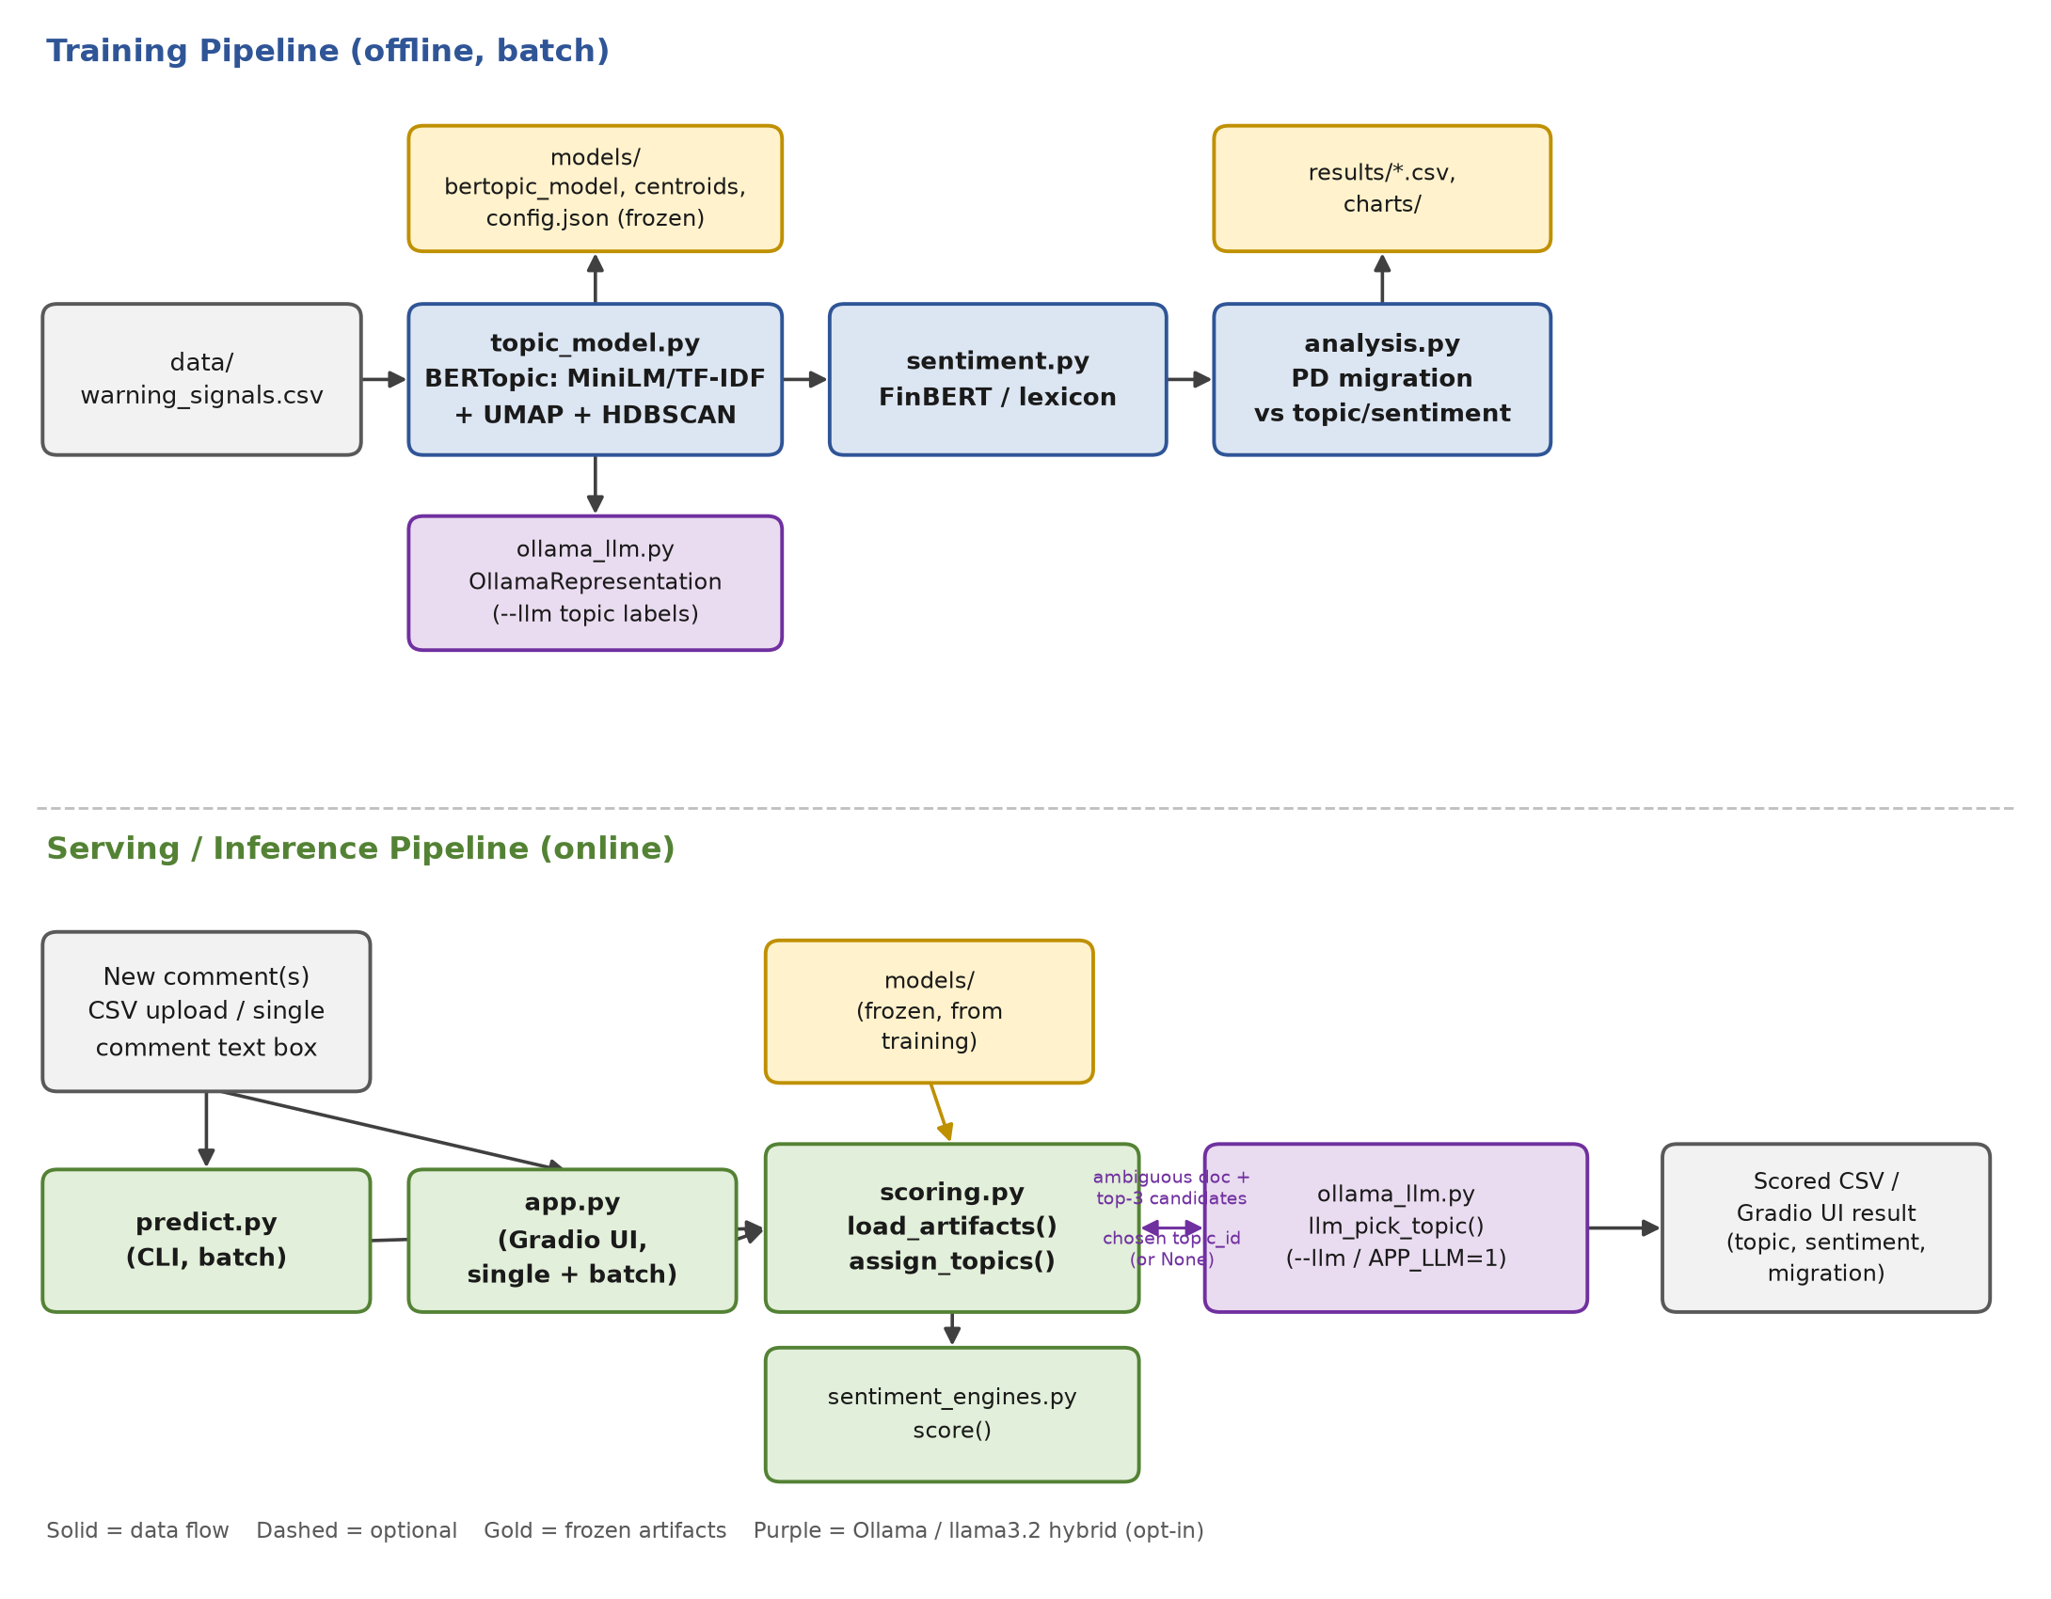
Figure 1. End-to-end architecture — training (top) and serving (bottom) pipelines.

2.1 Training pipeline (run_pipeline.py)
run_pipeline.py orchestrates four stages as separate subprocess calls, each reading the previous stage's output from disk:
Stage | Script | Reads | Writes
1. Data | generate_data.py | — (synthetic) or real extract | data/warning_signals.csv
2. Topic modeling | topic_model.py | data/warning_signals.csv | models/*, results/doc_topics.csv, topic_summary.csv
3. Sentiment | sentiment.py | results/doc_topics.csv | results/doc_topics_sentiment.csv
4. Analysis | analysis.py | results/doc_topics_sentiment.csv | results/topic_migration_summary.csv + 3 more CSVs, results/charts/*.png

python run_pipeline.py --skip-datagen # train on the existing data/warning_signals.csv
python run_pipeline.py --skip-datagen --offline # fully offline: TF-IDF + lexicon sentiment
generate_data.py is skipped with --skip-datagen so training uses the comments already in data/warning_signals.csv rather than overwriting them with a freshly generated synthetic sample — this is how the current model in models/ was trained.

2.2 Serving pipeline (predict.py / app.py)
Both entry points call the exact same two functions — scoring.load_artifacts() and scoring.assign_topics() for topics, sentiment_engines.score() for sentiment — so a comment gets an identical result whether it's scored through the CLI or the Gradio UI.
Entry point | Use case | Key flags / env vars
predict.py | Batch-score a CSV from the command line | --engine finbert|lexicon, --llm
app.py (Gradio) | Interactive single-comment or batch-CSV scoring in a browser | APP_ENGINE, APP_LLM

3. Component Reference

3.1 generate_data.py — synthetic data generator
Produces a synthetic dataset of underwriter comments with a known ground-truth theme per row (the true_theme column), used only to validate that BERTopic's discovered clusters line up with real themes (see topic_vs_true_theme.csv). Not used when training on real data (run_pipeline.py --skip-datagen).

3.2 topic_model.py — BERTopic topic discovery
Fits BERTopic on the comment corpus in five steps:
- 1. Embed — MiniLM (sentence-transformers/all-MiniLM-L6-v2, 384-dim) by default, or a TF-IDF + TruncatedSVD (150 components) pipeline for fully offline use. Cached to results/embeddings_<backend>.npy so re-runs are instant.
- 2. Reduce dimensionality — UMAP (n_neighbors=15, n_components=5, cosine metric, random_state=42) reduces to 5 dimensions before clustering.
- 3. Cluster — HDBSCAN (min_cluster_size=45, min_samples=15) clusters the reduced embeddings; points that don't fit any cluster get topic_id = -1.
- 4. Extract keywords — a CountVectorizer with domain stopwords (“borrower”, “quarter”, “million”, etc.) builds class-based TF-IDF (c-TF-IDF) keywords per topic. min_df=2 counts topics, not documents, since BERTopic fits this on concatenated per-topic text.
- 5. Reassign outliers — topic_model.reduce_outliers(..., strategy="embeddings") reassigns every -1 document to its nearest topic by embedding similarity, so every comment keeps a theme.
With --llm, a sixth step runs: see Section 4.
Artifacts written to models/ for later scoring (frozen, no refitting at inference time):
File | Contents
bertopic_model/ | Pickled BERTopic model (fitted UMAP + HDBSCAN + vectorizer)
topic_centroids.npy | Per-topic mean embedding, used for outlier fallback at inference time
config.json | embedding_backend, topic_ids, topic_labels, llm_enabled, llm_model, seed
embed_pipeline_tfidf.joblib | Fitted TF-IDF+SVD pipeline (only when --embedding tfidf)

3.3 sentiment.py / sentiment_engines.py — sentiment scoring
sentiment_engines.py exposes score(docs, engine) with two interchangeable engines, shared by the batch stage and predict.py/app.py:
Engine | Method | Score meaning
finbert | ProsusAI/finbert transformer classifier (positive/negative/neutral) | softmax confidence of the predicted class, 0–1
lexicon | VADER + a 60-term Loughran-McDonald-style credit lexicon (“breach” -2.5, “cured” +1.8, etc.) injected into VADER's vocabulary | VADER compound polarity, -1 to +1; thresholded at ±0.15

3.4 analysis.py — migration analysis
Joins topic and sentiment back to the PD grade change (pd_grade_after − pd_grade_before; positive = downgrade) and produces four CSVs plus four charts: downgrade/upgrade rate and average notch change per topic, a sentiment-vs-migration crosstab, a topic×sentiment average-grade-change matrix, and (on synthetic data only) a topic-purity check against the known true_theme.

3.5 scoring.py — shared inference logic
The single code path both predict.py and app.py call. Artifacts(models_dir) loads the frozen BERTopic model, centroids and config once; assign_topics(docs, arts) then:
- 1. maps new comments through the frozen UMAP + HDBSCAN (BERTopic.transform(), i.e. approximate_predict);
- 2. any comment landing in no cluster (-1) is assigned to its nearest topic centroid by cosine similarity instead of being left unthemed;
- 3. with use_llm=True (predict.py --llm, or APP_LLM=1 for the app), those same outlier comments are additionally re-checked by the LLM (Section 4.2) before the result is returned.
Output fields: topic_id, topic_label, topic_assignment (direct | nearest_centroid | llm_assigned), topic_similarity (cosine confidence, 0–1 — the app flags values below 0.15 for manual review).

3.6 predict.py — CLI batch scoring
python predict.py --input data/new_comments.csv --output results/predictions.csv [--engine finbert|lexicon] [--llm]
Requires PD_ID, warning_signal_comment columns; derives grade_change / migration if pd_grade_before/after are present. Prints a direct / nearest_centroid / llm_assigned breakdown and the sentiment distribution.

3.7 app.py — Gradio interactive UI
Loads models/ once at startup (ARTS = load_artifacts()) and never refits. Two tabs:
- Single comment — paste a comment (optionally with before/after PD grade), returns the theme, c-TF-IDF keywords, assignment method + centroid similarity, sentiment with score, derived migration, and that topic's historical downgrade rate / average notch change from the training run (read from results/topic_migration_summary.csv).
- Batch CSV — upload a CSV with the same columns as predict.py's input, get a scored table in-browser plus a downloadable CSV (saved to results/app_batch_predictions.csv).
app.py was intentionally left unmodified while adding the LLM hybrid — it picks up both the new topic labels and LLM-assisted assignment automatically through scoring.py, with no direct Ollama dependency of its own.

3.8 run_pipeline.py — orchestrator
python run_pipeline.py [--offline] [--skip-datagen]
Chains generate_data.py → topic_model.py → sentiment.py → analysis.py as subprocess.run(..., check=True) calls, stopping on the first failure.

4. BERTopic + LLM Hybrid (ollama_llm.py)
An opt-in layer that calls a local Ollama server (no API keys, nothing leaves the machine) to improve on two specific weak points of the pure statistical pipeline: topic labels that are just keyword lists, and outlier comments resolved by a single cosine-similarity number with no semantic judgment. Every call fails soft — if Ollama isn't reachable, both features silently fall back to the original behavior.
Setting | Default | Overridable via
Ollama server URL | http://localhost:11434 | OLLAMA_HOST env var
Model | llama3.2:latest | OLLAMA_MODEL env var, or --llm-model
Topic labeling | off | topic_model.py --llm
Assignment re-check | off | predict.py --llm, or APP_LLM=1 for app.py

4.1 Topic creation — OllamaRepresentation
topic_model.py --llm passes representation_model={"LLM": OllamaRepresentation()} into BERTopic. This registers the LLM as an additional representation “aspect” rather than replacing the default one — BERTopic still computes its ordinary c-TF-IDF keyword representation (what get_topic() / scoring.py's topic_keywords() return, and what the app's “Keywords:” field shows); the LLM label is stored separately in topic_model.topic_aspects_["LLM"].
For every topic, OllamaRepresentation.extract_topics():
- 1. pulls that topic's c-TF-IDF keywords and its 4 most representative comments (BERTopic's own _extract_representative_docs);
- 2. builds a prompt asking for a short (2–5 word), title-case theme name — no explanation;
- 3. sends it to llama3.2 via POST /api/generate (temperature 0.2, ~40 tokens);
- 4. on any failure (timeout, bad response, Ollama down) for that single topic, silently keeps the topic's existing keyword representation instead of crashing the whole training run.
topic_model.py then writes both labels: keyword_label (raw c-TF-IDF, e.g. “violation / equity / breach / operations”) and llm_label (e.g. “Covenant Breach Indicators”) to results/topic_summary.csv. topic_label — the field everything downstream (doc_topics.csv, models/config.json, the app's “Theme:” field) actually uses — prefers llm_label when non-empty, falling back to keyword_label otherwise.

4.2 Topic assignment — llm_pick_topic
In scoring.assign_topics(), comments that HDBSCAN couldn't cluster directly (topic_id == -1) are, by default, assigned to whichever topic centroid has the highest raw cosine similarity — a single number with no semantic reasoning behind it. With use_llm=True, those comments get a second pass:
- 1. the top-3 nearest topic centroids by cosine similarity are selected as candidates (id, LLM label, keywords);
- 2. the comment text plus the 3 candidates are sent to llama3.2, asking for just the id number of the best match;
- 3. the response is parsed with a regex and validated against the 3 candidate ids; if Ollama is unreachable, the response is unparseable, or the model names a topic outside the 3 candidates, the function returns None and the original cosine-similarity pick is kept unchanged;
- 4. on a valid pick, topic_assignment is recorded as llm_assigned (vs. direct or nearest_centroid) so it's auditable which comments were LLM-adjudicated.
This only ever runs for comments the clustering algorithm was already unsure about — it never overrides a direct cluster assignment.

4.3 Observed behavior
Retraining data/warning_signals.csv (2,000 comments) with --llm produced 19 topics with labels such as “Refinancing Risk Indicators”, “Working Capital Squeeze”, “Governance Board Composition” and “Debt Maturity Wall” in place of the previous keyword-only labels. On a 12-row test batch (data/new_comments.csv) with predict.py --llm, 2 of 12 comments were outliers that got an llm_assigned topic instead of a raw centroid pick — e.g. “The finance chief quit with no successor lined up, the third senior departure this year” was correctly routed to “Governance Board Composition” rather than a less relevant covenant or liquidity topic.
Limitation: the LLM can only choose among the top-3 centroid candidates, so a genuinely novel comment (e.g. a benign “no issues this quarter” remark, with no matching topic in the trained set) still gets forced into the least-bad of three unrelated options. This is a topic-coverage gap in the underlying model, not a bug in the re-check logic.

5. Modeling Details & Reproducibility
Parameter | Value | Why
UMAP random_state | 42 | deterministic clustering across re-runs — required for model governance
UMAP n_neighbors / n_components | 15 / 5 | BERTopic defaults tuned for short-text comment corpora
HDBSCAN min_cluster_size / min_samples | 45 / 15 | avoids over-fragmenting ~2,000 comments into too many tiny topics
Outlier strategy | “embeddings” (nearest centroid) | every comment keeps a theme; no silently dropped rows
Vectorizer min_df | 2 | counts topics, not comments, since c-TF-IDF fits on concatenated per-topic text
Sentiment thresholds (lexicon) | ±0.15 on VADER compound | separates neutral from weak positive/negative

6. Current Results Snapshot
From the most recent training run on data/warning_signals.csv (2,000 comments, MiniLM + FinBERT + --llm):
Metric | Value
Topics discovered | 19
Mean topic purity vs. synthetic ground truth | 66.8%
Sentiment distribution | negative 1,460 · positive 345 · neutral 195
Embedding backend / sentiment engine | MiniLM (all-MiniLM-L6-v2) / FinBERT (ProsusAI/finbert)

Highest-risk topics by average PD grade change (positive = downgrade):
Topic | n | Downgrade rate | Avg. grade change
Liquidity Risk Warning Signals | 69 | 84.1% | +2.03
Leverage Covenant Breaches | 49 | 75.5% | +1.76
Cash Flow Monitoring | 99 | 80.8% | +1.58
Borrowing Base Discrepancies | 95 | 83.2% | +1.56
Demand and Revenue Decline | 53 | 88.7% | +1.51

7. Technology Stack
Layer | Library / Tool | Role
Topic modeling | bertopic, umap-learn, hdbscan, scikit-learn | clustering + c-TF-IDF keyword extraction
Embeddings | sentence-transformers (MiniLM) or TF-IDF/SVD | vector representation of each comment
Sentiment | transformers (FinBERT) or vaderSentiment | tone classification
LLM hybrid | requests → local Ollama server (llama3.2) | topic labeling + ambiguous-assignment re-check
UI | gradio | interactive single/batch scoring in the browser
Data / viz | pandas, numpy, matplotlib | aggregation, migration analysis, charts

8. Repository Layout
BERTopic_Text_analysis/
generate_data.py Synthetic dataset generator (skipped on real data)
topic_model.py BERTopic training (--embedding, --llm, --llm-model)
sentiment.py Batch sentiment scoring (--engine)
sentiment_engines.py Shared FinBERT / lexicon scoring functions
analysis.py PD migration vs. topic/sentiment
scoring.py Shared inference logic (predict.py + app.py)
ollama_llm.py BERTopic + LLM hybrid (local Ollama)
predict.py CLI batch scoring (--engine, --llm)
app.py Gradio UI (APP_ENGINE, APP_LLM)
run_pipeline.py Orchestrator (--offline, --skip-datagen)
data/warning_signals.csv Training input
data/new_comments.csv Example new-comment batch for predict.py
models/ Frozen artifacts (bertopic_model, centroids, config.json)
results/ Training outputs: CSVs + charts/

9. Known Limitations
- Synthetic training data — the current data/warning_signals.csv is generator-produced with a built-in true_theme; most of its predictive power may come from already-tagged signal words (e.g. “breach”, “downgrade”) rather than genuinely novel pattern discovery.
- Fixed topic set at inference time — the LLM hybrid can only choose among the top-3 nearest centroid candidates per outlier comment, so genuinely novel comments with no matching topic still get forced into the least-bad option (Section 4.3).
- LLM latency — each LLM call (topic labeling or assignment re-check) takes roughly 1–2 seconds against a local 2B-parameter model on CPU; training with --llm on ~19 topics adds under a minute, but a batch CSV with many outlier comments and --llm enabled will be noticeably slower than the pure-statistical path.
- Label stability — because the LLM topic-labeling step is non-deterministic by nature (even at low temperature), re-running topic_model.py --llm can reword a topic's label slightly between runs even though the underlying cluster is identical — keyword_label remains the stable, reproducible fallback.

