**Institute of Engineering and Technology (DAVV)**

**Project Report**

**Group 1**

**Topic: Self Balancing of Wheel with the help of Gyroscopic Effect**

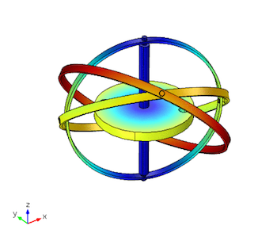

**Group Members: Guided under:**

**Amulya Jain (17M8008) Dr. Suwarna Torgal**

**Trapti Shakya (17M8059)**

**Contents –**

**Introduction and Aim –**

* Our aim is to design and fabricate a self-stabilizing wheel that can be used in two wheeler to balance it which is both efficient and cheap.
* With the help of gyroscopic principle we are aiming to design a self-balancing wheel.
* Gyroscopic principle is nothing but a real world manifestations of the law of conservation of angular momentum.
* The major reasons to use a gyroscope for the stabilization of wheel are:-

1) They make really small stabilized system

2) They impart greater stabilization

3) They are accurate and easy to understand

**Literature Survey-**

Many people face difficulty to keep a bicycle upright once it is non-stationary during learning period and some of them drop the idea of learning a bicycle or a two wheeler.

When the bike is in motion, disturbances can occur wherein which at high speeds the bike may experience low frequency weaving.

On the other hand, at low speeds the bike undergoes high frequency wobbles.

The concept of gyroscope can be implemented in the optimizing the control parameters to obtain a smooth flight control even. It can also be used to identify configurations that can help us obtaining most stability for a self-balancing wheel which can help in providing stability to a bicycle.



**Motivation-**

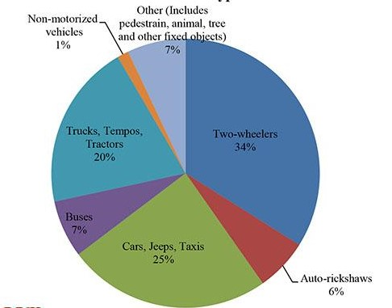

Road accidents in India due to misbalance of 2-wheelers (bike, bicycle, scooters, etc.) has risen up to 34% in India.

Hence, there is a need of a device which provides more stability to the vehicle in high and in low speeds as-well.

Gyroscopic effect is best suitable for providing stability to the wheel.

**Scope of work-**

Self-balancing of wheel is going to help people not only in easy learning but people with special abilities can also be benefited. A self-balanced wheel be helpful in following situations:-

**Gyroscopic principle –**

* Gyroscopes exhibit smooth balancing and accurate analogue readings as they adhere completely to the conservation of angular momentum.

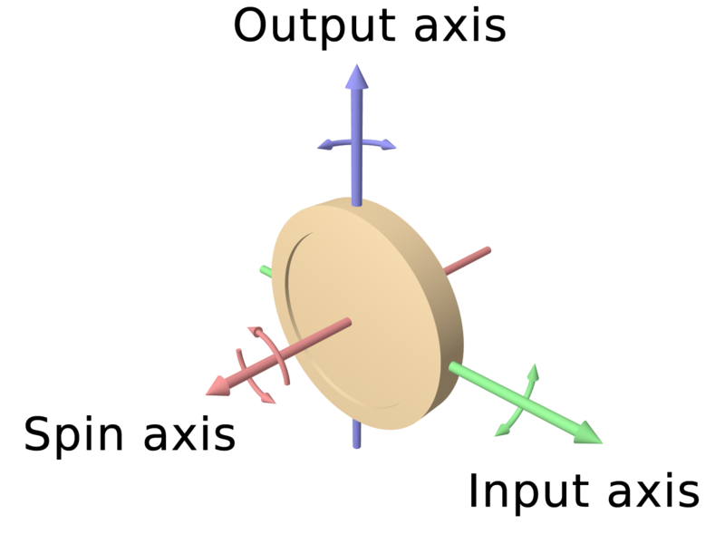

* They conserve the magnitude as well as the direction in the absence of an external torque.
* The spin axis always moves in the same direction as that of the applied torque.
* 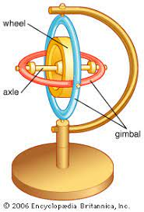The gyroscope can be used to maintain physical stability when the input and output are perpendicular to the spin axis.

**Design Methodology-**

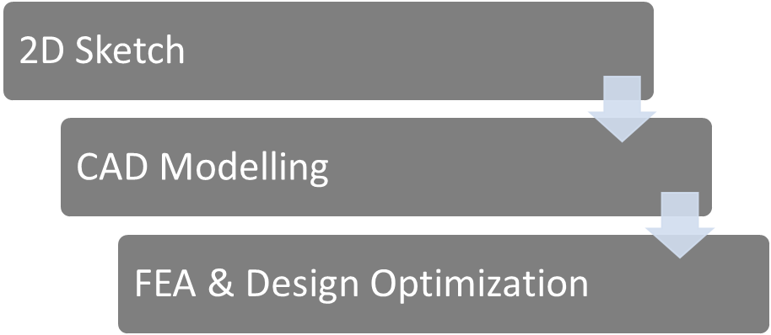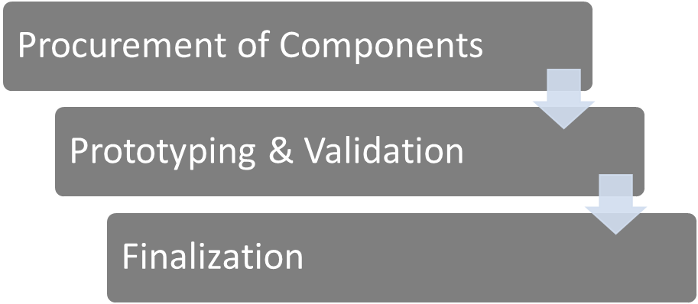



**Calculations-**

Let mass of the system = m kg  
Location of centre of mass (m) from the ground= h (m)  
When angle of Tilt = θ  
Then Torque induced = m g h sin θ  
∴ Reactive Gyroscopic Torque = m g h sin θ (opposite direction)  
∴ τ’ = I ω ωp  
⇒ m g h sinθ = I ω ωp  
⇒ ωp =

Mass of Flywheel=0.769 kg  
 Coefficient of friction between surface & wheel=0.3  
 = 2500 rpm  
 Moment of Inertia of flywheel =   
 =   
 =0.003488kg/  
 =   
= 262.069 rad/s

Angular Momentum =  
 =0.003488 x 262.069  
 = 0.9141   
Diameter of wheel = 0.4572m  
Moment of Inertia of wheel = M =0.8 x   
 =0.0418kg

Conserving angular momentum:-

Angular momentum =

0.9141 = 0.0418 x  
 =21.87rad/s

=

=208.86rpm

Speed of wheel (in m/s) = v

v= = 5m/s

So the model remains stable at speed 5m/s.

If wheel tilts 15 to vertical axis  
 Torque = g ×  
 = 0.911

To balance this torque reactive gyroscopic couple is react  
 C=  
 =0.003488*262.069*0.995  
 =0.909  
 0.91  
Hence balanced

**Observations-**

From our calculations we found that with high RPM hub motor the vehicle/wheel can be stabilized. The disc used as gyroscope was balanced and centred properly to prevent any vibrations and wobbling of the disc.

From the project some certain observations are provided:

* The higher the RPM, the bigger the counterforce.
* The more the tilt angle, the more force is needed to stabilizes the vehicle.
* The direction of rotating wheel tilt determines the force direction of when spinning is in a particular direction.

**CAD Model -**

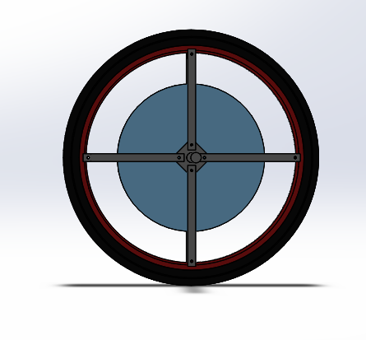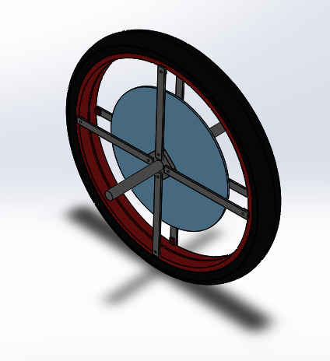



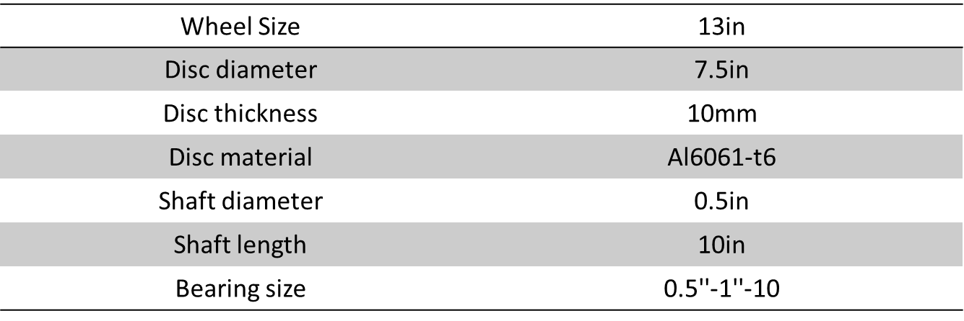

**Design specifications**

**Exploded View-**

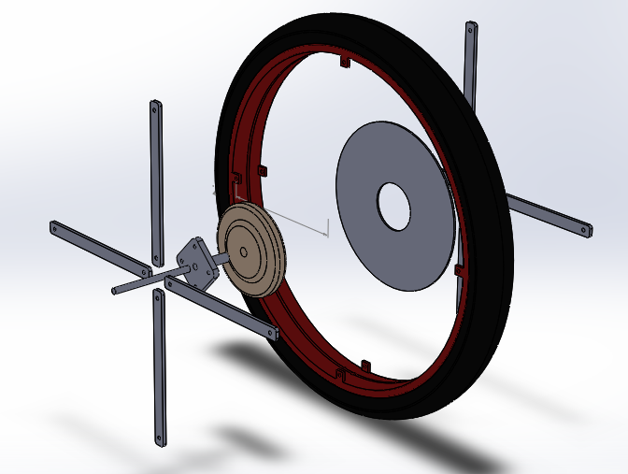

**Components used:**

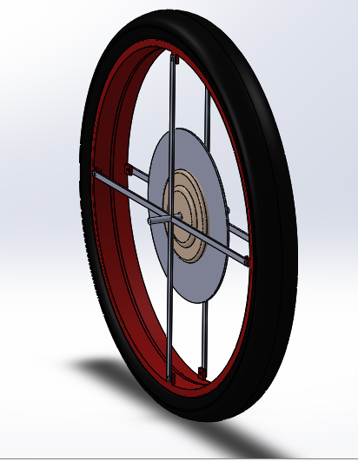



**Ansys-**

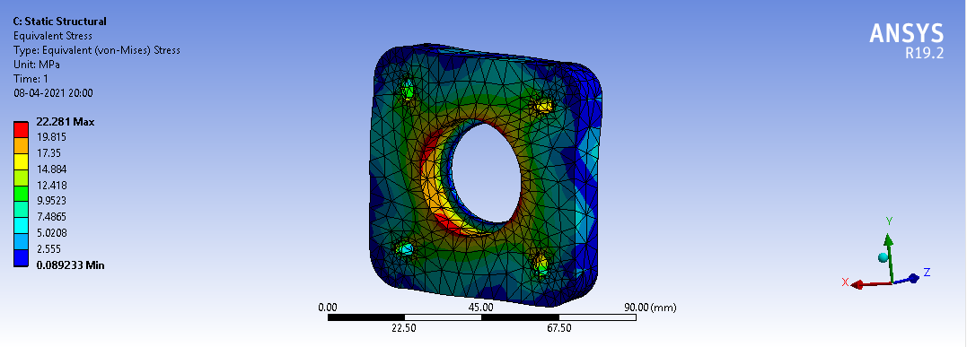

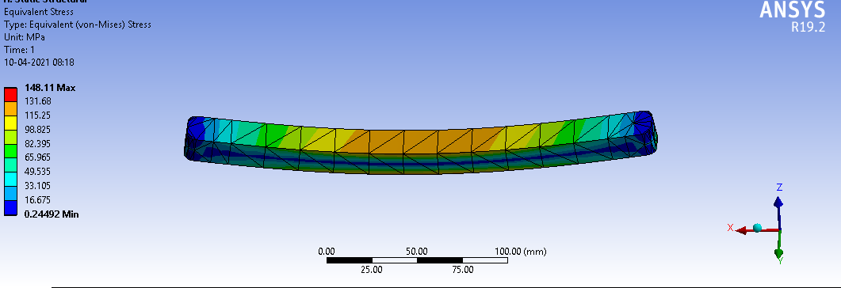Ansys of Hub of the wheel

Ansys of Spokes of the wheel

* Red shaded portion indicates the maximum stress.
* Blue shaded portion indicates the minimum stress.

**Stresses in spokes calculated theoretically-**

Area moment of inertia of spoke (I) =

=

= 5625 mm4



**3000N**

**1500N**

**1500N**

Bending moment at A = 0

Bending moment (M) at B = 1500 x 116.235

= 174352.5 N-mm

Bending moment at C = 0

Distance from neutral axis to the plane of maximum bending (Y) = 6 mm

Maximum stress (σ) =

=

= 185.976 N/mm2

= 185.976Mpa

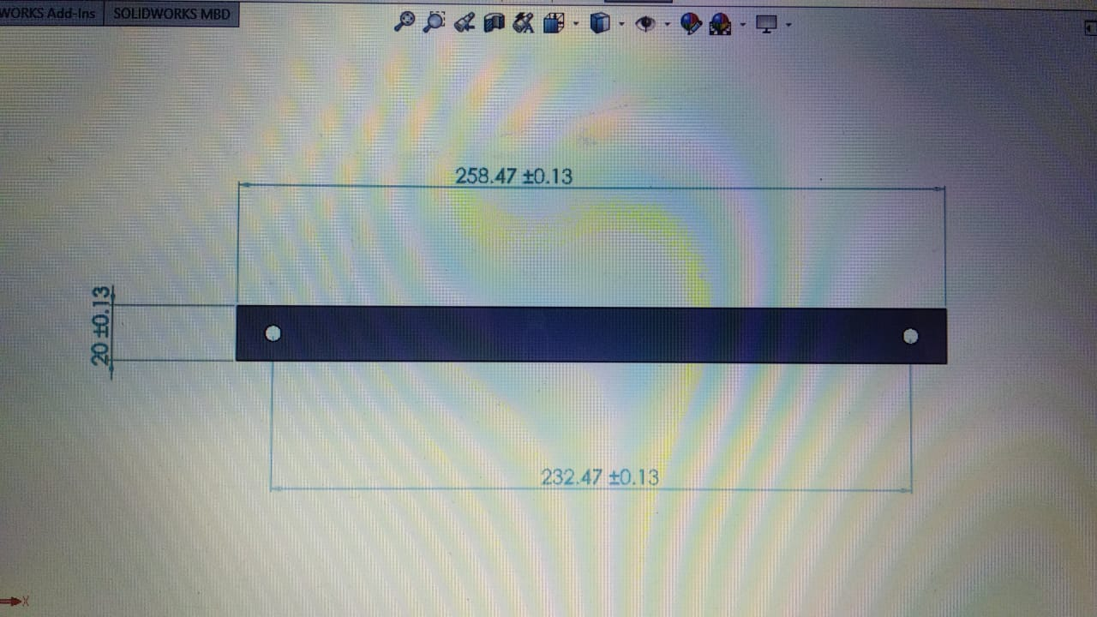

Thickness = 15mm

**Material Selection-**

**Nylon 6,6**

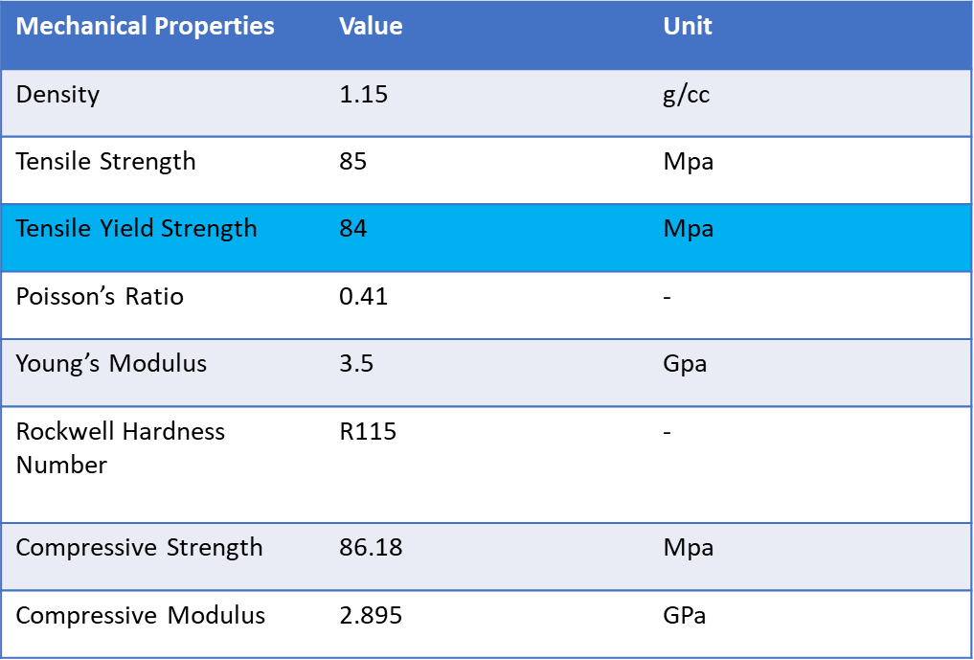



Yield Strength of Nylon 6,6 = 84MPa

Maximum stress in cage = 23MPa

FOS for Hub = = 3.77

* Hence, Nylon 6,6 suitable as Hub material.

**Structural Steel**

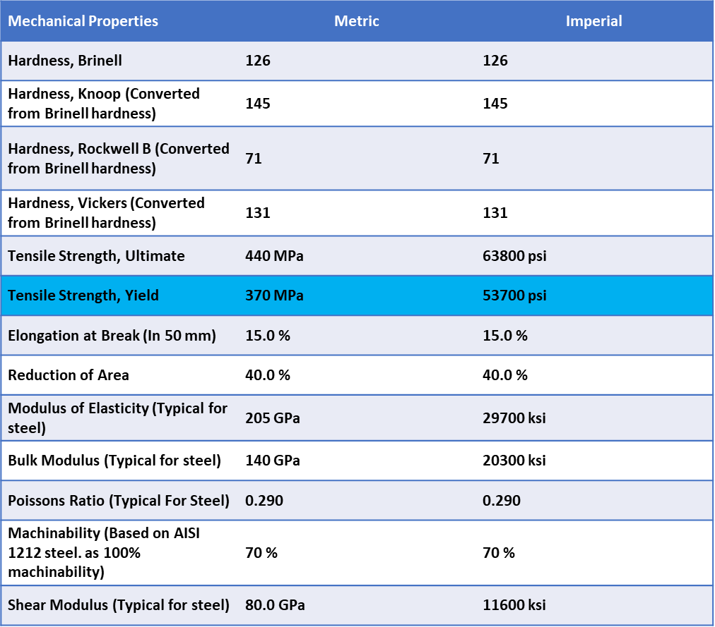



Yield Strength of Steel = 370MPa

Maximum stress in cage = 186MPa

FOS for Spokes = = 2.02

* Hence, Structural Steel is suitable as Spokes material.

**Specification of Motor-**

**HUB MOTOR:**

Specifications:-

* 0.201153 HP (150 W)
* 24-48 Volt
* 1.15 amps
* 2500 RPM, 1 speed
* 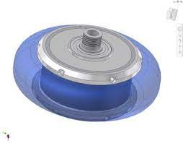Motor shaft: M12
* Net weight: 0.7kg
* CCW rotation
* Single Phase
* 1.0 service factor
* Enclosure TENV
* Continuous duty
* Shaft 1/2‘’ dia x 3 1/4’’
* Capacitor 5 mfd
* 5 1/2’’ dia x 5’’
* Shpg 15Ibs

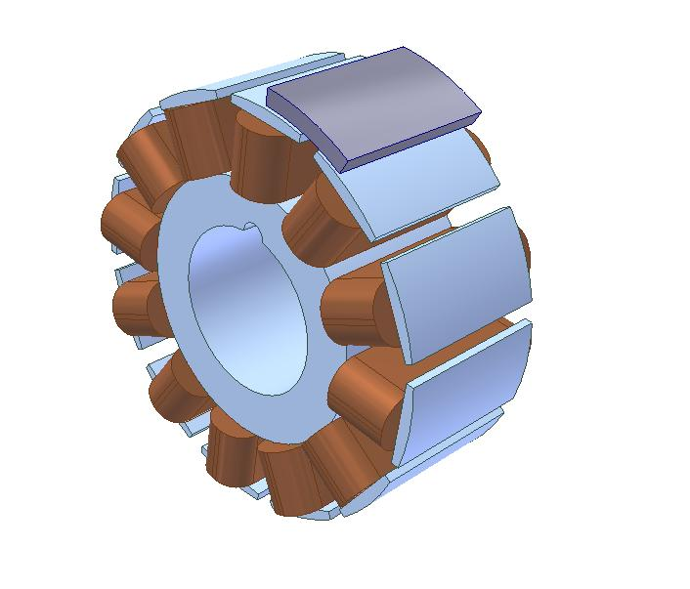

Why BLDC Hub motor?

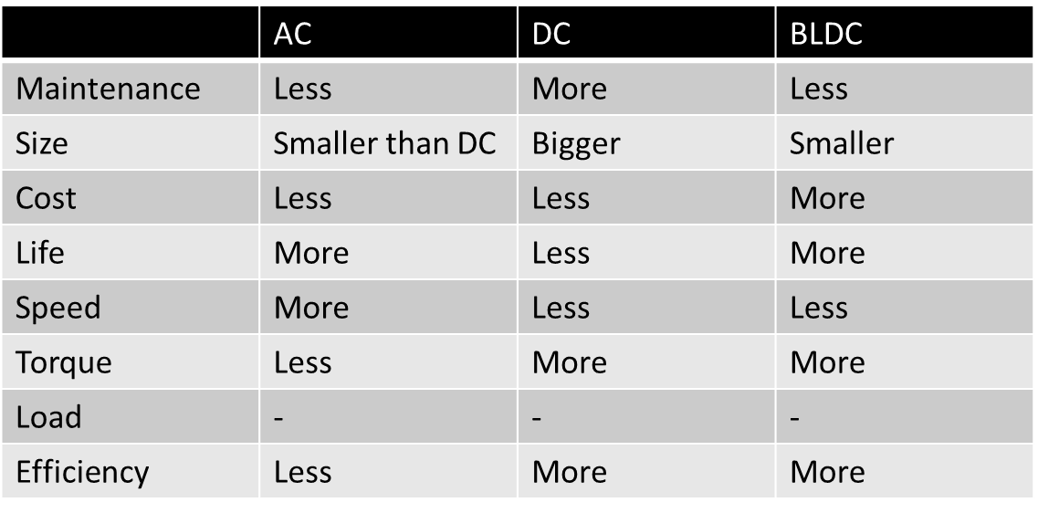

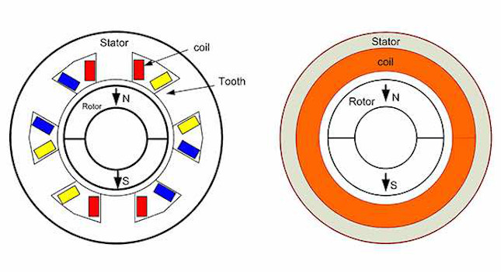

**Assembly and Design-**

1. A shaft (main axel) is being attached to the hub of wheel such that they act as single body and there is no motion between them.
2. Between the two cages of the wheel a cylindrical ball bearing is grooved (from inner part) on the main shaft.
3. A hub motor is being installed on the outer side of cylindrical roller bearing.
4. Eventually this hub motor provides motion to the disc mounted on it.
5. A Lithium ion battery is mounted on the flanges joining the seat and the steering of the wheel which provides power to the motor.
6. Thus, disc rotates on same axis as that of the shaft but without causing any motion to it.
7. 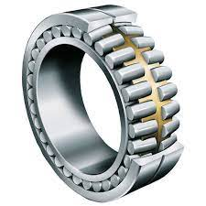Hence our wheel is stabilized with the help of gyroscopic effect.

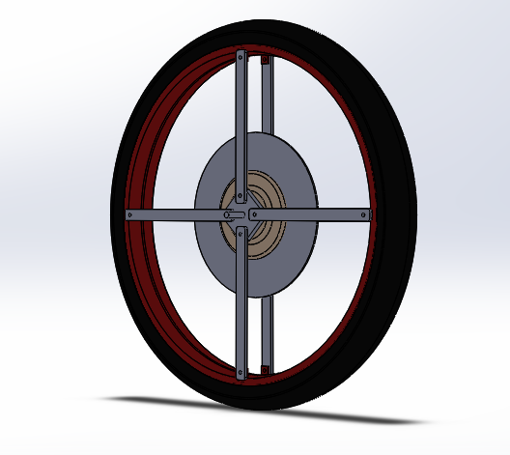

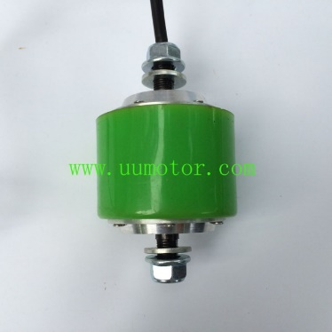

**Cost analysis-**

|  |  |
| --- | --- |
| Components | Cost (Rs) |
| Motor | 4000 - 5000 |
| Frame | 600 |
| Batteries | 3000 |
| Wheel | 800 |
| Fabrication | 1000 -1500 |
| Miscellaneous | 200 |
| Total | 10350 |

This is the price of production of single unit. Components used in here are solely taken online so market price can be less.

Production of self-balanced bike will be cheaper than for a single unit.

**Conclusion-**

Now a day, if a person has to commute from one place to another he/she has to use a two wheeler or four wheeler. Those who commute with a car don’t need effort for self-balancing of a vehicle but in case of bikes balancing is very important particularly at low speed. The balancing of two wheeler is achieved by the gyroscopic effect.

The gyroscopes which are conventionally used in airplanes and ships mainly for stabilization purpose can be effectively used for self- stabilization of wheel that can balance a two-wheeled vehicle. The prototype mentioned above was thus designed to validate the same.

The wheel balances vehicle under various conditions like the forced tilt of the vehicle. Thus the proposed system can be much helpful for reducing accidents or unwanted falls, increasing safety to the rider and provide easy riding to the people with disability.

**Applications-**

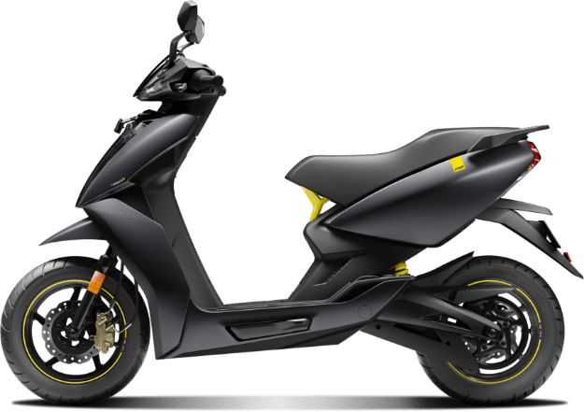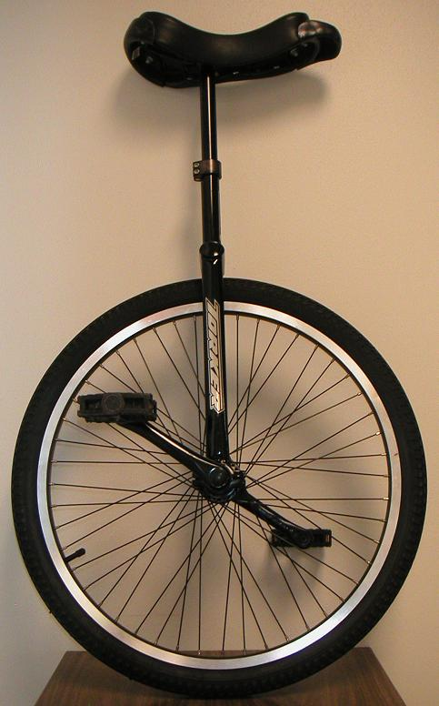

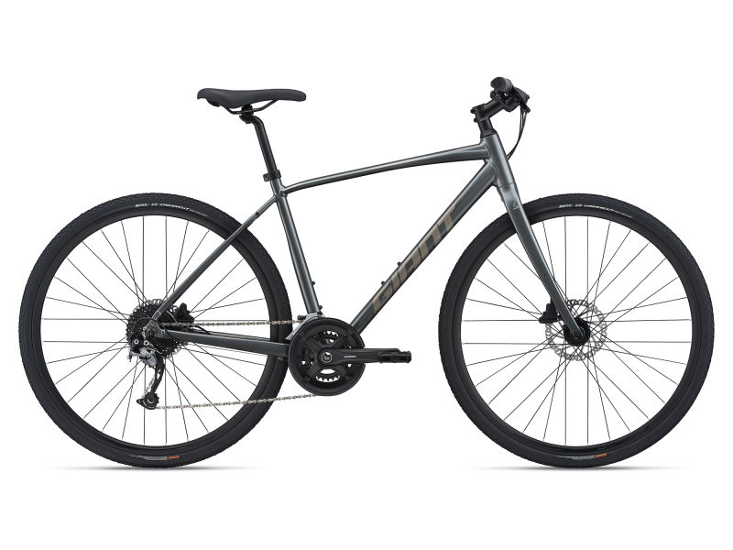

**Scope and future work-**

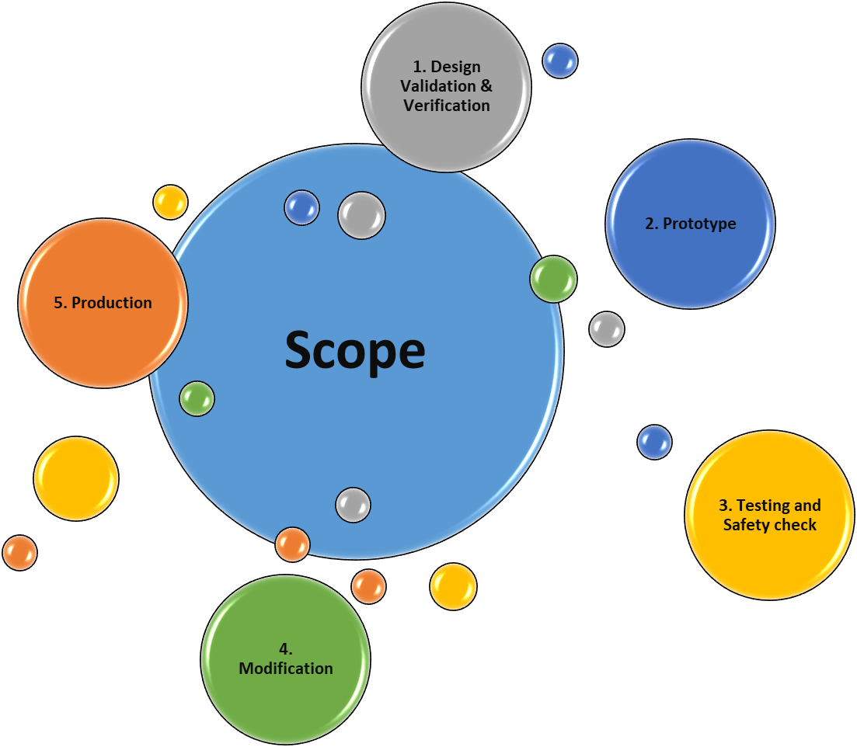

Cost reduction and reduction of weight.

There are several areas in which the system can be further developed in order to move the project from a prototype to a marketable product. These design changes, which include designing for modularity, safety and the inclusion of an on board power supply. They are intended to increase the commercial viability of the system by satisfying requirements necessary for the system to be sold as a finished product.

**References-**

* About Gyroscopic effect and couple [2,4].
* Stability of automobile/two-wheel vehicle [4].
* Flywheel [1,3]

1. John J. Dicker, Gordon R. Pennock and Joseph E. Shigley,"Flywheel" in Theory of Machines and Mechanisms, Ed. 3, New York , New York, USA, 2003, Ch. 21, pg. 678-682.
2. John J. Dicker, Gordon R. Pennock and Joseph E. Shigley,"Gyroscopes" in Theory of Machines and Mechanisms, Ed. 3, New York , New York, USA, 2003, Ch. 23, pg. 699-710.
3. SS Rattan, "Dynamic Force Analysis" in Theory of Machines, Ed. 3, Tata Mcgraw Hill Publishing Co Ltd, India, 2009, Ch. 13, pg. 461-470.
4. SS Rattan, "Gyroscope" in Theory of Machines, Ed. 3, Tata Mcgraw Hill Publishing Co Ltd, India, 2009, Ch. 17, pg. 605-610.
5. Research Paper: “**DESIGN AND ANALYSIS OF THE WHEEL HUB FOR AN ALL- TERRAIN VEHICLE WITH THE PLASTIC POLYMER: NYLON- 6,6**”

(https://www.researchgate.net/publication/335496655_DESIGN_AND_ANALYSIS_OF_THE_WHEEL_HUB_FOR_AN_ALL- _TERRAIN_VEHICLE_WITH_THE_PLASTIC_POLYMER_NYLON-_66#:~:text=The%20materials%20used%20for%20these,weight%20of%20the%20wheel%20assembly.)

**Project Timeline-**

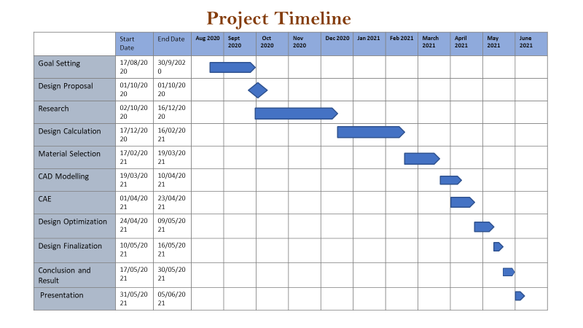

**Thank You**