Java Programming Assignment
Leave Management System
Build and Refactor Using Object-Oriented Programming

1. Introduction
A company needs a simple system to manage employee leave. The system stores employee information, handles leave requests and applies different leave rules depending on the type of employee. This report describes how a Java application for this was designed, built, extended with a new employee type and then refactored, and which Object-Oriented Programming concepts were used at each step.
The work was done in stages. A basic Employee class came first, then inheritance and polymorphism for the employee types, then the Manager change request, and finally a refactoring pass. Each stage was compiled and run before moving to the next, and the code in this report is the final, tested version.
The table below shows where each deliverable can be found.
Deliverable | Where to find it
Java source code | Appendix A and the src folder of the repository
Class diagram | Section 3 (drawn before coding) and Section 8 (final)
README file | Section 9 and README.md in the repository
Sample output / screenshots | Section 10 and docs/screenshots in the repository
GitHub repository link | Section 2
Explanation of OOP concepts used | Section 5
Refactoring notes | Section 7

2. GitHub Repository
Repository link: [Paste your GitHub repository link here]
The repository contains the Java source code (src), the documentation and diagrams (docs) and the README file.

3. Design Before Coding
Before writing any code, the scenario was read for its nouns (the objects and data) and its verbs (the behaviours). The result was a short list of classes and how they relate.

3.1 Objects, data and behaviours
Class | Data | Behaviour
Employee | Employee ID, name, department, leave balance | Apply leave, cancel leave, check leave balance, display details
FullTimeEmployee, PartTimeEmployee, Intern | Everything an Employee has, plus their own yearly leave allowance | Apply leave using their own rule
LeaveManagementApp | None | Creates employee objects and tests them

3.2 Relationships
- FullTimeEmployee, PartTimeEmployee and Intern are kinds of Employee, so they extend it (inheritance).
- Employee is abstract, because the program should only ever create a specific type of employee.
- LeaveManagementApp uses Employee objects and keeps all employee types in a single collection (polymorphism).
The Manager type and the exception classes were not part of this first design. They were added later, and the final diagram in Section 8 shows them.

3.3 Class diagram (before implementation)
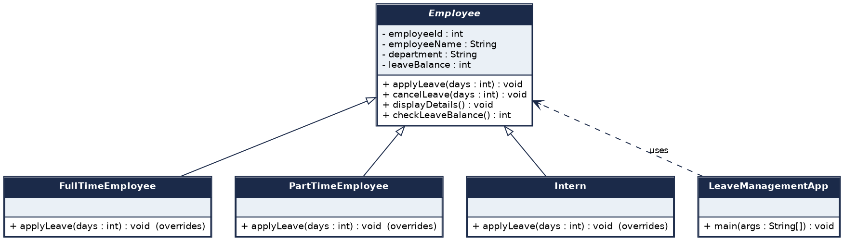
Figure 1: Class diagram drawn before the code was written

4. The Basic Application
The first version has a single Employee class with four private fields: employee ID, employee name, department and leave balance. A fifth private field, leave taken, was added so that a cancellation can be checked against the leave that was actually taken.
Method | What it does
applyLeave(days) | Rejects zero, negative or too many days; otherwise reduces the balance and records the days taken
cancelLeave(days) | Gives days back to the balance, but never more than the days taken
checkLeaveBalance() | Returns the current leave balance
displayDetails() | Prints the ID, name, department, balance and leave taken

The application created three employees (Anita Rao in Engineering with 20 days, Ravi Kumar in HR with 15 days and Meera Nair in Finance with 10 days) and ran five tests: a valid request, a request larger than the balance, a request for zero days, a valid cancellation and a cancellation larger than the leave taken.
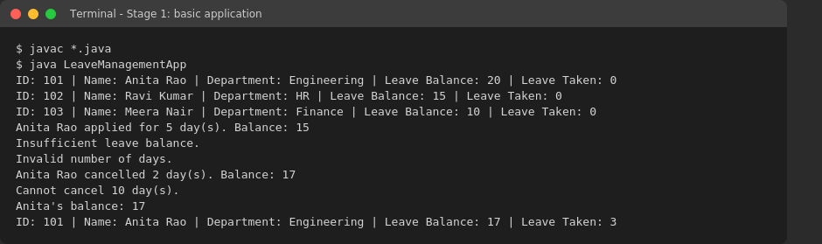
Figure 2: Output of the basic application
All five results were as expected. Anita applied for 5 days (balance 15), Ravi's 20-day request was refused for insufficient balance, Meera's zero-day request was refused as invalid, Anita's cancellation of 2 days restored her balance to 17, and her attempt to cancel 10 days was refused.

5. Applying OOP Concepts

5.1 Leave rules by employee type
Employee type | Annual leave (days) | Max days per request | Extra benefit
Full-Time | 24 | 10 | None
Part-Time | 12 | 5 | None
Intern | 6 | 2 | None
Manager | 30 + 5 bonus = 35 | 15 | 5 bonus leave days

Each type follows its own rule, but the steps for applying and cancelling leave are written only once, in Employee. A subclass states only what is different about it.

5.2 Explanation of the OOP concepts used
Encapsulation
Encapsulation means keeping an object's data private and allowing changes only through methods that enforce the rules. In Employee every field is private. The balance cannot be set directly. It changes only inside applyLeave() and cancelLeave(), which check the request first, and the constructor refuses an ID that is not positive or a blank name. Other code reads the balance through checkLeaveBalance().
private final int employeeId;
private final String employeeName;
private final String department;
private int leaveBalance;
private int leaveTaken;

Inheritance
Inheritance lets a class reuse another class's fields and methods. FullTimeEmployee, PartTimeEmployee and Intern extend Employee, so they all get the ID, name, department, balance and the leave operations without rewriting them. Manager extends FullTimeEmployee, which makes a two-level hierarchy: a Manager is a kind of full-time employee.
public class FullTimeEmployee extends Employee { ... }
public class PartTimeEmployee extends Employee { ... }
public class Intern extends Employee { ... }
public class Manager extends FullTimeEmployee { ... }

Polymorphism
Polymorphism means the same method call behaves differently depending on the actual object. LeaveManagementApp keeps all four employee types in one Employee array and sends every one of them the same request. The result depends on the real type: with the same 8-day request, Anita (Full-Time) and Karthik (Manager) are approved, while Ravi (Part-Time, limit 5) and Meera (Intern, limit 2) are refused. The decision is made at run time.
Employee[] staff = { new FullTimeEmployee(...), new PartTimeEmployee(...),
new Intern(...), new Manager(...) };
for (Employee employee : staff) {
applyLeave(employee, 8, "Long break");
}

Abstraction
Abstraction hides the details and exposes only what matters. Employee is an abstract class, so it cannot be created on its own. It declares two abstract methods, the employee type label and the maximum days per request, and leaves each subclass to supply them. Code that uses Employee does not need to know which concrete type it is working with.
public abstract class Employee {
public abstract String getEmployeeType();
protected abstract int getMaxDaysPerRequest();
...
}

Method overriding
Overriding means a subclass replaces a method it inherited. Every employee type overrides getEmployeeType() and getMaxDaysPerRequest() with @Override. Manager goes further: it overrides getMaxDaysPerRequest() to raise the limit from 10 to 15, and overrides displayDetails() to add the bonus leave line after calling the parent version with super.
@Override
protected int getMaxDaysPerRequest() {
return MAX_DAYS_PER_REQUEST;
}

@Override
public void displayDetails() {
super.displayDetails();
System.out.println(" Bonus leave days (manager benefit): " + BONUS_LEAVE_DAYS);
}

Method overloading
Overloading means several methods share a name but take different parameters. Employee has two versions of applyLeave(): one that takes only the number of days and one that also takes a reason. The first simply calls the second with a default reason. The compiler picks the right version from the arguments. The demo class overloads its own helper method the same way.
public void applyLeave(int days) throws LeaveException {
applyLeave(days, "Not specified");
}

public void applyLeave(int days, String reason) throws LeaveException {
...
}

Access modifiers
Modifier | Where it is used | Why
private | All Employee fields, the validateRequest() helper, and the constants in each subclass | Keeps data and internal steps hidden from every other class
protected | The Employee constructor, getMaxDaysPerRequest(), and a second FullTimeEmployee constructor | Available to subclasses such as Manager but not to outside code
public | applyLeave(), cancelLeave(), checkLeaveBalance(), displayDetails() and the classes themselves | This is the interface the rest of the program uses
package-private (no modifier) | The LeaveRecord class and its members | An internal detail of the project that outside code should not use

6. Change Request: Manager
The change request was to add a Manager employee type with additional leave benefits. Managers receive 30 base leave days plus 5 bonus days, can take up to 15 days in a single request, and their bonus days are shown in their details.
Because the design was built on an abstract base class, this needed one new class and no change to the leave logic. Manager extends FullTimeEmployee, inherits everything, and states only what differs: its entitlement, its request limit, its label and the extra line in displayDetails().
public class Manager extends FullTimeEmployee {
private static final int BASE_ENTITLEMENT = 30;
private static final int BONUS_LEAVE_DAYS = 5;
private static final int MAX_DAYS_PER_REQUEST = 15;

public Manager(int employeeId, String employeeName, String department) {
super(employeeId, employeeName, department, BASE_ENTITLEMENT + BONUS_LEAVE_DAYS);
}
...
}

The demo shows the benefit working. Karthik Iyer's 12-day request is approved, which a Full-Time employee could not take because their limit is 10.
This is not how the Manager class was first written. The first version extended Employee directly and copied the validation code once more. That duplication was one of the problems found in the refactoring step below.

7. Debugging and Refactoring Notes
After the Manager stage the code worked, but reviewing it showed several weaknesses. Six improvements were made. Long lines in the code samples below are wrapped to fit the page.
# | Area | Problem found | Improvement
1 | Duplicate code | The same 17-line applyLeave() was copied into four classes | One shared method in Employee; subclasses give only their limit
2 | Class responsibilities | Business methods printed results to the screen | Employee classes change state only; the app prints
3 | Exception handling | Errors were printed and the method returned silently | Custom exceptions carry the reason to the caller
4 | Maintainability | Numbers such as 24, 10 and 35 were written inline | Named constants, one limit method per class
5 | Reusability | Manager copied the full-time logic | Manager now extends FullTimeEmployee
6 | Naming | Parameters named d, id, dept; a bonus field that could be changed | Descriptive names; bonus is a constant

7.1 Duplicate code
Full-Time, Part-Time, Intern and Manager each contained their own copy of the same validation and deduction steps, differing only in one number and one label. A change to the rule, such as a new check, would have had to be made four times and could easily have been missed in one.
Before (repeated in four classes)
@Override
public void applyLeave(int d) {
if (d <= 0) {
System.out.println("Invalid number of days.");
return;
}
if (d > 10) {
System.out.println(getEmployeeName()
+ ": full-time employees can take at most 10 days at a time.");
return;
}
if (d > checkLeaveBalance()) {
System.out.println(getEmployeeName() + ": insufficient leave balance.");
return;
}
deduct(d);
System.out.println(getEmployeeName() + " (Full-Time) leave approved for "
+ d + " day(s).");
}

After (written once in Employee)
public void applyLeave(int days, String reason) throws LeaveException {
validateRequest(days);
leaveBalance -= days;
leaveTaken += days;
leaveHistory.add(new LeaveRecord(LeaveRecord.Action.APPLIED, days, reason));
}

private void validateRequest(int days) throws LeaveException {
if (days <= 0) {
throw new InvalidLeaveRequestException("Leave days must be greater than zero.");
}
if (days > getMaxDaysPerRequest()) {
throw new InvalidLeaveRequestException(getEmployeeType()
+ " employees can take at most " + getMaxDaysPerRequest()
+ " day(s) per request.");
}
if (days > leaveBalance) {
throw new InsufficientLeaveBalanceException(days, leaveBalance);
}
}

Each subclass now overrides only getMaxDaysPerRequest() and getEmployeeType(). Adding a new rule means editing one method.

7.2 Class responsibilities
The employee classes were doing two jobs: applying the leave rules and printing the outcome. Mixing them made the classes hard to reuse, because any other program using them would be forced to accept console messages. It also caused a real bug: the overloaded applyLeave(days, reason) printed "Reason: ..." even when the request had just been refused.
Before
public void applyLeave(int d, String reason) {
applyLeave(d);
System.out.println(" Reason: " + reason); // printed even if the leave was refused
}

After (printing moved to LeaveManagementApp)
private static void applyLeave(Employee employee, int days, String reason) {
try {
employee.applyLeave(days, reason);
System.out.println("OK " + employee.getEmployeeName() + " took " + days
+ " day(s) (" + reason + ").");
} catch (LeaveException e) {
System.out.println("DENIED " + employee.getEmployeeName() + ": " + e.getMessage());
}
}

Employee now only changes its own state and reports problems. LeaveManagementApp decides what the user sees, and the reason bug is gone because success and failure are now separate paths.

7.3 Exception handling
A refused request used to print a message and return, so the calling code could not tell whether the leave had been granted, and could not react to the cause. Three small exception classes were added: LeaveException as the base, InvalidLeaveRequestException for broken rules, and InsufficientLeaveBalanceException, which also records the days requested and the days available. The Employee constructor now rejects an ID that is not positive or a blank name with an IllegalArgumentException, so an invalid object can never be created.
Before
if (d > checkLeaveBalance()) {
System.out.println(getEmployeeName() + ": insufficient leave balance.");
return;
}

After
if (days > leaveBalance) {
throw new InsufficientLeaveBalanceException(days, leaveBalance);
}

7.4 Maintainability
Leave allowances and limits were written as bare numbers inside methods and constructors, for example 24, 10 and 35. Anyone reading the code had to guess what each number meant. They are now named constants at the top of each class, and each type has a single small method that returns its limit.
Before
super(id, name, dept, 24);
...
if (d > 10) { ... }

After
private static final int ANNUAL_ENTITLEMENT = 24;
private static final int MAX_DAYS_PER_REQUEST = 10;

@Override
protected int getMaxDaysPerRequest() {
return MAX_DAYS_PER_REQUEST;
}

7.5 Reusability
The first Manager class extended Employee directly and repeated the full-time validation, so it did not reuse the work already done in FullTimeEmployee. FullTimeEmployee was given a protected constructor that accepts an entitlement, and Manager now extends it and overrides only what differs. The Manager class no longer contains any validation logic.
Before
public class Manager extends Employee {
private int bonusLeaveDays = 5;
public Manager(int id, String name, String dept) {
super(id, name, dept, 35);
}
@Override public void applyLeave(int d) { /* the same checks again */ }
...
}

After
public class Manager extends FullTimeEmployee {
public Manager(int employeeId, String employeeName, String department) {
super(employeeId, employeeName, department, BASE_ENTITLEMENT + BONUS_LEAVE_DAYS);
}
...
}

7.6 Naming
Several names were too short to explain themselves. The parameter d became days, and the constructor parameters id, name and dept became employeeId, employeeName and department. The helper deduct() disappeared because the logic moved into applyLeave(). The bonusLeaveDays field in Manager could be changed after construction, although the bonus is a fixed benefit, so it became the constant BONUS_LEAVE_DAYS.

7.7 Checking the result
After refactoring, the program was recompiled and the demo was run again. The same requests are approved and refused as before, so the behaviour is unchanged. Refusals now carry clearer messages, and the reason bug no longer occurs. One addition was made during this stage: each employee keeps a leave history made of LeaveRecord objects. It is useful in itself and shows package-private access in use.

8. Final Class Diagram
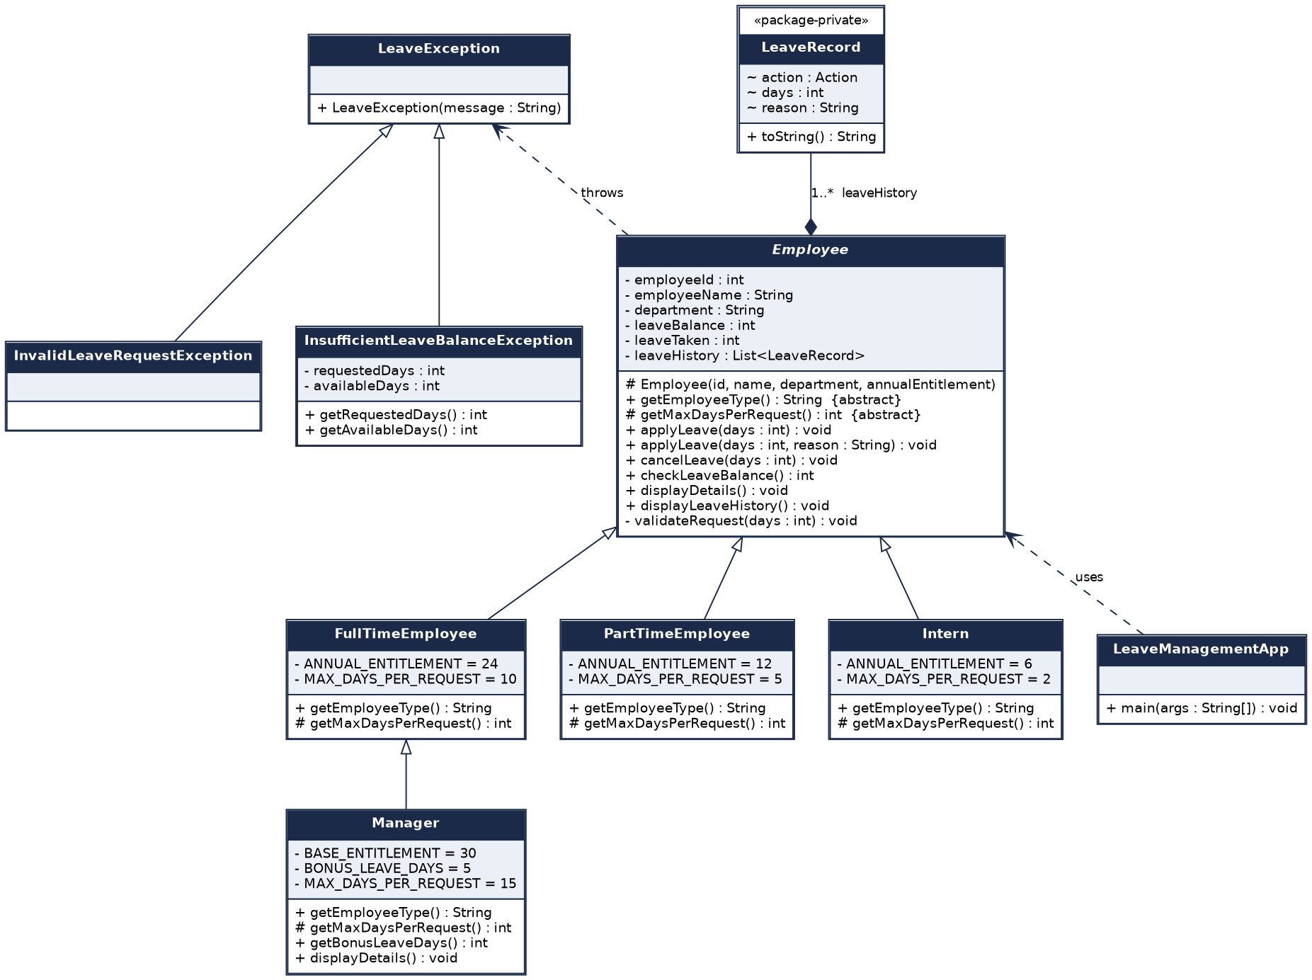
Figure 3: Final class diagram after the Manager change and the refactoring
- Inheritance (hollow arrow): FullTimeEmployee, PartTimeEmployee and Intern extend Employee, and Manager extends FullTimeEmployee. The two specific exceptions extend LeaveException.
- Composition (filled diamond): an Employee owns a list of LeaveRecord objects, its leave history.
- Dependency (dashed arrow): Employee throws LeaveException, and LeaveManagementApp uses Employee.
- Symbols: + public, - private, # protected, ~ package-private. Italics mark an abstract class.

9. README
The README.md file in the root of the repository is reproduced below.
# Leave Management System

A simple Java console application that manages employee leave and applies different leave rules by
employee type. It was built step by step to practise Object-Oriented Programming: encapsulation,
inheritance, polymorphism, abstraction, method overriding, method overloading and access modifiers.

## Features

- Stores employee ID, name, department and leave balance
- Apply for leave, cancel leave, check the balance and display details
- Four employee types, each with its own leave rules
- Custom exceptions for invalid requests and insufficient balance
- A leave history for each employee
- A scripted demo (`LeaveManagementApp`) that runs the same steps every time

## Leave rules

| Employee type | Annual leave (days) | Max days per request | Extra benefit |
|---|---|---|---|
| Full-Time | 24 | 10 | none |
| Part-Time | 12 | 5 | none |
| Intern | 6 | 2 | none |
| Manager | 30 + 5 bonus = 35 | 15 | 5 bonus leave days |

## Project structure

```
leave-management-system/
├── README.md
├── src/
│ ├── Employee.java abstract base class
│ ├── FullTimeEmployee.java
│ ├── PartTimeEmployee.java
│ ├── Intern.java
│ ├── Manager.java extends FullTimeEmployee
│ ├── LeaveRecord.java package-private history entry
│ ├── LeaveException.java base exception
│ ├── InvalidLeaveRequestException.java
│ ├── InsufficientLeaveBalanceException.java
│ └── LeaveManagementApp.java scripted demo (main)
└── docs/
├── Leave_Management_System_Report.docx full report
├── class-diagram-design.png diagram drawn before coding
├── class-diagram-final.png final class diagram
└── screenshots/ sample program output
```

## How to run

Requires JDK 8 or later.

```
cd src
javac *.java
java LeaveManagementApp
```

The program prints the employee details, applies leave under each employee type's rules, shows the
edge cases (zero days, negative days, not enough balance, cancelling too much, a blank name), then
prints the final balances and leave history.

## Design notes

- `Employee` is abstract. Subclasses only state what differs: their label and their per-request
limit.
- Applying and cancelling leave are written once in `Employee`, so no subclass repeats the
validation.
- The employee classes never print results. They throw `LeaveException` subclasses and the
application decides what to show.
- `Manager` extends `FullTimeEmployee`, so the Manager change request needed only the differences.

See `docs/Leave_Management_System_Report.docx` for the design, the OOP explanation and the
refactoring notes.

10. Sample Output and Screenshots
The program was compiled with javac and run with java. It is a scripted demo, so it prints the same output on every run. The screenshots below show the complete output of the final version.
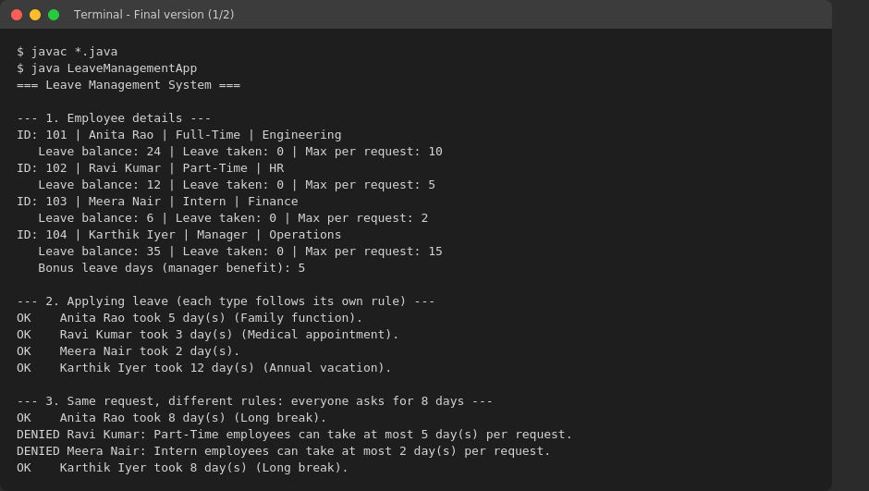
Figure 4: Final version, employee details, normal requests and the same request under different rules
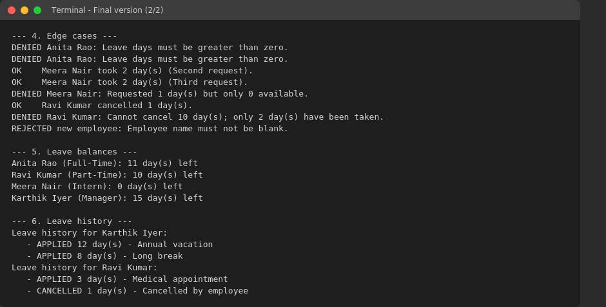
Figure 5: Final version, edge cases, final balances and leave history
What the output shows:
- Section 1 lists four employees, one of each type, with different balances and limits.
- Section 2 applies leave under each type's rules. Karthik, a Manager, is approved for 12 days.
- Section 3 sends the same 8-day request to everyone. Part-Time and Intern are refused because their limits are lower.
- Section 4 covers the edge cases: zero and negative days, an intern with no balance left, cancelling more than was taken, and a blank employee name.
- Sections 5 and 6 show the final balances and the leave history of two employees.

Appendix A: Java Source Code
The complete source of the final version. Each file is also provided as a .java file in the src folder.

Employee.java
import java.util.ArrayList;
import java.util.List;

/**
* Base class for every employee type.
*
* Abstraction: subclasses only say WHAT is different (their label and their
* per-request limit). The shared steps for applying and cancelling leave
* live here once, so no subclass repeats them.
*/
public abstract class Employee {

// Encapsulation: all state is private and changed only through methods
private final int employeeId;
private final String employeeName;
private final String department;
private int leaveBalance;
private int leaveTaken;
private final List<LeaveRecord> leaveHistory = new ArrayList<>();

protected Employee(int employeeId, String employeeName, String department, int annualEntitlement) {
if (employeeId <= 0) {
throw new IllegalArgumentException("Employee ID must be positive.");
}
if (employeeName == null || employeeName.trim().isEmpty()) {
throw new IllegalArgumentException("Employee name must not be blank.");
}
this.employeeId = employeeId;
this.employeeName = employeeName.trim();
this.department = department;
this.leaveBalance = annualEntitlement;
}

// ---- Rules that differ by employee type (implemented by subclasses) ----

public abstract String getEmployeeType();

protected abstract int getMaxDaysPerRequest();

// ---- Leave operations ----

// Method overloading: same name, different parameter lists
public void applyLeave(int days) throws LeaveException {
applyLeave(days, "Not specified");
}

public void applyLeave(int days, String reason) throws LeaveException {
validateRequest(days);
leaveBalance -= days;
leaveTaken += days;
leaveHistory.add(new LeaveRecord(LeaveRecord.Action.APPLIED, days, reason));
}

public void cancelLeave(int days) throws InvalidLeaveRequestException {
if (days <= 0) {
throw new InvalidLeaveRequestException("Days to cancel must be greater than zero.");
}
if (days > leaveTaken) {
throw new InvalidLeaveRequestException("Cannot cancel " + days + " day(s); only "
+ leaveTaken + " day(s) have been taken.");
}
leaveBalance += days;
leaveTaken -= days;
leaveHistory.add(new LeaveRecord(LeaveRecord.Action.CANCELLED, days, "Cancelled by employee"));
}

public int checkLeaveBalance() {
return leaveBalance;
}

public void displayDetails() {
System.out.printf("ID: %d | %s | %s | %s%n",
employeeId, employeeName, getEmployeeType(), department);
System.out.printf(" Leave balance: %d | Leave taken: %d | Max per request: %d%n",
leaveBalance, leaveTaken, getMaxDaysPerRequest());
}

public void displayLeaveHistory() {
System.out.println("Leave history for " + employeeName + ":");
if (leaveHistory.isEmpty()) {
System.out.println(" (no leave activity)");
}
for (LeaveRecord record : leaveHistory) {
System.out.println(" - " + record);
}
}

public String getEmployeeName() {
return employeeName;
}

// ---- Private helper: the one place where every request is checked ----

private void validateRequest(int days) throws LeaveException {
if (days <= 0) {
throw new InvalidLeaveRequestException("Leave days must be greater than zero.");
}
if (days > getMaxDaysPerRequest()) {
throw new InvalidLeaveRequestException(getEmployeeType() + " employees can take at most "
+ getMaxDaysPerRequest() + " day(s) per request.");
}
if (days > leaveBalance) {
throw new InsufficientLeaveBalanceException(days, leaveBalance);
}
}
}

FullTimeEmployee.java
/**
* Full-time employees: 24 days a year, up to 10 days per request.
*/
public class FullTimeEmployee extends Employee {

private static final int ANNUAL_ENTITLEMENT = 24;
private static final int MAX_DAYS_PER_REQUEST = 10;

public FullTimeEmployee(int employeeId, String employeeName, String department) {
this(employeeId, employeeName, department, ANNUAL_ENTITLEMENT);
}

// protected: lets a subclass such as Manager reuse this class with its own entitlement
protected FullTimeEmployee(int employeeId, String employeeName, String department,
int annualEntitlement) {
super(employeeId, employeeName, department, annualEntitlement);
}

@Override
public String getEmployeeType() {
return "Full-Time";
}

@Override
protected int getMaxDaysPerRequest() {
return MAX_DAYS_PER_REQUEST;
}
}

PartTimeEmployee.java
/**
* Part-time employees: 12 days a year, up to 5 days per request.
*/
public class PartTimeEmployee extends Employee {

private static final int ANNUAL_ENTITLEMENT = 12;
private static final int MAX_DAYS_PER_REQUEST = 5;

public PartTimeEmployee(int employeeId, String employeeName, String department) {
super(employeeId, employeeName, department, ANNUAL_ENTITLEMENT);
}

@Override
public String getEmployeeType() {
return "Part-Time";
}

@Override
protected int getMaxDaysPerRequest() {
return MAX_DAYS_PER_REQUEST;
}
}

Intern.java
/**
* Interns: 6 days a year, up to 2 days per request.
*/
public class Intern extends Employee {

private static final int ANNUAL_ENTITLEMENT = 6;
private static final int MAX_DAYS_PER_REQUEST = 2;

public Intern(int employeeId, String employeeName, String department) {
super(employeeId, employeeName, department, ANNUAL_ENTITLEMENT);
}

@Override
public String getEmployeeType() {
return "Intern";
}

@Override
protected int getMaxDaysPerRequest() {
return MAX_DAYS_PER_REQUEST;
}
}

Manager.java
/**
* Managers are full-time employees with extra benefits:
* 30 base days plus 5 bonus days a year, and up to 15 days per request.
* Only what differs from FullTimeEmployee is written here.
*/
public class Manager extends FullTimeEmployee {

private static final int BASE_ENTITLEMENT = 30;
private static final int BONUS_LEAVE_DAYS = 5;
private static final int MAX_DAYS_PER_REQUEST = 15;

public Manager(int employeeId, String employeeName, String department) {
super(employeeId, employeeName, department, BASE_ENTITLEMENT + BONUS_LEAVE_DAYS);
}

@Override
public String getEmployeeType() {
return "Manager";
}

@Override
protected int getMaxDaysPerRequest() {
return MAX_DAYS_PER_REQUEST;
}

public int getBonusLeaveDays() {
return BONUS_LEAVE_DAYS;
}

@Override
public void displayDetails() {
super.displayDetails();
System.out.println(" Bonus leave days (manager benefit): " + BONUS_LEAVE_DAYS);
}
}

LeaveRecord.java
/**
* One entry in an employee's leave history.
* Package-private (no modifier): it is an internal detail of the leave
* package and is not meant to be used by outside code.
*/
class LeaveRecord {

enum Action { APPLIED, CANCELLED }

private final Action action;
private final int days;
private final String reason;

LeaveRecord(Action action, int days, String reason) {
this.action = action;
this.days = days;
this.reason = reason;
}

@Override
public String toString() {
return action + " " + days + " day(s) - " + reason;
}
}

LeaveException.java
/**
* Base class for every error raised by the leave rules.
* Checked on purpose: callers must decide how to handle a rejected request.
*/
public class LeaveException extends Exception {

public LeaveException(String message) {
super(message);
}
}

InvalidLeaveRequestException.java
/**
* Thrown when a request breaks a rule: zero or negative days,
* more days than the employee type allows at once, or a cancellation
* larger than the leave actually taken.
*/
public class InvalidLeaveRequestException extends LeaveException {

public InvalidLeaveRequestException(String message) {
super(message);
}
}

InsufficientLeaveBalanceException.java
/**
* Thrown when an employee asks for more days than their remaining balance.
*/
public class InsufficientLeaveBalanceException extends LeaveException {
private final int requestedDays;
private final int availableDays;

public InsufficientLeaveBalanceException(int requestedDays, int availableDays) {
super("Requested " + requestedDays + " day(s) but only " + availableDays + " available.");
this.requestedDays = requestedDays;
this.availableDays = availableDays;
}

public int getRequestedDays() {
return requestedDays;
}

public int getAvailableDays() {
return availableDays;
}
}

LeaveManagementApp.java
/**
* Scripted console demo. It runs the same steps every time, so the output
* can be compared with the screenshots. All printing of results happens here;
* the employee classes only apply the rules and throw exceptions.
*/
public class LeaveManagementApp {

public static void main(String[] args) {
System.out.println("=== Leave Management System ===");

// Polymorphism: one array holds every employee type
Employee[] staff = {
new FullTimeEmployee(101, "Anita Rao", "Engineering"),
new PartTimeEmployee(102, "Ravi Kumar", "HR"),
new Intern(103, "Meera Nair", "Finance"),
new Manager(104, "Karthik Iyer", "Operations")
};

printHeading("1. Employee details");
for (Employee employee : staff) {
employee.displayDetails();
}

Employee anita = staff[0];
Employee ravi = staff[1];
Employee meera = staff[2];
Employee karthik = staff[3];

printHeading("2. Applying leave (each type follows its own rule)");
applyLeave(anita, 5, "Family function");
applyLeave(ravi, 3, "Medical appointment");
applyLeave(meera, 2);
applyLeave(karthik, 12, "Annual vacation");

printHeading("3. Same request, different rules: everyone asks for 8 days");
for (Employee employee : staff) {
applyLeave(employee, 8, "Long break");
}

printHeading("4. Edge cases");
applyLeave(anita, 0, "Zero days");
applyLeave(anita, -3, "Negative days");
applyLeave(meera, 2, "Second request");
applyLeave(meera, 2, "Third request");
applyLeave(meera, 1, "Balance already used up");
cancelLeave(ravi, 1);
cancelLeave(ravi, 10);
createEmployeeWithBlankName();

printHeading("5. Leave balances");
for (Employee employee : staff) {
System.out.println(employee.getEmployeeName() + " (" + employee.getEmployeeType()
+ "): " + employee.checkLeaveBalance() + " day(s) left");
}

printHeading("6. Leave history");
karthik.displayLeaveHistory();
ravi.displayLeaveHistory();
}

// Overloaded helpers keep the demo short and show overloading in use
private static void applyLeave(Employee employee, int days) {
try {
employee.applyLeave(days);
System.out.println("OK " + employee.getEmployeeName() + " took " + days + " day(s).");
} catch (LeaveException e) {
System.out.println("DENIED " + employee.getEmployeeName() + ": " + e.getMessage());
}
}

private static void applyLeave(Employee employee, int days, String reason) {
try {
employee.applyLeave(days, reason);
System.out.println("OK " + employee.getEmployeeName() + " took " + days
+ " day(s) (" + reason + ").");
} catch (LeaveException e) {
System.out.println("DENIED " + employee.getEmployeeName() + ": " + e.getMessage());
}
}

private static void cancelLeave(Employee employee, int days) {
try {
employee.cancelLeave(days);
System.out.println("OK " + employee.getEmployeeName()
+ " cancelled " + days + " day(s).");
} catch (LeaveException e) {
System.out.println("DENIED " + employee.getEmployeeName() + ": " + e.getMessage());
}
}

private static void createEmployeeWithBlankName() {
try {
new Intern(105, " ", "Finance");
} catch (IllegalArgumentException e) {
System.out.println("REJECTED new employee: " + e.getMessage());
}
}

private static void printHeading(String title) {
System.out.println();
System.out.println("--- " + title + " ---");
}
}

