**Experiment-2**

**Familiarisation with RC Low Pass Filter, RC High Pass Filter, RL Low Pass Filter and RL High Pass Filter**

**Aim**  
The aim of the experiment is to explain the working of

1. **RC Low pass filter**
2. **RC High pass filter**
3. **RL Low pass filter**
4. **RL High pass filter**

**Circuit Diagram**

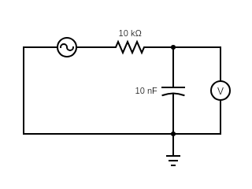**RC Low Pass Filter:**

**VIN= 10 V**

**VOUT**

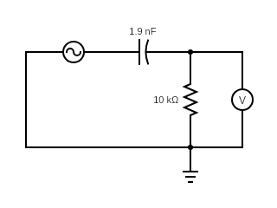**RC High Pass Filter:**

**VIN= 10 V**

**VOUT**

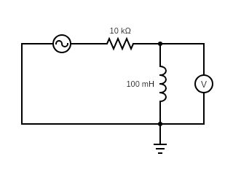**RL Low Pass Filter:**

**VOUT**

**VIN= 10 V**

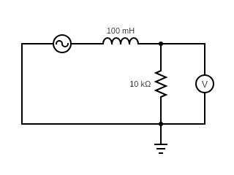**RL High Pass Filter:**

**VOUT**

**VIN= 10 V**

**Procedure**

**Frequency Response of RC Low Pass Filter**

1. Set Load Resistance (RL) to 10 KΩ.
2. Set Load Capacitor (CL) to 10.01nF.
3. The source voltage (Vin) is set to 10V.
4. Keeping source voltage constant, vary the frequency from 50 Hz in regular steps.
5. Note down the Frequency (in Hz), Magnitude (in dB), Phase (theta) and Output Voltage (Vout) for different frequencies.
6. Vary the Frequency by keeping the load resistance and load capacitance constant.
7. Plot the plot the frequency response graph of the RC low pass filter- Frequency (Hz) along X-axis and Magnitude (dB) along Y-axis.

**Frequency Response of RC High Pass Filter**

1. Set Load Resistance (RL) to 10 KΩ.
2. Set Load Capacitor (CL) to 1.91nF.
3. The source voltage (Vin) is set to 10V.
4. Keeping source voltage constant, vary the frequency from 50 Hz in regular steps.
5. Note down the Frequency (in Hz), Magnitude (in dB), Phase (theta) and Output Voltage (Vout) for different frequencies.
6. Vary the Frequency by keeping the load resistance and load capacitance constant.
7. Plot the plot the frequency response graph of the RC high pass filter- Frequency (Hz) along X-axis and Magnitude (dB) along Y-axis.

**Frequency Response of RL Low Pass Filter**

1. Set Load Resistance (RL) to 10 KΩ.
2. Set Load Inductance (LL) to 100mH.
3. The source voltage (Vin) is set to 10V.
4. Keeping source voltage constant, vary the frequency from 50 Hz in regular steps.
5. Note down the Frequency (in Hz), Magnitude (in dB), Phase (theta) and Output Voltage (Vout) for different frequencies.
6. Vary the Frequency by keeping the load resistance and load inductance constant.
7. Plot the plot the frequency response graph of the RL low pass filter- Frequency (Hz) along X-axis and Magnitude (dB) along Y-axis.

**Frequency Response of RL High Pass Filter**

1. Set Load Resistance (RL) to 10 KΩ.
2. Set Load Inductance (LL) to 100mH.
3. The source voltage (Vin) is set to 10V.
4. Keeping source voltage constant, vary the frequency from 50 Hz in regular steps.
5. Note down the Frequency (in Hz), Magnitude (in dB), Phase (theta) and Output Voltage (Vout) for different frequencies.
6. Vary the Frequency by keeping the load resistance and load inductance constant.
7. Plot the plot the frequency response graph of the RL High pass filter- Frequency (Hz) along X-axis and Magnitude (dB) along Y-axis.

**Observation Tables and Plots**

**[1] Frequency Response of RC Low Pass Filter (Virtual Labs)**

|  |  |  |  |  |
| --- | --- | --- | --- | --- |
| **Serial No.** | **Frequency (Hz)** | **Magnitude (dB)** | **Phase (theta)** | **Output Voltage (V)** |
| 1 | 50 | -0.00434504 | -1.81306 | 9.9950 |
| 2 | 149 | -0.0376986 | -5.33703 | 9.956 |
| 3 | 438 | -0.31785 | -15.4138 | 9.6407 |
| 4 | 1294 | -2.2046 | -39.1389 | 7.7584 |
| 5 | 3818 | -8.2995 | -67.4144 | 3.8461 |
| 6 | 11267 | -17.08998 | -82.0054 | 1.3980 |
| 7 | 33252 | -26.4142 | -87.3054 | 0.47785 |
| 8 | 98134 | -35.8054 | -89.1165 | 0.16208 |
| 9 | 289614 | -45.2044 | -89.7308 | 0.054926 |
| 10 | 854713 | -54.6042 | -89.9390 | 0.01861 |

**[1] Frequency Response Plot of RC Low Pass Filter (Virtual Labs)**

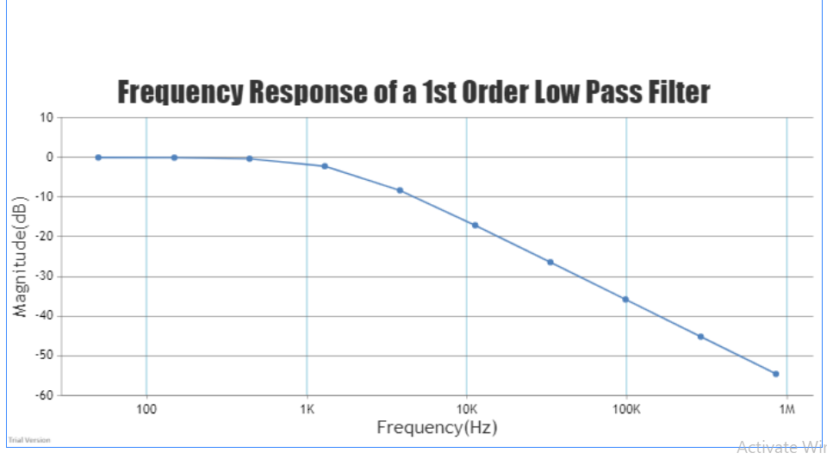

**Observation Tables and Plots**

**[2] Frequency Response of RC High Pass Filter (Virtual Labs)**

|  |  |  |  |  |
| --- | --- | --- | --- | --- |
| **Serial No.** | **Frequency (Hz)** | **Magnitude (dB)** | **Phase (theta)** | **Output Voltage (V)** |
| 1 | 50 | -44.38380000000001 | 89.6996 | 0.060368 |
| 2 | 149 | -34.9852 | 89.0245 | 0.17813 |
| 3 | 438 | -25.5958 | 87.0343 | 0.52507 |
| 4 | 1294 | -16.28706 | 81.2208 | 1.5334 |
| 5 | 3818 | -7.6105599999999995 | 65.4280 | 4.1636 |
| 6 | 11267 | -1.896272 | 36.5171 | 8.0387 |
| 7 | 33252 | -0.26476 | 14.0821 | 9.6998 |
| 8 | 98134 | -0.0312318 | 4.85834 | 9.9641 |
| 9 | 289614 | -0.0035973199999999998 | 1.64972 | 9.9959 |
| 10 | 854713 | -0.000413178 | 0.559134 | 9.9995 |

**[2] Frequency Response Plot of RC High Pass Filter (Virtual Labs)**

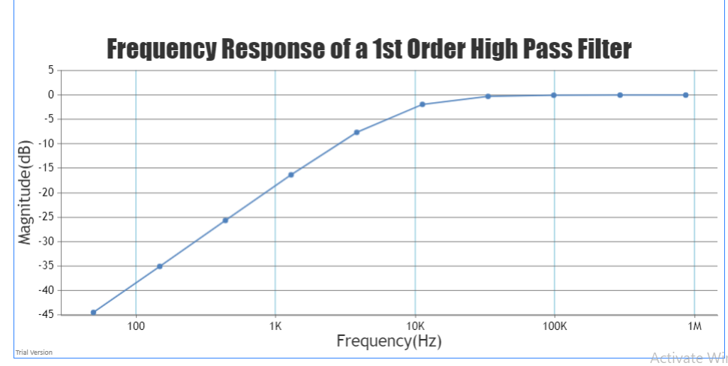

**Observation Tables and Plots**

**[3] Frequency Response of RC Low Pass Filter (Circuit Simulator)**

|  |  |  |  |  |  |
| --- | --- | --- | --- | --- | --- |
| **Serial No.** | **Frequency f (Hz)** | **Log(f)** | **Magnitude (dB)** | **Phase (theta)** | **Output Voltage (V)** |
| 1 | 80 | 1.90309 | -0.00028 | -2.880 | 9.989 |
| 2 | 100.1 | 2.000434 | -0.00044 | -3.601 | 9.984 |
| 3 | 320.1 | 2.505286 | -0.17238 | -11.3773 | 9.839 |
| 4 | 1200 | 3.079181 | -1.95637 | -37.0292 | 8.36 |
| 5 | 1600 | 3.20412 | -3.03551 | -45.1658 | 7.424 |
| 6 | 3100 | 3.491362 | -6.81025 | -62.8354 | 5.003 |
| 7 | 7500 | 3.875061 | -13.6602 | -78.0249 | 2.3 |
| 8 | 10100 | 4.004321 | -16.1607 | -81.0494 | 1.732 |
| 9 | 15500 | 4.190332 | -19.82 | -84.1402 | 1.121 |
| 10 | 20500 | 4.311754 | -22.229 | -85.5628 | 0.836474 |

**[3] Frequency Response Plot of RC Low Pass Filter (Circuit Simulator)**

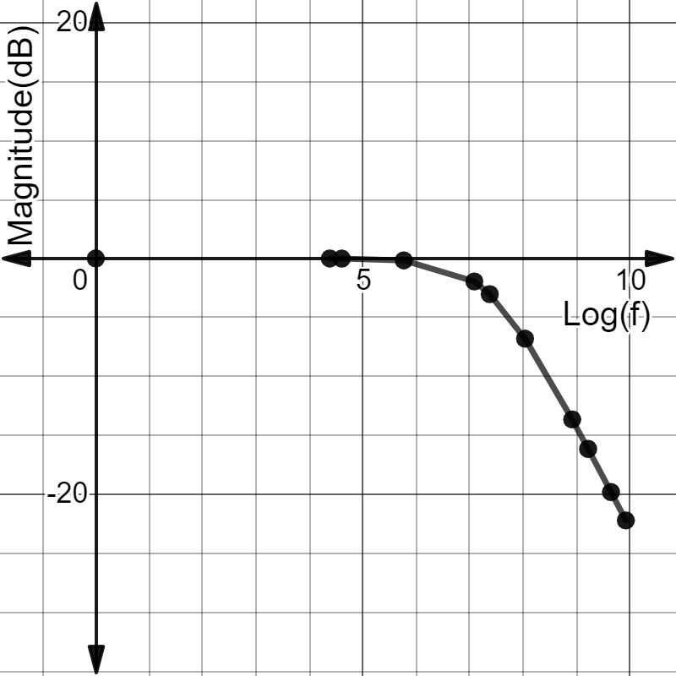

**Observation Tables and Plots**

**[4] Frequency Response of RC High Pass Filter (Circuit Simulator)**

|  |  |  |  |  |  |
| --- | --- | --- | --- | --- | --- |
| **Serial No.** | **Frequency f (Hz)** | **Log(f)** | **Magnitude (dB)** | **Phase (theta)** | **Output Voltage (V)** |
| 1 | 421 | 2.624282 | -25.9456 | 87.10913 | 0.475185 |
| 2 | 823 | 2.9154 | -20.1543 | 84.36219 | 0.967579 |
| 3 | 1200 | 3.079181 | -16.9256 | 81.80924 | 1.371 |
| 4 | 2500 | 3.39794 | -10.8353 | 73.30759 | 2.884 |
| 5 | 6500 | 3.812913 | -4.22439 | 52.05781 | 6.125 |
| 6 | 8300 | 3.919078 | -3.02963 | 45.12724 | 7.058 |
| 7 | 12100 | 4.082785 | -1.68711 | 34.56699 | 8.259 |
| 8 | 15500 | 4.190332 | -1.10354 | 28.27436 | 8.85 |
| 9 | 20300 | 4.307496 | -0.6769 | 22.32732 | 9.293 |
| 10 | 24000 | 4.380211 | -0.49477 | 19.15583 | 9.494 |

**[4] Frequency Response Plot of RC High Pass Filter (Circuit Simulator)**

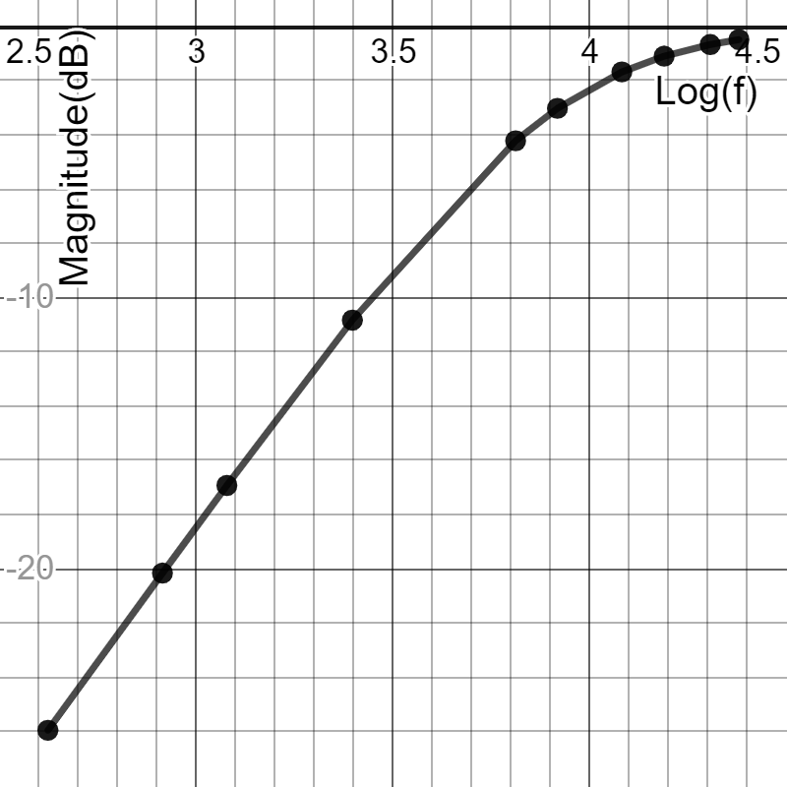

**Observation Tables and Plots**

**[5] Frequency Response of LR Low Pass Filter (Circuit Simulator)**

|  |  |  |  |  |  |
| --- | --- | --- | --- | --- | --- |
| **Serial No.** | **Frequency f (Hz)** | **Log(f)** | **Magnitude (dB)** | **Phase (theta)** | **Output Voltage (V)** |
| 1 | 615 | 2.788875 | -0.00647 | -2.21178 | 9.999 |
| 2 | 1000 | 3 | -0.01709 | -3.59346 | 9.993 |
| 3 | 2400 | 3.380211 | -0.09755 | -8.57111 | 9.923 |
| 4 | 4000 | 3.60206 | -0.26575 | -14.1009 | 9.751 |
| 5 | 8300 | 3.919078 | -1.04382 | -27.5303 | 8.955 |
| 6 | 12200 | 4.08636 | -2.00577 | -37.4579 | 8.006 |
| 7 | 16000 | 4.20412 | -3.03115 | -45.1372 | 7.069 |
| 8 | 17500 | 4.243038 | -3.4396 | -47.7004 | 6.737 |
| 9 | 20100 | 4.303196 | -4.13861 | -51.6131 | 6.173 |
| 10 | 24600 | 4.390935 | -5.29771 | -57.085 | 5.312 |

**[5] Frequency Response Plot of RL Low Pass Filter (Circuit Simulator)**

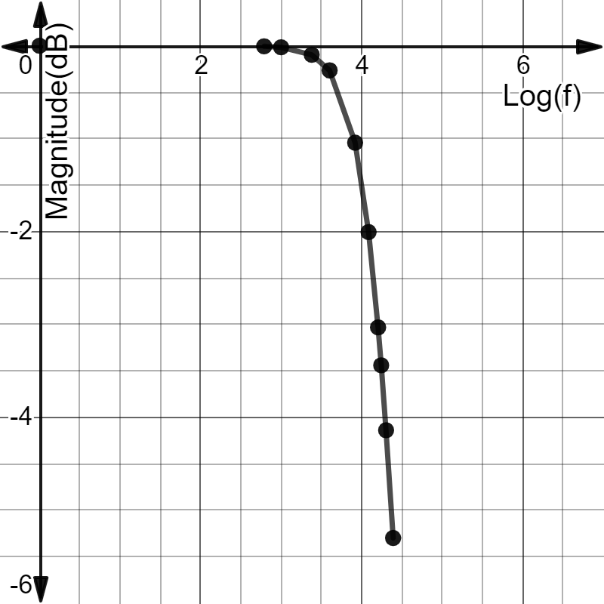

**Observation Tables and Plots**

**[6] Frequency Response of RL High Pass Filter (Circuit Simulator)**

|  |  |  |  |  |  |
| --- | --- | --- | --- | --- | --- |
| **Serial No.** | **Frequency f (Hz)** | **Log(f)** | **Magnitude (dB)** | **Phase (theta)** | **Output Voltage (V)** |
| 1 | 606 | 2.782473 | -28.3976 | 87.82056 | 0.374069 |
| 2 | 1100 | 3.041393 | -23.2336 | 86.04829 | 0.651175 |
| 3 | 2800 | 3.447158 | -15.2299 | 80.02706 | 1.712 |
| 4 | 5000 | 3.69897 | -10.4698 | 72.56771 | 3.006 |
| 5 | 9600 | 3.982271 | -5.74182 | 58.91507 | 5.174 |
| 6 | 12000 | 4.079181 | -4.4104 | 52.99832 | 6.066 |
| 7 | 15900 | 4.201397 | -3.01674 | 45.04243 | 7.133 |
| 8 | 18000 | 4.255273 | -2.51052 | 41.49734 | 7.573 |
| 9 | 22100 | 4.344392 | -1.81602 | 35.77363 | 8.219 |
| 10 | 24500 | 4.389166 | -1.53029 | 33.02151 | 8.51 |

**[6] Frequency Response Plot of RL High Pass Filter (Circuit Simulator)**

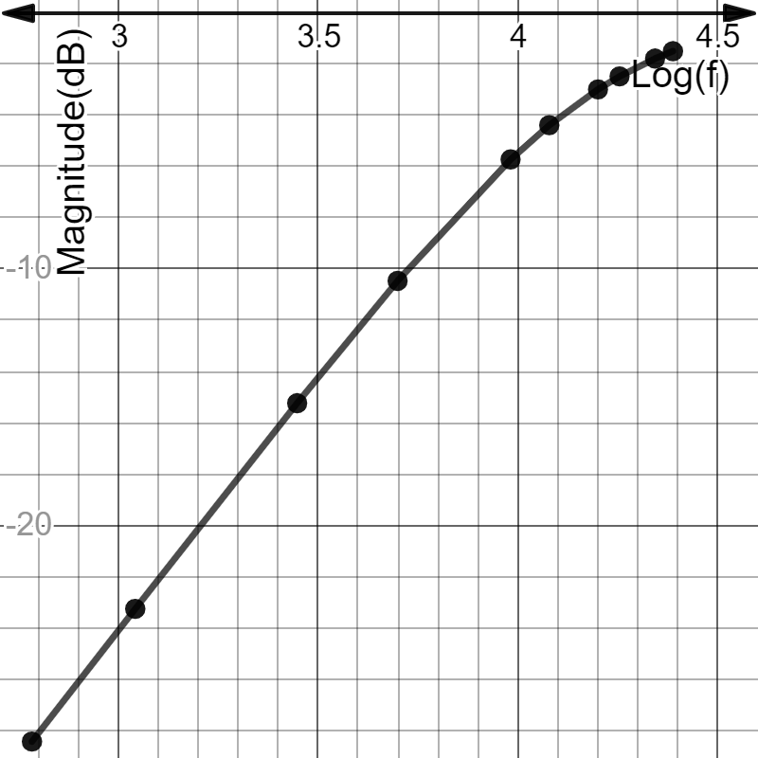

**Discussion**

* A filter is a circuit that allows to pass a specified range of frequency components, while blocking or “attenuating” the rest according to the frequency range of signals.
* The Low Pass Filter- Filter passes low frequencies and blocks high frequencies. It only allows low frequency signals from 0Hz to its cut-off frequency point to pass while blocking those any higher.
* The High Pass Filter-Filter passes high frequencies and blocks low frequencies. It only allows high frequency signals from its cut-off frequency point and higher to infinity to pass through while blocking those any lower.
* The Band Pass Filter- Filter passes only a relatively narrow range of frequencies. It allows signals falling within a certain frequency band, setup between two points to pass through while blocking both the lower and higher frequencies either side of this frequency band.
* Filters can also be classified according to the types of components that are used to implement the circuit. Passive filters are made up of passive components such as resistors, capacitors and inductors and have no amplifying elements (transistors, op-amps, etc.) so have no signal gain, therefore their output level is always less than the input.
* The cut-off frequency of a filter is the frequency at which the amplitude of the input signal is reduced by 3 dB (this value was chosen because a 3dB reduction in amplitude corresponds to a 50% reduction in power). Thus, the cut-off frequency is also called the –3dB frequency. The term bandwidth refers to the width of a filter’s pass band, and in the case of a low-pass filter, the bandwidth is equal to the –3 dB frequency.
* Low pass filters are used to filter noise from a circuit. 'Noise' is a high frequency signal. When passed through a low pass filter most of the noise is removed and a clear sound is produced. Applications of Active Low Pass Filters are in audio amplifiers, equalizers or speaker systems to direct the lower frequency bass signals to the larger bass speakers or to reduce any high frequency noise or “hiss” type distortion.
* A very common application of passive high pass filter, is in audio amplifiers as a coupling capacitor between two audio amplifier stages and in speaker systems to direct the higher frequency signals to the smaller “tweeter” type speakers while blocking the lower bass signals or are also used as filters to reduce any low frequency noise or “rumble” type distortion. When used like this in audio applications the high pass filter is sometimes called a “low-cut”, or “bass cut” filter.
* Band pass filters are widely used in wireless transmitters and receivers. The main function of such a filter in a transmitter is to limit the bandwidth of the output signal to the band allocated for the transmission. This prevents the transmitter from interfering with other stations.