Experiment No.:1
Familiarisation with Resistors, Capacitors and Inductors

Familiarisation with Resistors

Aim :

- To understand the functioning of a resistor
- To read the value of a resistor
- To read the tolerance of a resistor
- To look into various types of resistors

Circuit Diagram :

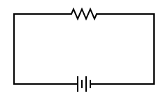
R

I
R –Resistor
I – Current
V – Voltage
V

Theory :

A resistor is a passive two-terminal electrical component that opposes the passage of an electric current.

The S.I. unit of Resistance is ohm(Ω).

In a circuit diagram, it is represented as shown above.

The relationship between current and voltage in the above circuit is given by Ohm’s law:

Ohm's law states that the current through a conductor between two points is directly proportional to the voltage across the two points.
I ∝ V
I=V/R
Here R is the constant of proportionality and is the total resistance of the conductor.

To read the value of a resistor :

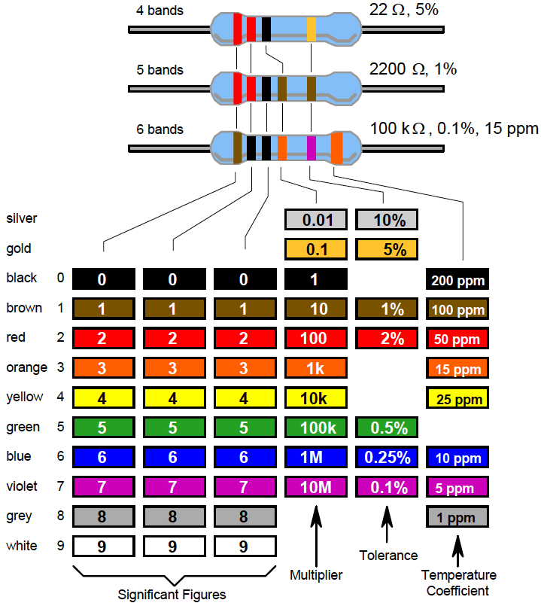
Resistors are color coded as they are too small for the value to be written on them.There are 4 or 5 bands of color . Value of a Resistor is decoded from these band of colors.
Reading Value:
- If your resistor has four color bands ,turn the resistor so that the gold or silver band is on right hand side or the end with more bands should point left.
- The first band is now on the left hand side. This represents the first digit .Based on the color make a note of the digit.In this case- 4 band its ‘2’ and for 5 band its ‘2’.
- The second band represents the second digit. The colors represent the same numbers as did the first digit .In this case -4 band its ’2’ and for 5 band its ’2’.
- The third band divulges how many zeros to add/divide to the first two numbers –for a 4 band Resistor . In this case – 4 band its no zeroes to be added . So value is 22Ω.
- The third band denotes the 3rd digit – for a 5 band Resistor. In this case -5 band its ‘0’ . So the value of the 5 band resistor is 2200Ω as its multipier digit is ‘1’.

Reading Tolerance:
- The last band denotes the tolerance . So the value of the 4 band resistor it is +/- 5% while for the 5 band resistor it is +/- 1%.
- Tolerance of a Resistor is also an important property to consider.
  - A 100 ohm resistor with a 10 % tolerance can mean its value can be any fixed value between 90 to 110 Ohms.
  - A 120 Ohm resistor with a 10 % tolerance can mean its value can be any fixed value between 108 and 132 Ohms.
  - So there is some overlap between 100 Ohm and 120 Ohm resistance in terms of its limits.

Reading Temperature co-efficient:
- Sometimes there are resistors which have 6 bands. In such resistors, the last band on the right end indicates the temperature co-efficient.
- The temperature co-efficient of a resistor is the calculation of a relative change of resistance per degree of temperature change. It is measured in ppm/°C. ( 1ppm= 0.0001%)
- It is defined as:
Temperature Coefficient of ResistanceTCR = (R2– R1)/ (R1*(T2– T1))
- This effect of temperature becomes prominent only at very high temperatures and thus the co-efficient can be neglected for moderate values of temperature depending on the material of the resistor.
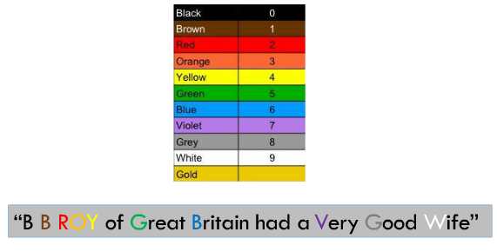
Mnemonic to Remember :

Various types of resistors :

1) Fixed Value Resistor
Value of resistor is specified and cannot be changed.
- Carbon film resistor
- Metal film resistor
- Wire wound resistor

2) Variable Value Resistor
Value of resistor can be changed by rotating the wiper.
- Potentiometer
- Rheostat

Carbon Film Resistors
- Most general purpose ,cheap resistor
- Tolerance of Resistance value is usually +/- 5%
- Power ratings of 1/8 W ,1/4 W and ½ W are usually used
- Con:Tend to be electrically noisy

Metal Film Resistor
- Used when higher tolerance is needed , ie more value.
- They have about +/- 0.05% tolerance

Wire Wound Resistors
- A wire wound resistor is made of metal resistance wire, and because of this they can be manufactured to precise values
- Also, high wattage resistors can be made by thick wire material
- Wire wound resistors in a ceramic case are called as ceramic resistors
- Wire wound resistors in a ceramic case are called as ceramic resistors

Familiarisation with Capacitors

Aim :

- Provide a definition of capacitor and name its units
- Explain how a capacitor can be constructed to give a particular value of capacitance
- Explain why a capacitor has maximum working voltage
- Determine experimentally the energy stored in a capacitor
- Identify the value and type of capacitor
- Identify the polarity of terminals

Circuit Diagram :
R2
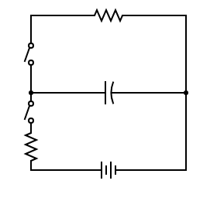

R1
C
S2
S1

C-Capacitor
R1,R2-Resistors
S1,S2-Switches
V-Voltage

V
Theory :

It is one of the passive electronic component with two terminals like resistor. Capacitor is also known as condenser. Capacitor is generally used to store the charge. The charge is stored in the form of “electrical field”. Capacitors play a major role in many electrical and electronic circuits.

The S.I. unit of capacitance is farad(F).

In the circuit diagram, it is represented as shown above.

Capacitance of a capacitor is defined as the amount of charge stored on a plate of the capacitor when one volt is applied across it.

C=Q/V

The above relation establishes the following:

I_{c}=C*(dV/dt)

It can be seen from the above equation that current-voltage relationship is non-linear.

Construction of a Capacitor :

The basic construction of all capacitors is of two parallel metal plates separated by an insulating material (the dielectric). An insulator is a material which is non-conducting i.e. it shows a high resistance to passage of electric current through it. The most common dielectric used is air, other types are oil or paper. Real capacitors are made by taking thin strips of metal foil and the appropriate dielectric material and sandwiching them together.

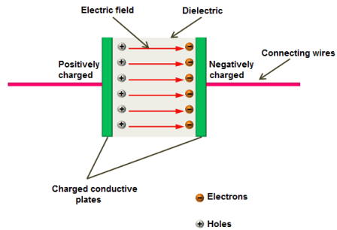
A capacitor is so called because it has the capacity to store charge- just like a beaker storing a liquid. Capacitors are marked with a value which indicates their capacitance – their ability to store charge . Capacitance can be thought of as the “electrical capacity” of that body.Capacitance of a capacitor is also given by:

C=εA/d
where ε is the absolute permittivitty of the dielectric material, A is the cross section areea of the plate and d is the distance between the two plates.

Capacitor can achieve large area (thus large capacitance) by doing something tricky, such as putting a dielectric between 2 layers of metal foil and rolling it up like in this figure.
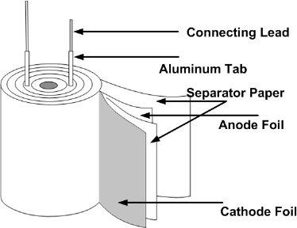

Maximum working voltage of Capacitor :

If the voltage across a capacitor is too high, the insulator between the plates fails to insulate and charge passes from one plate to the other implying that the dielectric breaks and thus is also known as dielectric breakdown. Capacitor are usually marked with the maximum working voltage to help the user avoid such situations.
A good rule of thumb is to never place a voltage across the capacitor which exceeds about two thirds of this value, especially for alternating current circuits.

Experimental determination of energy stored in a capacitor:

- In order to determine, energy stored in a capacitor after being charged, it will be enough if we can calculate the amount of energy that is dissipated through a resistor when the capacitor is discharging.
- For this, we will require a battery of known voltage V, two switches namely S₁ and S₂ , two resistors of known resistances R₁ and R₂ and a capacitor of known capacitance C.
- Connect the above elements as shown in the circuit diagram above.
- Additionally, in order to find the heat dissipated via R₂ in the discharging process, we can immerse the resistor in known volume of water (Immersion heaters used in the past works on this principle) and measuring its rise in temperature.
- Knowing the heat capacity of water, its volume and temperature change, one can easily calculated the heat dissipated by the resistor. This is nothing but the amount of energy stored in the capacitor.
Steps:
- Measure the initial temperature of water.
- Charge the capacitor by turning on switch S₁.
- After some time, open switch S₁ and turn on switch S₂.
- Note: The water must be preferably put in an insulated environment to prevent unnecessary heat loss to environment. Such an environment can be created by use of a calorimeter and then appropriate heat capacity must be taken into account.
- Measure the final temperature of water.
- Using the known values of heat capacity and temperature change, one can calculate the heat loss, thus determining the energy stored in the capacitor.

Classification of Capacitors and Identification of polarity of terminals:

UN-POLARIZED | POLARIZED
Ceramic | Electrolytic
Multilayer | Tantalum
Polystyrene Film | Super
Polyster Film | They have positive and negative electrode
Polypropylene
Mica
They don't have positive and negative electrode

Ceramic Capacitors:

Ceramic capacitors are the most used capacitors in the electronics industry. Ceramic capacitors are fixed capacitance type capacitors and they are usually very small (in terms of both physical dimensions and capacitance). The capacitance of ceramic capacitors is usually in the range of picofarads to few micro farads (less than 10µF). They are non-polarised type capacitors and hence can be used in both DC as well as AC circuits.

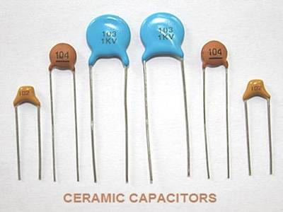

Electrolytic Capacitors:

Electrolytic capacitors are polarized and they must be connected the correct way round , atleast one of their leads will be marked + or – . It is very easy to find the values of electrolytic capacitors because they are clearly printed with their capacitance and voltage rating.

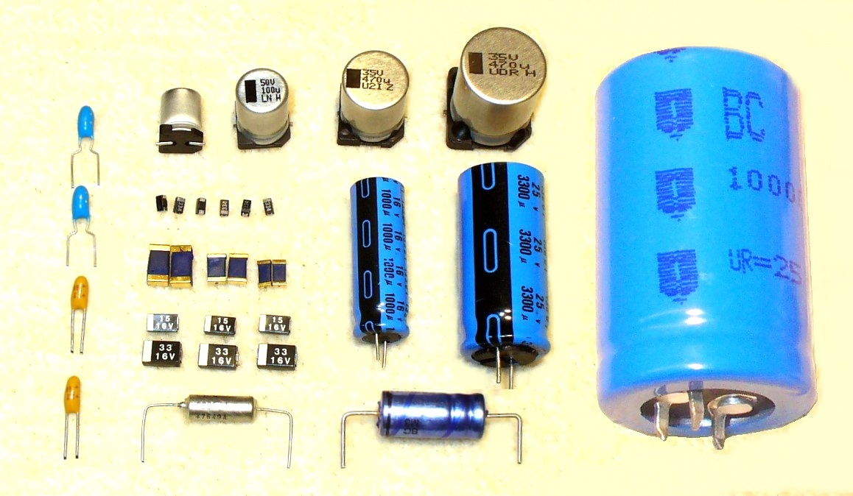
Electrolytic capacitors

Tantalum Capacitors:

Tantalum bead capacitors are polarized and have low voltage ratings like electrolytic capacitors . Usually , the “+” symbol is used to show the positive component lead . Modern tantalum bead capacitors are printed with their capacitance voltage and polarity in full. However older ones use a color – code systems which has two stripes (for the two digits ) and a spot of color for the number of zeros to give the value in uF.
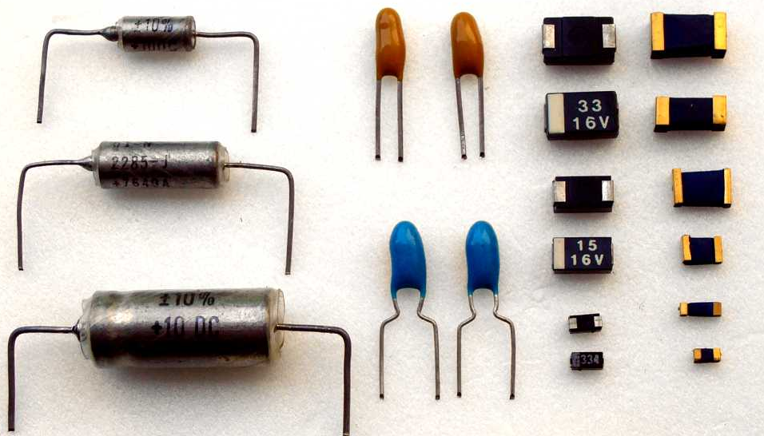

Tantalum capacitors

Unpolarized Capacitors(small values upto 1µF):

The value printed but without a multiplier, so you need to use experience to work out what the multiplier should be! For example 0.1 means 0.1 pF. Sometimes the multiplier is used in place of the decimal point: For example: 4n7 means 4.7nF.

Un-polarized Capacitors — Capacitor Number Code:

A number code is often used on small capacitors where printing is difficult: The 1st number is the 1st digit, the 2nd number is the 2nd digit, the 3rd number is the number of zeros to give the capacitance in pF. Ignore any letters - they just indicate tolerance and voltage rating. For example: 102 means 1000pF (not 102pF!) For example: 472J means 4700pF (J means 5% tolerance).

Un-polarized Capacitors — Capacitor Color Code:

A color code was used on polyester capacitors for many years. It is now obsolete, but of course there are many still around. The colors should be read like the resistor code, the top three color bands giving the value in pF. Ignore the 4th band (tolerance) and 5th band (voltage rating). .For example: brown, black, orange means 10000pF. Note that there are no gaps between the color bands, so 2 identical bands actually appear as a wide band. For example: wide red, yellow means 220nF.
Familiarisation with Inductors

Aim :

- To understand the functioning of a inductor
- Explain the factors influencing inductance

Circuit Diagram :

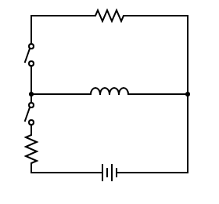
R2
S2
L-Inductor
S1,S2-Switch
R1,R2-Resistor
V-Voltage
L

S1
R1
V

Theory :

An inductor, also called a coil, choke, or reactor, is a passive two-terminal electrical component that stores energy in a magnetic field when electric current flows through it. An inductor typically consists of an insulated wire wound into a coil around a core.

The S.I. unit of inductance is henry(H).

In the circuit diagram, it is represented as shown above.

Inductance of a inductor is defined as the property of an electric conductor or circuit that causes an electromotive force to be generated by a change in the current flowing.

V=-L*(dI_{L}/dt)

It can be seen from the above equation that current-voltage relationship is non-linear.

Factors affecting Inductance:

- Before jumping into the factors influencing the inductance of an inductor, let us briefly discuss the construction of an inductor.
  - It consists of a wire wound as a coil around a core. The core may consist of a air filled hollow tube or solid material.
  - Some common types of core are:
    - Air core
    - Steel core inductor
    - Solid ferrite cores
  - Inductors also come in various shapes and sizes.
- There are four factors influencing Inductance:
  - Number of turns of wire wound around the core
  - Cross sectional area of coil
  - Material of the core
  - Distance between turns of the coil
Number of turns of wire wound around the core:
All other factors remaining constant, as the number of turns increases the inductance of the coil increases. This is opposition to change of current increases because the e.m.f generated is now stronger due to contribution from more turns.
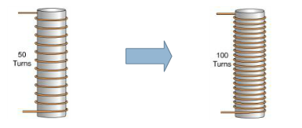

Distance between turns of the coil:
All other factors remaining constant, the inductance of the coil decreases with increase in distance between turns of the coil. This is because the coil is an energy accumulator – it turns the electrical energy into magnetic field and vice versa. If the gap between adjacent turns is small, the magnetic bounding between turns is stronger and the inductance increase.
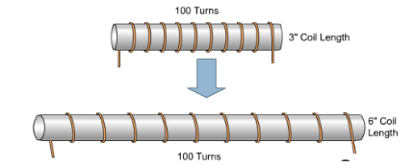

Cross sectional area of the coil:
All other factors remaining constant, the inductance of an inductor increases with increase in area of cross section of the coil. This is because greater coil area presents less opposition to the formation of magnetic field flux, for a given amount of field force (amp-turns).

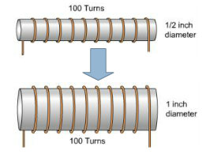

Discussion:

- This experiment’s goal was to make us familiar with resistors, capacitors and inductors as these are the most primary elements of a circuit which are used everywhere, therefore making this experiment, one of very high importance.
- As we grow more advanced, machines keep growing smaller and so does it’s components. I came to know that on such small components it is almost impossible to print something legible and therefore the colour coding system was introduced and is now widely accepted.
- We have also seen how capacitor and inductors are similar in their non-linear current-voltage relationship, a property different from that of resistors. They have one more aspect of similarity, that is they both store energy, capacitor in the form of electric field and inductor in the form of magnetic field unlike a resistor which dissipates energy in the form of heat.
- Capacitors and Inductors differ in the form of energy they store and when they can store energy.
      - Capacitors store energy in the form of electric field formed due to development of opposite charges on their plates and that is why even after removal of voltage source from across it, it continues to store that energy.
      - On the other hand, the inductor stores energy in the form of magnetic field produced due to a continuous change of current through it and can store it only uptil the time current is flowing through it because we know a current carrying wire produces a magnetic field. The moment current is cut off from the inductor, there is an infinite rate of change of current due to jump of value from finite to zero in an inifinitesimal amount of time, therefore causing a huge voltage to develop across it. If there is no discharging circuit available then it will cause a spark through air.( This property of causing sparks is sometimes used in ignition and is called inductance kick. ) This also implies that inductors do not store energy when there is no current through it.
- We have also learnt about the various types of resistors, capacitors and inductors.
- Last but not the least, some precautions to take:
  - Resistors should be operated below their rated wattage in order to avoid melting of the material.
  - Capacitors should be operated atleast below 2/3rd of it’s rated voltage especially when the supply voltage is alternating in order to prevent a dielectric breakdown.
  - Inductors should have an discharge outlet in case of unexpected and sudden current cut off in order to prevent infinite voltage development which causes heavy damage to devices. In some cases though the property of Inductive Kick is used to ignite fuels or ionise the material through which the sparks travel.

