**Experiment-5**

**Studies Of Analog Circuits Using OP-AMP**

**Aim**

The aim of the experiment is to study the basic properties and explain the working of **Inverting Operational Amplifier** and **Non-Inverting Operational Amplifier** and to explain the working of **Differentiator and Integrator using Operational Amplifiers.**

**Circuit Diagram**

**[1]Inverting Operational Amplifier**

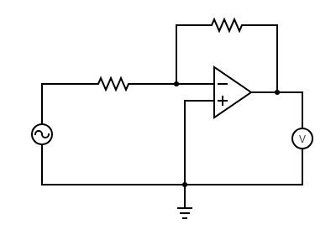

**RF**

**IF**

**Iin**

**Rin**

**Iout**

**Vin**

**Vout**

**[2]Non Inverting Operational Amplifier**

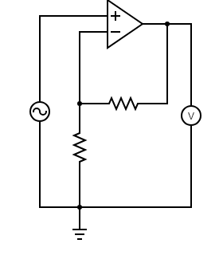

**Iin**

**Iout**

**RF**

**Vout**

**Vin**

**IF**

**R2**

**[3]Integrator**

**+ Vc -**

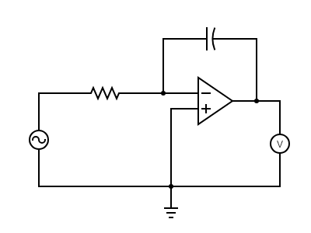

**Ic**

**Iin**

**Rin**

**Vout**

**Vin**

**[4]Differentiator**

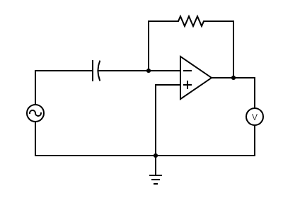

**If**

**Rf**

**+ Vc -**

**Iin**

**Vout**

**Vin**

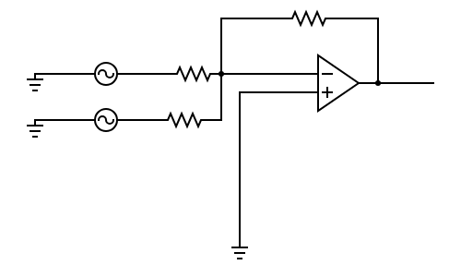**[5]Summing Operational Amplifier**

**Vout**

**Vin2**

**Vin1**

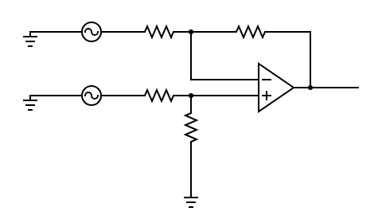**[6]Differential Operational Amplifier**

**Vout**

**Vin2**

**Vin1**

**Procedure:**

**[1]Inverting Operational Amplifier (in Virtual Labs)**

1. Connect the components as mentioned below:   
   L1-L3, L4-L7, L4-L5, L6-L9, and L8-L12. (For e.g. click on 1 and then drag to 3 and so on.)
2. Click on 'Check Connection' button to check the connections.
3. If connected wrong click on 'Delete all connection' button to erase all the connections.
4. Set the Resistance (R1) Value (1k Ω - 50k Ω).
5. Set the Feedback Resistance (Rf) Value (2k Ω – 100k Ω).
6. Set input voltage (Vin) (-15 to 15 V).
7. Now note the output voltage and click on 'Add to table' button.
8. Increase the input voltage by a factor of 2.
9. Click on 'Plot' button to plot the output voltage versus input voltage.
10. Repeat the experiment for another set of resistance value.

**[2]Non Inverting Operational Amplifier (in Virtual Labs)**

1. Connect the components as mentioned below:   
   L1-L8, L4-L7, L4-L5, L6-L9, and L3-L12. (For e.g. click on 1 and then drag to 3 and so on.)
2. Click on 'Check Connection' button to check the connections.
3. If connected wrong click on 'Delete all connection' button to erase all the connections.
4. Set the Resistance (R1) Value (1k Ω - 50k Ω).
5. Set the Feedback Resistance (Rf) Value (2k Ω – 100k Ω).
6. Set input voltage (Vin) (-15 to 15 V).
7. Now note the output voltage and click on 'Add to table' button.
8. Increase the input voltage by a factor of 2.
9. Click on 'Plot' button to plot the output voltage versus input voltage.
10. Repeat the experiment for another set of resistance value.

**[3]Integrator (in Virtual Labs)**

1. Connect the components as mentioned below:   
   L1-L7 or L1-L3, L3-L7, L4-L5, L11-L8, L12-L6, L8-L9, L4-L10. (For e.g. click on 1 and then drag to 3 and so on.)
2. Click on 'Check Connection' button to check the connections.
3. If connected wrong click on 'Delete all connection' button to erase all the connections.
4. Set the resistance(R) and the capacitance (C) (Initially set R=10 kΩ and C=0.1 µF).
5. Click on 'ON' button to start the experiment.
6. Click on 'Square Wave' button to generate input waveform.
7. Click on 'Oscilloscope' button to get the output waveform.
8. Vary the Amplitude, Frequency, volt/div using the controllers.
9. Click on "Dual" button to observe both the waveform.
10. Channel 1 shows the input square waveform, Channel 2 shows the output waveform.
11. Repeat the experiment by applying 'Sine wave' as input.
12. Click on 'Sine Wave' button to generate input waveform.
13. Click on 'Oscilloscope' button to get the output waveform.
14. Vary the Amplitude, Frequency, volt/div using the controllers.
15. Click on "Dual" button to observe both the waveform.
16. Channel 1 shows the input sine waveform, Channel 2 shows the output waveform.
17. Note: Sometimes due to page load or cache, the graph may not come exact at one click. So it is better to double click on the channel-1 function/ channel-2 function/ dual function/ ground function to get the respective signals.

**[4]Differentiator (in Virtual Labs)**

1. Connect the components as mentioned below:   
   L1-L7 or L1-L3, L3-L7, L4-L5, L11-L8, L12-L6, L8-L9, L4-L10. (For e.g. click on 1 and then drag to 3 and so on.)
2. Click on 'Check Connection' button to check the connections.
3. If connected wrong click on 'Delete all connection' button to erase all the connections.
4. Set the resistance(R) and the capacitance (C) (Initially set R=1 kΩ and C=0.1 µF).
5. Click on 'ON' button to start the experiment.
6. Click on 'Square Wave' button to generate input waveform.
7. Click on 'Oscilloscope' button to get the output waveform.
8. Vary the Amplitude, Frequency, volt/div using the controllers.
9. Click on "Dual" button to observe both the waveform.
10. Channel 1 shows the input square waveform, Channel 2 shows the output waveform.
11. Repeat the experiment by applying 'Sine wave' as input.
12. Click on 'Sine Wave' button to generate input waveform.
13. Click on 'Oscilloscope' button to get the output waveform.
14. Vary the Amplitude, Frequency, volt/div using the controllers.
15. Click on "Dual" button to observe both the waveform.
16. Channel 1 shows the input sine waveform, Channel 2 shows the output waveform.
17. Note: Sometimes due to page load or cache, the graph may not come exact at one click. So it is better to double click on the channel-1 function/ channel-2 function/ dual function/ ground function to get the respective signals.

**Procedure:**

**[1]Inverting Operational Amplifier (in Falstad Circuit Simulator)**

1. Set the Resistance (R1) Value = 1k Ω
2. Set the Feedback Resistance (Rf) Value = 2k Ω.
3. Set input voltage (Vin) -15V and Frequency 40 Hz..
4. Now note the output voltage.
5. Increase the input voltage by a factor of 2.
6. Plot the output voltage versus input voltage on a graph.

**[2]Non Inverting Operational Amplifier (in Falstad Circuit Simulator)**

1. Set the Resistance (R1) Value = 1k Ω.
2. Set the Feedback Resistance (Rf) Value = 2k Ω.
3. Set input voltage (Vin) (-15 to 15 V).
4. Now note the output voltage.
5. Increase the input voltage by a factor of 2.
6. Plot the output voltage versus input voltage on a graph.

**[3]Integrator (in Falstad Circuit Simulator)**

1. Set the resistance(R) and the capacitance (C) (Initially set R=10 kΩ and C=0.1 µF).
2. Generate Square Wave input waveform.
3. Vary the Amplitude and Frequency of the input wave.
4. Channel 1 shows the input square waveform, Channel 2 shows the output waveform.
5. Repeat the experiment by applying 'Sine wave' as input.
6. Generate Sine Wave input waveform.
7. Vary the Amplitude and Frequency of the input wave.
8. Channel 1 shows the input square waveform, Channel 2 shows the output waveform.

**[4]Differentiator (in Falstad Circuit Simulator)**

1. Set the resistance(R) and the capacitance (C) (Initially set R=1 kΩ and C=0.1 µF).
2. Generate Square Wave input waveform.
3. Vary the Amplitude and Frequency of the input wave.
4. Channel 1 shows the input square waveform, Channel 2 shows the output waveform.
5. Repeat the experiment by applying 'Sine wave' as input.
6. Generate Sine Wave input waveform.
7. Vary the Amplitude and Frequency of the input wave.
8. Channel 1 shows the input square waveform, Channel 2 shows the output waveform.

**[5]Summing Amplifier (in Falstad Circuit Simulator)**

1. Set the all resistances to 1k Ω.
2. Set both the input waveforms to be sine wave of amplitude 5V and frequency 60Hz.
3. Channel 1 shows the first input square waveform, Channel 2 shows the second input waveform and Channel 3 shows the output waveform.
4. Repeat the experiment with different input waveforms.

**[6]Differential Amplifier (in Falstad Circuit Simulator)**

1. Set the all resistances to 1k Ω.
2. Set both the input waveforms to be sine wave of amplitude 5V and frequency 60Hz.
3. Channel 1 shows the first input square waveform, Channel 2 shows the second input waveform and Channel 3 shows the output waveform.
4. Repeat the experiment with different input waveforms.

**Observation Table**

**[1]Inverting Operational Amplifier (in Virtual Labs)**

**(a) R1 =1k Ω and Rf =2k Ω**

|  |  |  |  |
| --- | --- | --- | --- |
| **Serial Number** | **Input Voltage(V)** | **Output Voltage(V)** | **Current**  **(mA)** |
| **1** | **-15** | **30.0** | **-3.75** |
| **2** | **-13** | **26.0** | **-3.25** |
| **3** | **-11** | **22.0** | **-2.75** |
| **4** | **-9** | **18.0** | **-2.25** |
| **5** | **-7** | **14.0** | **-1.75** |
| **6** | **-5** | **10.0** | **-1.25** |
| **7** | **-3** | **6.00** | **-0.750** |
| **8** | **-1** | **2.00** | **-0.250** |
| **9** | **1** | **-2.00** | **0.250** |
| **10** | **3** | **-6.00** | **0.750** |
| **11** | **5** | **-10.0** | **1.25** |
| **12** | **7** | **-14.0** | **1.75** |
| **13** | **9** | **-18.0** | **2.25** |
| **14** | **11** | **-22.0** | **2.75** |
| **15** | **13** | **-26.0** | **3.25** |

**PLOT OF OUTPUT VOLTAGE v/s INPUT VOLTAGE FOR INVERTING AMPLIFIER**

**(a) R1 =1k Ω and Rf =2k Ω**

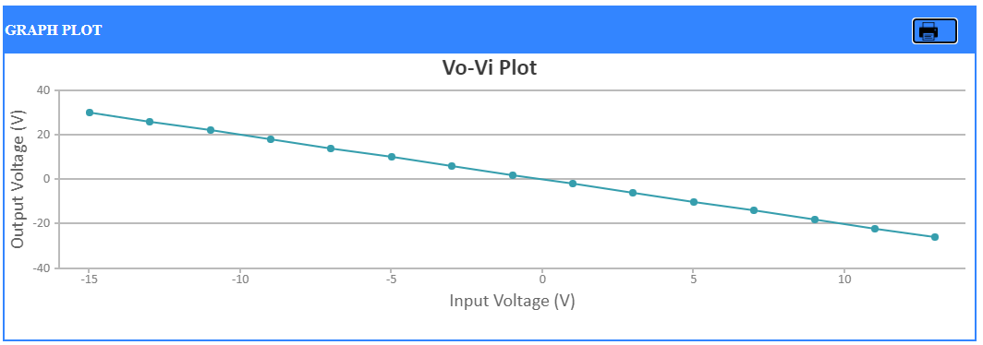

**Observation Table**

**[1]Inverting Operational Amplifier (in Virtual Labs)**

**(b) R1 =10k Ω and Rf =30k Ω**

|  |  |  |  |
| --- | --- | --- | --- |
| **Serial Number** | **Input Voltage(V)** | **Output Voltage(V)** | **Current**  **(mA)** |
| **1** | **-15** | **45.0** | **-0.0583** |
| **2** | **-13** | **39.0** | **-0.0505** |
| **3** | **-11** | **33.0** | **-0.0427** |
| **4** | **-9** | **27.0** | **-0.0350** |
| **5** | **-7** | **21.0** | **-0.0272** |
| **6** | **-5** | **15.0** | **-0.0194** |
| **7** | **-3** | **9.00** | **-0.0117** |
| **8** | **-1** | **3.00** | **-0.00388** |
| **9** | **1** | **-3.00** | **0.00388** |
| **10** | **3** | **-9.00** | **0.0117** |
| **11** | **5** | **-15.0** | **0.0194** |
| **12** | **7** | **-21.0** | **0.0272** |
| **13** | **9** | **-27.0** | **0.0350** |
| **14** | **11** | **-33.0** | **0.0427** |
| **15** | **13** | **-39.0** | **0.0505** |

**PLOT OF OUTPUT VOLTAGE v/s INPUT VOLTAGE FOR INVERTING AMPLIFIER**

**(b) R1 =10k Ω and Rf =30k Ω**

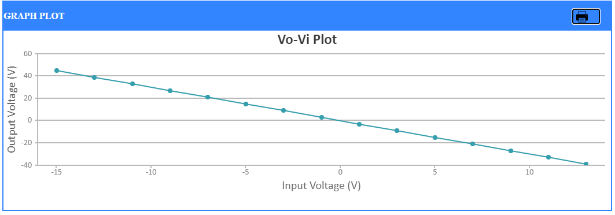

**Observation Table**

**[2] Non Inverting Operational Amplifier (in Virtual Labs)**

**(a) R1 =1k Ω and Rf =2k Ω**

|  |  |  |  |
| --- | --- | --- | --- |
| **Serial Number** | **Input Voltage(V)** | **Output Voltage(V)** | **Current**  **(mA)** |
| **1** | **-15** | **-45.0** | **-5.00** |
| **2** | **-13** | **-39.0** | **-4.33** |
| **3** | **-11** | **-33.0** | **-3.67** |
| **4** | **-9** | **-27.0** | **-3.00** |
| **5** | **-7** | **-21.0** | **-2.33** |
| **6** | **-5** | **-15.0** | **-1.67** |
| **7** | **-3** | **-9.00** | **-1.00** |
| **8** | **-1** | **-3.00** | **-0.333** |
| **9** | **1** | **3.00** | **0.333** |
| **10** | **3** | **9.00** | **1.00** |
| **11** | **5** | **15.0** | **1.67** |
| **12** | **7** | **21.0** | **2.33** |
| **13** | **9** | **27.0** | **3.00** |
| **14** | **11** | **33.0** | **3.67** |
| **15** | **13** | **39.0** | **4.33** |

**PLOT OF OUTPUT VOLTAGE v/s INPUT VOLTAGE FOR NON INVERTING AMPLIFIER**

**(a) R1 =1k Ω and Rf =2k Ω**

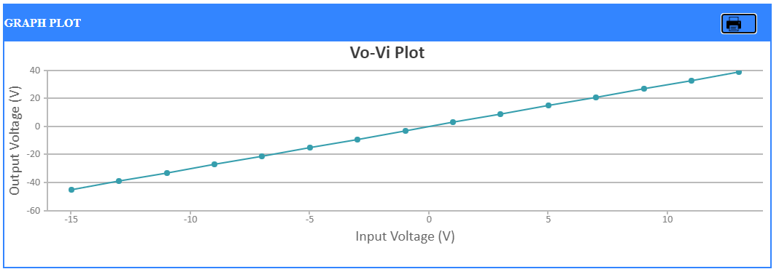

**Observation Table**

**[2] Non Inverting Operational Amplifier (in Virtual Labs)**

**(b) R1 =15k Ω and Rf =60k Ω**

|  |  |  |  |
| --- | --- | --- | --- |
| **Serial Number** | **Input Voltage(V)** | **Output Voltage(V)** | **Current**  **(mA)** |
| **1** | **-15** | **-75.0** | **-0.0577** |
| **2** | **-13** | **-65.0** | **-0.0500** |
| **3** | **-11** | **-55.0** | **-0.0423** |
| **4** | **-9** | **-45.0** | **-0.0346** |
| **5** | **-7** | **-35.0** | **-0.0269** |
| **6** | **-5** | **-25.0** | **-0.0192** |
| **7** | **-3** | **-15.0** | **-0.0115** |
| **8** | **-1** | **-5.00** | **-0.00385** |
| **9** | **1** | **5.00** | **0.00385** |
| **10** | **3** | **15.0** | **0.0115** |
| **11** | **5** | **25.0** | **0.0192** |
| **12** | **7** | **35.0** | **0.0269** |
| **13** | **9** | **45.0** | **0.0346** |
| **14** | **11** | **55.0** | **0.0423** |
| **15** | **13** | **65.0** | **0.0500** |

**PLOT OF OUTPUT VOLTAGE v/s INPUT VOLTAGE FOR NON INVERTING AMPLIFIER**

**(b) R1 =15k Ω and Rf =60k Ω**

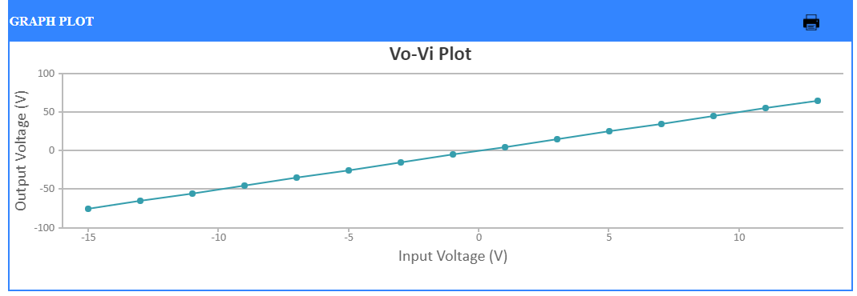

**[3]Integrator (in Virtual Labs)**

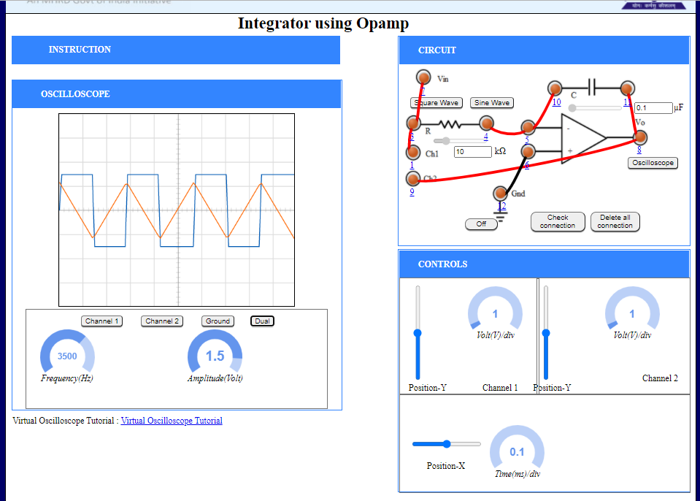

**Plot**

**(a)Input Waveform: Square Wave Amplitude =1.5 V and Frequency =3500Hz (with R=10k Ω and C=0.1µF)**

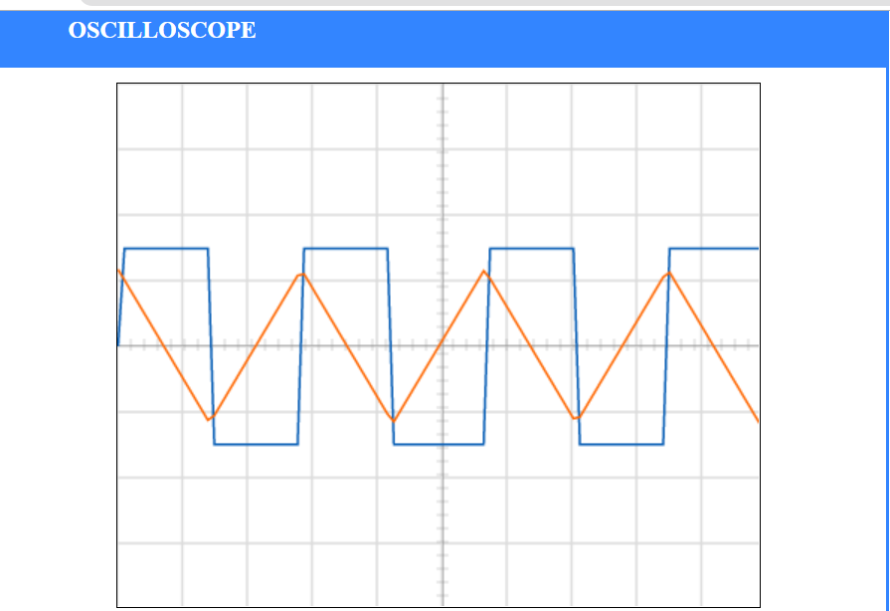

**Plot**

**(b)Input Waveform: Square Wave Amplitude =2 V and Frequency =5000Hz (with R=10k Ω and C=0.1µF)**

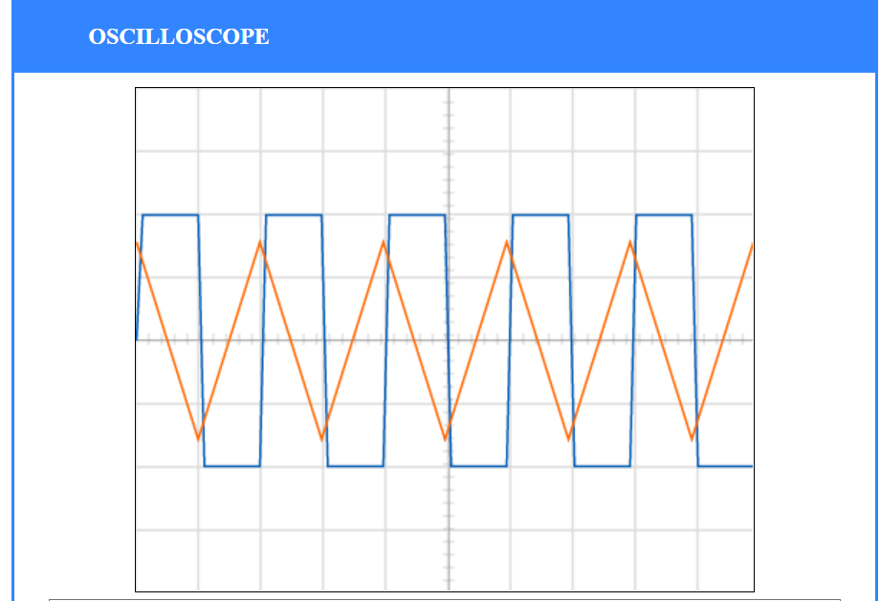

**Plot**

**(c)Input Waveform: Sine Wave Amplitude =2 V and Frequency =4000Hz (with R=2k Ω and C=0.2µF)**

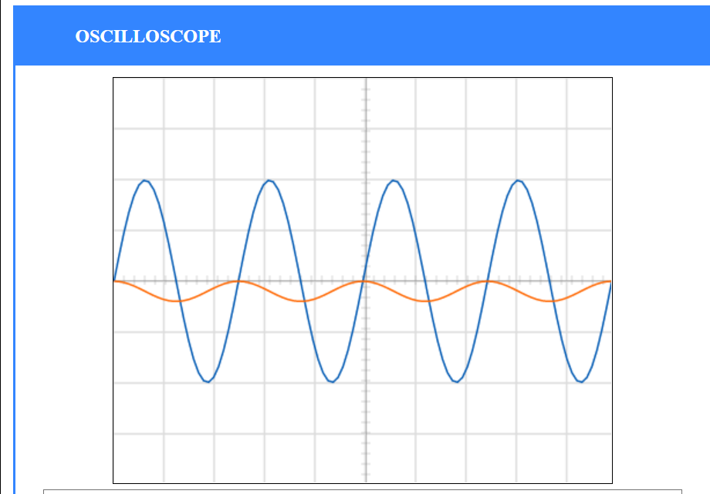

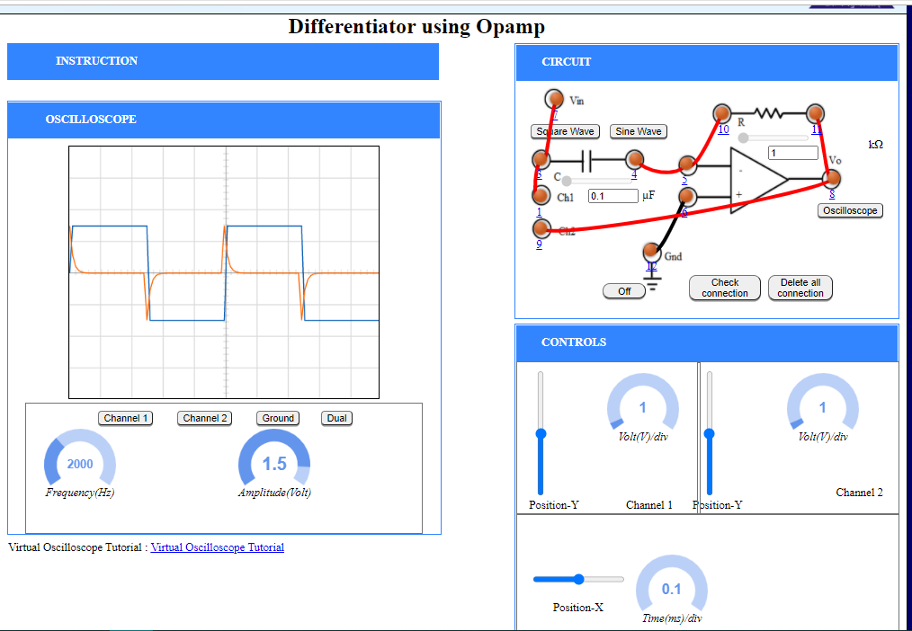**[4]Differentiator (in Virtual Labs)**

**Plot**

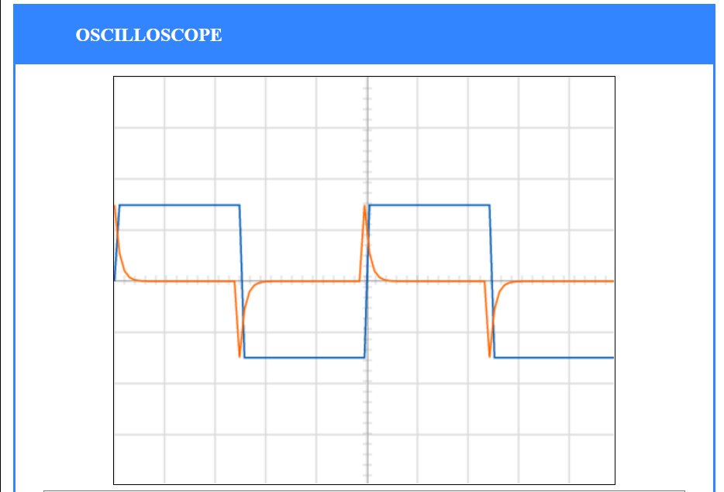**(a)Input Waveform: Square Wave Amplitude =1.5 V and Frequency =2000Hz (with R=1k Ω and C=0.1µF)**

**Plot**

**(b)Input Waveform: Sine Wave Amplitude =1.5 V and Frequency =4000Hz (with R=1k Ω and C=0.1µF)**

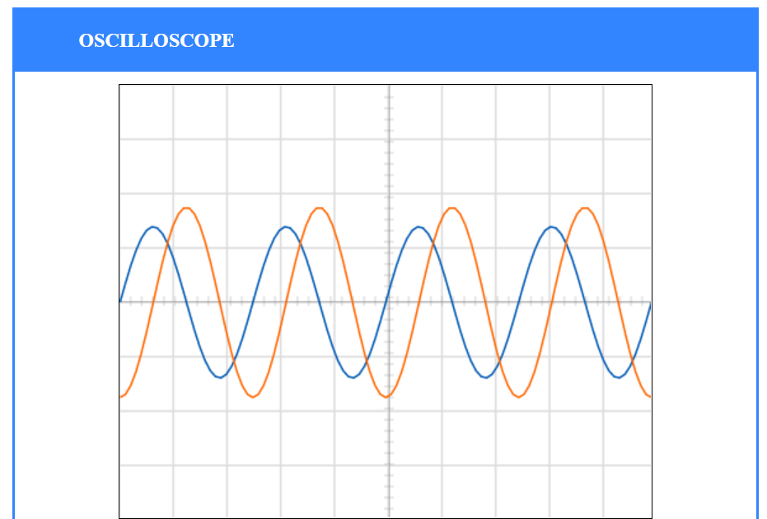

**Plot**

**(c)Input Waveform: Sine Wave Amplitude =1 V and Frequency =2500Hz (with R=3k Ω and C=0.2µF)**

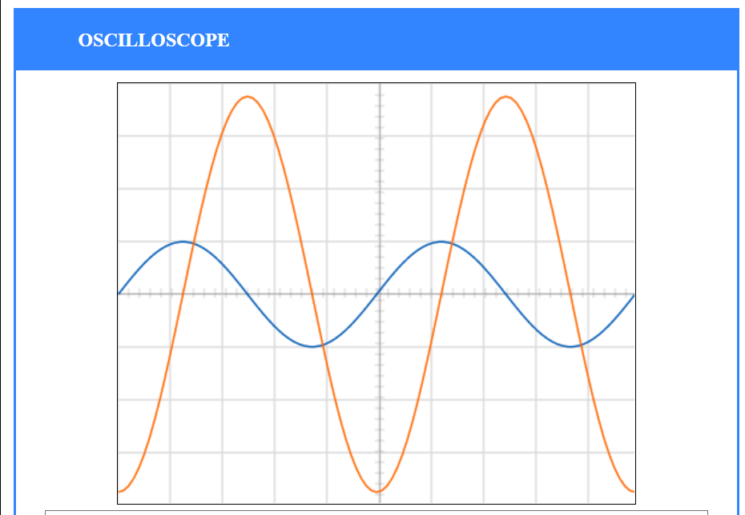

**[1]Inverting Operational Amplifier (in Falstad Circuit Simulator)**

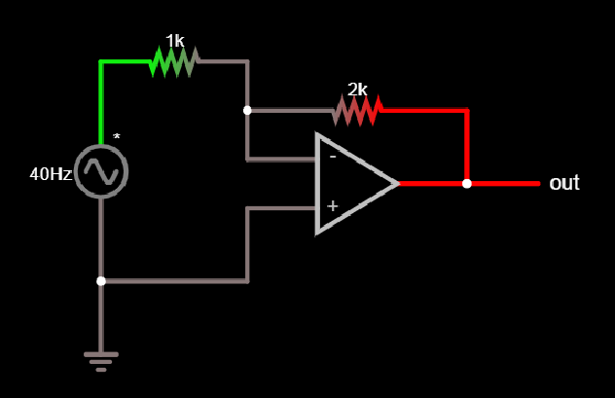

**Observation Table:**

**R1 =1k Ω and Rf =2k Ω**

|  |  |  |  |
| --- | --- | --- | --- |
| **Serial Number** | **Input Voltage(V)** | **Output Voltage(V)** | **Current**  **(mA)** |
| **1** | **-15** | **29.999** | **15** |
| **2** | **-13** | **25.999** | **13** |
| **3** | **-11** | **21.999** | **11** |
| **4** | **-9** | **17.999** | **9** |
| **5** | **-7** | **14** | **7** |
| **6** | **-5** | **10** | **5** |
| **7** | **-3** | **6** | **3** |
| **8** | **-1** | **2** | **0.99998** |
| **9** | **2** | **-4** | **2** |
| **10** | **4** | **-8** | **4** |
| **11** | **6** | **-12** | **6** |
| **12** | **8** | **-16** | **8** |
| **13** | **10** | **-19.999** | **10** |
| **14** | **12** | **-23.999** | **12** |
| **15** | **14** | **-27.999** | **14** |
| **16** | **16** | **-31.999** | **16** |

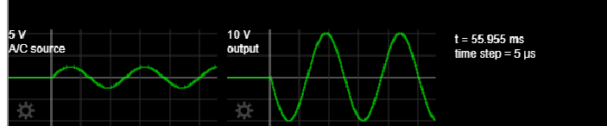

**PLOT OF OUTPUT VOLTAGE v/s INPUT VOLTAGE FOR INVERTING AMPLIFIER**

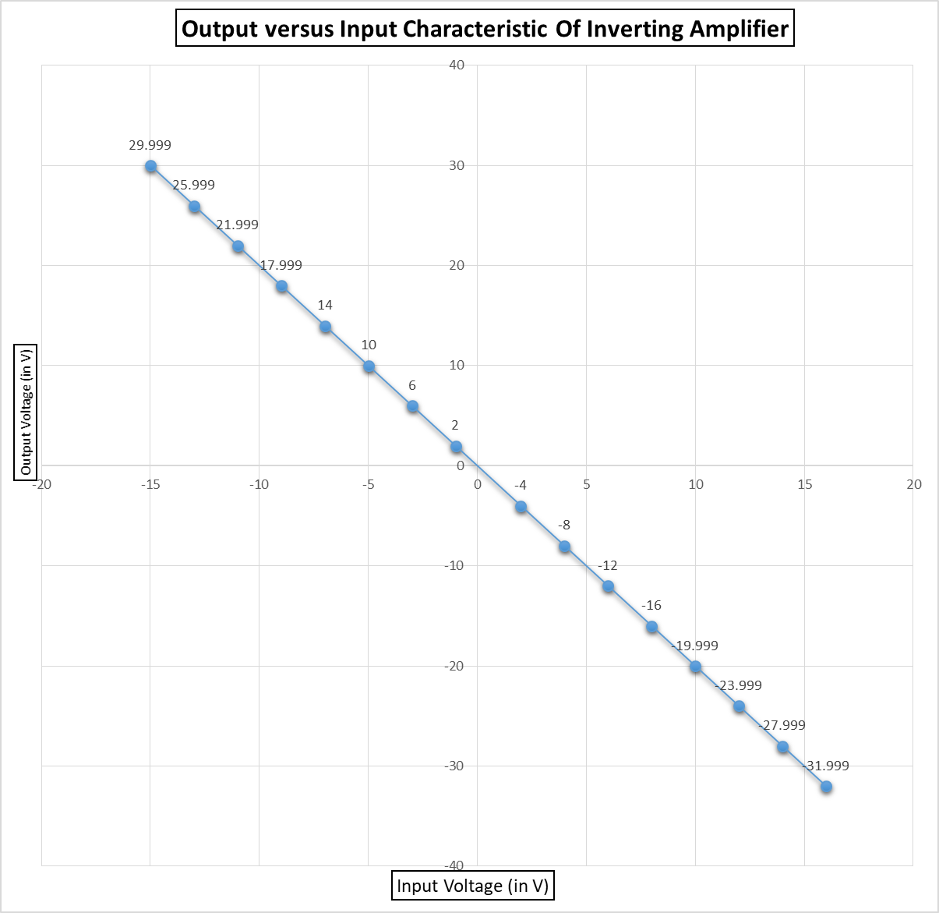**R1 =1k Ω and Rf =2k Ω**

**[2]Non Inverting Operational Amplifier (in Falstad Circuit Simulator)**

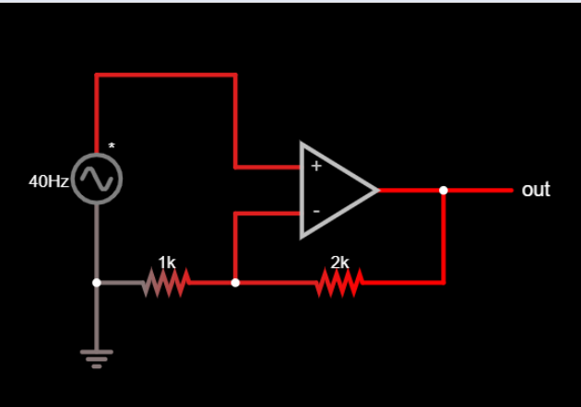

**Observation Table:**

**R1 =1k Ω and Rf =2k Ω**

|  |  |  |  |
| --- | --- | --- | --- |
| **Serial Number** | **Input Voltage(V)** | **Output Voltage(V)** | **Current**  **(mA)** |
| **1** | **-15** | **29.999** | **15** |
| **2** | **-13** | **25.999** | **13** |
| **3** | **-11** | **21.999** | **11** |
| **4** | **-9** | **17.999** | **9** |
| **5** | **-7** | **14** | **7** |
| **6** | **-5** | **10** | **5** |
| **7** | **-3** | **6** | **3** |
| **8** | **-1** | **2** | **0.99998** |
| **9** | **2** | **-4** | **2** |
| **10** | **4** | **-8** | **4** |
| **11** | **6** | **-12** | **6** |
| **12** | **8** | **-16** | **8** |
| **13** | **10** | **-19.999** | **10** |
| **14** | **12** | **-23.999** | **12** |
| **15** | **14** | **-27.999** | **14** |
| **16** | **16** | **-31.999** | **16** |

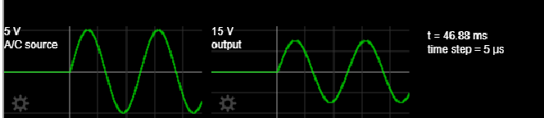

**PLOT OF OUTPUT VOLTAGE v/s INPUT VOLTAGE FOR NON INVERTING AMPLIFIER**

**R1 =1k Ω and Rf =2k Ω**

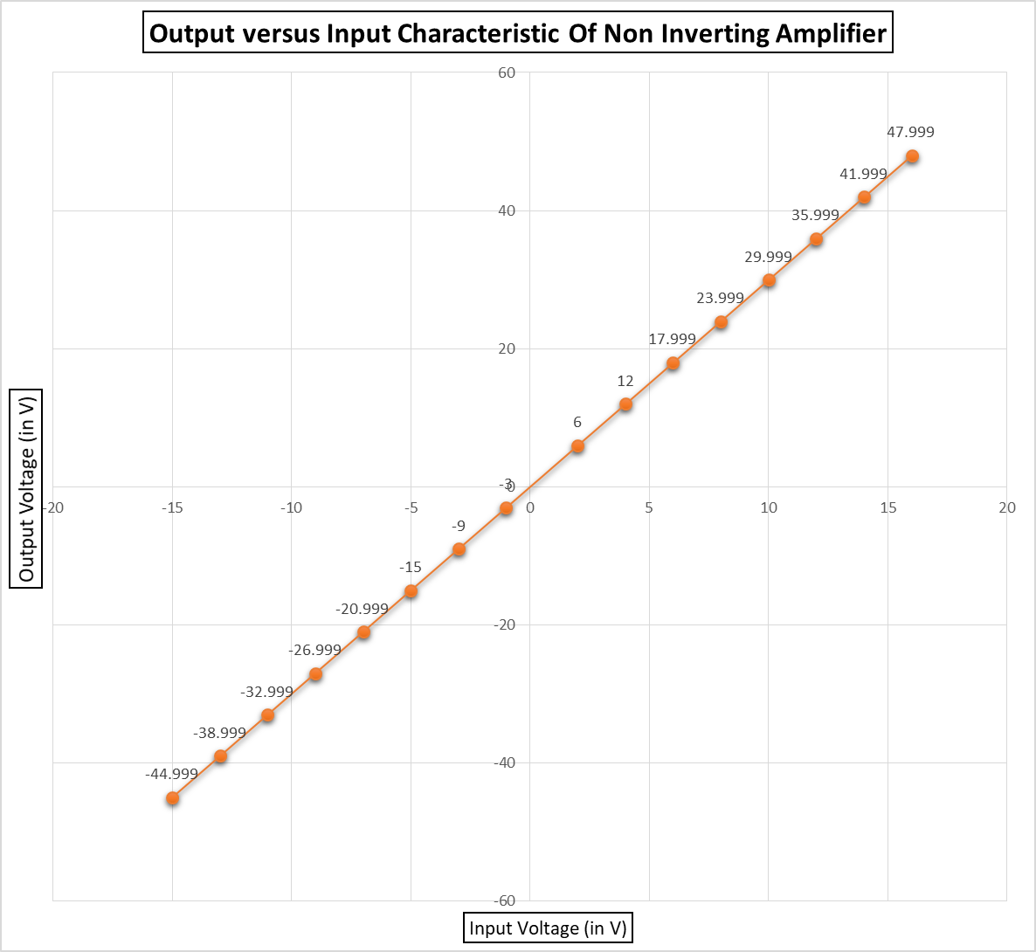

**[3]Integrator (in Falstad Circuit Simulator)**

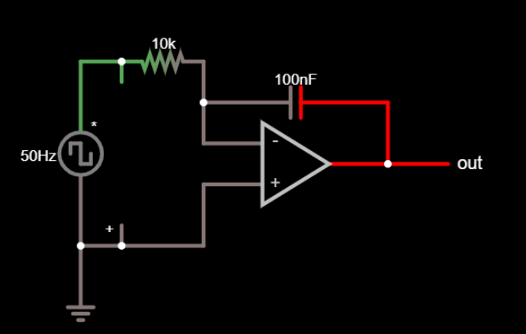

**Plot**

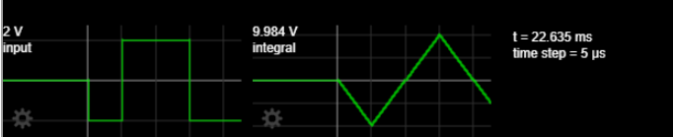**(a)Input Waveform: Square Wave Amplitude =2 V and Frequency =50Hz (with R=10k Ω and C=0.1µF)**

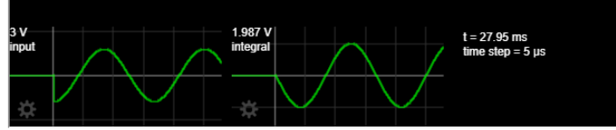**(b)Input Waveform: Sine Wave Amplitude =3 V and Frequency =60Hz (with R=20k Ω and C=0.2µF)**

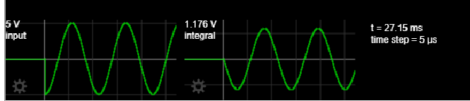**(c)Input Waveform: Sine Wave Amplitude =5 V and Frequency =90Hz (with R=15k Ω and C=0.5µF)**

**[4]Differentiator (in Falstad Circuit Simulator)**

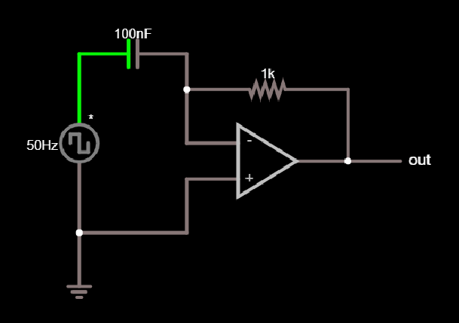

**Plot**

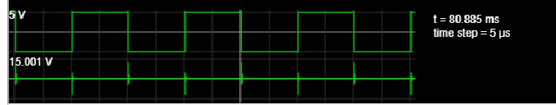**(a)Input Waveform: Square Wave Amplitude =5 V and Frequency =50Hz (with R=1k Ω and C=0.1µF)**

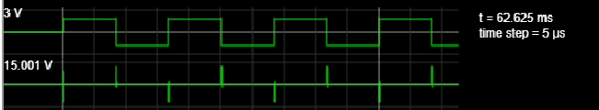**(b)Input Waveform: Square Wave Amplitude =3 V and Frequency =60Hz (with R=2k Ω and C=0.2µF)**

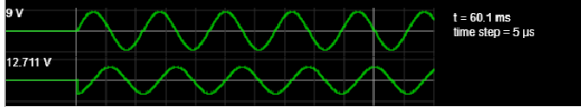**(c)Input Waveform: Sine Wave Amplitude = 9V and Frequency =90Hz (with R=5k Ω and C=0.5µF)**

**[5]Summing Amplifier (in Falstad Circuit Simulator)**

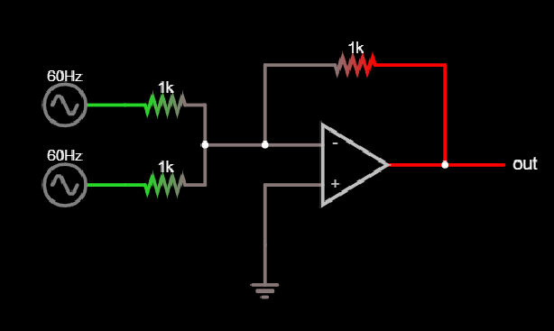

**Plot**

**(a)Input 1: Sine Wave Amplitude =5 V and Frequency =60Hz**

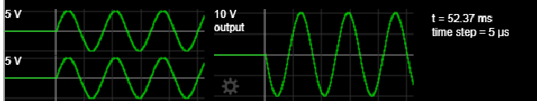**Input 2: Sine Wave Amplitude =5 V and Frequency =60Hz**

**(b)Input 1: Sine Wave Amplitude =5 V and Frequency =120Hz**

**Input 2: Square Wave Amplitude =10 V and Frequency =120Hz**

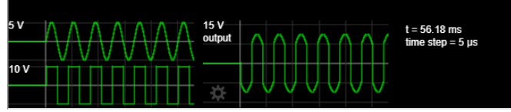

**(c)Input 1: Sine Wave Amplitude =5 V and Frequency =30Hz**

**Input 2: Sine Wave Amplitude =1 V and Frequency =500Hz**

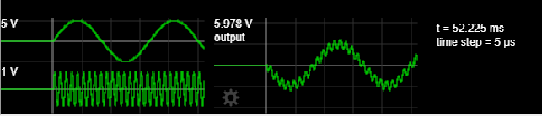

**(d)Input 1: Triangular Wave Amplitude =5 V and Frequency =30Hz**

**Input 2: Square Wave Amplitude =1 V and Frequency =500Hz**

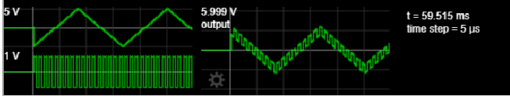

**[5]Differential Amplifier (in Falstad Circuit Simulator)**

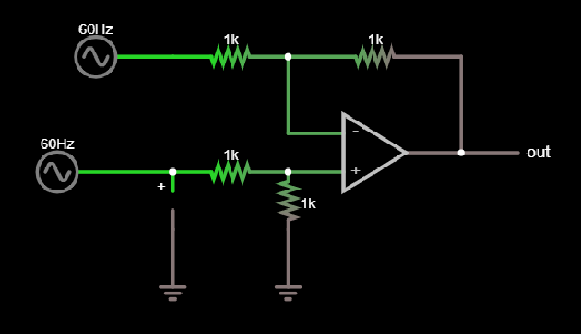

**Plot**

**(a)Input 1: Sine Wave Amplitude =5 V and Frequency =60Hz**

**Input 2: Sine Wave Amplitude =5 V and Frequency =60Hz**

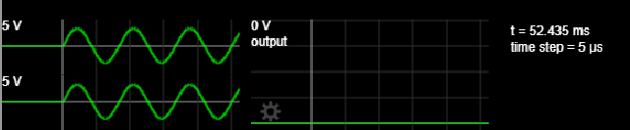

**(b)Input 1: Sine Wave Amplitude =5 V and Frequency =120Hz**

**Input 2: Square Wave Amplitude =10 V and Frequency =120Hz**

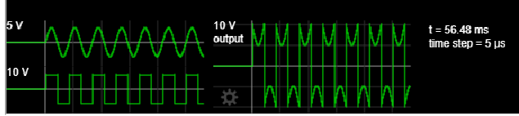

**(c)Input 1: Sine Wave Amplitude =5 V and Frequency =30Hz**

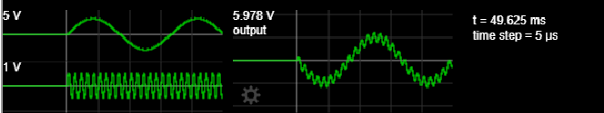**Input 2: Sine Wave Amplitude =1 V and Frequency =500Hz**

**(d)Input 1: Triangular Wave Amplitude =5 V and Frequency =30Hz**

**Input 2: Saw Tooth Wave Amplitude =1 V and Frequency =500Hz**

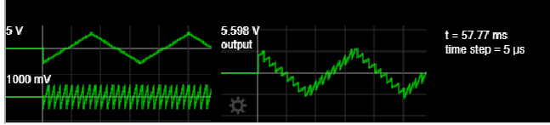

**Discussion**

1. Originally, op-amps were so named because they were used to model the basic mathematical operations of addition, subtraction, integration, differentiation, etc. in electronic analogue computers. In this sense a true operational amplifier is an ideal circuit element.
2. Operational amplifiers are linear devices that have all the properties required for nearly ideal DC amplification and are therefore used extensively in signal conditioning, filtering or to perform mathematical operations such as add, subtract, integration and differentiation.
3. As we have performed this experiment in Virtual Labs and FALSTAD Circuit Simulator, where ideal Op-Amps are being used, we could not observe the deviation of real Op-Amps from ideality as we would have if the experiment was performed in the laboratory.
4. Real op amps differ from the ideal model in various aspects.

* DC imperfections
* Finite gain
* Finite input impedances
* Non-zero output impedance
* Input current
* Input offset voltage
* Common-mode gain
* Power-supply rejection
* Temperature effects
* Drift

#### AC imperfections

* Finite bandwidth
* Stability
* Distortion, and other effects
* Noise
* Input capacitance
* Saturation
* Slewing

1. However, the simulations in the software have very well demonstrated the power of Op-Amps and how it can be used in digital electronics, audio- and video-frequency pre-amplifiers and buffers, differential amplifiers, differentiators and integrators, filters, precision rectifiers, precision detectors, voltage and current regulators, analogue calculators, Analogue-to-digital converters, Digital-to-analogue converters, Voltage clamping, oscillators and waveform generators, clipper, clamper (dc inserter or restorer), log and antilog amplifiers and many more.
2. The popularity of the op amp as a building block in analog circuits is due to its versatility. By using negative feedback, the characteristics of an op-amp circuit, its gain, input and output impedance, bandwidth etc. are determined by external components and have little dependence on temperature coefficients or engineering tolerance in the op amp itself.