**Experiment-4**

**Studies on BJT CE Amplifier**

**Aim**

The aim of the experiment is to explain the working of

**BJT CE Amplifier** and to plot the Magnitude (dB) versus

Frequency (Hz) of the amplifier to determine its Mid-band

Gain, Low Frequency cut-off and High Frequency cut-off.

**Circuit Diagram**

**Rc**

**Rs**

**RB2**

**Cc1**

**Cc2**

**Vout**

**RL**

**CE**

**RE**

**RB1**

**Vcc**

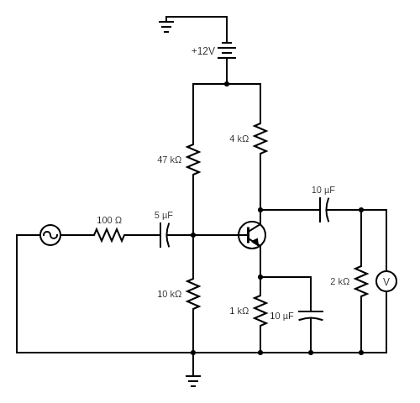

**Procedure:**

1. The source voltage (VS) is set to 50mV at 1 KHz frequency.
2. Keeping source voltage constant, vary the frequency from 50 Hz in regular steps.
3. Set Source Resistance (RS) =100Ω.
4. Set Collector Resistance (RC) =4000Ω, Set Emitter Resistance (RE) =1000Ω, Set Load Resistance (RL) =2000Ω.
5. Set Base Resistance1 (RB1) =47 KΩ, Set Base Resistance2 (RB2) =10KΩ.
6. Set Coupling Capacitor1 (CC1) =10μF, Set Coupling Capacitor2 (CC2) =10μF, Set Bypass Capacitance (CE) =10μF.
7. Vary the Frequency by keeping the resistances constant.
8. Plot the Magnitude graph of the CE Amplifier, Frequency (Hz) along X-axis and Magnitude (dB) along Y-axis.

**Observation Tables and Plots**

**[1]BJT CE Amplifier (Virtual Labs)**

|  |  |  |
| --- | --- | --- |
| **Serial No.** | **Frequency(Hz)** | **Magnitude(dB)** |
| **1** | **50** | **10.599** |
| **2** | **241** | **23.5496** |
| **3** | **419** | **27.673199999999998** |
| **4** | **663** | **30.4588** |
| **5** | **727** | **30.916800000000002** |
| **6** | **798** | **31.339000000000002** |
| **7** | **875** | **31.724** |
| **8** | **959** | **32.0726** |
| **9** | **2896** | **34.065400000000004** |
| **10** | **7275** | **34.3358** |
| **11** | **21970** | **34.382600000000004** |
| **12** | **95900** | **34.3848** |
| **13** | **264131** | **34.3626** |
| **14** | **874621** | **34.1124** |
| **15** | **2408910** | **32.633** |
| **16** | **2896140** | **32.0332** |
| **17** | **3175560** | **31.6804** |
| **18** | **3481930** | **31.2908** |
| **19** | **3817860** | **30.8644** |
| **20** | **8746210** | **25.5998** |
| **21** | **20036400** | **18.89108** |
| **22** | **34819300** | **14.173860000000001** |
| **23** | **50329200** | **10.99534** |

**Mid band gain= -52.4119**

**Low frequency cut-off =836.5 Hz**

**High frequency cut-off=3328745 Hz**

**Observation Tables and Plots**

**[1]Plot of Magnitude versus Frequency for BJT CE Amplifier (Virtual Labs)**

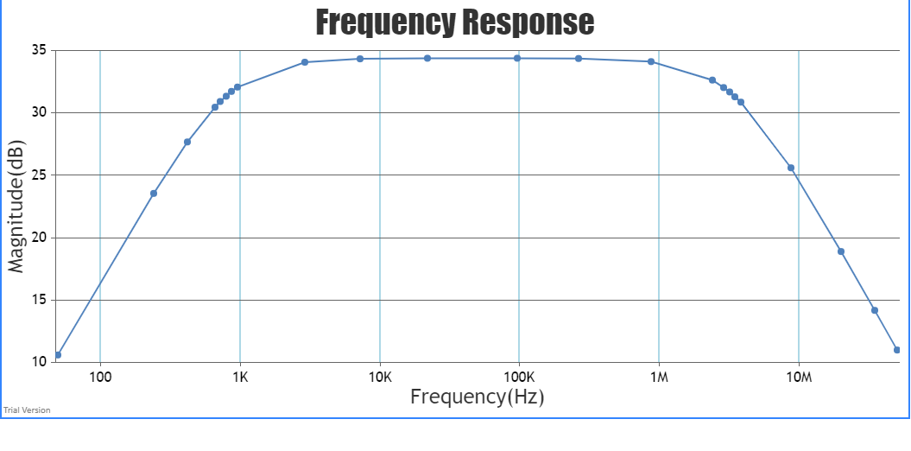

**Circuit Model in Falstad Circuit Simulator**

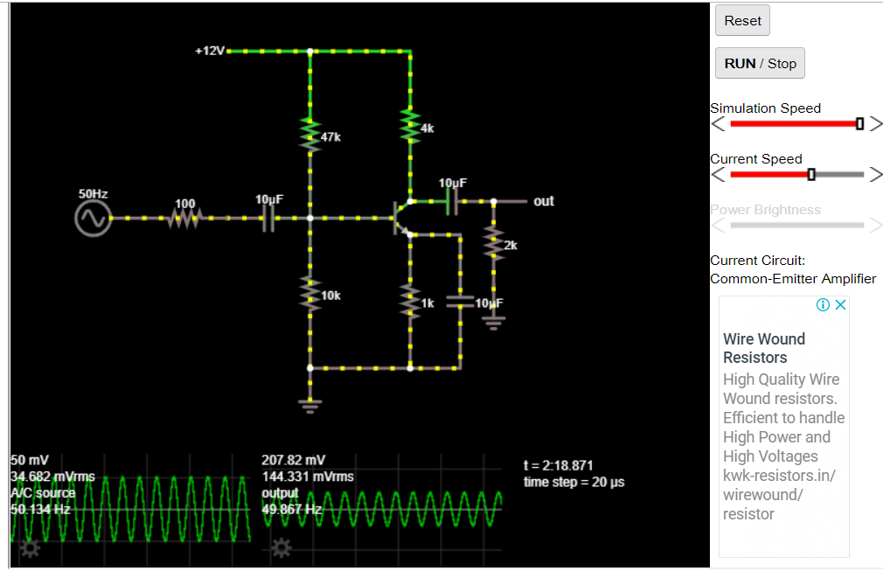

**Observation Tables and Plots**

|  |  |  |  |
| --- | --- | --- | --- |
| **Serial No.** | **Frequency(Hz)** | **Vout(V)** | **Magnitude(dB)** |
| **1** | **50** | **0.207817** | **12.37422134** |
| **2** | **241** | **0.875651** | **24.86722087** |
| **3** | **330** | **1.097** | **26.82473** |
| **4** | **350** | **1.138** | **27.14345** |
| **5** | **419** | **1.257** | **28.00730547** |
| **6** | **663** | **1.491** | **29.49015278** |
| **7** | **727** | **1.524** | **29.68029925** |
| **8** | **798** | **1.553** | **29.84402903** |
| **9** | **875** | **1.578** | **29.98273989** |
| **10** | **959** | **1.599** | **30.09756919** |
| **11** | **2896** | **1.699** | **30.62446749** |
| **12** | **7275** | **1.71** | **30.68052212** |
| **13** | **21970** | **1.712** | **30.69067512** |
| **14** | **95900** | **1.712** | **30.69067512** |
| **15** | **264131** | **1.712** | **30.69067512** |
| **16** | **874621** | **1.711** | **30.6856001** |
| **17** | **2408910** | **1.712** | **30.69067512** |
| **18** | **2896140** | **1.712** | **30.69067512** |
| **19** | **3175560** | **1.712** | **30.69067512** |
| **20** | **3481930** | **1.712** | **30.69067512** |
| **21** | **3817860** | **1.712** | **30.69067512** |
| **22** | **8746210** | **1.712** | **30.69067512** |
| **23** | **20036400** | **1.712** | **30.69067512** |
| **24** | **34819300** | **1.712** | **30.69067512** |
| **25** | **50329200** | **1.712** | **30.69067512** |

**[1]BJT CE Amplifier (Falstad Circuit Simulator**)**

**Low frequency cut-off =350 Hz**

**Discussion**

1. The Amplifier is an electronic circuit that is used to increase the strength of a weak input signal in terms of voltage, current, or power. When a transistor is used as an amplifier, the first step is to choose an appropriate configuration, in which device it is to be used. Then, the transistor should be biased to get the desired Q-point. The signal is applied to the amplifier input and output gain is achieved.
2. **At low frequencies (< FL):** The reactance of coupling capacitor CC2 is relatively high and hence very small part of the signal will pass from amplifier stage to the load. Moreover, CE cannot shunt the RE effectively because of its large reactance at low frequencies. These two factors cause a drops off of voltage gain at low frequencies.
3. **At high frequencies (> FH):** The reactance of coupling capacitor CC2 is very small and it behaves as a short circuit. This increases the loading effect of the amplifier stage and serves to reduce the voltage gain. Moreover, at high frequencies, the capacitive reactance of base-emitters junction is low which increases the base current. This frequency reduces the current amplification factor β. Due to these two reasons, the voltage gain drops off at high frequency.
4. **At mid frequencies (FL to FH):** The voltage gain of the amplifier is constant. The effect of the coupling capacitor CC2 in this frequency range is such as to maintain a constant voltage gain. Thus, as the frequency increases in this range, the reactance of CC2 decreases, which tend to increase the gain. However, at the same time, lower reactance means higher almost cancel each other, resulting in a uniform fair at mid-frequency.
5. The common emitter circuit is popular because it's well-suited for voltage amplification, especially at low frequencies. Common-emitter amplifiers are also used in radio frequency transceiver circuits. Common emitter configuration commonly used in low-noise amplifiers.

** In the Falstad Circuit Simulator, due to limitations of the software, we are not able to obtain the high-frequency cut-off as the value of the output voltage never deceases. This is the reason why we were not able to plot a frequency response for the same.