**Experiment-3**

**Studies on Rectifiers**

**Aim**

The aim of the experiment is to explain the working of

1. **Half-Wave Rectifier**
2. **Full-Wave Rectifier**
3. **Full-Wave Rectifier with Filter**

**Circuit Diagram:**

**Half Wave Rectifier:**

**Diode**

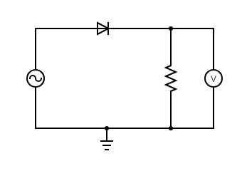

**V in**

**RL**

**V out**

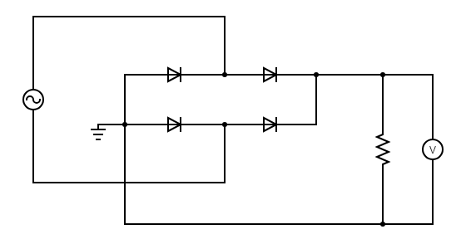**Full Wave Rectifier:**

**D4**

**D3**

**D2**

**D1**

**V out**

**RL**

**V in**

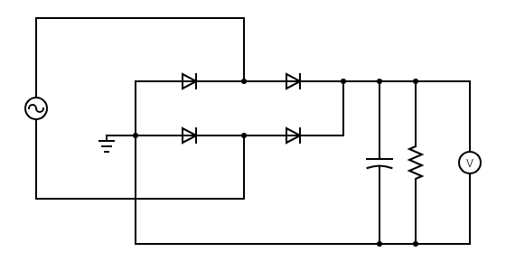**Full Wave Rectifier with Filter:**

**C**

**D4**

**D3**

**D2**

**D1**

**V out**

**RL**

**V in**

**Procedure**

**Half Wave Rectification (in Virtual Labs)**

1. Set the resistor RL to 500Ω.
2. Set the peak value of input supply voltage to 2V, 1000Hz in Virtual Labs.
3. Set the Volt (V)/div to 1 for both Channel 1 and Channel 2, and the Time (ms)/div to 0.2 in Virtual Labs.
4. Note the Peak value of current as Im and calculate the Peak Value of output voltage from that by Vm=Im*R.
5. Then, calculate the AVG value and RMS value of output voltage.
6. Keep decreasing the peak value of input supply voltage in steps of 0.2 V and repeat the steps keeping the frequency constant.
7. Calculate the Ripple Factor. Theoretical Ripple Factor= 1.21.

**Half Wave Rectification (in Falstad Circuit Simulator)**

1. Set the resistor RL to 500Ω.
2. Set the peak value of input supply voltage to 5V, 50Hz in Virtual Labs.
3. Note the Peak Value of output voltage.
4. Then, calculate the AVG value and RMS value of output voltage.
5. Calculate the Ripple Factor. Theoretical Ripple Factor= 1.21.

**Full Wave Rectification (in Virtual Labs)**

1. Set the resistor RL to 500Ω.
2. Set the peak value of input supply voltage to 2V, 1000Hz in Virtual Labs.
3. Set the Volt (V)/div to 1 for both Channel 1 and Channel 2, and the Time (ms)/div to 0.2 in Virtual Labs.
4. Note the Peak value of current as Im and calculate the Peak Value of output voltage from that by Vm=Im*R.
5. Then, calculate the AVG value and RMS value of output voltage.
6. Keep decreasing the peak value of input supply voltage in steps of 0.2 V and repeat the steps keeping the frequency constant.
7. Calculate the Ripple Factor. Theoretical Ripple Factor= 0.483.

**Full Wave Rectification (in Falstad Circuit Simulator)**

1. Set the resistor RL to 500Ω.
2. Set the peak value of input supply voltage to 5V, 50Hz in Virtual Labs.
3. Note the Peak Value of output voltage.
4. Then, calculate the AVG value and RMS value of output voltage.
5. Calculate the Ripple Factor. Theoretical Ripple Factor= 0.483.

**Full Wave Rectification with Filter (in Falstad Circuit Simulator)**

1. Set the resistor RL to 500Ω and Capacitance C to 102µF.
2. Set the peak value of input supply voltage to 5V, 50Hz in Virtual Labs.
3. Note the Peak Value of output voltage.
4. Then, calculate the AVG value and RMS value of output voltage.
5. Calculate the Ripple Factor.

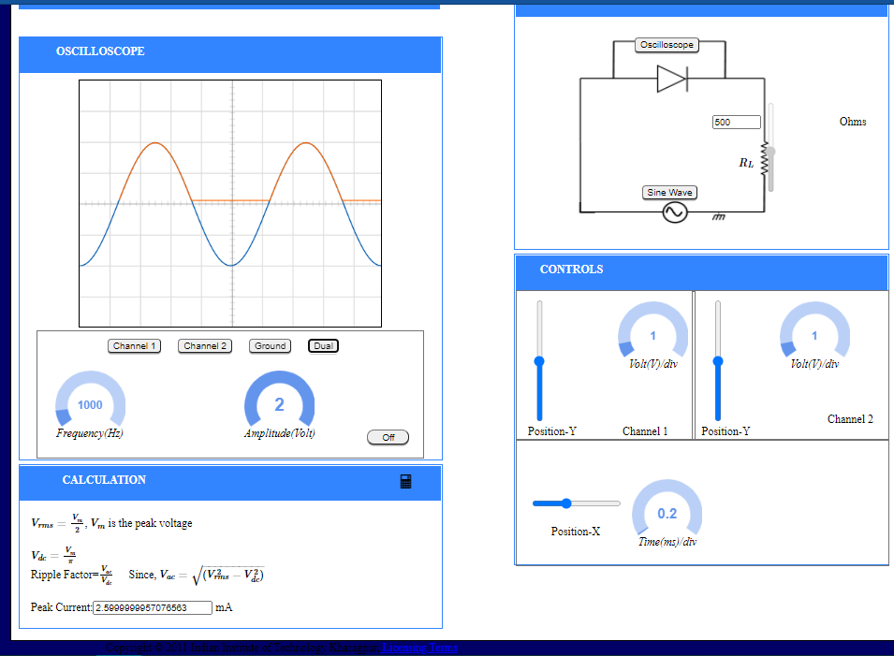**Half Wave Rectification (in Virtual Labs) Full Wave Rectification (in Virtual Labs)**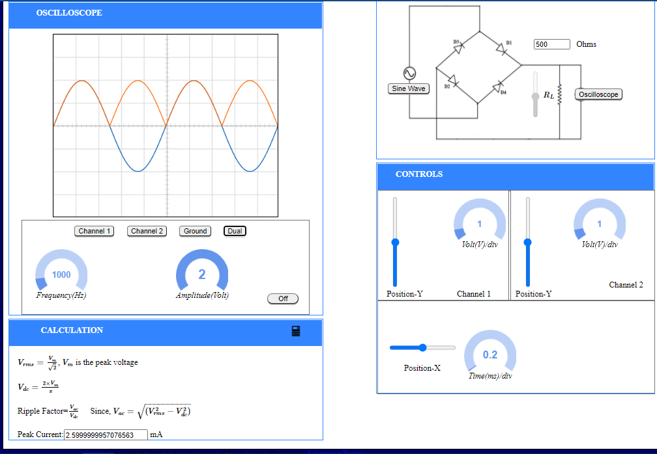

**Observation Tables and Plots**

**[1] Half Wave Rectification (Virtual Labs)**

|  |  |  |  |  |  |
| --- | --- | --- | --- | --- | --- |
| **Im**  **(mA)** | **Vm**  **(Vm=Im*R)**  **R=500** Ω  **(V)** | **Vavg**  **Vavg=Vm/π**  **Vdc=Vavg**  **(V)** | **Vrms**  **Vrms=Vm/2**  **(V)** | **Vac**  **Vac=**  **(V)** | **Ripple Factor**  **Rf=Vac/Vdc** |
| **2.600** | **1.300** | **0.414** | **0.650** | **0.501** | **1.210** |
| **2.400** | **1.200** | **0.382** | **0.6** | **0.462547** | **1.210** |
| **2.200** | **1.100** | **0.350** | **0.55** | **0.424001** | **1.210** |
| **1.800** | **0.900** | **0.286** | **0.45** | **0.34691** | **1.210** |
| **1.400** | **0.700** | **0.223** | **0.35** | **0.269819** | **1.210** |
| **1.000** | **0.500** | **0.159** | **0.25** | **0.192728** | **1.210** |
| **0.600** | **0.300** | **0.095** | **0.15** | **0.115637** | **1.210** |
| **0.200** | **0.100** | **0.032** | **0.05** | **0.038546** | **1.210** |

**[1]Plot for Half Wave Rectification (Virtual Labs)**

Represents Input Voltage (VIN)

Represents Output Voltage (VOUT)

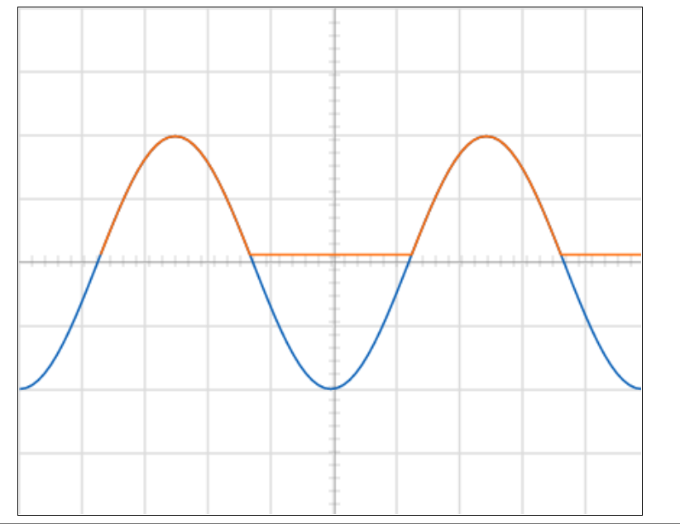

**V(V)**

**t (s)**

**Observation Tables and Plots**

**[2] Half Wave Rectification (Falstad Circuit Simulator)**

|  |  |  |  |  |  |
| --- | --- | --- | --- | --- | --- |
| **Vin**  **(V)** | **Vm**  **(V)** | **Vavg**  **Vavg=Vm/π**  **Vdc=Vavg**  **(V)** | **Vrms**  **Vrms=Vm/2**  **(V)** | **Vac**  **Vac=**  **(V)** | **Ripple Factor**  **Rf =Vac/Vdc** |
| **5** | **4.438** | **1.413** | **2.219** | **1.711** | **1.211** |
| **10** | **9.4** | **2.993631** | **4.7** | **3.623282** | **1.210** |
| **12** | **11.39** | **3.627389** | **5.695** | **4.390339** | **1.210** |
| **14** | **13.381** | **4.261465** | **6.6905** | **5.157781** | **1.210** |
| **16** | **15.374** | **4.896178** | **7.687** | **5.925994** | **1.210** |

**[2] Plot for Half Wave Rectification (Falstad Circuit Simulator)**

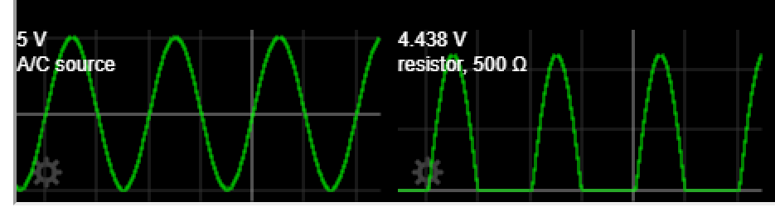

**Vin (V) v/s time(s)**

**Vout (V) v/s time(s)**

**Observation Tables and Plots**

**[3] Full Wave Rectification (Virtual Labs)**

|  |  |  |  |  |  |
| --- | --- | --- | --- | --- | --- |
| **Im**  **(mA)** | **Vm**  **(Vm=Im*R)**  **R=500 Ω**  **(V)** | **Vavg**  **Vavg=2*Vm/π**  **Vdc=Vavg**  **(V)** | **Vrms**  **Vrms=Vm/2**  **(V)** | **Vac**  **Vac=**  **(V)** | **Ripple Factor**  **Rf =Vac/Vdc** |
| **2.600** | **1.3** | **0.828025** | **0.919239** | **0.399216** | **0.482131** |
| **2.400** | **1.2** | **0.764331** | **0.848528** | **0.368508** | **0.482131** |
| **2.200** | **1.1** | **0.700637** | **0.777817** | **0.337799** | **0.482131** |
| **1.800** | **0.9** | **0.573248** | **0.636396** | **0.276381** | **0.482131** |
| **1.400** | **0.7** | **0.44586** | **0.494975** | **0.214963** | **0.482131** |
| **1.000** | **0.5** | **0.318471** | **0.353553** | **0.153545** | **0.482131** |
| **0.600** | **0.3** | **0.191083** | **0.212132** | **0.092127** | **0.482131** |
| **0.200** | **0.1** | **0.063694** | **0.070711** | **0.030709** | **0.482131** |

**[3] Plot forFull Wave Rectification (Virtual Labs)**

**V(V)**

Represents Input Voltage (VIN)

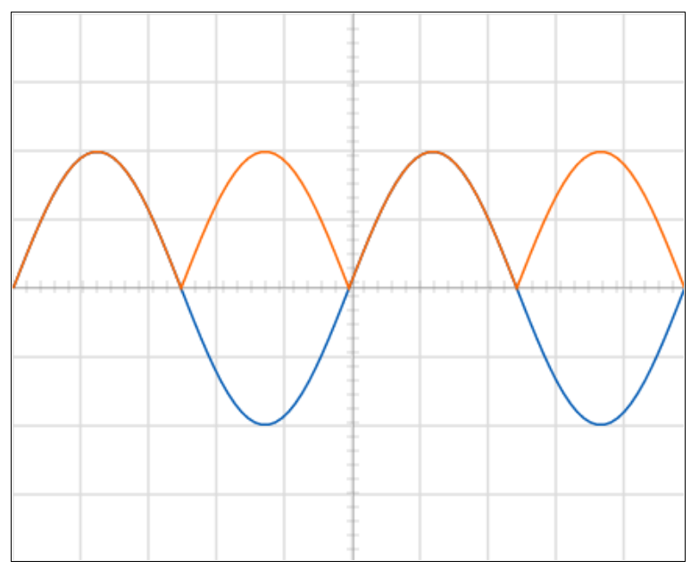

**t (s)**

Represents Output Voltage (VOUT)

**Observation Tables and Plots**

**[4] Full Wave Rectification (Falstad Circuit Simulator)**

|  |  |  |  |  |  |
| --- | --- | --- | --- | --- | --- |
| **Vin**  **(V)** | **Vm**  **(V)** | **Vavg**  **Vavg=2*Vm/π**  **Vdc=Vavg**  **(V)** | **Vrms**  **Vrms=Vm/2**  **(V)** | **Vac**  **Vac=**  **(V)** | **Ripple Factor**  **Rf =Vac/Vdc** |
| **5** | **3.891** | **2.477** | **2.751** | **1.197** | **0.4832** |
| **10** | **8.806** | **5.608917** | **6.226782** | **2.704231** | **0.482131** |
| **12** | **10.785** | **6.869427** | **7.626147** | **3.311961** | **0.482131** |
| **14** | **12.768** | **8.132484** | **9.028339** | **3.92092** | **0.482131** |
| **16** | **14.753** | **9.396815** | **10.43195** | **4.530493** | **0.482131** |

**[4] Plot for Full Wave Rectification (Falstad Circuit Simulator)**

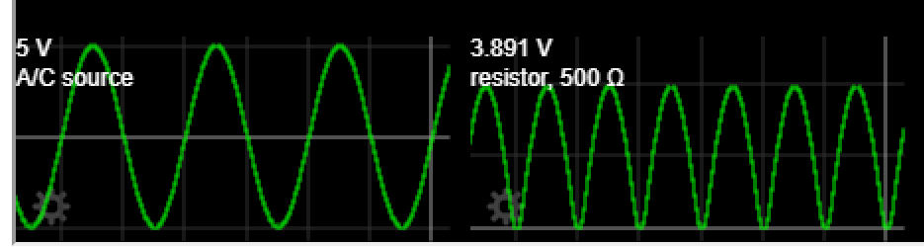

**Vout (V) v/s time(s)**

**Vin (V) v/s time(s)**

**Observation Tables and Plots**

**[5] Full Wave Rectification with Filter (Falstad Circuit Simulator)**

|  |  |  |  |  |  |
| --- | --- | --- | --- | --- | --- |
| **Vin**  **(V)** | **Vm**  **(V)** | **Vavg**  **Vavg≈(Vmin+Vmax)/2**  **Vdc=Vavg**  **(V)** | **Vrms**  **From Graph**  **(V)** | **Vac**  **Vac=**  **(V)** | **Ripple Factor**  **Rf =Vac/Vdc** |
| **5** | **3.816** | **3.5585** | **3.57** | **0.286** | **0.08046** |
| **10** | **8.757** | **8.143** | **8.178** | **0.755801** | **0.092816** |
| **15** | **13.721** | **12.747** | **12.806** | **1.227855** | **0.096325** |
| **20** | **18.696** | **17.371** | **17.442** | **1.572171** | **0.090506** |
| **25** | **23.676** | **22.010** | **22.082** | **1.781747** | **0.080952** |

**Note:**

In this case, the average value of the output voltage is approximated to be **(Vmin+Vmax)/2** and the value of Vmax is the peak value of the output voltage and the value of Vmin is obtained from the graph to be 3.301V.

**[5] Plot for Full Wave Rectification with Filter (Falstad Circuit Simulator)**

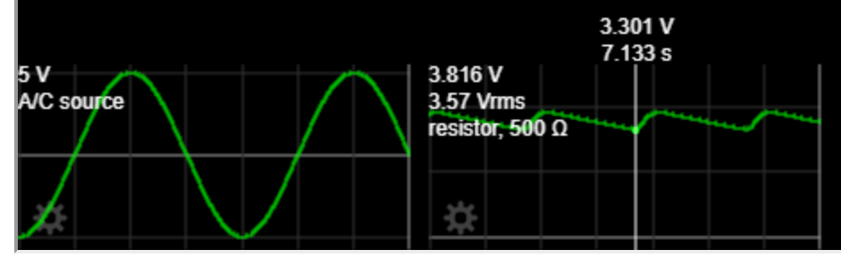

**Vout (V) v/s time(s)**

**Vin (V) v/s time(s)**

**Discussion**

* A rectifier is a device that converts alternating current (AC) to direct current (DC), a process known as rectification. Rectifiers are essentially of two types – a half wave rectifier and a full wave rectifier.
* The simplest kind of rectifier circuit is the half-wave rectifier. The half-wave rectifier is a circuit that allows only part of an input signal to pass. The circuit is simply the combination of a single diode in series with a resistor, where the resistor is acting as a load.
* A full-wave rectifier is exactly the same as the half-wave, but allows unidirectional current through the load during the entire sinusoidal cycle (as opposed to only half the cycle in the half-wave). A full-wave rectifier converts the whole of the input waveform to one of constant polarity (positive or negative) at its output.
* In the Virtual Labs platform, we see that the input voltage and output voltage have the same peak value in both half and full wave rectifier, this is because the diode in this platform is taken to be nearly ideal and thus Vγ≈0 but in the Falstad Circuit Simulator we see significant difference in the peak values of input and output voltages, as in this case the diodes are taken to be practical diodes and Vγ has significant effect, but for all practical purposes in order to simplify the calculation we ignore the effect of Vγ and approximate the output waveform as a sine wave.
* A half-wave rectifier is used in soldering iron types of circuit and is also used in mosquito repellent to drive the lead for the fumes.
* Purpose is to convert full wave AC input in to DC output. A centre tapped full wave rectifier is a type of rectifier which uses a centre tapped transformer and two diodes to convert the complete AC signal into DC signal.
* Full Wave Bridge Rectifier is used to detect the amplitude of the modulating radio signal. Bridge rectifier circuits are also used to supply steady and polarized Dc voltage in electric welding.
* For rectifier applications, peak inverse voltage (PIV) or peak reverse voltage (PRV) is the maximum value of reverse voltage which occurs at the peak of the input cycle when the diode is reverse-biased