

National Institute of Technology Agartala

**PROJECT REPORT**

SOLAR TRACKING SYSTEM

Semester: 6th Semester

Branch: Electronics and

Instrumentation Engineering

|  |  |
| --- | --- |
| Name | Enrollment |
| SRIPARNA CHANDA | 22UEI050 |
| HRITADIP DATTA | 22UEI053 |
| SUBHRADEEP BHATTACHARJEE | 22UEI055 |
| SOUMADITYA MAJUMDER | 22UEI056 |
| AMRITA CHEL | 22UEI058 |
| BAHAI KAHAM DEBBARMA | 22UEI059 |
| PRITAM SHOME | 22UEI060 |

UNDER THE SUPERVISION OF:

**DR. SUBIR DAS**

contents

* Acknowledgement
* Aim
* Introduction
* Objective
* Components Required
* Circuit Diagram
* Program Algorithm
* Applications
* Future Enhancements
* Conclusion

ACKNOWLEDGEMENT

I would like to express my heartfelt gratitude to all those who supported and guided me throughout the completion of this project titled “Dual Axis Solar Tracker with Power Monitoring System.” This endeavor has not only enhanced my technical knowledge but also provided invaluable practical experience in the fields of embedded systems, renewable energy, and real-time data acquisition.

First and foremost, I am sincerely thankful to my project guide, Dr. Subir Das, for their constant support, expert guidance, and constructive feedback throughout the development of this project. Their experience and encouragement were instrumental in shaping the direction and success of this work.

I would also like to extend my sincere thanks to Mr. Suraj Das and Mr. Kailash Pratim Phukan, Technical Assistants, for their invaluable technical support, timely assistance, and guidance during the implementation and troubleshooting phases of the project.

Additionally, I am grateful to the faculty members of the Electronics and Instrumentation Engineering Department, National Institute of Technology Agartala, for creating a stimulating learning environment and providing access to the necessary tools, components, and lab facilities required for implementing and testing the system.

A special mention goes to my friends and classmates, whose support, ideas, and team spirit kept me motivated and inspired. Their suggestions helped me explore different aspects of the project with greater depth and confidence.

AIM

Dual Axis Solar Tracking with Power Monitoring System.

INTRODUCTION

The increasing demand for renewable energy has turned global attention toward solar power as a clean and sustainable source of electricity. However, the efficiency of a solar panel depends heavily on its orientation toward the sun. Fixed-position solar panels are unable to follow the sun’s path, leading to sub-optimal power generation during various times of the day. To overcome this limitation, solar tracking systems are employed.

This project presents a Dual Axis Solar Tracking System using Arduino. The goal is to build a system that can orient a solar panel automatically in the direction of maximum sunlight throughout the day. The system uses Light Dependent Resistors (LDRs) to detect sunlight direction and two servo motors to adjust the panel’s horizontal and vertical angles accordingly.

Additionally, this system includes real-time power monitoring using a current sensor (ACS712) and a voltage divider circuit. The measured voltage and current values are used to compute the panel’s power output. A switch allows the user to toggle between tracking and fixed (non-tracking) modes. In fixed mode, the panel locks at a stable 90° position.

This project demonstrates not only energy optimization through sun tracking but also offers an understanding of embedded control, sensor interfacing, and real-time monitoring in a practical application.

OBJECTIVE

The primary objective of this project is to design and implement a Dual Axis Solar Tracking System that automatically aligns a solar panel toward the direction of maximum sunlight using a microcontroller-based system. The tracking system aims to enhance solar energy efficiency by maintaining an optimal angle between the solar panel and the sun throughout the day.

*COMPONENTS REQUIRED*

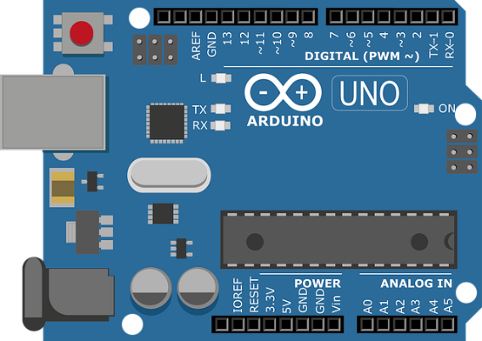**Arduino Uno**

* Microcontroller: ATmega328P
* Operating Voltage: 5V
* Digital I/O Pins: 14 (of which 6 can provide PWM output)
* Analog Input Pins: 6
* Clock Speed: 16 MHz
* Description: The Arduino Uno is the central microcontroller board used in this project. It reads sensor data (LDRs, current, voltage) and controls the servo motors based on programmed logic. It also handles serial communication to display data on a connected computer.

***Light Dependent Resistors (4× LDRs)***

* Resistance Range: ~1 kΩ (bright light) to >100 kΩ (dark)
* 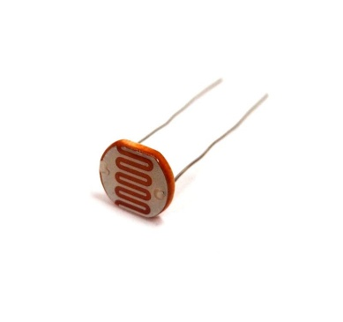Type: Photoconductive resistor
* Description: LDRs are used to detect the intensity of light in different directions. In this project, four LDRs are positioned around the solar panel (top-left, top-right, bottom-left, bottom-right) to sense the sun’s position and help calculate the direction for optimal alignment.

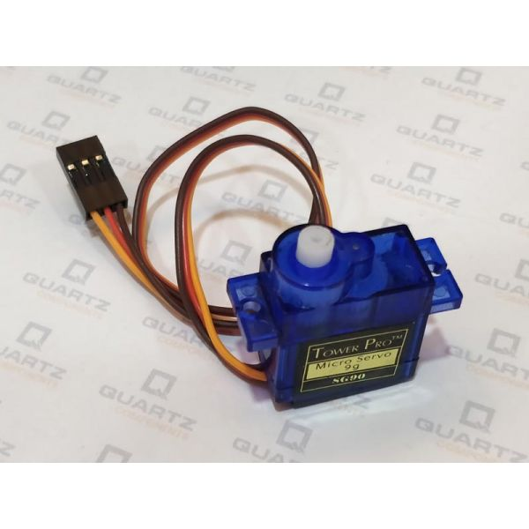 Servo Motors (2×) – SG90 and MG995

* Operating Voltage: 4.8V – 6V
* Torque:
  + SG90: ~1.8 kg·cm
  + 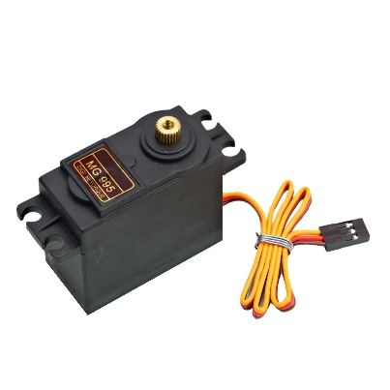MG995: ~10 kg·cm (metal gear, more durable)
* Rotation Range: 0° to 180°
* Description: Two servo motors are used—one for horizontal (azimuth) rotation and one for vertical (elevation) tilt. Based on LDR readings, the Arduino adjusts the angles to ensure the panel is always facing the direction of maximum sunlight.

***ACS712 Current Sensor (5A Module)***

* 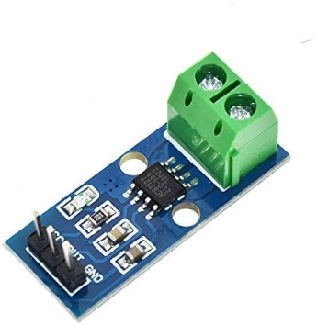Current Range: ±5 Amps
* Sensitivity: 185 mV per Ampere
* Output: Analog voltage proportional to current
* Description: This sensor is used to measure the output current from the solar panel. It produces an analog voltage that is read by the Arduino and converted into current using a calibration formula.

***Voltage Divider Circuit (2× 10kΩ Resistors)***

* Configuration: Series connection between solar panel and ground
* Purpose: Step down the voltage from the solar panel (which can be >5V) to a safe level readable by the Arduino analog pin.
* Description: Since the Arduino can only read voltages between 0–5V, a voltage divider reduces higher solar panel voltages (e.g., 6V) to within this range. The real voltage is then calculated using the divider ratio.

***6V Solar Panel***

* Rated Voltage: 6V
* Power Output: Typically 1W – 3W depending on size and sunlight
* Description: This is the power source being tracked and monitored. It provides electrical energy based on solar irradiance and its orientation with respect to the sun. Both the current and voltage output are used to calculate instantaneous power.

**Switch**

* Type: Mechanical toggle switch
* Operating Voltage: 0–5V (logic input to Arduino)
* Description: This switch is used to toggle between two operational modes—tracking and non-tracking. When the switch is ON (logic HIGH), the system actively tracks the sun. When OFF (logic LOW), the servos are locked at a fixed 90° position.

**Breadboard and Jumper Wires**

* Description: Essential for prototyping and building the circuit without soldering. Jumper wires connect various components to the Arduino, while the breadboard allows for easy placement and rearrangement.

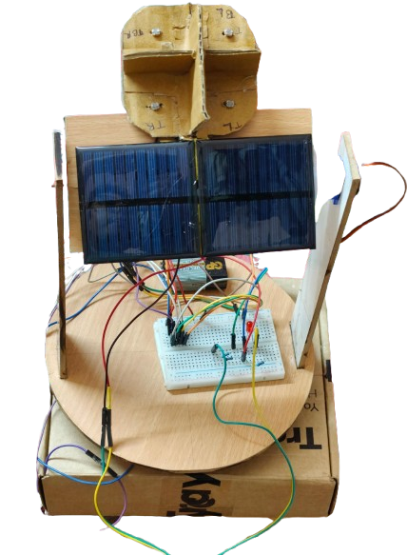***CIRCUIT DIAGRAM***

Figure: Solar tracking system

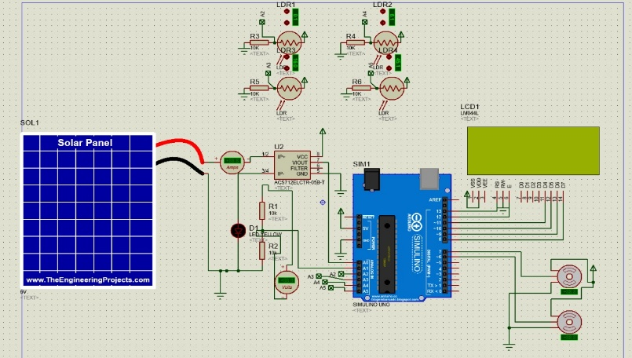

***PROGRAM ALGORITHM***

* Initialize the servo motors and sensors in the setup().
* Continuously read the state of the switch.
  + If the switch is ON (logic HIGH), enable tracking mode:
    - Read light intensities from 4 LDRs.
    - Calculate average light values from top, bottom, left, and right.
    - Compare differences between top & bottom and left & right:
      * Adjust vertical servo if top ≠ bottom.
      * Adjust horizontal servo if left ≠ right.
      * Use a threshold to prevent jitter.
  + If the switch is OFF (logic LOW), disable tracking:
    - Set both servos to 90°, holding panel in fixed position.
* In both modes:
  + Measure current from ACS712 sensor.
  + Measure voltage using analog input via voltage divider.
  + Calculate power = Voltage × Current.
  + Print real-time data to the Serial Monitor.

APPLICATIONS

* Solar energy harvesting systems for homes or remote areas
* Educational projects on renewable energy and automation
* Smart solar farms with energy tracking and logging
* Battery charging systems with maximum power point tracking

FUTURE PROSPECTS

* Add data logging to SD card for long-term performance analysis.
* Integrate IoT (e.g., Wi-Fi or Bluetooth module) to monitor data remotely via app or web dashboard.
* Use stepper motors with encoders for more precise movement and feedback control.
* Implement solar position algorithm (SPA) for predictive tracking even under cloudy conditions.
* Add rain or wind sensors to automatically retract the panel during bad weather.
* Include a rechargeable battery system with charge controller for complete autonomous operation.

CONCLUSION

The Dual Axis Solar Tracker developed in this project effectively demonstrates how solar panel efficiency can be improved through automatic sun tracking. By using LDRs for light detection and servo motors for movement, the system aligns the panel with the sun throughout the day. The inclusion of a switch allows for both tracking and fixed-angle modes, offering flexibility in operation.

Additionally, the integration of current and voltage sensing enables real-time monitoring of power output, making the system both efficient and informative. The project is simple, cost-effective, and scalable, serving as a strong foundation for future enhancements such as IoT connectivity, weather-based control, and data logging.