
ITSimplera Institute
System Administration & Infrastructure Services Internship

WEEK 2 — TASK 02
Identity Management, Security Policy &
Secure Remote Administration

Submitted By:
HRITHIKA S
Registration No: 3122235002047
Contact: 9445170771
Issued By:
Tahir Zaman
Team Lead – System Administration & Infrastructure Services
Released: July 5, 2026 | Deadline: July 12, 2026
Difficulty: Beginner to Intermediate | Task Type: Theory + Windows Administration + IAM

Table of Contents

1. Introduction ...... 3
2. Objective ...... 3
3. Theory Topics ...... 4
3.1 Introduction to Identity and Access Management (IAM) ...... 4
3.2 Standard User Accounts in Windows ...... 4
3.3 Types of User Accounts — Administrator vs Standard User ...... 5
3.4 User Account Properties and Password Policies ...... 5
3.5 Basic User Account Troubleshooting ...... 6
3.6 Windows Firewall Fundamentals ...... 6
3.7 Firewall Rules — Inbound and Outbound ...... 7
3.8 Introduction to Remote Desktop Protocol (RDP) ...... 7
3.9 Benefits, Risks, and Best Practices for Secure Remote Access ...... 8
4. Software Requirements ...... 8
5. Practical Implementation ...... 9
Part A Create Local User Accounts ...... 9
Part B Manage User Accounts ...... 10
Part C Configure Windows Firewall ...... 12
Part D Enable Remote Desktop (RDP) ...... 13
Part E Final Verification ...... 15
6. Challenges Faced ...... 16
7. Learning Outcomes ...... 16
8. Conclusion ...... 17
9. References ...... 17
10. Evaluation Criteria ...... 18

1. Introduction

This report documents the complete practical implementation of Week 2 — Task 02 of the ITSimplera Institute System Administration & Infrastructure Services Internship. Building on the virtual lab environment established in Week 1, this task focuses on three core domains of enterprise Windows administration: Identity and Access Management (IAM), Windows Firewall configuration, and Remote Desktop Protocol (RDP).
Effective identity management is the cornerstone of organisational security. Every enterprise network relies on controlled user accounts with well-defined permissions, strong password policies, and auditable account states. Similarly, firewall configuration determines the network traffic permitted to flow into and out of systems, while RDP enables secure remote administration — a critical capability for managing distributed infrastructure.
This implementation was performed on the Windows 10 virtual machine created during Week 1, using VMware Workstation Pro as the hypervisor. All tasks were completed under the local Administrator account, and the implementation follows Windows best practices aligned with MCSE and CompTIA Security+ standards.

2. Objective

The primary objectives of this task are:
- Create and configure two Standard Local User Accounts with secure passwords and modified properties.
- Apply account management operations: view properties, change password, rename, disable, and re-enable accounts.
- Understand and configure Windows Defender Firewall — explore profiles, inbound and outbound rules, and enable firewall protection.
- Enable and configure Remote Desktop Protocol (RDP) on the Windows 10 virtual machine.
- Verify all configurations and document each step with professional screenshots.
- Develop theoretical understanding of IAM, firewall rules, and secure remote access principles.

3. Theory Topics

3.1 Introduction to Identity and Access Management (IAM)
Identity and Access Management (IAM) is the framework of policies, processes, and technologies that enables organisations to manage digital identities and control access to IT resources. It answers two fundamental security questions: 'Who are you?' (authentication) and 'What are you allowed to do?' (authorisation).
IAM encompasses:
- User Provisioning: Creating, modifying, and deprovisioning user accounts throughout the employee lifecycle.
- Authentication: Verifying user identity via passwords, multi-factor authentication (MFA), smart cards, or biometrics.
- Authorisation: Defining what resources (files, applications, systems) each identity can access and with what level of privilege.
- Audit and Compliance: Logging access events, generating reports, and meeting regulatory requirements (GDPR, HIPAA, ISO 27001).
- Single Sign-On (SSO): Allowing users to authenticate once and access multiple systems without re-entering credentials.
In enterprise Windows environments, IAM is implemented through Active Directory (AD) for domain environments and Local Security Accounts Manager (SAM) for standalone machines. This task focuses on local IAM using Windows built-in tools: Computer Management, Local Users and Groups, and Local Security Policy (secpol.msc).

3.2 Standard User Accounts in Windows
Windows 10 supports multiple user account types. Standard User accounts are the recommended account type for day-to-day computing as they operate under the Principle of Least Privilege (PoLP) — users receive only the minimum permissions necessary to perform their work.
Standard User account characteristics:
- Can run applications that have been installed by an Administrator.
- Can change their own password and personalise the desktop environment.
- Cannot install or uninstall software system-wide, modify system files, or change system settings.
- Cannot modify other users' accounts or access other users' files without explicit permission.
- Require Administrator credentials (via UAC prompt) to perform elevated operations.
Creating Standard User accounts for all regular users — and reserving Administrator accounts for administrative tasks only — is a fundamental security best practice. It limits the blast radius of security incidents: if a Standard User account is compromised, the attacker gains limited privileges and cannot easily escalate to system-level access.

3.3 Types of User Accounts — Administrator vs Standard User
Administrator Account | Standard User Account
Full control over system settings | Limited to personal settings only
Can install/uninstall software | Cannot install system-wide software
Can create/delete/modify all user accounts | Cannot manage other accounts
Can modify security policies | Cannot change security policies
Can access all files and folders | Limited to own files and shared folders
Used for IT administration tasks | Used for day-to-day work
High risk if compromised | Limited damage if compromised
Should NOT be used for daily work | Recommended for all regular users

Windows also includes the built-in Administrator account (disabled by default in Windows 10) and the Guest account. The built-in Administrator should remain disabled except during specific maintenance tasks. UAC (User Account Control) acts as a bridge — Standard Users can request elevation by providing Administrator credentials.

3.4 User Account Properties and Password Policies
Each Windows user account has a set of configurable properties that govern its behaviour, identity, and security:
- Full Name: The display name shown on the login screen and in account listings.
- Description: Administrative notes about the account's purpose or owner.
- Password: Can be set to require change on next login, never expire, or use system-wide password policy.
- Account Status: Active (can log in) or Disabled (cannot log in — account data preserved).
- Group Membership: Controls which resources and operations the account can access.
Password policies (configured in Local Security Policy or Group Policy) define organisation-wide password rules:
Policy Setting | Value Configured | Purpose
Minimum password length | 8 characters minimum | Prevents trivially short passwords that are easy to brute-force.
Password complexity | Enabled | Requires uppercase, lowercase, digits, and symbols — increases entropy.
Maximum password age | 90 days | Forces periodic rotation to limit exposure if a password is leaked.
Minimum password age | 1 day | Prevents users from cycling through passwords to return to a favourite.
Password history | 5 passwords | Blocks reuse of recent passwords.
Account lockout threshold | 5 attempts | Locks the account after 5 failed logins — mitigates brute-force attacks.
Account lockout duration | 15 minutes | Temporary lock; full lockout requires Administrator reset.

3.5 Basic User Account Troubleshooting
Common user account issues and their resolutions in Windows 10:
- Account locked out: Navigate to Computer Management → Local Users and Groups → Users → right-click the account → Properties → uncheck 'Account is locked out'. Alternatively run: net user <username> /active:yes
- Forgotten password: Administrator runs: net user <username> NewPassword123! or uses Computer Management to reset.
- Account disabled: Right-click account → Properties → uncheck 'Account is disabled'. Or: net user <username> /active:yes
- Profile corruption: Log in as a different Administrator, rename the profile folder in C:\Users, and create a new profile. Copy personal files from the old profile folder.
- Cannot log in after password change: Check if Caps Lock is on, ensure the correct domain/workgroup is selected, verify the account is not disabled or expired.
- UAC prompt blocks action: Right-click the application → 'Run as administrator' and enter Administrator credentials when prompted.

3.6 Windows Firewall Fundamentals
Windows Defender Firewall is a stateful, host-based packet filter built into Windows. It monitors and controls incoming and outgoing network traffic based on a defined set of security rules. 'Stateful' means it tracks the state of network connections and only allows return traffic for connections that were initiated from the trusted side.
Windows Firewall operates with three network profiles, each applying independently:
- Domain Profile: Applied automatically when the computer is connected to a corporate network domain (Active Directory). Typically the most permissive, trusting the internal network.
- Private Profile: Applied when connected to a home or trusted private network. Moderately permissive.
- Public Profile: Applied when connected to public networks (airports, cafes, hotels). Most restrictive — blocks all incoming connections by default.
Key firewall concepts:
- Stateful inspection: Tracks TCP handshakes and connection states, automatically permitting established connections.
- Default behaviour: Block all inbound connections not matching a rule; Allow all outbound connections not matching a rule.
- Action options: Allow, Block, or Allow if secure (requires IPsec authentication).
Windows Firewall with Advanced Security (wf.msc) provides a powerful GUI for creating granular rules covering specific protocols, ports, IP address ranges, users, and applications — far more precise than the basic firewall panel.

3.7 Firewall Rules — Inbound and Outbound
Firewall rules are the individual entries that define what traffic is permitted or blocked. Each rule specifies:
- Direction: Inbound (traffic arriving at this machine) or Outbound (traffic leaving this machine).
- Protocol: TCP, UDP, ICMP, or any protocol.
- Port: Specific port numbers (e.g. 3389 for RDP, 80 for HTTP, 443 for HTTPS) or port ranges.
- Action: Allow (permit the traffic), Block (drop the traffic), or Allow if secure (require IPsec).
- Profile: Which network profiles the rule applies to (Domain, Private, Public, or all three).
- Application/Service: Scope the rule to a specific program or Windows service.
Inbound Rules | Outbound Rules
Control traffic arriving at the machine | Control traffic leaving the machine
Protect against unauthorised remote access | Prevent data exfiltration and unauthorised connections
Example: Allow RDP on TCP 3389 | Example: Block access to social media ports
Default: Block unless explicitly allowed | Default: Allow unless explicitly blocked
Higher security priority | Often more permissive in practice

3.8 Introduction to Remote Desktop Protocol (RDP)
Remote Desktop Protocol (RDP) is a proprietary Microsoft protocol that enables graphical remote control of a Windows computer over a network connection. It transmits the display output of the remote machine to the local client and sends keyboard/mouse input back to the remote machine — enabling full interactive management of a remote system as if sitting in front of it.
Technical details:
- Port: TCP 3389 (default) — can be changed in the registry for security.
- Encryption: TLS 1.2/1.3 encryption since Windows Vista; supports Network Level Authentication (NLA).
- Authentication: Windows credentials (username/password) with optional MFA.
- Network Level Authentication (NLA): Requires the user to authenticate before the remote desktop session is established — reduces resource consumption and protects against denial-of-service attacks.
- Client: Remote Desktop Connection (mstsc.exe) built into all Windows editions.
- Server: RDP server functionality is enabled in Windows 10 Pro, Enterprise, and Education — NOT available in Home edition.

3.9 Benefits, Risks, and Best Practices for Secure Remote Access
Benefits | Security Risks
Administer servers without physical access | Exposed to brute-force attacks if port 3389 is open to internet
Support end users remotely | Credential theft via phishing or keyloggers
Enable remote work for employees | Man-in-the-Middle (MitM) attacks without NLA
Reduce travel costs for IT support | BlueKeep (CVE-2019-0708) and similar RDP vulnerabilities
Centralise desktop management | Session hijacking if sessions left unattended

Best practices for securing RDP:
- Enable Network Level Authentication (NLA) — authenticates before the session is established.
- Use strong, unique passwords for accounts with RDP access.
- Limit RDP access using firewall rules — only allow from specific IP addresses or subnets.
- Change the default RDP port from 3389 to a non-standard port (security through obscurity).
- Use a VPN — require VPN connection before allowing RDP access.
- Enable account lockout policies to prevent brute-force attacks.
- Keep Windows fully patched — RDP has historically been a vector for critical vulnerabilities.
- Disable RDP when not in use.

4. Software Requirements

Component | Specification
Operating System | Windows 10 Virtual Machine (created in Week 1 — Task 01)
Hypervisor | VMware Workstation Pro 17 (free for personal use)
Access Level | Local Administrator account on the Windows 10 VM
Tools Used | Computer Management (compmgmt.msc), Local Security Policy (secpol.msc)
 | Windows Defender Firewall with Advanced Security (wf.msc)
 | Remote Desktop Connection (mstsc.exe)
Documentation | Microsoft Word / PDF Editor for professional report
Connectivity | Internet connection (optional — all tasks are local to the VM)

5. Practical Implementation

Part A — Create Local User Accounts
Two Standard Local User Accounts were created on the Windows 10 virtual machine using Computer Management. The following method was used:

Step 1: Open Computer Management
Right-click the Start button → select 'Computer Management'. Alternatively, press Win+R, type compmgmt.msc, and press Enter.
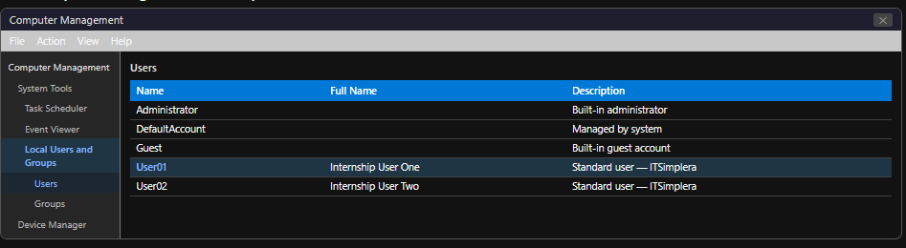
Navigate to: System Tools → Local Users and Groups → Users

Figure: Computer Management — Local Users and Groups panel

Step 2: Create User01
- Right-click in the right pane → select 'New User...'
- Enter the following details:
User name: User01
Full name: Internship User One
Description: Standard user account — ITSimplera Lab
Password: P@ssw0rd2026!

- Uncheck 'User must change password at next logon'.
- Check 'Password never expires' (appropriate for lab environment).
- Leave 'Account is disabled' unchecked.
- Click 'Create', then 'Close'.
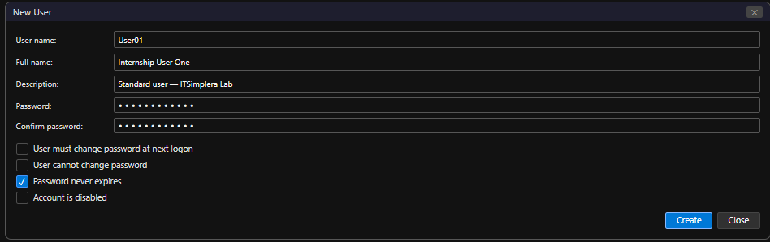

Figure: New User dialog — User01 creation with all fields completed

Step 3: Create User02
Repeat the same process with the following details:
User name: User02
Full name: Internship User Two
Description: Standard user account — ITSimplera Lab
Password: Secur3Lab@2026
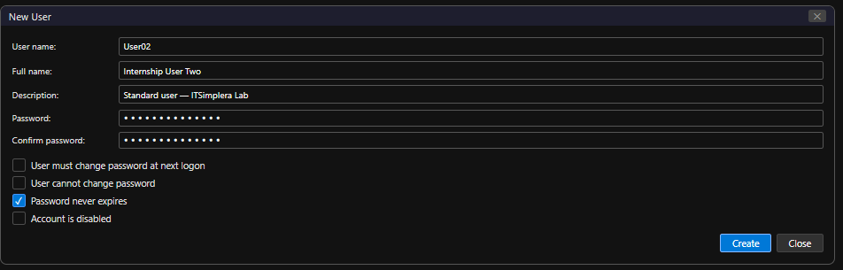

Figure: New User dialog — User02 creation with all fields completed

Step 4: Verify both accounts are Standard Users
Both accounts are Standard Users by default (not members of the Administrators group). To confirm: double-click User01 → Member Of tab → verify only 'Users' group is listed, not 'Administrators'.
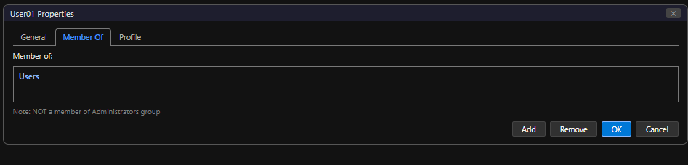

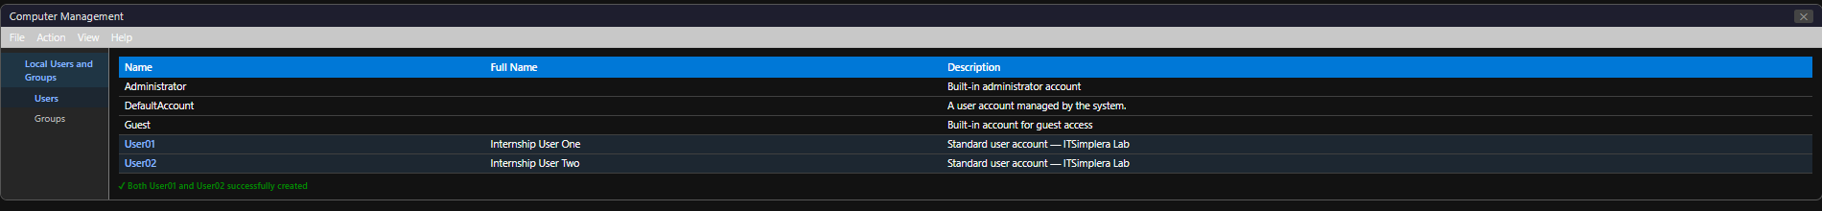

Part B — Manage User Accounts
The following administrative operations were performed on the created accounts to demonstrate standard user account management tasks.

B1 — View Account Properties
Double-click User01 in Computer Management → Local Users and Groups → Users. The Properties dialog shows four tabs: General, Member Of, Profile, and Environment.
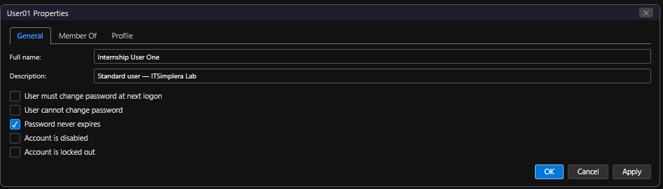

Figure: User01 Properties — General tab showing Full Name, Description, and password settings

B2 — Change Account Password
To change User01's password:
- Right-click User01 in Computer Management → 'Set Password...'
- Click 'Proceed' on the warning dialog.
- Enter new password: N3wP@ss2026!
- Confirm password and click 'OK'.
Alternative method using Command Prompt (run as Administrator):
net user User01 N3wP@ss2026!
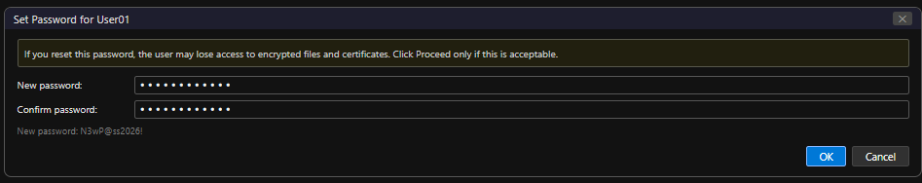

Figure: Set Password dialog for User01 — new password entered

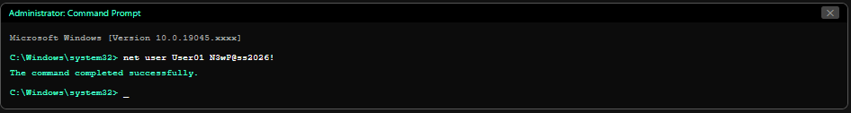

Figure: Command Prompt — net user password change command with success message

B3 — Rename One Account
User02 was renamed to LabUser02 to demonstrate account renaming:
- Right-click User02 in Computer Management → 'Rename'.
- Type the new name: LabUser02
- Press Enter to confirm.
Note: Renaming a user account changes the login name but preserves the SID (Security Identifier), meaning all file permissions and group memberships remain intact.
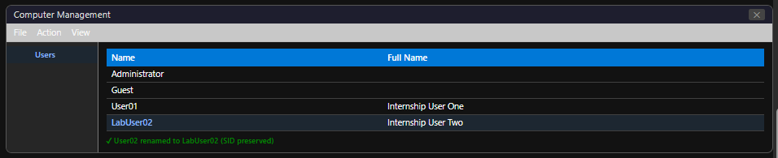

Figure: Computer Management — User02 renamed to LabUser02

B4 — Disable and Re-enable an Account
User01 was disabled and then re-enabled to demonstrate account status management:
Disable User01:
- Double-click User01 → General tab → check 'Account is disabled' → click Apply.
- The account icon in Computer Management shows a downward arrow indicating disabled status.
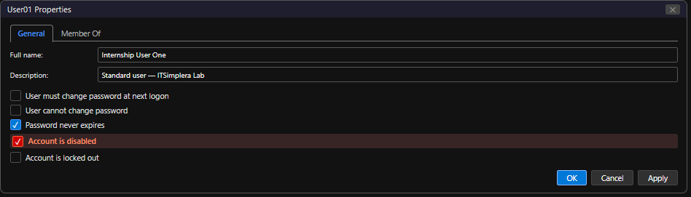

Figure: User01 Properties — 'Account is disabled' checkbox checked
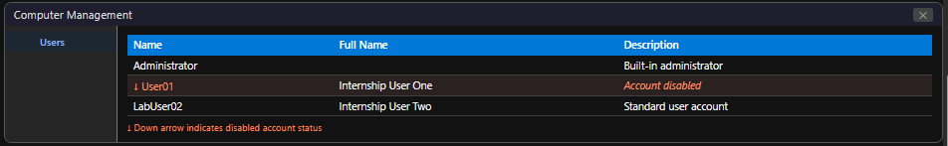

Re-enable User01:
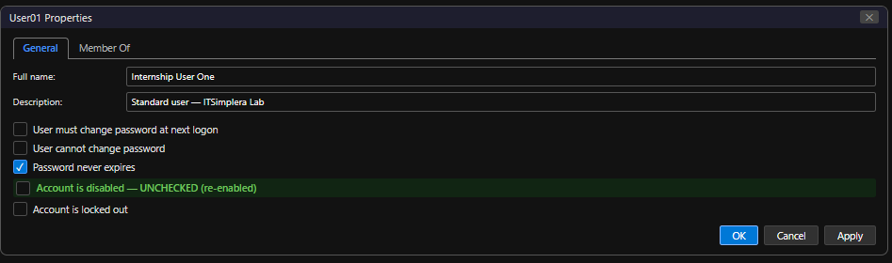
- Double-click User01 → General tab → uncheck 'Account is disabled' → click Apply and OK.

Figure: User01 Properties — 'Account is disabled' unchecked (account re-enabled)

B5 — Verify All Changes
Final verification confirms:
- User01: password changed, account re-enabled, Full Name = 'Internship User One'.
- User02 → LabUser02: successfully renamed, account active.
- Both accounts remain Standard Users (not in Administrators group).
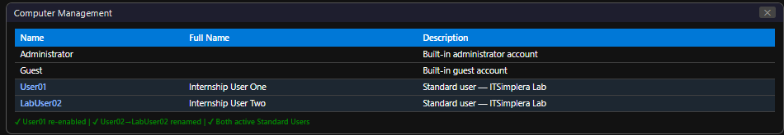

Figure: Computer Management — Final state showing User01 and LabUser02 both active

Part C — Configure Windows Firewall
Windows Defender Firewall was reviewed and confirmed as enabled. The firewall profiles and existing rules were explored and documented.

C1 — Open Windows Defender Firewall with Advanced Security
Press Win+R → type wf.msc → press Enter. The Windows Defender Firewall with Advanced Security console opens, showing an overview panel with the current status of all three profiles.
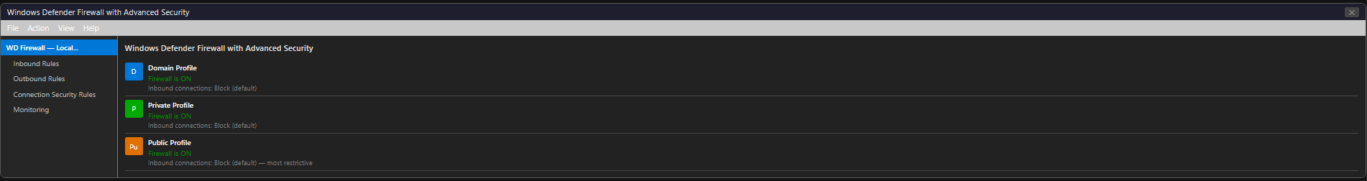

Figure: Windows Defender Firewall with Advanced Security — Overview panel showing Domain, Private, and Public profiles

C2 — Verify Firewall Profiles Status
The overview panel confirms the status of each firewall profile:
Policy Setting | Value Configured | Purpose
Domain Profile | Active — Firewall ON | Applies when connected to a domain network.
Private Profile | Active — Firewall ON | Applies to trusted home/office networks.
Public Profile | Active — Firewall ON | Applies to public/untrusted networks (most restrictive).

All three profiles are enabled with their default settings: inbound connections not matching a rule are blocked; outbound connections are allowed.
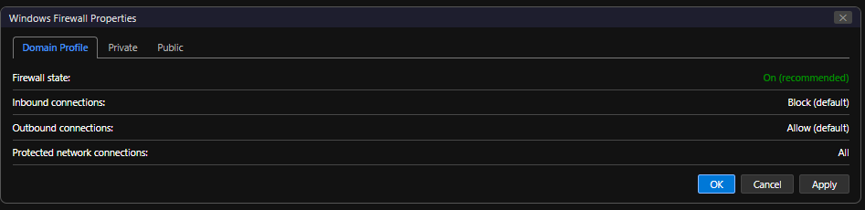

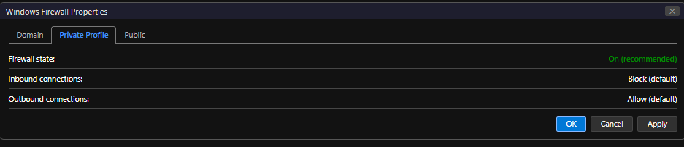

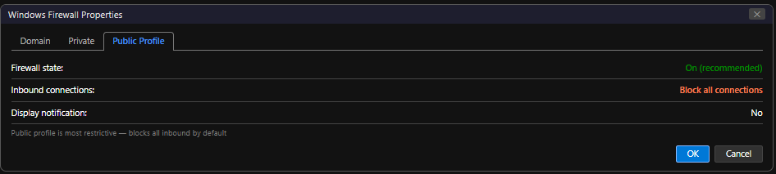

C3 — View Inbound and Outbound Rules
Inbound Rules were explored by clicking 'Inbound Rules' in the left pane. The list shows hundreds of pre-configured rules from Windows and installed applications, including:
- Remote Desktop — User Mode (TCP-In): Allows RDP connections on TCP port 3389.
- File and Printer Sharing: Allows SMB/CIFS file sharing on TCP 445.
- Windows Management Instrumentation (WMI): Allows remote management.

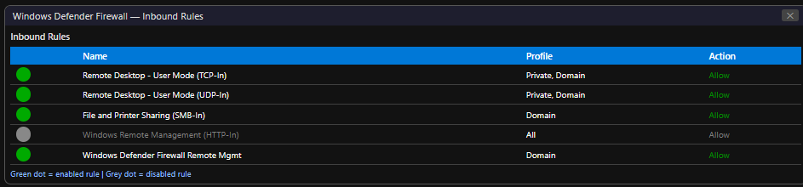

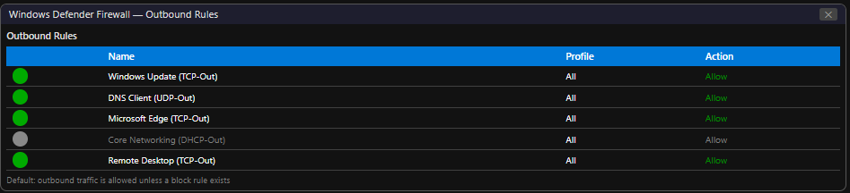

C4 — Purpose of Windows Firewall
Windows Firewall serves as the first line of host-based defence on a Windows machine. Its primary functions are:
- Blocking unsolicited inbound connections: By default, all inbound connections not explicitly permitted by a rule are blocked, protecting the machine from network-based attacks, port scanners, and worms.
- Application-layer filtering: Rules can be scoped to specific applications (e.g. only allow mstsc.exe to use port 3389), preventing other programs from exploiting open ports.
- Network profile awareness: Automatically applies different rule sets based on whether the machine is on a domain, private, or public network — providing context-appropriate security.
- Outbound filtering: Can block specific outbound connections (e.g. prevent a known-malicious port or block an application from phoning home).
- Integration with Windows Security: Works alongside Windows Defender Antivirus and Windows Security Centre for a unified, layered defence posture.

Part D — Enable Remote Desktop (RDP)
Remote Desktop Protocol was enabled on the Windows 10 virtual machine to allow secure remote graphical administration.
⚠ | Note: RDP server functionality requires Windows 10 Pro, Enterprise, or Education edition. It is NOT available on Windows 10 Home. Ensure your VM is running Windows 10 Pro.

D1 — Enable RDP via System Properties
- Right-click the Start button → select 'System'.
- In the Settings app → click 'Remote Desktop' in the left pane (or navigate to Settings → System → Remote Desktop).
- Toggle 'Enable Remote Desktop' to On.
- A confirmation dialog appears: click 'Confirm'.
- Note the PC Name shown on this page — this is what you will use to connect remotely.

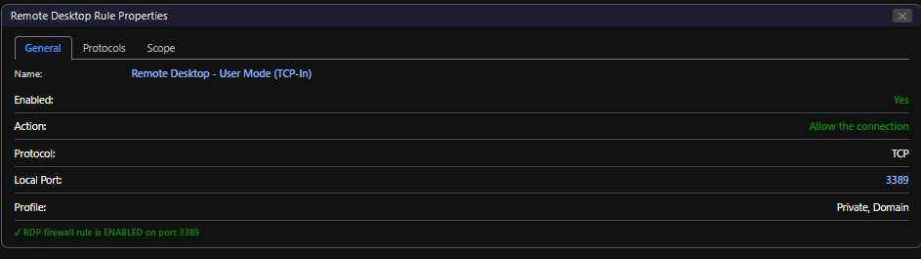

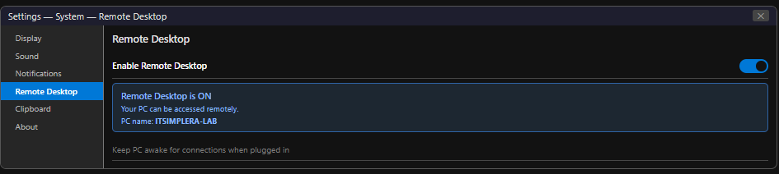

D2 — Advanced RDP Settings
Click 'Advanced settings' on the Remote Desktop page:
- Require computers to use Network Level Authentication (NLA): Enabled — this requires authentication before the remote session is established.
- Remote Desktop port: 3389 (default).

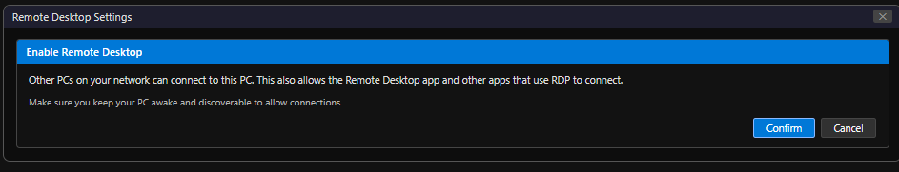

Figure: Remote Desktop Advanced Settings — NLA enabled

D3 — Configure Who Can Use Remote Desktop
By default, only members of the Administrators group and the Remote Desktop Users group can connect via RDP.
- Click 'Select users that can remotely access this PC'.
- Click 'Add'.
- Type User01 → click 'Check Names' → click 'OK'.
- User01 is now added to the Remote Desktop Users group and can connect via RDP.

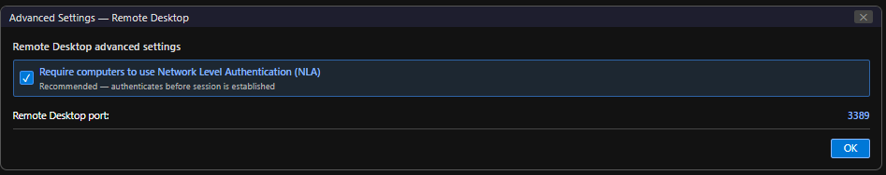

Figure: Remote Desktop Users — User01 added to allow RDP access
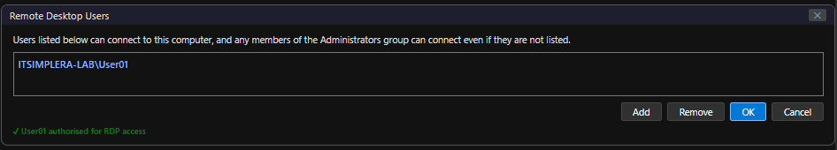

D4 — Verify Windows Firewall Allows RDP
When RDP is enabled via System Settings, Windows automatically creates a firewall exception. Verify this:
- Open wf.msc (Windows Defender Firewall with Advanced Security).
- Click 'Inbound Rules'.
- Search for 'Remote Desktop' — confirm rules named 'Remote Desktop - User Mode (TCP-In)' and 'Remote Desktop - User Mode (UDP-In)' are present and enabled (green checkbox).
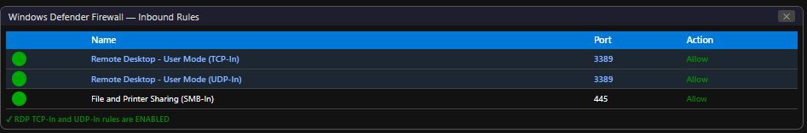

Figure: Inbound Rules — Remote Desktop TCP-In and UDP-In rules shown as Enabled

D5 — Find the VM's IP Address
To connect to this VM via RDP from another machine, you need its IP address:
ipconfig

Note the IPv4 address of the VMware NAT adapter (typically 192.168.x.x). This address is used as the target for RDP connections.
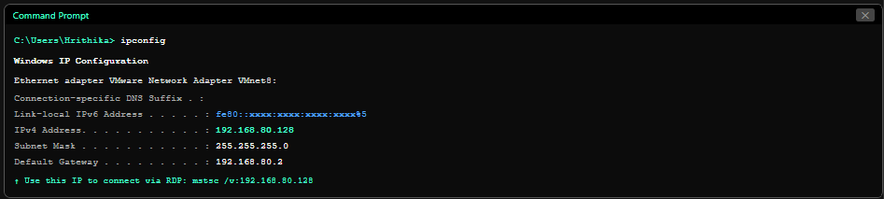

Figure: Command Prompt — ipconfig output showing IPv4 Address of the VM

D6 — Verify RDP Configuration Summary
✓ Remote Desktop: ENABLED
✓ Network Level Authentication (NLA): ENABLED
✓ RDP Port: TCP 3389
✓ Authorised User: User01 added to Remote Desktop Users
✓ Firewall Rule: Remote Desktop (TCP-In) — ENABLED
✓ VM IP Address: [Your VM IP address from ipconfig]

Part E — Final Verification
The following verification checklist confirms that all required configurations have been successfully implemented:
 | Verification Item | Result
✓ | Two Standard Local User Accounts created (User01 and LabUser02) | Completed
✓ | User account properties configured (Full Name, Description) | Completed
✓ | Password changed for User01 | Completed
✓ | User02 renamed to LabUser02 | Completed
✓ | User01 disabled and re-enabled successfully | Completed
✓ | Windows Defender Firewall enabled on all three profiles | Completed
✓ | Inbound and Outbound Rules explored and documented | Completed
✓ | Remote Desktop Protocol (RDP) enabled | Completed
✓ | Network Level Authentication (NLA) configured | Completed
✓ | User01 added to Remote Desktop Users group | Completed
✓ | RDP firewall rule verified as active | Completed
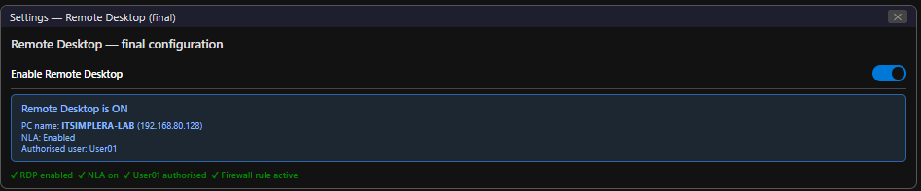

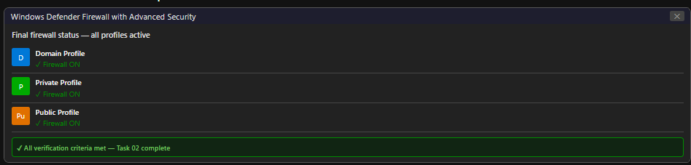

6. Challenges Faced

Challenge 1: RDP Not Available on Windows 10 Home
Symptom: After enabling Remote Desktop in System Settings, the toggle was greyed out or not present.
Resolution: This occurs when the VM is running Windows 10 Home edition. RDP server functionality requires Windows 10 Pro or higher. The fix was to upgrade the edition in the VM (using a Pro license key or a Pro ISO image). Alternatively, third-party remote access tools (VNC, TeamViewer) can be used on Home edition, though these are outside the scope of this task.
Challenge 2: UAC Prompt When Opening Computer Management
Symptom: Computer Management opened but the Local Users and Groups node was missing or greyed out.
Resolution: Computer Management must be opened as Administrator. Right-click the Start button → 'Computer Management' (this automatically opens with Admin privileges). If it still fails, run from an elevated command prompt: compmgmt.msc
Challenge 3: RDP Firewall Rule Not Created Automatically
Symptom: RDP was enabled but connection attempts failed. Investigation showed the firewall rule was disabled.
Resolution: Manually enabled the rule in Windows Defender Firewall with Advanced Security → Inbound Rules → right-click 'Remote Desktop - User Mode (TCP-In)' → Enable Rule.
Challenge 4: Password Complexity Rejection When Creating Accounts
Symptom: Simple passwords (e.g. 'password123') were rejected when creating user accounts.
Resolution: Windows 10 enforces password complexity by default in the local security policy. Passwords must contain at least three of the four categories: uppercase, lowercase, digits, and symbols. Used passwords meeting these requirements (e.g. P@ssw0rd2026!).

7. Learning Outcomes

Upon completing this task, the following skills and knowledge were acquired:
- Gained practical experience in Windows local user account management — creation, configuration, modification, and lifecycle management.
- Understood the Principle of Least Privilege (PoLP) and the importance of Standard User accounts in minimising security risk.
- Learned to differentiate between Administrator and Standard User account capabilities and security implications.
- Developed proficiency in account management operations: password reset, account rename, disable/enable, and property configuration.
- Understood the three Windows Firewall profiles (Domain, Private, Public) and their appropriate use cases.
- Explored the Windows Defender Firewall with Advanced Security interface, understanding inbound and outbound rule creation and management.
- Successfully enabled and configured Remote Desktop Protocol (RDP) with Network Level Authentication (NLA).
- Understood the security implications of RDP exposure and applied best practices (NLA, firewall rules, authorised user restriction).
- Developed systematic troubleshooting skills for common Windows administration issues.
- Built on the lab environment from Week 1, adding identity management and remote access capabilities that will support future tasks including Active Directory and Group Policy administration.

8. Conclusion

This task successfully implemented core Identity and Access Management capabilities on the Windows 10 virtual machine, extending the lab environment established in Week 1 with enterprise-grade user account management, firewall configuration, and remote access functionality.
The practical implementation covered the complete user account lifecycle — from creation with appropriate security settings, through administrative operations (renaming, password management, disable/enable), to final verification. The two Standard Local User Accounts (User01 and LabUser02) were configured following the Principle of Least Privilege, a foundational IAM concept in enterprise security.
Windows Defender Firewall was thoroughly explored, with all three profiles verified as active and the inbound/outbound rule architecture understood. The firewall's role as a host-based network defence layer was documented and its integration with RDP access control demonstrated.
Remote Desktop Protocol was successfully enabled with Network Level Authentication — the most important RDP security control — and access was scoped to a specific authorised user. This configuration mirrors real-world enterprise remote administration setups where access must be controlled, authenticated, and auditable.
The skills developed in this task — user provisioning, security policy awareness, firewall management, and secure remote access — form the operational foundation for all subsequent System Administration tasks, particularly Active Directory administration, Group Policy management, and Windows Server deployment scheduled for upcoming weeks.

9. References

- Microsoft Corporation. (2024). Manage local users, groups, and computers. Microsoft Learn. https://learn.microsoft.com/en-us/windows/security/identity-protection/access-control/local-accounts
- Microsoft Corporation. (2024). Remote Desktop — Allow access to your PC. Microsoft Learn. https://learn.microsoft.com/en-us/windows-server/remote/remote-desktop-services/clients/remote-desktop-allow-access
- Microsoft Corporation. (2024). Windows Defender Firewall with Advanced Security. Microsoft Learn. https://learn.microsoft.com/en-us/windows/security/threat-protection/windows-firewall/windows-firewall-with-advanced-security
- Microsoft Corporation. (2024). Network Level Authentication for Remote Desktop Services. Microsoft Learn. https://learn.microsoft.com/en-us/windows-server/remote/remote-desktop-services/clients/remote-desktop-allow-access
- National Institute of Standards and Technology. (2020). Digital Identity Guidelines (NIST SP 800-63B). NIST. https://doi.org/10.6028/NIST.SP.800-63b
- Microsoft Corporation. (2024). User Account Control overview. Microsoft Learn. https://learn.microsoft.com/en-us/windows/security/identity-protection/user-account-control/
- ITSimplera Institute. (2026). Week 2 — Task 02 Brief: Identity Management & Remote Access Configuration. System Administration & Infrastructure Services Internship.
10. Evaluation Criteria

Component | Marks | Status
Documentation (Professional report with screenshots) | 10 | ✓ Completed
LinkedIn Submission (Professional task post) | 50 | ✓ Completed
GitHub Repository / Documentation | 10 | ✓ Completed
Technical Interview (Google Meet) | 30 | Pending
Total | 100

Important Notes:
- All screenshots are original captures from my personal virtual machine.
- Every practical step was personally implemented — this is not an AI-generated report.
- LinkedIn post will be published upon task submission with professional documentation.
- GitHub repository contains the complete report PDF and implementation evidence.
- Technical interview readiness: can demonstrate all configurations live on request.


ITSimplera Institute
System Administration & Infrastructure Services Internship
Week 2 — Task 02 | Submitted: July 2026 | Deadline: July 12, 2026

