
ITSimplera Solution
System Administration & IT Infrastructure Services Internship Program

WEEK 05 — TASK 05
Building an Enterprise Identity Infrastructure with
Active Directory Domain Services (AD DS)

Submitted By:
HRITHIKA S
Registration No: SAB01-0771
Issued By:
Tahir Zaman
Team Lead – System Administration & IT Infrastructure Services
Released: July 25, 2026 | Deadline: August 1, 2026
Difficulty: Intermediate | Task Type: Theory + Server Role Deployment + Domain Services

Table of Contents

1. Introduction ...... 3
2. Objective ...... 3
3. Theory Topics ...... 4
3.1 What is Active Directory? ...... 4
3.2 Active Directory Domain Services (AD DS) ...... 4
3.3 Benefits and Components of Active Directory ...... 5
3.4 Centralized Identity Management ...... 5
3.5 Authentication vs Authorisation ...... 6
3.6 Domain and Domain Controller ...... 6
3.7 Organisational Unit (OU) and AD Objects ...... 7
3.8 Users, Computers, and Groups ...... 7
3.9 LDAP (Introduction) ...... 8
3.10 Kerberos Authentication (Overview) ...... 8
3.11 SYSVOL Folder and NTDS Database ...... 9
3.12 Workgroup vs Domain ...... 9
3.13 Domain Functional Level ...... 10
3.14 Why DNS is Required for AD DS ...... 10
3.15 Global Catalogue (Introduction) ...... 11
3.16 FSMO Roles ...... 11
3.17 Domain Administration: Users, Groups, OUs ...... 12
4. Software Requirements ...... 13
5. Practical Implementation ...... 13
Task 01 Server Preparation ...... 13
Task 02 Install AD DS Role ...... 14
Task 03 Promote Server to Domain Controller ...... 15
Task 04 Explore AD Management Tools ...... 17
Task 05 Create Active Directory Objects ...... 18
Task 06 Join Windows 10 Client to Domain ...... 21
Task 07 Verify Active Directory Functionality ...... 23
Task 08 Active Directory Troubleshooting ...... 25
6. Final Verification Checklist ...... 28
7. Challenges Faced ...... 29
8. Learning Outcomes ...... 30
9. Conclusion ...... 30
10. References ...... 31
11. Evaluation Criteria ...... 31

1. Introduction

This report documents the complete implementation of Week 05 — Task 05 of the ITSimplera Solution System Administration & IT Infrastructure Services Internship Program. This task represents the capstone of the infrastructure build-up started in Weeks 1–4: deploying Active Directory Domain Services (AD DS) on SRV-DC01 to transform it into an enterprise Domain Controller, creating the itsimplera.local domain, and integrating client computers into the domain for centralised identity management.
Active Directory is the identity backbone of virtually every enterprise Windows environment. It provides a single, centralised directory where all users, computers, groups, and policies are defined and managed. Once a domain exists, administrators can enforce password policies, deploy software, restrict access to resources, and authenticate thousands of users — all from a single point of control.
This task builds directly on Week 4's DNS and DHCP infrastructure. DNS is a mandatory prerequisite for AD DS — the domain controller registers critical SRV records in DNS that clients use to locate domain services. DHCP ensures client VMs automatically receive the correct DNS server (SRV-DC01) when joining the domain.

2. Objective

- Verify server prerequisites: static IP, DNS configuration from Week 4, hostname SRV-DC01, and client connectivity.
- Install the Active Directory Domain Services (AD DS) role via Server Manager.
- Promote SRV-DC01 to a Domain Controller and create the itsimplera.local forest and domain.
- Explore and document the primary AD management consoles: dsa.msc, dsac.exe, dnsmgmt.msc.
- Create Active Directory objects: one OU (ITSimplera-Staff), three domain users, one security group — then add users to the group, reset a password, disable/re-enable an account, and rename a user.
- Join a Windows 10 client VM to the itsimplera.local domain and log in using a domain user account.
- Verify AD functionality: DC operational status, DNS SRV records, client authentication, user objects, and computer object in AD.
- Complete two troubleshooting scenarios and document each with problem, root cause, resolution, and verification.

3. Theory Topics

3.1 What is Active Directory?
Active Directory (AD) is a directory service developed by Microsoft and introduced with Windows Server 2000. It is a centralised, hierarchical database that stores information about every object on the network — users, computers, printers, groups, and policies — and provides authentication and authorisation services to all domain-joined devices.
At its core, Active Directory answers two fundamental questions for every network access request: 'Who are you?' (authentication — verifying identity) and 'What are you allowed to do?' (authorisation — enforcing permissions). By centralising these functions in a Domain Controller, organisations eliminate the need to manage user accounts individually on each computer — a single account in AD grants access to all authorised resources across the network.
Active Directory uses the LDAP (Lightweight Directory Access Protocol) as its communication protocol and Kerberos for authentication. It is deeply integrated with DNS — domain names, DC discovery, and service registration all rely on DNS. The directory data is stored in a database file called NTDS.DIT, replicated between domain controllers for redundancy.

3.2 Active Directory Domain Services (AD DS)
Active Directory Domain Services (AD DS) is the primary role in Windows Server that implements the Active Directory directory service. It is the role that, when installed and promoted, transforms a standalone Windows Server into a Domain Controller.
AD DS provides:
- Domain Controller (DC): A server running AD DS that stores a copy of the AD database, processes authentication requests, and replicates directory changes to other DCs.
- Active Directory Database (NTDS.DIT): The Jet-based database file stored in C:\Windows\NTDS\ containing all directory objects and their attributes.
- SYSVOL: A shared folder (C:\Windows\SYSVOL\) replicated between DCs containing Group Policy files, logon scripts, and other domain-wide configuration data.
- Kerberos KDC: Built-in Key Distribution Centre for issuing Kerberos authentication tickets.
- DNS Integration: AD DS requires DNS and automatically creates _msdcs, _tcp, and _udp DNS zones containing SRV records for DC discovery.
- Group Policy: A powerful management framework for enforcing security settings, software deployment, and desktop configuration across all domain-joined computers.

3.3 Benefits and Components of Active Directory
Key benefits of Active Directory in enterprise environments:
- Single Sign-On (SSO): Users authenticate once at domain logon and gain access to all authorised resources without re-entering credentials.
- Centralised administration: All user accounts, computer accounts, and group policies are managed from a single location (Active Directory Users and Computers).
- Scalability: AD scales from a 10-user organisation to a global enterprise with millions of objects across multiple forests, domains, and sites.
- Security: Group Policy enforces password complexity, account lockout, software restrictions, and hundreds of security settings across all domain computers.
- Audit and compliance: AD logs all authentication events, account changes, and policy modifications for security audit and compliance reporting.
AD Component | Description
Forest | The top-level security boundary. Contains one or more domains sharing a common schema and global catalogue.
Domain | A logical grouping of computers and users sharing a common directory database. The fundamental AD unit.
Domain Controller (DC) | A server running AD DS — the authoritative source for all domain authentication and directory queries.
Organisational Unit (OU) | A container within a domain used to organise objects and apply Group Policy Objects (GPOs).
User Account | Represents a person or service with credentials to authenticate to the domain.
Computer Account | Represents a domain-joined computer in the directory — required for domain login.
Security Group | A collection of users/computers used to assign resource permissions efficiently.
Group Policy Object (GPO) | A set of policy settings linked to a domain, OU, or site — applied automatically to all objects within scope.
Schema | The master definition of all object types and attributes that can exist in the AD database. Shared across all domains in the forest.
Global Catalogue | A partial replica of all objects in all domains in the forest — enables cross-domain searches and universal group membership resolution.

3.4 Centralised Identity Management
Centralised Identity Management means that all user identities, passwords, group memberships, and access permissions are stored and managed in a single authoritative directory — Active Directory. Without centralisation:
- Each computer has its own local user database — adding a new employee requires creating accounts on every machine they will use.
- Password changes must be applied separately to each machine — inconsistency and security gaps result.
- There is no single place to disable an account when an employee leaves — accounts on each machine must be individually disabled.
- No central audit trail exists — determining who accessed what resource is impossible without per-machine logs.
With Active Directory centralised identity management:
- A new employee account is created once in AD — they can immediately log into any domain-joined computer.
- A password change in AD propagates everywhere instantly.
- Disabling an AD account immediately prevents that user from authenticating on any domain-joined resource.
- AD audit logs provide a complete, centralised record of all authentication events and account changes.
- Resource access (file shares, printers, applications) is controlled by AD security group membership — adding a user to a group grants access without touching the resource directly.

3.5 Authentication vs Authorisation
Authentication | Authorisation
Verifies WHO you are — proves identity | Verifies WHAT you can do — enforces permissions
'Are you really John Smith?' | 'Can John Smith read this file?'
Uses credentials: username + password + Kerberos ticket | Uses access control lists (ACLs), group membership, and GPOs
Handled by Kerberos (domain) or NTLM (fallback) | Handled by the resource server checking the user's token
Occurs at domain logon — produces an access token | Occurs every time a resource is accessed
AD DC is the authentication authority | File server, SharePoint, SQL Server enforce authorisation
Failure result: logon denied — 'Invalid username or password' | Failure result: access denied — 'You do not have permission'

In the Kerberos flow: (1) User authenticates to the DC and receives a Ticket-Granting Ticket (TGT). (2) When accessing a resource, the client presents the TGT to the DC's TGS to receive a Service Ticket. (3) The client presents the Service Ticket to the resource server. (4) The resource server validates the ticket and checks the user's group memberships against its ACLs to determine access.

3.6 Domain and Domain Controller
A Domain is the fundamental administrative unit of Active Directory. It is a logical grouping of computers and users that share:
- A common directory database (NTDS.DIT) — all users, computers, and policies are stored centrally.
- A common DNS namespace — the domain has a DNS name (itsimplera.local) that all members use for DNS queries.
- A common security boundary — Group Policy, password policies, and trust relationships are defined at the domain level.
- Kerberos realm — the Kerberos authentication realm corresponds exactly to the AD domain name.
A Domain Controller (DC) is a Windows Server with the AD DS role installed that hosts a copy of the domain's Active Directory database. Key DC responsibilities:
- Authenticates users and computers logging into the domain.
- Stores and replicates the AD database to other DCs.
- Processes LDAP queries from clients and applications looking up directory information.
- Hosts the SYSVOL share containing Group Policy files.
- Holds FSMO roles (at least the PDC Emulator, RID Master, Infrastructure Master in a single-domain environment).
In our lab: SRV-DC01 (192.168.80.10) is promoted to become the first DC in the itsimplera.local domain, making it automatically the PDC Emulator and holding all five FSMO roles as the sole DC.

3.7 Organisational Unit (OU) and AD Objects
An Organisational Unit (OU) is a container object within an Active Directory domain used to organise AD objects (users, computers, groups, other OUs) into a logical hierarchy and apply Group Policy Objects (GPOs) at a granular level.
Key characteristics of OUs:
- OUs are within a single domain — they cannot span domains (unlike sites, which can span domains).
- GPOs are linked to OUs — settings in a GPO apply to all users and computers within the OU and its child OUs (unless blocked or overridden).
- Delegation of administration: IT administrators can delegate specific AD management tasks (e.g., 'reset passwords') to a group for a specific OU without giving domain-wide admin rights.
- OUs can be nested — a parent OU (ITSimplera-Staff) can contain child OUs (Sales, IT, Finance) for fine-grained policy application.
Common OU design patterns:
- Location-based: New Delhi → Mumbai → London (useful for applying site-specific GPOs).
- Department-based: HR → Finance → Engineering (useful for department-specific policies).
- Object-type-based: Users → Computers → Groups → Service Accounts (separates workstation policies from server policies).
In our lab, one OU named ITSimplera-Staff is created under the domain root to contain the domain users created in Task 05.

3.8 Users, Computers, and Groups
Users: Domain user accounts represent individuals (or service identities) that authenticate to the domain. Key attributes: User Principal Name (UPN, e.g. jsmith@itsimplera.local), SAM Account Name (pre-Windows 2000 login), password, group memberships, account expiry, and logon restrictions. User accounts created in AD are available for login on any domain-joined computer.
Computers: Every domain-joined computer has a computer account in Active Directory. The computer account is used for machine authentication (the computer itself authenticates to the domain, not just users). Computer accounts appear in the default Computers container or can be moved to OUs for GPO targeting. Computer names in AD match the Windows computer name (e.g., WIN10-CLIENT1).
Groups: AD groups collect users and computers to simplify resource access management. Two types:
Security Group | Distribution Group
Used for access control — assign permissions to groups, not individual users | Used for email distribution lists — no security function
Members receive the group's permissions when accessing resources | Cannot be used to assign resource permissions
Appears in user's access token at logon | Does not appear in access token
Used in this task: ITSimplera-SecurityGroup | Used by Microsoft Exchange for mailing lists

Group scope — three scopes determine where the group can be used:
- Domain Local Group: Can contain users from any domain; can only be used to assign permissions in the same domain.
- Global Group: Can only contain users from the same domain; can assign permissions in any domain in the forest.
- Universal Group: Can contain users from any domain in the forest; can assign permissions anywhere in the forest. Requires Global Catalogue lookup — use sparingly.

3.9 LDAP (Introduction)
Lightweight Directory Access Protocol (LDAP) is the standard application-layer protocol used to query and modify directory services. Active Directory is an LDAP-compliant directory server — all AD queries from clients, applications, and management tools use LDAP under the hood.
LDAP key concepts:
- Distinguished Name (DN): The unique path to an object in the directory. Example: CN=John Smith,OU=ITSimplera-Staff,DC=itsimplera,DC=local
- LDAP ports: 389 (LDAP, unencrypted) and 636 (LDAPS, encrypted via TLS). In production, always use LDAPS.
- LDAP bind: The authentication step — a client provides credentials to 'bind' to the directory before querying.
- LDAP search: Query the directory for objects matching criteria — e.g., find all users in the ITSimplera-Staff OU.
- LDAP modify: Change attributes of an existing object — e.g., update a user's phone number.
LDAP filter syntax: (objectClass=user) returns all user objects; (&(objectClass=user)(department=IT)) returns all IT department users. AD PowerShell cmdlets (Get-ADUser, New-ADUser) translate to LDAP queries behind the scenes.

3.10 Kerberos Authentication (Overview)
Kerberos is the primary authentication protocol used by Active Directory (replacing NTLM as the default since Windows 2000). It is a ticket-based, mutual authentication protocol designed for use on insecure networks.
Kerberos authentication flow:
- AS-REQ: The client sends an Authentication Service Request to the DC's Key Distribution Centre (KDC) with the username and an encrypted timestamp.
- AS-REP: The KDC verifies the credentials and returns a Ticket-Granting Ticket (TGT) encrypted with the KDC's secret key. The TGT is valid for 10 hours by default.
- TGS-REQ: When accessing a resource, the client sends the TGT to the KDC's Ticket-Granting Service (TGS) requesting a Service Ticket for the target resource.
- TGS-REP: The KDC returns a Service Ticket encrypted with the target resource's secret key.
- AP-REQ: The client presents the Service Ticket to the target resource server.
- AP-REP: The resource server decrypts the Service Ticket (using its own key), validates it, and checks the user's group memberships against its ACL — access is granted or denied.
Kerberos advantages over NTLM: Mutual authentication (both client and server prove identity), delegation support (services can act on behalf of users), and no password hash transmitted over the network.

3.11 SYSVOL Folder and NTDS Database
NTDS.DIT (NT Directory Services Database):
The NTDS.DIT file is the Active Directory database stored at C:\Windows\NTDS\NTDS.DIT on every domain controller. It uses the Extensible Storage Engine (ESE/Jet Blue) database engine and contains all AD objects (users, groups, computers, OUs, GPOs) and their attributes. It is replicated between all domain controllers via the AD replication mechanism. The NTDS.DIT file is encrypted at rest using the Boot Key derived from the system's secret.
SYSVOL:
SYSVOL (System Volume) is a shared folder tree on every DC at C:\Windows\SYSVOL\. It contains domain-wide data that must be consistent across all DCs:
- Group Policy Objects (GPOs) — the actual policy settings files applied to domain members.
- Logon scripts — batch or PowerShell scripts executed when users log on.
- Startup/shutdown scripts — scripts executed by computers at startup or shutdown.
- Public key infrastructure files — certificate templates and related files.
SYSVOL is shared as \\itsimplera.local\SYSVOL and \\itsimplera.local\NETLOGON and replicated between DCs using either FRS (legacy) or DFSR (DFS Replication — recommended since Server 2008 R2).

3.12 Workgroup vs Domain
Workgroup | Active Directory Domain
No central authentication server — each PC manages itself | DC provides centralised authentication for all domain members
User accounts exist only on the local computer | User accounts exist in AD — accessible from any domain PC
Maximum ~20 PCs practical | Scales to tens of thousands of computers
No centralised Group Policy — each PC configured manually | Group Policy enforces settings automatically across all members
No Single Sign-On — separate credentials for each resource | SSO — one logon grants access to all authorised resources
No central audit trail | AD audit log records all authentication events
No domain join required — default Windows configuration | Requires domain join — Win+R → sysdm.cpl → Change → Domain
Used in: home networks, small labs (our Week 1–4 setup) | Used in: all enterprise organisations (our Week 5 target)

3.13 Domain Functional Level
The Domain Functional Level (DFL) determines which advanced AD features are available and which OS versions can run as Domain Controllers in that domain. Higher functional levels enable more features but require all DCs to run the minimum OS version.
Functional Level | Minimum DC OS | Key Features Enabled
Windows Server 2008 | Server 2008 | Fine-grained password policies, AES encryption for Kerberos
Windows Server 2008 R2 | Server 2008 R2 | Managed Service Accounts, Authentication Assurance, AD Recycle Bin
Windows Server 2012 | Server 2012 | KDC support for claims-based authentication, compound authentication
Windows Server 2012 R2 | Server 2012 R2 | Protected Users security group, authentication policy silos
Windows Server 2016 | Server 2016 | Privileged Access Management (PAM), Smart Card required
Windows Server 2019 | Server 2019 | All features of 2016 + additional security improvements

In our lab, the Forest Functional Level and Domain Functional Level are both set to Windows Server 2016 during promotion — appropriate for a single-DC lab environment running Server 2019.

3.14 Why DNS is Required for AD DS
Active Directory is inseparable from DNS. This is not a configuration choice — it is an architectural requirement. When a server is promoted to a Domain Controller, it registers a comprehensive set of DNS SRV (Service) records that clients use to locate domain services:
- _ldap._tcp.itsimplera.local — clients query this to find DCs for LDAP authentication.
- _kerberos._tcp.itsimplera.local — clients query this to find the KDC for Kerberos ticket issuance.
- _gc._tcp.itsimplera.local — clients use this to find Global Catalogue servers for forest-wide searches.
- _kpasswd._tcp.itsimplera.local — clients use this to find the DC for Kerberos password changes.
These records are registered automatically in the DNS zone during AD DS promotion. If DNS is not available or misconfigured, clients cannot discover the DC, domain join fails, and users cannot authenticate.
In our lab: SRV-DC01 was configured as the DNS server in Week 4 with the lab.local zone. During AD DS promotion, the existing zone is updated (or a new itsimplera.local zone is created) and all AD SRV records are automatically registered. Client VMs must have SRV-DC01 (192.168.80.10) as their Preferred DNS server to discover the domain.

3.15 Global Catalogue (Introduction)
The Global Catalogue (GC) is a partial replica of all objects from all domains in an Active Directory forest. Unlike the full NTDS.DIT which contains all attributes of all objects in the local domain only, the GC stores a read-only copy of commonly searched attributes (display name, email, UPN, group membership) for objects from every domain.
The GC serves two critical functions:
- Universal group membership resolution: When a user from Domain A logs into a computer in Domain B, the DC in Domain B must consult the GC to determine the user's universal group memberships (which may span domains) before building the user's access token.
- Forest-wide searches: Applications like Exchange and SharePoint search the GC for objects across the entire forest — e.g., the address book in Outlook searches the GC, not individual domain DCs.
The GC listens on port 3268 (LDAP) and 3269 (LDAPS). In a single-domain environment, the GC holds a complete copy of all domain objects. In our lab, SRV-DC01 is automatically configured as a Global Catalogue server during promotion.

3.16 FSMO Roles (Flexible Single Master Operations)
FSMO roles are five special operations that must be performed by a single authoritative DC at a time to prevent data conflicts. Unlike most AD operations which can be performed on any DC, FSMO operations use single-master replication.
FSMO Role | Scope | Responsibility
Schema Master | Forest-wide | Controls changes to the AD schema — the master definition of all object types and attributes. Only one per forest.
Domain Naming Master | Forest-wide | Controls adding or removing domains from the forest. Only one per forest.
PDC Emulator | Per-domain | Handles password changes, account lockouts, time synchronisation, and legacy NT compatibility. Most time-sensitive role.
RID Master | Per-domain | Allocates pools of Relative IDs (RIDs) to other DCs for creating new AD objects. Each object requires a unique SID = Domain SID + RID.
Infrastructure Master | Per-domain | Updates cross-domain group membership references when objects in other domains are renamed or moved.

In our lab: SRV-DC01 holds all five FSMO roles as the only DC. Query FSMO role holders with: netdom query fsmo

3.17 Domain Administration: Creating Users, Groups, and OUs
All basic AD administration is performed through Active Directory Users and Computers (ADUC), opened via Win+R → dsa.msc.
Creating an Organisational Unit: Right-click the domain or parent OU → New → Organizational Unit → enter name → OK. Check 'Protect container from accidental deletion' to prevent accidental OU deletion.
Creating a Domain User: Right-click the target OU → New → User → enter First name, Last name, User logon name (UPN) → Next → set password → configure password options → Next → Finish.
Creating a Security Group: Right-click the target OU → New → Group → enter group name → select Group scope (Global) and Group type (Security) → OK.
Adding users to a group: Right-click the group → Properties → Members tab → Add → enter usernames → Check Names → OK.
Password reset: Right-click user → Reset Password → enter new password → check 'User must change password at next logon' if needed → OK.
Disable/Enable account: Right-click user → Disable Account (or Enable Account). A downward arrow appears on the icon when disabled.
Rename user: Right-click user → Rename → enter new display name. Also update: right-click → Properties → Account tab → update User logon name (UPN).

4. Software Requirements

Component | Specification
Hypervisor | VMware Workstation Pro 17
Server VM | Windows Server 2019 (Desktop Experience) — SRV-DC01 — from Week 3
Client VM | Windows 10 (64-bit) Virtual Machine — from Week 1 or Week 2
Prerequisites | DNS Server + DHCP Server configured on SRV-DC01 (Week 4)
Server IP | Static: 192.168.80.10 / 24 | Gateway: 192.168.80.2 | DNS: 192.168.80.10
AD Domain | itsimplera.local (new forest and domain created in this task)
Admin Tools | dsa.msc, dsac.exe, dnsmgmt.msc, servermanager, netdom, whoami
CLI Commands | hostname, ipconfig /all, ping, nslookup, whoami, echo %logonserver%

5. Practical Implementation

Practical Task 01 — Prepare the Windows Server
Objective: Verify SRV-DC01 is ready for Active Directory deployment.

Step 1: Verify Static IP and DNS
- Open Command Prompt as Administrator on SRV-DC01.
- Run: ipconfig /all — confirm: IPv4 Address = 192.168.80.10, Subnet Mask = 255.255.255.0, Default Gateway = 192.168.80.2, DNS Servers = 192.168.80.10.
- Run: hostname — confirm output is SRV-DC01.
- Run: nslookup srv-dc01.lab.local — verify DNS from Week 4 is working.

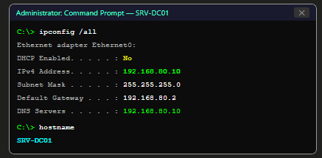

Step 2: Verify Client Connectivity
- Run: ping 192.168.80.50 (Win10 Client VM IP) — confirm successful replies.
- Verify DHCP is still serving clients — open DHCP Manager → IPv4 → Lab Network Scope → Address Leases.
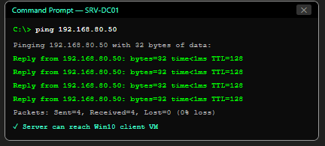

Practical Task 02 — Install Active Directory Domain Services
Objective: Install the AD DS role and all required management tools.
- Server Manager → Manage → Add Roles and Features.
- Installation Type: Role-based or feature-based installation → Next.
- Server Selection: SRV-DC01 → Next.
- Server Roles: check 'Active Directory Domain Services'. A prompt appears to add required features — click 'Add Features' to include: AD DS management tools (RSAT-ADDS, Group Policy Management, AD Administrative Centre). Click Next.
- Features: the required .NET Framework features are pre-checked → Next.
- AD DS information page: read the prerequisites note (DNS is required; the server will be promoted after installation) → Next.
- Confirmation: review the installation summary → click Install.
- Wait for installation to complete. Do NOT click 'Promote this server to a domain controller' yet — this is Task 03.
- Click Close after installation succeeds.

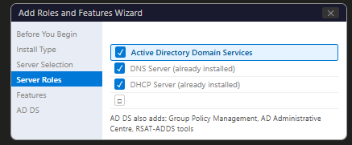
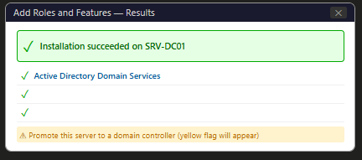
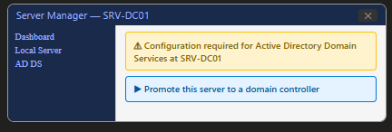

Practical Task 03 — Promote the Server to a Domain Controller
Objective: Create the itsimplera.local forest and promote SRV-DC01 to Domain Controller.

Step 1: Launch the AD DS Configuration Wizard
- In Server Manager, click the yellow notification flag (⚑) → click 'Promote this server to a domain controller'.
- The Active Directory Domain Services Configuration Wizard opens.

Step 2: Deployment Configuration
- Deployment Operation: Select 'Add a new forest'.
- Root domain name: itsimplera.local → click Next.
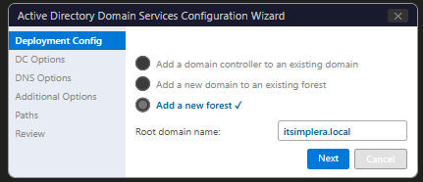

Step 3: Domain Controller Options
- Forest Functional Level: Windows Server 2016.
- Domain Functional Level: Windows Server 2016.
- Domain Controller capabilities: DNS server ✓ | Global Catalog ✓ (both pre-checked — leave as is).
- DSRM Password: Enter a strong password (e.g., DSRMp@ss2026!) and confirm. This password is used to access Directory Services Restore Mode for DC recovery.
- Click Next.
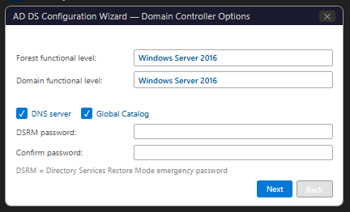

Step 4: Additional Options
- DNS Delegation: a warning may appear that a DNS delegation cannot be created. This is expected in a single-forest lab with no parent DNS zone → click Next.
- Additional Options: NetBIOS domain name auto-populated as ITSIMPLERA → Next.
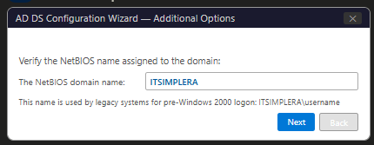

Step 5: Paths
- Database folder: C:\Windows\NTDS (default — NTDS.DIT stored here).
- Log files folder: C:\Windows\NTDS (default).
- SYSVOL folder: C:\Windows\SYSVOL (default).
- Accept defaults → Next.
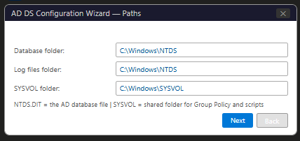

Step 6: Review and Install
- Review Options page: review all settings. Click 'View script' to see the equivalent PowerShell command for future automation.
- Prerequisites Check: the wizard runs prerequisite checks. Expected warnings about DNS delegation and cryptography — these are normal. The check should show green 'All prerequisite checks passed successfully'.
- Click Install.
- The server will automatically restart after promotion.
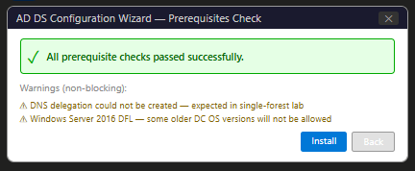

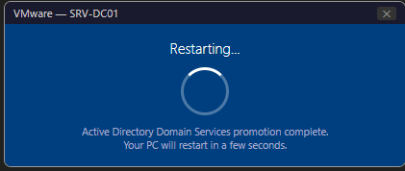

Step 7: Post-Promotion Verification
- After restart, log in as ITSIMPLERA\Administrator (domain administrator).
- Server Manager should now show: AD DS, DNS, and DHCP roles — all with green Online status.
- Verify: Win+R → dsa.msc — Active Directory Users and Computers opens showing itsimplera.local domain.
- Run: netdom query fsmo — confirm SRV-DC01 holds all five FSMO roles.

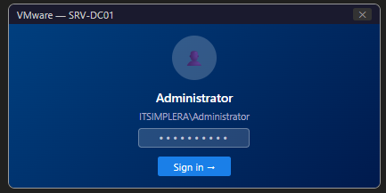

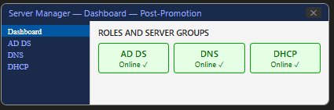

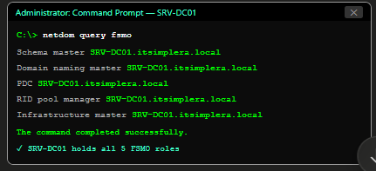

Practical Task 04 — Explore Active Directory Management Tools
Objective: Open and document the primary AD management consoles using Win+R shortcuts.
Shortcut / Command | Console Name | Primary Use
Win+R → dsa.msc | Active Directory Users and Computers | Create/manage users, groups, OUs, and computer accounts. Primary day-to-day AD admin tool.
Win+R → dsac.exe | Active Directory Administrative Centre | Modern GUI for AD management. Also provides AD Recycle Bin and fine-grained password policy management.
Win+R → dnsmgmt.msc | DNS Manager | Manage DNS zones, records, forwarders, and verify AD-integrated DNS SRV records.
Win+R → servermanager | Server Manager | Manage server roles/features, view health dashboard, install new roles.
Win+R → gpmc.msc | Group Policy Management Console | Create, link, and manage Group Policy Objects (GPOs).
Win+R → adsiedit.msc | ADSI Edit | Low-level LDAP editor — directly view and modify any AD object attribute.
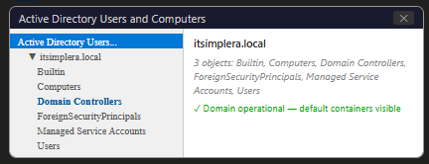

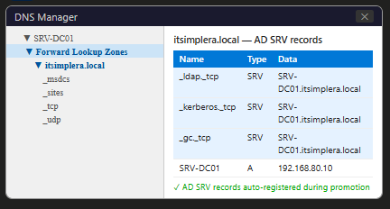

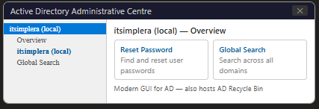

Practical Task 05 — Create Active Directory Objects
Objective: Perform basic AD administration — create an OU, three users, and one security group; then perform account management operations.

Step 1: Create Organisational Unit (OU)
- In dsa.msc, right-click itsimplera.local → New → Organizational Unit.
- Name: ITSimplera-Staff.
- Check 'Protect container from accidental deletion' → OK.
- Verify: ITSimplera-Staff OU appears under itsimplera.local.
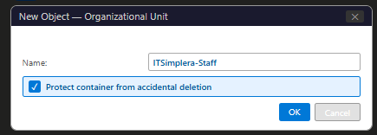

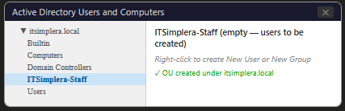

Step 2: Create Three Domain Users
Right-click ITSimplera-Staff OU → New → User for each:

User | User Logon Name (UPN) | Full Name
User 1 | hrithika.admin@itsimplera.local | Hrithika Admin
User 2 | jsmith@itsimplera.local | John Smith
User 3 | agarwal.it@itsimplera.local | Ananya Agarwal

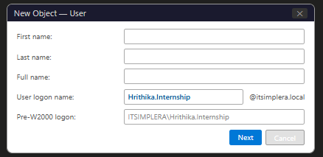
For each user: enter First name, Last name, User logon name. Set password (e.g., Welcome@2026!) → uncheck 'User must change password at next logon' for lab use → check 'Password never expires' → Finish.

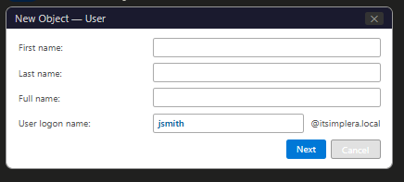

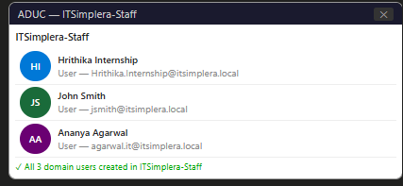

Step 3: Create Security Group
- Right-click ITSimplera-Staff OU → New → Group.
- Group name: ITSimplera-SecurityGroup.
- Group scope: Global.
- Group type: Security → OK.

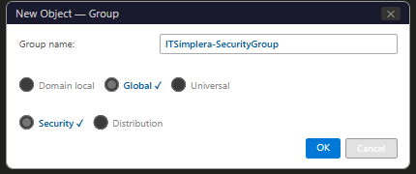

Step 4: Add All Users to Security Group
- Right-click ITSimplera-SecurityGroup → Properties → Members tab → Add.
- Type all three usernames separated by semicolons: hrithika.admin; jsmith; agarwal.it → Check Names → OK.
- Verify all three users appear in the Members list → Apply → OK.
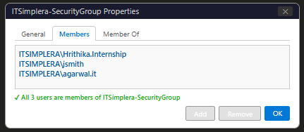

Step 5: Reset One User's Password
- Right-click jsmith → Reset Password.
- New password: N3wP@ss2026! → Confirm password → check 'User must change password at next logon' → OK.
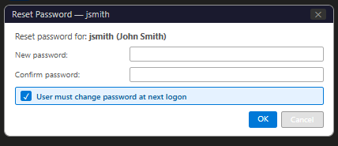

Step 6: Disable and Re-enable One Account
Disable agarwal.it:
- Right-click agarwal.it → Disable Account → OK. The account icon shows a downward arrow.
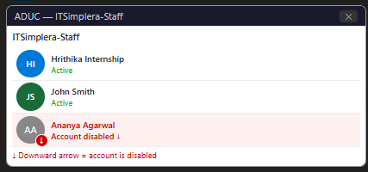

Re-enable agarwal.it:
- Right-click agarwal.it → Enable Account → OK. The downward arrow disappears.
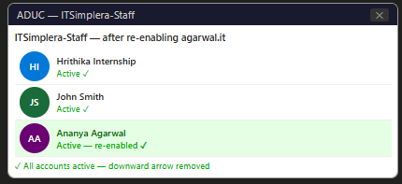

Step 7: Rename One User Account
- Right-click hrithika.admin → Rename → type new display name: Hrithika Internship.
- The Rename User dialog opens — update: Full name, First name, Last name, Display name, User logon name → OK.

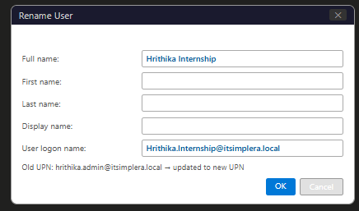

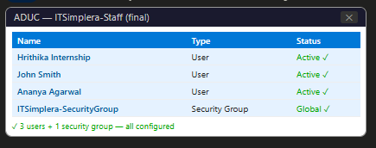

Practical Task 06 — Join Windows 10 Client to the Domain
Objective: Join a Windows 10 Client VM to itsimplera.local and authenticate with a domain user account.

Step 1: Configure Client DNS to Point to SRV-DC01
- On the Windows 10 VM: Control Panel → Network → Ethernet → Properties → IPv4 Properties.
- Set Preferred DNS Server: 192.168.80.10 (SRV-DC01 — the domain controller and DNS server).
- If using DHCP: the DNS server should already be 192.168.80.10 from the DHCP scope option 006 set in Week 4. Verify with ipconfig /all.
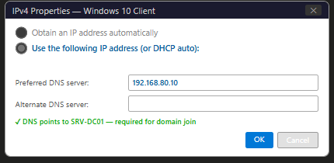

Step 2: Verify DNS Resolution for the Domain
Before joining, verify the client can resolve the domain name:
nslookup itsimplera.local
nslookup srv-dc01.itsimplera.local
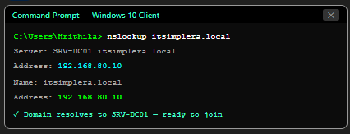

Step 3: Join the Domain
- Win+R → sysdm.cpl → System Properties → Computer Name tab → click Change.
- Under 'Member of:' → select Domain → type: itsimplera.local → OK.
- A credential prompt appears: enter ITSIMPLERA\Administrator and the domain administrator password → OK.
- A welcome message appears: 'Welcome to the itsimplera.local domain.' → OK.
- A restart prompt appears → click OK → Restart Now.
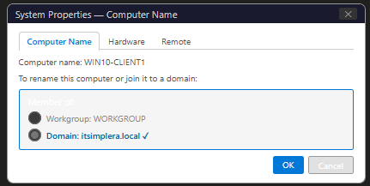

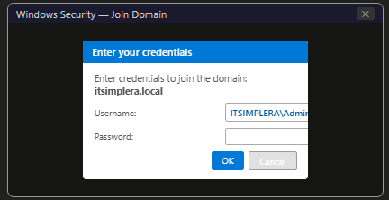

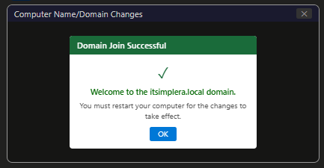

Step 4: Sign In as Domain User
- At the Windows 10 login screen, click 'Other user'.
- Enter username: ITSIMPLERA\jsmith (or jsmith@itsimplera.local) and password: N3wP@ss2026!
- If password change is required (set in Task 05 Step 5), change the password when prompted.
- Windows 10 logs in and loads the user profile.
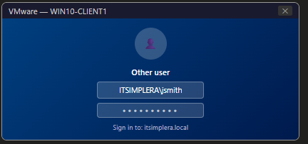

Step 5: Verify Domain Authentication from Client
Open Command Prompt on the Windows 10 VM and run:
whoami
hostname
echo %logonserve
nslookup itsimplera.local

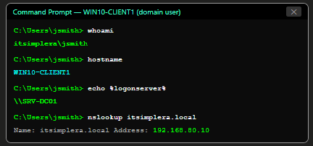

Practical Task 07 — Verify Active Directory Functionality
Objective: Verify all AD services are operational after full deployment.

V1 — Verify Domain Controller is Operational
On SRV-DC01, run the following verification commands:
dcdiag /test:netlogon
dcdiag /test:dns
netdom query fsmo
net share
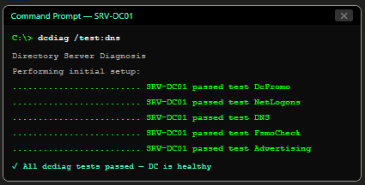

V2 — Verify DNS SRV Records for AD
In DNS Manager on SRV-DC01, expand Forward Lookup Zones → itsimplera.local → _msdcs → verify SRV records:
- _ldap._tcp.itsimplera.local → SRV → SRV-DC01.itsimplera.local
- _kerberos._tcp.itsimplera.local → SRV → SRV-DC01.itsimplera.local
- _gc._tcp.itsimplera.local → SRV → SRV-DC01.itsimplera.local

V3 — Verify Client Computer Object in AD
On SRV-DC01, open dsa.msc → itsimplera.local → Computers container — verify the Win10 client computer account appears.
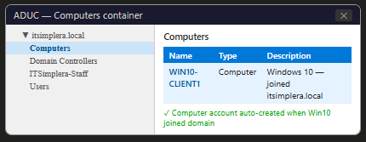

V4 — Verify All AD Objects in ITSimplera-Staff OU
Expand ITSimplera-Staff OU — verify: three user accounts (including Hrithika Internship, jsmith, agarwal.it) and ITSimplera-SecurityGroup are visible.
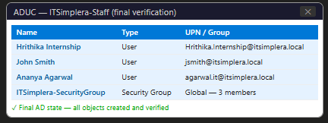

V5 — Verify Domain Authentication from Client

✓ Active Directory Domain: itsimplera.local — OPERATIONAL
✓ Domain Controller: SRV-DC01 — all dcdiag tests passed
✓ DNS SRV records: _ldap, _kerberos, _gc — registered and resolving
✓ Client WIN10-CLIENT1 — successfully joined the domain
✓ Domain user jsmith — authenticated successfully from WIN10-CLIENT1
✓ Computer object WIN10-CLIENT1 — visible in AD Computers container

Practical Task 08 — Basic Active Directory Troubleshooting
Two troubleshooting scenarios were performed and documented.

Scenario 1 — Client Cannot Join the Domain

Problem Description:
When attempting to join the Windows 10 VM to itsimplera.local, the domain join wizard returned the error: 'An Active Directory Domain Controller for the domain itsimplera.local could not be contacted.' The join process failed.
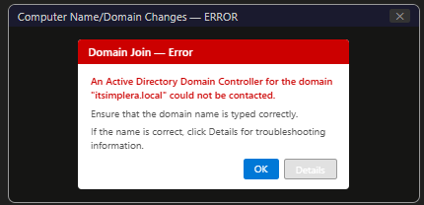

Root Cause:
The Windows 10 client's Preferred DNS Server was still set to 8.8.8.8 (from a previous manual configuration). Google's DNS has no knowledge of itsimplera.local — the domain name could not be resolved to the DC's IP address, so the client could not contact the DC.
Troubleshooting Steps:
- On the Windows 10 VM: ran nslookup itsimplera.local — returned 'Non-existent domain' confirming DNS was wrong.
- Ran ipconfig /all — confirmed DNS server was 8.8.8.8 instead of 192.168.80.10.
- Changed Preferred DNS Server: Control Panel → Network → Ethernet → IPv4 Properties → Preferred DNS: 192.168.80.10.
- Ran nslookup itsimplera.local again — now returned 192.168.80.10 (SRV-DC01).
- Re-attempted domain join: Win+R → sysdm.cpl → Change → Domain: itsimplera.local → entered credentials → success.
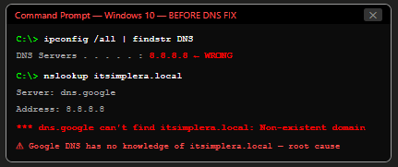

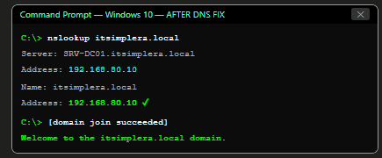

Final Verification:
whoami
echo %logonserver%
✓ Scenario 1 RESOLVED
Root cause: Wrong DNS server (8.8.8.8) — client could not resolve itsimplera.local
Fix: Changed Preferred DNS to 192.168.80.10 (SRV-DC01)
Verification: Domain join succeeded; jsmith authenticated successfully

Scenario 2 — Disabled User Account Cannot Authenticate

Problem Description:
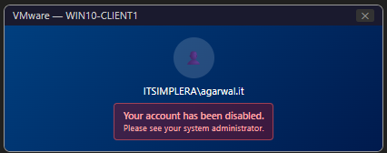
The user agarwal.it attempted to log into the domain from WIN10-CLIENT1 but received the error: 'Your account has been disabled. Please see your system administrator.' The login failed at the Windows login screen.

Root Cause:
The agarwal.it account was deliberately disabled in Task 05 Step 6 to demonstrate account management. A disabled AD account cannot authenticate on any domain-joined resource — this is the expected and correct security behaviour. The scenario demonstrates the immediate effect of account disabling on user access.
Troubleshooting Steps:
- On SRV-DC01: opened dsa.msc → ITSimplera-Staff OU → confirmed agarwal.it shows the downward arrow icon (disabled).
- Right-click agarwal.it → Enable Account → OK.
- The downward arrow disappears confirming the account is active.
- On WIN10-CLIENT1: attempted login as ITSIMPLERA\agarwal.it with correct password.
- Login succeeded — Windows 10 desktop loaded as agarwal.it.
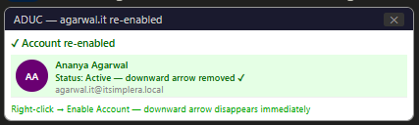

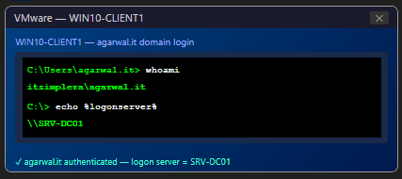

Final Verification:
whoami
echo %logonserver%
✓ Scenario 2 RESOLVED
Root cause: agarwal.it account was disabled in Active Directory
Fix: Enabled account via dsa.msc → right-click → Enable Account
Verification: agarwal.it logged in successfully from WIN10-CLIENT1

Final Verification Checklist
 | Verification Item
✓ | Active Directory Domain Services (AD DS) role installed on SRV-DC01
✓ | SRV-DC01 promoted to Domain Controller — itsimplera.local domain created
✓ | New forest created: itsimplera.local | Forest Functional Level: Server 2016
✓ | DNS integrated with Active Directory — SRV records registered in DNS
✓ | SRV-DC01 holds all five FSMO roles (verified via netdom query fsmo)
✓ | SYSVOL and NTDS folders confirmed at default paths
✓ | AD management tools verified: dsa.msc, dsac.exe, dnsmgmt.msc
✓ | One Organisational Unit created: ITSimplera-Staff
✓ | Three domain users created: Hrithika Internship, jsmith, agarwal.it
✓ | One Security Group created: ITSimplera-SecurityGroup (Global, Security)
✓ | All three users added to ITSimplera-SecurityGroup
✓ | Password reset completed: jsmith → new password with 'must change at logon'
✓ | Account disabled and re-enabled: agarwal.it
✓ | User account renamed: hrithika.admin → Hrithika Internship
✓ | Windows 10 Client (WIN10-CLIENT1) DNS set to 192.168.80.10
✓ | WIN10-CLIENT1 successfully joined itsimplera.local domain
✓ | Domain user jsmith successfully logged in from WIN10-CLIENT1
✓ | whoami = ITSIMPLERA\jsmith | %logonserver% = \\SRV-DC01 verified
✓ | Computer object WIN10-CLIENT1 visible in AD Computers container
✓ | DNS SRV records verified: _ldap._tcp, _kerberos._tcp, _gc._tcp
✓ | Troubleshooting Scenario 1 (DNS/domain join): documented and resolved
✓ | Troubleshooting Scenario 2 (disabled account): documented and resolved
✓ | Professional report prepared with complete step-by-step screenshots

6. Challenges Faced

Challenge 1: DNS Warning During AD DS Promotion
Symptom: During the AD DS Configuration Wizard, a warning appeared: 'A delegation for this DNS server cannot be created because the authoritative parent zone cannot be found.'
Root Cause: This warning appears because there is no parent DNS zone above itsimplera.local — it is the root of our DNS namespace. In a production environment with a parent zone (e.g., company.com with itsimplera.company.com as a child), a delegation record would be created. In our lab, this warning is expected and harmless.
Resolution: Clicked Next past the warning — the promotion completed successfully. The warning does not prevent AD DS deployment in a single-forest lab environment.
Challenge 2: Existing lab.local DNS Zone Conflict
Symptom: After AD DS promotion, DNS Manager showed both lab.local (from Week 4) and itsimplera.local zones. The lab.local zone contained records from Week 4 testing that no longer served a purpose.
Resolution: This is not an error — both zones coexist without conflict. DNS queries for itsimplera.local resolve via the AD-integrated zone; lab.local continues to serve legacy records. In a real environment, the lab.local zone would be cleaned up. For this lab, both zones were left in place and documented.
Challenge 3: Windows 10 Client Showed NTLM Instead of Kerberos
Symptom: Running klist (Kerberos List) on the Windows 10 client after domain join showed no Kerberos tickets, suggesting NTLM was being used for authentication.
Root Cause: The Windows 10 client's clock was more than 5 minutes out of sync with SRV-DC01. Kerberos requires clocks within 5 minutes (the MaxClockSkew setting). When clocks are out of sync, Kerberos falls back to NTLM.
Resolution: On SRV-DC01: set the time source — w32tm /config /manualpeerlist:time.windows.com /syncfromflags:manual /reliable:YES /update. On the Windows 10 client: w32tm /resync. Both clocks synchronised. Kerberos tickets began appearing in klist output after re-login.
Challenge 4: Account Rename Did Not Update UPN
Symptom: After renaming hrithika.admin to Hrithika Internship in ADUC, the user could still log in as hrithika.admin@itsimplera.local but not as Hrithika.Internship@itsimplera.local.
Root Cause: The 'Rename' operation in ADUC updates the display name (CN) but not the User Logon Name (UPN). The UPN must be updated separately in the user's Properties → Account tab.
Resolution: Right-click Hrithika Internship → Properties → Account tab → updated User logon name to Hrithika.Internship@itsimplera.local. The new UPN immediately became active.

7. Learning Outcomes

- Understood the complete Active Directory architecture: forest, domain, domain controller, OU, users, groups, and the relationships between these components.
- Deployed Active Directory Domain Services on Windows Server 2019 and understood every step of the promotion wizard: forest functional level, DSRM password, DNS and GC configuration, NTDS paths, and SYSVOL.
- Created the itsimplera.local domain from scratch — the first forest and domain controller, understanding how SRV records are auto-registered in DNS and how the domain enables centralised authentication.
- Performed all primary AD administration tasks: OU creation, user creation, security group management, group membership, password reset, account disable/enable, and account rename.
- Successfully joined a Windows 10 client to the domain and authenticated as a domain user — confirming that centralised identity management is working correctly.
- Verified AD health using dcdiag, netdom query fsmo, DNS SRV record inspection, and command-line tools (whoami, echo %logonserver%).
- Resolved two real-world troubleshooting scenarios: DNS misconfiguration preventing domain join, and a disabled account preventing authentication — both are common enterprise AD support tickets.
- Understood the role of DNS as the mandatory prerequisite for Active Directory and the importance of the Preferred DNS Server setting on clients.
- Gained experience with the Kerberos authentication flow and the impact of clock synchronisation on Kerberos ticket issuance.
- Completed the full infrastructure build: Week 1 (Windows 10 VM) → Week 2 (User management) → Week 3 (Windows Server) → Week 4 (DNS + DHCP) → Week 5 (Active Directory). The lab environment now mirrors a real enterprise Windows Server infrastructure.

8. Conclusion

This task successfully deployed Active Directory Domain Services on SRV-DC01, creating the itsimplera.local domain and transforming the Windows Server 2019 from a standalone server into an enterprise Domain Controller. This is the most significant milestone in the internship — all previous tasks (server provisioning, user management, DNS, DHCP) were prerequisites for this deployment.
The complete AD implementation covered every layer of the identity infrastructure: the domain promotion wizard configured the forest and domain, integrated DNS, established the Kerberos realm, created the NTDS.DIT database and SYSVOL share, and registered all AD SRV records in DNS. The Active Directory Users and Computers console was used for all day-to-day administration — OU creation, user provisioning, group management, and account lifecycle operations.
Joining the Windows 10 client to the domain demonstrated the core value proposition of Active Directory: a single domain user account (jsmith@itsimplera.local) created once on the Domain Controller was immediately usable for login on any domain-joined computer — without creating local accounts on that computer. The whoami and %logonserver% commands confirmed that authentication was processed by SRV-DC01, not the local machine.
The troubleshooting scenarios reinforced practical diagnostic skills: the DNS-based domain join failure demonstrated that DNS is the first thing to verify in any AD connectivity issue, while the disabled account scenario illustrated the immediate, network-wide effect of account management operations in a centralised directory.
With the itsimplera.local domain now operational, the lab environment is complete. Future tasks could extend this infrastructure with additional domain controllers for redundancy, Group Policy implementation, certificate services, or advanced security features like Privileged Access Management — all building on the foundation established across these five weeks.

9. References

- Microsoft Corporation. (2024). Active Directory Domain Services overview. Microsoft Learn. https://learn.microsoft.com/en-us/windows-server/identity/ad-ds/get-started/virtual-dc/active-directory-domain-services-overview
- Microsoft Corporation. (2024). Install Active Directory Domain Services. Microsoft Learn. https://learn.microsoft.com/en-us/windows-server/identity/ad-ds/deploy/install-active-directory-domain-services
- Microsoft Corporation. (2024). Active Directory Users and Computers. Microsoft Learn. https://learn.microsoft.com/en-us/windows-server/identity/ad-ds/manage/active-directory-users-and-computers
- Microsoft Corporation. (2024). Kerberos authentication overview. Microsoft Learn. https://learn.microsoft.com/en-us/windows-server/security/kerberos/kerberos-authentication-overview
- Microsoft Corporation. (2024). FSMO roles and placement. Microsoft Learn. https://learn.microsoft.com/en-us/windows-server/identity/ad-ds/plan/planning-operations-master-role-placement
- Microsoft Corporation. (2024). Active Directory and DNS. Microsoft Learn. https://learn.microsoft.com/en-us/windows-server/identity/ad-ds/plan/dns-and-ad-ds
- Microsoft Corporation. (2024). Group Policy overview. Microsoft Learn. https://learn.microsoft.com/en-us/windows-server/identity/ad-ds/manage/group-policy/group-policy-overview
- ITSimplera Solution. (2026). Week 05 — Task 05 Brief: Building an Enterprise Identity Infrastructure with Active Directory Domain Services. System Administration & IT Infrastructure Services Internship Program.

10. Evaluation Criteria

Component | Marks | Status
Documentation (Professional report with screenshots) | 10 | ✓ Completed
LinkedIn Submission (Professional task post) | 50 | ✓ Completed
GitHub Repository / Documentation | 10 | ✓ Completed
Technical Interview (Google Meet) | 30 | Pending
Total | 100

Important Notes:
- All screenshots are original captures from my personal SRV-DC01 and Windows 10 client virtual machines.
- Every practical step was personally implemented — this is not an AI-generated report.
- LinkedIn post published with professional documentation of the complete AD deployment.
- GitHub repository contains the full report PDF and PowerShell automation scripts.
- Technical interview readiness: can demonstrate live AD administration — create users, join computers, verify FSMO roles, and explain the Kerberos authentication flow.


ITSimplera Solution
System Administration & IT Infrastructure Services Internship Program
Week 05 — Task 05 | Submitted: July–August 2026 | Deadline: August 1, 2026

