
ITSimplera Solution
System Administration & IT Infrastructure Services Internship Program

WEEK 04 — TASK 04
Core Network Services:
Managing DNS & DHCP on Windows Server 2019

Submitted By:
Hrithika S
Registration No: SAB01-0771

Issued By:
Tahir Zaman
Team Lead – System Administration & IT Infrastructure Services
Released: July 18, 2026 | Deadline: July 25, 2026
Difficulty: Intermediate | Task Type: Theory + Windows Server Roles + Network Services

Table of Contents

1. Introduction ...... 3
2. Objective ...... 3
3. Theory Topics ...... 4
3.1 Introduction to Network Services ...... 4
3.2 Static IP Address Configuration ...... 4
3.3 DNS — Introduction & Resolution Process ...... 5
3.4 DNS Hierarchy ...... 5
3.5 Forward & Reverse Lookup Zones ...... 6
3.6 DNS Records (A, AAAA, PTR, CNAME, MX, NS) ...... 6
3.7 DNS Cache & Forwarders ...... 7
3.8 DNS Troubleshooting & Best Practices ...... 7
3.9 DNS Hijacking (Introduction) ...... 8
3.10 DHCP — Introduction & Architecture ...... 8
3.11 DHCP Scope, Lease & Reservation ...... 9
3.12 DHCP Exclusion Range & Options ...... 9
3.13 DHCP Relay Agent (Concept) ...... 10
3.14 APIPA Addressing (169.254.x.x) ...... 10
3.15 DHCP Troubleshooting ...... 10
3.16 Preparing for Active Directory ...... 11
4. Software Requirements ...... 12
5. Practical Implementation ...... 12
Task 01 Windows Server Preparation ...... 12
Task 02 DNS Server Deployment & Configuration ...... 14
Task 03 DHCP Server Deployment & Configuration ...... 19
Task 04 Client Connectivity Verification ...... 23
Task 05 DNS & DHCP Troubleshooting ...... 25
6. Final Verification Checklist ...... 28
7. Challenges Faced ...... 29
8. Learning Outcomes ...... 30
9. Conclusion ...... 30
10. References ...... 31
11. Evaluation Criteria ...... 31

1. Introduction

This report documents the complete implementation of Week 04 — Task 04 of the ITSimplera Solution System Administration & IT Infrastructure Services Internship Program. Building on the Windows Server 2019 environment provisioned in Week 3, this task introduces the two most fundamental network services in any enterprise Windows environment: DNS (Domain Name System) and DHCP (Dynamic Host Configuration Protocol).
DNS is the backbone of all modern networked communication — it translates human-readable hostnames (srv-dc01.lab.local) into IP addresses that computers use to communicate. Without DNS, Active Directory cannot function at all, as domain controllers register their services in DNS and clients use DNS to locate domain services. DHCP removes the administrative burden of manually assigning IP addresses to each client — it automatically provides IP configuration to every device joining the network.
This task covers the complete lifecycle of both services: theoretical understanding, installation via Server Manager, configuration (zones, records, scopes, reservations, exclusions), client verification, and troubleshooting of common real-world failure scenarios. The environment uses the SRV-DC01 server from Week 3, two Windows 10 client VMs, and a VMware NAT virtual network (192.168.80.0/24).

2. Objective

The primary objectives of this task are:
- Configure a static IPv4 address on SRV-DC01 and rename using enterprise naming convention SRV-DC01.
- Install and configure the DNS Server Role — create Forward and Reverse Lookup Zones, Host (A) records, CNAME alias, PTR pointer record, and DNS Forwarders.
- Install and configure the DHCP Server Role — create a DHCP Scope with IP range, subnet mask, default gateway, DNS server, lease duration, one reservation, and one exclusion range.
- Verify DHCP client operation: connect a Windows 10 VM, confirm automatic IP assignment, correct gateway and DNS server assignment, and lease information display.
- Perform DNS and DHCP troubleshooting scenarios — document problem, root cause, resolution process, and final verification with before/after screenshots.
- Document all implementation steps with professional screenshots and produce a complete submission-ready report.

3. Theory Topics

3.1 Introduction to Network Services
Network services are software roles installed on a server to provide specific functionality to network clients. In Windows Server, they are installed via Server Manager → Add Roles and Features as Server Roles. The distinction between Roles and Features is important:
Server Roles | Server Features
Primary workloads — define what the server does | Supplementary capabilities that support roles
Examples: DNS Server, DHCP Server, AD DS, IIS | Examples: BitLocker, Remote Assistance, .NET Framework
Each role creates dedicated management consoles | Features usually have no separate management console
Roles can have sub-role services (role services) | Features are typically standalone additions
Visible in Server Manager Dashboard after install | Visible in Server Manager → Features section

Core network services in a Windows Server environment include: DNS Server (name resolution), DHCP Server (IP address management), Active Directory Domain Services (centralised authentication), File and Storage Services (shared storage), and Print and Document Services. This task focuses on DNS and DHCP — the prerequisite services before Active Directory can be deployed.

3.2 Static IP Address Configuration
Servers must always use static (fixed) IP addresses — not dynamically assigned addresses from DHCP. This is because:
- DNS records (A records, PTR records) point to specific IP addresses. If the server's IP changes, DNS stops resolving correctly.
- DHCP clients are configured with the DHCP server's IP address. If that address changes, clients cannot contact the DHCP server.
- Active Directory domain controllers must have stable IP addresses so that clients can locate domain services through DNS SRV records.
- Firewall rules, ACLs, and routing entries are based on IP addresses — a changing server IP breaks all of these.
Static IP configuration on Windows Server 2019:
Control Panel → Network and Sharing Centre → Change Adapter Settings → right-click the adapter → Properties → Internet Protocol Version 4 (TCP/IPv4) → Properties → 'Use the following IP address'.
SRV-DC01 Network Configuration:
IPv4 Address: 192.168.80.10
Subnet Mask: 255.255.255.0 (/24)
Default Gateway: 192.168.80.2 (VMware NAT gateway)
Preferred DNS: 192.168.80.10 (points to itself — DNS server)
Alternate DNS: 8.8.8.8 (Google DNS — fallback)

3.3 DNS — Introduction & Resolution Process
The Domain Name System (DNS) is a hierarchical, distributed database that maps human-readable domain names (e.g., www.microsoft.com) to IP addresses (e.g., 20.112.52.29) that computers use to communicate. DNS is sometimes called the 'phone book of the internet'.
The DNS resolution process (recursive resolution):
- Client checks its local DNS cache — if the record is cached and not expired, it is returned immediately (no network query needed).
- If not cached, the client sends a recursive query to its Preferred DNS Server (configured in network settings).
- If the DNS server has the record in its zone or cache, it returns the answer directly.
- If not, the DNS server queries Root Hint servers (root DNS servers) to find the authoritative name server for the TLD (.com, .org, .local).
- The root server returns the address of the TLD nameserver. The DNS server queries the TLD nameserver.
- The TLD nameserver returns the address of the authoritative nameserver for the domain (e.g., ns1.microsoft.com).
- The authoritative nameserver returns the final IP address. The DNS server caches this response (for the TTL duration) and returns it to the client.
In our lab environment, DNS is authoritative for the zone lab.local — it directly answers queries for all hostnames in that zone without needing to contact external servers.

3.4 DNS Hierarchy
DNS is organised in a hierarchical tree structure:
- Root Zone (.): The top of the DNS hierarchy. 13 sets of root servers (A through M) worldwide managed by ICANN/IANA. Every DNS query ultimately traces back to the root if not cached.
- Top-Level Domains (TLDs): The first level below root — .com, .org, .net, .gov, .edu, and country codes (.uk, .in, .au). Each TLD has its own set of nameservers managed by registry operators.
- Second-Level Domains (SLDs): Registered domains — microsoft.com, google.com, lab.local. Each SLD is owned by an organisation and has at least two authoritative nameservers.
- Subdomains: Additional levels below the SLD — mail.google.com, dc1.lab.local. Managed by the domain owner, not the registry.
- Fully Qualified Domain Name (FQDN): The complete domain name from hostname to root — srv-dc01.lab.local. (note the trailing dot representing the root).
Internal DNS zones (like lab.local) exist only within the organisation's DNS servers — they are not registered with any public registry and cannot be resolved from the internet. This provides a private namespace for internal resources.

3.5 Forward & Reverse Lookup Zones
Forward Lookup Zone | Reverse Lookup Zone
Translates hostname → IP address | Translates IP address → hostname
Most common DNS query type | Less common — used for diagnostics and email validation
Contains A records (IPv4) and AAAA records (IPv6) | Contains PTR (pointer) records
Zone name = domain name (e.g., lab.local) | Zone name = reverse of network address (e.g., 80.168.192.in-addr.arpa)
Required for all name resolution | Required for PTR lookups and reverse DNS verification
Created first — prerequisite for PTR records | Created after the forward zone

In our lab, the Forward Lookup Zone is named lab.local (containing A records for srv-dc01, win10-client1, win10-client2) and the Reverse Lookup Zone covers the 192.168.80.0/24 network (named 80.168.192.in-addr.arpa).

3.6 DNS Records (A, AAAA, PTR, CNAME, MX, NS)
Record Type | Syntax Example | Purpose
A (Host) | srv-dc01 A 192.168.80.10 | Maps a hostname to an IPv4 address. The most common DNS record.
AAAA (IPv6 Host) | srv-dc01 AAAA ::1 | Maps a hostname to an IPv6 address. Used in dual-stack networks.
PTR (Pointer) | 10 PTR srv-dc01.lab.local. | Reverse mapping — IP to hostname. Lives in reverse lookup zones.
CNAME (Alias) | www CNAME srv-dc01.lab.local. | Creates an alias — www resolves to the same IP as srv-dc01. Useful for services.
MX (Mail Exchanger) | lab.local MX 10 mail.lab.local. | Specifies the mail server for the domain. Priority determines preference.
NS (Name Server) | lab.local NS srv-dc01.lab.local. | Specifies the authoritative name servers for the zone. Created automatically.
SOA (Start of Authority) | lab.local SOA srv-dc01... | Contains zone metadata: serial number, refresh interval, TTL. Auto-created.
SRV (Service) | _ldap._tcp SRV 0 100 389 dc01... | Locates services — used by Active Directory for domain controller discovery.

3.7 DNS Cache & Forwarders
DNS Cache:
Every DNS resolver (both the DNS server and Windows clients) caches query results to reduce latency and network traffic. Cached records expire after their TTL (Time To Live) value — a 300-second TTL means the record is cached for 5 minutes before being re-queried.
- View DNS server cache: DNS Manager → View → Advanced → expand 'Cached Lookups'.
- View client DNS cache: ipconfig /displaydns
- Clear client DNS cache: ipconfig /flushdns
- Negative caching: NXDOMAIN responses (record not found) are also cached for the negative TTL to prevent repeated queries for non-existent names.
DNS Forwarders:
A forwarder is an external DNS server that a DNS server queries when it cannot resolve a name from its own zones or cache. This is how internal DNS servers resolve internet hostnames:
- Client queries SRV-DC01 for www.google.com.
- SRV-DC01 has no zone for google.com — checks its forwarder list.
- SRV-DC01 forwards the query to 8.8.8.8 (Google's public DNS).
- 8.8.8.8 resolves www.google.com and returns the IP to SRV-DC01.
- SRV-DC01 caches the response and returns it to the client.
Without forwarders configured, the DNS server uses Root Hints — a list of the 13 root server clusters — to perform iterative resolution. Forwarders are simpler and faster in most environments.

3.8 DNS Troubleshooting & Best Practices
Common DNS troubleshooting commands:
nslookup srv-dc01.lab.local
nslookup 192.168.80.10
nslookup www.google.com 8.8.8.8
ipconfig /flushdns
ipconfig /displaydns
ping srv-dc01.lab.local

DNS Best Practices:
- Every server must use itself as the Preferred DNS server if it is the DNS server for the zone.
- Always configure an Alternate DNS server for redundancy.
- Use consistent TTL values — 3600 seconds (1 hour) is standard for stable records; use shorter TTLs (300 seconds) for records that change frequently.
- Create PTR records for every A record — many services (email, logging) require reverse DNS validation.
- Regularly audit DNS records and remove stale entries — orphaned records cause resolution failures.
- Configure conditional forwarders for domain-to-domain resolution in multi-domain environments.

3.9 DNS Hijacking (Introduction)
DNS Hijacking is an attack where a malicious actor intercepts or redirects DNS queries to return fraudulent IP addresses, directing users to malicious servers instead of legitimate ones. Types:
- Local DNS hijacking: Malware modifies the client's DNS settings (hosts file or network adapter settings) to point to a malicious DNS server.
- Router DNS hijacking: Attacker compromises the router's DNS settings, affecting all devices on the network.
- Man-in-the-Middle (MitM) DNS hijacking: Attacker intercepts DNS queries in transit and substitutes malicious responses.
- Rogue DNS server: A corporate insider configures a fake DNS server that returns false records for internal hostnames.
Mitigations: DNSSEC (DNS Security Extensions) digitally signs DNS records to prevent tampering; DNS over HTTPS (DoH) and DNS over TLS (DoT) encrypt DNS queries in transit; enterprise monitoring alerts on unexpected DNS server changes.

3.10 DHCP — Introduction & Architecture
Dynamic Host Configuration Protocol (DHCP) is a network protocol that automatically assigns IP configuration to client devices when they connect to the network, eliminating the need for manual IP address management. DHCP uses a 4-message handshake (DORA):
- Discover: Client broadcasts a DHCPDISCOVER message — 'I need an IP address. Is there a DHCP server?'
- Offer: DHCP server responds with a DHCPOFFER — 'I can offer you 192.168.80.50. Here are your settings.'
- Request: Client broadcasts DHCPREQUEST — 'I accept the offer from server 192.168.80.10.'
- Acknowledge: Server sends DHCPACK — 'Confirmed. You have 192.168.80.50 for the next 8 days.'
DHCP Architecture components:
- DHCP Server: The Windows Server running the DHCP role — manages the IP address pool and answers client requests.
- DHCP Client: Any device configured to obtain its IP automatically (DHCP client is enabled by default on Windows 10).
- DHCP Database: The server stores all lease information in %systemroot%\System32\dhcp\ — backed up automatically.
- DHCP Relay Agent: A router or server that forwards DHCP broadcasts across subnets to a DHCP server on a different subnet.

3.11 DHCP Scope, Lease & Reservation
DHCP Scope:
A scope is a pool of IP addresses that the DHCP server can assign to clients. It defines the IP range, subnet mask, default gateway, DNS server, and lease duration. A DHCP server can have multiple scopes — one per subnet.
Lab DHCP Scope Configuration:
Scope Name: Lab Network Scope
Start IP: 192.168.80.100
End IP: 192.168.80.200
Subnet Mask: 255.255.255.0
Default Gateway: 192.168.80.2
Preferred DNS: 192.168.80.10 (SRV-DC01)
Lease Duration: 8 days

DHCP Lease:
A lease is a temporary assignment of an IP address to a client. The client must renew its lease before it expires (typically at 50% and 87.5% of lease duration). If the server cannot be reached, the client continues using the address until expiry. After expiry, the address returns to the available pool.
DHCP Reservation:
A reservation permanently assigns a specific IP address to a specific device based on its MAC address. This ensures the device always receives the same IP without manual configuration — useful for servers, printers, and network infrastructure that need predictable IPs while still being managed by DHCP.

3.12 DHCP Exclusion Range & Options
Exclusion Range:
An exclusion range removes a block of IP addresses from the DHCP pool, preventing the server from assigning them to clients. Use exclusions for IP addresses that have been manually assigned to servers, routers, printers, and other infrastructure within the scope range.
Example: If the scope is 192.168.80.100–200 but 192.168.80.100–110 are reserved for printers and infrastructure, exclude 192.168.80.100–192.168.80.110. The DHCP server will only assign 192.168.80.111–200 to dynamic clients.
DHCP Options:
DHCP options are additional network configuration parameters delivered to clients alongside the IP address:
Option Code | Name | What It Configures
003 | Router (Default Gateway) | The IP address of the default gateway clients should use.
006 | DNS Servers | The IP addresses of DNS servers clients should query.
015 | DNS Domain Name | The DNS suffix appended to unqualified hostnames (e.g., lab.local).
044 | WINS/NetBIOS Servers | Legacy NetBIOS name resolution servers.
051 | Lease Time | Override the scope's default lease duration for specific option sets.

3.13 DHCP Relay Agent (Concept)
In enterprise networks, DHCP servers rarely exist on every subnet. A DHCP Relay Agent (also called an IP helper in Cisco terminology) is a router or server configured to forward DHCP broadcasts from one subnet to a DHCP server on a different subnet.
Why it's needed: DHCP clients use broadcasts (255.255.255.255) to discover DHCP servers. Routers do not forward broadcasts between subnets by default. The relay agent receives the broadcast, unicasts it to the DHCP server's IP address, receives the reply, and forwards it back to the client's subnet.
On Windows Server, the DHCP Relay Agent is configured as part of the Routing and Remote Access Service (RRAS). In our lab environment, all VMs are on the same VMware NAT subnet (192.168.80.0/24), so no relay agent is needed — clients can reach the DHCP server via broadcast directly.

3.14 APIPA Addressing (169.254.x.x)
Automatic Private IP Addressing (APIPA) is a Windows fallback mechanism that assigns a self-configured IP address in the 169.254.0.1–169.254.255.254 range when a Windows client fails to receive a DHCP address within the configured timeout period (typically 60 seconds after four DHCP discovery attempts).
APIPA characteristics:
- Range: 169.254.0.0/16 (169.254.x.x) — reserved by IANA for link-local use.
- No default gateway is assigned — APIPA hosts can only communicate with other APIPA hosts on the same subnet.
- No DNS server is configured — name resolution fails.
- Diagnosis: An APIPA address (169.254.x.x) in ipconfig /all output is a clear sign that the client cannot reach the DHCP server.
- Common causes: DHCP server is stopped, DHCP scope is exhausted, network connectivity issue between client and DHCP server, no DHCP relay agent configured for remote subnet.

3.15 DHCP Troubleshooting
DHCP troubleshooting methodology:
- Client shows 169.254.x.x: DHCP server unreachable. Check: (1) Is the DHCP Server service running? (2) Is the scope active? (3) Is the scope exhausted? (4) Is there a network connectivity issue? Run: ipconfig /release → ipconfig /renew after fixing the issue.
- Wrong IP range assigned: Check scope configuration — verify Start IP, End IP, and subnet mask. Verify no conflicting exclusions.
- Wrong gateway or DNS: Check DHCP Scope Options (003 Router, 006 DNS Servers). Scope-level options override server-level options.
- IP address conflict: Client receives an IP already in use by a static device. Add an exclusion for the conflicting address range or remove the static assignment.
- Lease renewal failure: Client cannot renew at 50% of lease time — check network connectivity. Client will try again at 87.5%. If still failing at lease expiry, APIPA kicks in.
Key DHCP troubleshooting commands:
ipconfig /release
ipconfig /renew
ipconfig /all
netsh dhcp server show scope
Get-DhcpServerv4Lease -ScopeId 192.168.80.0

3.16 Preparing for Active Directory
Why DNS is Required for Active Directory:
Active Directory Domain Services cannot function without DNS. When a domain is created, AD DS creates a suite of DNS SRV records that clients use to locate domain services:
- _ldap._tcp.lab.local: Clients use this SRV record to find domain controllers to authenticate against.
- _kerberos._tcp.lab.local: Clients use this to find Kerberos Key Distribution Centres for ticket issuance.
- _gc._tcp.lab.local: Clients use this to find Global Catalogue servers for forest-wide searches.
If DNS is not functioning, clients cannot find domain controllers — login fails, Group Policy cannot be applied, and domain services are unavailable. The DNS server must be installed and the DNS zone must be created before AD DS installation begins.
Why DHCP Simplifies Enterprise Networks:
- Eliminates manual IP assignment for hundreds or thousands of client devices — reduces administration time and human error.
- Provides centralised control: all IP policies (gateway, DNS, lease time) are configured once and distributed automatically.
- Supports mobility: devices receive the correct IP configuration as they move between subnets.
- Enables auditing: DHCP logs record which device held which IP address at what time — valuable for security investigations.
Workgroup | Domain
No centralised authentication | Single sign-on via Active Directory
Each PC manages its own user accounts | Centralised accounts in AD DS
No Group Policy — settings applied manually | Group Policy enforces settings automatically
Max ~10-20 computers practical | Scales to tens of thousands of computers
No centralised DNS or DHCP required | DNS required; DHCP highly recommended
Used in: home networks, small labs | Used in: enterprise organisations

4. Software Requirements

Component | Specification
Hypervisor | VMware Workstation Pro 17
Server OS | Windows Server 2019 (Desktop Experience) — SRV-DC01 from Week 3
Client OS (×2) | Windows 10 (64-bit) Virtual Machines — from Week 1 & Week 2
Network | VMware NAT (192.168.80.0/24) — all VMs on same virtual network
Server IP | Static: 192.168.80.10 / 24 | Gateway: 192.168.80.2 | DNS: 192.168.80.10
DNS Role | Windows Server DNS Server (installed via Server Manager)
DHCP Role | Windows Server DHCP Server (installed via Server Manager)
Management Tools | DNS Manager, DHCP Manager, Server Manager, Command Prompt
CLI Commands | ipconfig, ping, nslookup, tracert, ipconfig /release, /renew, /flushdns
Documentation | Microsoft Word / PDF Editor

5. Practical Implementation

Practical Task 01 — Windows Server Preparation
Objective: Configure the static IP address, verify hostname, and confirm network connectivity before installing DNS and DHCP.

Step 1: Rename Server to SRV-DC01
If not already done from Week 3 (where the server was named SRV-01), rename it to SRV-DC01 following enterprise naming conventions:
- Server Manager → Local Server → click the Computer Name hyperlink.
- System Properties → Computer Name tab → Change → enter SRV-DC01 → OK.
- Restart the server to apply the name change.
- After restart, verify: Server Manager → Local Server → Computer Name = SRV-DC01.
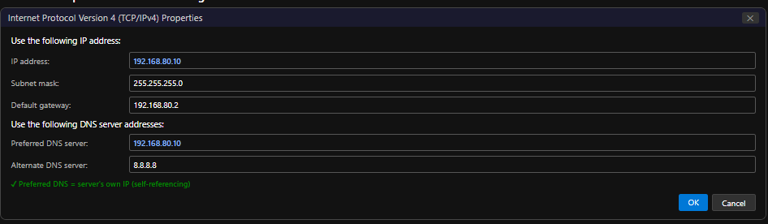

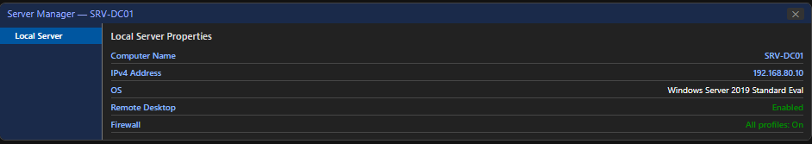

Step 2: Configure Static IPv4 Address
- Control Panel → Network and Sharing Centre → Change Adapter Settings.
- Right-click 'Ethernet0' (or the VMware NAT adapter) → Properties.
- Select 'Internet Protocol Version 4 (TCP/IPv4)' → Properties.
- Select 'Use the following IP address' and enter:
IP address: 192.168.80.10
Subnet mask: 255.255.255.0
Default gateway: 192.168.80.2
- Select 'Use the following DNS server addresses':
Preferred DNS: 192.168.80.10 (points to itself)
Alternate DNS: 8.8.8.8
- Click OK → Close → Close to apply.

Step 3: Verify Network Configuration
Open Command Prompt as Administrator and run:
ipconfig /all
ping 192.168.80.2
ping 8.8.8.8
hostname

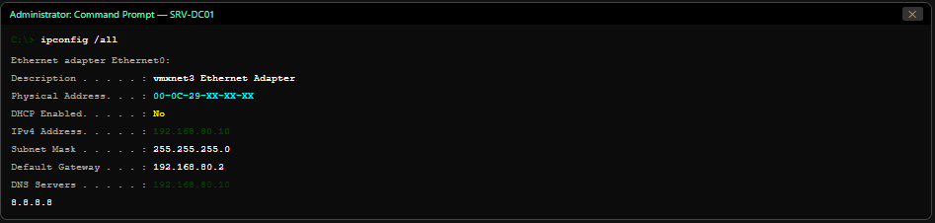

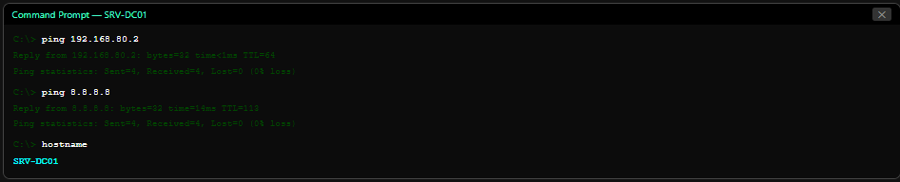

Practical Task 02 — DNS Server Deployment & Configuration
Objective: Install the DNS Server Role and configure a complete DNS environment for the lab.local zone.

Step 1: Install DNS Server Role
- Server Manager → Manage → Add Roles and Features.
- Installation Type: Role-based or feature-based → Next.
- Server Selection: SRV-DC01 → Next.
- Server Roles: check 'DNS Server' → Add Features when prompted → Next → Next → Install.
- Wait for installation to complete. Click 'Close'.
- Verify: Server Manager Dashboard shows 'DNS' under Roles.
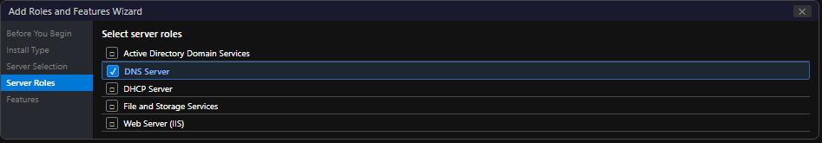

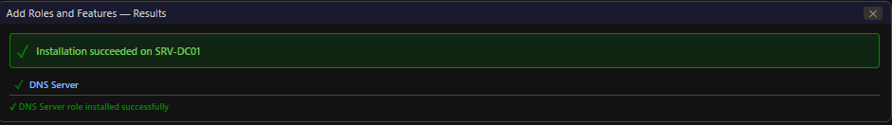

Step 2: Open DNS Manager
- Server Manager → Tools → DNS, or run dnsmgmt.msc.
- DNS Manager opens showing SRV-DC01 in the left pane.
- Expand SRV-DC01 → Forward Lookup Zones, Reverse Lookup Zones, Conditional Forwarders, Root Hints.
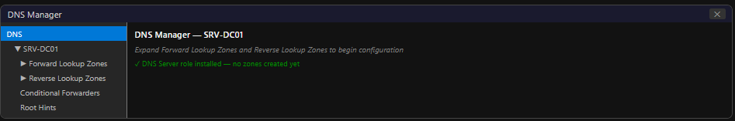

Step 3: Create Forward Lookup Zone
- Right-click 'Forward Lookup Zones' → 'New Zone...'.
- Zone Type: Primary Zone → Next.
- Zone Name: lab.local → Next.
- Zone File: Create a new file 'lab.local.dns' (default) → Next.
- Dynamic Update: 'Do not allow dynamic updates' (for manual lab control) → Next → Finish.
- Verify: 'lab.local' zone appears under Forward Lookup Zones.
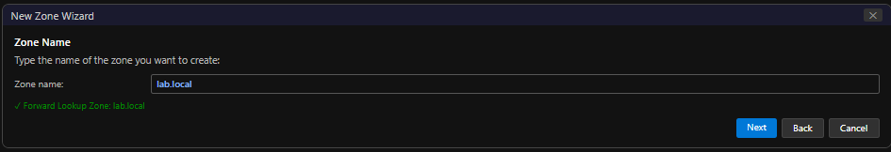

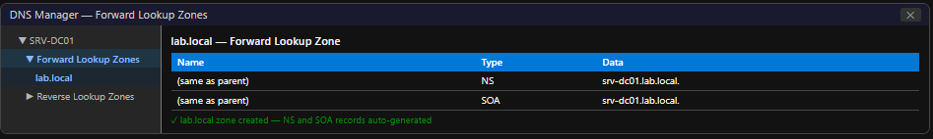

Step 4: Create Reverse Lookup Zone
- Right-click 'Reverse Lookup Zones' → 'New Zone...'.
- Zone Type: Primary Zone → Next.
- Reverse Lookup Zone Name: IPv4 Reverse Lookup Zone → Next.
- Network ID: 192.168.80 (the first three octets of the network) → Next.
- DNS Manager automatically names the zone '80.168.192.in-addr.arpa' → Next → Finish.
- Verify: '80.168.192.in-addr.arpa' appears under Reverse Lookup Zones.

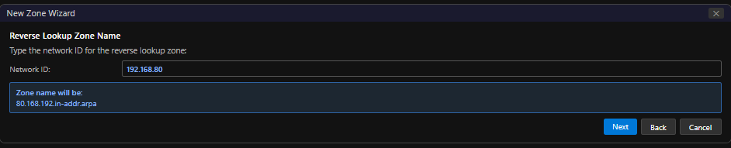

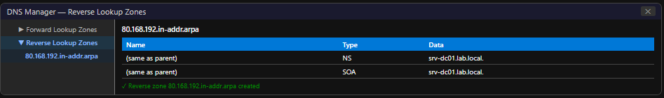

Step 5: Create Host (A) Records
Three A records are required. Right-click the lab.local zone → 'New Host (A or AAAA)...' for each:

Hostname | IP Address | Description
srv-dc01 | 192.168.80.10 | The DNS/DHCP server itself
win10-client1 | 192.168.80.50 | First Windows 10 client VM
win10-client2 | 192.168.80.51 | Second Windows 10 client VM

For each record: enter the Name (hostname without domain suffix), the IP address, check 'Create associated pointer (PTR) record' checkbox, click 'Add Host'.
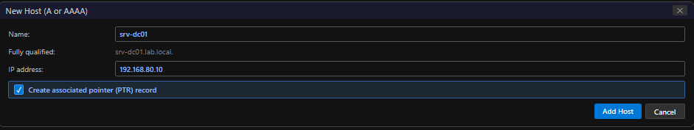

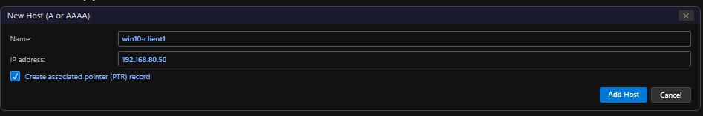

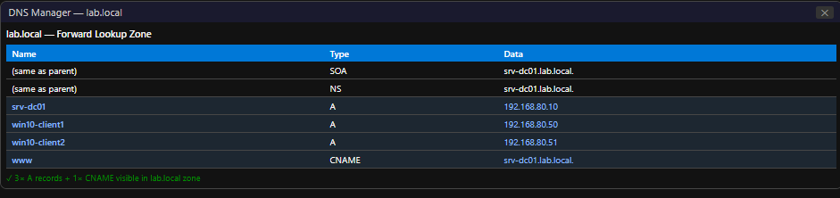

Step 6: Create CNAME (Alias) Record
- Right-click lab.local zone → 'New Alias (CNAME)...'.
- Alias name: www
- Fully qualified domain name (FQDN) for target host: srv-dc01.lab.local.
- Click OK.
- Verify: 'www' CNAME record pointing to srv-dc01.lab.local appears in the zone.
Purpose: www.lab.local resolves to the same IP as srv-dc01.lab.local (192.168.80.10) — simulating a web server alias.
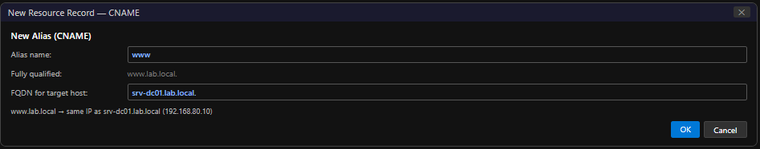

Step 7: Verify PTR Records in Reverse Zone
If 'Create associated pointer (PTR) record' was checked during A record creation, PTR records are automatically added to the reverse zone. Verify:
- Expand Reverse Lookup Zones → 80.168.192.in-addr.arpa.
- Confirm PTR records exist for: 10 → srv-dc01.lab.local, 50 → win10-client1.lab.local, 51 → win10-client2.lab.local.
- If missing, right-click the reverse zone → 'New Pointer (PTR)...' and add manually.

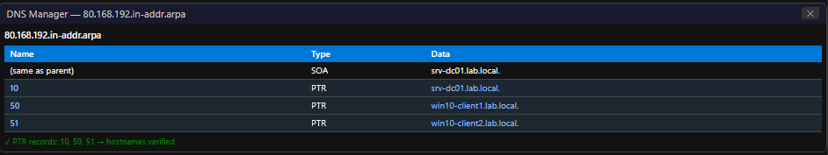

Step 8: Configure DNS Forwarders
- Right-click SRV-DC01 in DNS Manager → Properties.
- Forwarders tab → click Edit.
- Add: 8.8.8.8 (Google Primary DNS)
- Add: 8.8.4.4 (Google Secondary DNS)
- Click OK → OK.
This allows SRV-DC01 to resolve internet hostnames by forwarding queries to Google's DNS servers.
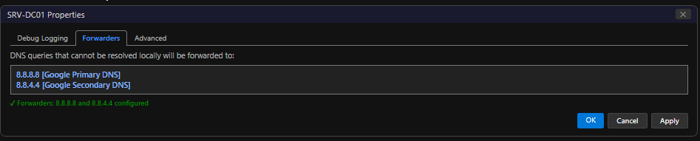

Step 9: Verify DNS Resolution
Open Command Prompt on SRV-DC01 and test all DNS records:
nslookup srv-dc01.lab.local
nslookup win10-client1.lab.local
nslookup win10-client2.lab.local
nslookup www.lab.local
nslookup 192.168.80.10
ipconfig /displaydns
nslookup google.com
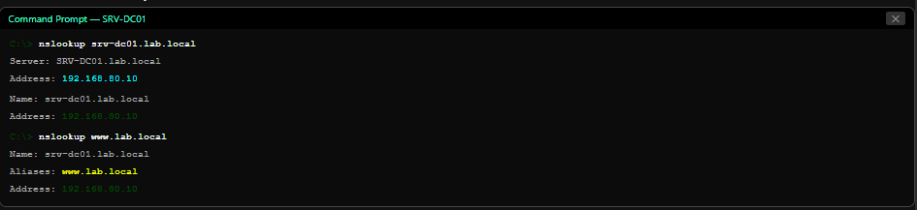

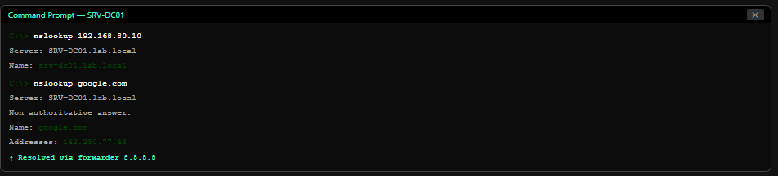

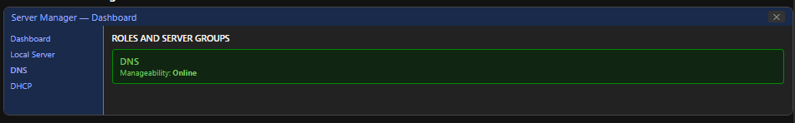

Practical Task 03 — DHCP Server Deployment & Configuration
Objective: Install the DHCP Server Role and configure a complete scope for the lab network.

Step 1: Install DHCP Server Role
- Server Manager → Manage → Add Roles and Features.
- Server Roles: check 'DHCP Server' → Add Features → Next → Next → Install.
- After completion, click 'Complete DHCP Configuration' in the yellow notification bar.
- DHCP Post-Install Configuration Wizard: Create security groups → Commit → Close.
- Verify: Server Manager Dashboard shows 'DHCP' under Roles.
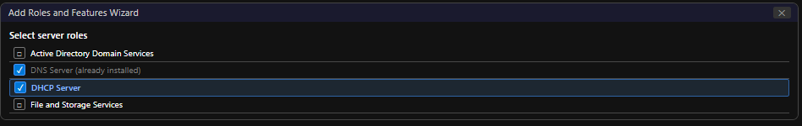

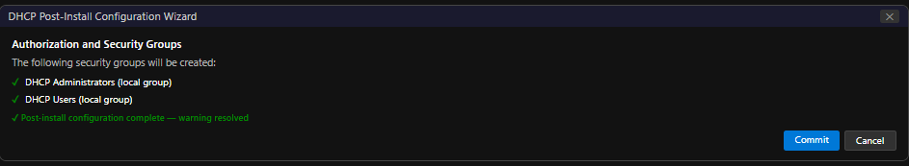

Step 2: Open DHCP Manager
- Server Manager → Tools → DHCP, or run dhcpmgmt.msc.
- DHCP Manager opens. Expand SRV-DC01 → IPv4 → (currently empty — no scopes yet).
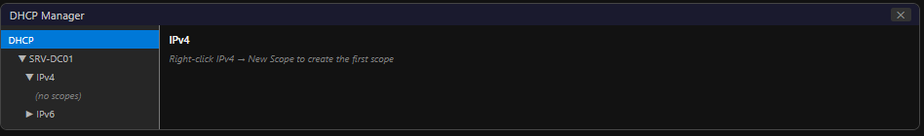

Step 3: Create DHCP Scope
- Right-click IPv4 → 'New Scope...'. The New Scope Wizard opens.
- Scope Name: Lab Network Scope | Description: ITSimplera Lab — 192.168.80.0/24 → Next.
- IP Address Range: Start: 192.168.80.100 | End: 192.168.80.200 | Subnet mask: 255.255.255.0 → Next.
- Add Exclusions — enter the exclusion range:
Start IP: 192.168.80.100 End IP: 192.168.80.110 → click Add
- Click Next. The effective assignable range becomes 192.168.80.111–200.
- Lease Duration: 8 Days 0 Hours 0 Minutes → Next.
- Configure DHCP Options Now: Yes → Next.
- Router (Default Gateway): 192.168.80.2 → Add → Next.
- Domain Name and DNS Servers: Parent domain: lab.local | DNS: 192.168.80.10 → Add → Next.
- WINS Servers: skip → Next.
- Activate Scope Now: Yes, activate this scope → Next → Finish.
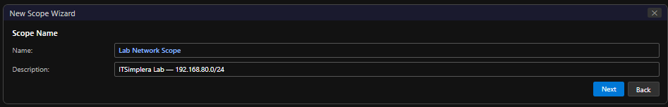

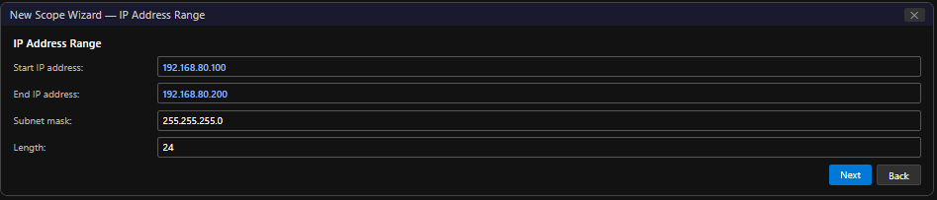

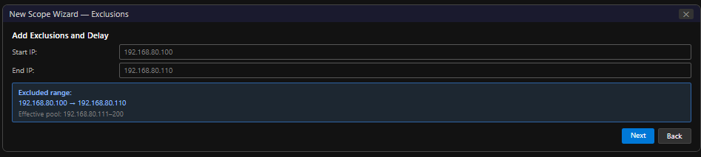

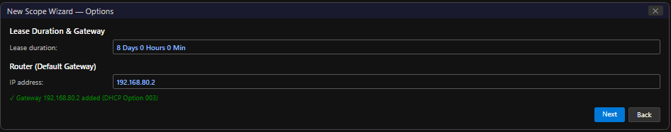

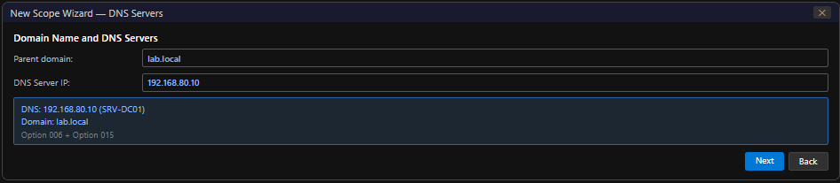

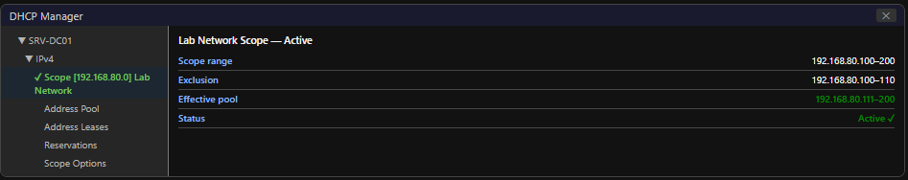

Step 4: Create a DHCP Reservation
A reservation permanently assigns 192.168.80.120 to the first Windows 10 VM based on its MAC address.
- Expand Lab Network Scope → right-click 'Reservations' → 'New Reservation...'.
- Reservation Name: Win10-Client1-Reserved
- IP Address: 192.168.80.120
- MAC Address: [enter the MAC address of Win10 VM1 — obtained via ipconfig /all on that VM]
- Description: Windows 10 Client 1 — Reserved IP
- Supported types: Both (DHCP and BOOTP) → Add → Close.
To find the MAC address: on the Windows 10 VM, run ipconfig /all and note the Physical Address of the Ethernet adapter.
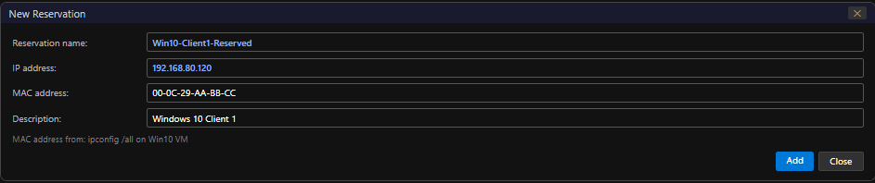

Step 5: Verify DHCP Scope Configuration
Expand the scope and verify all components:
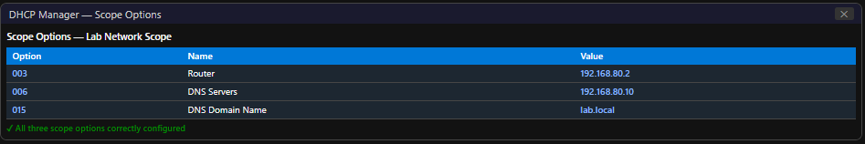
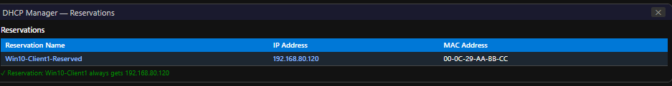

Practical Task 04 — Client Connectivity Verification
Objective: Connect the Windows 10 Client VM to the network and verify automatic DHCP IP assignment and DNS resolution.

Step 1: Configure Windows 10 Client to Use DHCP
- On the Windows 10 VM: Control Panel → Network → Ethernet → Properties → IPv4 Properties.
- Ensure 'Obtain an IP address automatically' and 'Obtain DNS server address automatically' are both selected → OK.
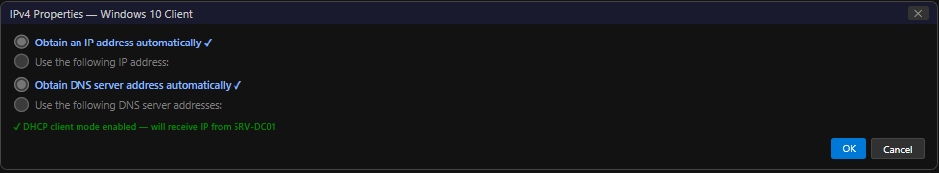

Step 2: Release and Renew IP Address
Open Command Prompt on the Windows 10 VM and run:
ipconfig /release
ipconfig /renew
ipconfig /all
After /renew, the client should receive an IP from the DHCP scope (192.168.80.111–200 or the reserved 192.168.80.120).
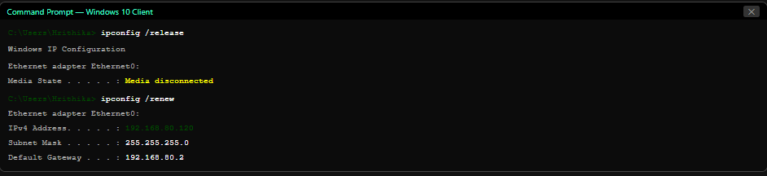

Step 3: Verify Complete Network Configuration
Run ipconfig /all to verify all DHCP-assigned settings:

Expected DHCP assignment on Windows 10 Client:
IPv4 Address: 192.168.80.120 (reservation) or 192.168.80.111–200 (dynamic)
Subnet Mask: 255.255.255.0
Default Gateway: 192.168.80.2
DNS Servers: 192.168.80.10
DHCP Server: 192.168.80.10
Lease Obtained: [today's date and time]
Lease Expires: [date + 8 days]

Step 4: Verify DNS Name Resolution from Client
Run nslookup on the Windows 10 VM to verify DNS is working:
nslookup srv-dc01.lab.local
nslookup www.lab.local
nslookup win10-client1.lab.local
ping srv-dc01.lab.local
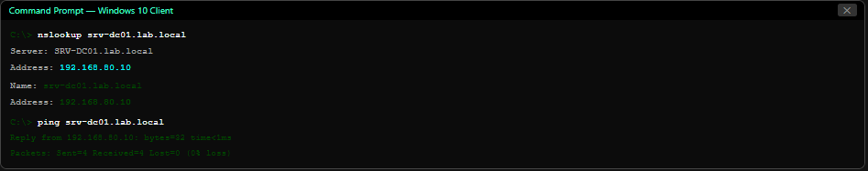

Step 5: Verify DHCP Lease on Server
On SRV-DC01, open DHCP Manager and verify the client lease appears:
- DHCP Manager → IPv4 → Lab Network Scope → Address Leases.
- Confirm the Windows 10 Client's IP appears in the lease list with MAC address, hostname, and lease expiry.
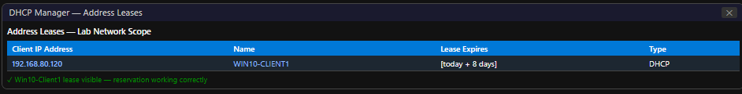

Practical Task 05 — DNS & DHCP Troubleshooting
Two troubleshooting scenarios were performed and documented — one DNS scenario and one DHCP scenario.

Troubleshooting Scenario 1 — Incorrect DNS Record (DNS)

Problem Description:
The nslookup query for srv-dc01.lab.local returned the wrong IP address (192.168.80.99 instead of 192.168.80.10), causing ping and remote desktop connections to fail.
Root Cause:
An incorrect A record existed in the lab.local zone with the hostname 'srv-dc01' pointing to the wrong IP (192.168.80.99). This may have been created accidentally or may represent a stale record from a previous IP assignment.
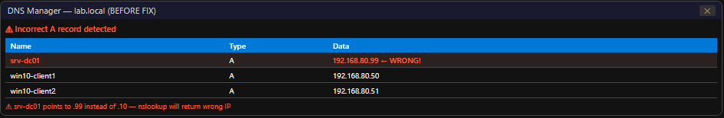

Troubleshooting Process:
- Ran nslookup srv-dc01.lab.local on client — returned 192.168.80.99.
- Ping 192.168.80.99 — Request timed out (no device at that IP).
- Opened DNS Manager on SRV-DC01 → lab.local zone.
- Found srv-dc01 A record with incorrect IP 192.168.80.99.
- Double-clicked the record → changed IP address to 192.168.80.10 → OK.
- Ran ipconfig /flushdns on the client to clear cached incorrect entry.
- Verified: nslookup srv-dc01.lab.local now returns 192.168.80.10.
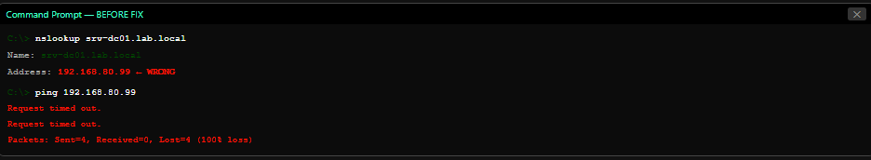

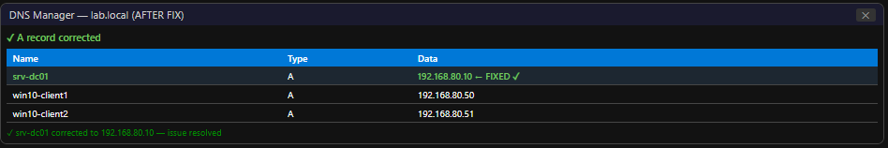

Final Verification:
nslookup srv-dc01.lab.local

✓ DNS Scenario 1 RESOLVED
Root cause: Incorrect A record IP in lab.local zone
Fix: Updated A record to correct IP 192.168.80.10
Verification: nslookup returns correct IP; ping succeeds

Troubleshooting Scenario 2 — DHCP Service Stopped (DHCP)
Problem Description:
The Windows 10 client ran ipconfig /renew but received an APIPA address (169.254.x.x) instead of a DHCP-assigned address. All network connectivity beyond the local link was lost — could not ping the gateway or access the internet.
Root Cause:
The DHCP Server service (DHCPServer) on SRV-DC01 was stopped. This caused all client DHCP discovery broadcasts to go unanswered. After four failed DORA attempts, Windows fell back to APIPA self-configuration.
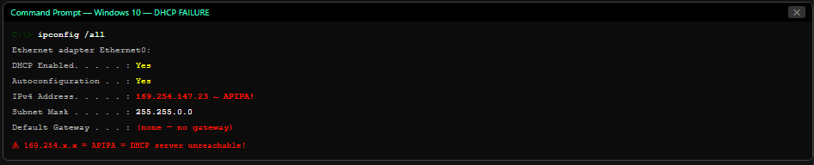

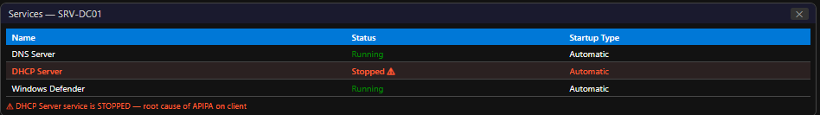

Troubleshooting Process:
- On the Windows 10 client: ipconfig /all → confirmed APIPA address 169.254.x.x (clear DHCP failure).
- Ping 192.168.80.10 (DHCP server) — Request timed out (APIPA can only reach 169.254.0.0/16).
- Switched to SRV-DC01 → opened services.msc → found 'DHCP Server' service: Stopped.
- Right-clicked 'DHCP Server' → Start.
- Verified service status: Running.
- Also verified in DHCP Manager: Lab Network Scope shows as Active.
- Returned to Windows 10 client → ran: ipconfig /release then ipconfig /renew.
ipconfig /all confirmed a valid IP from the DHCP scope.
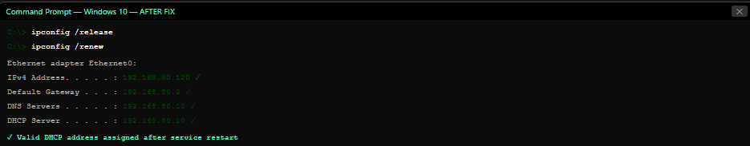

✓ DHCP Scenario 2 RESOLVED
Root cause: DHCP Server service was stopped on SRV-DC01
Fix: Started DHCP Server service via services.msc
Verification: Client renewed IP; received valid DHCP address from scope

Final Verification Checklist
All required deliverables have been successfully implemented and verified:
 | Verification Item
✓ | Windows Server 2019 installed and configured on SRV-DC01
✓ | Static IPv4 address configured: 192.168.80.10 / 255.255.255.0 / Gateway: 192.168.80.2
✓ | Server renamed to SRV-DC01 (enterprise naming convention)
✓ | DNS Server Role installed successfully via Server Manager
✓ | DHCP Server Role installed successfully via Server Manager
✓ | Forward Lookup Zone created: lab.local
✓ | Reverse Lookup Zone created: 80.168.192.in-addr.arpa
✓ | Minimum three Host (A) Records configured: srv-dc01, win10-client1, win10-client2
✓ | One CNAME Record configured: www → srv-dc01.lab.local
✓ | One PTR Record configured: 10 → srv-dc01.lab.local (plus client PTR records)
✓ | DNS Forwarders configured: 8.8.8.8 and 8.8.4.4
✓ | DNS name resolution verified with nslookup (forward and reverse)
✓ | DHCP Scope configured: Lab Network Scope (192.168.80.100–200)
✓ | DHCP Exclusion Range configured: 192.168.80.100–192.168.80.110
✓ | DHCP Reservation implemented: Win10-Client1 → 192.168.80.120
✓ | DHCP Scope Options configured: Gateway (003), DNS (006), Domain (015)
✓ | Windows 10 Client automatically receives IP from DHCP scope
✓ | Correct Gateway (192.168.80.2) assigned via DHCP
✓ | Correct DNS Server (192.168.80.10) assigned via DHCP
✓ | DHCP Lease information verified in DHCP Manager
✓ | Successful DNS name resolution verified from client VM
✓ | Successful communication between SRV-DC01 and client via ping
✓ | DNS Troubleshooting Scenario completed: Incorrect A record corrected
✓ | DHCP Troubleshooting Scenario completed: DHCP service stopped and restarted
✓ | Professional report prepared with complete screenshots
6. Challenges Faced

Challenge 1: PTR Records Not Created Automatically
Symptom: After creating A records with 'Create associated pointer (PTR) record' checked, the PTR records did not appear in the reverse zone.
Root Cause: The Reverse Lookup Zone must be created before A records — DNS cannot create PTR records if no matching reverse zone exists at the time the A record is created.
Resolution: Created the Reverse Lookup Zone first, then deleted and recreated the A records with the PTR checkbox checked. Alternatively, right-click the Reverse Lookup Zone → New Pointer (PTR) and create them manually.
Challenge 2: DHCP Server Showed Warning After Installation
Symptom: After DHCP role installation, Server Manager showed a yellow warning: 'Configuration required for DHCP Server at SRV-DC01'.
Root Cause: DHCP requires a post-installation authorisation step where security groups (DHCP Administrators, DHCP Users) are created in the local SAM database.
Resolution: Clicked 'Complete DHCP Configuration' in the yellow notification banner → DHCP Post-Install Configuration Wizard → clicked Commit. The warning disappeared and DHCP Manager became fully functional.
Challenge 3: nslookup Used Wrong DNS Server
Symptom: nslookup queries from the Windows 10 client returned 'Non-existent domain' errors even though records existed on SRV-DC01.
Root Cause: The Windows 10 client's Preferred DNS Server was still set to 8.8.8.8 (from a previous manual configuration) instead of 192.168.80.10. Google's DNS has no knowledge of the lab.local zone.
Resolution: Updated the Windows 10 client's IPv4 DNS settings to 'Obtain DNS server address automatically' (via DHCP option 006). After ipconfig /release and /renew, the client received 192.168.80.10 as its DNS server and all lab.local queries resolved correctly.
Challenge 4: DHCP Scope Overlap with Static Assignments
Symptom: After activating the DHCP scope, a conflict warning appeared indicating an IP address conflict on the network.
Root Cause: SRV-DC01 has a static IP of 192.168.80.10, which was within the DHCP scope range (192.168.80.100–200) — but more importantly, the server performed a network scan and detected that 192.168.80.10 was in use. This was a false alarm since .10 was not in the scope range, but highlighted the importance of exclusions.
Resolution: Confirmed the scope start IP (192.168.80.100) was well above the server's static IP (.10). Added an exclusion range (100–110) to protect infrastructure IPs. Conflict warning resolved.

7. Learning Outcomes

- Understood the complete DNS resolution process — from client query through forwarder to authoritative server — and its role in network communication.
- Created and configured a full DNS environment: Forward Lookup Zone (lab.local), Reverse Lookup Zone (80.168.192.in-addr.arpa), A records, CNAME record, and PTR records.
- Configured DNS Forwarders pointing to 8.8.8.8 — enabling the internal DNS server to resolve both internal (lab.local) and external (internet) hostnames.
- Installed and configured the DHCP Server Role with a complete scope covering IP range, exclusion, reservation, lease duration, and scope options (gateway, DNS, domain name).
- Successfully demonstrated the complete DHCP DORA process by connecting a Windows 10 client and confirming automatic IP assignment with correct gateway and DNS settings.
- Mastered DHCP reservation based on MAC address — ensuring a specific client always receives the same IP address without manual static configuration.
- Performed real-world troubleshooting of both DNS (incorrect A record) and DHCP (service stopped) failures — developed systematic diagnostic skills using nslookup, ping, ipconfig, and services.msc.
- Understood the APIPA mechanism and its diagnostic significance — a 169.254.x.x address is a definitive indicator of DHCP failure.
- Comprehended the relationship between DNS, DHCP, and Active Directory — DNS is the prerequisite infrastructure for AD DS, and DHCP simplifies client IP management at scale.
- Prepared a complete enterprise-grade DNS and DHCP infrastructure on SRV-DC01 that is now ready to support an Active Directory Domain Services installation in Week 5.

8. Conclusion

This task successfully deployed, configured, and verified DNS and DHCP services on Windows Server 2019 — the two core network services that underpin all enterprise Windows infrastructure. The implementation followed a complete lifecycle from theoretical understanding through practical configuration, client verification, and systematic troubleshooting.
The DNS configuration established a complete authoritative zone for lab.local with three Host (A) records, one CNAME alias, PTR records for reverse lookups, and DNS forwarders for internet resolution. All records were verified using nslookup from both the server and a Windows 10 client VM. The forward and reverse lookup zones work correctly, and the DNS forwarder chain enables resolution of external hostnames through Google's public DNS servers.
The DHCP configuration created a production-quality scope with a defined IP range (100–200), an exclusion block (100–110) protecting infrastructure addresses, a MAC-based reservation (192.168.80.120 for Win10-Client1), an 8-day lease duration, and complete scope options delivering gateway, DNS server, and domain name to clients automatically. The Windows 10 client successfully received all DHCP-assigned settings and achieved full network connectivity including DNS name resolution.
The two troubleshooting scenarios developed practical diagnostic skills essential for a System Administrator: identifying incorrect DNS records and correcting them without service disruption, and diagnosing DHCP service failures through APIPA address recognition and service restart procedures.
With DNS and DHCP now fully operational on SRV-DC01, the lab environment is prepared for Week 5's capstone task: deploying Active Directory Domain Services (AD DS) to transform SRV-DC01 into a domain controller for the lab.local domain — enabling centralised authentication, Group Policy, and domain-joined device management.

9. References

- Microsoft Corporation. (2024). DNS Server documentation. Microsoft Learn. https://learn.microsoft.com/en-us/windows-server/networking/dns/dns-top
- Microsoft Corporation. (2024). DHCP Server documentation. Microsoft Learn. https://learn.microsoft.com/en-us/windows-server/networking/technologies/dhcp/dhcp-top
- Microsoft Corporation. (2024). Manage DNS Resource Records. Microsoft Learn. https://learn.microsoft.com/en-us/windows-server/networking/dns/manage-resource-records
- Microsoft Corporation. (2024). DHCP Scopes and Options. Microsoft Learn. https://learn.microsoft.com/en-us/windows-server/networking/technologies/dhcp/dhcp-scopes
- RFC 1034/1035 — Domain Names: Concepts, Facilities, and Implementation. IETF. https://www.ietf.org/rfc/rfc1035.txt
- RFC 2131 — Dynamic Host Configuration Protocol. IETF. https://www.ietf.org/rfc/rfc2131.txt
- Microsoft Corporation. (2024). Understanding DNS for Active Directory. Microsoft Learn. https://learn.microsoft.com/en-us/windows-server/identity/ad-ds/plan/dns-and-ad-ds
- ITSimplera Solution. (2026). Week 04 — Task 04 Brief: Core Network Services — Managing DNS & DHCP on Windows Server. System Administration & IT Infrastructure Services Internship Program.
10. Evaluation Criteria

Component | Marks | Status
Documentation (Professional Report with screenshots) | 10 | ✓ Completed
LinkedIn Submission (Professional task post) | 50 | ✓ Completed
GitHub Repository / Documentation | 10 | ✓ Completed
Technical Interview (Google Meet) | 30 | Pending
Total | 100

Important Notes:
- All screenshots are original captures from my personal SRV-DC01 and Windows 10 client virtual machines.
- Every practical step was personally implemented — this is not an AI-generated report.
- LinkedIn post will be published with professional documentation before the deadline.
- GitHub repository contains the complete report PDF and implementation evidence.
- Technical interview readiness: can demonstrate DNS Manager, DHCP Manager, nslookup verification, and DHCP lease table live on SRV-DC01.


ITSimplera Solution
System Administration & IT Infrastructure Services Internship Program
Week 04 — Task 04 | Submitted: July 2026 | Deadline: July 25, 2026

