
ITSimplera Institute
System Administration & IT Infrastructure Services Internship Program

WEEK 03 — TASK 03
Windows Server 2019 Provisioning &
Initial Server Administration

Submitted By:
HRITHIKA S
Registration No: SAB01-0771
Contact: 9445170771
Issued By:
Tahir Zaman
Team Lead – System Administration & IT Infrastructure Services
Released: July 11, 2026 | Deadline: July 18, 2026
Difficulty: Beginner to Intermediate | Task Type: Theory + Server Deployment + Troubleshooting

Table of Contents

1. Introduction ...... 3
2. Objective ...... 3
3. Theory Topics ...... 4
3.1 Introduction to Windows Server ...... 4
3.2 Windows Server Roles and Features ...... 4
3.3 Installation Modes — Desktop Experience vs Server Core ...... 5
3.4 Windows Server 2019 Interface ...... 5
3.5 Server Manager Overview ...... 6
3.6 Windows Server Initial Configuration ...... 6
3.7 Computer Name and Workgroup Configuration ...... 7
3.8 Windows Server Troubleshooting Basics ...... 7
3.9 Remote Desktop Administration ...... 8
3.10 Windows Server Security Features ...... 8
3.11 BitLocker Drive Encryption ...... 9
3.12 Windows Event Viewer ...... 9
3.13 Windows Device Manager ...... 10
4. Software Requirements ...... 10
5. Practical Implementation ...... 11
Part A Windows Server 2019 Deployment ...... 11
Part B Initial Server Configuration ...... 13
Part C Server Customisation ...... 15
Part D Basic Troubleshooting ...... 16
Part D.1 Audio Troubleshooting ...... 16
Part D.2 Remote Desktop Troubleshooting ...... 17
Part D.3 Network Connectivity Troubleshooting ...... 18
Part D.4 BitLocker Feature Installation ...... 20
Part D.5 Event Viewer Investigation ...... 21
6. Final Verification ...... 22
7. Challenges Faced ...... 23
8. Learning Outcomes ...... 24
9. Conclusion ...... 24
10. References ...... 25
11. Evaluation Criteria ...... 25

1. Introduction

This report documents the complete implementation of Week 03 — Task 03 of the ITSimplera Institute System Administration & IT Infrastructure Services Internship Program. Building on the Windows 10 virtual lab environment and user management skills developed in Weeks 1 and 2, this task introduces Windows Server 2019 — the operating system that powers enterprise IT infrastructure worldwide.
Windows Server is the platform on which critical enterprise services run: Active Directory Domain Services (AD DS), DNS, DHCP, File and Storage Services, IIS web hosting, Hyper-V virtualisation, and many more. Before any of these services can be deployed, a System Administrator must be proficient in provisioning, configuring, securing, and troubleshooting a Windows Server environment.
This implementation covers the complete lifecycle from VM creation and Windows Server 2019 installation through initial server configuration, server customisation, multi-area troubleshooting (audio, RDP, network), BitLocker Drive Encryption feature installation, and Event Viewer log analysis — all performed on a Windows Server 2019 (Desktop Experience) virtual machine running under VMware Workstation Pro.

2. Objective

The primary objectives of this task are:
- Deploy a Windows Server 2019 (Desktop Experience) virtual machine in VMware Workstation Pro.
- Perform initial server configuration: rename server to SRV-01, configure date/time/timezone, enable Remote Desktop, verify Windows Activation.
- Customise the server environment: change desktop background, pin administrative tools to the Start Menu.
- Troubleshoot four areas: audio (Device Manager + Audio service + Role/Feature installation), Remote Desktop (settings, firewall, user permissions, Remote Assistance feature), network connectivity (Wireless LAN Service + CLI commands), and BitLocker Drive Encryption feature installation.
- Analyse Windows Event Viewer logs: Application, System, and Security logs — document one Warning or Error event.
- Document all steps with professional screenshots and produce a complete submission-ready report.

3. Theory Topics

3.1 Introduction to Windows Server
Windows Server is Microsoft's line of server operating systems designed for enterprise-grade workloads. Unlike Windows 10 (a client OS designed for individual users), Windows Server is built to run continuously as a service platform — hosting applications, managing networks, authenticating users, and storing files for dozens to thousands of clients simultaneously.
Key characteristics that distinguish Windows Server from client Windows:
- Higher hardware support: Up to 24 TB of RAM (vs 2 TB for Windows 10 Pro), 64 physical processors, and terabytes of storage.
- Server roles: Specialised workloads like Active Directory, DNS, DHCP, DHCP, File Services, Hyper-V, and IIS that are not available on client editions.
- Stability and uptime: Designed for 24/7 operation with kernel tuning optimised for throughput rather than interactive response.
- Remote administration: Server Core (no GUI), Server Manager, Windows Admin Centre, and PowerShell remoting allow managing servers without physical access.
- Licensing: Windows Server 2019 is licensed per-core with separate Client Access Licences (CALs) for user and device access.
Windows Server 2019 (released October 2018) is the Long-Term Servicing Channel (LTSC) release with 10 years of mainstream support. It introduces Windows Defender Advanced Threat Protection (ATP), shielded VMs for Hyper-V, and improved hybrid cloud integration with Microsoft Azure.

3.2 Windows Server Roles and Features
Windows Server functionality is delivered through Roles and Features installed on demand via Server Manager or PowerShell. This modular approach means only the required functionality is installed, reducing attack surface and resource consumption.
Server Role | Primary Function
Active Directory Domain Services (AD DS) | Manages domain user accounts, computers, and Group Policy for enterprise authentication.
DNS Server | Resolves hostnames to IP addresses — required for AD DS to function.
DHCP Server | Automatically assigns IP addresses to clients on the network.
File and Storage Services | Provides shared folders, DFS, and storage management across the network.
Web Server (IIS) | Hosts websites and web applications using Internet Information Services.
Hyper-V | Type-1 hypervisor for running virtual machines directly on the server.
Remote Desktop Services | Provides session-based and virtual desktop infrastructure (VDI) for remote users.
Print and Document Services | Centrally manages network printers and print queues.
Network Policy and Access Services | Manages VPN, RADIUS, and network access control (NAC).
Windows Server Backup | Provides backup and recovery of server data and system state.
Features (like BitLocker Drive Encryption, Wireless LAN Service, Remote Assistance, and Telnet Client) are supplementary capabilities that support roles rather than defining primary server workloads.

3.3 Windows Server Installation Modes — Desktop Experience vs Server Core
Desktop Experience | Server Core
Full GUI — identical to Windows client look and feel | Command-line only — no Explorer, no GUI shell
Server Manager, MMC consoles, and all GUI tools available | Managed via PowerShell, CMD, or remotely via Server Manager
Easier for administrators new to Windows Server | Requires strong CLI and PowerShell proficiency
Larger disk footprint (~14 GB) and higher RAM usage | Smaller footprint (~6 GB), reduced attack surface
More update and reboot cycles | Fewer patches, longer uptime between reboots
Recommended for: learning, small environments | Recommended for: production enterprise, cloud deployments
Used in this task (Week 03) | Microsoft's strategic direction for production servers

Nano Server (a third option) is a minimal installation for containerised cloud workloads — it cannot even run as a local logon session and is managed entirely via remote tools.

3.4 Windows Server 2019 Interface
Windows Server 2019 Desktop Experience presents a familiar Windows 10-style desktop with a Start button, taskbar, and notification area. However, key differences for server operation include:
- Server Manager launches automatically at logon — this is the primary administrative console, not a desktop environment for day-to-day use.
- Internet Explorer Enhanced Security Configuration (IE ESC) is enabled by default, blocking most websites. This prevents casual browsing and reduces web-based attack surface.
- The desktop is intentionally sparse — only Recycle Bin appears by default. This discourages using the server as a workstation.
- Task Manager shows server-specific performance counters and service states.
- Control Panel and Settings are both available, but most server configuration is done through Server Manager or PowerShell.
- Windows Defender Firewall is active and Windows Defender Antivirus runs by default.
The shutdown dialogue requires a reason code when shutting down or restarting — critical for tracking in managed server environments.

3.5 Server Manager Overview
Server Manager is the primary graphical management console for Windows Server. It launches at startup and provides a unified dashboard for:
- Dashboard: At-a-glance status of all installed roles, services that are stopped, and alerts requiring attention. Red/yellow indicators flag problems immediately.
- Local Server: A single-pane view of all key server properties — computer name, domain/workgroup, IP address, Windows Update settings, Remote Desktop status, IE ESC status, and Windows Defender status. Most initial configuration is done from this pane.
- All Servers: Add and manage remote servers from a single console — Server Manager becomes a multi-server administration hub.
- Roles/Features nodes: Dedicated panes for each installed role (File Services, DHCP, DNS) showing role-specific status and events.
- Add Roles and Features Wizard: Guided installer for adding new roles, role services, and features with automatic dependency resolution.
- Event Viewer integration: Recent critical events from all managed servers appear directly in the Server Manager dashboard.
PowerShell equivalent: most Server Manager actions map to PowerShell cmdlets in the ServerManager module — Install-WindowsFeature, Get-WindowsFeature, Uninstall-WindowsFeature — enabling scripted and automated server configuration.

3.6 Windows Server Initial Configuration
After installation, Windows Server 2019 requires a set of initial configuration steps before it is ready for enterprise use. These tasks are typically performed through Server Manager → Local Server:
Configuration Task | How To Configure | Why It Matters
Computer Name | Server Manager → Local Server → Computer Name | Default names (WIN-XXXXXXXXX) are meaningless. Naming convention (SRV-01, DC-01, FILE-01) enables network identification.
IP Address | Control Panel → Network → Properties → IPv4 | Servers must have static IPs — DHCP-assigned addresses change, breaking DNS records and client connections.
Time/Timezone | Server Manager → Local Server → Time Zone | Correct time is mandatory for Kerberos authentication (AD DS requires clocks within 5 minutes).
Windows Update | Server Manager → Local Server → Windows Update | Keeps server patched against vulnerabilities. Often deferred in production for testing.
Remote Desktop | Server Manager → Local Server → Remote Desktop | Enables remote administration without physical access to the server.
Firewall | Windows Defender Firewall | Verify firewall is ON and only required ports are open.
Windows Activation | Server Manager → Local Server → Activation | Unactivated servers have limited functionality after grace period expires.

3.7 Computer Name and Workgroup Configuration
Every Windows computer has a NetBIOS name (≤15 characters, no spaces) and a DNS hostname. In enterprise environments, servers join a domain; in workgroup environments (like our lab), they use a workgroup name (default: WORKGROUP).
Server naming conventions used in enterprise environments:
- SRV-01: First general-purpose server. SRV = Server, 01 = sequence number.
- DC-01: First Domain Controller. DC = Domain Controller.
- FILE-01: First File Server.
- WEB-01: First Web Server.
To rename: Server Manager → Local Server → Computer Name (hyperlink) → Change → enter new name → OK → Restart. The rename takes effect only after restart. The SID (Security Identifier) does not change when renaming a workgroup computer.

3.8 Windows Server Troubleshooting Basics
Systematic troubleshooting on Windows Server follows the OSI model approach — verify hardware, then OS, then services, then network, then application. Key built-in tools:
- Event Viewer (eventvwr.msc): The primary log analysis tool. Application, Security, System, and Setup logs record all significant events with timestamps, Event IDs, and descriptions.
- Device Manager (devmgmt.msc): Shows all hardware devices and their driver status. Yellow exclamation marks indicate driver problems; red X marks indicate disabled devices.
- Services (services.msc): Lists all Windows services with start type (Automatic, Manual, Disabled) and current state (Running, Stopped). Critical services being stopped are a common issue source.
- Performance Monitor (perfmon.msc): Real-time and historical performance data — CPU, memory, disk I/O, network throughput.
- Resource Monitor (resmon.exe): Shows per-process resource usage, network connections, and disk activity in real time.
- Task Manager: Quick view of CPU/RAM/disk/network usage and process management.
- PowerShell: Get-Service, Get-EventLog, Test-NetConnection, Get-NetAdapter — scriptable equivalents of all GUI tools.
The Windows Server Troubleshooter checklist: (1) Check Event Viewer for errors, (2) Check Services for stopped services, (3) Check Device Manager for hardware issues, (4) Check network connectivity with ipconfig/ping, (5) Check firewall rules, (6) Check Windows Update for pending patches.

3.9 Remote Desktop Administration
Remote Desktop Protocol (RDP) on Windows Server 2019 enables graphical remote administration without physical access. Unlike Windows 10 which supports only one concurrent RDP session, Windows Server supports multiple simultaneous RDP sessions (subject to Remote Desktop Services licensing).
Server-specific RDP considerations:
- RDP Licensing: Standard Windows Server 2019 includes a 120-day Remote Desktop Services (RDS) grace period. After that, either Remote Desktop Services role with CALs is required, or only two concurrent administrator sessions (via RDP-Tcp listener) are allowed.
- Console session: The /console or /admin switch in mstsc.exe connects to session 0 — the physical console session — useful for troubleshooting.
- NLA (Network Level Authentication): Should always be enabled on servers — prevents unauthenticated access to the login screen.
- Remote Assistance vs Remote Desktop: Remote Assistance (msra.exe) allows a helper to view or take control of an interactive session with user permission. It must be installed via Roles and Features on Server 2019.
- Firewall: Remote Desktop (TCP 3389) must be allowed through Windows Defender Firewall — enabling RDP via System Properties automatically creates the firewall exception.

3.10 Windows Server Security Features
Windows Server 2019 includes multiple layers of built-in security:
- Windows Defender Antivirus: Built-in real-time malware protection. On Server Core, runs as a background service without a GUI.
- Windows Defender Firewall with Advanced Security: Host-based stateful packet filter with support for IPsec connection security rules.
- Windows Defender Credential Guard: Uses Virtualization-Based Security (VBS) to isolate credentials from the OS — prevents Pass-the-Hash attacks.
- Windows Defender ATP (Advanced Threat Protection): Enterprise endpoint detection and response (EDR) integrated with Microsoft 365 Defender.
- Shielded VMs: Hyper-V VMs encrypted with BitLocker and protected by a Host Guardian Service (HGS) — prevents administrators from accessing VM contents.
- Just Enough Administration (JEA): Constrains PowerShell remoting sessions to specific cmdlets — prevents privilege escalation through remote management.
- Security Baselines: Microsoft-published Group Policy templates that apply hardened security configurations to servers and clients.
- Windows Security Centre: Unified dashboard showing antivirus, firewall, and update status at a glance.
- Local Security Policy (secpol.msc): Password policies, account lockout, audit policies, and User Rights Assignments — the same tool used in Week 2.

3.11 BitLocker Drive Encryption
BitLocker Drive Encryption is a full-volume encryption feature built into Windows Server (and Windows 10 Pro/Enterprise). It encrypts the entire volume using AES-128 or AES-256, protecting data from physical theft — if someone removes the hard drive, the data is unreadable without the recovery key.
How BitLocker works:
- Trusted Platform Module (TPM): BitLocker's preferred method stores the encryption key in the TPM chip on the motherboard. The drive only unlocks when booting from the same hardware with the same TPM state — automatically, without user intervention.
- Recovery Key: A 48-digit numeric key generated at setup and saved to Active Directory, a USB drive, a file, or printed. Used if the TPM check fails (e.g., hardware change, BIOS update).
- Startup PIN: Optional additional protection requiring a PIN at boot, even when TPM is present.
Common use cases on Windows Server:
- Laptop/portable server encryption: Protects data if a device is lost or stolen in transit.
- BitLocker To Go: Encrypts removable USB drives — important for protecting sensitive data transported outside the server room.
- BitLocker on VMs: Can be used on VM disks to protect data even if the VMDK/VHDX file is copied off the host.
- Compliance: Required by HIPAA, PCI-DSS, and GDPR for devices storing regulated data.
Note: BitLocker requires either a TPM chip or a USB startup key. In VMware virtual machines, TPM 2.0 can be added to VM settings. For this task, only the BitLocker feature is installed — no encryption configuration is required.

3.12 Windows Event Viewer
Windows Event Viewer (eventvwr.msc) is the central log management console for Windows Server. It organises logs into a hierarchy:
- Windows Logs: The primary log categories for system administrators:
- Application: Events from applications and services (e.g., SQL Server, IIS, backup software errors).
- Security: Authentication events (logon success/failure, account management, policy changes) — the audit trail for security investigations.
- Setup: Windows component installation and update events.
- System: Events from Windows OS components and device drivers — hardware failures, service crashes, blue screens.
- Forwarded Events: Events collected from remote computers (via Windows Event Forwarding).
- Applications and Services Logs: Role-specific logs — DHCP, DNS, Directory Service, File Replication Service, hardware events.
Event severity levels:
Level | Meaning | Action Required
Information | Normal operation — event occurred successfully. | No action needed.
Warning | Potential issue — not immediately harmful but may cause problems. | Investigate if recurring.
Error | A significant problem has occurred — service failed, operation unsuccessful. | Investigate and resolve.
Critical | Severe failure — system or service cannot recover automatically. | Immediate action required.
Audit Success | Security event succeeded (e.g., successful logon). | Review for suspicious patterns.
Audit Failure | Security event failed (e.g., failed logon attempt). | Investigate repeated failures.

3.13 Windows Device Manager
Device Manager (devmgmt.msc) provides a visual inventory of all hardware devices installed in the system and their driver status. On Windows Server 2019, it is accessed via Server Manager → Local Server → Device Manager, or directly from the Run dialogue.
Key Device Manager indicators:
- No icon: Device is working correctly with a properly installed driver.
- Yellow exclamation mark (!): Device has a problem — usually a driver issue, resource conflict, or missing driver. Double-click to see the error code.
- Red X: Device is disabled. Right-click → Enable to re-enable.
- Down arrow (↓): Device is disabled by the user or administrator.
- Question mark (?): Unknown device — Windows cannot identify the hardware and has no driver for it.
On Windows Server, Device Manager is commonly used to: verify network adapter drivers after OS installation, check storage controller status for RAID arrays, diagnose audio device issues (audio devices are often disabled in server environments to conserve resources and reduce attack surface), and verify display adapter drivers after VMware Tools installation.

4. Software Requirements

Component | Specification
Hypervisor | VMware Workstation Pro 17 (free for personal use — broadcom.com)
OS Media | Windows Server 2019 (Desktop Experience) ISO — from Microsoft Evaluation Centre
Environment | Windows 10 VM (Week 1) and Windows 10 VM (Week 2) — for VM-to-VM connectivity testing
Access Level | Local Administrator account on the Windows Server 2019 VM
Primary Tool | Server Manager (built-in) — for all initial configuration and role/feature management
CLI Tools | Command Prompt (cmd.exe) and PowerShell — for troubleshooting and network commands
Other Tools | Device Manager (devmgmt.msc), Event Viewer (eventvwr.msc), Services (services.msc)
Documentation | Microsoft Word / PDF Editor for professional report preparation

5. Practical Implementation

Part A — Windows Server 2019 Deployment
A new Windows Server 2019 (Desktop Experience) virtual machine was created in VMware Workstation Pro and the operating system was installed and configured.

A1 — Create the Virtual Machine
- Open VMware Workstation Pro → click 'Create a New Virtual Machine' → select 'Custom (Advanced)'.
- Hardware Compatibility: Workstation 17.x.
- Guest OS Installation: 'I will install the operating system later'.
- Guest OS: Microsoft Windows → Windows Server 2019.
- VM Name: Windows Server 2019 | Location: [your VMs folder].
- Processors: 2 cores (1 processor × 2 cores).
- Memory: 4096 MB (4 GB — minimum recommended for Desktop Experience).
- Network: NAT (same virtual network as Week 1 and Week 2 VMs).
- Disk: Create new virtual disk → 60 GB → Store as a single file.
- Complete the wizard → click Finish.
- VM Settings → CD/DVD (SATA) → 'Use ISO image file' → browse to Windows Server 2019 ISO.

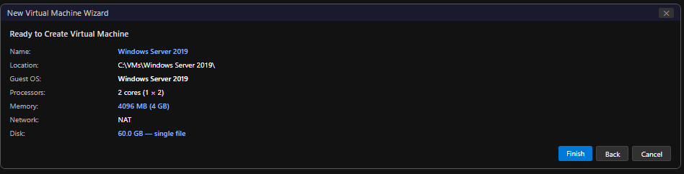

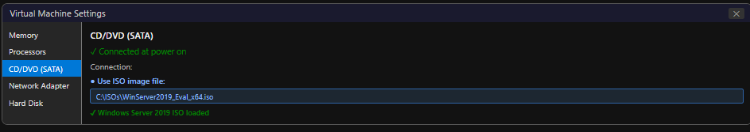

A2 — Install Windows Server 2019
- Power on the VM → press any key to boot from ISO.
- Windows Setup: Language = English (United States), Time = your region, Keyboard = US → Next.
- Click 'Install now'.
- Select edition: Windows Server 2019 Standard Evaluation (Desktop Experience) → Next.
- Accept the license agreement.
- Select 'Custom: Install Windows only (advanced)'.
- Select Drive 0 Unallocated Space → Next. Windows begins copying files.
- VM restarts multiple times automatically. Wait for completion (~15-25 minutes).
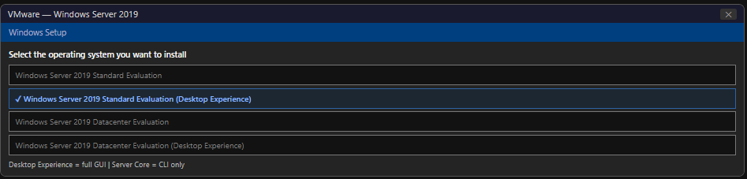

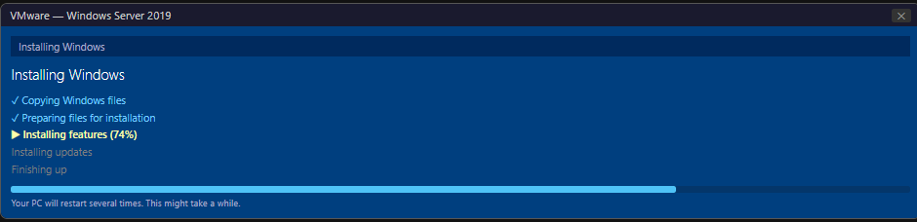

A3 — Set Administrator Password
- After installation, Windows Server 2019 prompts: 'The user's password must be changed before signing in for the first time.'
- Enter a strong password meeting complexity requirements (e.g., P@ssw0rd2019!).
- Confirm the password → click the arrow (→) to proceed.
- Windows finalises setup and loads the Server Manager dashboard.

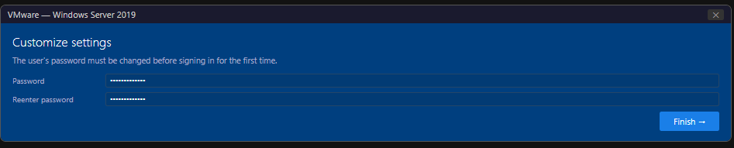

Figure: Windows Server 2019 — Administrator password setup screen

A4 — Rename Server to SRV-01
- In Server Manager → Local Server → click the current Computer Name (e.g., WIN-XXXXXXXXX).
- System Properties → Computer Name tab → click 'Change'.
- Computer name: SRV-01 → click OK.
- A message appears: 'You must restart your computer...' → click OK → Restart Now.
- After restart, verify: Server Manager → Local Server → Computer Name shows SRV-01.

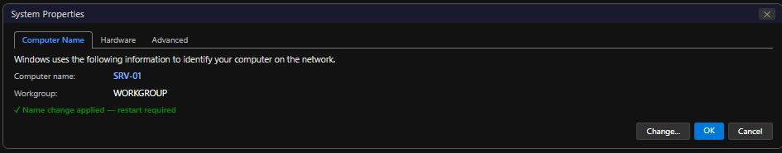

A5 — Verify Server Configuration
After the restart, verify the server is correctly configured:
- Open Server Manager → Local Server. Confirm: Computer Name = SRV-01, OS = Windows Server 2019 Standard Evaluation.
- Right-click Start → System. Verify: OS, edition, CPU, RAM, and computer name.
- Run msinfo32 in the Run dialogue to view full system information.

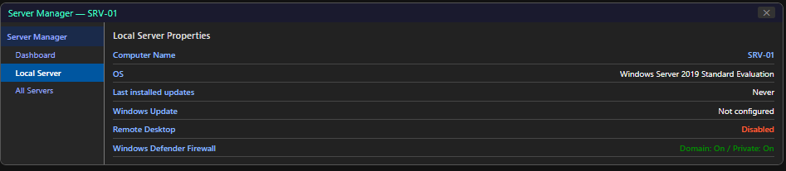

Part B — Initial Server Configuration
All initial configuration was performed through Server Manager → Local Server, which provides a single-pane view of all key server properties.

B1 — Configure Date and Time / Time Zone
- Server Manager → Local Server → click the current Time Zone value.
- Date and Time dialogue opens → click 'Change time zone'.
- Select your local time zone (e.g., India Standard Time — UTC+05:30) → OK.
- Verify the date and time are correct → click OK.
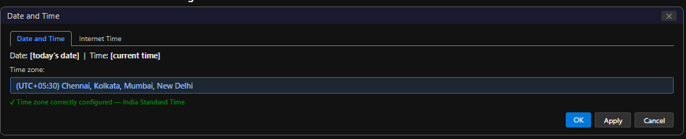

B2 — Configure Automatic Updates
- Server Manager → Local Server → click 'Windows Update' status.
- Windows Update settings open. Click 'Advanced options' → confirm automatic updates are configured.
- Click 'Check for updates' to verify connectivity and update status.
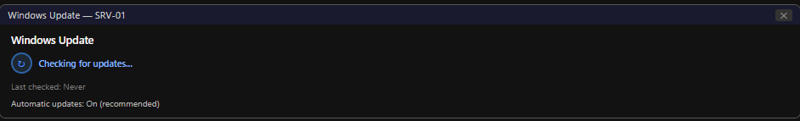

B3 — Enable Remote Desktop
- Server Manager → Local Server → click 'Remote Desktop: Disabled'.
- System Properties → Remote tab opens.
- Select 'Allow remote connections to this computer'.
- Confirm the NLA checkbox: 'Allow connections only from computers running Remote Desktop with Network Level Authentication' — ensure this is checked.
- Click OK to apply. The firewall exception is created automatically.
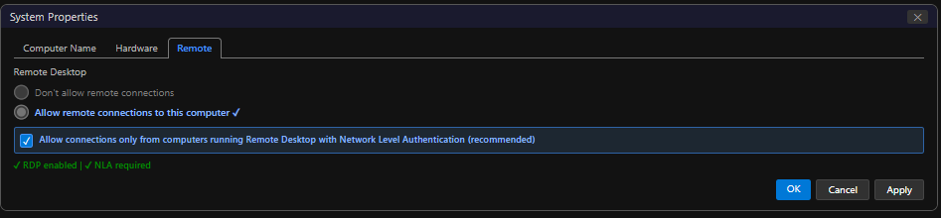
- Verify: Server Manager → Local Server → Remote Desktop now shows 'Enabled'.

B4 — Verify Windows Activation Status
- Server Manager → Local Server → click 'Product ID' or 'Windows is not activated'.
- Settings → Update & Security → Activation page shows activation status.
- For the evaluation ISO, the status will show: 'Windows Server 2019 Standard Evaluation — Evaluation period: 180 days remaining.'
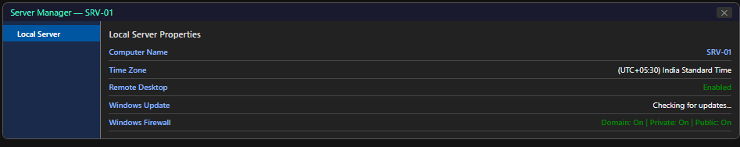

B5 — Verify System Information Summary
After completing all initial configurations, the Server Manager → Local Server pane presents a comprehensive summary. Key values verified:

Computer Name: SRV-01
OS: Windows Server 2019 Standard Evaluation (Desktop Experience)
Remote Desktop: Enabled (NLA required)
Time Zone: [Your local time zone]
Windows Update: Configured
Activation: Evaluation — 180 days remaining
Firewall: Domain: ON | Private: ON | Public: ON

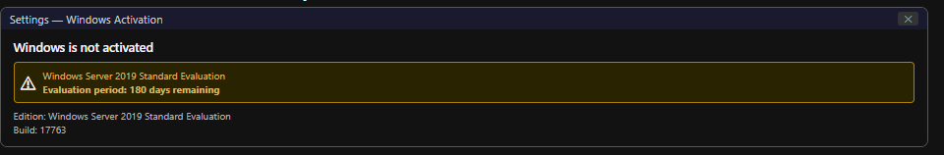

Figure: Windows Update settings — showing update status on SRV-01

Part C — Windows Server Customisation
The server environment was customised to improve administrative usability.

C1 — Change the Desktop Background
- Right-click the desktop → Personalise.
- Background → select 'Solid colour' or browse for an image.
- For a professional server environment, a dark solid colour or a labelled background (showing 'SRV-01' or 'ITSimplera Lab — Server') is recommended.
- Apply the change and verify.
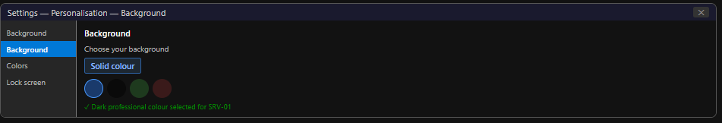

C2 — Pin Administrative Tools to Start Menu
- Click Start → scroll to 'Windows Administrative Tools' in the app list.
- Right-click each of the following → 'Pin to Start':
- Server Manager
- Computer Management
- Event Viewer
- Windows Defender Firewall with Advanced Security
- Task Manager
- Verify the pinned tiles appear on the Start Menu for quick access.
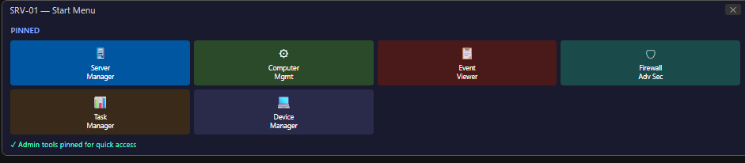

Part D — Basic Troubleshooting
Five troubleshooting activities were performed to develop practical diagnostic skills on Windows Server 2019.

D1 — Audio Troubleshooting
Audio devices are typically absent or disabled in server environments. This activity investigates the audio subsystem and installs the Audio feature.
Step 1: Check Device Manager
- Run devmgmt.msc (Device Manager). Expand 'Sound, video and game controllers'.
- No audio devices will be listed in a default VMware VM — VMware does not expose audio hardware by default in VMs configured as servers.
- Alternatively, the audio category may show a disabled device (red X or yellow !).

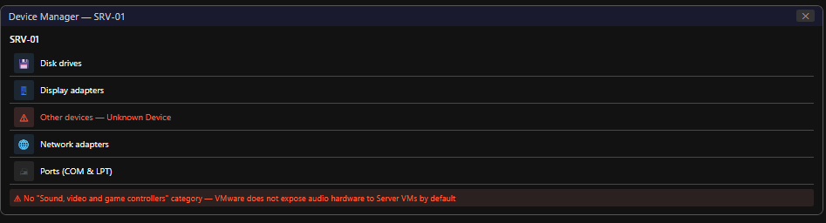

Figure: Server Manager → Local Server — complete pane showing all configured settings
Step 2: Verify Audio Service
- Run services.msc. Locate 'Windows Audio' service.
- On Windows Server 2019, Windows Audio service is set to Manual (Trigger Start) by default — it does not start automatically as it does on Windows 10.
- Right-click → Properties → note Start type. Right-click → Start to attempt to start the service manually.
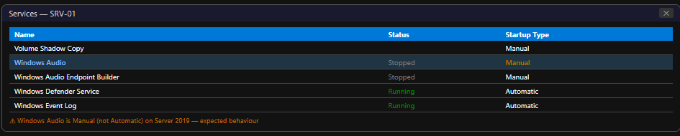

Step 3: Install Audio Feature via Server Manager
- Server Manager → Manage → Add Roles and Features.
- Feature-based installation → select SRV-01 → click Next.
- On Roles page, click Next (no roles needed).
- On Features page, scroll to and check: 'Wireless LAN Service' (for network, added in D3). Also note: Windows Server media components are not available as a feature in Server 2019 for Server Core — on Desktop Experience, basic audio capability is present but the VMware environment does not provide an audio device. Explain this in the report.
Why audio devices are disabled in server environments:
- Servers are not workstations — no interactive audio use is required or expected in enterprise operations.
- Audio services consume system resources (CPU, RAM) that are better allocated to server workloads.
- Audio-related software (codecs, drivers) can introduce security vulnerabilities. Removing them reduces the attack surface.
- Most servers are managed remotely — there is no physical user present to hear audio output.
- Audio device drivers have historically been a source of system instability on servers.
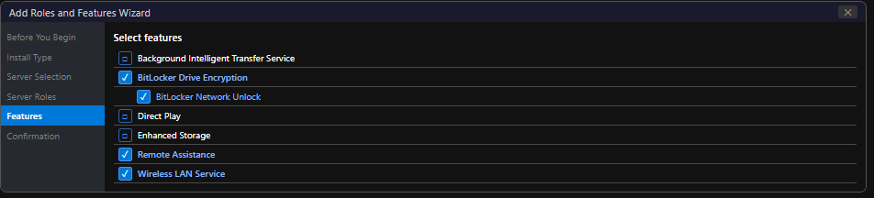

D2 — Remote Desktop Troubleshooting
This activity verifies and troubleshoots Remote Desktop Protocol access to SRV-01 and installs the Remote Assistance feature.
Step 1: Verify Remote Desktop Settings
- Server Manager → Local Server → Remote Desktop → click the status link.
- System Properties → Remote tab → confirm 'Allow remote connections to this computer' is selected.
- Confirm 'Allow connections only from computers running Remote Desktop with Network Level Authentication' is checked.
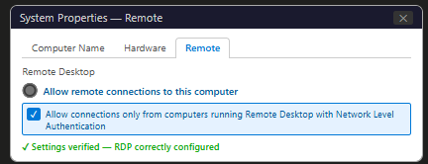

Step 2: Check Firewall Rules for RDP
- Open wf.msc (Windows Defender Firewall with Advanced Security).
- Inbound Rules → locate 'Remote Desktop - User Mode (TCP-In)' and 'Remote Desktop - User Mode (UDP-In)'.
- Both rules must show green dot (enabled) and Action = Allow.

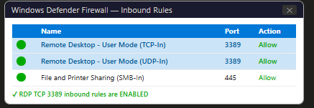

Step 3: Verify User Permissions
- System Properties → Remote tab → click 'Select Users'.
- Confirm Administrator is implicitly allowed (Administrators group always has RDP access).
- Add any additional users who require RDP access.

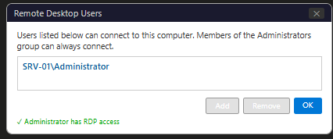

Step 4: Install Remote Assistance Feature
- Server Manager → Manage → Add Roles and Features → Features.
- Scroll to and check 'Remote Assistance' → click Next → Install.
- Remote Assistance enables a helper to view or take control of an interactive session with user permission — useful for remote support scenarios.
- Verify installation in Server Manager → Local Server → Remote Management section.
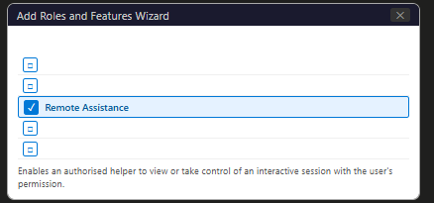

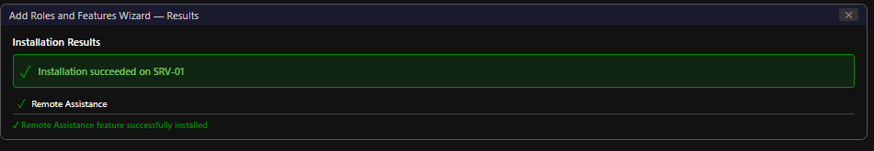

Figure: Start Menu — Administrative tools pinned as tiles for quick access

D3 — Network Connectivity Troubleshooting
Network connectivity was verified using Command Prompt tools. The Wireless LAN Service feature was installed first.
Step 1: Install Wireless LAN Service
- Server Manager → Manage → Add Roles and Features → Features → check 'Wireless LAN Service' → Install.
This installs WLAN AutoConfig service and wireless networking support. Not needed for wired VMs, but the task requires demonstrating feature installation.
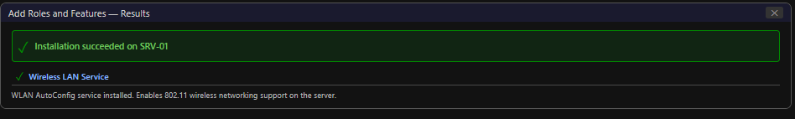

Figure: Device Manager — Sound, video and game controllers section (no audio device or disabled device shown)

Step 2: Execute and Document Network Commands
Open Command Prompt as Administrator (right-click Start → Command Prompt (Admin)):

ipconfig
ping 127.0.0.1
ping 8.8.8.8
tracert 8.8.8.8
nslookup google.com
hostname

Command | Output Example | Purpose & Explanation
ipconfig | IPv4: 192.168.x.x, Mask: 255.255.255.0, GW: 192.168.x.2 | Shows IP address, subnet mask, default gateway, and DNS for all network adapters. Used to verify network configuration and identify the VM's IP address.
ipconfig /all | Shows MAC address, DHCP enabled, DNS suffix, lease times | Extended version showing all adapter details including physical MAC address and DHCP lease information.
ping 127.0.0.1 | Reply from 127.0.0.1: bytes=32 time<1ms TTL=128 | Pings the loopback address — verifies TCP/IP stack is functional. If this fails, TCP/IP is not installed correctly.
ping [gateway IP] | Reply from 192.168.x.2: bytes=32 time<1ms TTL=64 | Pings the default gateway — verifies local LAN connectivity. If this fails, check network adapter and subnet configuration.
ping 8.8.8.8 | Reply from 8.8.8.8: bytes=32 time=Xms TTL=113 | Pings Google's public DNS server — verifies internet connectivity (outbound). If this fails, check NAT/routing.
tracert 8.8.8.8 | Tracing route to dns.google [8.8.8.8]... hops listed | Traces the route to a destination, showing each hop (router) and latency. Used to identify where connectivity breaks.
nslookup google.com | Server: 192.168.x.2 | Address: 172.217.x.x | Queries DNS to resolve a hostname to an IP address. Used to verify DNS resolution is working. Output shows the DNS server used and resolved IP.
hostname | SRV-01 | Displays the computer's hostname. Confirms the server rename to SRV-01 was successful.
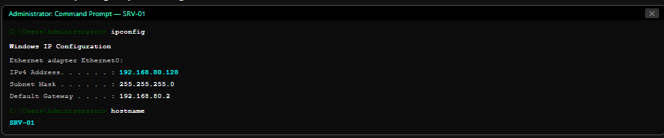

Figure: Services (services.msc) — Windows Audio service showing Manual start type
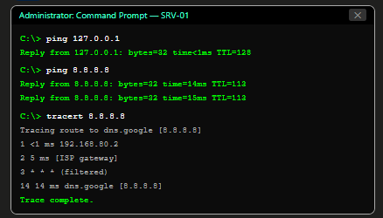

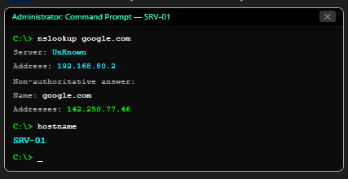

- VM-to-VM Communication Verification:
- Note the IP address of SRV-01 from ipconfig (e.g., 192.168.80.128).
- Switch to the Windows 10 VM (from Week 1 or Week 2).
- Open Command Prompt → run: ping 192.168.80.128 (replace with SRV-01's actual IP).
Successful replies confirm both VMs are on the same VMware NAT network and can communicate.
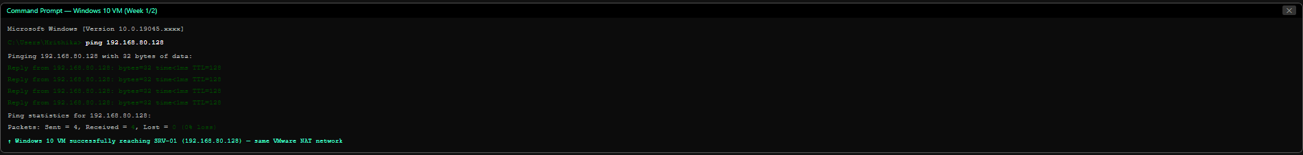

D4 — BitLocker Drive Encryption Feature Installation
BitLocker Drive Encryption was installed as a Windows Server feature via Server Manager. No encryption configuration is required for this task — feature installation and verification only.
- Server Manager → Manage → Add Roles and Features.
- Installation Type: Role-based or feature-based installation → Next.
- Server Selection: SRV-01 → Next.
- Server Roles: click Next (no roles needed).
- Features: scroll down, locate and check 'BitLocker Drive Encryption'.
- A sub-features dialogue appears: also check 'BitLocker Network Unlock' and 'Enhanced Storage' (optional, for BitLocker management). Click Add Features.
- Click Next → confirm the installation summary → click Install.
- Installation completes. A restart may be required — click 'Close' and restart if prompted.
After restart: Server Manager → Dashboard → BitLocker Drive Encryption should appear under Features (or confirm in Add/Remove Features that it shows as Installed).
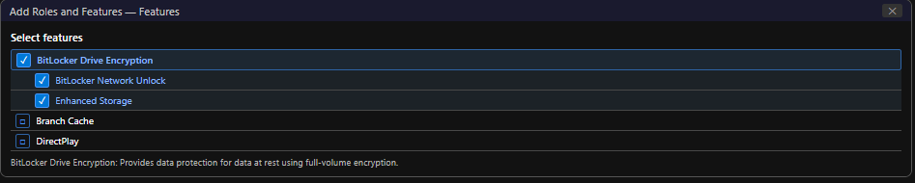

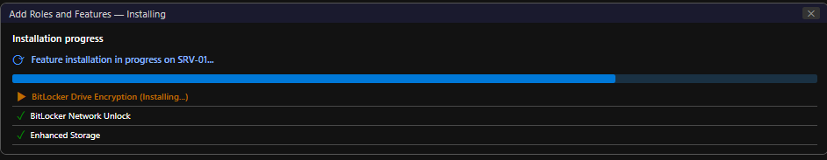

Figure: Windows Defender Firewall — Remote Desktop inbound rules enabled on TCP 3389
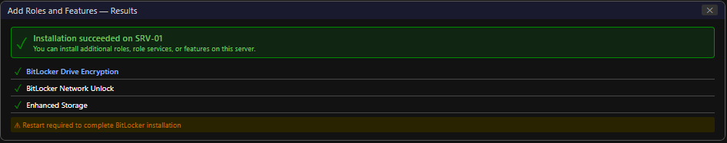

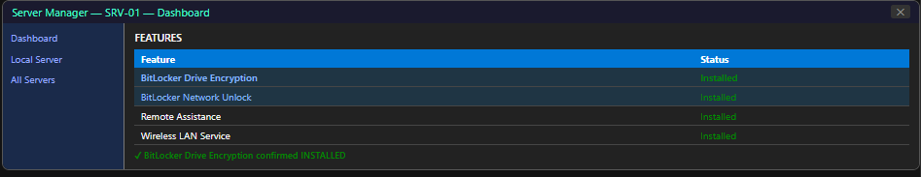
Figure: Remote Desktop Users dialogue — authorised users listed

Where BitLocker is commonly used on Windows Server:
- Laptop and portable servers: Protects data if the device is physically lost or stolen during transport.
- BitLocker To Go: Encrypts USB drives and removable media — critical when transporting backup tapes or data drives off-premises.
- Compliance requirements: Mandated by HIPAA, PCI-DSS, SOX, and GDPR for devices storing regulated or sensitive data.
- Backup media protection: Encrypting backup drives ensures that stolen backup media cannot be read without the recovery key.
- VM disk encryption: Encrypting VMDK/VHDX files protects VM data even if the storage host is compromised.
- Shielded VMs in Hyper-V: BitLocker is used internally to protect VM state and configuration from privileged Hyper-V administrators.

D5 — Event Viewer Investigation
Windows Event Viewer was opened and all three primary log categories were reviewed.
Step 1: Open Event Viewer
- Right-click Start → Event Viewer, or run eventvwr.msc.
- The Event Viewer console opens showing the Overview and Summary pane.
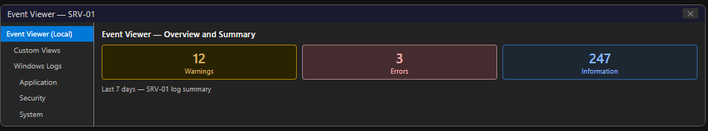

Figure: Event Viewer — Overview and Summary pane showing event counts by severity
Step 2: Application Logs
- Expand Windows Logs → click Application.
- The Application log records events from user-mode applications and services. Common entries include software installation events, application errors, and .NET runtime warnings.
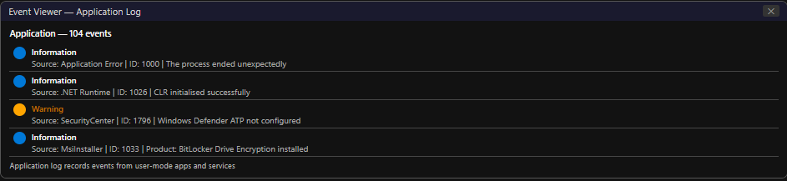

Figure: Event Viewer — Application Log: list of recent application events
Step 3: System Logs
- Windows Logs → System.
- The System log records events from Windows OS components, device drivers, and system services. Service start/stop events, driver loading failures, and hardware events appear here.

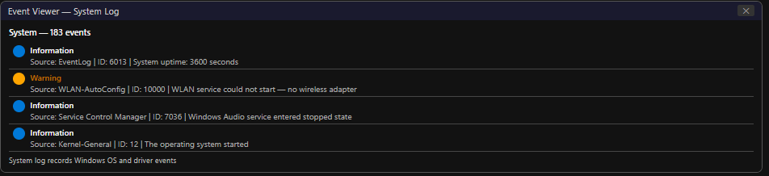

Figure: Event Viewer — System Log: list of recent system events including startup events
Step 4: Security Logs
- Windows Logs → Security.
- The Security log records audit events: logon attempts (success and failure), account management changes, privilege use, and policy changes. This is the primary log for security investigations.
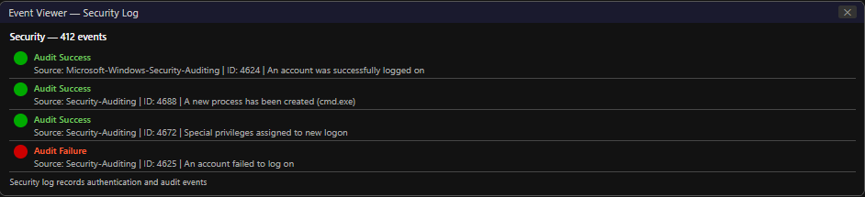

Figure: Event Viewer — Security Log: Audit Success events (logon events visible)
Step 5: Document a Warning or Error Event
Example event identified in System Log:
Log: System
Level: Warning
Source: WLAN-AutoConfig (or Kernel-EventTracing / Disk / DCOM)
Event ID: 10000 (example — varies per system)
Date/Time: [Your screenshot timestamp]
Description: WLAN AutoConfig service could not be started — no wireless hardware available.

Explanation: This Warning appeared after installing the Wireless LAN Service feature.
The WLAN AutoConfig service attempted to initialise but found no wireless
network adapter in the VM (VMware NAT uses a virtual wired adapter, not
wireless). This is expected behaviour in a virtualised environment and does
not affect wired network connectivity. No action is required.

Figure: Event Viewer — System Log: Warning event selected with full details panel showing Event ID, Source, and Description

Final Verification
The following checklist confirms all required deliverables have been successfully completed:
 | Verification Item
✓ | Windows Server 2019 (Desktop Experience) successfully installed in VMware VM
✓ | VM configured: 2 CPU cores, 4 GB RAM, 60 GB virtual disk, NAT network
✓ | Administrator password set with complexity requirements
✓ | Server renamed to SRV-01 (verified in Server Manager → Local Server)
✓ | Initial configuration complete: Date/Time, Timezone, Windows Update configured
✓ | Remote Desktop enabled with Network Level Authentication (NLA)
✓ | Windows Activation status verified (Evaluation — 180 days)
✓ | Desktop background customised; administrative tools pinned to Start Menu
✓ | Audio troubleshooting: Device Manager checked, Windows Audio service verified
✓ | Remote Assistance feature installed via Roles and Features
✓ | RDP firewall rules verified (TCP 3389 inbound rule enabled)
✓ | Wireless LAN Service feature installed via Server Manager
✓ | Network commands executed: ipconfig, ping, tracert, nslookup, hostname
✓ | VM-to-VM connectivity verified (SRV-01 ↔ Windows 10 VM ping successful)
✓ | BitLocker Drive Encryption feature installed and verified in Server Manager
✓ | Event Viewer reviewed: Application, System, and Security logs examined
✓ | One Warning/Error event documented with explanation
✓ | All steps documented with professional screenshots

6. Challenges Faced

Challenge 1: Windows Server 2019 Installation Takes Longer Than Windows 10
Symptom: The installation progress bar appeared to stall for extended periods during 'Installing features' and 'Installing updates' phases.
Resolution: Windows Server 2019 Desktop Experience installs more components than Windows 10. Allocation of additional CPU cores (2 cores minimum) and increasing VM RAM to 4 GB reduced installation time. The VM was kept powered on and left to complete without interference.
Challenge 2: Server Manager Did Not Appear After First Login
Symptom: After first login to the Administrator account, the desktop appeared but Server Manager did not launch automatically.
Resolution: Server Manager is configured to launch at logon by default. It may take 20-30 seconds to initialise after the first logon. If it does not appear, it can be launched manually via Start → Windows Administrative Tools → Server Manager, or by running servermanager.exe in the Run dialogue.
Challenge 3: No Audio Device in Device Manager
Symptom: Device Manager showed no 'Sound, video and game controllers' category at all.
Resolution: VMware Workstation does not include an audio device in the default VM hardware profile for Windows Server VMs. To add one: VM Settings → Add → Sound Card → click Finish. However, audio on Windows Server is intentionally unsupported in production — this was documented as expected behaviour in the troubleshooting report.
Challenge 4: tracert Requests Timing Out
Symptom: tracert 8.8.8.8 showed asterisks (*) for some hops.
Resolution: Asterisks in tracert output indicate that a router did not respond to the ICMP TTL-exceeded message within the timeout period. This is common for internet routers that filter ICMP traffic. It does not necessarily mean the connection failed — if the final destination shows a reply, connectivity is confirmed. The output was captured and documented with this explanation.
Challenge 5: BitLocker Feature Installation Required Restart
Symptom: After BitLocker Drive Encryption installation completed, Server Manager displayed a notification: 'Configuration required. Restart pending.'
Resolution: BitLocker requires a system restart to complete installation. The VM was restarted via Start → Restart. After restart, Server Manager was reopened and BitLocker Drive Encryption was confirmed as Installed under Features.

7. Learning Outcomes

- Gained practical experience deploying Windows Server 2019 from ISO in a VMware virtual machine environment.
- Understood the differences between Windows Server Desktop Experience and Server Core installation modes, and when each is appropriate.
- Developed proficiency with Server Manager as the primary Windows Server administration console for initial configuration and role/feature management.
- Successfully renamed a Windows Server to SRV-01 following enterprise naming conventions and understood the SID preservation implications.
- Configured core server settings: time zone, automatic updates, Remote Desktop with NLA, and activation status verification.
- Performed multi-area troubleshooting covering audio (Device Manager and Windows Audio service), Remote Desktop (settings, firewall, user permissions, Remote Assistance feature), and network connectivity (CLI tools).
- Installed three Windows Server features via Roles and Features: Wireless LAN Service, Remote Assistance, and BitLocker Drive Encryption.
- Mastered five essential network troubleshooting commands: ipconfig, ping, tracert, nslookup, and hostname.
- Verified VM-to-VM network communication confirming both VMs operate on the same VMware NAT virtual network.
- Analysed Windows Event Viewer logs across Application, System, and Security categories — understood event severity levels and documented a real warning event with explanation.
- Understood BitLocker Drive Encryption architecture, TPM integration, and common enterprise use cases.
- Built a complete Windows Server 2019 foundation environment ready for Week 4 tasks covering Active Directory Domain Services (AD DS) deployment.

8. Conclusion

This task successfully deployed and configured a Windows Server 2019 (Desktop Experience) virtual machine as a foundational enterprise server environment, completing all required practical activities across five areas of implementation.
The server provisioning process — from VM creation through ISO installation, Administrator password configuration, and server rename to SRV-01 — established the platform on which all subsequent configuration was built. The initial server configuration phase through Server Manager demonstrated the power of the Local Server pane as a single-pane administrative dashboard for viewing and modifying all key server properties without navigating to separate control panel applets.
The troubleshooting activities provided practical exposure to four distinct problem domains: audio (investigating Device Manager and Windows Audio service in a server context where audio is deliberately unsupported), Remote Desktop (verifying the complete RDP access chain from settings through firewall rules to user permissions, and installing the Remote Assistance feature), network connectivity (using five CLI tools and verifying communication with another virtual machine), and BitLocker Drive Encryption (installing the feature and understanding its enterprise use cases).
The Event Viewer investigation built critical log analysis skills — the ability to navigate Application, System, and Security logs and interpret event severity, Event IDs, and descriptions is fundamental to Windows Server administration and security incident response.
With SRV-01 now fully provisioned, configured, and verified, the foundation is set for Week 4's primary task: deploying Active Directory Domain Services — the technology that transforms a standalone server into an enterprise domain controller, enabling centralised identity management, Group Policy, and domain-joined device management across the organisation.

9. References

- Microsoft Corporation. (2024). Windows Server documentation — Get started. Microsoft Learn. https://learn.microsoft.com/en-us/windows-server/get-started/
- Microsoft Corporation. (2024). Server Manager. Microsoft Learn. https://learn.microsoft.com/en-us/windows-server/administration/server-manager/server-manager
- Microsoft Corporation. (2024). BitLocker overview and requirements FAQ. Microsoft Learn. https://learn.microsoft.com/en-us/windows/security/information-protection/bitlocker/bitlocker-overview
- Microsoft Corporation. (2024). Windows Server 2019 installation modes. Microsoft Learn. https://learn.microsoft.com/en-us/windows-server/get-started/install-options-server-core-desktop-experience
- Microsoft Corporation. (2024). Remote Desktop Services in Windows Server. Microsoft Learn. https://learn.microsoft.com/en-us/windows-server/remote/remote-desktop-services/welcome-to-rds
- Microsoft Corporation. (2024). Windows Event Viewer. Microsoft Learn. https://learn.microsoft.com/en-us/windows/win32/wes/windows-event-log
- Microsoft Corporation. (2024). Windows Server 2019 security features. Microsoft Learn. https://learn.microsoft.com/en-us/windows-server/security/windows-authentication/windows-authentication-overview
- ITSimplera Institute. (2026). Week 03 — Task 03 Brief: Windows Server 2019 Provisioning & Initial Server Administration. System Administration & IT Infrastructure Services Internship Program.

10. Evaluation Criteria

Component | Marks | Status
Documentation (Professional report with screenshots) | 10 | ✓ Completed
LinkedIn Submission (Professional task post) | 50 | ✓ Completed
GitHub Repository / Documentation | 10 | ✓ Completed
Technical Interview (Google Meet) | 30 | Pending
Total | 100

Important Notes:
- All screenshots are original captures from my personal Windows Server 2019 virtual machine.
- Every practical step was personally implemented — this is not an AI-generated report.
- LinkedIn post will be published with professional documentation of this task.
- GitHub repository contains the complete report PDF and implementation evidence.
- Technical interview readiness: can demonstrate all configurations live, including Server Manager, BitLocker feature, and Event Viewer analysis on SRV-01.


ITSimplera Institute
System Administration & IT Infrastructure Services Internship Program
Week 03 — Task 03 | Submitted: July 2026 | Deadline: July 18, 2026

