Customer Churn Analysis
SQL and EXCEL
Prepared by

PANDIAYARAJ D
Tools: MySQL Workbench,Excel-2024 | Dataset: 10,000 customer records
Domain: Banking / Customer Retention
May 2026

1. Project Overview
This project performs an end-to-end exploratory analysis on a banking customer dataset of 10,000 records to understand customer churn behaviour. The objective is to identify the demographic, financial and behavioural patterns that distinguish churned customers from retained customers, using SQL and EXCEL as the analytical tool.
The analysis is structured as 22 progressive queries and at last excel dashboard — beginning with basic descriptive counts and moving toward segmented churn-rate analysis across geography, age, tenure, product usage and financial profile, and finishing with two nested-subquery investigations. Each query was written and executed in MySQL Workbench against the table customer_churn_table.

Dataset Snapshot
Table name: customer_churn_table | Total records: 10,000 Key columns used in the analysis:
Column | Description
CustomerId / Surname | Customer identifier and last name
CreditScore | Customer credit score
Geography | Country of the customer (France, Spain, Germany)
Gender | Male / Female
Age | Customer age in years
Tenure | Years the customer has been with the bank
Balance | Account balance
NumOfProducts | Number of bank products held (1 to 4)
HasCrCard | 1 if customer has a credit card, else 0
IsActiveMember | 1 if active member, else 0
EstimatedSalary | Estimated annual salary
Exited | Target variable: 1 = churned, 0 = retained

Analytical Approach
The 22 queries progress through five analytical layers:
- Descriptive baseline (Q1 to Q8): record counts, distributions, simple averages.
- Behavioural slicing (Q9 to Q11): activity, product holdings, salary by gender.
- Segmented churn analysis (Q12 to Q17): churn rate by country, tenure, products, age and gender.
- Risk profiling (Q18 to Q20): financial profile of churned customers and high-risk segments.
- Subquery-driven analysis (Q21 to Q22): nested SELECTs in WHERE and HAVING clauses to benchmark against derived values.

2. SQL Queries and Results
Each section below contains the business question, the SQL query, the result returned by MySQL Workbench, and a short interpretation.

Q1. Total number of customers in the dataset
Establishes the baseline record count for the analysis.
SQL Query:
SELECT COUNT(*) AS total_customers
FROM customer_churn_table;

Result:
total_customers
10,000

Insight
The dataset contains 10,000 customer records, large enough for meaningful segmentation analysis.

Q2. How many customers churned vs not churned?
Measures the overall class distribution of the target variable (Exited).
SQL Query:
SELECT
Exited AS churn_flag,
COUNT(*) AS customer_count
FROM customer_churn_table
GROUP BY Exited;

Result:
churn_flag | customer_count
1 (Churned) | 2,038
0 (Retained) | 7,962

Insight
Overall churn rate is 20.38%. The dataset is imbalanced — roughly 1 in 5 customers leaves the bank.
Q3. What is the average credit score of all customers?
Provides a baseline measure of customer creditworthiness across the portfolio.
SQL Query:
SELECT AVG(CreditScore) AS avg_credit_score
FROM customer_churn_table;

Result:
avg_credit_score
650.5288

Insight
The average credit score is ~650, considered fair-to-good. This is the benchmark for comparing churned vs retained segments later.

Q4. Number of customers from each country
Geographic distribution of the customer base.
SQL Query:
SELECT
Geography,
COUNT(*) AS customer_count
FROM customer_churn_table
GROUP BY Geography;

Result:
Geography | customer_count
France | 5,014
Germany | 2,509
Spain | 2,477

Insight
France accounts for ~50% of customers. Germany and Spain are nearly equal at ~25% each. Sample sizes are large enough in all three to compare churn rates fairly.

Q5. Number of male vs female customers
Gender distribution of the customer base.
SQL Query:
SELECT
Gender,
COUNT(*) AS customer_count
FROM customer_churn_table
GROUP BY Gender;

Result:
Gender | customer_count
Male | 5,457
Female | 4,543

Insight
The dataset is moderately male-skewed (54.6% male, 45.4% female). Both groups have large enough samples for gender-based segmentation.

Q6. How many customers have zero account balance?
Identifies customers with no balance — potentially dormant accounts.
SQL Query:
SELECT COUNT(*) AS zero_balance_customers
FROM customer_churn_table
WHERE Balance = 0;

Result:
zero_balance_customers
3,617

Insight
36.17% of customers carry a zero balance. This is a significant segment and likely overlaps with France (which has lower average balances than Germany).

Q7. Average balance of churned customers
Computes the mean balance for customers who exited.
SQL Query:
SELECT ROUND(AVG(Balance), 2) AS avg_balance_churned
FROM customer_churn_table
WHERE Exited = 1;

Result:
avg_balance_churned
91,109.48

Insight
Churned customers carry an average balance of ~91,109. This is meaningful — the bank is losing customers with substantial deposits, not just inactive accounts.

Q8. Average tenure of non-churned customers
Measures the average years-with-bank for retained customers.
SQL Query:
SELECT ROUND(AVG(Tenure), 2) AS avg_tenure_retained
FROM customer_churn_table
WHERE Exited = 0;

Result:
avg_tenure_retained
5.03

Insight
Retained customers average ~5 years tenure — sitting near the middle of the 0 to 10 year range. Tenure alone is not strongly predictive of retention (confirmed later in Q14).

Q9. Number of active members with more than 2 products
Counts highly-engaged customers — active AND holding 3 or more products.
SQL Query:
SELECT COUNT(*) AS active_members_high_products
FROM customer_churn_table
WHERE NumOfProducts > 2
AND IsActiveMember = 1;

Result:
active_members_high_products
142

Insight
Only 142 customers (1.42%) are both active AND holding 3+ products — a very small but valuable segment. Q15 will show why this matters.

Q10. Average balance comparison: active vs inactive customers
Compares mean balance for active members against inactive ones.
SQL Query:
SELECT
IsActiveMember AS activity_status,
ROUND(AVG(Balance), 2) AS avg_balance
FROM customer_churn_table
GROUP BY IsActiveMember;

Result:
activity_status | avg_balance
1 (Active) | 75,875.42
0 (Inactive) | 77,134.38

Insight
Surprisingly, inactive members hold marginally higher balances than active ones. Activity status is not driven by balance — it is a separate behavioural signal.

Q11. Average estimated salary by gender
Compares mean estimated salary between male and female customers.
SQL Query:
SELECT
Gender,
ROUND(AVG(EstimatedSalary), 2) AS avg_estimated_salary
FROM customer_churn_table
GROUP BY Gender;

Result:
Gender | avg_estimated_salary
Female | 100,601.54
Male | 99,664.58

Insight
Average salaries are nearly identical across genders (difference ~$937, < 1%). Salary is unlikely to be a useful churn predictor by itself.

Q12. Which country has the highest churn rate?
Calculates churn rate per country to identify geographic risk.
SQL Query:
SELECT
Geography,
COUNT(*) AS total_customers,
SUM(Exited) AS churned_customers,
ROUND(AVG(Exited) * 100, 2) AS churn_rate_percent
FROM customer_churn_table
GROUP BY Geography
ORDER BY churn_rate_percent DESC;

Result:
Geography | total_customers | churned_customers | churn_rate_percent
Germany | 2,509 | 814 | 32.44 %
Spain | 2,477 | 413 | 16.67 %
France | 5,014 | 811 | 16.17 %

Insight
Germany has a churn rate of 32.44% — roughly DOUBLE Spain and France. This is the single most striking finding so far and warrants further investigation into the German market.

Q13. Top 5 customers with highest estimated salary who churned
Identifies the highest-value (by salary) customers the bank lost.
SQL Query:
SELECT
Surname,
Geography,
Age,
EstimatedSalary
FROM customer_churn_table
WHERE Exited = 1
ORDER BY EstimatedSalary DESC
LIMIT 5;

Result:
Surname | Geography | Age | EstimatedSalary
Hopkins | Germany | 39 | 199,808.10
Chidozie | Germany | 31 | 199,725.39
Grant | Germany | 37 | 199,693.84
Hsia | France | 43 | 199,378.58
McDonald | Spain | 41 | 199,304.74

Insight
3 of the top 5 highest-salary churners are from Germany, reinforcing Q12. All five are in their 30s–40s — the prime earning age group.

Q14. Churn rate per tenure year
Measures churn rate at each tenure year (0 through 10).
SQL Query:
SELECT
Tenure,
COUNT(*) AS total_customers,
SUM(Exited) AS churned_customers,
ROUND(AVG(Exited) * 100, 2) AS churn_rate_percent
FROM customer_churn_table
GROUP BY Tenure
ORDER BY Tenure;

Result:
Tenure | total_customers | churned_customers | churn_rate_percent
0 | 413 | 95 | 23.00 %
1 | 1,035 | 232 | 22.42 %
2 | 1,048 | 201 | 19.18 %
3 | 1,009 | 213 | 21.11 %
4 | 989 | 203 | 20.53 %
5 | 1,012 | 209 | 20.65 %
6 | 967 | 196 | 20.27 %
7 | 1,028 | 177 | 17.22 %
8 | 1,025 | 197 | 19.22 %
9 | 984 | 214 | 21.75 %
10 | 490 | 101 | 20.61 %

Insight
Churn rate is remarkably flat across tenure years (17–23%). New customers (tenure 0–1) churn slightly more, and 7-year customers slightly less, but tenure is NOT a strong predictor of churn.

Q15. Churn rate by number of products held
Calculates churn rate at each product-count level.
SQL Query:
SELECT
NumOfProducts,
COUNT(*) AS total_customers,
SUM(CASE WHEN Exited = 1 THEN 1 ELSE 0 END) AS churned_customers, ROUND(
SUM(CASE WHEN Exited = 1 THEN 1 ELSE 0 END) * 100.0 / COUNT(*), 2
) AS churn_rate_percent FROM customer_churn_table
GROUP BY NumOfProducts
ORDER BY NumOfProducts;

Result:
NumOfProducts | total_customers | churned_customers | churn_rate_percent
1 | 5,084 | 1,409 | 27.71 %
2 | 4,590 | 349 | 7.60 %
3 | 266 | 220 | 82.71 %
4 | 60 | 60 | 100.00 %

Insight
The single strongest churn signal in the entire dataset. 2-product customers are the “sweet spot” (only 7.6% churn). Customers with 3 products churn at 82.7%, and all 60 customers with 4 products churn. This suggests product cross-selling beyond 2 may be backfiring or these are dissatisfied complex-product customers.

Q16. Churn rate segmented by age groups
Groups customers into age bands and computes churn rate per band.
SQL Query:
SELECT
CASE
WHEN Age BETWEEN 18 AND 30 THEN '18-30'
WHEN Age BETWEEN 31 AND 45 THEN '31-45'
WHEN Age BETWEEN 46 AND 60 THEN '46-60'
WHEN Age > 60 THEN '60+'
END AS age_group,
COUNT(*) AS total_customers,
SUM(Exited) AS churned_customers,
ROUND(AVG(Exited) * 100, 2) AS churn_rate_percent
FROM customer_churn_table
GROUP BY age_group
ORDER BY age_group;

Result:
age_group | total_customers | churned_customers | churn_rate_percent
18-30 | 1,968 | 148 | 7.52 %
31-45 | 5,921 | 933 | 15.76 %
age_group | total_customers | churned_customers | churn_rate_percent
46-60 | 1,647 | 842 | 51.12 %
60+ | 464 | 115 | 24.78 %

Insight
Age is the second-strongest churn signal. Customers aged 46–60 churn at 51.12% — more than 6x the 18–30 group. This is the bank’s highest-risk demographic and likely overlaps with the German market issue.

Q17. Churn rate by Geography × Gender combinations
Crosses geography with gender to find the most at-risk demographic cells.
SQL Query:
SELECT
Geography,
Gender,
COUNT(*) AS total_customers,
SUM(Exited) AS churned_customers,
ROUND(AVG(Exited) * 100, 2) AS churn_rate_percent
FROM customer_churn_table
GROUP BY Geography, Gender
ORDER BY churn_rate_percent DESC;

Result:
Geography | Gender | total | churned | churn %
Germany | Female | 1,193 | 448 | 37.55 %
Germany | Male | 1,316 | 366 | 27.81 %
Spain | Female | 1,089 | 231 | 21.21 %
France | Female | 2,261 | 460 | 20.34 %
Spain | Male | 1,388 | 182 | 13.11 %
France | Male | 2,753 | 351 | 12.75 %

Insight
Across every country, females churn more than males. German females are the single highest-risk segment at 37.55%. The Female-Male gap is largest in Germany (~10 points), narrowest in France (~8 points).

Q18. Average credit score and balance for churned customers per country
Profiles the financial characteristics of churners in each country.
SQL Query:
SELECT
Geography,
ROUND(AVG(CreditScore)) AS avg_credit_score,
ROUND(AVG(Balance), 2) AS avg_balance,
COUNT(*) AS churned_customer_count
FROM customer_churn_table
WHERE Exited = 1
GROUP BY Geography;

Result:
Geography | avg_credit_score | avg_balance | churned_count
France | 642 | 71,219.71 | 811
Spain | 647 | 72,513.35 | 413
Germany | 648 | 120,361.08 | 814

Insight
Credit scores of churners are nearly identical across countries (~645). But German churners hold an average balance of 120,361 — about 68% higher than France or Spain. Germany is losing wealthier customers AND losing them at twice the rate. This is the most financially damaging finding in the analysis.

Q19. Top 10 most at-risk profiles — highest balance customers who churned
Lists the 10 highest-balance customers that the bank lost. These are the single most expensive losses.
SQL Query:
SELECT *
FROM customer_churn_table
WHERE Exited = 1
ORDER BY Balance DESC
LIMIT 10;

Result:
Surname | CreditScore | Geography | Gender | Age | Tenure | Balance | NumOfProducts
Lo | 655 | Spain | Male | 38 | 3 | 250,898.09 | 3
Surname | CreditScore | Geography | Gender | Age | Tenure | Balance | NumOfProducts
To Rot | 583 | France | Female | 57 | 3 | 238,387.56 | 1
Haddon | 749 | Spain | Male | 42 | 9 | 222,267.63 | 1
Shaw | 663 | Spain | Female | 58 | 5 | 216,109.88 | 1
Chia | 584 | Spain | Female | 48 | 2 | 213,146.20 | 1
Macartney | 850 | France | Female | 35 | 1 | 211,774.31 | 1
Macdonald | 596 | France | Male | 21 | 4 | 210,433.08 | 2
Fleming | 672 | Spain | Female | 56 | 2 | 209,767.31 | 2
Webb | 706 | Spain | Female | 29 | 1 | 209,490.21 | 1
Burke | 479 | France | Female | 33 | 2 | 208,165.53 | 1

Insight
Of the 10 most expensive churn losses, 7 are female and 8 hold only 1 product. This is consistent with Q15 (single-product = high churn) and Q17 (female = higher churn). Note that Spain dominates the top 10 here — different pattern than the country-level rate analysis.

Q20. Churn rate among customers with no credit card
Tests whether not having a credit card is associated with higher churn.
SQL Query:
SELECT
COUNT(*) AS total_no_credit_card,
SUM(Exited) AS churned_customers,
ROUND(SUM(Exited) * 100.0 / COUNT(*), 2) AS churn_rate_percent
FROM customer_churn_table
WHERE HasCrCard = 0;

Result:
total_no_credit_card | churned_customers | churn_rate_percent
2,945 | 613 | 20.81 %

Insight
Customers without a credit card churn at 20.81% — essentially identical to the overall 20.38% rate. Credit card holding is NOT a churn driver, which is a useful negative finding.

Q21. Customers with balance higher than the average balance of churned customers
Uses a scalar subquery in the WHERE clause to benchmark each customer against the average balance of churners (91,109.48 from Q7). Returns all customers above that threshold, ordered by balance.
SQL Query:
SELECT
Surname,
Geography,
Balance,
Exited
FROM customer_churn_table
WHERE Balance > (
SELECT AVG(Balance)
FROM customer_churn_table
WHERE Exited = 1
)
ORDER BY Balance DESC;

Result:
Surname | Geography | Balance | Exited
Lo | Spain | 250,898.09 | 1
To Rot | France | 238,387.56 | 1
Haddon | Spain | 222,267.63 | 1
McIntosh | Spain | 221,532.80 | 0
Shaw | Spain | 216,109.88 | 1
Dilke | Germany | 214,346.96 | 0
Chia | Spain | 213,146.20 | 1
Moore | France | 212,778.20 | 0
… (additional rows)

Insight
Demonstrates a scalar subquery inside WHERE. The top 8 results are a near-even mix of churned (Exited = 1) and retained (Exited = 0) customers — high balance alone does not drive churn. Multiple Spain customers appear at the top, but several of the highest-balance accounts (McIntosh, Dilke, Moore) are retained. This complements Q19, which isolated only the high-balance churners.

Q22. Countries with churn rate higher than the overall average churn rate
Uses a subquery inside HAVING to compare each country's churn rate against the dataset-wide average (~20.38%). Only countries above that benchmark are returned.
SQL Query:
SELECT
Geography,
COUNT(*) AS total_customers,
SUM(Exited) AS churned_customers,
ROUND(AVG(Exited) * 100, 2) AS country_churn_rate
FROM customer_churn_table
GROUP BY Geography
HAVING AVG(Exited) > (
SELECT AVG(Exited) FROM customer_churn_table
)
ORDER BY country_churn_rate DESC;

Result:
Geography | total_customers | churned_customers | country_churn_rate
Germany | 2,509 | 814 | 32.44 %

Insight
Demonstrates a subquery inside HAVING — a step up from WHERE because HAVING filters AFTER aggregation. Only Germany exceeds the overall 20.38% churn rate. Spain (16.67%) and France (16.17%) both sit below the benchmark, confirming Germany as the single problematic market and aligning with Q12.

3. Summary of Key Findings
Across 22 queries, four findings stand out as the clear churn drivers in this dataset:
- Number of products held is the single strongest predictor. 2-product customers churn at 7.6%; 3-product at 82.7%; 4-product at 100%. Product strategy needs urgent review.
- Age group 46–60 churns at 51% — over 6x the 18–30 rate. This is the bank's highest-risk demographic.
- Germany is the highest-churn country at 32.44%, roughly double Spain (16.67%) and France (16.17%). German churners also hold ~68% higher balances than churners elsewhere.
- Female customers churn more than male customers in every country. German females (37.55%) are the single most at-risk demographic cell.

Variables that did NOT predict churn well
- Tenure — churn rate is flat (17–23%) across all 11 tenure years.
- HasCreditCard — non-cardholders churn at 20.81% vs overall 20.38%; effectively no difference.
- Estimated Salary — averages by gender differ by under 1%, and the highest-salary churners are spread across all three countries.
- IsActiveMember vs Balance — active and inactive members hold nearly identical average balances.

Recommended Next Steps
Based on these SQL findings, three follow-on analyses would be valuable:
- Investigate the 3+ product cohort qualitatively — is this a forced cross-sell pattern, or are these complex-needs customers being under-served?
- Build a retention campaign targeted at the German female 46–60 segment, the intersection of all three top risk factors.
- Move from descriptive SQL to predictive modelling — build a logistic regression or classification tree using NumOfProducts, Age, Geography and Gender as the primary features.

EXCEL ANALYSIS :

1.OVERVIEW
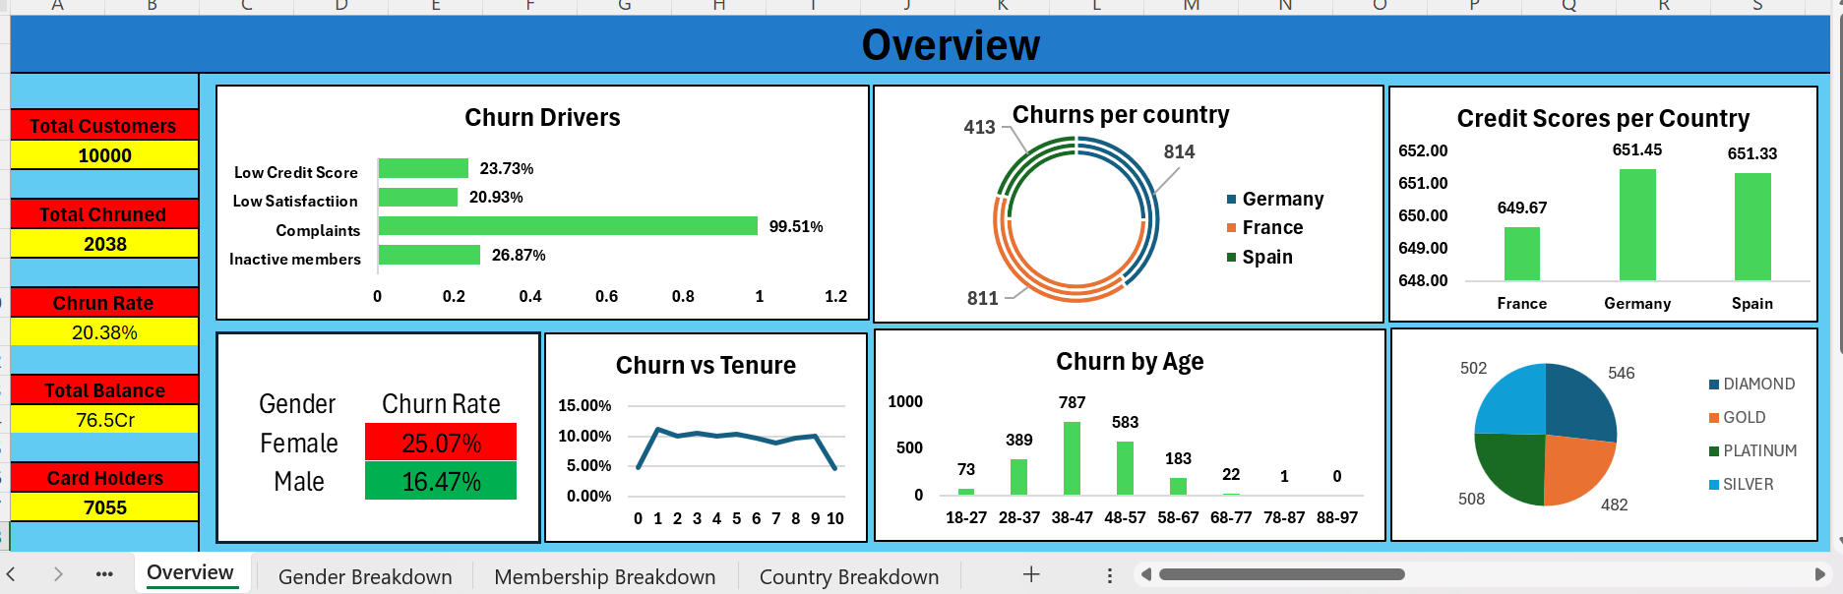
Findings:
1.Every complaints are almost turning into a churn.
2.Female’s Churn Rate is pretty much higher than male’s.
3.Litrally the persons with more tenure churns less so make them to stay longer.
4.Over all 38-47 years are churning a lots, so need more care for them.
5.Credit scores are almost equal among countries.
6.Each memberships are also having equal amount of churns.
Recommendations:
1. Treat complaints as a churn emergency — with a 99.51% churn rate among complainants, build a priority complaint-resolution desk that flags and follows up on every complaint within 24–48 hours.
2. Launch a women-focused retention programme, since female churn (25.07%) runs well above male churn (16.47%); review whether product fit, fees or service experience differ by gender.
3. Reward tenure with loyalty benefits and early-tenure onboarding, as longer-tenured customers churn less; concentrate retention effort on the first few years.
4. Design a dedicated 38–47 age-group offer (advisory contact, tailored products), as this band shows the highest churn volume (787 customers).
5. Reactivate inactive members, whose churn (26.87%) sits clearly above the 20.38% overall rate — trigger engagement nudges when activity drops.

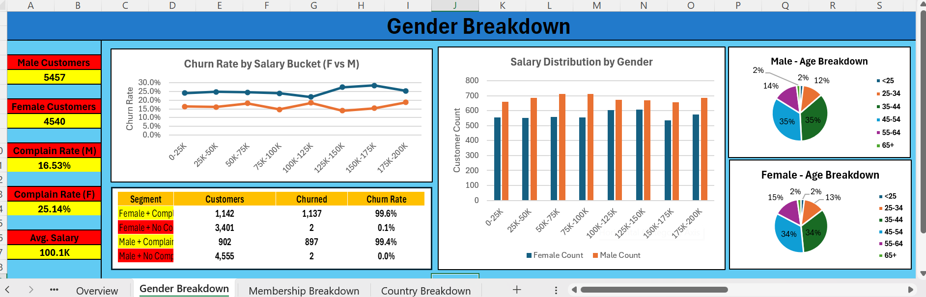
Findings:
1. Females churn far more than males — complain rate for females is 25.14% versus 16.53% for males.
2. Complaints are the deciding factor for both genders: Female + Complaint churns at 99.6% and Male + Complaint at 99.4%, while customers with no complaint barely churn at all (0.1% and 0.0%).
3. Salary is not a churn driver — churn rate is flat across every salary bucket from 0–25K up to 175–200K, and salary distribution is nearly identical for both genders.
4. The age mix is almost the same for both genders, with the 25–34 and 35–44 bands dominating (about 34–35% each) for males and females alike.
Recommendations:
1. Make complaint resolution the top retention lever for both genders, since the complaint flag — not salary or age — almost perfectly predicts churn.
2. Investigate why women complain and leave more often, then close that service gap with targeted follow-up calls and a dedicated relationship contact.
3. Stop using salary as a retention filter — spend the retention budget on complaint handling and the high-churn 35–44 age band instead.
4. Set up a simple early-warning alert that fires the moment any customer raises a complaint, so the retention team can act before the account is lost.

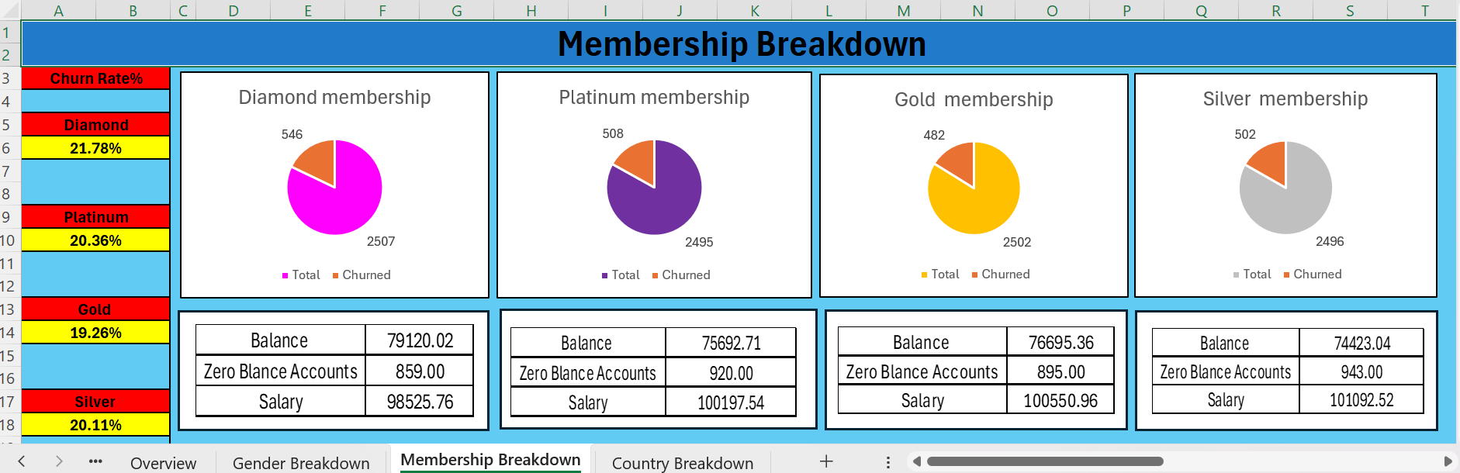
Findings:
1. Churn rate is almost identical across all four membership tiers — Diamond 21.78%, Platinum 20.36%, Gold 19.26% and Silver 20.11% — so membership level does not protect against churn.
2. Diamond, the top tier, actually has the highest churn (21.78%), so premium customers are leaving at the same or higher rate as everyone else.
3. Average balance and salary are very close across tiers (balances around 74K–79K, salaries around 98K–101K), confirming the tiers are not strongly differentiated on financial profile.
4. Each tier carries a sizeable block of zero-balance accounts (roughly 859–943), which are dormant relationships at risk of quietly leaving.
Recommendations:
1. Add real, differentiated benefits to the higher tiers (especially Diamond) so that premium status delivers value worth staying for, rather than being a label only.
2. Run a win-back and re-engagement campaign on zero-balance accounts in every tier before they become silent churners.
3. Since tiers do not predict churn, prioritise retention by the proven drivers — complaints, gender and the 38–47 age group — rather than by membership level.
4. Review whether the current tier structure is worth maintaining, or whether it should be redesigned to reward genuine loyalty and activity.

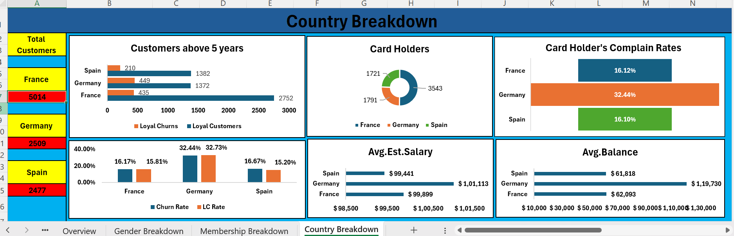
Findings:
1. Germany is the clear problem market — its churn rate of 32.44% is roughly double that of France (16.17%) and Spain (16.67%).
2. German card-holders also complain the most (32.44%), while France (16.12%) and Spain (16.10%) are far lower, pointing to a service problem concentrated in Germany.
3. German customers carry a much higher average balance (about 1,19,730) than France (62,093) or Spain (61,818), so the highest-churn market also holds the most money at risk.
4. France has by far the most loyal long-tenure customers (2,752 above 5 years), and even among loyal customers Germany churns more than France and Spain.
5. Average estimated salary is similar across the three countries (about 99K–101K), so income does not explain Germany’s higher churn.
Recommendations:
1. Make Germany the priority market for retention — investigate the root cause of its high complaint and churn rates (pricing, product fit, local service quality).
2. Protect high-balance German accounts first, since this market combines the highest churn with the largest balances, putting the most revenue at risk.
3. Strengthen the German complaint-handling process specifically, as complaints there are both more frequent and strongly tied to churn.
4. Study what keeps French customers loyal for 5+ years and apply those practices — onboarding, service, loyalty rewards — to Germany and Spain.
5. Avoid income-based targeting across countries, since salaries are similar everywhere; focus instead on country, complaints and balance at risk.
— End of Project Report —

