Report of the Sales Analysis Project:
The objective of this project is to analyse sales, profitability, customer behaviour, and pricing impact using Excel dashboard.
Sales Dashboard:
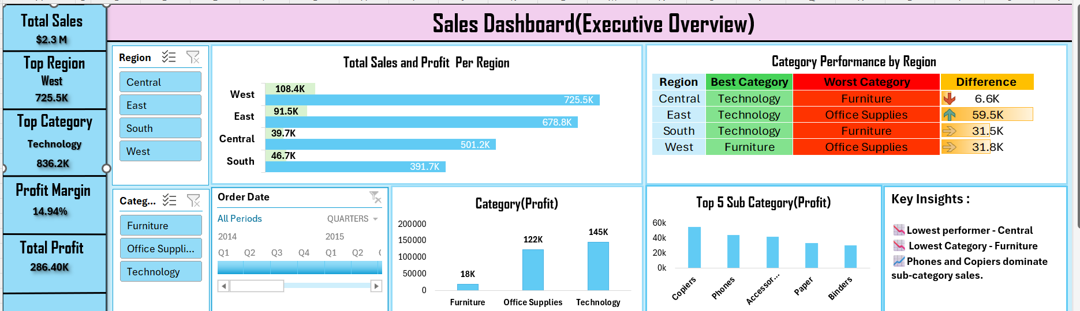
Sales & Profit Analysis

- Total sales across all regions are $2.29M, indicating strong overall performance.
- West Region remains as the top region with 725.5k sales and Profit Margin is 14.9%.
- Technology category generates the highest revenue, making it the primary driver of sales. Furniture category shows relatively lower profitability despite moderate sales.
Tools and Ideas Used:
- Pivot table and charts for finding the Profit per Category and Top 5 Sub Category.
- Conditional Formatting and (index, match, max linked) for finding the difference between best and worst category helps identifying the performance gaps across the regions, enabling businesses to prioritize improvement areas and optimize category-level strategies.
- Integrated Dynamic slicers and Timelines with pivot charts to allow users to flexibly explore time-series trends.
- Calculated Profit Margin (Profit/Sales) to determine true product profitability and uncover underlying value and Utilized Bar charts for category/sub-category profit breakdowns, and Clustered-Column charts to directly compare sales versus profit.
Profit & Pricing Analysis:

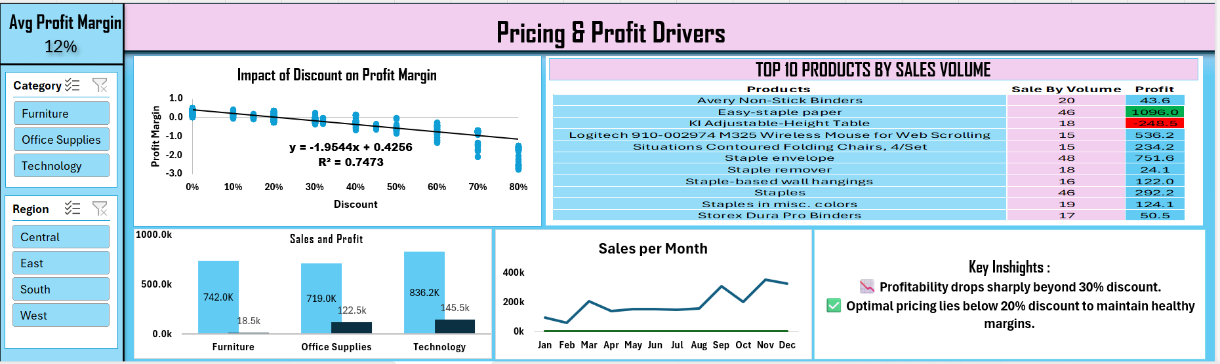
Pricing & Discount Analysis
- Profit margin decreases as discount increases.
- Significant drop in profitability observed beyond 30% discount.
- Optimal pricing strategy is to keep discounts below 20%.

Tools and Ideas Used
- Statistical Regression & Correlation: Leveraged linear regression analysis to quantify the exact impact of discounts on profit margins, successfully identifying the 30% discount threshold where profitability sharply declines.
- Targeted Conditional Formatting: Applied conditional formatting to the "Top 10 Products by Volume" table to instantly flag high-volume items that yield negative or low profits, highlighting immediate areas for pricing review.
- Time-Series Trend Analysis: Aggregated multi-year monthly sales data using line charts to uncover seasonal demand and cyclical revenue trends across the business.
- Comparative Visualization: Built clustered column charts to provide stakeholders with a direct, side-by-side comparison of gross sales versus actual profit for core product categories.
- Interactive Controls: Incorporated dynamic slicers to allow end-users to filter the dashboard by specific regions or categories for customized, on-the-fly analysis.
Operations and Customer Analysis:
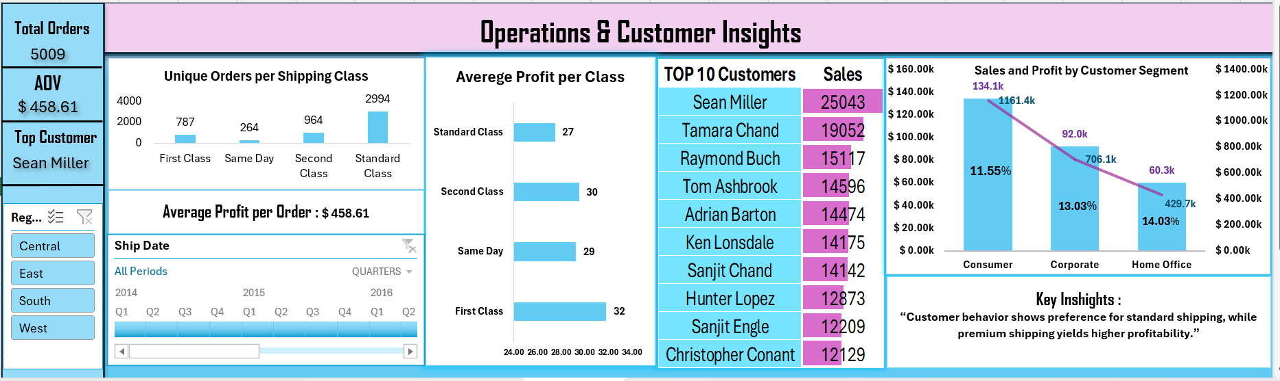
Customer & Operations Insights:
- Standard class shipping is most frequently used by customers.
- However, premium shipping classes yield higher average profit per order.
- A small group of top customers contributes significantly to total revenue.
Tools and Ideas Used
- Key Performance Indicators (KPIs): Designed a summary panel to provide immediate, high-level visibility into critical operational metrics, including Total Orders, Average Order Value (AOV), and Top Customer.
- Advanced Data Modelling: Integrated the pivot table with the Excel Data Model to accurately calculate distinct unique orders, ensuring operational volume was not artificially inflated by multi-item purchases.
- Targeted Conditional Formatting: Applied conditional formatting to the "Top 10 Customers" analysis to instantly visualize the revenue concentration among the highest-value accounts.
- Multi-Metric Visualization: Built a combination chart (incorporating both bars and lines on a secondary axis) to simultaneously display gross sales, net profit, and profit margin percentages across different customer segments.
- Operational Flow Tracking: Utilized column and bar charts to directly compare the frequency of shipping class utilization against the average profit yielded per class, highlighting a key operational discrepancy.
- Dynamic Time-Series Exploration: Implemented an interactive Timeline control, allowing end-users to seamlessly filter and isolate data across specific quarters or years to identify seasonal shifts in customer behaviour without altering the underlying data structure.

Recommendations:
Pricing Strategy:
Avoid discounts above 30%, as they consistently lead to negative profit margins.
Maintain optimal discount range between 10%–20% to balance sales volume and profitability.
Product Strategy:
Review and optimize pricing for loss-making products (e.g., high-volume but negative profit items).
Focus on promoting high-margin products within the Technology category.
Regional Strategy:
Strengthen performance in South region by improving category mix and pricing strategies.
Replicate successful strategies from West region to underperforming regions.
Customer Strategy:
Develop retention programs for top customers contributing significant revenue.
Reduce dependency on a small group of customers by expanding mid-tier customer base.
Operations Strategy:
Encourage use of premium shipping where feasible, as it generates higher profit per order.
Optimize Standard Class efficiency due to its high usage volume.
Business Impact Summary:
Identified 30% discount threshold causing profit loss,
Detected loss-making high-volume products,
Highlighted regional performance gaps,
Revealed customer revenue concentration risk,
Suggested pricing and operational optimization strategies .

