Steps to use the Web Application

1. Open <https://hrx101-bird-main-classification-home-irkdih.streamlit.app/>
2. Click “Browse files” button to add music file from the local machine or local

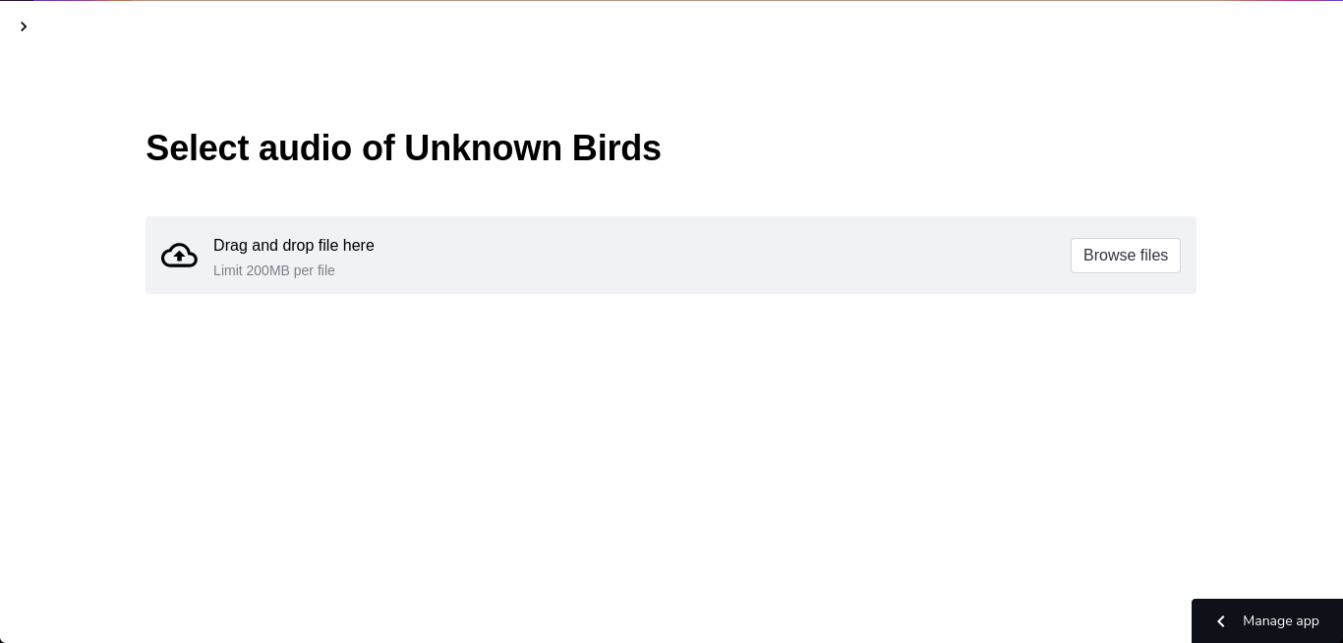computer/laptop

1. After clicking the "Browse files" button, a window will appear where you may see files on your local machine and select audio files with.wav extensions.

Add audio files

1. 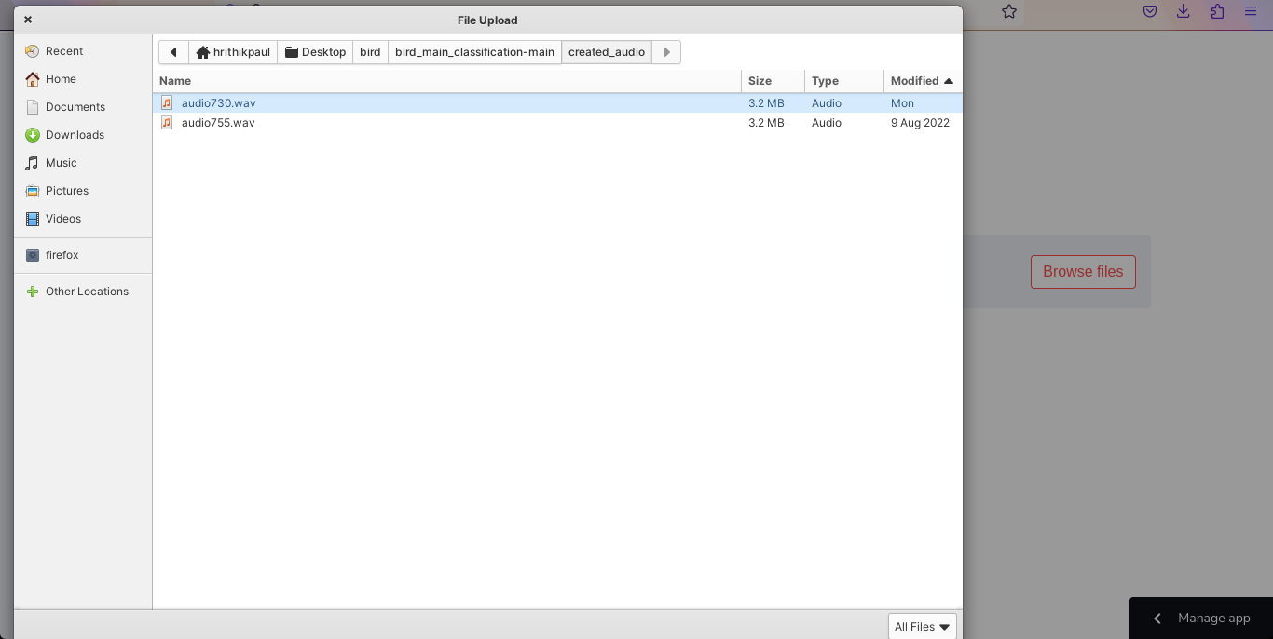Afterwards the bird's sounds will be predicted and displayed, along with its data; we can even play music by pressing the button.

Select audio files from local machine

1. 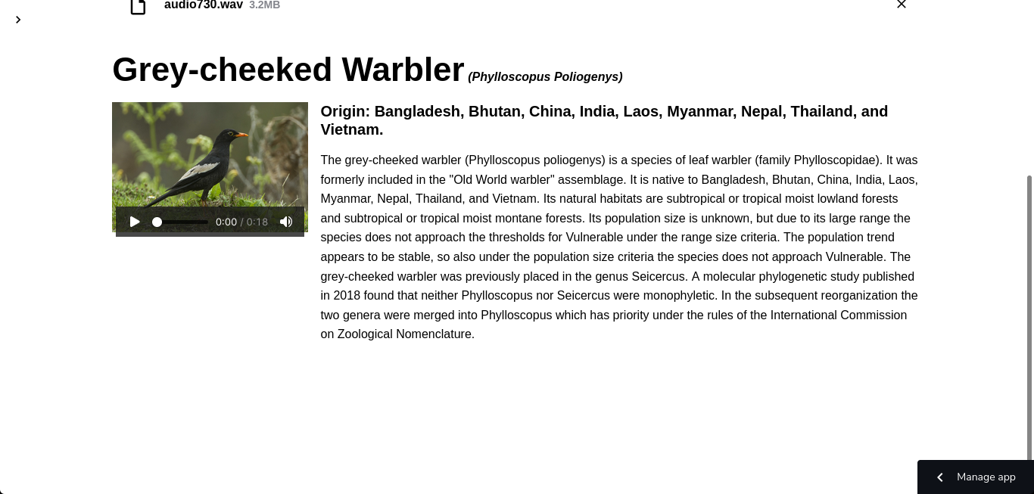Then for adding another button, click the above cross button and adding the new music audio which will be in .wav format or have .wav extension.

Play the audio

1. 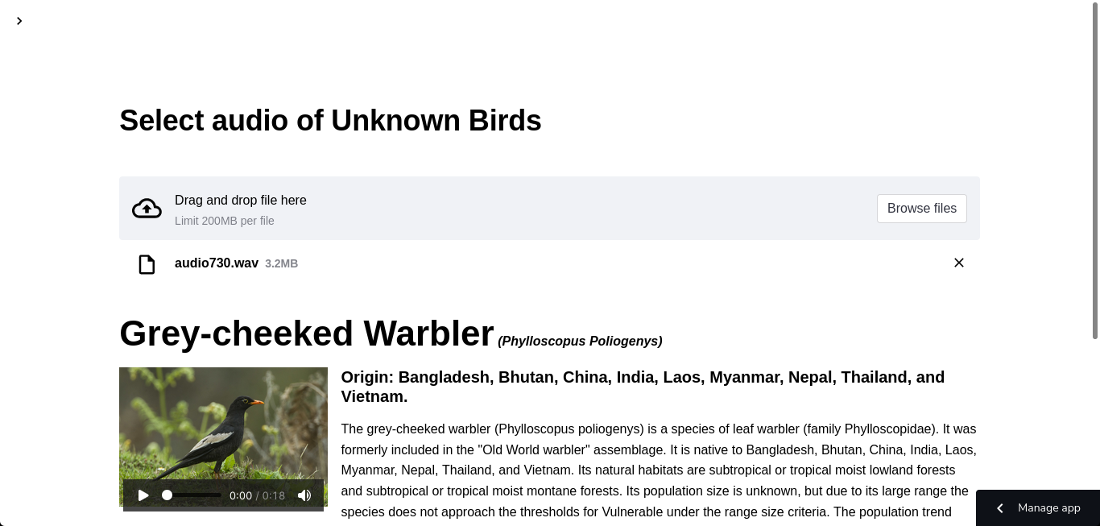If any user wants to read details about the project and webapp, they can click the top left corner button and a side menu will be appeared.

Add new audio/ remove current audio

1. 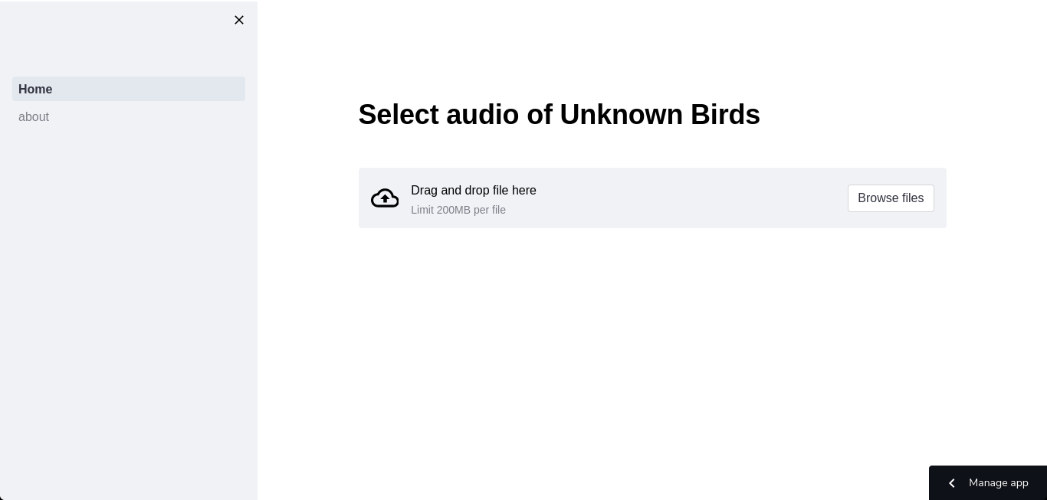Then after clicking about button user will be shown the about page

Open side menu

Open about page

