Activity | Data Type
Number of beatings from Wife | Discrete
Results of rolling a dice | Discrete
Weight of a person | Continuous
Weight of Gold | Continuous
Distance between two places | Continuous
Length of a leaf | Continuous
Dog's weight | Continuous
Blue Color | Discrete
Number of kids | Discrete
Number of tickets in Indian railways | Discrete
Number of times married | Discrete
Gender (Male or Female) | Discrete
Q1) Identify the Data type for the Following:

Q2) Identify the Data types, which were among the following
Nominal, Ordinal, Interval, Ratio.
Data | Data Type
Gender | Nominal
High School Class Ranking | Ordinal
Celsius Temperature | Interval
Weight | Ratio
Hair Color | Nominal
Socioeconomic Status | Ordinal
Fahrenheit Temperature | Interval
Height | Ratio
Type of living accommodation | Nominal
Level of Agreement | Ordinal
IQ(Intelligence Scale) | Ratio
Sales Figures | Ratio
Blood Group | Nominal
Time Of Day | Ordinal
Time on a Clock with Hands | Interval
Number of Children | Ratio
Religious Preference | Nominal
Barometer Pressure | Ratio
SAT Scores | Ratio
Years of Education | Ratio

Q3) Three Coins are tossed, find the probability that two heads and one tail are obtained?
ANS -
Possible combination – ( HHH ,HHT ,HTH ,THH ,TTT ,TTH ,THT ,HTT )
Two heads and one tail are – ( HHT ,HTH ,THH )
Three coins are tossed ,the probability of two heads and one tail is 3/8.

Q4) Two Dice are rolled, find the probability that sum is
- Equal to 1 = 0/36
- Less than or equal to 4 = 6/36 = 1/6
- Sum is divisible by 2 and 3 = 6/36 = 1/6

Q5) A bag contains 2 red, 3 green and 2 blue balls. Two balls are drawn at random. What is the probability that none of the balls drawn is blue?

ANS –
Total no. of balls = 2 + 3 + 2 = 7
n(S) = No. of drawing two balls out of 7 = ⁷C₂
=7! / 2!.5!
=7*6 / 2
= 21
n(E) = No. of drawing two balls out of 5 balls = ⁵C₂
= 5! / 2!.3!
= 5*4 / 2
= 10
The probability of none of the drawn ball blue is 10/21.

Q6) Calculate the Expected number of candies for a randomly selected child
Below are the probabilities of count of candies for children (ignoring the nature of the child-Generalized view)
CHILD | Candies count | Probability
A | 1 | 0.015
B | 4 | 0.20
C | 3 | 0.65
D | 5 | 0.005
E | 6 | 0.01
F | 2 | 0.120
Child A – probability of having 1 candy = 0.015.
Child B – probability of having 4 candies = 0.20
Ans = ( 0.015 * 1 ) + ( 0.20 * 4 ) + ( 0.65 * 3 ) + ( 0.005 * 5 ) + ( 0.01 * 6 ) + ( 0.120 * 2 )
= 0.015 + 0.8 + 1.95 + 0.025 + 0.06 + 0.24
= 3.09
Expected number of candies for a randomly selected child is 3.09

Q7) Calculate Mean, Median, Mode, Variance, Standard Deviation, Range & comment about the values / draw inferences, for the given dataset
- For Points,Score,Weigh>
Find Mean, Median, Mode, Variance, Standard Deviation, and Range and also Comment about the values/ Draw some inferences.
Use Q7.csv file

ANS –
Points - Mean = 3.59
Median = 4.16
Mode = 3.92
Variance = 0.057
Score - Mean = 3.21
Median = 8.09
Mode = 3.44
Variance = 0.15
Weigh - Mean = 17.84
Median = 26.53
Mode = 17.02
Variance = 0.19
Standard Deviation – Point = 0.22
Score = 0.38
Weigh = 0.43
Range – Point = 2.17
Score = 3.91
Weigh = 8.4

Q8) Calculate Expected Value for the problem below
- The weights (X) of patients at a clinic (in pounds), are
108, 110, 123, 134, 135, 145, 167, 187, 199
Assume one of the patients is chosen at random. What is the Expected Value of the Weight of that patient?
Ans - = 108 + 110 + 123 + 134 + 135 + 145 + 167 + 187 + 199 / 9
= 1308 / 9
= 145.33
Expected Value of the Weight of that patient is 145.33

Q9) Calculate Skewness, Kurtosis & draw inferences on the following data
Cars speed and distance
Use Q9_a.csv

SP and Weight(WT)
Use Q9_b.csv

Q10) Draw inferences about the following boxplot & histogram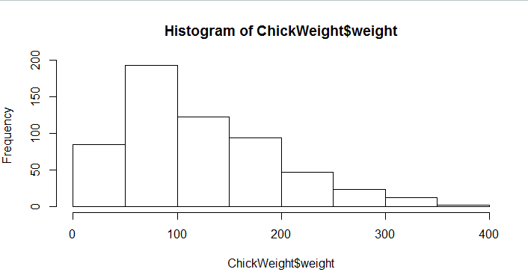
The above Histogram shows that it is not a Normal distribution,it is right skewed. There might be chance of present outliers in chickweight as we can see there is very smaller number of datapoints in right bin of 350 to 400. Central tendency of data is between 50 to 100. Most datapoints fall under range of 50 to 100 where between 300 to 400 very smaller numbers of datapoints are present.
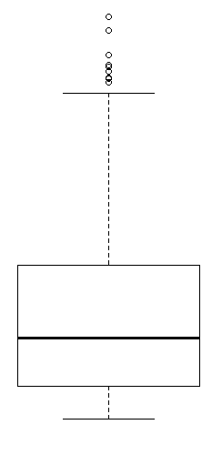
The above box plot shows that the data is more concentrated in the lower half.The IQR is smaller so we can say that there is less variability in datapoints. Given distribution of data is asymmetric as it has longer whisker than other. There are more than one outliers are present.

Q11) Suppose we want to estimate the average weight of an adult male in Mexico. We draw a random sample of 2,000 men from a population of 3,000,000 men and weigh them. We find that the average person in our sample weighs 200 pounds, and the standard deviation of the sample is 30 pounds. Calculate 94%,98%,96% confidence interval?

ANS –
Confidence Interval –
The Confidence Interval for 94% is 201.20613 and 198.739864
The Confidence Interval for 98% is 201.558621 and 198.441379
The Confidence Interval for 96% is 201.172969 and 198.827031

Q12) Below are the scores obtained by a student in tests
34,36,36,38,38,39,39,40,40,41,41,41,41,42,42,45,49,56
- Find mean, median, variance, standard deviation.
ANS –
Mean = 41.0
Median = 40.5
Variance = 24.1111
Standard Deviation = 4.910

- What can we say about the student marks?
ANS – Mean & Median is quite close to each other which means given distribution of data is not much skewed. Variance & standard Deviation is high which means the spread of data is more.

Q13) What is the nature of skewness when mean, median of data are equal?

Ans – When Mean & Median of data is equal that means there is no skewness present in data and the given data is normal distribution.

Q14) What is the nature of skewness when mean > median ?
ANS – When mean median of data is equal that means there is no skewness present in the data and the given data is Normal distribution.

Q15) What is the nature of skewness when median > mean?
ANS – When Median is greater than Mean , it means given data is negative skewed.

Q16) What does positive kurtosis value indicates for a data ?
ANS – Positive Kurtosis indicated that in given data outliers are present and high peakness.

Q17) What does negative kurtosis value indicates for a data?
ANS – Positive kurtosis indicated that in given data outliers present is less and low peakness.

Q18) Answer the below questions using the below boxplot visualization.
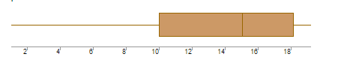
What can we say about the distribution of the data?
ANS – Given data is skewed and had median value of approx 15
Most values lie between 10 to 18 data point.
More data is concentrated in one side.
What is nature of skewness of the data?
ANS – Left skewned.
What will be the IQR of the data (approximately)?
ANS – IQR of given Boxplot is approximately 10 to 18.
Q19) Comment on the below Boxplot visualizations?
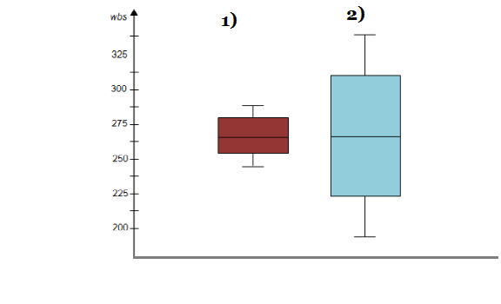
Draw an Inference from the distribution of data for Boxplot 1 with respect Boxplot 2.
ANS – Boxplot 1 has less variance compare to 2 boxplot .we don’t have any idea about how many datapoints are present in both boxplot. Median point of both boxplot is equal. Data is normally distribution. There is no skewness present.

Q 20) Calculate probability from the given dataset for the below cases

Data _set: Cars.csv
Calculate the probability of MPG of Cars for the below cases.
MPG <- Cars$MPG
  - P(MPG>38)
ANS – Total no. of MPG greater than 38 = 33
= 33/81
= 0.40

  - P(MPG<40)
ANS – Total no. of MPG less than 40 =61
= 61/81
= 0.75

  - P (20<MPG<50)
ANS – Total no. of MPG between 20 and 50 = 60
= 69/81
= 0.85

Q 21) Check whether the data follows normal distribution
- Check whether the MPG of Cars follows Normal Distribution
Dataset: Cars.csv
Ans – MPG of cars is slightly left skewed.

- Check Whether the Adipose Tissue (AT) and Waist Circumference(Waist) from wc-at data set follows Normal Distribution
Dataset: wc-at.csv
Ans – Adipose Tissue is Right Skewed Distribution, and
Waist Cricumference is not a normal distribution.

Q 22) Calculate the Z scores of 90% confidence interval,94% confidence interval, 60% confidence interval
Ans - 90% confidence interval –
C = 0.90
α = 1 – C = 0.10
Z_{α/2} = Z_{0.05}
Z = 1.645
94% confidence interval =
C = 0.94
α = 1 – C = 0.06
Z_{α/2} = Z_{0.03}
Z = 1.555
60% confidence interval =
C = 0.60
α = 1 – C = 0.40
Z_{α/2} = Z_{0.20}
Z = 0.253

Q 23) Calculate the t scores of 95% confidence interval, 96% confidence interval, 99% confidence interval for sample size of 25
Ans – df n – 1 = 25 , 1 = 24
95% confidence interval =
C = 0.95
df = 24
t_{α/2} = t0.025
t_{α/2} = 2.06390
96% confidence interval =
C = 0.96
df = 24
t_{α/2} = t0.02
t_{α/2} = 2.172
99% confidence interval =
C = 0.99
df = 24
t_{α/2} = t0.005
t_{α/2} = 2.79694

Q 24) A Government company claims that an average light bulb lasts 270 days. A researcher randomly selects 18 bulbs for testing. The sampled bulbs last an average of 260 days, with a standard deviation of 90 days. If the CEO's claim were true, what is the probability that 18 randomly selected bulbs would have an average life of no more than 260 days
Hint:
rcode pt(tscore,df)
df degrees of freedom

