Deliverable 1: Relational Design
Placement Records Management System
Hrithik | M.Tech CSE | IIIT Guwahati

1. Project Domain
A relational database for managing campus placements at IIIT Guwahati. Tracks students (B.Tech/M.Tech, CSE/ECE), companies with tier classification (Normal/Dream/Super Dream), placement drives with per-department eligibility, HR contacts, multi-round applications, and tier-based re-eligibility policies enforced through triggers.

2. Relational Schema (4 Entities → 8 Tables)
Table | PK | Foreign Keys | Normalization
Departments | dept_id | — | From Students (2NF — redundancy)
Students | student_id | dept_id → Departments | Cleaned
Companies | company_id | — | Already 3NF
HR_Contacts | hr_id | company_id → Companies | From Drives (3NF — transitive dep.)
Drives | drive_id | company_id → Companies, hr_id → HR_Contacts | Cleaned
DriveEligibility | eligibility_id | drive_id → Drives, dept_id → Departments | From Drives (4NF — multi-valued)
Applications | application_id | student_id → Students, drive_id → Drives | Cleaned
Rounds | round_id | application_id → Applications | From Applications (1NF — repeating)
Additional: UNIQUE(student_id, drive_id) on Applications prevents duplicate applications.

3. ER Diagram
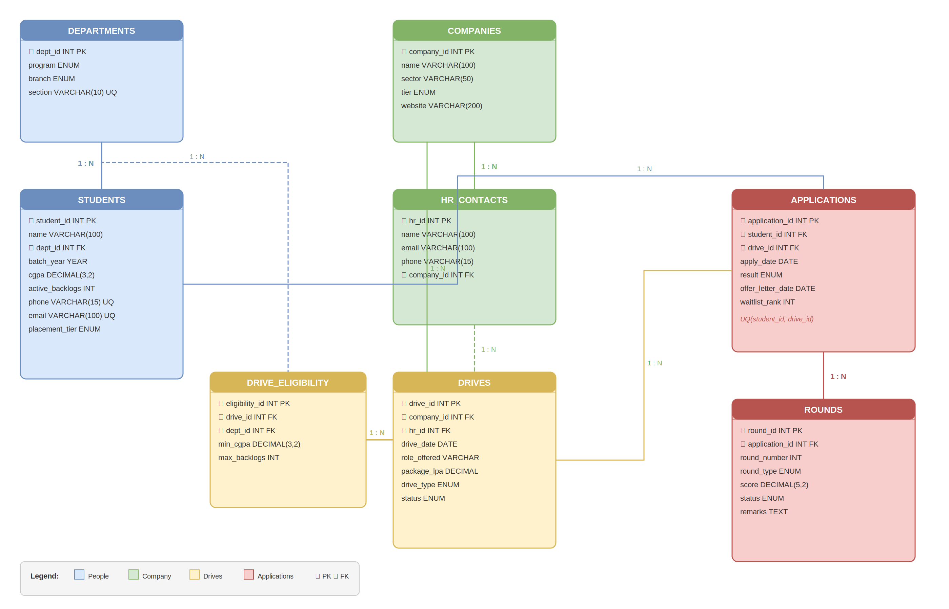

4. Triggers and Indexes
Trigger 1 (after_selection): AFTER UPDATE on Applications. When result = ‘Selected’, auto-updates student’s placement_tier to match company’s tier.
Trigger 2 (prevent_ineligible_apply): BEFORE INSERT on Applications. Rejects if student is placed at same/higher tier or doesn’t meet CGPA/backlog criteria.
Trigger 3 (validate_hr_company): BEFORE INSERT/UPDATE on Drives. Rejects if assigned HR doesn’t belong to the drive’s company.
Trigger 4 (auto_offer_date): BEFORE UPDATE on Applications. Auto-sets offer_letter_date to CURDATE() when result changes to ‘Selected’.
Trigger 5 (auto_reject_on_fail): AFTER UPDATE on Rounds. When a round status = ‘Fail’, auto-updates application result to ‘Rejected’.

Indexes: Students(dept_id, cgpa), Applications(student_id, result), Drives(drive_date, status), Rounds(application_id, round_number).

5. Design Assumptions
- IIITG has 2 programs (B.Tech, M.Tech) × 2 branches (CSE, ECE) × 2 sections each = 8 departments: C13, C14, E13, E14, M13, M14, ME13, ME14.
- Tier policy: Normal-placed students can sit for Dream/Super Dream. Dream-placed can sit for Super Dream only.
- Each company visit is a separate drive. Same company may visit multiple times with different roles.
- CGPA/backlog eligibility can differ per department for the same drive (DriveEligibility).
- HR contacts belong to companies. Each drive has one HR coordinator. HR changes are handled by adding new records.
- Rounds are sequential (Aptitude → Coding → Technical → HR) but not all rounds apply to every drive.
- Package stored as CTC in LPA. Detailed breakdowns out of scope.

Deliverable 2: Query Demonstration

The following queries are domain-equivalent to the hospital example queries specified in the project description, plus additional analytical queries demonstrating advanced SQL concepts.

A. Mandatory Queries (Mapped from Hospital Example)

Q1: Students who applied after January 2025
Hospital equivalent: “List patients who had appointments after January 2024.”
SELECT DISTINCT s.student_id, s.name, dep.section, a.apply_date
FROM Students s
JOIN Applications a ON s.student_id = a.student_id
JOIN Departments dep ON s.dept_id = dep.dept_id
WHERE a.apply_date > '2025-01-31'
ORDER BY a.apply_date;

Q2: IT-sector companies offering packages above 10 LPA
Hospital equivalent: “Find doctors specializing in Cardiology with 5+ years experience.”
SELECT c.name, c.sector, d.role_offered, d.package_lpa
FROM Companies c
JOIN Drives d ON c.company_id = d.company_id
WHERE c.sector = 'IT' AND d.package_lpa > 10
ORDER BY d.package_lpa DESC;

Q3: Students selected in a specific company’s drive
Hospital equivalent: “Find patients treated by a specific doctor with diagnosis.”
SELECT s.name, dep.section, dr.role_offered, dr.package_lpa
FROM Students s
JOIN Applications a ON s.student_id = a.student_id
JOIN Drives dr ON a.drive_id = dr.drive_id
JOIN Companies c ON dr.company_id = c.company_id
JOIN Departments dep ON s.dept_id = dep.dept_id
WHERE c.name = 'Google' AND a.result = 'Selected';

Q4: Company placing highest number of students in 2025
Hospital equivalent: “Identify doctor generating highest revenue in 2023.”
SELECT c.name, COUNT(*) AS total_placed
FROM Companies c
JOIN Drives d ON c.company_id = d.company_id
JOIN Applications a ON d.drive_id = a.drive_id
WHERE a.result = 'Selected' AND YEAR(d.drive_date) = 2025
GROUP BY c.company_id
ORDER BY total_placed DESC LIMIT 1;

Q5: Average package and placement count per department
Hospital equivalent: “Average treatment cost and patients per month per doctor.”
SELECT dep.program, dep.branch,
COUNT(*) AS total_placed,
ROUND(AVG(d.package_lpa), 2) AS avg_package,
MAX(d.package_lpa) AS max_package
FROM Departments dep
JOIN Students s ON dep.dept_id = s.dept_id
JOIN Applications a ON s.student_id = a.student_id
JOIN Drives d ON a.drive_id = d.drive_id
WHERE a.result = 'Selected'
GROUP BY dep.program, dep.branch
ORDER BY avg_package DESC;

Q6: Highest package offer with student and company details
Hospital equivalent: “List the most expensive treatment with patient and doctor details.”
SELECT s.name AS student, dep.section, c.name AS company,
d.role_offered, d.package_lpa
FROM Students s
JOIN Applications a ON s.student_id = a.student_id
JOIN Drives d ON a.drive_id = d.drive_id
JOIN Companies c ON d.company_id = c.company_id
JOIN Departments dep ON s.dept_id = dep.dept_id
WHERE a.result = 'Selected'
ORDER BY d.package_lpa DESC LIMIT 1;

B. Analytical Queries (Additional)

Q7: Tier-wise placement distribution per department
Concepts: CASE-based conditional aggregation, GROUP BY.
SELECT dep.program, dep.branch,
COUNT(CASE WHEN s.placement_tier = 'Normal' THEN 1 END) AS normal_tier,
COUNT(CASE WHEN s.placement_tier = 'Dream' THEN 1 END) AS dream_tier,
COUNT(CASE WHEN s.placement_tier = 'Super Dream' THEN 1 END) AS super_dream,
COUNT(CASE WHEN s.placement_tier = 'Unplaced' THEN 1 END) AS unplaced,
ROUND(COUNT(CASE WHEN s.placement_tier != 'Unplaced' THEN 1 END)
* 100.0 / COUNT(*), 2) AS placement_pct
FROM Students s
JOIN Departments dep ON s.dept_id = dep.dept_id
GROUP BY dep.program, dep.branch;

Q8: Eligible students for an upcoming drive (excluding placed)
Concepts: Multi-table JOIN, NOT EXISTS / tier filtering.
SELECT s.name, dep.section, s.cgpa, s.active_backlogs
FROM Students s
JOIN Departments dep ON s.dept_id = dep.dept_id
JOIN DriveEligibility de ON dep.dept_id = de.dept_id
WHERE de.drive_id = 5
AND s.cgpa >= de.min_cgpa
AND s.active_backlogs <= de.max_backlogs
AND s.placement_tier = 'Unplaced'
ORDER BY s.cgpa DESC;

Q9: Round-wise elimination analysis
Concepts: Conditional COUNT, percentage calculation.
SELECT r.round_type,
COUNT(*) AS total_appeared,
COUNT(CASE WHEN r.status = 'Fail' THEN 1 END) AS eliminated,
ROUND(COUNT(CASE WHEN r.status = 'Fail' THEN 1 END) * 100.0
/ COUNT(*), 2) AS elimination_pct
FROM Rounds r
GROUP BY r.round_type
ORDER BY elimination_pct DESC;

Q10: Monthly placement funnel
Concepts: DATE_FORMAT, conditional aggregation, temporal analysis.
SELECT DATE_FORMAT(d.drive_date, '%Y-%m') AS month,
COUNT(DISTINCT d.drive_id) AS drives_conducted,
COUNT(a.application_id) AS total_applications,
COUNT(CASE WHEN a.result = 'Selected' THEN 1 END) AS selections,
COUNT(CASE WHEN a.result = 'Rejected' THEN 1 END) AS rejections
FROM Drives d
JOIN Applications a ON d.drive_id = a.drive_id
GROUP BY DATE_FORMAT(d.drive_date, '%Y-%m')
ORDER BY month;

C. Query Summary
# | Description | Hospital Equivalent | SQL Concepts
Q1 | Students applied after Jan 2025 | Patients with appointments after Jan 2024 | JOIN, WHERE, DATE filter
Q2 | IT companies with packages > 10 LPA | Cardiology doctors with 5+ years exp | JOIN, WHERE, AND
Q3 | Students selected in a company’s drive | Patients treated by a doctor with diagnosis | Multi-table JOIN, filter
Q4 | Company with most placements in 2025 | Doctor with highest revenue in 2023 | GROUP BY, COUNT, LIMIT
Q5 | Avg package per department | Avg cost and patients per month per doctor | AVG, GROUP BY, JOIN
Q6 | Highest package with details | Most expensive treatment with details | ORDER BY DESC, LIMIT
Q7 | Tier-wise placement distribution | — (additional) | CASE, conditional aggregation
Q8 | Eligible students for upcoming drive | — (additional) | Multi-JOIN, tier filter
Q9 | Round-wise elimination analysis | — (additional) | Conditional COUNT, %
Q10 | Monthly placement funnel | — (additional) | DATE_FORMAT, GROUP BY

