Question 1: Explain this following bash script:

#!/bin/bash → shebang; indicates it’s a script

space_free=$( df -h | awk '{ print $5 }' | sort -n | tail -n 1 | sed 's/%//' )

1st : df -h → gives disk utilization details.

In my case:

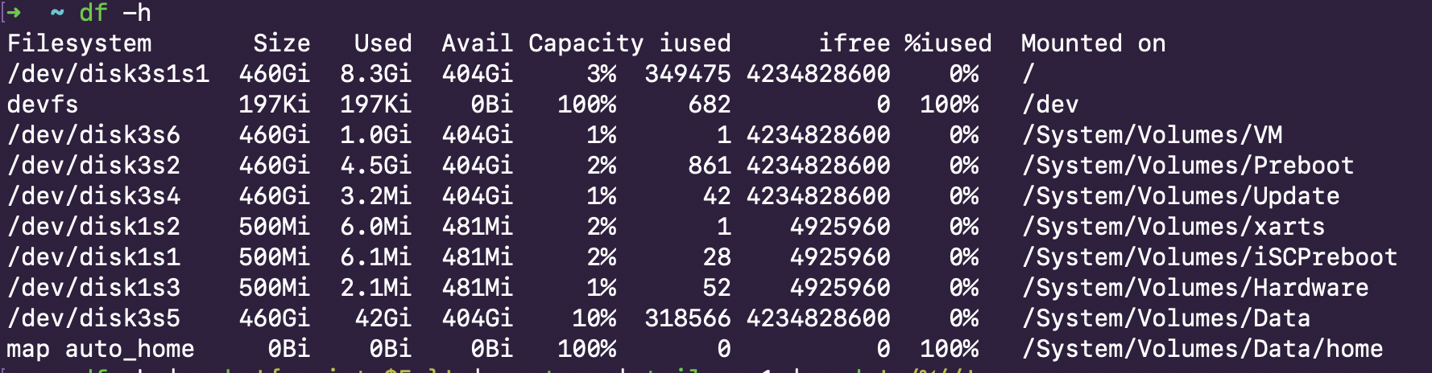

2nd: awk '{ print $5 }' → is a text processing command and $5 prints the 5th column, in my case the capacity

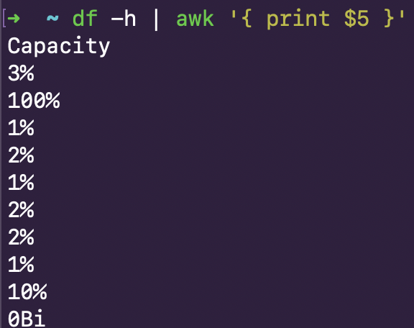

3rd: sort -n is to sort the output from the previous command passed via pipelinig, ( -n; sort the numeric field )

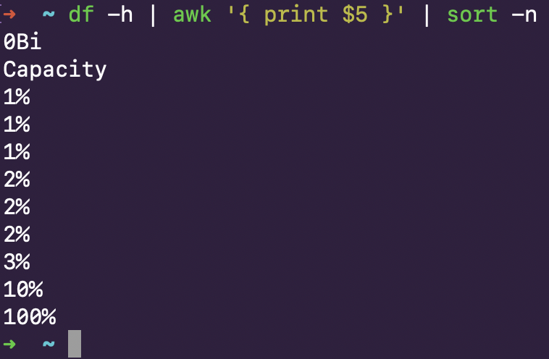

4th: tail -n 1 → tail command is used to print the last lines of file, -n specifies number of lines.



5th: sed 's/%//' → substitute command.. Substitutes % with nothing or blank



The rest of the script is a switch statement with 100 as a switch valus.

In my case, it is the last option (Something is not quite right here) as I have a different file dir with 100% consumption (on my native machine, not an EC2 instance)