Assignment-1

Connect and disconnect with login Access

What happens when you login a non-existent users or username?

Provide Screenshot and What you understand, explain in short brief?

Prompts error on lock screen authenticstion failed.

Password changing

Login into your account and then change password?

Change your password into IneuR0n#42 and hit the Enter key

Explain what happen and give screenshot?

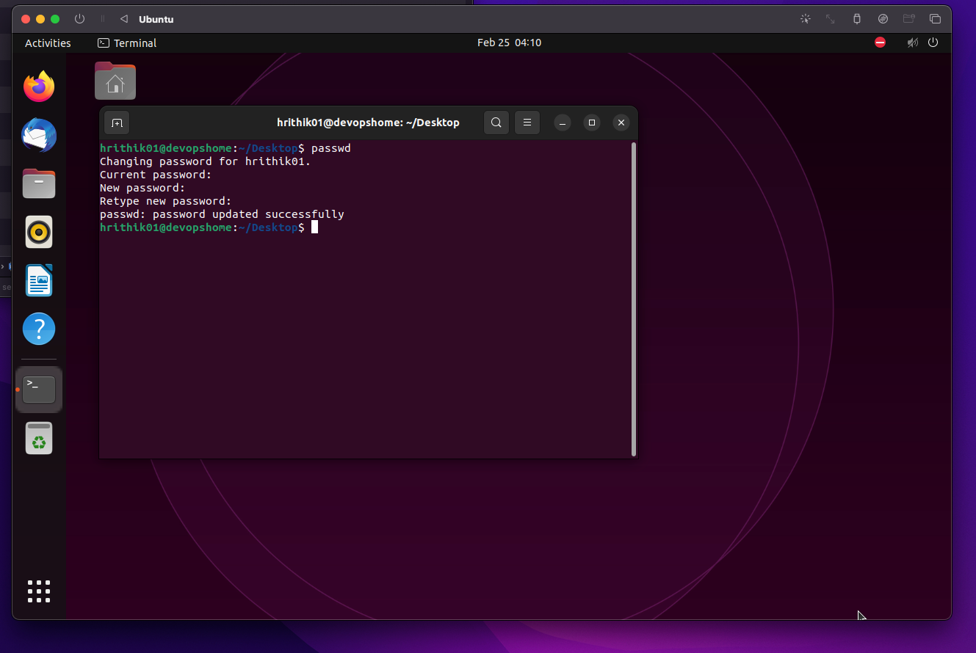

Try again to change password but use like password 1234 or abcd

Explain what happen and give screenshot?

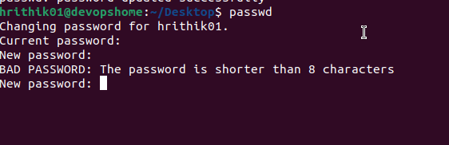

Try again to change password but now don’t use any password just hit Enter key

Explain what happen and give screenshot?

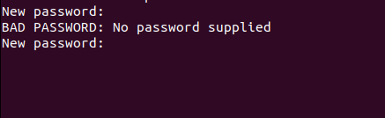

Assignment-3

Working with Directories

Enter the command cd / and then ls and then hit Enter key

Take screenshot and explain what output we got?

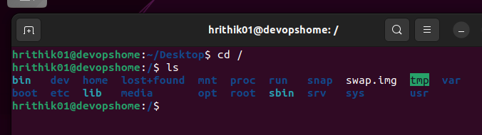

cd / -- takes me to root dir

ls -- lists the contents of root dir

Enter the command now cd /home and then hit Enter key

Do ls, provide screenshot and explain what is /home directory used for?

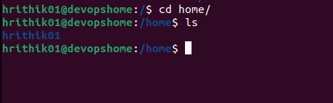

cd home/ --- takes me to users home dir

ls -- lists the contents in home dir (in my[root] case list of users)

Enter cd .. and hit Enter key [ Note: here we have space after cd then use double dot]

Check what happen and give screenshot?

Takes to immediate parent (one dir back)



Now enter cd /var/www/html and then type cd and hit Enter key

Explain what happen and give screenshot?

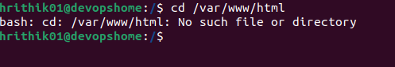

No such dir in my case

Now type cd /root and then hit Enter key

Do ls, check any output we have on screen if yes then take screenshot?

I cannot cd to root but can su -

in case if I do...

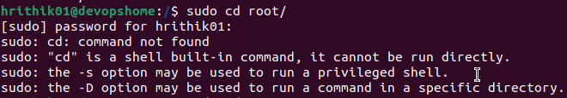

Go to cd /etc and type ls

Take screenshot and explain what files you have seeing?

Take screenshot and explain what different output you found compare to previous command you used?

etc is where system config files are preset

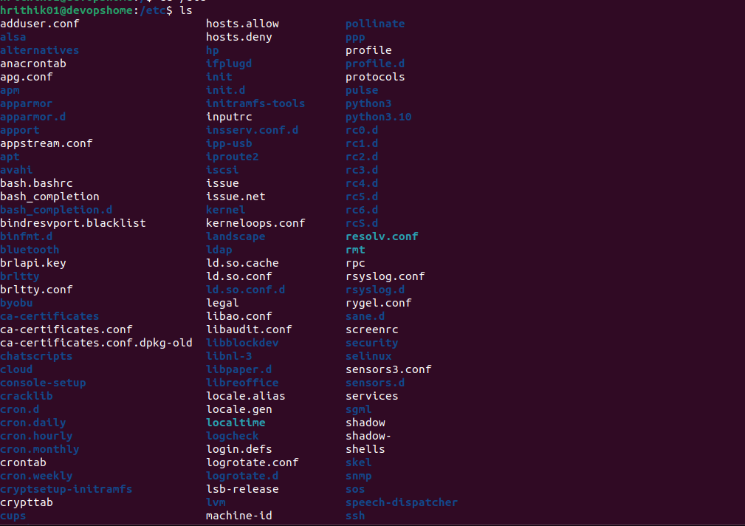

Then type ls -al and hit Enter key

Take screenshot and explain what new file or directory you found?

ls -al gives detailed list of all files, owners, created/modified, size and permissions etc..

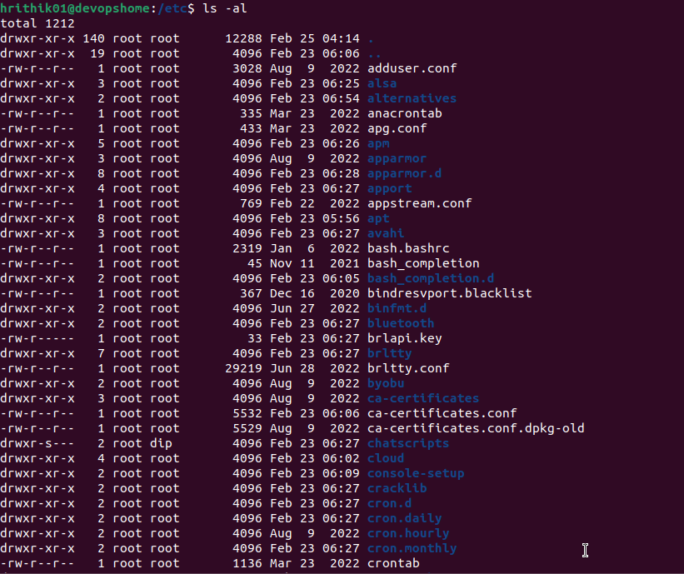

Then use ls -i and hit Enter key

Now see what different output its shows and take screenshot?

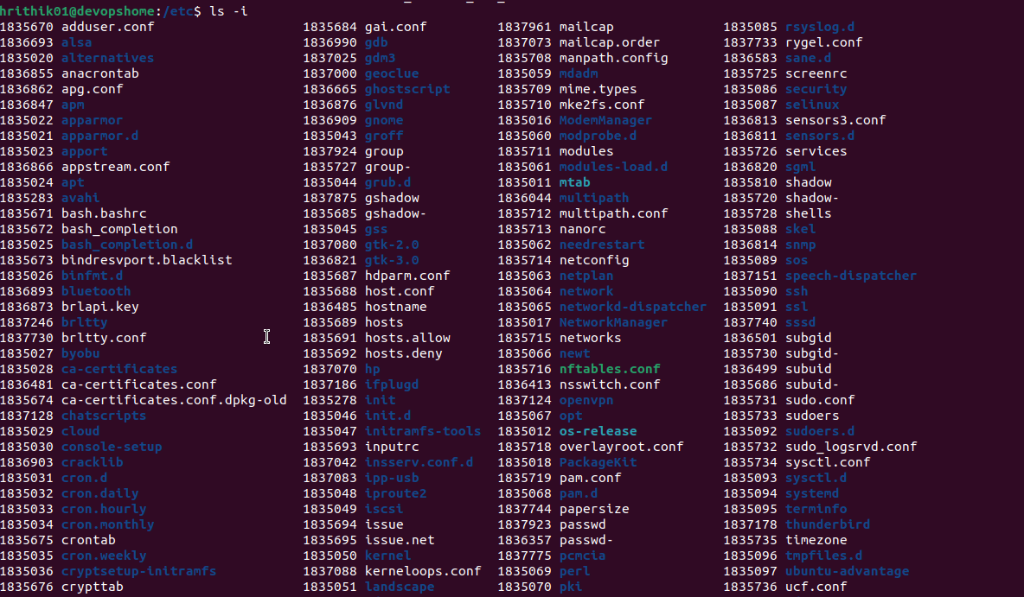

Assignment-5

Know where you are and where you working

Here we use pwd, cd and ls as combine task to understand where you working on terminal and how you can switch from one directory to another one.

Open terminal after restart the linux

Check which location you working, type pwd and take screenshot

Now use cd /var and hit Enter key

Do ls, and see what output comes, give screenshot?

Do explore other help options of each command to learn more other things we can do with these commands

pwd -- prints current working dir

Screenshot 2023-02-25 at 10.09.48 AM