**Assignment 1** :- Create an IAM user with username of your own wish and grant

administrator policy.

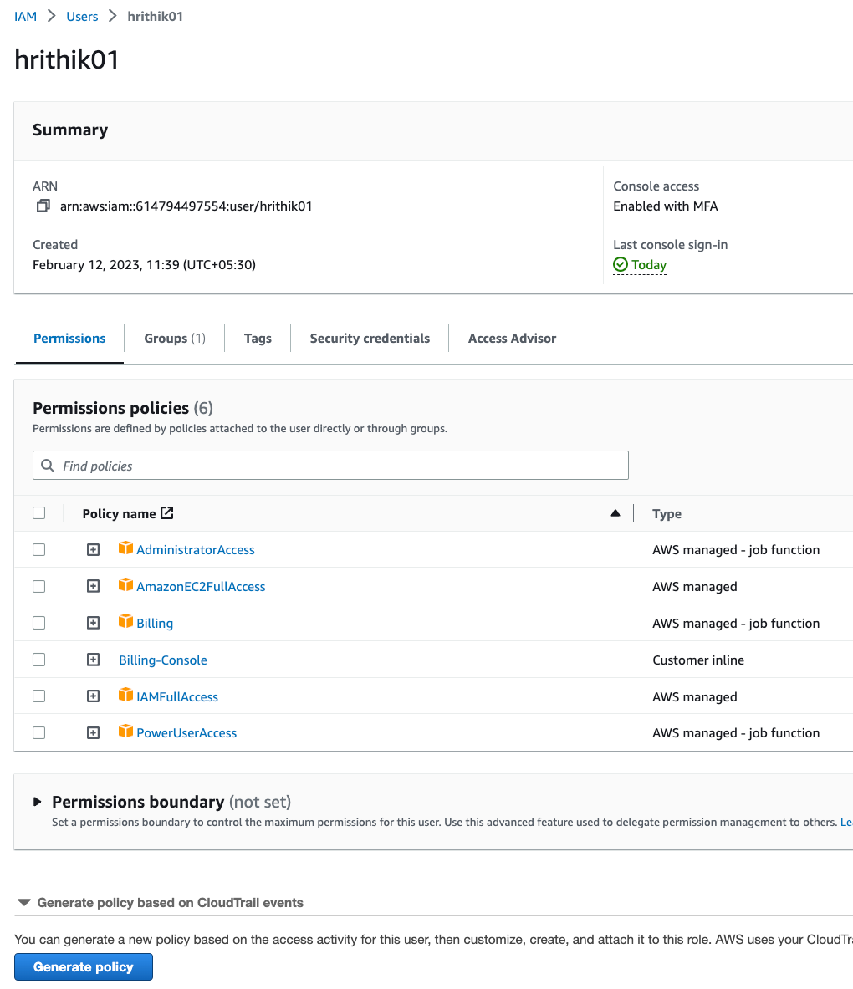

Assignment 2 :- Hello students, in this assignment you need to prepare a developers team of avengers. - Create 3 IAM users of avengers and assign them in developer’s groups with IAM policy

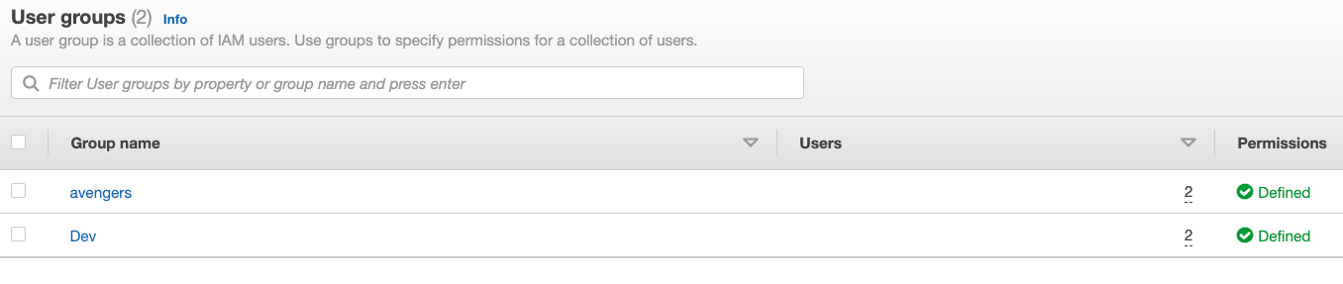

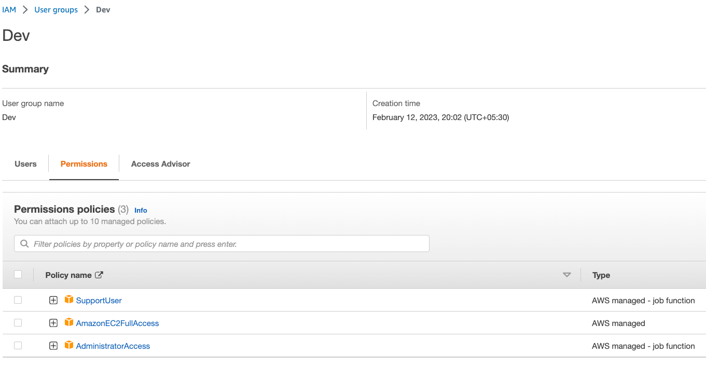

**Assignment 3** :- Define a condition in policy for expiration like

"DateGreaterThan": {"aws:CurrentTime":

"2020-04-01T00:00:00Z"},

"DateLessThan": {"aws:CurrentTime":

"2020-06-30T23:59:59Z"}

Define the span of 4 months as per your wish

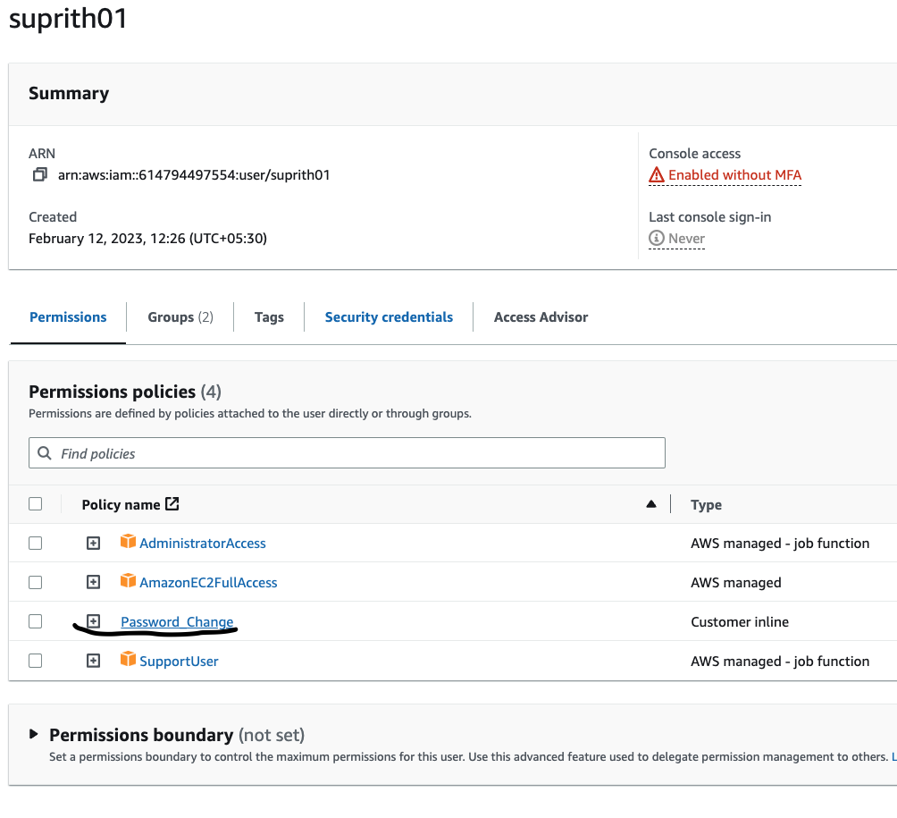

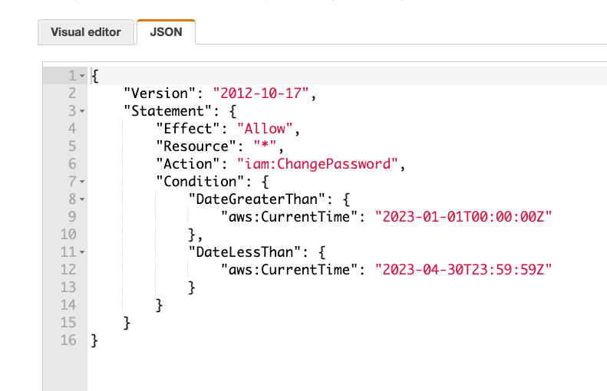

Assignment 3 :- Prepare 15 authentic MCQ questions related to IAM. Assignment 4 :- Launch your linux instance in IAM and update your machine.

Both activities are done.I come from azure background so I’m familiar with the concept. I Don’t have the EC2 running at the moment for screenshot.