1. Explain the below AWS Architecture

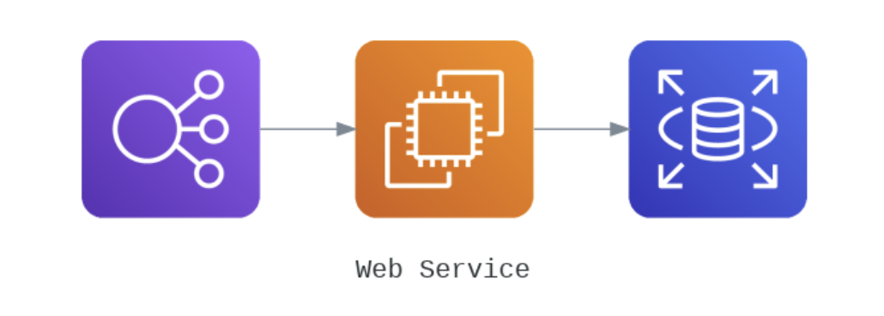

The Elastic load balancer configured on an EC2 instance attached to a AWD RDB.

2. Implement the same in the AWS(only do a proper connection between service)

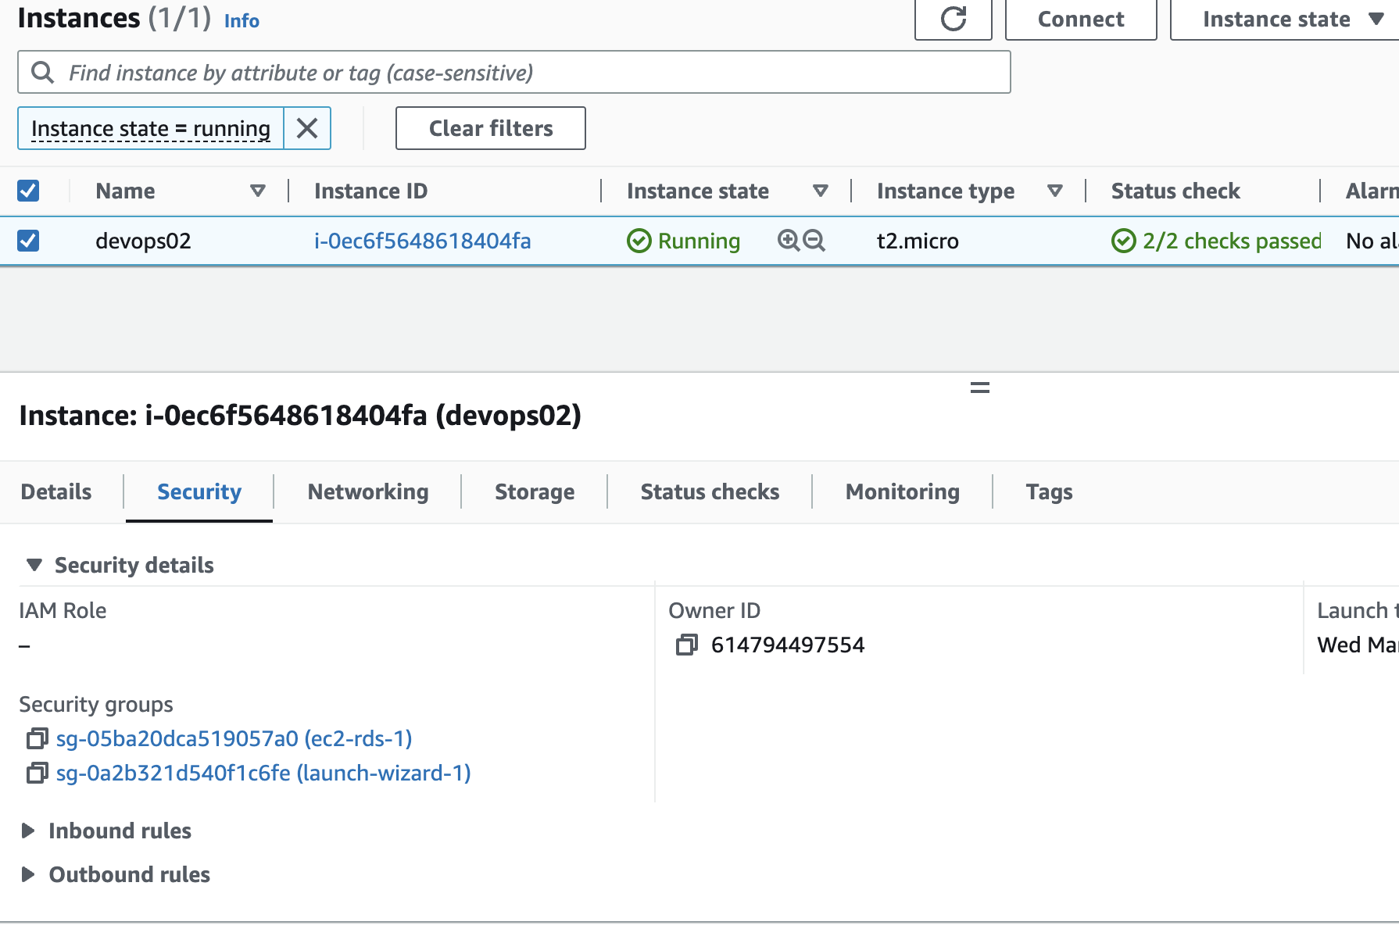

EC2 instance with ec2-rds-1 sg to allow traffic from ec2 to rds (outbound )

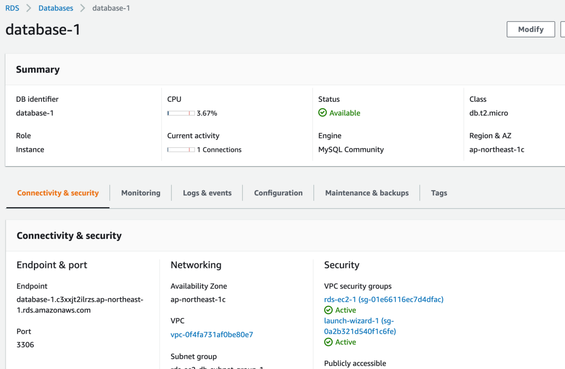

Mysql - RDS connected to ec2, the rds-ec2-1 sg allows inbound from ec2

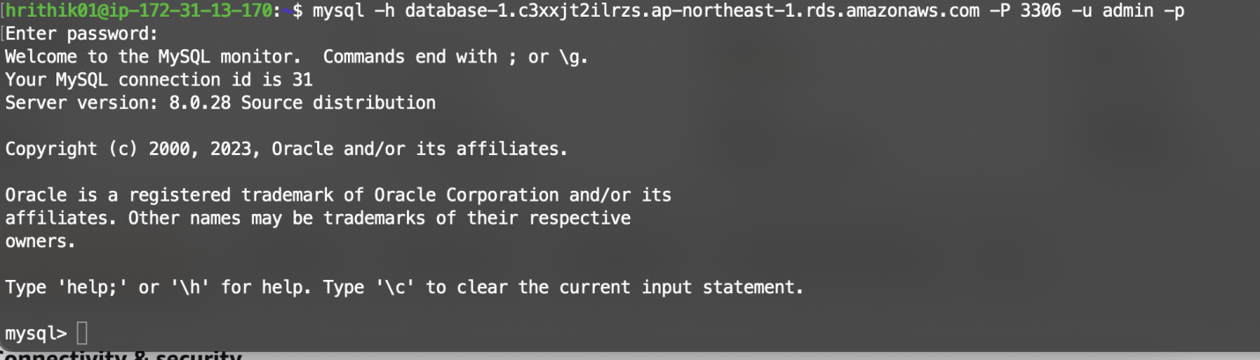

Connection established successfully

Load Balancer

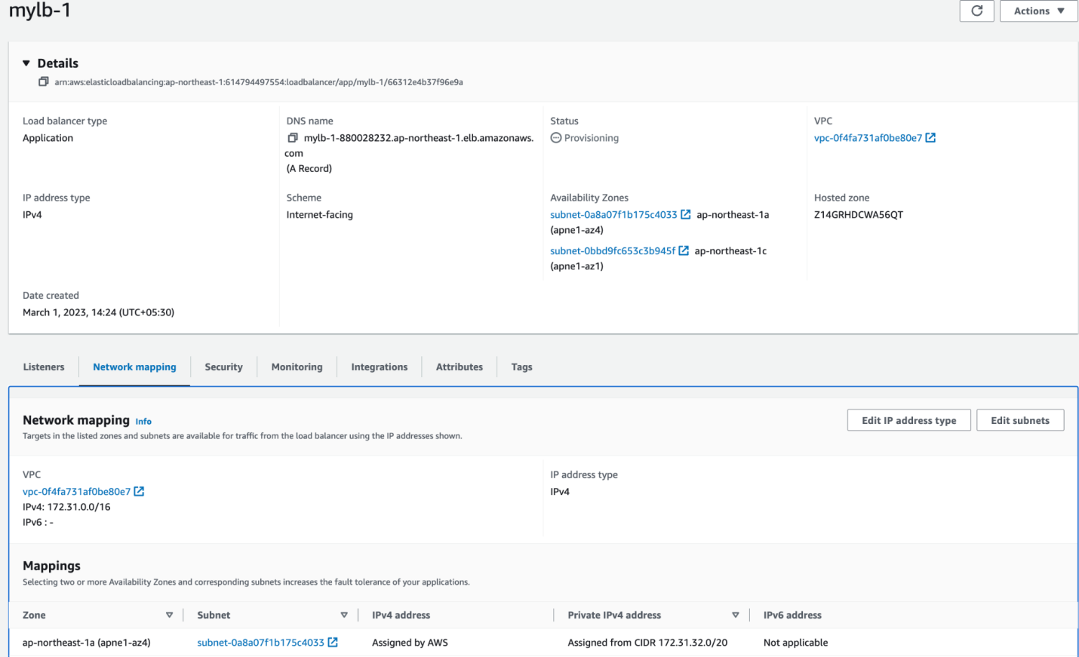

This is the load balancer mylb-1, deployed in the same VPC as the ec2

(Need to learn more on AWS ELB..!)