Create your own new custom VPC

- And configure your EC2 linux instance inside your custom VPC

- and then create 3 subnets of that VPC

- Attach an internet gateway to your custom VPC

Create your own new custom VPC

And configure your EC2 linux instance inside your custom VPC

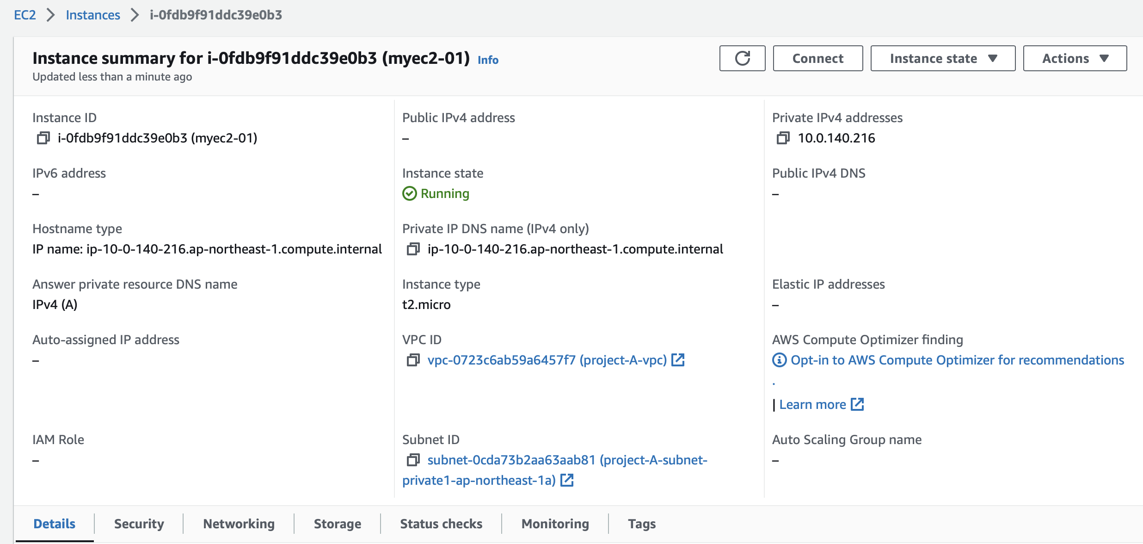

And then create 3 subnets of that VPC

I have created 2 public subnets and 2 private subnets.

* The EC2 is hosted in the private subnet of this VPC
* The EC2 is not given an public IP, only has private IP
* This VPC is peered to another default VPC

* The default VPC has an EC2 instance hosted in it with a public IP, which will be used to SSH into the EC2 myec2-01 (with private IP)
* Established a connection between the EC2 (with public IP on one VPC ) and another EC2 (with private IP, in a private subnet on a different VPC)

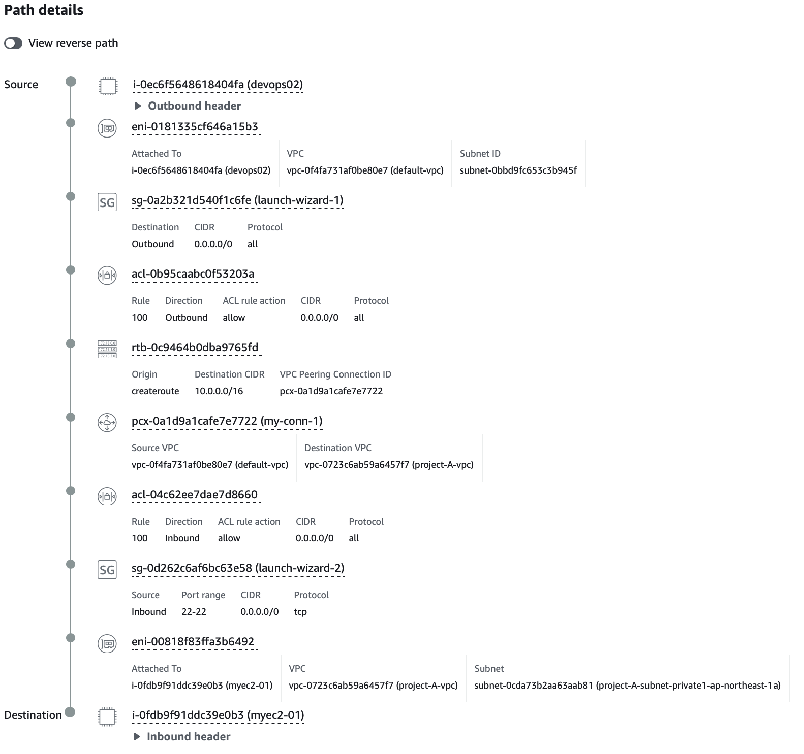

Ping between both EC2’s (both ways)

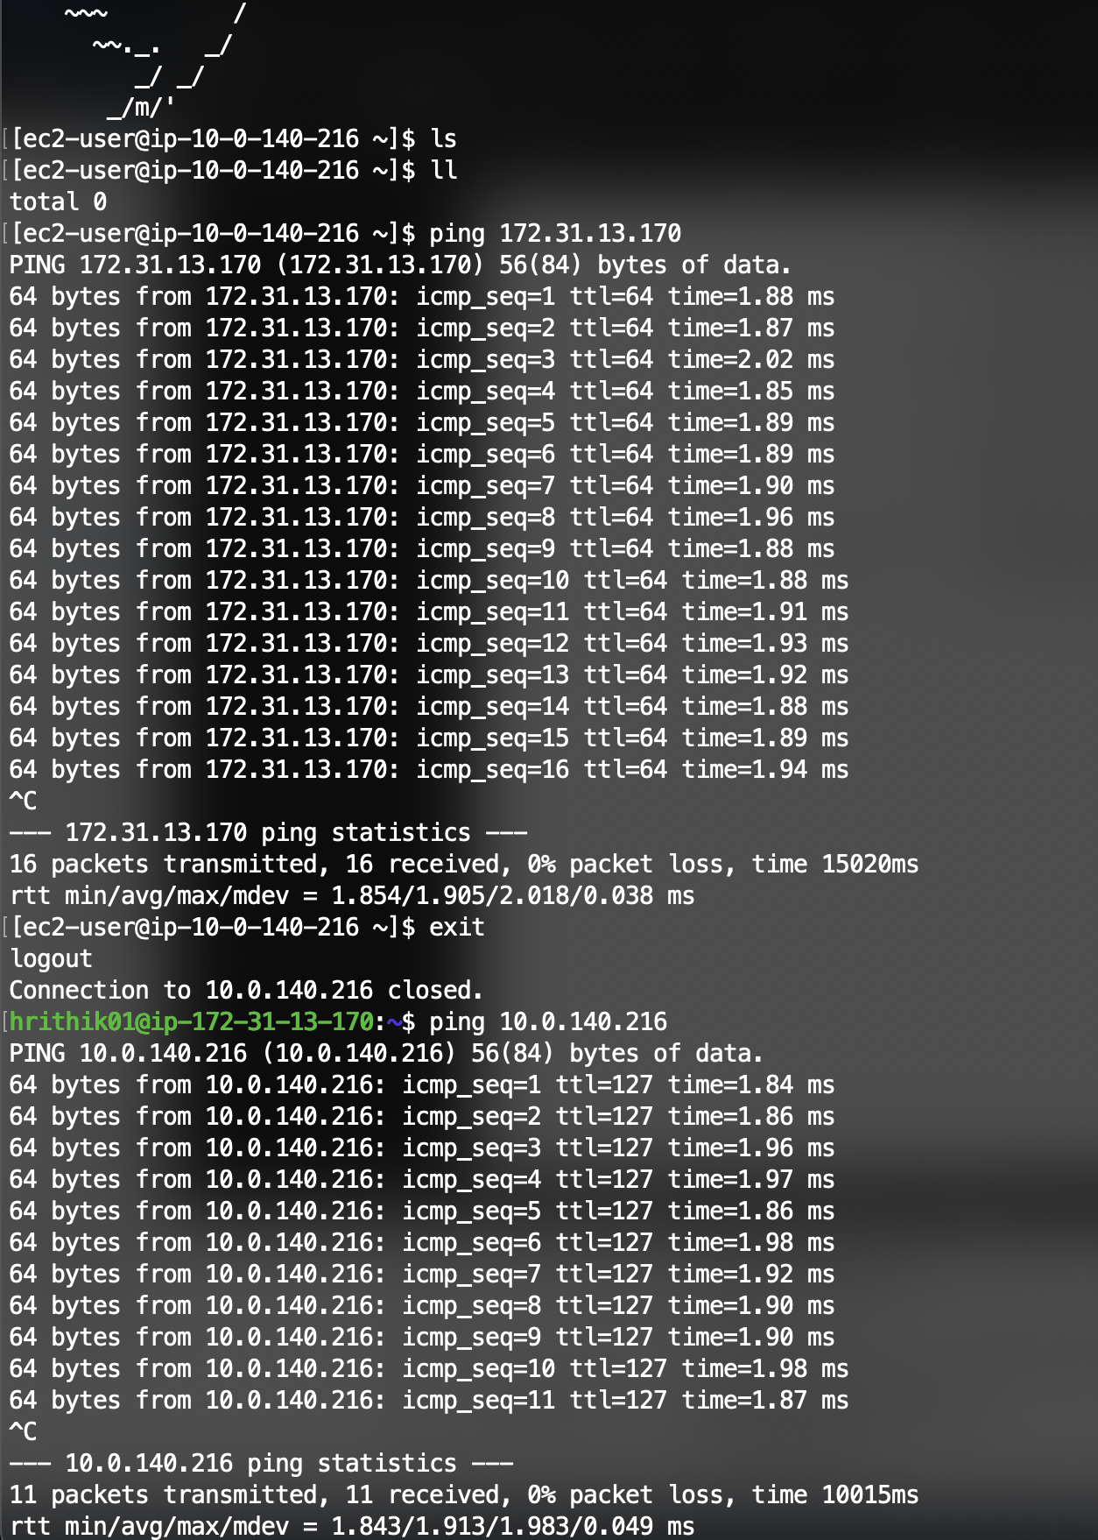

Attach an internet gateway to your custom VPC

Project-A-igw : Internet gateway, connected to 2 public and 1 private subnet of custom VPC

and defined a route table.

